DELWP Grants Online Information Sheet
for Community Users

The DELWP Grants Online Portal ‘GEMS’ is used to accept applications for the Coastcare Victoria Community Grants. This Portal is used across all DELWP grants programs.

Registration & login
If you will be creating/submitting grant applications on behalf of your community group, it is highly recommended that you register an account with an organisational generic email address, so that account login details can be shared across the organisation.
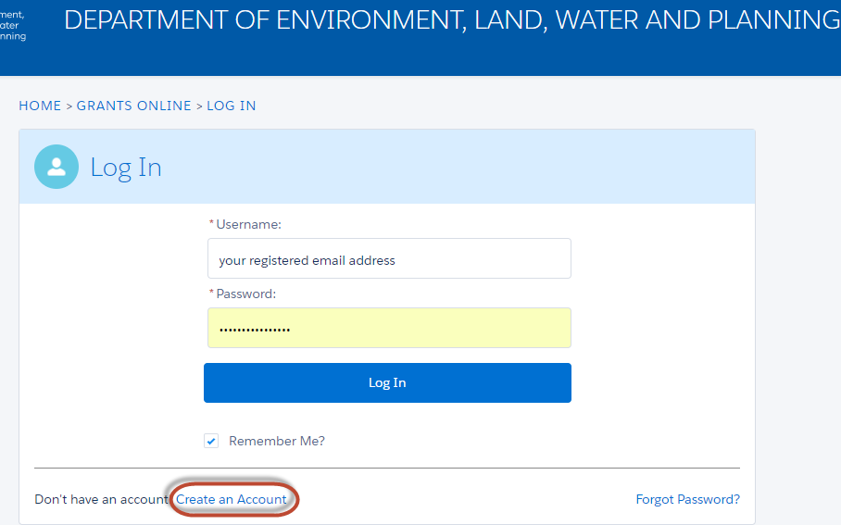

Starting a new application
The ‘Create new application’ link will be available from the relevant DELWP website, as well as the Grants Victoria website, for example:
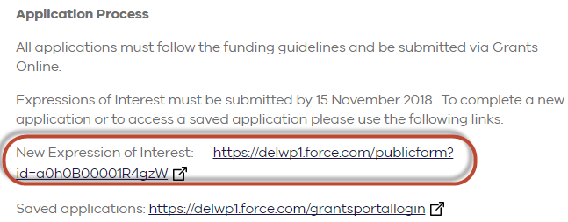

Accessing existing draft & submitted applications
A unique application reference number is generated by the system when your application is saved as draft, the application number starts with “GA-F” and looks like “GA-F12345-1234”. It is important that you include your application reference number in any communication with this grant program.

There are three ways to access existing draft and submitted applications:
- Login to https://delwp1.force.com/GrantsPortalLogin to access all your draft and submitted applications.
- Using the link provided on the program page under “How to apply” section
- Using the link provided in notification email you received after creating a new draft.

Site navigation
- The side navigation bar helps you to quickly navigate to the page you have worked on. The navigation bar colour changes from grey to green once the page is completed. And you can only jump to a page that is in green colour.
- When you click on Save as Draft button, your application form is saved.
- When you click on View as PDF button, you can view the entire application form.
- When you click on Next Page button, the previous page content is saved automatically.
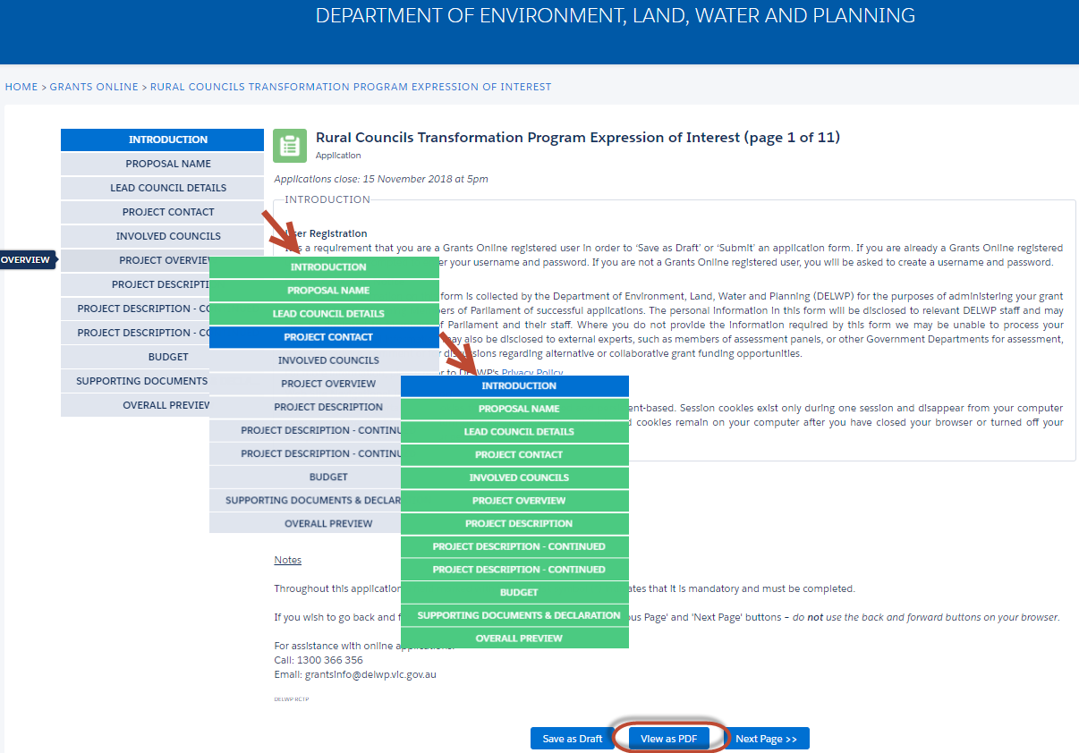

Communicate with Program representatives
When communicating with program representatives (Coastcare facilitators), for example, emailing coastcare@delwp.vic.gov.au, please include the program name abbreviation, your application reference number, and program staff name if known in the subject line.

