|  |
| --- |
| Cape to Cape Resilience Project  STAGE 2 COMMUNITY ENGAGEMENT FINDINGS  APRIL 2023 |

Community Engagement Summary

Stage 2 of the Cape to Cape Resilience Project involves developing a Resilience Plan to allow us to manage coastal hazards strategically. Extensive community and stakeholder engagement is helping to inform the Resilience Plan.

## Introduction

Over January to March 2023, we ran a series of engagement events and activities to gather input from residents, visitors and stakeholders on adaptation planning.

In particular, we were gathering perspectives on:

* Coastal hazard risk and outcomes from the Coastal Hazard Assessment and Risk and Vulnerability Studies
* Adaptation action preferences and appropriate actions for different locations.
* Additional actions or feedback on building coastal resilience in the Cape to Cape communities

This update provides a snapshot of what we heard. We thank everyone who participated.

Adaptation actions being considered for managing coastal hazard risk in the region align with the Marine and Coastal Policy’s strategic options:

***non-intervention, avoid, nature-based methods, accommodate, retreat, and protect***

## How did we engage?

So far, engagement for Stage 2 of the project has included a range of activities:

|  |  |
| --- | --- |
| Circus Tent outline | Seven community pop-up events |
| Door Open outline | A dedicated community drop-in session |
| Clipboard Partially Checked outline | An online survey |
| Meeting outline | Four round table discussions |
| Boardroom outline | Targeted briefings with Traditional Owners, agencies and authorities |

## Who did we hear from?

We’ve talked to a range of community members across the past couple of months. This has included:

* Chatting in person to over 500 people through pop-up and drop in events
* Around 40 attendees to round-table sessions
* 92 survey submissions

Demographic data gathered through our survey showed:

|  |  |
| --- | --- |
| Man and woman outline | An even gender split in responses |
| Cake outline | Responses from a range of ages, and reflective of the region’s demographics |
| Map with pin outline | Around 80% of respondents from the Cape to Cape region |
| Neighborhood outline | A mix of two thirds permanent residents and a third holiday homeowners and visitors |

## What we heard

Findings from the recent survey have been summarised under the following themes:

* Previous involvement with the project
* Perspectives on coastal hazard risk and adaptation
* Adaptation actions and action appropriateness
* Further comments

### Previous involvement with the project

Many respondents were well-informed, having participated in previous activities and read project updates, factsheets and other materials. We also heard from some new voices, with 24 respondents getting involved in the project for the first time.

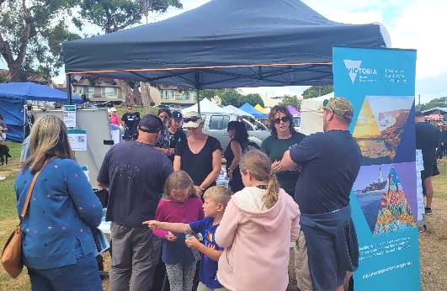

### Perspectives on coastal hazard risk and adaptation

When asked how they thought they might be impacted by coastal hazards in the future, respondents raised impacts to road and recreational access, impacts to private property, use and enjoyment of the sandy beach, liveability/desirability of the region, and environmental impacts.

#### How do you think you might be impacted by coastal hazards in the future?

#### How would you feel about moving assets or changing land use?

We asked how people felt about moving the following assets if it meant we could continue having a sandy beach at **Inverloch**. We found:

* There was general support for moving the different types of assets.
* There was most support for actions to move Bunurong Road and the Surf Lifesaving Club over time.
* Actions to move private properties out of at-risk areas received mixed responses.

Rating on a scale of 0 to 10 (0 = don’t support, 10 = fully support)

We asked how people felt about moving the following assets or changing land use around **Anderson Inlet** if it meant we could make space for natural ecosystems. We found:

* There was general support for moving the different types of assets.
* There was most support for moving at-risk roads and services.
* A dirt road in the woods

  Description automatically generated with low confidenceThere were mixed responses for actions to move private properties out of at-risk areas over time.

Rating on a scale of 0 to 10 (0 = don’t support, 10 = fully support)

We also asked people if being cut off/isolated by flooding several times a year around **Venus Bay and Tarwin Lower** would influence peoples’ decision to live in this community. For those that the question was applicable, over 70% said it would influence their decision.

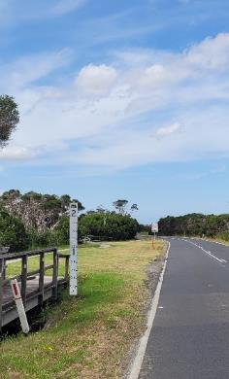

When asked what steps people might take if they knew flooding might become more frequent in the community, responses included:

* Sell/move properties.
* Lobby/advocate Council and agencies for road raising and planning updates.
* Avoid the risk by not buying in flood prone areas.
* Prepare and make emergency plans.
* Modify or upgrade their property/assets to be more flood resilient.
* Limit use of holiday homes.
* Seek more information, options and advice from experts, agencies and authorities.

## Action appropriateness

Through the online survey and at pop-up events, we asked people how appropriate they thought a range of actions were for each location. Not all respondents submitted responses for all locations. Results are presented for each location below.

### Inverloch

For Inverloch surf beach:

* Respondents want some form of action, with non-intervention not seen as appropriate.
* Planned relocation of assets and/or changed land use and infrastructure upgrades/redesign were seen as appropriate.
* Dune and beach renourishment was seen as appropriate, but with a preference for no groynes.
* Hard engineering options such as seawalls, breakwaters and groynes were seen as less appropriate.

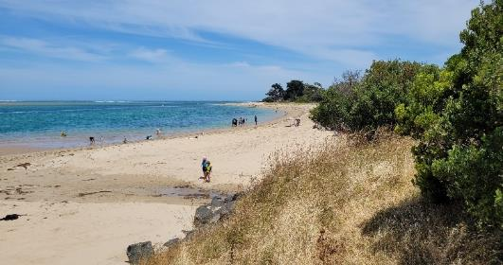

### Anderson Inlet (east of Point Norman)

For areas inside Anderson Inlet, responses were quite mixed, with many responding that most options could be somewhat appropriate. This highlights that different actions or combined actions may be appropriate in different places within the inlet.

### Bunurong Road (Cape Paterson-Inverloch Rd)

For Bunurong Road:

* Respondents want some form of action, with non-intervention not seen as appropriate.
* Planned relocation of assets and/or changed land use, and infrastructure upgrades/redesign and dune/beach renourishment were generally seen as appropriate.

*\* “Accommodate” and “Protect”* actions have been combined in *“Redesign/upgrade infrastructure”* response as some respondents interpreted the existing seawall as infrastructure rather than additional protection.

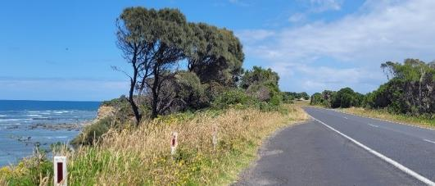

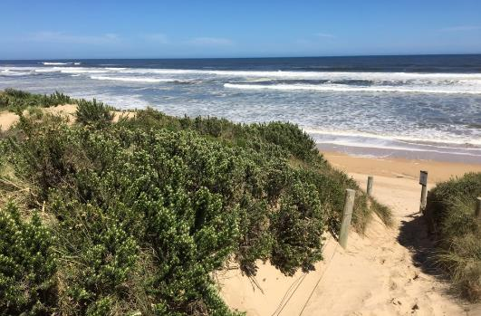

### Tarwin Lower, Venus Bay and surrounds

For the areas including and around Tarwin Lower and Venus Bay, respondents want some form of action, with non-intervention not seen as appropriate.

Redesigning/upgrading infrastructure was seen as slightly more appropriate than relocation and land use transition. Different actions or combined actions may be appropriate in different places across the townships and Inlet.

|  |  |  |
| --- | --- | --- |
|  |  |  |

There is a diverse range of community perspectives on how we should manage coastal hazards and increase our resilience.

At Inverloch – the Surf Beach, Bunurong Road and within the inlet, here is some of what we heard: includes:

**Non-intervention**

*Allow natural processes, if risk allows*

*"Keep options natural, minimal intervention"*

*"Let it go and leave the area alone"*

*"Intervene only when issue becomes critical"*

*"Do nothing, natural processes, can't fight against nature”*

*"Council needs to use the new modelling to change overlays"*

**Avoid**

*Strong support for land use planning*

*"Better planning/ building controls to prevent development in hazard areas”*

*"Planning scheme updates to prevent development in inundation zones"*

*"Natural character with no big developments"*

*"Embed vegetation re-establishment across the region"*

**Nature-based**

*Support for adaptive,**nature-based actions*

*“Renourishment is not long-lasting, need revegetation”*

*"More natural interventions like beach renourishment"*

*"Move some built assets from at risk areas"*

**Retreat**

*Relocation of some assets*

*"Retreat of Surf Parade"*

*"Space for vegetation/ habitat retreat"*

*"Relocating some at risk properties seems like a good long term option"*

*"VicRoads to compulsorily acquire some of the RACV and realignment of Bunurong Rd"*

*"A seawall to protect Bunurong Road"*

*"Keep options natural/ minimal intervention"*

*"Rocks in bags and flexibility to change designs"*

**Protect**

*Mixed views on protection structures*

*"Prioritise temporary options over permanent"*

**Other feedback**

*Evidence-based, adaptable, resilient and the value of an informed community*

*“Holistic planning with the latest science”*

*“Proactive, rather than reactive”*

*“Community education and awareness is paramount”*

*“Informed, strategic, resourced approach”*

*“Clear action plan, timelines, endorsed by community”*

For Venus Bay and Tarwin Lower, some of the community perspectives on how we should manage coastal hazards include:

**Avoid**

*Support for planning updates*

**Non-intervention**

*Some support for allowing natural processes, where risk levels allow*

*“Less development combined with enhancement of natural landscapes”*

*“Venus Bay re-zoned as a sanctuary”*

*“Eco-town role model to show what is possible”*

*“Allow natural processes to continue”*

*“Protection, enhancement of coastal vegetation e.g. mangroves, saltmarsh to increase resilience”*

*“Health of environment of Anderson Inlet”*

**Nature-based**

*Strong support for enhancing ecology*

*“The priority should be maintaining the natural environment”*

*"Environment comes first, no more structures”*

*“Maintain and protect native vegetation throughout Venus Bay estates”*

*“What about septic in Venus Bay interacting with groundwater”*

*"Access in the future – raise the road”*

*"Think about utilities and services into the future"*

**Accommodate**

*Support for actions to maintain access and services*

*“Retrofitting existing buildings (double glazing, firewalls, re-roofing to increase resilience)”*

*“An upgrade to small sections of the main road would eliminate virtually all road flooding.”*

*“The coast will inevitably erode and episodes of inundation increase, so retreat and transition of land use is the only sensible option”*

**Retreat**

*Support for offering retreat and transitioning to alternate uses*

*“Offering support for people who are willing to retreat from the coast could be a good solution”*

*“De-commission some existing developments”*

*“Convert at risk roads to walking/hiking trails”*

**Other feedback**

*Importance of raising awareness and tackling communication challenges, authorities working together with a clear plan*

*“Complex management of the inlet by one authority”*

*“Communications when grid is down”*

*“Coordinated plan with clear actions based on best available information”*

*“Bushfire overlay needs re-visiting to protect dunes”*

*“Community awareness/ education to impacts of storm surge”*

*“Resilience against isolation – road closures, communications”*

*“Community messaging to generate awareness”*

## Further comments

We received further comments and feedback on the project, what people want to see from the Resilience Plan, and implementing actions into the future:

|  |  |
| --- | --- |
| Document outline | Eagerness to review the draft plan: |
|  | * Full plan of preferred options * Timeline and proposed pathway/s of actions and their implementation * Further opportunity to comment on the proposed options |
| Magnifying glass outline | Further detail on actions: |
|  | * Further details on how strategic land use and planning methods and tools could be used to transition particular land-uses and/or to retreat from at-risk areas. * Integration of actions with Council and other agency programs and strategies * Examples, pilots/trials and case studies of actions |
| Users outline | Further engagement opportunities: |
|  | * Promotion of the project on social media * Video explainers * Further opportunity to comment on proposed adaptation actions and the Resilience Plan |
| Gears outline | Implementation of actions: |
|  | * Funding and resourcing for actions * Ongoing beach monitoring |

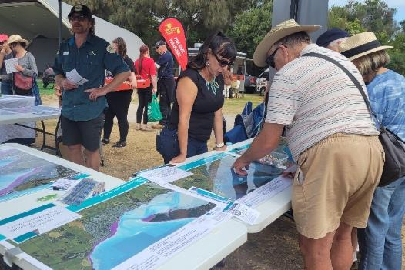

## Next steps

Hearing ideas and perspectives from the Cape to Cape communities remains an important part of this project. Your feedback helps to inform how we adapt to and manage coastal hazards in the future.

We’re incorporating all this feedback into developing the draft Resilience Plan. The draft Plan will include:

* Adaptation actions for the entire region
* Preferred adaptation pathways for each location
* Further detail on actions, implementation and funding

There will be opportunities to provide feedback on the draft Cape to Cape Resilience Plan.

|  |
| --- |
| How can I get involved? Check out the hazard maps and read our latest updates - Visit the project website at [marineandcoasts.vic.gov.au/coastal-programs/cape-to-cape-resilience-project](http://www.marineandcoasts.vic.gov.au/coastal-programs/cape-to-cape-resilience-project)  Ask a question or sign-up to receive updates – email [capetocape.project@delwp.vic.gov.au](mailto:capetocape.project@delwp.vic.gov.au) |

|  |  |
| --- | --- |
| © The State of Victoria Department of Energy, Environment and Climate Action 2023  LogoThis work is licensed under a Creative Commons Attribution 4.0 International licence. You are free to re-use the work under that licence, on the condition that you credit the State of Victoria as author. The licence does not apply to any images, photographs or branding, including the Victorian Coat of Arms, the Victorian Government logo and the Department of Environment, Land, Water and Planning (DELWP) logo. To view a copy of this licence, visit http://creativecommons.org/licenses/by/4.0/  ISBN 978-1-76136-205-7 (pdf/online/MS Word)  Disclaimer  This publication may be of assistance to you but the State of Victoria and its employees do not guarantee that the publication is without flaw of any kind or is wholly appropriate for your particular purposes and therefore disclaims all liability for any error, loss or other consequence which may arise from you relying on any information in this publication. | Accessibility  If you would like to receive this publication in an alternative format, please telephone the DEECA Customer Service Centre on 136186, email [customer.service@delwp.vic.gov.au](mailto:customer.service@delwp.vic.gov.au), or via the National Relay Service on 133 677 [www.relayservice.com.au](http://www.relayservice.com.au). This document is also available on the internet at [www.deeca.vic.gov.au](http://www.deeca.vic.gov.au). |