|  |
| --- |
| Cape to Cape Resilience Project  PROJECT UPDATE #10 August 2024 |

## The Cape to Cape Resilience Plan will enable management agencies and communities to proactively manage coastal hazard impacts and increase resilience for coastal areas from Cape Paterson to Cape Liptrap. Project update

The draft Resilience Plan is available for public comment through a formal 28-day public consultation period beginning Friday 23 August 2024.

Developed over two years, agencies, stakeholders and communities actively collaborated to create the plan, which provides a roadmap to build resilience across communities and adapt to coastal hazards both now and into the future.

The development of this plan has combined comprehensive and robust technical and strategic work with extensive community engagement to inform long-term planning, to manage important places, assets and other values in the future.

The draft Resilience plan includes actions and pathways to respond and adapt to climate change impacts on the coast across the Cape to Cape region

The **Resilience Plan** aims to:

* Inform future decisions regarding the protection and management of our coast and foreshore.
* Inform future land use planning.
* Guide management of public utilities / facilities
* Guide the management of areas of environmental and cultural significance.
* Safeguard our coastal values and lifestyle.
* Foster collaboration and shared care of our coastline.

Developing the Resilience plan included:

* Understanding **community values and vision** for the future, including cultural values, through extensive engagement
* Understanding **coastal processes** that have shaped the coastline in the past, and what they may look like in the future.
* Identifying coastal hazard areas through a **Coastal Hazard Assessment (CHA).**
* Understanding **vulnerabilities and risks** to assets, including an **economic base case**.
* **Engaging with the community** to understand the preferred approaches to adaptation.
* 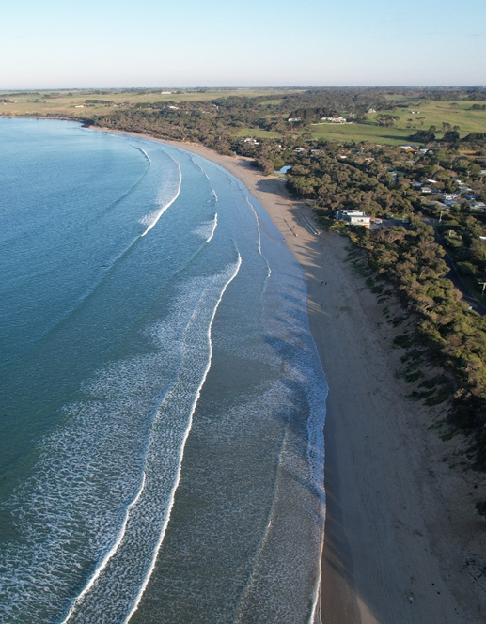**Determining adaptation actions, costs, priorities**, and timeframes for implementation, including action modelling and assessment.
* Coastal **resilience planning and adaptation pathways.**
* Guiding the next stages for **implementation** of actions.

*Once you have reviewed the Resilience Plan, Visit* [*Engage Victoria*](https://engage.vic.gov.au/cape-cape-resilience-project) *and complete our 10 – 15 minute survey to provide us with your feedback on the Resilience Plan’s structure, approach and* *development and the actions and outcomes. The survey will close on Sunday 22 September 2024.*

### What’s included in the Plan?

The draft Cape to Cape Resilience Plan includes:

* An overview of Statewide marine and coastal policy, adaptation planning guidance, and the journey to develop the Resilience Plan
* An understanding of the Cape to Cape coastal landscape, communities, and values
* Coastal hazard modelling and mapping results from the Coastal Hazard Assessment
* Exposure and risk assessment results, including vulnerability and economic assessments
* A strategic approach to adaptation, including adaptation pathways and foundational, regional and location-specific actions.

This Resilience Plan represents the start of an ongoing process of planned adaptation over time. All stakeholders and community members, including residents, visitors, and workers in the region, share the responsibility of adapting to coastal hazards.

Adaptation pathways will be continuously refined, updated, and implemented as new information, knowledge, and community aspirations emerge.

You can read the [Cape to Cape Resilience Plan here](https://www.marineandcoasts.vic.gov.au/__data/assets/pdf_file/0023/715730/CapetoCapeResilienceProject_DEECA_ResiliencePlan_FinalDraft.pdf).

## Public Consultation Period (28-days)

We are seeking community feedback on the draft Resilience Plan through a 28-day public consultation period beginning mid-August 2024. This feedback will assist us in refining the final Cape to Cape Resilience Plan.

There are also technical reports, summaries, hazard maps, factsheets, updates and other information available on our [project website](https://www.marineandcoasts.vic.gov.au/coastal-programs/cape-to-cape-resilience-project).  [marineandcoasts.vic.gov.au/coastal-programs/cape-to-cape-resilience-project](https://www.marineandcoasts.vic.gov.au/coastal-programs/cape-to-cape-resilience-project)

Once the consultation period ends, we will review all the feedback we have gathered and provide a further update with a summary of what we heard. We will also draw on the feedback to refine and finalise our Resilience Plan.

## How can I get involved?

To ensure you keep up to date with the Cape to Cape Resilience Project and upcoming events and activities:

* Visit the project website at [marineandcoasts.vic.gov.au/coastal-programs/cape-to-cape-resilience-project](http://www.marineandcoasts.vic.gov.au/coastal-programs/cape-to-cape-resilience-project)
* Sign-up to receive progress updates or to ask us a question at email [capetocape.project@deeca.vic.gov.au](mailto:capetocape.project@deeca.vic.gov.au)



We acknowledge Victorian Traditional Owners and their Elders past and present as the original custodians of Victoria’s land and waters and commit to genuinely partnering with them and Victoria’s Aboriginal community to progress their aspirations.

© The State of Victoria Department of Energy, Environment and Climate Action August 2024.

Creative Commons

This work is licensed under a Creative Commons Attribution 4.0 International licence, visit the [Creative Commons website](http://creativecommons.org/licenses/by/4.0/) (<http://creativecommons.org/licenses/by/4.0/>).

You are free to re-use the work under that licence, on the condition that you credit the State of Victoria as author. The licence does not apply to any images, photographs or branding, including the Victorian Coat of Arms, and the Victorian Government and Department logos.

ISBN 978-1-76136-878-3 **(print)**   
ISBN 978-1-76136-879-0 **(pdf/online/MS word)**

Disclaimer

This publication may be of assistance to you but the State of Victoria and its employees do not guarantee that the publication is without flaw of any kind or is wholly appropriate for your particular purposes and therefore disclaims all liability for any error, loss or other consequence which may arise from you relying on any information in this publication.

Accessibility

To receive this document in an alternative format, phone the Customer Service Centre on 136 186, email [customer.service@delwp.vic.gov.au](mailto:customer.service@delwp.vic.gov.au), or contact National Relay Service on 133 677. Available at [DEECA website](https://www.marineandcoasts.vic.gov.au/coastal-programs/cape-to-cape-resilience-project) (www.deeca.vic.gov.au).