|  |
| --- |
| Cape to Cape Resilience Project  PROJECT UPDATE #6: October 2022 |

We now have a wealth of knowledge from Stage 1 of the Cape to Cape Resilience Project. Armed with technical, strategic and engagement outcomes, the project team is now working towards shaping our resilience plan.

## Project update and key milestones

Over the past two years, we have delivered Stage 1 of the Cape to Cape Resilience Project. This extensive scope of work has produced various technical, strategic and engagement assessments.

The outcomes of this work allow us to better understand the region’s coastal hazards and possible implications for our local communities, now and into the future.

|  |  |
| --- | --- |
| **Key outcomes of Cape to Cape Resilience Project: Stage 1** | **Timeline** |
| Project plan | Mar-21 |
| Engagement plan | Mar-21 – Jul-21 |
| Community values study | Oct-21 |
| Cultural values assessment | Dec-21 |
| Inverloch region coastal hazard assessment | Jun-21 – Jun-22 |
| Coastal hazard modelling and mapping | Sep-21 – Mar-22 |
| Coastal hazard asset exposure assessment | Mar-22– May-22 |
| Coastal hazard risk and vulnerability assessment |
| Economic base case |
| Preliminary adaptation actions planning and modelling and assessment | May-22 – Jun 22 |

Useful information we now have includes:

* New research through a Coastal Hazard Assessment (CHA)
* Coastal hazard modelling, maps and spatial data layers
* Extensive community engagement and Community and Cultural Values studies,
* A coastal risk and vulnerability assessment,
* Economic base case for coastal hazards

The technical reports for these assessmets will soon be publicly available.

|  |  |  |  |
| --- | --- | --- | --- |
| P51C1T3#yIS1 | You can find more information at the project website:   |  |  | | --- | --- | | [marineandcoasts.vic.gov.au/coastal-programs/cape-to-cape-resilience-project](http://www.marineandcoasts.vic.gov.au/coastal-programs/cape-to-cape-resilience-project) |  |   This includes technical reports, factsheets, project updates, maps and other important project information |

We have prepared four summary reports to share some of the outcomes of the Stage 1 technical and strategic work with our community:

* 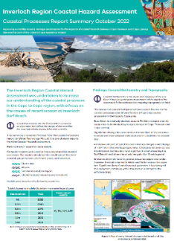[***Coastal Processes Report Summary***](https://www.marineandcoasts.vic.gov.au/__data/assets/pdf_file/0023/602591/Cape-to-Cape-Coastal-Processes-Report-Summary_OCT22_FINAL.pdf)
* [***Inundation Report Summary***](https://www.marineandcoasts.vic.gov.au/__data/assets/pdf_file/0024/602592/Cape-to-Cape-Inundation-Report-Summary_OCT22_FINAL.pdf)
* [***Adaptation Actions Technical Assessment Report Summary***](https://www.marineandcoasts.vic.gov.au/__data/assets/pdf_file/0022/602590/Cape-to-Cape-Adaptation-Actions-Technical-Assessment-Summary_OCT22_FINAL.pdf)
* [***Risk and Vulnerability Report Summary***](https://www.marineandcoasts.vic.gov.au/__data/assets/pdf_file/0025/602593/Cape-to-Cape-Risk-and-Vulnerability-Report-Summary_OCT22_FINAL.pdf)

## Increasing our resilience to coastal hazards

We have now started Stage 2, the development of the Cape to Cape Resilience Plan. Our approach for developing the plan aligns closely with the state-wide guidance for long-term coastal hazard resilience and adaptation called *Victoria’s Resilient Coast – Adapting for 2100+ (VRC)*.

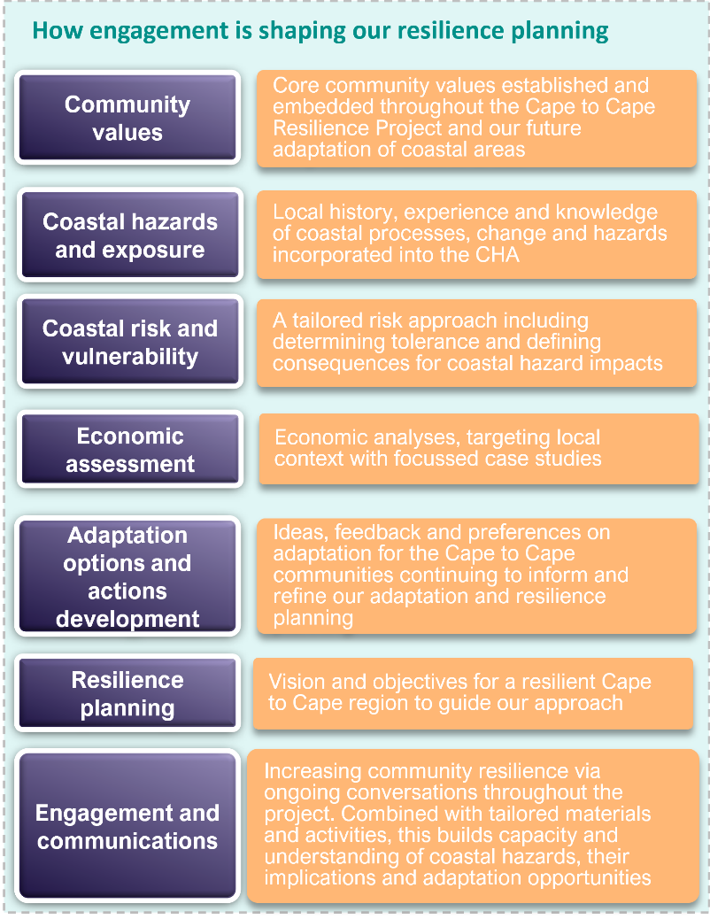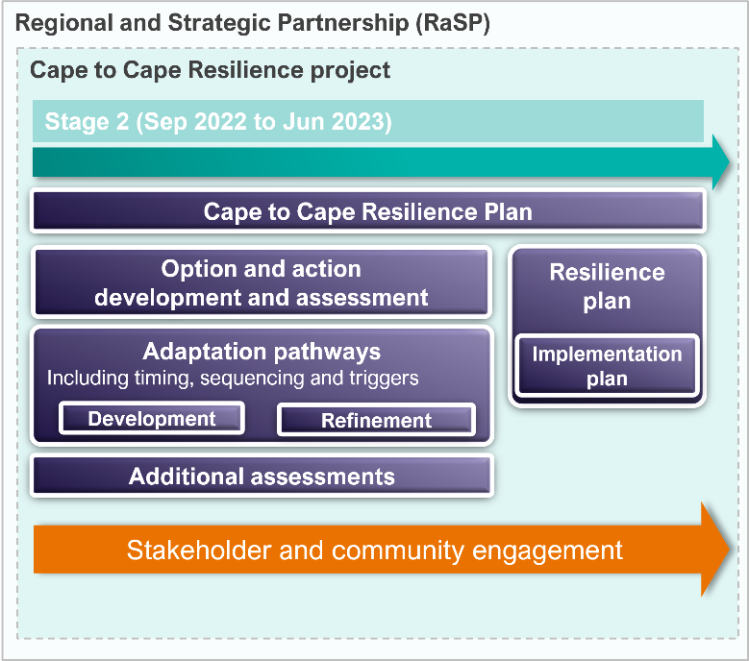

A resilience plan will allow us to strategically manage coastal hazards, increasing our region’s resilience into the future. It will include:

* managing recent changes seen along Inverloch’s coastline
* long-term coastal hazard resilience and adaptation planning to enable the Cape to Cape community to respond and adapt to climate change impacts on the coast

Stage 2 will determine which adaptation options and actions are the most suitable for managing hazard risk for the region. We will be considering a range of adaptation themes - from land management, planning and design, through to on-the-ground works with nature based and engineering solutions. It’s likely that a suite of integrated measures may be required.

Progressing on the work so far

Our next steps bring together all the results and knowledge from the project work to date. We are considering all the findings, at both a regional and localised scale, and using this to shape appropriate adaptation response/s and resilience planning.

Our work will build upon some preliminary thinking already happening for Inverloch, and across the region.

## Hearing from our community

Engaging with our community as part of this project is essential for decision-making on adaptation and resilience planning.

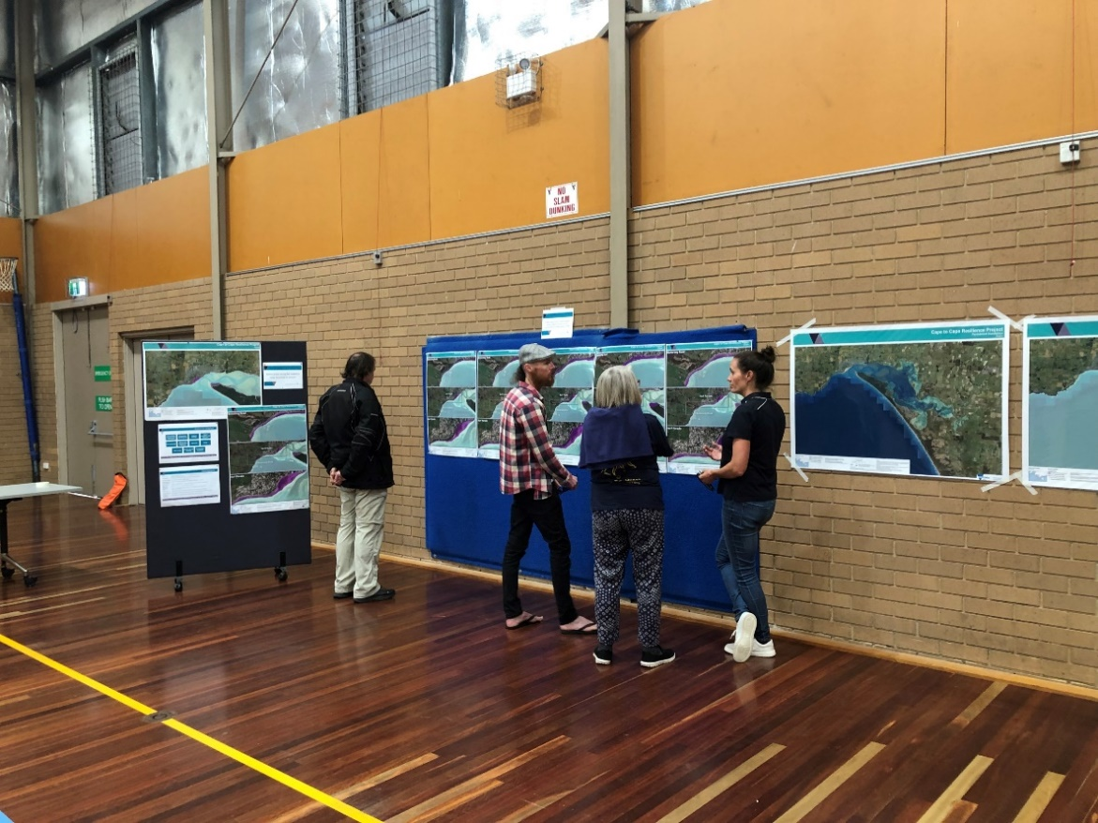

Our work to date has already explored a range of topics relating to coastal hazards and their management with our community:

* community values, usage and enjoyment of the Cape to Cape region’s coastal areas
* perceived threats to these values and uses
* what the community hopes to see in the future
* ideas, perspectives and preferences that may enable us to adapt and increase our resilience

## Next steps

As our project team continue with our adaptation and resilience planning, we will also continue to talk to our key stakeholders and our community.

Hearing ideas and perspectives from the Cape to Cape communities remains an important part of this project and will help to shape the adaptation pathways and actions for the region.

Extensive and targeted community and stakeholder engagement is happening throughout Stage 2, over the coming six months, to help inform our Resilience Plan.

We’ll be popping up around the region over summer to talk to residents and holiday makers. The range of engagement activities will also include drop-in sessions and stakeholder roundtables.

If you’d like to be involved, please get in touch via the project’s email address (see text box).

Keep an eye out on Engage Victoria for further details about our upcoming engagement.

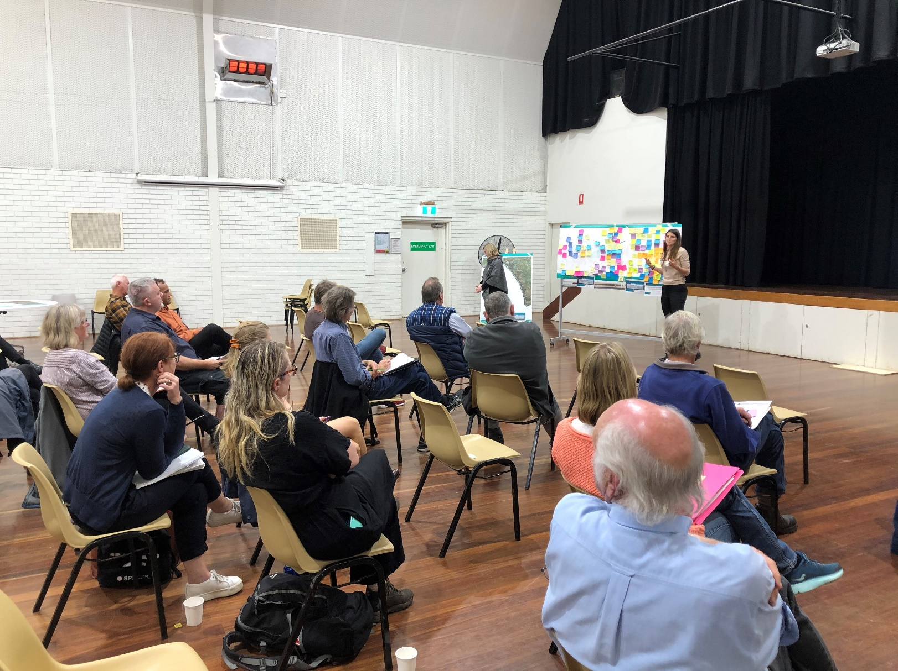

|  |  |
| --- | --- |
| |  | | --- | | 0B**How can I get involved?** To ensure you keep up to date with the Cape to Cape Resilience Project and upcoming events and activities:  Visit the project website at [marineandcoasts.vic.gov.au/coastal-programs/cape-to-cape-resilience-project](http://www.marineandcoasts.vic.gov.au/coastal-programs/cape-to-cape-resilience-project)  Sign-up to receive progress updates and notifications – email [capetocape.project@delwp.vic.gov.au](mailto:capetocape.project@delwp.vic.gov.au)  Read our latest factsheets updates and technical summaries via the website  Ask us a question – email [capetocape.project@delwp.vic.gov.au](mailto:capetocape.project@delwp.vic.gov.au)  Visit our Engage Victoria page at [engage.vic.gov.au/cape-cape-resilience-projec](https://engage.vic.gov.au/cape-cape-resilience-project)t | |

|  |  |
| --- | --- |
| © The State of Victoria Department of Environment, Land, Water and Planning 2022  P104C1T5#y1This work is licensed under a Creative Commons Attribution 4.0 International licence. You are free to re-use the work under that licence, on the condition that you credit the State of Victoria as author. The licence does not apply to any images, photographs or branding, including the Victorian Coat of Arms, the Victorian Government logo and the Department of Environment, Land, Water and Planning (DELWP) logo. To view a copy of this licence, visit http://creativecommons.org/licenses/by/4.0/  ISBN 978-1-76136-150-0 **(pdf/online/MS word)**  Disclaimer  This publication may be of assistance to you but the State of Victoria and its employees do not guarantee that the publication is without flaw of any kind or is wholly appropriate for your particular purposes and therefore disclaims all liability for any error, loss or other consequence which may arise from you relying on any information in this publication. | Accessibility  If you would like to receive this publication in an alternative format, please telephone the DELWP Customer Service Centre on 136186, email [customer.service@delwp.vic.gov.au](mailto:customer.service@delwp.vic.gov.au), or via the National Relay Service on 133 677 [www.relayservice.com.au](http://www.relayservice.com.au). This document is also available on the internet at [www.delwp.vic.gov.au](http://www.delwp.vic.gov.au). |