Coastcare Victoria 30 Year Forum, delivered by Coastcare Victoria, on behalf of the Department of Energy, Environment and Climate Action (DEECA).
This document is an Event Access Key. It outlines details about the upcoming event, accessibility details and other safety considerations. The Coastcare Victoria team has endeavoured to provide a comprehensive document, however please let us know via the email below if we have left out critical accessibility information.
If you require further support to be able to attend this event, email Coastcare.victoria@delwp.vic.gov.au
Coastcare Victoria acknowledges and respects Victorian Traditional Owners as the original custodians of Victoria’s land and waters, their unique ability to care for Country and deep spiritual connection to it. We honour Elders past and present whose knowledge and wisdom has ensured the continuation of culture and traditional practices. DEECA is committed to genuinely partnering with Victorian Traditional Owners and Victoria’s Aboriginal community to progress their aspirations.

Key Coastcare Victoria contacts:
Shaya Kaartinen-Price - Shaya.kaartinen-price@delwp.vic.gov.au / 0436 604 127
Mathew Mitchell – matt.mitchell@delwp.vic.gov.au / 0459 876 747

Event overview
This is a Volunteer Forum provided by Coastcare Victoria on 22 May 2024 at 9:30am. Everyone will meet at 200 The Blvd, Port Melbourne VIC 3207, situated on Bunurong Country.
This event will be delivered in English.

Time | Session
9:30am – 10am | Opening
10am – 10:45am | Morning session 1
10:45am – 11:15am | Morning Tea
11:15am – 12pm | Morning session 2
12pm – 12:30pm | Q&A debrief session
12:30pm – 1:30pm | Lunch
1:30pm – 2pm | Afternoon session 1
2pm – 2:30pm | Q&A debrief session
2.30pm – 2.45pm | Afternoon Tea
2.45pm – 3.15pm | Afternoon session 2
3.15pm – 3.45pm | Q&A debrief session
3.45 – 4pm | Closing

Learn more about the Country on which you will be learning, engaging and enjoying
Bunurong Land Council Aboriginal Corporation (BLCAC) are the Registered Aboriginal Party with native title rights of this area.

BLCAC plays a vital role in representing the country, community, culture, and heritage of the Bunurong people in the region. If you would like to learn more before attending the event, please follow this link: https://www.bunuronglc.org/

Getting there
- Free parking is available on site. There is a main carpark and a second carpark, both are accessed via the Boulevard (street address of venue).
- The best venue access via public transport is to catch the 109 tram or the 236 bus to the venue.
109 Tram – For timetable click here
236 Bus – For timetable click here
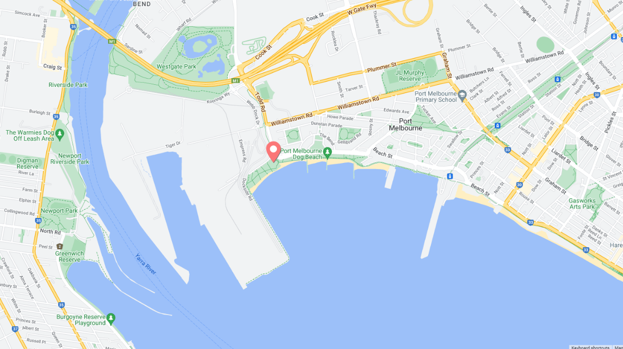

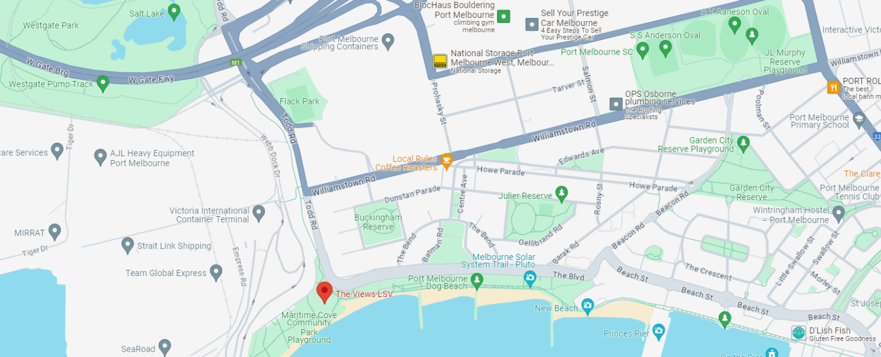

Arriving at the location
- Arrive via The Boulevard, and make your way towards reception (signage will be available)

Inside the location
- The venue is wheelchair accessible.

Facilities
- Toilets are available on site.
- Drinking water will be available, in addition to tea + coffee on arrival.
- Catering will be provided on the day, including morning tea, and lunch. To ensure your dietary needs are catered to, please ensure you have completed the dietary requirements section in the registration form for the event.

Quiet time
- Quiet spaces may not be available within the building, due to the public nature of the event, however there is plenty of open space on beachfront area outside of the venue.
- Coastcare Victoria seeks to provide a quality experience, with an agenda filled with informative and engaging presentations, discussions and activities. Due to the limited time on the day, there will not be specific additional quiet breaks included in the agenda, however there will be regular break/movement intervals throughout the day and attendees are welcome to take a break from participating whenever they feel is necessary. in the registration form for the event.

If you have anything you would like to discuss further with a Coastcare Victoria staff member, don’t hesitate to reach out via the contact details at the beginning of this document. Alternately, reach out to Coastcare.victoria@delwp.vic.gov.au and we will get back to you as promptly as possible.

