|  |
| --- |
| DELWP marine and coasts newsletter |

Welcome to the Department of Environment, Land, Water and Planning’s (DELWP’s) quarterly marine and coasts newsletter**.**

# In this issue

* Eastern View short term protection works
* Queenscliff Dog Beach Coastal Adaptation Plan
* Erosion Warning Indicators for Victorian Coastal Monitoring Sites
* Coastcare Victoria’s Coastline



|  |
| --- |
| Email [marine.coasts@delwp.vic.gov.au](mailto:marine.coasts@delwp.vic.gov.au) to subscribe or unsubscribe to this newsletter and for more information. |

# Coastal projects

## Eastern View short term protection works

Work is underway at Eastern View to protect the foreshore and Great Ocean Road from coastal erosion.

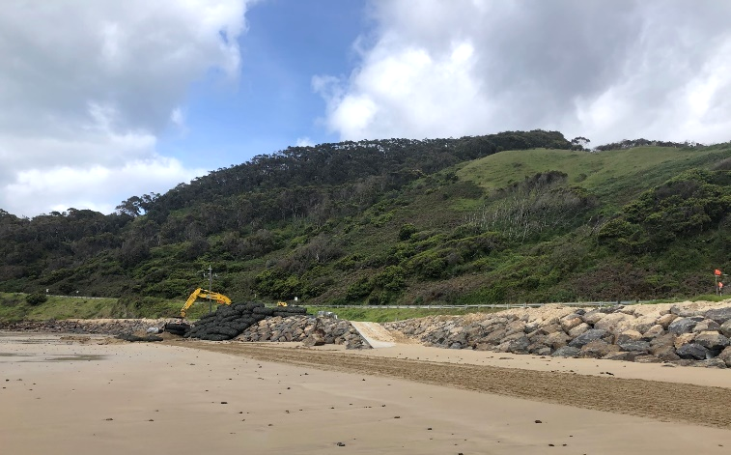

Works underway at Eastern View

Machinery is on-site and moving around, so we’re asking everyone to follow all signage and stay safe, including keeping dogs on leashes in the area.

The $2 million project includes:

* construction of a section of rock revetement at the Devil’s Elbow carpark
* rock bag protection for car parks and power poles north of the Memorial Arch.

The project follows a Coastal Adaptation Plan, and community feedback provided at a ‘listening post’ held at Aireys Inlet in April 2022.

The works are a partnership between DELWP and the Great Ocean Road Coast and Parks Authority (GORCAPA) and should be completed by the end of December 2022.

Find out more about this project at [www.marineandcoasts.vic.gov.au/coastal-programs/coastal-adaptation-plans](http://www.marineandcoasts.vic.gov.au/coastal-programs/coastal-adaptation-plans)

## Queenscliff Dog Beach Coastal Adaptation Plan

Shaped by community consultation, a Coastal Adaptation Plan has been developed for Dog Beach, Queenscliff ‘The Narrows’, which connects Point Lonsdale to Queenscliff.

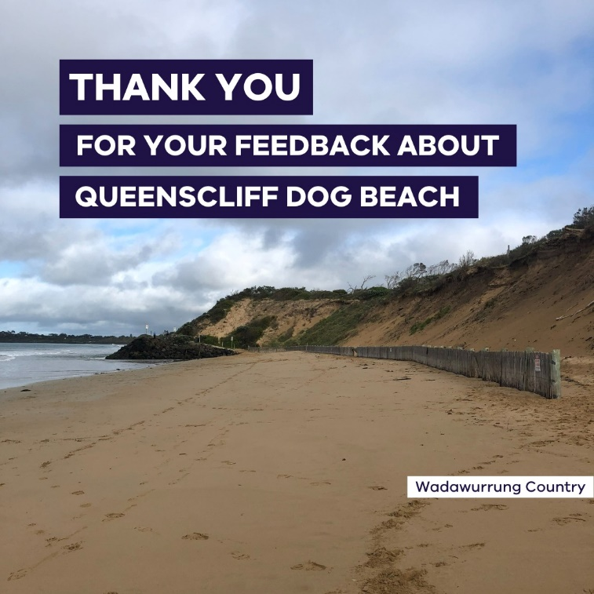

A huge thank you to everyone who got involved – your local knowledge and input has been invaluable through surveys or attending our drop in session. It is clear that the local community has a good understanding of the history and processes impacting the area, and really values the beach for recreational use.

The adaptation plan includes a review of available options to manage erosion and terminal scour and respond to sea level rise within the adaptive pathway approach found in the Marine and Coastal Policy 2020.

As a result of terminal scour, the dune face at Dog Beach has become steep and unstable, posing a public safety risk for users of the area. Terminal scour occurs at the end of a hard structure such as a sea wall or rock revetment, where sediment is eroded away.

The study found that the rate of erosion appears to have slowed from 2015 to the present and may be reaching a state of equilibrium.

This has informed the recommended option for short and medium-term management of erosion at Dog Beach to manage public safety and access, including:

* extending the sand fencing to reduce access to the dune face
* installing signage advising the dangers of climbing on the dune
* extending the access ramp to prevent the end being exposed during low sand levels
* relocating sections of the footpath (Lovers Walk) if necessary.

This minimal intervention approach was strongly supported by the community and will maintain the wide beach and natural character valued by beach users. It is expected to be effective until at least 2050.

Find out more at [www.marineandcoasts.vic.gov.au/coastal-programs/coastal-adaptation-plans](http://www.marineandcoasts.vic.gov.au/coastal-programs/coastal-adaptation-plans)

# Marine and coastal knowledge

## Erosion warning indicators for Victorian Coastal Monitoring sites

The Victorian Coastal Monitoring Program (VCMP) is responsible for collecting and providing knowledge to coastal managers and communities to manage coasts in the present. The program is a key action of the [Marine and Coastal Strategy 2022](https://www.marineandcoasts.vic.gov.au/coastal-management/marine-and-coastal-strategy) and supports coasts to be more adaptive and resilient to future climate change.

The VCMP has developed a new initiative designed to determine coastal response – an Erosion Warning Level indicator for 20 beaches regularly surveyed as part of the VCMP Drone Survey Program. This type of indicator is made possible by the dataset developed over several years of VCMP surveying.

The Erosion Warning Indicator is designed to detect areas where ‘Hotspot Erosion’ has recently occurred, then calculates a Total Warning Level from a combination of:

* long-term shoreline change
* short-term shoreline change
* amount of Hotspot Erosion occurring to the beach and dunes.

The Erosion Warning Indicator is intended to be a tool for land managers to identify potential coastal areas of concern and sits within the [Marine and Coastal Knowledge Framework](https://www.marineandcoasts.vic.gov.au/coastal-programs/marine-and-coastal-knowledge-framework).

Outputs will be made available through CoastKit in early 2023 – [www.mapshare.vic.gov.au/coastkit/](https://mapshare.vic.gov.au/coastkit/)

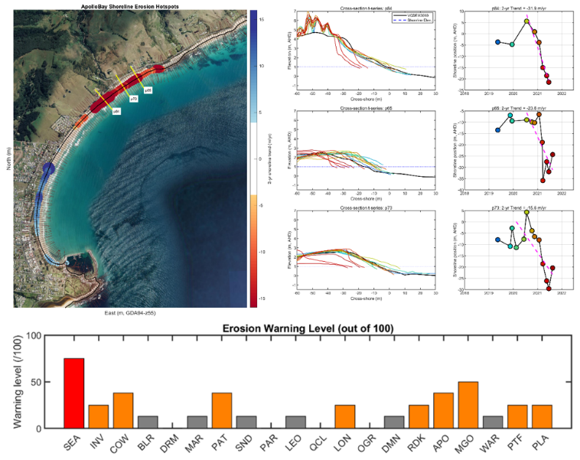

An example of how the Erosion Warning Level comes together, with mapped Erosion Hotspots along the Apollo Bay shoreline (top left), a series of graphs looking at shoreline change (top right), and a graph of the Erosion Warning Level for multiple sites (bottom).

Keep reading for Coastcare Victoria’s Coastline!



# **In this issu**e

Farewell Madi

Welcome Corinne

Welcome Lux

Summer by the Sea planning underway

A Coastcare Victoria graduation

Ricketts Point Marine Sanctuary 20th anniversary celebration

Friends of Mallacoota Gabo Weeding Project

## Farewell Madi

In November we farewelled our Bellarine-Surf Coast Coastcare Victoria facilitator Madi Cassie – sad for us but great for Madi’s new colleagues in the consultancy world.

Madi achieved a lot in her time with us, with her main claim to fame was delivering the new Coastcare Victoria Schools Kit.

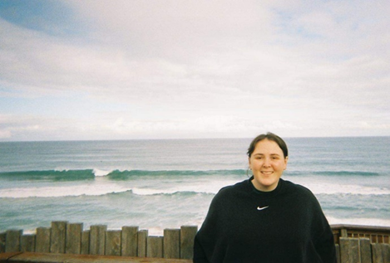

Farewell to Coastcare Victoria facilitator, Madi

She will be greatly missed and we wish her all the best for the future. Here is a message to our Coastcare Victoria volunteers from Madi:

Farewell western Coastcare Victoria volunteers! It has been a blast working with you all over the past year. Thank you for welcoming me with open arms and allowing me to help you with all your extraordinary projects.

I have left DELWP to work as an ecologist at a consulting firm in Geelong. However I will still be watching the success of your projects from the sidelines and hopefully will still be able to come out as a volunteer and work alongside you.

Best wishes, Madi.

## Welcome Corinne

We recently welcomed Corinne Donohue into the Coastcare Victoria Grants Officer role. Corinne has a background in fisheries and will bring a unique perspective to administering our community grants. You’re sure to hear from her soon if you currently have a grant with us!

Welcome to our new Grants Officer, Corinne

## Welcome Lux

Luxshika (Lux) Kannan has joined the team as a summer intern in the Port Phillip and Westernport region until February 2023.

Located in Port Phillip, Lux sits alongside her manager, Port Phillip Coastcare Victoria facilitator Joiee Tachas.

Lux has hit the ground running, contributing to building volunteer profiles for Coastcare Victoria’s social media, supporting preparations for Summer By The Sea (SBTS) and bringing a fantastic energy to the team! You will see her around at some of the SBTS events early next year, so make sure you say hello.

A few words from Lux:

Hi everyone! I’m Lux, and I’m studying at the University of Melbourne, doing a Bachelor of Science, majoring in Geography. I love volunteering and am inspired by sustainability for the future, so that’s why I hopped into the Coastcare Victoria Team😊 Thank you to the Coastcare Victoria team for welcoming me and I’m looking forward to getting involved in community engagement.

Welcome Lux!

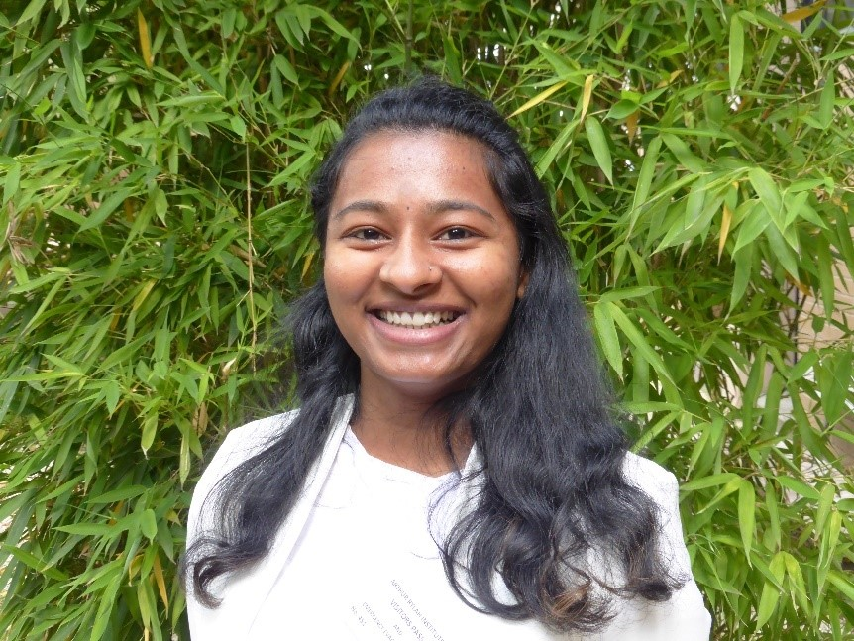

Lux on her first day at the Heidelberg office.

## Summer by the Sea planning underway

Summer by the Sea logo

We know it’s getting to that time of the year when everyone is keen to know what’s happening for our annual Summer by the Sea program.

The 2023 program will run from 7 January to 5 February 2023 and rest assured planning is well underway. You will see updates on our websites and socials as soon as bookings open!

You can keep up to date via the [Summer by the Sea blog](https://summerbythesea.vic.gov.au/blog/).

## A Coastcare Victoria graduation

On the evening of Wednesday 30 November 2022, Coastcare Victoria facilitators Johanna (Joiee) Tachas (Port Phillip and Westernport) and Laura Town-Hopkinson (South Gippsland) graduated from the Department of Environment, Land, Water and Planning (DELWP) and Department of Jobs, Regions and Precincts (DJPR) [Science and Planning Graduate Program](https://www.delwp.vic.gov.au/careers-and-volunteering/science-and-planning-graduate-program).

This two-year program consists of varied and meaningful development experiences to kick-start early career professionals’ careers within the Victorian Public Sector. Both Joiee and Laura gained exposure to field and policy work, research, and community engagement.

The graduation evening was attended by the entire graduating 2021 cohort, the ongoing 2022 cohort, DELWP and DJPR executives, managers, and mentors.

The night was a celebration of the completion of the program and the ongoing careers of the graduates in their chosen departments.

Each graduate gave insightful presentations on their employment rotations within the program, including career highlights, learning and development opportunities and extracurricular roles.

Both Joiee and Laura are passionate about coastal and marine conservation through community engagement with enthusiastic environmental volunteers and look forward to continuing their current roles with Coastcare Victoria.

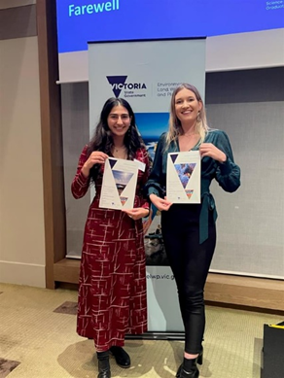

Joiee and Laura receiving their DELWP and DJPR Science and Planning Graduate Program completion certificates.

## Ricketts Point Marine Sanctuary 20th anniversary celebration

On 12 November 2022, Marine Care Ricketts Point (MCRP) celebrated the 20th anniversary of the Ricketts Point Marine Sanctuary.

The Ricketts Point Marine Sanctuary, located on Bunurong Country, is an iconic part of Melbourne. It was protected as a Marine Sanctuary in November 2002, largely due to the long campaign by Marine Care Ricketts Point’s inaugural President, Mr Bob Whiteway OAM.

Marine Education Science and Community’s (MESAC’s) Ray Lewis recounted the inspiring campaign and honoured Mr Bob Whiteway’s memory as well as the Sanctuary itself.

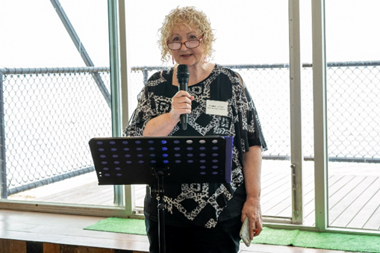

Beth Jensen, MCRP President MC-ing the celebration.

Bob Whiteway’s second book, ‘Teacher Down Under’, was recently published with the help of his daughter Jane Mack and was announced at the event. The book recounts how one man’s love for a world down under led to the establishment of the sanctuary at Ricketts Point. If you are interested in getting your hands on a copy of the book, email [tdubook@gmail.com](mailto:tdubook@gmail.com) or call Jane on 0409 935 932.

The event also featured a range of activities including a smoking ceremony by a Bunurong Elder, rock pool rambles, and touch tanks. Congratulations MCRP on such a wonderful celebratory event, supported by their 2021 Coastcare Victoria Community Grant!

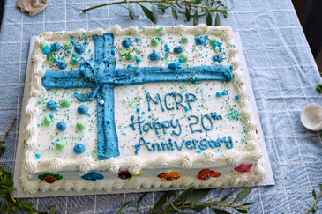

MCRP's celebratory cake (photo by Peter Lamshed).

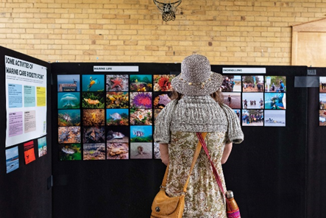

MCRP's info boards at the celebration (photo by Peter Lamshed).

## Friends of Mallacoota – Gabo Weeding Project

*Article and photos provided by Martyn Hiley of Friends of Mallacoota*

The Friends of Mallacoota is a group of volunteers, established in 1983, aiming to sustain the character of Mallacoota and its surrounds by protecting and caring for the natural environment. There are about 110 members as of October 2022.

One of the Friend’s projects is on Gabo Island, a 154-hectare lighthouse reserve located off the coast of eastern Victoria, 13 kilometres from Mallacoota (between Mallacoota and Cape Howe). Gabo Island is managed by Parks Victoria

A number of invasive weeds are spreading throughout the island. The Gabo Weeding Project is intended to remove Mirror Bush (*Coprosma repens*) and help restore Gabo Island’s environment to its natural state.

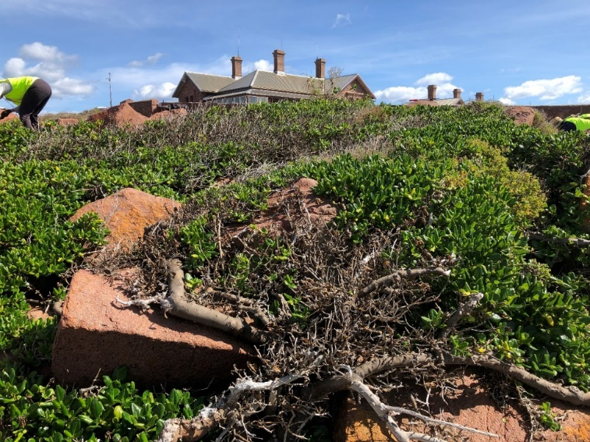

Mirror Bush on Gabo Island.

The project started in 2017 and so far, Friends of Mallacoota have undertaken six trips to the island. Each trip consists of eight volunteers who stay on the island for five days. The main activities are weeding, vegetation mapping and flora identification.

Weeding consists of hand pulling seedlings and small invasive weeds, cutting and painting larger growth with either secateurs or large loppers, and sawing down and treating four to five metre trees.

As many of the root systems are large and go deep into rocky crevices where we cannot get any tools in, Friends of Mallacoota have had to develop some innovative ways to treat these plants.

The group have surveyed 2-3 hectares of the vulnerable Dwarf Zieria and added 15 new species to the Parks Victoria flora list for the island, including a daisy (*Coronidium elatum*) first described in the 1860s, and a new population of the vulnerable fern Shore Spleenwort.

Although Friends of Mallacoota were unable to go to the island for two years due to fires and COVID-19 restrictions, they have removed Mirror Bush from over 7 hectares so far. The group have undertaken two trips this year, with 14,000 invasive weeds removed during our last trip in August. More trips are planned for 2023.

You can find out more about the Friends of Mallacoota at <https://environmentvictoria.org.au/group-member/friends-mallacoota/>.

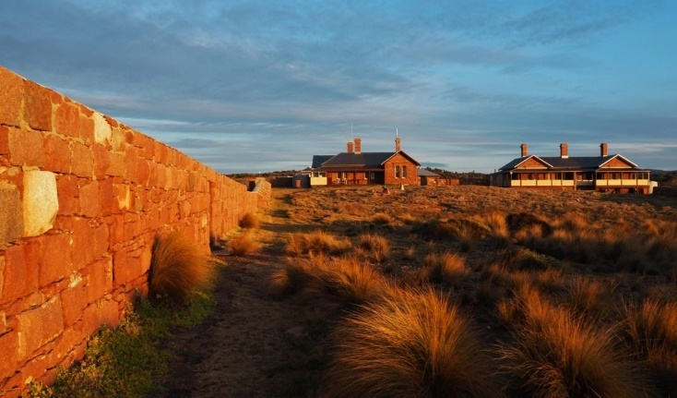

Look Ma, no Mirror Bush

|  |  |
| --- | --- |
| © The State of Victoria Department of Environment, Land, Water and Planning 2022  LogoThis work is licensed under a Creative Commons Attribution 4.0 International licence. You are free to re-use the work under that licence, on the condition that you credit the State of Victoria as author. The licence does not apply to any images, photographs or branding, including the Victorian Coat of Arms, the Victorian Government logo and the Department of Environment, Land, Water and Planning (DELWP) logo. To view a copy of this licence, visit http://creativecommons.org/licenses/by/4.0/  Disclaimer  This publication may be of assistance to you but the State of Victoria and its employees do not guarantee that the publication is without flaw of any kind or is wholly appropriate for your particular purposes and therefore disclaims all liability for any error, loss or other consequence which may arise from you relying on any information in this publication. | Accessibility  If you would like to receive this publication in an alternative format, please telephone the DELWP Customer Service Centre on 136186, email [customer.service@delwp.vic.gov.au](mailto:customer.service@delwp.vic.gov.au), or via the National Relay Service on 133 677 [www.relayservice.com.au](http://www.relayservice.com.au). This document is also available on the internet at [www.delwp.vic.gov.au](http://www.delwp.vic.gov.au). |