# Coastal and Marine Management Plan Resource Kit – MERI Program Logic Template





[deeca.vic.gov.au](https://delwpvicgovau.sharepoint.com/Users/fionadurante/Downloads/deeca.vic.gov.au)

The aim of the Coastal and Marine Management Plan (CMMP) Resource Kit is to provide a collection of tools to guide coastal Crown land managers through the necessary steps of preparing a CMMP.

Drawing from the CMMP Guidelines, managers can determine how best to use this resource kit for their planning process. However, they should consider using the following order:

1. Scope and Scale template: defines the management area
2. Engagement Plan template: to identify and engage all relevant rightsholders and stakeholders
3. MERI Program Logic template: defines what and how objectives, activities, and anticipated outcomes of the CMMP will be delivered
4. Management Plan template: in which insights gathered from the above templates are consolidated
5. MERI Framework template: establishes robust monitoring, evaluation, reporting and improvement criteria

This template can assist with stages three and four of CMMP preparation.

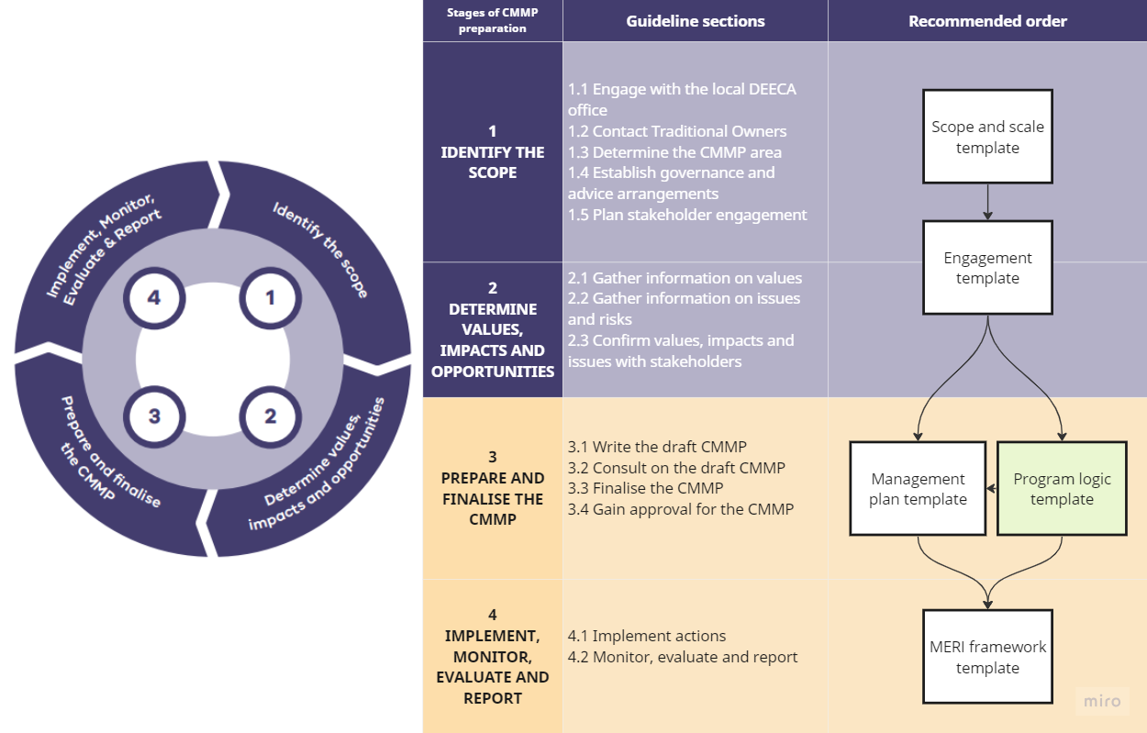

## How to use this template

Use the MERI Program Logic Template to:

* Support the development of a Monitoring, Evaluation, Reporting and Improvement Plan for a Coastal and Marine Management Plan.

Additional resources to guide the development of the MERI Plan (delete before finalising MERI plan):

<https://www.vic.gov.au/evidence-reform-victoria>

<https://www.dcceew.gov.au/sites/default/files/documents/nrm-meri-framework.pdf>

<https://www.dcceew.gov.au/sites/default/files/documents/rdp-meri-framework.pdf>

Grey text – guides what to include under each subheading.

Black text – includes generic information that can be included in the CMMP.

# Introduction

## Coastal and Marine Management Plan (CMMP)

Provide a brief overview of the CMMP, including its vision, objectives and timeframe.

## Purpose of the MERI Plan

The purpose of this plan is to guide how the land manager monitors, evaluates, reports and improves on the implementation of the CMMP. Include reference to how this MERI plan links into other reporting processes if applicable.

## Structure of the Plan

The components of this Monitoring, Evaluation, Reporting and Improvement Plan are:

* Roles and Responsibilities
* Program theory and logic
* Monitoring
* Reporting
* Evaluation
* Improvement

The **Roles and responsibilities** section outlines who will be involved with each step of the MERI process.

The **Program Logic** form the basis of the framework. The program theory explains how each action of the CMMP contributes to the CMMP’s objectives. The program logic also identifies the resources that will contribute to achieving each action.

The **Monitoring** section outlines what information needs to be collected as part of monitoring, key evaluation questions that need to be asked during evaluation and reporting and Key Performance Indicator (KPI) to provide supporting evidence for each evaluation question.

The **Reporting** section describes how delivery of the CMMP will be reported on.

The **Evaluation** section describes the process that will be used to evaluate the CMMP and how the key evaluation questions will be analysed.

The **Improvement** section describes how findings from the MERI process will be used to improve delivery of the CMMP.

## Monitoring and Evaluation Timeframes

Provide detail on key reporting periods, evaluation milestones and any reports/data that will support the MERI process.

## Roles and Responsibilities

Outline the roles and responsibilities for different organisations or teams in relation to monitoring, evaluation, reporting and improvement as appropriate for the CMMP. This section can also include a governance structure.

## Definitions

|  |  |
| --- | --- |
| **Logic Framework Element** | **Definition** |
| Vision | The 15-year vision of the CMMP (See 3.1.2 of the CMMP guidelines) |
| Issues and Risks | The issues and challenges that the CMMP aims to address:   * protection of identified values * and management of risks to these values   (See 2.2 of the CMMP Guidelines) |
| Objectives (5 years) | Specific and measurable steps that are needed to achieve the CMMP’s vision.  The objectives will guide specific actions in the CMMP.  (See 3.1.3 of the CMMP Guidelines) |
| Actions (Outputs) | The tangible deliverables of CMMP actions. Action statements must be specific, measurable, achievable, realistic and time-bound (SMART). They are on-ground responses to the opportunities, issues and risks identified during the development of the CMMP. Actions should be relevant to achieving the CMMP’s vision and objectives. |
| Outcomes (15 years) | The long-term measurable changes that implementing the CMMP will accomplish. The outcomes of the CMMP should link closely to the Vision and steps of the Planning and Decision Pathway in the Marine and Coastal Policy 2020:   * Traditional Owner rights, aspirations and knowledge are acknowledged. * The marine and coastal environment is protected and enhanced. * Natural processes are respected. * Strengthened resilience to climate change. * The marine and costal environment has been used and developed sustainably. * A stewardship approach is embedded in managing the marine and coastal environment. * Understanding and knowledge has been built. * A wide variety of communities and user groups have been engaged. * Collaborating across the breadth of people and organisations has resulted in an integrated and coordinated approach to planning. |
| Key Evaluation Questions | Questions that will assess whether the actions (outputs) of the CMMP are delivering on the objectives and vision of the CMMP. |
| KPIs - Key Performance Indicators | Selected indicators that demonstrate whether outputs of actions are leading to the desired outcomes and objectives of the CMMP.  KPIs are key measures that demonstrate that the actions are making an impact towards the outcome. These indicators should provide evidence to answer the Key Evaluation Questions.  E.g.  Key Evaluation Question: Have Registered Aboriginal Parties and Traditional Owners been able to participate and lead the management and decision making on coastal Country?  Indicators: Time engaging with Traditional Owners and Aboriginal Victorians, Actions implemented with Traditional Owners and Aboriginal Victorian input.  Key Evaluation Question: Has there been a continued or increase in volunteer effort since the CMMP was implemented?  Indicators: Volunteer time  Key Evaluation Question: Has natural habitat condition improved in the CMMP area?  Indicator: Extent of weed control/ native plantings / revegetation works  (See 3.1.6 in the CMMP Guidelines) |

# Program Logic

## Vision

15+ year vision of CMMP

|  |  |  |  |
| --- | --- | --- | --- |
| Issues and challenges  (List issues and challenges identified in CMMP) | Objectives (List objectives of CMMP) | Actions/Outputs | Outcome |
| Example: vegetation within the CMMP is mostly weed species |  | * Weed management program * Dune revegetation | The CMMP area has |
|  |  |  |  |

# Monitoring

## Process

Outline the processes or information sources that will be used to regularly collect and analyse data that will monitor the delivery of the CMMP’s actions and outputs.

## Key Performance Indicators

Defining practical and measurable indicators and collecting data for them is often challenging.

Before defining your KPIs, it may be helpful to consider what data or information you need to gather to answer your Key Evaluation Questions (KEQ). Your KEQs should capture exactly what you need to know to assess whether the actions are making an impact towards achieving the CMMP’s five-year objectives.

Evaluate what data you already have to answer these questions and identify any gaps. Then design your KPIs based on your data and information needs. This will ensure that your indicators are relevant, quantifiable, and clearly measure progress towards accomplishing the CMMP’s objectives.

In the following table, list the CMMP’s five-year objectives (specific and measurable steps that are needed to achieve the CMMP’s vision) and the actions you will take to accomplish them.

Your KPIs should demonstrate whether outputs of the actions are leading to the objectives of the CMMP.

### Five-year objective of CMMP:

|  |  |  |  |  |
| --- | --- | --- | --- | --- |
| Action | KPIs | | | Comment |
|  |  |  |
|  |  |  |  |  |
|  |  |  |  |  |

### Five-year objective of CMMP:

|  |  |  |  |  |
| --- | --- | --- | --- | --- |
| Action | KPIs | | | Comment |
|  |  |  |
|  |  |  |  |  |
|  |  |  |  |  |

# Evaluation

Outline the process for evaluating implementation of the CMMP. Evaluation questions should link to KPIs and CMMP’s five-year objectives.

# Reporting

Outline the reporting process for the CMMP. This may be part of your organisation’s annual reporting process.

# Improvement

Plan for how the improvements identified through the MERI process will be incorporated into implementing the CMMP.