Silverleaves Coastal Adaptation Project Update #2

PROJECT UPDATE #2: October 2024

[deeca.vic.gov.au](/Users/fionadurante/Downloads/deeca.vic.gov.au)



### In recent months, the Department of Energy, Environment and Climate Action (DEECA) have been working on interim protection designs for Silverleaves beach and understanding more about what the community values, to inform adaptation planning.

#### Interim protection works update

Following our community information session at Cowes in August, DEECA representatives met with FSC Range to discuss options for short-term works to protect the highly impacted terminal scour area at the end of the rock revetment.

FSC Range have now developed designs and costings for these works while we continue with the adaptation planning. Andrew from FSC has put together a video presentation to explain this process and the preferred option, a geotextile revetment that can be modified, relocated or removed in the future to align with final adaptation options. [Check out the video here for the full details.](https://player.vimeo.com/video/1022761147?badge=0&amp;autopause=0&amp;player_id=0&amp;app_id=58479)

We are continuing to seek funding for the revetment through grants and budget bids and we will keep the community updated as things progress.

**Silverleaves beach, September 2024**

The easiest way to ensure you are across our updates for Silverleaves is via our mailing list.

Send an email with your name and details to [gippsland.coastalprojects@deeca.vic.gov.au](mailto:gippsland.coastalprojects@deeca.vic.gov.au) to join.

#### Values and experiences survey

​Between August and September, we asked the community to complete our Values and Experiences survey on Engage Victoria. The survey asked people to share their perspectives on how we should be responding to increasing coastal hazards (such as erosion and inundation) and what they value most about the Silverleaves foreshore.

We received 216 responses to our survey and we thank everyone who contributed, sharing their views, ideas and experiences. This feedback is now being reviewed and will inform our broader adaptation planning.

#### Silverleaves Coastal Adaptation Community Reference Group

#### We will be establishing a Community Reference Group to support the adaptation planning process at Silverleaves. The CRG will support the project and ensure representation of community views and needs.

It will include key organisations and community members, selected through an expression of interest process.

CRG members will not have decision-making power but will be asked to provide informed comment reflective of the group or organisation they represent.

#### If this sounds like something that interests you, keep an eye out. We will be sharing details of how to apply in the next project update.

#### Adaptation pathways planning update

Now that the values and experiences survey has been completed, FSC Range are compiling these results and continuing with the adaptation pathways planning.

Adaptation pathways planning involves compiling strategic adaptation options into a long list of potentially viable options for managing coastal hazards along the foreshore. To do this, FSC Range will be following the Victoria’s Resilient Coast Guidelines. A range of actions may be considered for each strategic adaptation option.

Options will be considered as below:

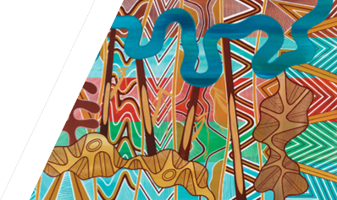

We acknowledge Victorian Traditional Owners and their Elders past and present as the original custodians of Victoria’s land and waters and commit to genuinely partnering with them and Victoria’s Aboriginal community to progress their aspirations.

© The State of Victoria Department of Energy, Environment and Climate Action October 2024

Creative Commons

This work is licensed under a Creative Commons Attribution 4.0 International licence, visit the [Creative Commons website](http://creativecommons.org/licenses/by/4.0/) (<http://creativecommons.org/licenses/by/4.0/>).

You are free to re-use the work under that licence, on the condition that you credit the State of Victoria as author. The licence does not apply to any images, photographs or branding, including the Victorian Coat of Arms, and the Victorian Government and Department logos.

**ISBN** 978-1-76136-987-2 **(pdf/online/MS word)**

Disclaimer

This publication may be of assistance to you but the State of Victoria and its employees do not guarantee that the publication is without flaw of any kind or is wholly appropriate for your particular purposes and therefore disclaims all liability for any error, loss or other consequence which may arise from you relying on any information in this publication.

Accessibility

To receive this document in an alternative format, phone the Customer Service Centre on 136 186, email [customer.service@delwp.vic.gov.au](mailto:customer.service@delwp.vic.gov.au), or contact National Relay Service on 133 677. Available at [DEECA website](http://www.deeca.vic.gov.au/) (www.deeca.vic.gov.au).

Once the options are refined, FSC Range will assemble them into adaptation pathways.

An adaptation pathway approach enables a range of actions to be identified to reduce current and emerging coastal hazard risk. These pathways will set out the relative sequence, timing and triggers for implementation from present day to longer term.

Read more about the adaptation pathways approach in the [Marine and Coastal Policy 2020](https://www.marineandcoasts.vic.gov.au/__data/assets/pdf_file/0027/456534/Marine-and-Coastal-Policy_Full.pdf) and [Victoria’s Resilient Coast Guidelines](https://www.marineandcoasts.vic.gov.au/marine-coastal-management/victorias-resilient-coast-adapting-for-2100).

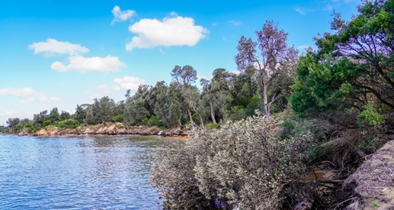

**Silverleaves, February 2024**

**Next steps**

We will be sending our next update in November, to share the results from the values and experiences survey and the adaptation planning.

Have questions for the project team? Email us at [gippsland.coastlprojects@deeca.vic.gov.au](mailto:gippsland.coastlprojects@deeca.vic.gov.au) or visit the [Gippsland Coastal Projects](https://www.marineandcoasts.vic.gov.au/coastal-programs/gippsland-projects) webpage.