delwp.vic.gov.au

|  |
| --- |
| 2021 Port Phillip Bay Fund  Guidelines |

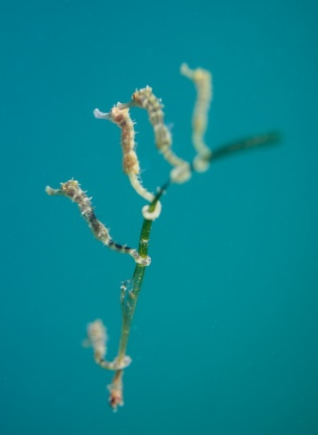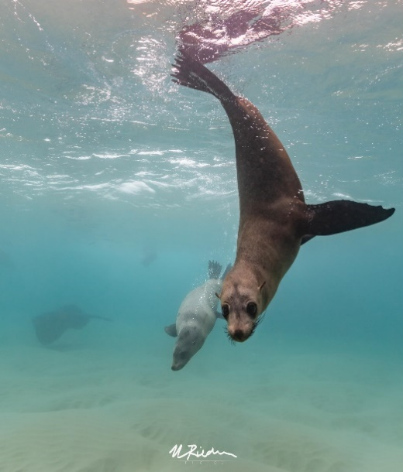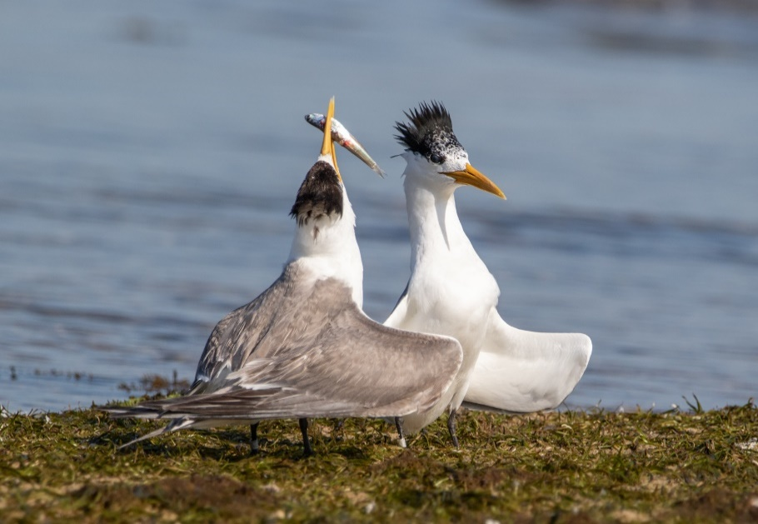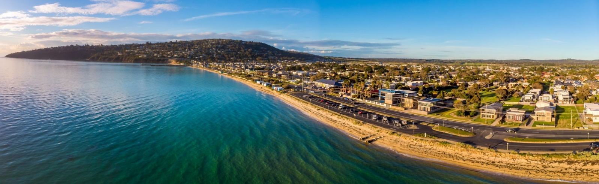

|  |  |
| --- | --- |
|  |  |

**Warning: Health and safety is paramount**

You must put in place relevant Work Health Safety policies and procedures to ensure the safety of those undertaking grant activities.

You must comply with any government measures and requirements in relation to COVID-19 (Coronavirus).  Stay up to date at [www.dhhs.vic.gov.au/coronavirus](mailto:customer.service@delwp.vic.gov.au)

|  |
| --- |
| Acknowledgments  We acknowledge and respect Victorian Traditional Owners as the original custodians of Victoria's land and waters, their unique ability to care for Country and deep spiritual connection to it. We honour Elders past and present whose knowledge and wisdom has ensured the continuation of culture and traditional practices.  We are committed to genuinely partner, and meaningfully engage, with Victoria's Traditional Owners and Aboriginal communities to support the protection of Country, the maintenance of spiritual and cultural practices and their broader aspirations in the 21st century and beyond. |
| © The State of Victoria Department of Environment, Land, Water and Planning 2021  LogoThis work is licensed under a Creative Commons Attribution 4.0 International licence. You are free to re-use the work under that licence, on the condition that you credit the State of Victoria as author. The licence does not apply to any images, photographs or branding, including the Victorian Coat of Arms, the Victorian Government logo and the Department of Environment, Land, Water and Planning (DELWP) logo. To view a copy of this licence, visit <http://creativecommons.org/licenses/by/4.0/>  Disclaimer  This publication may be of assistance to you but the State of Victoria and its employees do not guarantee that the publication is without flaw of any kind or is wholly appropriate for your particular purposes and therefore disclaims all liability for any error, loss or other consequence which may arise from you relying on any information in this publication.  Accessibility  If you would like to receive this publication in an alternative format, please telephone the DELWP Customer Service Centre on 136186, email [customer.service@delwp.vic.gov.au](mailto:customer.service@delwp.vic.gov.au) or via the National Relay Service on 133 677 [www.relayservice.com.au](http://www.relayservice.com.au). This document is also available on the internet at [www.delwp.vic.gov.au](http://www.delwp.vic.gov.au). |

Photo credit

Photographs on the front cover by Marcia Riederer

Table of Contents

1 Program Overview 5

1.1 Introduction 5

1.2 Objectives of the 2021 Port Phillip Bay Fund 5

1.3 How is this round different from previous rounds? 6

2 Eligibility Criteria 6

2.1 Who can apply? 6

2.2 Who cannot apply? 6

2.3 Additional eligibility requirements 6

2.4 Do we need an auspice? 7

2.5 Who can act as an auspice, if we need one? 7

2.6 Other eligibility considerations 7

2.6.1 We have a previous PPBF Round 1-3 project, can we still apply? 7

2.6.2 Can we apply for more than one project? 7

3 Funding details 8

3.1 Available funding 8

3.2 Applicants must contribute towards project budget 8

4 What might be funded? 9

4.1 Projects 9

4.2 Activities 9

4.3 Eligible expenditure 9

4.4 Ineligible expenditure 10

5 Assessment Criteria 11

6 Application process 12

6.1 How to apply 12

6.2 Supporting documents 13

6.3 Additional application processes 13

7 Conditions of funding 13

7.1 Conditions 13

7.2 Approval Permits 14

7.3 Reporting requirements for successful projects 14

7.4 Acknowledging the Victorian Government for their support 14

7.5 Privacy Collection Notice 15

8 Key dates 15

9 Strategic Documents 16

Protecting Victoria’s Environment - Biodiversity 2037 16

Port Phillip Bay Environmental Management Plan 2017-2027 (EMP) 16

Victorians Volunteering For Nature – Environmental Volunteering Plan 16

Marine and Coastal Policy 16

Pupangarli Marnmarnepu – Aboriginal Self-Determination Reform Strategy 2020-2025 17

10 Useful resources 17

Coastal Management Act consent 17

Incorporation through Consumer Affairs Victoria 17

Australian Charities and Not for Profit Commission (ACNC) 17

Cultural Heritage 17

Child Safe Standards 17

Land manager consent to undertake works 18

11 Checklist 18

Attachment 1: Mapping instructions 19

Attachment 2: Port Phillip Bay Wetlands 23

Attachment 3: Erosion Vulnerability sites in Port Phillip Bay 24

# Program Overview

## Introduction

Port Phillip Bay is a unique and precious natural asset, supporting a wide range of community uses, rich and diverse marine life, spectacular scenery, and providing significant benefits for local businesses and the Victorian economy.

Maintaining the health of the Bay’s marine life, habitats and water quality is critical to providing these benefits and values and requires a coordinated effort from government, community and organisations as reflected in the *Port Phillip Bay Environmental Management Plan 2017-2027*, *Biodiversity 2037* as well as *Victorians* *Volunteering for Nature – Environmental Volunteering Plan*.

To maintain the environmental health of Port Phillip Bay, the Victorian Government is providing a further $1 million in the form of grants in 2021 to support community driven projects and to enable Traditional Owners to continue works on Land and Sea Country in and around the bay and its catchment.

## Objectives of the 2021 Port Phillip Bay Fund

The objectives of the 2021 Port Phillip Bay Fund (PPBF) are:

* Conserving and restoring the Bay’s habitat and marine life, and enhancing the marine environment.
* Enhancing waterways and significant wetlands through revegetation and soil erosion control.
* Encouraging strong partnerships across a range of interested groups including Traditional Owners and organisations with an interest in protecting ecological and culturally significant areas within the Bay’s catchment.
* Improving the appreciation and understanding of the Bay’s cultural and environmental values through on-ground actions.
* Engaging and involving urban communities in on-ground actions relating to Bay health.

The 2021 Port Phillip Bay Fund is a competitive grants program and will be delivered through a single funding round. To be funded, projects need to meet the objectives, be in the Port Phillip Bay catchment area (see Figure 1 below) and demonstrate a clear link and benefit to the Bay.

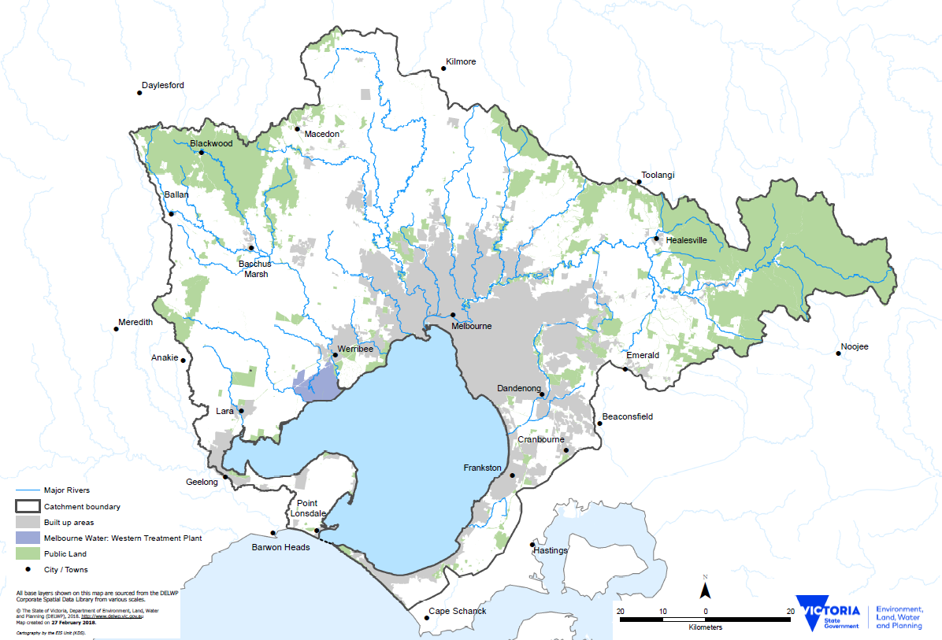Figure 1: Port Phillip Bay and its catchments

## How is this round different from previous rounds?

The differences and priorities of the 2021 PPBF are:

* Projects including litter related activities will be considered but should be part of a broader project, rather than a standalone project. Projects focussed purely on litter collection and/or litter monitoring and/or litter related education are still eligible but are less likely to be successful than projects with a focus on on-ground activities that protect, conserve and restore significant ecological and cultural sites, and
* Successful recipients are required to submit spatial data via the Department of Environment Land, Water and Planning (DELWP) online mapping tool [**MapshareVic**](https://mapshare.vic.gov.au/MapShareVic/index.html?viewer=MapShareVic.PublicSite&locale=en-AU)(see Attachment 1). This activity will be one of the funding milestones or deliverables.

We encourage groups with a waste/litter project to check out Sustainability Victoria’s [Recycling Victoria Communities Fund](https://www.sustainability.vic.gov.au/Grants-and-funding/Recycling-Victoria-Communities-Fund). Grants for this fund close on 19 March 2021. The proposed litter/waste project needs to focus on the top end of the waste hierarchy (i.e. avoidance and reduction measures).

# Eligibility Criteria

## Who can apply?

The 2021 PPBF grants are open to:

* Environmental groups and networks, such as Coastcare, Friends groups and Landcare
* Volunteer-based recreational and community groups with an interest in the Bay, such as diving and naturalist groups, Scouts, Rotary, Lions, senior citizens and youth clubs
* Public Land Committees of Management
* Traditional Owners and Aboriginal community groups
* Kindergartens, Primary and Secondary Schools
* Research institutes, Local Government and other non-profit organisations

In addition, to be eligible for funding, applicants must be located within the Bay itself or its catchment (refer to Figure 1). Inland projects need to demonstrate strong benefits to the Bay and foreshore.

## Who cannot apply?

The following organisations and individuals cannot apply for funding:

* Federal government departments and agencies;
* Commercial organisations;
* bodies established for profit-making purposes;
* Sole traders; and
* Individuals.

## Additional eligibility requirements

To be eligible for funding, applicants must have $10 million public liability insurance, with enough construction allowance to cover the project **and** meet one of the following:

* be incorporated through Consumer Affairs Victoria, **or**
* have an ABN with Australian Charities and Not-for-profit Commission registration, **or**
* be a registered scout group, **or**
* be a kindergarten, primary or secondary school, **or**
* be a Registered Aboriginal Party, **or**
* be a Public Land Committee of Management.

Applicants who don’t meet the eligibility criteria can partner with another organisation who does meet the criteria, known as an auspice.

## Do we need an auspice?

You do not need an auspice if your group or organisation meets the eligibility criteria listed above.

You can still apply if your group is listed under Who can apply but does not meet the eligibility criteria. In this case, you’ll need to partner with another group or organisation who does meet the requirements, known as an auspice.

The auspicing group or organisation will enter into a contract with DELWP and will be legally responsible for the project. They will receive the money from us and be responsible for reporting and acquittal (they will likely expect you to help or do this, but the legal requirement is theirs).

You will need to include an email or letter from your auspice in your application, showing that they agree to take on this responsibility for you.

## Who can act as an auspice, if we need one?

Potential auspicing organisations include:

* Catchment Management Authorities (CMA) – Corangamite CMA for Geelong and the western edge, and Port Phillip and Westernport CMA for the rest of the catchment;
* Water corporations and other state government authorities, such as Melbourne Water and Parks Victoria;
* Umbrella not-for-profit associations, such as Landcare Victoria Inc;
* Local councils; and
* Other volunteer-based environmental community groups and networks.

Please note that the auspicing group or organisation must meet the eligibility requirements listed above in Section 2.3.

## Other eligibility considerations

### 2.6.1 We have a previous PPBF Round 1-3 project, can we still apply?

Yes, you can still apply if you’ve already received a grant in a previous PPBF Round as long as the new project is different or would result in additional value. New applications will be assessed according to capacity, capability and resources necessary to deliver this new project within the 2021 PPBF Program timeline, if applicable.

### 2.6.2 Can we apply for more than one project?

Yes, you may submit more than one project. Each project submitted must be separate and clearly different. Projects will not be accepted if:

* they are dependent on another project getting funded, or
* scaled versions of the same project have been submitted.

If one of your projects is funded, preference may then be given to unfunded applicants over your other lower ranking projects.

# Funding details

## Available funding

The total amount available for the 2021 PPBF competitive grants is $1 million. There are two funding streams available. Projects must be completed by 15 September 2022.

**Table 1. Funding streams**

|  |  |
| --- | --- |
| **Stream** | **Funding Amount (Once off payment)** (excluding GST) |
| One | Up to $20,000 |
| Two | Up to $50,000 |

## Applicants must contribute towards project budget

Applicants are required to match their requested funding on a 1:1 fund ratio. For example, if you request $10,000 you need to demonstrate that you have at least $10,000 in matched funding from other sources.

The matched funding can include a combination of:

* volunteer time dedicated to the project (including planning, designing and organising)
* in-kind support (e.g. access to photo copier, free loan of equipment, donation of materials)
* staff time allocated to completing the project, where the salary comes from another source
* funding from other sources (e.g. donations, philanthropic grant programs).

**Table 2. Example of matched funding**

|  |  |  |  |
| --- | --- | --- | --- |
| **Grant requested from the Fund excluding GST** | **$** | **Matched funding from other sources** | **$** |
| Tubestock and tree guards | 2,000 | Staff time on project | 3,000 |
| Construction materials | 5,000 | Printing donated by ABC Office Supplies | 250 |
| Safety equipment | 500 | Volunteer time (200 volunteer hours x $30 per hour) | 6,000 |
| Contractor hire | 2,500 | Local government (Venue hire donated by local council) | 750 |
|  | **10,000** |  | **10,000** |

**Calculating the value of your volunteer contribution**

Volunteer time contributions should be valued at $40 per hour and the number of hours per day should be reasonable.

|  |
| --- |
| **Example**  35 volunteers x 5 hours per day x 2 days x $40 = $14,000 in volunteer time contribution |

# What might be funded?

## Projects

We are looking for project applications that:

* Articulate why your project is a priority and how the funding will achieve the program objectives.
* Clearly and logically explain what outcomes (i.e. changes) the project will deliver, and how the proposed activities are the best means to achieve this. What does success look like and how will It be measured?
* Outline a strong plan for how the project will be delivered, including how key partners, contractors, and interest groups are involved in the project
* Support and build partnership with the Traditional Owner organisations in protecting cultural significant sites and caring for country.
* Involve key project partners including community where this will add value and more effectively deliver the outcomes sought.
* Consider project risks including COVID-19 to the successful delivery of the project and describe how you intend to manage and/or mitigate these.
* Provide detail of any project manager or facilitator costs, and why they are essential to the delivery of the project.
* Build on what you (and other groups) have learnt and done in previous projects.
* Demonstrate the use of best practice for the project’s delivery.
* Have secured in-principle support from the land manager (if working on a site).
* Clearly show public benefit (if working on private land).

## Activities

The following is a non-exhaustive list of activities that may be funded through the 2021 PPBF fund:

* Protection, rehabilitation and restoration of marine and coastal habitats and biodiversity (e.g. preserving threatened species habitat, fencing, marine and coastal weed and pest control) (see **Attachment 2**).
* Actions that increase the awareness and understanding of Aboriginal values of Traditional Owners within Port Phillip Bay and its catchment area to support Aboriginal self-determination.
* Actions that directly reduce the amount of sediment and nutrients that enter the Bay and its tributaries (e.g. riparian revegetation, wetland systems to slow/treat storm water) (see **Attachment 3** or refer to Coastkit <https://mapshare.vic.gov.au/coastkit/>
* Managing visitor impacts on sensitive coastal and marine sites (e.g. improved access management, fencing, pathways).
* Education, monitoring and citizen science activities will be considered, where they are part of a broader project with direct on-ground outcomes.

## Eligible expenditure

The Fund will support the following categories of expenditure:

* Materials (e.g. Plants, tree guards, exclusion fencing, seating, and access steps)
* Site preparation (e.g. Equipment hire, security fencing, and for revegetation)
* Personal protective equipment (e.g. Gloves, goggles, and masks)
* Engaging and partnering with your local community, schools, Traditional Owners and registered aboriginal parties of the project area
* Contractors (e.g. Presenters, surveyors, installers, weed controllers for particularly difficult weeds or sites)
* Communication (e.g. seminars, webinars etc)
* Equipment hire or purchase (post hole diggers etc)
* Citizen science monitoring activities
* Promotional costs directly related to funded activities (e.g. Website update, video and interpretive signage)
* Advertising (costs to advertise in newspapers, posters etc)
* Training and education that supports the project’s activities (e.g. First aid)
* Project management and coordination (e.g. Staff time to manage the project, budget, coordinate volunteers, and secure approvals), and
* Technical specialist and advisers (e.g. Cultural heritage, cultural practises etc).

Other types of expenditure may be considered if they are well justified and deemed suitable. You will need to demonstrate that all activities and budget items are essential to the success of the project and that the amounts requested are reasonable. There are no caps or limits for eligible items. **Value for money** will be considered as part of the assessment process.

When developing budgets, you should ensure that activity items (such as equipment, materials and contractor charges) are fully costed. Refer to the Terms and Conditions of the Victorian Common Funding Agreement <https://www.vic.gov.au/victorian-common-funding-agreement-templates> for more information.

## Ineligible expenditure

The Program will not fund:

* Routine operation or running costs for example office rental and all aspects of facility;
* Costs and activities that are already funded through another organisation, program or fund source;

*Your project can build on the success of past or existing projects but must essentially be new work. The grant must fund additional activities that wouldn’t occur without this funding.*

* Activities that were intended to be your in-kind contribution to another funded project;
* Actions or costs associated with native vegetation offset sites or activities;

*For example, meeting a condition of a planning permit, contract or investment program, Section 173 agreement or offset covenant. no*

* Any activity involving clearing of native vegetation, unless it is a declared environmental weed in your area. In this instance, a permit for removal of vegetation may still be required;
* Any activity involving the use of firearms, tranquilisers, traps or explosives;

*Confinement traps are allowed under permit and expert supervision*

* Any illegal activity;
* Purchase of goods for competitions, prizes, giveaways, vouchers or alcohol;

*For example, plastic educational/promotional items, pens, sample packs, keep cups, stickers, bags*

* Barbed wire fencing;
* Computers, laptops, tablets and smartphones;
* Insurance;
* Any other action or activity determined by the Panel through the assessment process to be an inappropriate or unsuitable use of the funds;
* Any action that are part of a land manager’s legal duty of care; and
* Activities that are not focused on the environmental health of the bay and its catchment area.

# Assessment Criteria

First, applications will be checked for eligibility to ensure that the applicant and their activity are eligible for funding. After that, eligible applications will be assessed using the merit criteria listed below.

Each criterion is given a percentage weighting to indicate its relative importance in the assessment process. Applications should address all relevant criteria.

**Table 3. Assessment criteria**

|  |  |
| --- | --- |
| **Merit Criteria** | **Criteria Weighting** |
| **Does your project align and address the key strategic documents of the Port Phillip Bay Fund?**   * Proposed activities/actions strongly align and address priority actions within Biodiversity 2037, Port Phillip Bay Environmental Management Plan 2017-2027, Victorian Volunteering for Nature-Environmental Volunteering Plan, Marine and Coastal Policy or the Regional Catchment Strategy. * Proposed project supports DELWP’s Pupangarli Marnmarnepu ‘Owning Our Future’ Aboriginal Self-Determination Reform Strategy 2020-2025. * Proposed project targets specific problems e.g. indigenous flora and fauna species, terrestrial and marine habitats, biodiversity issues, water quality within and around the bay or threats to cultural or ecological significant sites. * Proposed project must demonstrate best practice and evidence based to achieve the desired outcomes for the Bay. * Proposed project must demonstrate the proposed actions will lead to increased community volunteerism or participation in environmental works. | **40%** |
| **Does your project demonstrate outcomes consistent with the scope of the Port Phillip Bay Fund?**   * Applicant must demonstrate that the proposed activities or actions will improve health of the bay as a result of the funding and contribute to measurable outcomes for the Bay. * Proposed project strengthens community groups and networks and encourages participation in nature activities. * Proposed project supports and builds partnership with the Traditional Owners to increase the awareness and understanding of Aboriginal values within the Bay its catchment. * Proposed Project represents good value for money e.g. Delivering multiple outcomes, good return on investment or high public benefit, reasonable costings and adequate in-kind contribution. This should be evidenced in the budget and by supplying quotes for proposed work that indicates value for money. | **40%** |
| **Does your project plan demonstrate you have the capacity and capability to successfully undertake the project/activity and manage risk?**   * Applicant must describe how the project will be delivered, including planning, financial planning and have relevant expertise in the project team. * Applicant must describe how the plan will be carried out including methodology, timeframes, budget and project delivery risks. * Applicant must demonstrate that he/she has all required approvals and insurance policies in place * Applicant must demonstrate ability to build new and/or leverage existing partnerships and to facilitate disseminating the project findings/learnings * Applicant’s track record in managing similar projects e.g. previous grants including program compliance. | **20%** |

Generally higher scoring projects will be funded; however, we may also consider the overall mix of project types and locations over the life of the program. Several strategies and priority actions of the EMP were not well represented through Rounds 1 – 3 of the PPBF including the following:

*1.1 Work with Traditional Owner groups to improve understanding of Aboriginal cultural values and interests in the Bay and support connections to Country*

*1.3 Build understanding of management responsibilities and programs for the Bay and its catchment*

* + *Minimise risks to human health from pathogens, particularly through projects:*
    - * *Enhancing the monitoring, reporting and detection of pathogens through targeted monitoring of drains*
      * *Improving understanding of links between pathogen concentrations and human health for swimming and consumption of shellfish*
  + *Conserve and restore habitats and marine life, particularly through projects:*
    - * *Monitoring indicator species and key habitats at priority locations*
      * *Improving understanding of ecological processes, threats and pressures, such as kelp dominated reefs, seagrass beds and species of conservation concern, for example spider crabs, cetaceans and marine dependent birds*
      * *Improving overall extent and condition of the Bay’s natural ecosystems, such as targeted restoration in priority estuary catchments and restoration of coastal wetlands, seagrass, coastal dune vegetation, and urchin control*
  + *Manage risks from marine pests, particularly through projects:*
    - * *Preventing introduction and dispersal of marine pests*
      * *Monitoring priority locations for early detection of marine pest introductions*
      * *Responding rapidly to new introductions of marine pests*
  + *Ensure nutrients and sediment loads do not exceed current levels and pollutant loads are reduced where practicable, particularly through:*
    - * *Restoration of coastal wetlands and riparian habitats in priority estuary catchments*

# Application process

## How to apply

Applications must be submitted online using the DELWP Grants Online portal.

* To apply, go to the grant program web page <https://delwp1.force.com/publicform?id=a0h4P00001dkxeR> and click on the ‘Start New Application’ button.
* To return to a saved draft application, go to <https://delwp1.force.com/>
* You can save your application and work on it until you are ready to submit it. We recommend that you start your application as early as possible.
* Your online application can only be accessed by one set of login details. We recommend that you use your generic group or team email if you have one.
* Alongside the application form, you must upload the ‘budget details’ template to your application. The template you use will depend on the stream you apply for:
  + [Stream 1 Budget Table](https://www.marineandcoasts.vic.gov.au/__data/assets/excel_doc/0022/510826/PPBF2021-application-form-Budget-final-20K-version.xlsx)
  + [Stream 2 Budget Table](https://www.marineandcoasts.vic.gov.au/__data/assets/excel_doc/0023/510827/PPBF2021-application-form-Budget-final-50K-version.xlsx)

If you have any questions about this grant program, you can contact our Customer Services Centre at 136 186 during normal business hours.

If you encounter any issues drafting and submitting your application online, please email [grantsinfo@delwp.vic.gov.au](mailto:grantsinfo@delwp.vic.gov.au). Please quote your application number in your communication with DELWP.

Make sure your application is submitted by **12pm on Thursday, 1 April 2021**

## Supporting documents

Supporting documents can be uploaded on Grants system. However, they must be in an acceptable file type, such as Word, Excel, PDF, SHP or JPEG. The maximum file size for each file is 5MB.

Only one file can be uploaded for each upload type in the application form. If you have more than one file to upload (for example, multiple landholder support letters), zip these into a file and then upload the file.

If you have documents to submit that cannot be attached to your online application, you can email them to [grantsinfo@delwp.vic.gov.au](mailto:grantsinfo@delwp.vic.gov.au).You will receive an application number when you submit your application online. Please **quote** this number in all communications with the department relating to your application. Attach all documents to one email, zipping the files if required. All supporting material must be received by the application deadline.

## Additional application processes

We may contact you any time between applications closing and announcement, asking for clarifications about aspects of your application. This doesn’t indicate that your project has been successful.

Unsuccessful applicants will be given a general indication of why their application did not received funding. All decisions, including conditional offers of funding, are final and are not subject to further review. You are welcome to ask for feedback on your application.

If you have an auspice, they will need to sign the funding agreement and will receive the payment on your behalf.

# Conditions of funding

## Conditions

Successful applicants and auspicing organisations are required to:

* Enter into a funding agreement with DELWP. Information about the Victorian Common Funding Agreement that will be used can be found at: <https://www.dhs.vic.gov.au/for-business-andcommunity/not-for-profit-organisations/common-funding-agreement>;
* Be responsible for meeting contractual obligations to deliver the project and report on its success by the due date
* Have appropriate land manager approval and relevant permits, including planning and cultural heritage
* Adhere to all relevant legislation including Occupational Health and Safety requirements and Child Safe Standards
* Acknowledge the Victorian Government funding in publications and promotions
* Work with DELWP to identify and promote major project milestones and completion, and
* Provide us with your worksite (polygon) using DELWP mapping tool [**MapshareVic**](https://mapshare.vic.gov.au/MapShareVic/index.html?viewer=MapShareVic.PublicSite&locale=en-AU)(**Attachment 1**).

You are advised to read the terms and conditions of the Victorian Government Funding Agreement. You can access the information by following this link [vic.gov.au/victorian-common-funding-agreement-templates](https://www.vic.gov.au/victorian-common-funding-agreement-templates).

## Approval Permits

If you are successful, you will need formal approval and appropriate permits before you start your activities. When planning your project, ensure that you factor in the time (and costs) that may be needed to complete this. You should also consult with your local Council and relevant authorities regarding any permits that may be required. You will need to provide copies of relevant permits to DELWP on request.

For advice about land manager consent, please refer to the ‘Useful Resources’ section below.

## Reporting requirements for successful projects

All successful applicants will need to complete a progress and final report including financial acquittal. This will be outlined in the Funding Agreement.

Reporting will be completed online using the links provided and submit through the DELWP Grants Online Portal. The reporting template will be made available a few months before it is due. The report will need to include:

* How you spent the grant
* What you achieved with the project, for example hectare of revegetation; weed control or number of new partnerships established including Traditional Owner groups
* Data that you collected during the project (if any). Data will be made publicly available
* What you learnt from the project, and
* Spatial data reporting of the project areas.

You may also be asked for information about specific aspects of your project. This information will contribute to monitoring the health of Port Phillip Bay, through the Port Phillip Bay Environmental Management Plan 2017-2027 and State of the Bay reporting. Successful applicants may be required to contribute information on activity outcomes for use in program evaluation or in the department’s communication materials.

## Acknowledging the Victorian Government for their support

Successful, applicants are expected to acknowledge the Victorian Government’s support and promotional guidelines will form part of the funding agreement. For further information on [Acknowledgment and Publicity Guidelines for Victorian Government Funding Support](https://www2.delwp.vic.gov.au/__data/assets/word_doc/0022/392503/DELWP-Acknowledgement-and-Publicity-Guidelines.docx) go to <https://www2.delwp.vic.gov.au/grants>.

Successful applicants must liaise with the departmental program area to coordinate any public events or announcements related to the project.

## Privacy Collection Notice

If successful, information about your project will be made publicly available, including project name, project description, the amount of funding received, and your group or organisation’s name.

Any personal information about you or a third party in your application will only be collected by the department for the purpose of grant administration. This information may be provided to other Victorian government bodies for the purposes of assessing your application. If you intend to include personal information about third parties in your application, please ensure that they are aware of the contents of this privacy statement.

Any personal information about you or a third party in your correspondence will be collected, held, managed, used, disclosed or transferred in accordance with the provisions of the Privacy and Data Protection Act 2014 and other applicable laws.

DELWP is committed to protecting the privacy of personal information. You can find the DELWP Privacy Policy online at http://www.delwp.vic.gov.au/privacy

Requests for access to information about you held by DELWP should be sent to the Manager Privacy, P.O. Box 500 East Melbourne 3002. Alternatively, contact by phone on 9637 8697.

# Key dates

**Table 4. Key milestones**

|  |  |
| --- | --- |
| **Key Milestones** | **Major task and timeline\*** |
| **Assessment and Decision Making**   * Review eligibility criteria * Assess application against merit criteria | Allow for 4-6 weeks depending on the quantity and complexity of applications received.  Review eligibility, project and expenditure.  Assess all eligible applications against key merit criteria including overall consideration like long term benefits, risk and budget by independent Panel members (internal and external including technical specialist).  Advise decision maker on the merits of each application and recommend projects for approval. |
| **Announcements** | Allow for 2-3 weeks  Notify the outcome of your application in writing. |
| **Funding Agreements Executed** | Allow for 2-3 weeks  Establish Common Funding Agreement with successful applicants and the type of agreement is based on the funding amount and level of the risks involved.  Ability and availability of successful application execute the funding agreement |
| **Project Commencement & Grant Payments** | As soon as the agreement signed by both parties. Normally it is an upfront payment. |
| **Project Progress** | About half-way from project commencement.  Provide update of your progress towards completion of agreed project activities. |
| **Completion of Project activities** | Complete all the project activities as per funding agreement. |
| **Final acquittal** | Submit final project and financial acquittal reports to fulfil the contractual obligations of the Funding Agreement. Normally this is within 12 months of commencement. |

*Please note that the timeframes provided are indicative.

# Strategic Documents

## [Protecting Victoria’s Environment - Biodiversity 2037](https://www.environment.vic.gov.au/__data/assets/pdf_file/0022/51259/Protecting-Victorias-Environment-Biodiversity-2037.pdf)

[*Protecting Victoria’s Environment – Biodiversity 2037*](https://www.environment.vic.gov.au/__data/assets/pdf_file/0022/51259/Protecting-Victorias-Environment-Biodiversity-2037.pdf) is the Victorian State Government’s policy response to addressing the decline in biodiversity. The Biodiversity Plan presents a long-term vision for Victoria’s biodiversity supported by two goals:

1. Victorians Value Nature, and
2. Victoria’s natural environment is healthy.

Specific targets have been developed to deliver on these goals, and 20 priorities have been identified to guide actions. Conservation actions delivered through the plan will be more strategic, deliver better value for money and will be underpinned by the best available science to ensure efforts deliver the most benefit for the most species. A collaborative *Monitoring, Evaluation and Reporting Framework* has been developed to track the progress of achieving the Plan’s goals and targets.

## [Port Phillip Bay Environmental Management Plan 2017-2027 (EMP)](https://www.marineandcoasts.vic.gov.au/coastal-programs/port-phillip-bay)

[The plan](https://www.marineandcoasts.vic.gov.au/coastal-programs/port-phillip-bay) was developed by DELWP in partnership with Melbourne Water and the Environment Protection Authority Victoria. It is part of the Victorian Government's commitment to ensure Port Phillip Bay remains healthy and resilient over the coming decade.

The plan has three main goals to guide future action and investment over the next 10 years:

1. Stewardship of the Bay is fostered across community, industry and government
2. Water quality is improved to ensure environmental health and community enjoyment of the Bay
3. The Bay's habitats and marine life are thriving

## [Victorians Volunteering For Nature – Environmental Volunteering Plan](https://www.environment.vic.gov.au/__data/assets/pdf_file/0035/394883/VVfN-Environmental-Volunteering-Plan_WEB.pdf)

[*Victorians Volunteering For Nature – Environmental Volunteering Plan*](https://www.environment.vic.gov.au/__data/assets/pdf_file/0035/394883/VVfN-Environmental-Volunteering-Plan_WEB.pdf)is a coordinated approach to environmental volunteering that supports and fosters a sustainable, modern, effective and valued environmental sector in Victoria. The Environmental Volunteering Plan has four key focus areas:

1. Sustain – to sustain existing environmental volunteering programs and networks
2. Expand – to regenerate environmental volunteering and encourage for Victorians to act for nature
3. Value – to value and recognise the contributions and environmental volunteers, and
4. Understand – to understand the diverse needs of the environmental volunteering sector.

Specific actions have been identified under each focus area to address barriers to participation in environmental volunteering, celebrate volunteer contributions, and facilitate new and innovative ways for the public to act for the environment.

## [Marine and Coastal Policy](https://www.marineandcoasts.vic.gov.au/coastal-management/marine-and-coastal-policy)

The [Marine and Coastal Policy](https://www.marineandcoasts.vic.gov.au/coastal-management/marine-and-coastal-policy) guides decision makers in the planning, management and sustainable use of our coastal and marine environment. It provides direction to decision makers including local councils and land managers on a range of issues such as dealing with the impacts of climate change, population growth and ageing coastal structures.

## [Pupangarli Marnmarnepu – Aboriginal Self-Determination Reform Strategy 2020-2025](https://www.delwp.vic.gov.au/aboriginalselfdetermination/self-determination-reform-strategy)

Pupangarli Marnmarnepu – Aboriginal [Self-Determination Reform Strategy 2020-2025 is the Department of Environment, L](https://www.delwp.vic.gov.au/aboriginalselfdetermination/self-determination-reform-strategy)and, Water and Planning’s (DELWP) commitment to partner with Victoria’s First People’s to advance self-determination. Port Phillip Bay Fund Program works towards this vision by supporting Traditional Owners’ rights on Country so that their aspirations for land, water and culture are realised.

# Useful resources

## Coastal Management Act consent

Projects between the outer limit of Victorian coastal waters and 200 metres inland of the high-water mark of the sea and on Crown land or water covering Crown land will need consent under the Marine and Coastal Act 2018. Most applicants working in water or near the coast will need to apply for consent. A small number of projects that involve site maintenance (for example, maintaining existing structures, fixing fences) may be covered under the general consent that was issued by the Minister in 2013 – if you think your project could be in this category, please speak to your local DELWP office to confirm.

For more information about the Marine and Coastal Act 2018 and the general consent issued in 2013, please refer to:   
<https://www.coastsandmarine.vic.gov.au/coastal-management/information-for-coastal-managers>

To locate your local DELWP office, please refer to:  
<https://www2.delwp.vic.gov.au/communities-and-regions/regions-and-locations>

## Incorporation through Consumer Affairs Victoria

To find your group’s incorporation number, and for information about incorporating, please visit the Consumer Affairs Victoria website:   
<https://www.consumer.vic.gov.au/clubs-and-not-for-profits/incorporated-associations>

## Australian Charities and Not for Profit Commission (ACNC)

To see if your organisation is already registered as a not for profit, and for more information about registering, please visit the ACNC website:   
<http://www.acnc.gov.au>

## Cultural Heritage

For information about Cultural Heritage, including maps of culturally sensitive areas and a planning tool, please visit the Aboriginal Victoria website:   
<http://www.dpc.vic.gov.au/index.php/aboriginal-affairs/aboriginal-cultural-heritage/cultural-heritage-management-plans/when-is-a-plan-required>

## Child Safe Standards

For information about Child Safe Standards, please visit the Department of Health and Human Services website: <http://providers.dhhs.vic.gov.au/resources-child-safe-standards>

## Land manager consent to undertake works

Applicants will need to demonstrate that the site land managers, both public and private, support the project being carried out on the land they manage. A short letter or email from your land manager will need to be attached to your application. Formal approval is not required at the application stage.

**Example land manager statement of support**

I, <name> of <organisation> support <insert activities as per this project> occurring on <site address>. My contact details are <insert contact phone number/email>.

For advice about land manager consent, please refer to the relevant contacts below:

* DELWP for crown land on 136 186, or your DELWP local office  
  <https://www2.delwp.vic.gov.au/communities-and-regions/regions-and-locations>
* Parks Victoria for parks and reserves on 131 963 or your local Parks Victoria office  
  <http://parkweb.vic.gov.au/>
* Corangamite Catchment Management Authority on (03) 5232 9100 for regional priorities, the regional catchment strategy, sub strategies and related plans and works on designated waterways  
  [www.ccma.vic.gov.au](https://delwpvicgovau.sharepoint.com/sites/ecm_137/Victorian%20Environmental%20Partnerships%20Program/www.ccma.vic.gov.au)
* Port Phillip and Westernport Catchment Management Authority on (03) 8781 7900 for regional priorities, the regional catchment strategy, sub strategies and related plans and works on designated waterways  
  [www.ppwcma.vic.gov.au](https://delwpvicgovau.sharepoint.com/sites/ecm_137/Victorian%20Environmental%20Partnerships%20Program/www.ppwcma.vic.gov.au)
* Local government planning staff for council‑owned land  
  <https://knowyourcouncil.vic.gov.au/>
* Melbourne Water, for water supply catchment areas  
  <https://www.melbournewater.com.au/>

# Checklist

Read these guidelines and the information about this grant program at [https://www.marineandcoasts.vic.gov.au/grants/port-phillip-bay-fund](https://delwp-search-new.clients.squiz.net/s/redirect?collection=delwp-meta&url=https%3A%2F%2Fwww.marineandcoasts.vic.gov.au%2Fgrants%2Fport-phillip-bay-fund&index_url=https%3A%2F%2Fwww.marineandcoasts.vic.gov.au%2Fgrants%2Fport-phillip-bay-fund&auth=3cdgu%2Bx%2Bge0uT%2BcOzQnCWA&profile=_default&rank=2&query=port+phillip+bay+fund) before applying and complete the following checklist.

Have you:

read these guidelines carefully?

checked if you are eligible for this grant funding?

checked if your items/activity is eligible for this grant funding?

checked that you would be able to comply with all relevant laws and regulations in delivery of your project?

prepared the appropriate supporting documents?

obtained all relevant permits and approvals?

considered if your project could impact on an Aboriginal cultural site?

considered consulting/engaging with the Traditional Owners?

**When you submit your application**

Please ensure you provide the following before you press submit

budget and activity details template

A copy of your public liability insurance Certificate of currency

Written support from relevant land manager to undertake works or activity on their land

Letter or email from your auspicor (sponsor) that confirms they agree to act as your auspicor, if required.

Other attachment e.g. mapping file

# Attachment 1: Mapping instructions

**We are asking project managers to please identify the key location for their activity on a map.**  
  
Each activity will be mapped and displayed on a new marine data platform, CoastKit, that DELWP has been developing.

There are two ways you can provide your activity's location for inclusion on CoastKit as outlined below. If your activity is occurring in multiple locations, please identify all relevant locations. If you have any questions, or if neither of these options work for you, please contact enviro.grants@delwp.vic.gov.au and quote *2021 Port Phillip Bay queries*.

Option A - Email shapefiles  
  
If you already have polygon or point data shape files for your activity, please email them to [enviro.grants@delwp.vic.gov.au](mailto:enviro.grants@delwp.vic.gov.au) in Shapefile (**.**shp) format noting the activity name. Please include your application number or project title.  
  
Option B - MapshareVic  
  
If you don't have pre-existing shapefiles, please open [**MapshareVic**](https://mapshare.vic.gov.au/MapShareVic/index.html?viewer=MapShareVic.PublicSite&locale=en-AU) and:

1. Agree to the disclaimer
2. Click the 'Drawing' tab on the top green bar
3. Click the drop-down arrow next to 'Point' and select 'Polygon' to draw a custom shape on the map
4. Zoom in to your desired location and click the boundaries of your project area to define the polygon shape
5. Double click to finish the polygon
6. If your project has multiple locations, please add additional polygons by repeating steps 4 and 5 as required
7. Once finished click 'Export Drawings' on the 'Drawing' toolbar. This will download a zipped folder containing the shapefiles you have just created to your device
8. Email the zipped folder as an attachment to [enviro.grants@delwp.vic.gov.au](mailto:enviro.grants@delwp.vic.gov.au) including the project title in the subject line or contents.

*MapshareVic step 1*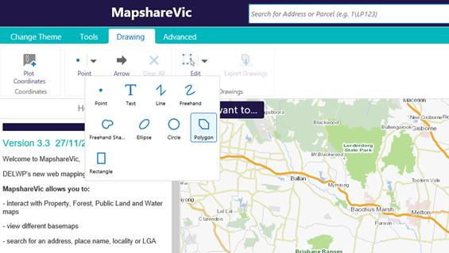

*MapshareVic steps 2 and 3*

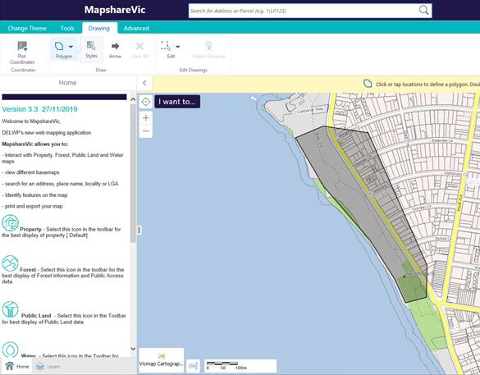

*MapshareVic step 4*

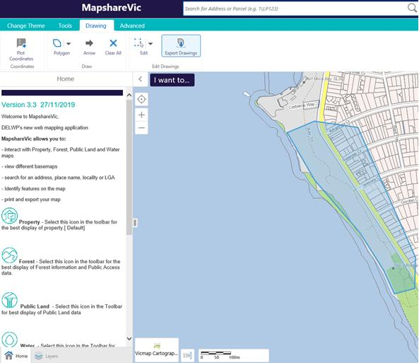

*MapshareVic step 7*

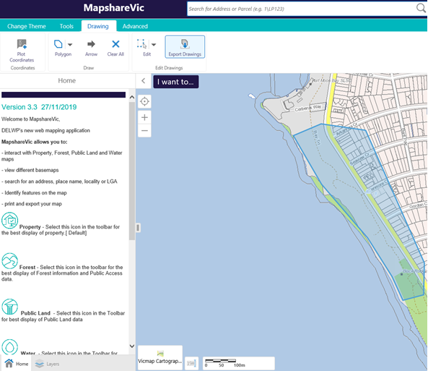

# Attachment 2: Port Phillip Bay Wetlands

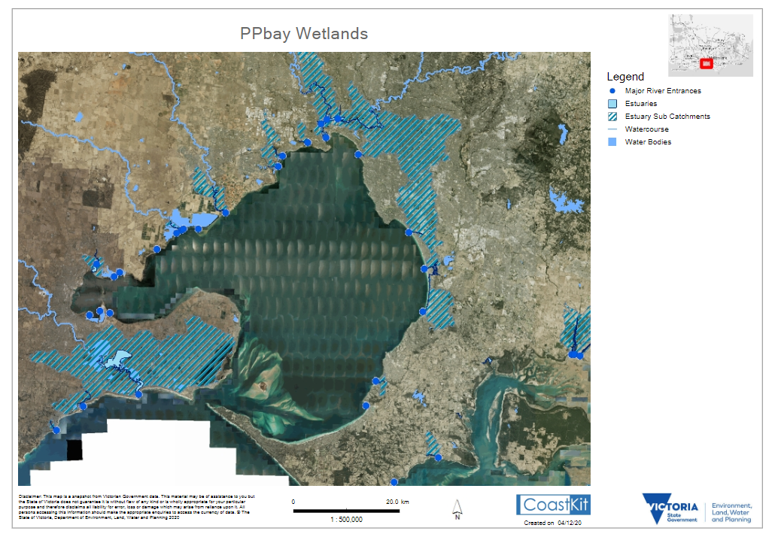

# Attachment 3: Erosion Vulnerability sites in Port Phillip Bay

