**Coastal and Marine Management Plan Resource Kit – Scope and Scale**

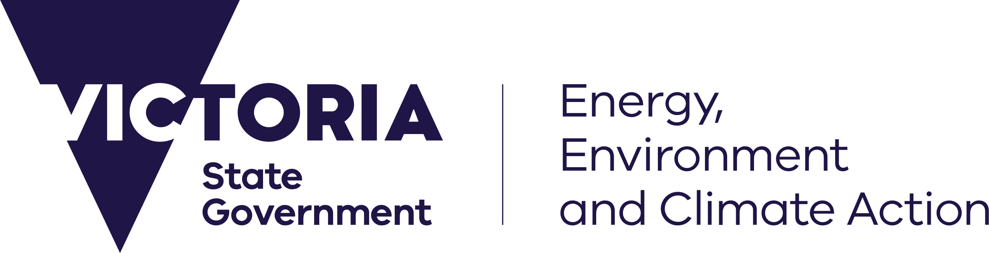



[deeca.vic.gov.au](https://ghdnet-my.sharepoint.com/Users/fionadurante/Downloads/deeca.vic.gov.au)

The aim of the Coastal and Marine Management Plan (CMMP) Resource Kit is to provide a collection of tools to guide coastal Crown land managers through the necessary steps of preparing a CMMP.

Drawing from the CMMP Guidelines, managers can determine how best to use this resource kit for their planning process. However, they should consider using the following order:

1. Scope and Scale template: defines the management area
2. Engagement Plan template: to identify and engage all relevant rightsholders and stakeholders
3. MERI Program Logic template: defines what and how objectives, activities, and anticipated outcomes of the CMMP will be delivered
4. Management Plan template: in which insights gathered from the above templates are consolidated
5. MERI Framework template: establishes robust monitoring, evaluation, reporting and improvement criteria

This template can assist with stage one of CMMP preparation.

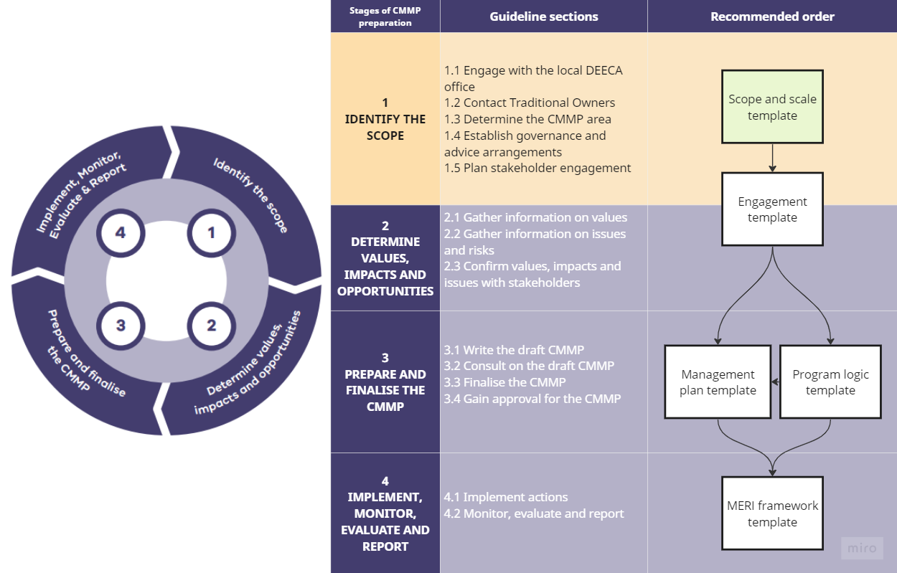

## How to use the template

Use the Scope and Scale Template to:

* Determine the appropriate scale of the CMMP.
* Determine the appropriate scope of the CMMP.

Guide engagement with a specialist consultant or provide clear lines of accountability for the Council/Committee.

Grey text – guides what to do under each subheading.

Black text – includes generic information that can be included in the Scope and Scale document.

# 1. Insert name of [Council/Committee]

Provide a brief description of:

* Management responsibilities
* Jurisdiction boundaries
* Key assets
* Current uses of the coastal and marine area

# 2. Scale of the CMMP

The *Marine and Coastal Strategy 2022* encourages land managers to adopt a coordinated and collaborative approach to planning and managing marine and coastal areas across government, industries and communities. This approach encourages systems, flows and processes in the marine and coastal environment to be managed cohesively to promote healthy, resilient and functional ecosystems and improve the effectiveness and cost-effectiveness of management actions.

The scale of a CMMP can vary – it can focus on a localised area (e.g., a single coastal reserve) that involves a simple and relatively discrete set of coastal processes and natural systems, or a broader area that involves a complex set of coastal processes and natural systems that have prominent cumulative and synergistic impacts.

Guidance on establishing the scale of a CMMP are provided in section 1.3 Determine the CMMP area and 3.1.1 Provide the background (in Additional Guidance) of the CMMP Guidelines.

Based on the characteristics of simple and complex CMMPs described in the table below, determine the appropriate scale of the CMMP and check the relevant box.

Please note that the characteristics of simple and complex CMMPs outlined are a guide and are not definitive. Suggested thresholds may need to be adjusted to suit the context of the marine and coastal area of focus.

The scale of the CMMP is:

|  |  |  |
| --- | --- | --- |
|  | Simple | Complex |
| Definition | A simple CMMP would address a local marine and coastal area. It would focus on an area with a discrete set of coastal processes and natural systems (based on tertiary coastal compartment mapping if available).  There would be a contained number of stakeholders. | A complex CMMP would address a broader marine and coastal area. It would focus on a larger area with complex coastal processes and natural systems that have prominent cumulative and synergistic effects (could be based on secondary coastal compartments). There would be a broad range of stakeholders. |
| Land managers | 1-2 | 1-2+ |
| Communities/townships within the area | 1-2 | 2 + |
| Approximate number of community stakeholder groups | 10 | 10+ |
| Approximate budget range for development of the CMMP | Up to $80,000 | $80,000 + |
|  |  |  |

# 3. Delivery

Determine how the CMMP will be delivered and check the relevant box.

The CMMP will be produced:

|  |  |
| --- | --- |
|  | In-house by the Council/Committee |
|  | By a specialist consultant |
|  | Through a combination of in-house and a specialist consultant |

# 4. Scope of the CMMP

The scope of work required to produce the CMMP is outlined in the table below.

Refer to the *Coastal and Marine Management Plan Guidelines* for more information.

Defining the scope of the CMMP is important to understand what tasks need to be undertaken and what is included and excluded in CMMP development.

If the CMMP is being produced in-house, mapping out its scope will support the project to stay on track and hold the team accountable. If the CMMP is produced by a consultant or through partnership between the Council/Committee and consultant, defining the scope provides useful information for the consultant to develop the proposal. Further information can be found in section 1.4 Establish governance and advice arrangements of the CMMP Guidelines.

Develop the scope of the CMMP by filling out the table below.

If you are preparing a scope for a Simple CMMP:

* Delete elements 3 and 6.
* Delete the bolded grey text in element 4.

|  |  |  |  |
| --- | --- | --- | --- |
| CMMP development phase | Scope element | Details | Deliverable(s) |
| Identify the scope | 1. Brief project background | To provide everyone involved with a basic understanding of the context:   * Describe what a CMMP is. * Describe the purpose of a CMMP. |  |
| 1. Project management requirements and project inception meeting | * How will the project be managed? * Who is the project manager? * Will there be a site meeting? * List the frequency of meetings and reporting. |  |
| 1. Governance arrangements | DELETE row for Simple CMMPs.  For Complex CMMPs only.   * Will there be a project steering group, reference group or administrative support? * Describe as appropriate. |  |
| Determine values, impacts and opportunities | 1. Understanding of existing conditions and context | Summarise background information and research, relevant legislation and literature.  Describe previous plans or strategies related to the marine and coastal area.  Identify adjoining land managers and discuss how management actions in CMMPs across management boundaries can complement each other to promote effectiveness and cost-effectiveness.   * **For Complex CMMPs, discuss with adjoining land managers whether to create a joint CMMP.** |  |
| 1. Engagement | Use the “Engagement Plan Template”  Consider how rights holders, including Traditional Owners, would like to be involved throughout CMMP development. | Engagement Plan  Engagement materials (e.g., presentation, fact sheet, survey, interview questions, informatory email)  Report on engagement activities |
| 1. Prepare discussion paper on issues and opportunities. | DELETE row for Simple CMMPs.  For Complex CMMPs only. | Issue discussion paper |
| Prepare and finalise the CMMP | 1. Develop preliminary draft CMMP | Use the “Management Plan Template”. | Preliminary draft CMMP |
| 1. Develop draft CMMP | Use the “Management Plan Template”.   * Define the number of drafts required.   Several drafts may be produced to allow for comments and changes.  More drafts are likely to be required for Complex CMMPs due to added complexity.  Allow for GIS/mapping if required. | Draft CMMP |
| 1. Consult with DEECA and/or Project Steering Group (PSG) | * For Complex CMMPs, consult with PSG, reference group or administrative support if the CMMP requires one (refer to scope element 3). A PSG is required for Complex CMMPs. The PSG should agree with the contents of the draft CMMP before it is released for public exhibition. * For Simple CMMPs, consult with DEECA to ensure the draft CMMP includes all mandatory content before it is released for public exhibition. |  |
| 1. Provide draft CMMP for public exhibition | The draft CMMP may need formatting.   * Define whether formatting will be completed in-house or by a consultant. | Draft CMMP |
| 1. Analyse and respond to submissions |  |  |
| 1. Finalise CMMP |  | Final CMMP |
| Monitor, Evaluate, Report, Improve | 1. Implement CMMP | Completed by the Committee/Council. |  |

## 4.1 Project area

* Include a map that outlines the boundaries of the marine and coastal area considered in the CMMP.

For complex CMMPs, consider dividing the area covered by the CMMP into management precincts or zones. These precincts or zones can be identified by natural landscape characteristics, by geographical location and/or management approaches e.g., activity and recreation nodes.

Further information on establishing management units and defining activity and recreation nodes can be found in Additional guidance – 3.1 ‘prepare and finalise the CMMP’ in the CMMP Guidelines.

## 4.2 Exclusions

**DELETE if delivering CMMP in-house.**

If the CMMP is being produced by a consultant or through partnership between the Council/Committee and consultant, list what is excluded in the consultant’s scope of work.

This might include:

* Formatting the draft CMMP.
* Updating the CMMP if changes are required after the final draft CMMP
* Submitting the CMMP.
* Implementing the CMMP.

# 5. Schedule

An indicative schedule for CMMP development is provided in the table below.

Fill in the relevant calendar dates using the suggested timeframes. Additional steps may need to be added to include processes relevant to the specific CMMP, such as adoption by Council.

|  |  |
| --- | --- |
| Scope element | Estimated timeframe |
| Initial research (understand existing conditions and context) | 2-6 weeks |
| Initial stakeholder engagement (including planning, undertaking activities and reporting) | 6-8 weeks |
| **Review hold point**  **For Complex CMMPs, the estimated timeframe for review may be longer due to the size of these documents and caseload priorities.** | 2 weeks |
| Prepare and issue discussion paper  **DELETE row for Simple CMMPs.**  **For Complex CMMPs only.** | 2-4 weeks |
| Further targeted stakeholder engagement (on discussion paper issues)  **DELETE row for Simple CMMPs.**  **For Complex CMMPs only.** | 2-4 weeks |
| Develop preliminary draft CMMP | 2-4 weeks |
| **Review hold point** | 2 weeks |
| Develop draft CMMP | 6-8 weeks |
| **Review hold point** | 2 weeks |
| Provide for public exhibition | 6 weeks |
| Analyse and respond to submissions from public exhibition, update draft CMMP | 4-6 weeks |
| **Review hold point** | 2 weeks |
| Consultant/Project team to prepare final draft CMMP for submission to DEECA | 2-4 weeks |
| **Review hold point: DEECA to provide feedback on final draft CMMP and advise on next steps and timeframes for referral to Victorian Marine and Coastal Council (VMaCC) and Ministerial approval** |  |