|  |
| --- |
| DELWP marine and coasts newsletter |

Welcome to the sixth issue of the Department of Environment, Land, Water and Planning’s (DELWP’s) quarterly marine and coasts newsletter**.**

## In this issue:

* DELWP’s maritime archaeologists
* Coastal protection projects across the state
* Coastal erosion in focus – the Cape to Cape Resilience Project
* Port Phillip Bay Environmental Management Plan
* CoastKit - Building biodiversity knowledge in Port Phillip Bay
* The Victorian Coastal Monitoring Program in Port Phillip Bay: Multi-method historical shoreline analysis
* Statewide Coastal Assets Management System
* Coastcare’s ‘Coastline’

|  |
| --- |
| Email [marine.coasts@delwp.vic.gov.au](mailto:marine.coasts@delwp.vic.gov.au) to subscribe or unsubscribe to this newsletter and for more information. |

# Maritime heritage

## DELWP’s maritime archaeologists

Did you know that there is a team of maritime archaeologists in Heritage Victoria?

Heritage Victoria’s Statutory Approval’s team has functions under the *Victorian Heritage Act 2017* and the *Commonwealth Underwater Cultural Heritage Act 2018* to protect shipwrecks, aircraft wrecks, maritime infrastructure and other historic traces of human evidence located in coastal and marine areas to the edge of the Exclusive Economic Zone (EEZ).

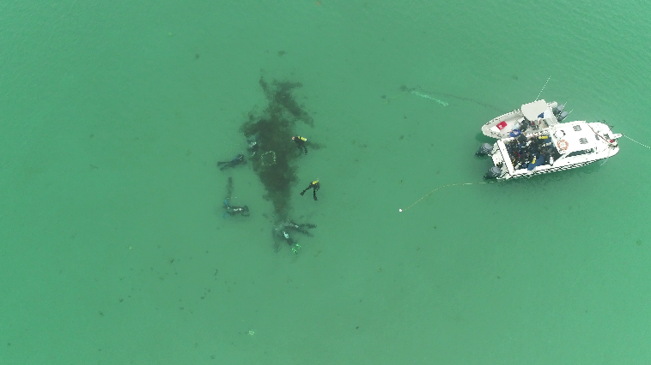

Fieldwork at the Barbara shipwreck, Rye.

Our team of three work on:

* permits, consents and compliance
* management of over 600 known shipwrecks and other sites listed on the [Victorian Heritage Register](https://heritagecouncil.vic.gov.au/heritage-protection/register/) and [Victorian Heritage Inventory](https://discover.data.vic.gov.au/dataset/victorian-heritage-inventory)
* site inspections to assess the condition of sites and risks to them (including biological, chemical, physical, climate and human)
* community engagement including with citizen scientists, universities and associations
* running programs such as [Maritime Heritage at Risk](https://www.heritage.vic.gov.au/about-us/our-programs-and-initiatives/maritime-heritage-at-risk-program), Shipwreck Discoveries Program and Community Shipwreck Monitoring.

We undertake fieldwork and diving inspections from our vessel, Trim. However, we rely heavily on volunteer and community involvement to be informed of the changing conditions or threats to sites.

Many of Victoria’s shipwrecks are along the shoreline including Amazon, Cerberus, and Redbird. Last year we also supported Flinders University of South Australia to undertake a field school at the shipwreck Barbara.

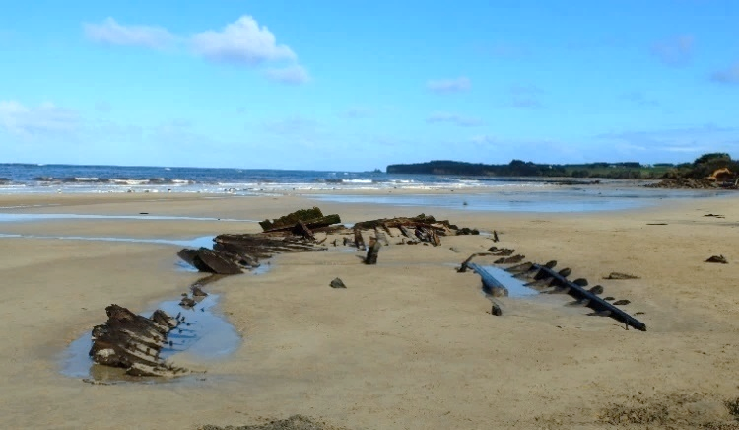

The Amazonshipwreck at Inverloch.

For more information, visit the new Heritage Victoria website at [heritage.vic.gov.au](https://www.heritage.vic.gov.au/) or contact Danielle Wilkinson (Senior Archaeologist Maritime) – [danielle.wilkinson@delwp.vic.gov.au](mailto:danielle.wilkinson@delwp.vic.gov.au).

# Coastal protection projects

## Construction to commence at Apollo Bay

The construction of new coastal protection infrastructure to manage the impacts of coastal erosion is set to commence at Apollo Bay in March 2021.

The first stage of these works will see two 70-metre-long rock groynes constructed to the south of the existing Milford Street revetment and to the south of Milford Creek.

The groynes will intersect the surf zone and trap sand as it moves along the beach, so there will be more sand for beach users within the groyne compartment.

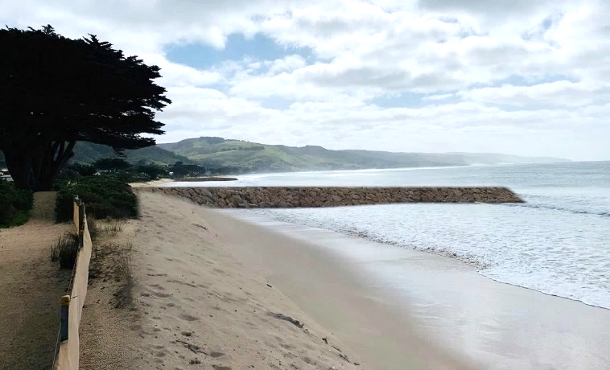

Artist’s impression of the groynes planned for Apollo Bay.

Sections of rock seawall will also be constructed between the two groynes to protect the dune, walking path, cypress trees and Great Ocean Road.

Detailed engineering work has determined the location and design of the new infrastructure and the success of the groynes will be monitored to inform future stages of work.

Community engagement over several years has helped shape the project with beach access and foreshore safety as key design objectives.

The Department of Transport is helping to deliver the construction works, which should be complete by mid-2021.

$3 million was provided for stage one of the project as part of the Victorian Government’s $2.7 billion Building Works package.

An additional $4.4 million has also been provided in the Victorian Budget 2020-21 for the next round of works that will include additional infrastructure and renourishment.

Planning and design works are currently underway for stage 2 and further announcements will occur later in the year.

For regular updates and more information on the concept design, please visit [marineandcoasts.vic.gov.au/coastal-programs/apollo-bay-and-marengo](https://www.marineandcoasts.vic.gov.au/coastal-programs/apollo-bay-and-marengo).

## Renourishment of Bellarine beaches

The Barwon South West region has delivered the Taylor Reserve Beach Renourishment project at Indented Head on the Bellarine Peninsula.

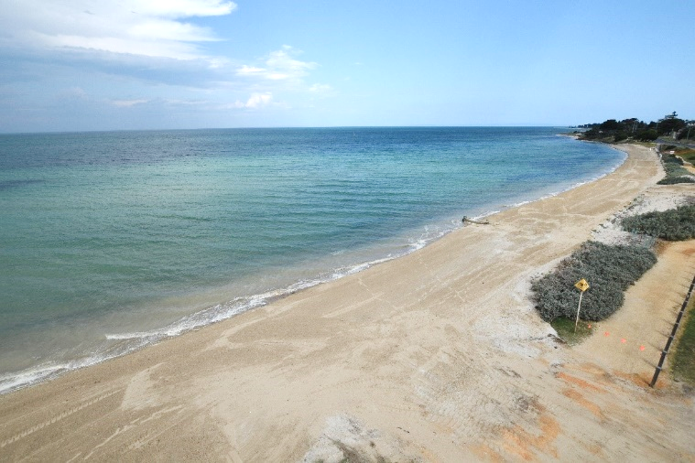

The recently completed renourishment at Anderson Reserve, December 2020.

Over 5,000 cubic metres (m3) of sand was placed along the foreshore at Anderson Reserve (a part of Taylor Reserve) to protect this section of the beach from coastal erosion, as part of the Victorian Government’s $8 million Port Phillip Bay Beach Renourishment Program. The works were guided by community consultation and completed just in time for the summer holidays.

Planning for the next round of beach renourishment priorities at St Leonards North at Salt Lagoon and St Leonards South at Lower Bluff is underway. Designs are complete with tendering about to commence.

Unlike the Indented Heads work, which saw sand harvested from the Queenscliff Ferry terminal (a naturally accreting beach), the St Leonards projects will require up to 50,000m3 from an offshore sand source to help widen the narrow beach and provide protection to the foreshore and the surrounding assets.

Additional coastal processes investigations, ecological surveys and numerical modelling identified two suitable sand source locations, both containing ideal clean sand with adequate partial size, suitable for renourishment purposes. Works are due to commence in the next month and are due to be complete by June this year.

Further community engagement is set to occur shortly. Please visit [marineandcoasts.vic.gov.au/coastal-programs/bellarine-renourishments](https://www.marineandcoasts.vic.gov.au/coastal-programs/bellarine-renourishments) for updates and more information.

## Mornington Peninsula and Eastern Port Phillip Beach Renourishments

The beach renourishment projects at Dromana and McCrae recommenced in February 2021, following a break during the peak summer period.

The contractors have been working seven days a week to deliver the project, which will cover a 650-metre length of beach at Dromana and an 800-metre length at McCrae.

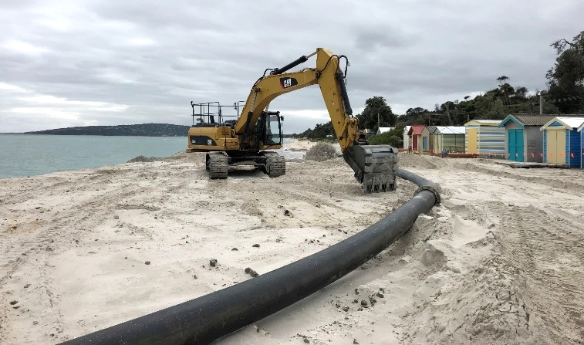

Renourishment works underway at Dromana beach, February 2021.

The renourishments have been designed to increase the width of each beach by approximately 20 metres. A great result for the community given these beaches were inaccessible at high tide as recently as January 2021. Works are scheduled to be completed by the end of March 2021, pending weather delays.

These projects will be immediately followed by beach renourishments at Sandringham, covering approximately 600 metres of coastline at Edward Street Beach and 150 metres at Half Moon Bay. Works are expected to conclude by the end of April 2021.

For more information, please visit the DELWP beach renourishment webpage –[marineandcoasts.vic.gov.au/coastal-programs/beach-renourishment](https://www.marineandcoasts.vic.gov.au/coastal-programs/beach-renourishment).

# Marine and coastal knowledge

## Coastal erosion in focus – the Cape to Cape Resilience Project

DELWP Gippsland is leading the first Regional and Strategic Partnership (RaSP) under the Marine and Coastal Act which was established by Minister Lily D’Ambrosio in August 2020.

The RaSP is a partnership of nine coastal and marine management agencies working with the [Bunurong Land Council Aboriginal Corporation](https://www.bunuronglc.org/) to investigate the extreme erosion the Inverloch coastline has experienced over the last eight years.

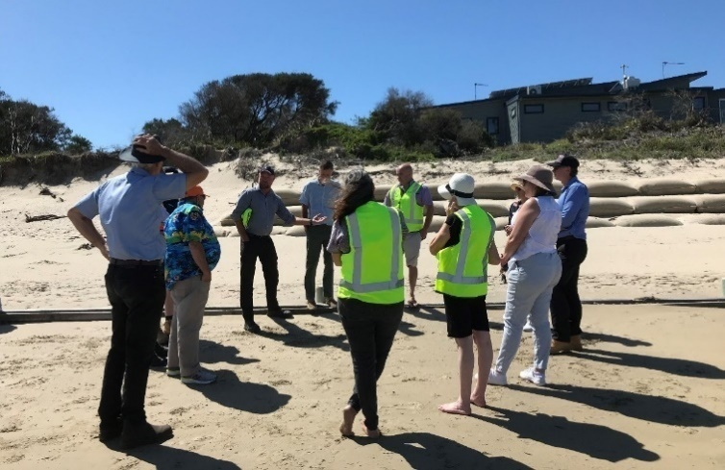

Bass Coast Shire Councillors on site with DELWP and shire staff at Inverloch Surf Beach.

The key objective of the RaSP is the development of a coastal resilience plan for the Inverloch region. The partner agencies will use this to create implementation plans to manage local values and assets into the future.

The coastal resilience plan will be informed by the Inverloch Region Coastal Hazard Assessment (CHA), being undertaken by local coastal engineering consultancy Water Technology, and extensive community engagement and consultation will be led by coastal engineering and engagement consultants Alluvium Consulting.

The project team has commenced the year with gusto, and a variety of technical and engagement work is underway. The technical team has started collecting data from government and research organisations, captured new aerial imagery, undertaken fieldwork to assess and characterise the coastal geomorphology and run a workshop with [Victorian Coastal Monitoring Program](https://www.marineandcoasts.vic.gov.au/coastal-programs/victorian-coastal-monitoring-program) researchers.

The engagement team is developing the whole of project engagement strategy, web page and design templates. A Stakeholder Reference Group has been formed and will meet for the first time in March 2021.

In February, the DELWP project team undertook a site visit and briefing for Bass Coast Shire Councillors, who showed great interest in the pilot RaSP and expressed their support for the first comprehensive coastal resilience planning project in Victoria.

The project will progress quickly during the year, with the CHA due in November 2021.

## Port Phillip Bay Environmental Management Plan 2017-2027

The 2019-2020 Annual Report and 2020 Delivery Plan Update for the Port Phillip Bay Environmental Management Plan 2017-2027 (EMP) is available at [marineandcoasts.vic.gov.au/coastal-programs/port-phillip-bay](https://www.marineandcoasts.vic.gov.au/coastal-programs/port-phillip-bay).

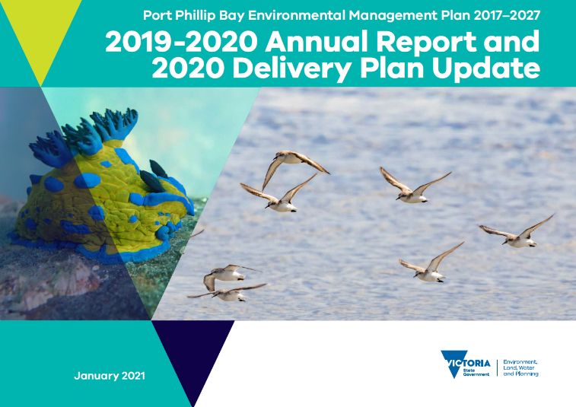

The amazing cover photos for the 2019-2020 Annual Report and 2020 Delivery Plan Update for the Port Phillip Bay Environmental Management Plan 2017-2027 were provided by the talented Katrina Richards (image left) and Marcia Riederer (image right).

The document provides an update on the progress of the implementation of the EMP through 191 activities led by a multitude of delivery partners.

The Annual Report highlights the achievements of the EMP from 2017 through to June 2020, including:

* A combined investment across the 191 activities of:
  + over $19 million in expenditure by agencies and non-profit organisations
  + $4 million of in-kind contributions and
  + 174,089 volunteer hours.
* A total of 95 activities have been completed to meet the priority actions of the EMP, collectively contributing to the:
  + education and training of over 94,000 people
  + removal of over 550 tonnes of litter
  + rehabilitation and protection of over 3,650 hectares
  + formation of 481 partnerships and collaborations and
  + planting of over 32,900 seedings and tube stock.

For the first time, this document is complemented by an interactive StoryMap, available at:

<https://storymaps.arcgis.com/stories/b1850930bce24dceabaa4ce9f27828d0>.

The StoryMap showcases video tours of [LitterWatch Victoria](https://www.litterwatchvictoria.org.au/) and the EMP theme on [CoastKit](https://www.marineandcoasts.vic.gov.au/coastal-programs/coastkit).

## CoastKit – Building biodiversity knowledge in Port Phillip Bay

### Mapping habitats of Port Phillip Bay

Port Phillip Bay hosts an array of marine animals and plants, supported by a diverse number of habitats.

DELWP, in collaboration with Fathom Pacific and Australian Marine Ecology, are working to produce a predictive habitat map, drawing upon available ground-truth survey data and applying machine learning tools.

The Combined Biotope Classification Scheme (CBiCS) is a hierarchal habitat classification system used to provide a broad to finer resolution of habitat assemblages to individual species. For more details about this, see [CoastKit](https://mapshare.vic.gov.au/coastkit/)’s Biotope Atlas, [marineandcoasts.vic.gov.au/coastal-programs/coastkit](https://www.marineandcoasts.vic.gov.au/coastal-programs/coastkit).

Resulting mapped habitats are key outputs for monitoring and reporting on the condition and health of marine life in Port Phillip Bay.

### Developing biodiversity indicators

The monitoring, evaluation, reporting and improvement (MERI) strategy for Port Phillip Bay facilitates the development of biodiversity indicators for achieving the vision of a healthy bay that is valued and cared for by all Victorians.

Biodiversity indicators will be created with stakeholder and expert scientists for multiple ecosystem components such as marine mammals, shorebirds, wetlands, commercial fish, reefs and invertebrates.

Long term monitoring datasets of marine and coastal populations will be combined with baselines and thresholds to depict a current status for marine species and groups. Report cards will be displayed through the [Coastkit online web portal](https://mapshare.vic.gov.au/coastkit/).

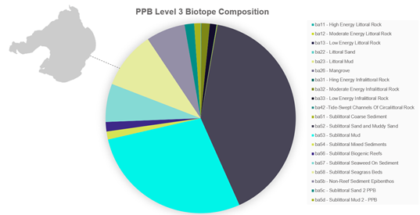

Habitat types (CBiCS Level 3) comprising Port Phillip Bay.

## The Victorian Coastal Monitoring Program in Port Phillip Bay: Multi-method historical shoreline analysis

The shorelines of Port Phillip Bay (PPB) are vital areas for public utility and recreation. Many sections within the bay are highly engineered, with historic ‘hard’ interventions, such as seawalls, and ongoing ‘soft’ interventions, in the form of sand renourishments.

A key challenge for coastal managers is understanding how the coast has behaved in the past and how it is likely to change in future, including in response to engineering interventions.

Critical to this understanding is the need for ongoing field observations of morphologic change, which can be used to calibrate morphodynamic models, to predict future behaviour.

For this reason, the Marine Biodiversity Policy and Programs group has expanded the Victorian Coastal Monitoring Program (VCMP) into Port Phillip Bay, including six wave buoys and four new citizen science drone monitoring sites across the bay.

In addition to gathering field data, a comprehensive multi-method historical shoreline analysis is being conducted (Figure 1), including:

* high-resolution topo-bathymetry for cross-shore profile extraction
* satellite and aerial imagery for shoreline change time series
* hydrodynamic wave model data, for calculating wave statistics and potential alongshore sediment flux
* combined analysis of waves, bathymetry, and shoreline trends to estimate sediment budgets.

Once complete, this analysis will be combined with ongoing field observations to calibrate a series of new shoreline modelling approaches. An initial goal of modelling efforts will be to assist in planning and prediction of shoreline renourishments in Port Phillip Bay.

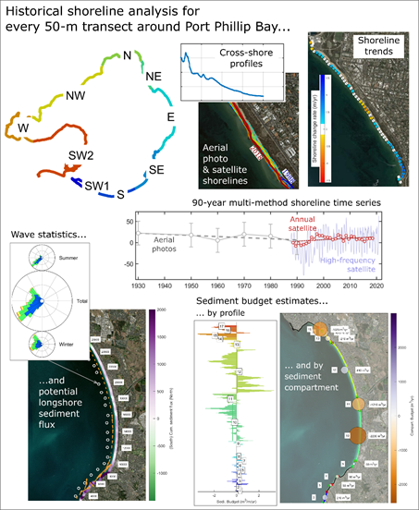

Figure 1: Multi-method historical shoreline analysis, an initial phase of the VCMP in Port Phillip Bay.

## Statewide Coastal Assets Management System – condition inspections underway!

DELWP’s Statewide Coastal Programs team is halfway through an ambitious assessment program of approximately 1,400 coastal protection assets (with a combined length of 170 kilometres!), located on Crown land along the Victorian coastline.

Since January 2021, engineers have been visiting coastal protection assets – seawalls, groynes, revetments and breakwaters – to record their overall condition and identify all visible defects.

A height survey acts as a benchmark for any subsidence and determines an asset’s suitability for providing continuous protection against wave action and storms, given future sea level rise projections.

800 assets have now been validated and inspected, along with 5,100 photographs to document asset condition.

All inspection information is uploaded to DELWP’s database using the Coastal Asset Management System (CAMS) mobile field application.

The resulting data and analytics will provide an evidence-base for future coastal decision making and will help determine priorities for future maintenance and investment in coastal protection assets.

The program is due for completion at the end of April 2021.

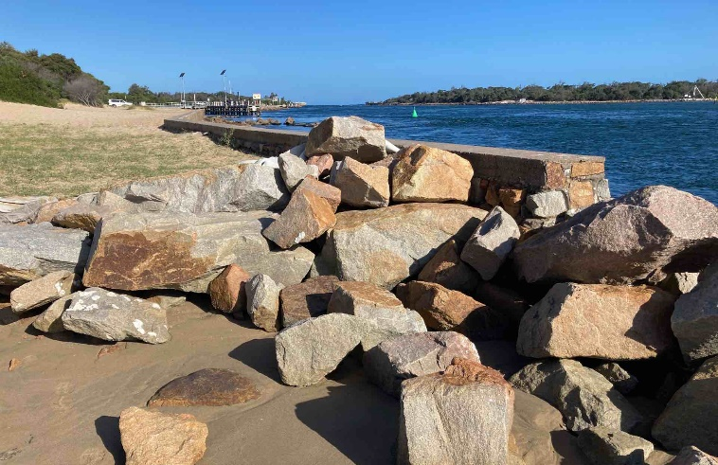

Terminal scour protection at the end of a seawall. This is often a reactive measure to prevent further damage and prolong the life of assets.

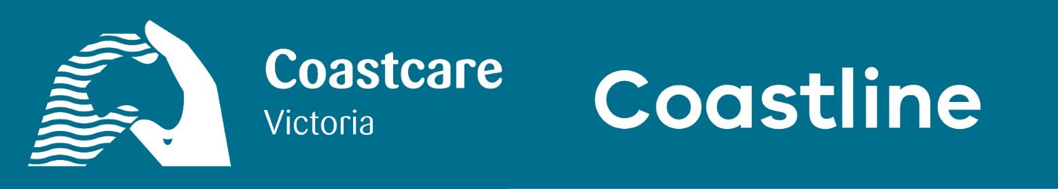

## Coastcare community grants are coming!

It’s that time of year again! The Coastcare Victoria team is busy preparing the annual Coastcare Community Grants program for 2021.

The grants are designed to support coastal community-based volunteer groups to do on ground works to build resilience to climate change, strengthen volunteer groups and to support Traditional Owner Self-Determination.

Some exciting changes are coming in 2021. To stay up to date on announcements, make sure you follow the [Coastcare Victoria Facebook](https://www.facebook.com/CoastcareVictoria/) page or speak to your [local Coastcare Victoria facilitator](https://www.marineandcoasts.vic.gov.au/coastal-programs/Coastcare-Victoria) about your project idea.

For some inspiration, see the [previously funded grants](https://www.marineandcoasts.vic.gov.au/coastal-programs/Coastcare-Victoria/coastcare-victoria-community-grants).

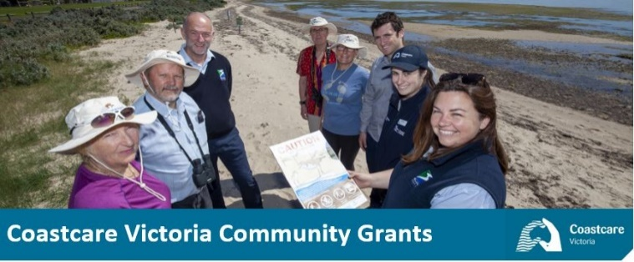

Coastcare Community Grants in action on the Bellarine and Surf Coast.

## Coastcare Victoria Volunteer Capacity Building 2021 is here!

In alignment with the delivery of the Coastcare Victoria 2021 Grants program, the Coastcare Victoria team are offering a series of free online workshops to our volunteer groups and organisations.

These workshops are designed to assist volunteers to be better equipped when applying for our grants and other funding opportunities.

The workshops kick off in March 2021 and continue into early April 2021. Each session is delivered live online and will run for 2 ½ hours. Workshops will be interactive, led by an external professional training provider – Non Profit Training – and include practical materials to support participant learning.

### Workshop 1 – Project Management

Understand the essentials of designing a project so that you have a solid base for your grant application, and funders can see everything is ready to go – all you need is the dollars!

* 18th March 2021 | 9:30 am – 12 pm
* 24th March 2021 | 1:30 pm – 4 pm

### Workshop 2 – Grant Writing

Build skills to help you formulate responses to a range of funder questions and develop a project outline that responds to the key objectives and criteria of the potential funder.

* 30th March 2021 | 9:30 am – 12 pm
* 1st April 2021 | 9:30 am – 12 pm
* 7th April 2021 | 1:30 pm – 4 pm

To attend any of the free workshops, [register here](https://forms.office.com/Pages/ResponsePage.aspx?id=99a96Bj8SE6lVH9UeSciO8eD_BSeTuJOtd8PA1ymG61URThJS0hLTEJWTFFGSFZHNTNVUzYxUUs4OS4u). The number of participants in each workshop is limited, so get in early, and contact your local Coastcare Victoria facilitator for further information.

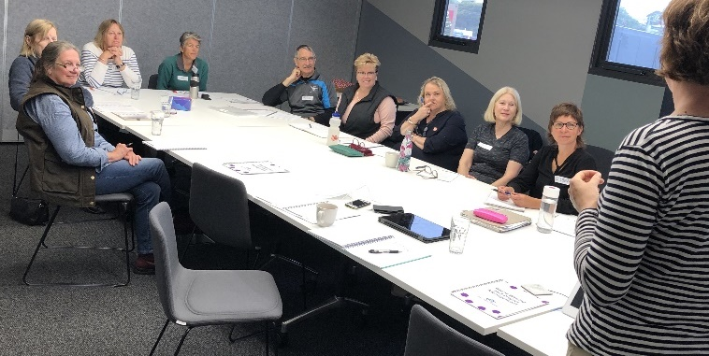

Volunteers attending Grant Writing Training with Non Profit Training in Warrnambool, 2018.

## ‘Bay Country’ mobile app connects community, culture and conservation

The Wadawurrung people have been caring for country for tens of thousands of years and are the world’s original conservationists.

Bellarine Catchment Network (BCN) are privileged to have partnered with the Wadawurrung Traditional Owners Aboriginal Corporation to develop the ‘Bay Country’ app, funded through the Port Phillip Bay Fund, which explores the [Caring for our Bays](http://www.environmentbellarine.org.au/CaringForOurBays) hero species through the eyes of the Wadawurrung.

The Bay Country app showcases 10 Caring for our Bays hero species, which have been developed to increase community awareness about the impact that litter inflicts on wildlife.

Users can learn interesting information about each species such as their breeding habits, ecological facts, distribution around Port Phillip Bay and Corio Bay and the impacts that humans have on each species.

The Bay Country app also introduces users to Wadawurrung language and culture. Users have the opportunity to learn some Wadawurrung words with an Acknowledgement of Country in Wadawurrung language, followed by an English translation.

Each Caring for our Bays hero species is recognised with its Wadawurrung language name, along with an explanation of its cultural connection to the Wadawurrung people and Wadawurrung Country and waters.

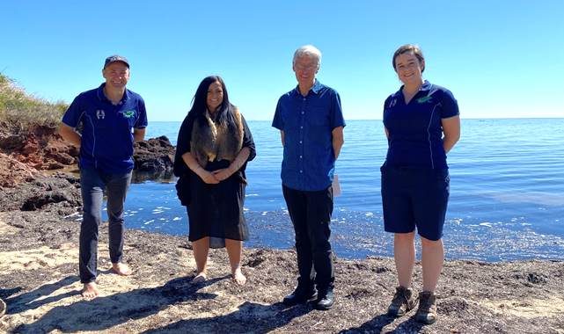

From left to right: Matthew Crawley (BCN Program Manager), Corrina Eccles (Wadawurrung woman), Graeme O’Leary (BCN President) and Rebecca St Ledger (BCN Coastal Program Officer) meeting together on Wadawurrung country at Portarlington.

BCN filmed a short video to launch the Bay Country app alongside Wadawurrung woman, Corrina Eccles, who conducted a smoking ceremony to open the launch and shares her Wadawurrung knowledge and perspectives throughout the video.

The Bay Country app is available now to download for free through the Apple App Store and will be available for Android phones via Google Play soon.

To view the launch video, head to the Bellarine Catchment Network’s YouTube channel, <https://www.youtube.com/user/BCNBELLARINELANDCARE>

## Phillip Island Coastcare blitz – collaboration, engagement, training and action!

In October 2020, the Phillip Island Landcare Group were delighted to hear the news that they had been successful in their application for a Coastcare Victoria Community Grant: ‘Phillip Island Coastcare Blitz – collaboration, engagement, training and action’.

This project brings together and supports five Coast Action groups across Phillip Island in collaboration with two separate landholders, Phillip Island Nature Parks and the Bass Coast Shire Council.

The Landcare Group supports the smaller Coastcare Victoria groups through project management, volunteer support and resources, such as sharing the group’s planting trailer. In return, the Coastcare Victoria groups provide knowledge of their local area and a willingness to continue caring for their respective coastal land. Together, they form a great team.

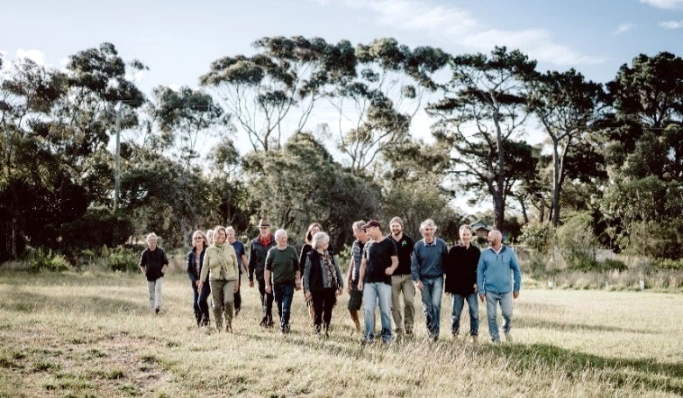

Phillip Island Landcare group members.

Phillip Island Coastcare Blitz involves each group holding their own ‘on ground works’ session, including revegetation, weed control and rabbit control.

In addition, they are holding three important events that tie into the group sessions: their famous Bunny Boiler to launch the project, a mid-term training session to further connect groups, and a workshop that focuses on success and failures from the project.

David Rooks, Phillip Island Landcare President says he is ‘…immensely excited about the July activities where coastal people and rural land holders will come together and share their stories and learnings’.

## Business beyond boundaries for Summer by the Sea 2021

[Summer by the Sea](https://summerbythesea.vic.gov.au/) (SBTS) is an annual program designed to showcase the diversity of the Victorian coastal and marine environments and allow those participating to do so in a safe and practical manner.

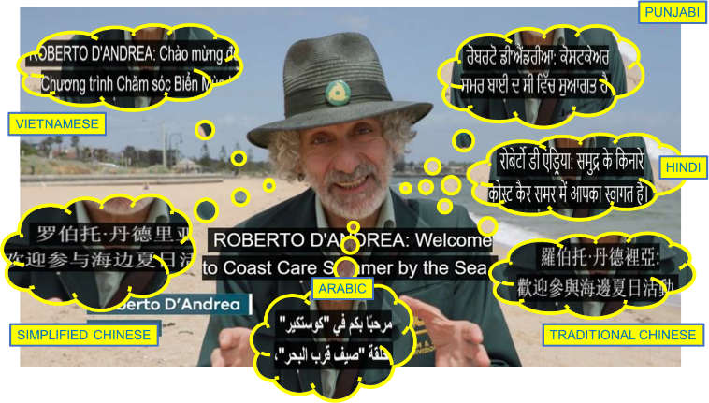

Roberto D’Andrea from The Connies, presenting on Catchment to the Sea in several languages as part of the online Summer by the Sea program.

Our innovative approach was to go virtual in a viral world. The 2021 program featured an array of activities, including live events, podcasts, online videos, and educational resources utilising the digital domain.

The live events featured citizen science, geomorphology, marine mammals, and penguin protectors. There were podcasts or self-guided tours of Port Phillip Bay, shipwrecks on the South Gippsland coast, watching whales at Warrnambool and nature imitating art along the Victorian foreshore, as well as video presentations on rockpool rambles, marine creatures, coastal fossils and much more!

Published video content featured captions in English, Arabic, Hindi, Punjabi, Simplified Chinese, Traditional Chinese, and Vietnamese.

Preliminary analytics indicate our audience was beyond our traditional boundaries as viewers logged in from countries including Poland and Germany.

Our audacious first attempt to take the program online required unprecedented collaboration from teams across DELWP including our Statewide Coastal Programs team, Digital Capability team, Workplace Services, Media and Communications, DigiComms and Legal teams – thanks for the support and contributing towards the success of a unique program under trying times!

|  |  |
| --- | --- |
| © The State of Victoria Department of Environment, Land, Water and Planning 2021  LogoThis work is licensed under a Creative Commons Attribution 4.0 International licence. You are free to re-use the work under that licence, on the condition that you credit the State of Victoria as author. The licence does not apply to any images, photographs or branding, including the Victorian Coat of Arms, the Victorian Government logo and the Department of Environment, Land, Water and Planning (DELWP) logo. To view a copy of this licence, visit http://creativecommons.org/licenses/by/4.0/  Disclaimer  This publication may be of assistance to you but the State of Victoria and its employees do not guarantee that the publication is without flaw of any kind or is wholly appropriate for your particular purposes and therefore disclaims all liability for any error, loss or other consequence which may arise from you relying on any information in this publication. | Accessibility  If you would like to receive this publication in an alternative format, please telephone the DELWP Customer Service Centre on 136186, email [customer.service@delwp.vic.gov.au](mailto:customer.service@delwp.vic.gov.au), or via the National Relay Service on 133 677 [www.relayservice.com.au](http://www.relayservice.com.au). This document is also available on the internet at [www.delwp.vic.gov.au](http://www.delwp.vic.gov.au). |