Coastal Public Access and Risk Grants 2020-21
  - Successful projects by region

Total projects funded: 12
Total funded amount: $500,000

Barwon South West | 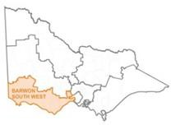

Recipient | Project | Grant amount
Moyne Shire Council | Replace Griffiths Island Southern Causeway | $72,984.50
Great Ocean Road Coast Committee Incorporated | Renew beach access and fencing - Eastern View & Anglesea | $12,450.00
Barwon Coast Committee of Management Inc. | Renew Hodgson St. beach access with a pedestrian ramp | $50,000.00
Great Ocean Road Coast Committee Incorporated | Formalisation of Beach Access Point - Staircase, The Gap Torquay | $21,000.00
Parks Victoria | Repair Gibson Steps public coastal access structure | $17,500.00
TOTAL |  | $173,934.50

Gippsland | 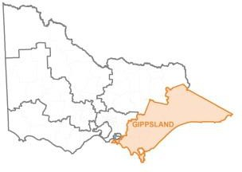

Recipient | Project | Grant amount
Phillip Island Nature Park | Coastal erosion intervention at the Penguin Parade | $78,770.00
Loch Sport Foreshore Committee of Management Incorporated | Realignment of Eroded Foreshore Walking Track at Seagull Drive and The Boulevard | $47,888.00
Walkerville Foreshore Committee of Management Incorporated | Walkerville South Coastal Access Tracks Rebuild and Repair | $22,565.00
TOTAL |  | $149,223

Port Phillip | 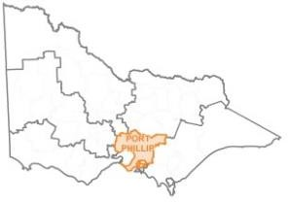

Recipient | Project | Grant amount
Balnarring Foreshore & Parks Reserve | Fire Hydrant installation in C Reserve | $15,584.50
Mornington Peninsula Shire | Fisherman’s Beach Geotechnical Risk Assessment | $16,750.00
Merricks Beach Foreshore Reserve Committee of Management Inc. | Merricks Beach Foreshore Access Paths Safety Improvement | $79,508.00
Kingston City Council | Carrum Beach Terminal Scour and Beach Access Works | $65,000.00
TOTAL |  | $176,842.50

