|  |
| --- |
| DELWP marine and coasts newsletter |

Welcome to the Department of Environment, Land, Water and Planning’s (DELWP’s) quarterly marine and coasts newsletter**.**

## In this issue…

* Diving into the draft Marine and Coastal Strategy
* Update on Marine Spatial Planning in Victoria
* Newly reappointed Victorian Marine and Coastal Council
* Coastal protection projects
* The Cape to Cape Resilience Project makes waves in Gippsland
* Coastal Infrastructure Project
* Statewide Coastal Assets Management System (CAMS)
* Coastcare’s ‘Coastline’

|  |
| --- |
| Email [marine.coasts@delwp.vic.gov.au](mailto:marine.coasts@delwp.vic.gov.au) to subscribe or unsubscribe to this newsletter and for more information. |

# Marine and coastal policy reforms

## Diving into the draft Marine and Coastal Strategy

The draft Marine and Coastal Strategy is the latest step in a body of work from DELWP that began with the groundwork to create the *Marine and Coastal Act 2018*, and the development of the Marine and Coastal Policy, released in March 2020.

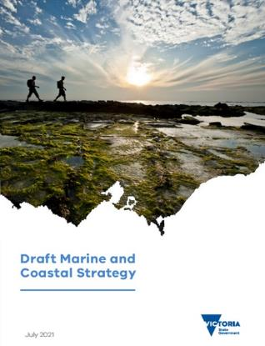

The Marine and Coastal Policy established a 15-year vision for a healthy, dynamic and biodiverse marine and coastal environment that is valued in its own right, and that benefits the Victorian community, now and in the future. It demands a new strategy every five years to ensure we stay on track and achieve that vision.

The draft Marine and Coastal Strategy identifies how we will achieve this vision. It is the first of three strategies that will deliver the outcomes of the policy and lays the foundation for the next 15 years of work to preserve our marine and coastal environment.

Thank you to all the members of the community who provided feedback on the Strategy throughout August and early September. Your contributions are valued and will ensure we build a strong first Marine and Coastal Strategy.

Visit [Draft Marine and Coastal Strategy (marineandcoasts.vic.gov.au)](https://www.marineandcoasts.vic.gov.au/coastal-management/marine-and-coastal-strategy) to keep up to date on the Strategy’s progress.

## Update on Marine Spatial Planning in Victoria

DELWP’s Land Management Policy (LMP) Division are continuing to implement the Marine Spatial Planning Framework (MSP Framework) outlined in the Marine and Coastal Policy 2020. The first steps of implementation are occurring through a Statewide Assessment and development of Marine Spatial Planning (MSP) guidelines.



Implementation of the Marine Spatial Planning Framework is underway.

The University of Tasmania have been engaged to design and deliver the Statewide Assessment, with targeted consultation occurring through a series of online stakeholder workshops. The first workshop was held on 6 August 2021. The Statewide Assessment is due for completion in late 2021/early 2022 and will determine marine planning areas and identify where MSP may be beneficial.

Concurrent with engagement and development of the Statewide Assessment, LMP will be working to draft guidelines (MSP Guidelines) that will provide instructions on how to undertake MSP. Drafting of the MSP Guidelines and targeted consultation will be separate to the Statewide Assessment process and is expected to take place later in 2021.

After completing the Statewide Assessment and MSP Guidelines, the next steps will be to scope and initiate the state’s first MSP process in an area identified through the Statewide Assessment.

For more information, please visit [DELWP Marine and Coasts](https://www.marineandcoasts.vic.gov.au/coastal-management/marine-and-coastal-policy) or contact the Marine Spatial Planning Team via [marine.spatial.planning@delwp.vic.gov.au](mailto:marine.spatial.planning@delwp.vic.gov.au).

## Newly reappointed Victorian Marine and Coastal Council

On 29 July 2021 the Victorian Government announced the appointment of members to the Victorian Marine and Coastal Council (VMaCC) for its second term.

VMaCC provides evidence-based and stakeholder-informed advice for Ministers to enable leadership in the adaptive planning and management of Victoria’s marine waters and coastal areas.

The Council is chaired by Anthony Boxshall, who brings outstanding experience and expertise in marine ecology, conservation and climate adaptation science. Dr Boxshall was the Inaugural Chairperson for VMaCC and has been reappointed for a second term.

Jacquie White has been appointed as Deputy Chairperson and is highly experienced in environmental science, conservation and stakeholder engagement.

The five current members, Ms Jennifer Fraser, Dr Anna Grage, Dr Ian Knuckey, Professor Alistar Robertson and Dr John Sherwood have been reappointed together with two new members, Ms Marianne Atkinson and Dr Rohan Henry.

Marianne Atkinson is expert in developing policy and strategy, providing advice to regional and strategic partnerships, and understanding of issues relevant to Aboriginal people. Rohan Henry is an expert in marine and coastal ecology, aquatic science, stakeholder engagement and facilitation.

The Council members bring extensive expertise in a range of important areas, including business and financial management, community relations, marine conservation, marine ecology, marketing, public sector governance, and sustainable fisheries.

The terms of appointment for members will be staggered enabling continuity of existing expertise and experience while broadening the capacity to bring new perspectives and experience to the Council and provide for succession planning.

Two members identify as Aboriginal, four members are female and five members are male, three members live in rural Victoria and two members live in regional Victoria, ensuring local issues are represented and diverse perspectives are considered.

Visit the [Victorian Marine and Coastal Council](https://www.marineandcoastalcouncil.vic.gov.au/) website to find out more.

# Coastal protection projects

## Apollo Bay Foreshore Protection Project

Stage two of the Apollo Bay Foreshore Protection Project has commenced with approximately 650 metres of new rock revetment being built along the foreshore north of Milford Street. New groynes will also be constructed followed by sand renourishment to fill the space next to the structures and prevent scouring of the beach to the north, and revegetation works will also take place.

Over $7.4 million has been invested in new coastal protection assets in and around Apollo Bay. The $4.4 million of funding for Stage 2 is part of the Victorian Budget 2020-21. The project will be completed by December 2021.

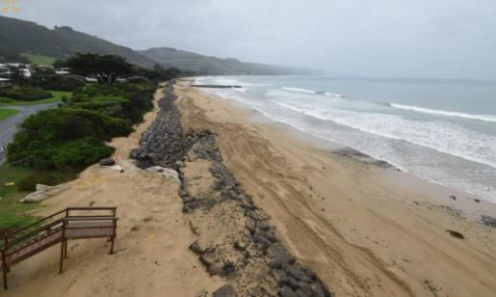

Progress on Stage 2 of the Apollo Bay Foreshore Bay Protection Project, 3 September 2021.

For more information about this project, visit [www.marineandcoasts.vic.gov.au/coastal-programs/apollo-bay-and-marengo](http://www.marineandcoasts.vic.gov.au/coastal-programs/apollo-bay-and-marengo).

## St Leonards beach renourishment

Stage 2 of the beach renourishment at St Leonards has commenced in front of Salt Lagoon along the Esplanade in St Leonards.

Approximately 35,000 cubic metres (m3) of sand will be pumped onshore and 25,000 m3 will be used to construct the beach profile while the remaining sand will be used to replenish beaches at Indented Head and St Leonards.

The sand harvesting will take place over several months. During the works a barge and sand sourcing equipment will be stationed approximately 800 metres offshore, in front of Salt Lagoon alongside the Esplanade.

The newly constructed beaches will provide an immediate buffer to storms and rising sea levels and safeguard key assets and coastal infrastructure.

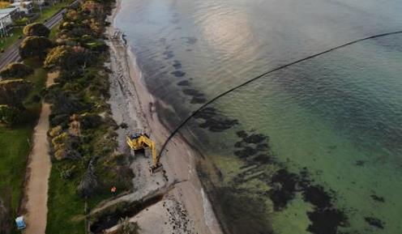

Sand being pumped onshore for the St Leonards beach renourishment.

Please visit [marineandcoasts.vic.gov.au/coastal-programs/bellarine-renourishments](https://www.marineandcoasts.vic.gov.au/coastal-programs/bellarine-renourishments) for more information about this project.

## Mallacoota Foreshore seawall replacement – Stage 1

Construction is progressing to replace a 200-metre long concrete panel seawall to protect the foreshore at the Mallacoota Foreshore Holiday Park, as part of the Victorian Government’s investment from the Building Works package.

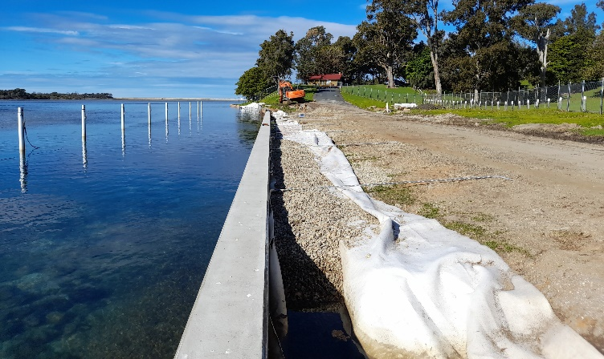

Construction of the Mallacoota Foreshore seawall replacement.

This first stage of the project will replace the northern section of the structure which has degraded and is a safety risk to the public.

The seawall and concrete capping has been constructed and installed. The next stage is to complete the earthworks behind the seawall, followed by the construction of the footpath and landscaping. The project will be completed by the end of 2021.

## Bullock Island North Arm seawall

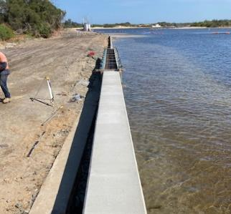

Construction of concrete capping for the Bullock Island North Arm seawall

Construction to replace the Bullock Island North Arm seawall is progressing well. The works extend from the breakwater at North Arm westward to the Bullock Island fuel jetty and will protect the Bullock Island North Arm foreshore and prevent further damage to the area.

The steel piles and concrete panels have all been installed and the pouring of concrete capping has begun. The project will be completed by the end of 2021.

This project is aligned with the Bullock Island Master Plan, managed by the East Gippsland Shire Council.

# Marine and coastal knowledge

## The Cape to Cape Resilience Project makes waves in Gippsland

The Cape to Cape Resilience Project is a long-term coastal hazard adaptation project, initiated to proactively plan for managing future changes to coastal area between Cape Paterson and Cape Liptrap on the Bass Coast.

Since our last update in this newsletter in March this year, the project team have been busy delivering this extensive body of work with the added complexities of coronavirus (COVID-19).

The technical work is well underway, with the Coastal Hazard Assessment team progressing through the gap analysis, data gathering and geomorphological assessment of the region. They have also started building the computer models of waves, wind, tides and sediment transport which will be used to develop adaptation options.

The Stakeholder Reference Group met in March and May 2021, and the first round of community engagement launched on Engage Victoria earlier this month. The response has been impressive, with over 300 contributions so far.

A group of people standing on a beach (Cape to Cape Resilience Project Stakeholder Reference Group workshop in May)



The Cape to Cape Resilience Project Stakeholder Reference Group workshop held in May (prior to current COVID-19 restrictions).

Complementary to the Engage Victoria activities, the team recently facilitated two virtual community workshops. Almost 50 people dialled in to listen, learn and discuss this important work, and share what they value about this significant coastal area.

Over the coming months, the team will be focused on gathering community perspectives to inform the Community Values Study, progressing the Coastal Hazard Assessment and identifying the values and assets vulnerable and at risk from coastal hazards. The team is working in close collaboration with DELWP’s Victoria’s Resilient Coast project.

For more information, please visit the [Cape to Cape Resilience Project webpage](https://www.marineandcoasts.vic.gov.au/coastal-programs/cape-to-cape-resilience-project).

## Coastal Infrastructure Project

Coastal recreation assets are important to the liveability and economic viability of communities they serve. However, many of these assets are vulnerable to climate change impacts including increased storm events, sea level rise, erosion, and population growth.

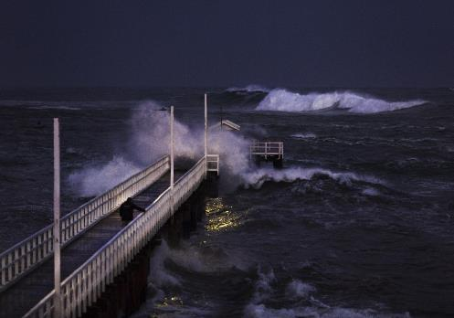

Funded by the Barwon Regional Partnership, the Coastal Infrastructure Project has increased coastal land managers’ capacity to improve asset management practices, better understand coastal hazard risk and develop science-based decision-making processes for future investment.

Through this project, the thousands of recreation assets located within 200 metres of marine and coastal Crown land in the Barwon South West partnership area (Avalon through to Marengo) have been GIS referenced and photographed to reflect the current condition of each asset, categorised into asset classes, and uploaded to a regional shared data platform.

Once overlayed with up-to-date hazard mapping, this data will be used to better understand risk, asset service levels, maintenance scheduling and thresholds to determine investment priorities. Coastal land managers have been provided with an asset management system and managed service for continued best practice.

The project includes the development of an investment framework to provide a science-based decision-making process that prioritises strategic future investment. The framework will be piloted within the Barwon South West region with a view to greater use along the Victorian coastline.

For more information about this project, please contact [marine.coasts@delwp.vic.gov.au](mailto:marine.coasts@delwp.vic.gov.au).

## Statewide Coastal Assets Management System (CAMS)

CAMS is DELWP’s statewide database of coastal protection assets, including seawalls, revetments, groynes and breakwaters. In this issue, we feature masonry seawalls.

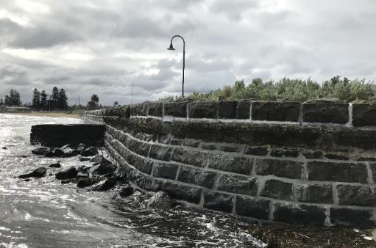

A bluestone masonry seawall.

The recently completed ‘Statewide Coastal Protection Structures Inspection Program’ inspected the overall condition and visually identified defects for most of the 416 masonry structures listed in CAMS.

In all, these structures provide coastal protection to 67 kilometres of the Victorian coastline.

Masonry coastal structures can be found in various forms, from groynes and breakwaters, to port facilities. However, over 90 per cent of these structures are seawalls!

Located widely around Port Phillip and the Bellarine Peninsula, bluestone masonry seawalls provide protection to communities, coastal promenades and infrastructure and can also be found providing erosion protection at the base of coastal headlands.

Bluestone is an iconic Victorian colonial building material. Heritage bluestone buildings, roads, and bridges adorn Melbourne and the Mt Alexander and Murray River railway, constructed in the 1860s, is a notable example of the resilience of this construction material. Victoria is blessed with ample sources of bluestone sourced from the volcanic plains west of Melbourne, so it is little wonder it became an early ‘material of choice’ for many of Port Phillip’s coastal structures.

With most masonry coastal structures now more than 100 years old, maintenance is a continual issue. Dislodgement of blockwork, regrouting, infiltration of seawater, exposure of footings and terminal end scour are the more common defects recorded in CAMS.

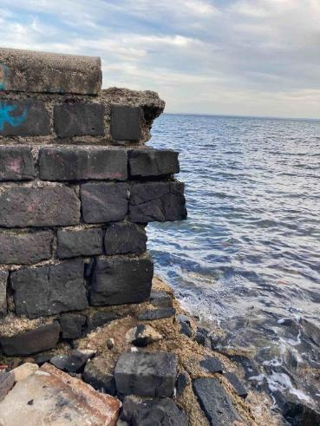

Maintenance is continual issue for masonry coastal structures.

Please email [marine.coasts@delwp.vic.gov.au](mailto:marine.coasts@delwp.vic.gov.au) if you would like more information.

Keep reading for Coastcare’s ‘Coastline’!



# In this issue of ‘Coastline’

Farewells and well wishes

Corner Inlet Citizen Science Water Quality Improvement project

Grants officer update and ‘Plants of the Great South West’

Great Victorian Fish Count report 2020 released

Return of the giant kelp at Port Campbell

Wilderness Coast Project: A unique cross-generational approach, looking after our precious coast!

# Farewells and well wishes

There has been some staff movement here at Coastcare Victoria.

Joiee Tachas, acting Coastcare Facilitator – Port Phillip and Westernport, is moving on to her next graduate rotation after finishing her secondment with us (Joiee filled in for Phillip Wierzbowski while he was on holidays). We thank her for her hard work and dedication and wish her all the best at her next posting.

This month also sees us farewell our Bellarine and Surf Coast Coastcare Facilitator, Ally Clark. Ally has been in this role while Elise Snell was on secondment. Ally has left a departing message for you all below:

‘Dear Coastcarers,

Thank you all for welcoming me as your Coastcare Facilitator over the last year. It has been an absolute pleasure to get to know you all and hear about the fantastic projects you are working on and inspiring ideas you have! Despite the impacts of COVID-19 and the associated lockdowns you have all continued to care for the environment and provide education where you can. I hope you are all as proud of your efforts as I am!

I am so grateful that I did get a chance to meet some of you in person. For those of you who I did not get the pleasure of meeting properly, I appreciate the phone calls and emails we have been able to share with each other. I wish you all the very best on your future projects and know that you will continue to do incredible and important work!

Thank you and good luck!

Ally Clark 😊’

Elise Snell, Coastcare Facilitator – Bellarine and Surf Coast, has moved on to pursue a career in Tasmania. Elise thanks all the amazing volunteers she had the privilege of meeting and working with during her time as a facilitator and passes on this message: ‘Thank you for all for the work you do, your passion for your area and for inspiring me’.

Left: Elise Snell, Volunteer Week 2020. Right: Ally Clark at a Clifton Springs beachcombing activity.

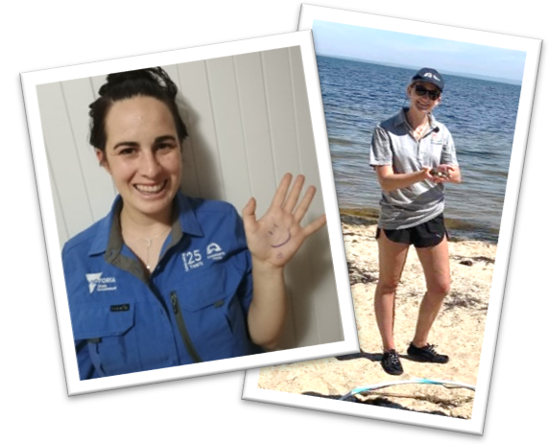We’re sure many of you will miss Joiee, Elise and Ally, as will we in the Coastcare Victoria team!

In our next newsletter, we hope to introduce you to the person who’ll be taking the reins for Bellarine and Surf Coast. Until then, please contact the team via [coastcare@delwp.vic.gov.au](mailto:coastcare@delwp.vic.gov.au) and we will be in touch to help.

# Corner Inlet Citizen Science Water Quality Improvement project

Coastcare Victoria acknowledges one of our groups who have been working hard in the area of citizen science!

[South Gippsland Landcare Network](https://www.facebook.com/southgippslandlandcarenetwork/?__cft__%5b0%5d=AZWJ9UkHya3SjsF2B9SY5kej5PTruI9Xd2ZYzEV9fWhLsVSk8JuBHdlpQeV-oBKv98VU1ykX-wMx3pYOyPfI4unVI-iDzjXhitPtWeERInm1uGfThSnt-u9vDW61yvyVg3fdxJdIiCe8zrjg0syvB9G4E4fksyXQaBdTnwvwRE2ajDkOfVLuQryMqahlf9z1YRYVfbpU0Wjxav8JED8Q8m5WhqZKt8KykndadPhCdJiCPA&__tn__=kK-R) (SGLN) have been adaptable and dedicated to completing their water testing project, even when faced with the challenges of COVID-19.

The 2018 Coastcare Victoria Community Grant recipients have collected twelve months’ worth of data on the quality of water flowing from four creeks near Foster into Corner Inlet. The data collected will enable a greater understanding of how land management practices influence the health of the Inlet and allow improvements to be made.

Community members learnt about the impact water quality in their local creeks has on the Ramsar listed Corner Inlet at a seminar in Foster in 2019. This was the start of SGLN’s Corner Inlet Citizen Science Water Quality Improvement Project. The project also involved monitoring water quality in four creeks near Foster that flow into Corner Inlet. Volunteers, including students from Foster Secondary College, collected samples from two sites on each waterway.

COVID-19 played havoc with the original timetable: 12 samples were collected over two years instead of over one year as originally planned. A final seminar was also held online – although well-attended, a face-to-face event would have offered more opportunities for engagement.

While final results from the project are still being processed, preliminary results suggest that the 75th percentile records for ammonia and turbidity in all four creeks, and nitrate levels in two of the creeks, exceeded the State Environmental Protection guidelines for total nitrogen.

While the results are only a snapshot and not based on long term data, this supports the need for further research and on-ground works to improve the health of local waterways.

Recently, the final seminar was attended by farmers, representatives from Agriculture Victoria, GippsDairy, the West Gippsland Catchment Management Authority (WGCMA) and members of the local community, providing opportunities for discussions about how landholders can help improve waterway health.

A Corner Inlet Landcare Group has recently been established and offers all members of the local community the opportunity to be involved in projects to improve the health of the Inlet.

For more information about this project, contact Cassie Wright, [cass@sgln.net.au](mailto:cass@sgln.net.au).

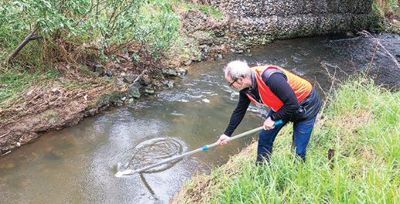

South Gippsland Landcare Network volunteer Paul Odgers, collecting a water sample.

# Grants officer update and ‘Plants of the Great South West’

The annual [Coastcare Victoria Community Grants program](https://www.marineandcoasts.vic.gov.au/coastal-programs/Coastcare-Victoria/coastcare-victoria-community-grants) supports community projects that conserve, restore and rehabilitate Victoria’s coastal and marine environments.

The assessment process for this year’s round is almost finished and successful applicants will be notified in due course (anticipated mid-September). In the meantime, some of our short projects have been finished from last year’s grant round.

One of these projects delivered a third version of the book ‘Plants of the Great South West’ by Kevin Sparrow. Thanks to Australian Plants Society - Warrnambool and District Group being awarded funding from Coastcare Victoria’s Community Grant program. Congratulations to Kevin and everyone who contributed to this project. We have limited copies available for volunteer groups that might find this a valuable resource.

Planning has already started for next year’s Coastcare Community Grants program. If your group has a project idea that will be ready to start in July 2022 and can be completed in less than 12 months, please get in touch with your [local Coastcare Facilitator](https://www.marineandcoasts.vic.gov.au/coastal-programs/Coastcare-Victoria/coastcare-victoria-community-grants) to discuss.

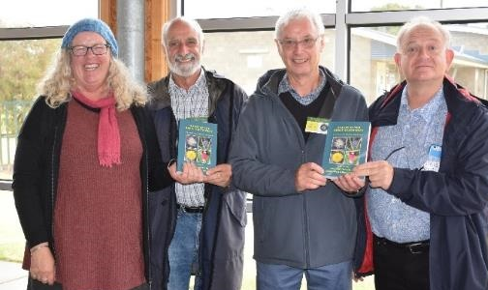

Left to right: Jodie Honan, John Sherwood, author Kevin Sparrow and Australian Plans Society President Chris Clarke at the launch of the book ‘Plants of the Great South West’ (March 2021).

# Great Victorian Fish Count report 2020 released

The results from the 2020 Great Victorian Fish Count (GVFC) have just been released in a detailed report full of facts, beautiful images and data on Victorian fish life.

The report, which showcases the charismatic Scaly Fin, can be found on the Victorian National Parks Association (VNPA) website:

<https://vnpa.org.au/programs/great-victorian-fish-count-3/>

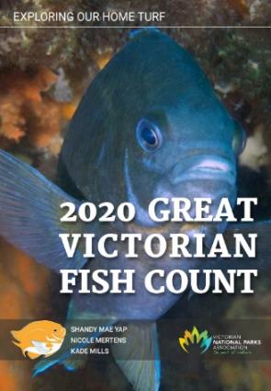

The 2020 Great Victorian Fish Count report (Victorian National Parks Association).

Held every year since 2002 between mid-November to mid-December (incorporating Coastcare Week!) the GVFC is a citizen science project which focuses on diving or snorkelling while recording the relative abundance of a set of 35 target fish species.

In 2020 the first COVID-19 safe fish counts happened, with groups picking their sites and focusing on ‘exploring our home turf’ (a fishy pun which you can read more in the report).

The team at [ReefWatch Victoria](https://vnpa.org.au/programs/reefwatch/) (VNPA) also came up with the ‘Virtual Fish Count’ lunchtime sessions, which utilised the livestream from the Nature Conservancy’s Reef Cam at Pope’s Eye (Port Phillip Heads Marine National Park). This enabled some data collection in a new way and introduced a new audience to the beautiful marine life we have in Victoria.

We know many of our Coastcarers get involved in this event every year and that it’s a highlight of the volunteering calendar. We’re very proud to have supported this project across the years – the 2020 Fish Count was a recipient of a 2019 Coastcare Victoria Community Grant – and look forward to Fish Count 2021.

# Return of the giant kelp at Port Campbell

**Giant** **kelp** is one of the fastest-growing plants on the planet; it can capture carbon more quickly than a rainforest. Growing up to 50 cm per day and up to 45 metres long, it is extremely important to the marine ecosystems where it grows, providing food and shelter for hundreds of species.

Unfortunately, over the past few decades this species of kelp has been disappearing along the east coast of Australia, and, as locals have noticed, around the Port Campbell area.

However, there have been some recent signs of regeneration. Port Campbell’s Marg O’Toole shares her story:

‘A lot of us who frequent the waters of Port Campbell Bay – fishers, surfers, swimmers, beach walkers – have noticed in recent weeks, a resurgence of giant kelp growing. When I first moved to Port Campbell in the early 1980s and according to ‘forever’ locals, these algae were once prolific.’

‘It has been a great concern and a puzzle as to why the kelp was disappearing. A strong theory is that it is due to climate change and ocean warming. It has also been found that there has been a declining level of dissolved nutrients in waters where it grows off Tasmania’s east coast. An increase of sea urchin populations has also decimated the kelp beds. You may have read in the media about the disappearance of kelp forests in Tasmania and about the urchin ‘barrens’ along southern NSW. But, for some unknown reason the kelp is growing back in Port Campbell Bay!’

‘The species of kelp which form our giant kelp forests are *Macrocystis pyrifera* and *Macrocystis augustifolia.* It usually grows in or on rocky reef areas and it’s long ‘fronds’ can be seen floating on the surface – which we can see in the bay. If diving or snorkelling, it is absolutely beautiful to swim amongst, especially if the sun is shining down through the blades. Fish love this environment and it’s interesting to note that some locals have mentioned they are catching some species off the jetty for the first time in years, for example, Trevally.’

‘I have no idea why it is growing back here, but it is wonderful and exciting. Apparently, it is the first report of this happening, that’s not to say it’s not happening elsewhere but perhaps just hasn’t been reported yet.’

‘Deakin University are interested to understand more about this and would appreciate reports (GPS data) of any sightings of kelp growing further out from the Bay.’

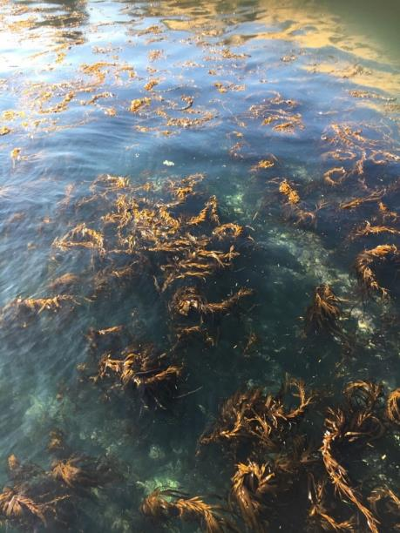

Giant kelp at Port Campbell (photo by Marg O’Toole).

# Wilderness Coast Project: A unique cross-generational approach, looking after our precious coast!

*Written by Paris Brooke, The Sanctuary Mallacoota Youth Group*

In 2020, the Sanctuary Mallacoota Youth Group was awarded a Coastcare Victoria Community Grant under Stream 2 ‘Strengthening Our Volunteer Groups’.

The grant project sought to foster the development, understanding, interest and connection that the youth of Mallacoota have to their unique patch of coastline.

The focus is on tangible on-ground land management activities and mentorships, by working with the long-standing Friends of Mallacoota volunteer group.

The project takes a unique approach by combining a cross-generational program with on-ground activities including bushfire recovery, seed propagation, weed mapping and control, and marine litter audit and removal, alongside fun recreational activities like surfing, art, music and film.

The delivery of this project has highlighted the resilience of the group in our ability to adapt, re-plan, rearrange and work with the challenges that the last 18 months have brought and is a true testament to the passion for this project!

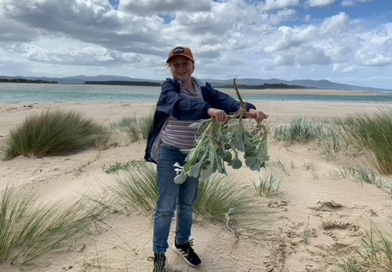

Matisse Turner, aged 10, busily pulling weeds at Bastion Beach.

To date, six working bee days have been held at Bastion Beach, removing beach daisy and gladioli species. The sessions have successfully brought together strong numbers of keen volunteers between the ages of 10 and 80 years old. They’ve dug, pulled, chatted and learnt about the coastal environment and plant species, while getting to know new members of the community and sharing in a meal afterwards (when COVID-19 restrictions have allowed).

The sessions have given a great sense of purpose to do something positive as a community post bushfires and we have successfully managed to remove the beach daisy from Bastion beach, so we can now focus on a different coastal area!

This project is allowing new young volunteers to learn under the knowledge and guidance of members from the hugely successful Friends of Mallacoota group, who have been stewards for the South-East coast for more than 25 years.

The Sanctuary group is looking forward to restrictions easing to start plant propagation activities under the project, where volunteers will be working on propagating seeds collected form bushfire affected areas and replanting in areas requiring revegetation support in Mallacoota.

The project has strengthened existing partnerships with local community groups and forged new opportunities with additional partners, which will be included in future events. As a sign of the program’s success, some of our initial youth volunteers have now taken up traineeships under Envite, which has been a wonderful outcome.

The cross-generational and combined community association model is working very successfully under the Wilderness Coast project. While this project is only part way through, we are already planning our second Wilderness Coast focus. This will include greater opportunities for our youth to learn propagation and permaculture techniques, as well as the potential for bushfire coastal regeneration and small-scale research trials with several partners.

In addition, we have been approached by several school groups about the possibility of hosting them to experience our Wilderness Coast project.

We are keen to explore potential opportunities that could even expand into nature-led tourism and employment options for our young people – to enable them to continue to live, work and enjoy this amazing piece of coastline.

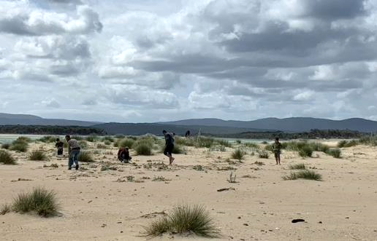

Members of the Sanctuary Mallacoota Youth Group and Friends of Mallacoota at a working bee at Bastion Beach.

|  |  |
| --- | --- |
| © The State of Victoria Department of Environment, Land, Water and Planning 2021  LogoThis work is licensed under a Creative Commons Attribution 4.0 International licence. You are free to re-use the work under that licence, on the condition that you credit the State of Victoria as author. The licence does not apply to any images, photographs or branding, including the Victorian Coat of Arms, the Victorian Government logo and the Department of Environment, Land, Water and Planning (DELWP) logo. To view a copy of this licence, visit http://creativecommons.org/licenses/by/4.0/  Disclaimer  This publication may be of assistance to you but the State of Victoria and its employees do not guarantee that the publication is without flaw of any kind or is wholly appropriate for your particular purposes and therefore disclaims all liability for any error, loss or other consequence which may arise from you relying on any information in this publication. | Accessibility  If you would like to receive this publication in an alternative format, please telephone the DELWP Customer Service Centre on 136186, email [customer.service@delwp.vic.gov.au](mailto:customer.service@delwp.vic.gov.au), or via the National Relay Service on 133 677 [www.relayservice.com.au](http://www.relayservice.com.au). This document is also available on the internet at [www.delwp.vic.gov.au](http://www.delwp.vic.gov.au). |