|  |
| --- |
| DEECA Biodiversity Environment and Community Grants |
| Fact Sheet 3 of 10  How to apply for funding |

This Fact Sheet will guide you through how to fill out the Biodiversity Environment and Community Grants application form.

## Before applying

* Make sure you have checked if you are an eligible applicant. Refer to Fact Sheet 2: Eligibility and required supporting documentation for further information.
* Make sure you have the relevant supporting documentation for the project before submitting. Keep copies of your application including supporting documentation. This information will be useful should your application be successful. Refer to Fact Sheet 2: Eligibility and required supporting documentation for further information.

## 1. Registering with Grants Online

To apply, you will need to register with Grants Online. Go to: <https://delwp1.force.com/GrantsPortallogin>

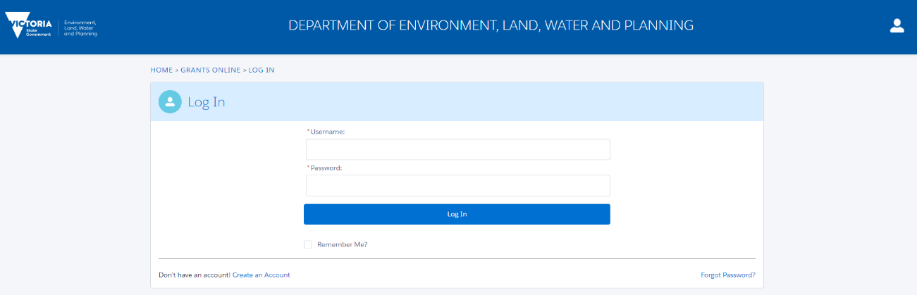

Reset your password

Create a new account

If you have previously registered, you will be able to access your Grants Online home page.

If you don’t have one, click the **Create an Account** button.

**Note –** ensure that you remember your username (email) and password for future reference. Try to choose an email that will not change in the future – because over time your account will record your grant history.

## 2. Completing the application

You can preview the application prior to starting an application by clicking the **View as PDF** button, which appears at the bottom of each page of the application (see screenshot below). This allows you to see what is required before beginning an application.

**Suggestion:** Save the PDF on your desktop and copy the questions to a word document. You can draft your responses in a word document before copying and pasting them to the application portal. Keep in mind the word limit for each question and the application closing date. The application form can be saved as you go. You can click through the sections and submit or save a draft. You can access your draft application by click on the ‘Access Saved Application’ button.

You must answer all fields before submitting your application. If fields are left blank, your application may be ineligible, scored lower as it does not meet the assessment criteria or may not be submitted for consideration.

**Note** – the symbol * denotes mandatory fields. If these fields are left blank, the application form will not save or allow you to move to the next or previous page.

Below is an example of what the front grants home page will look like when you click on the application link.

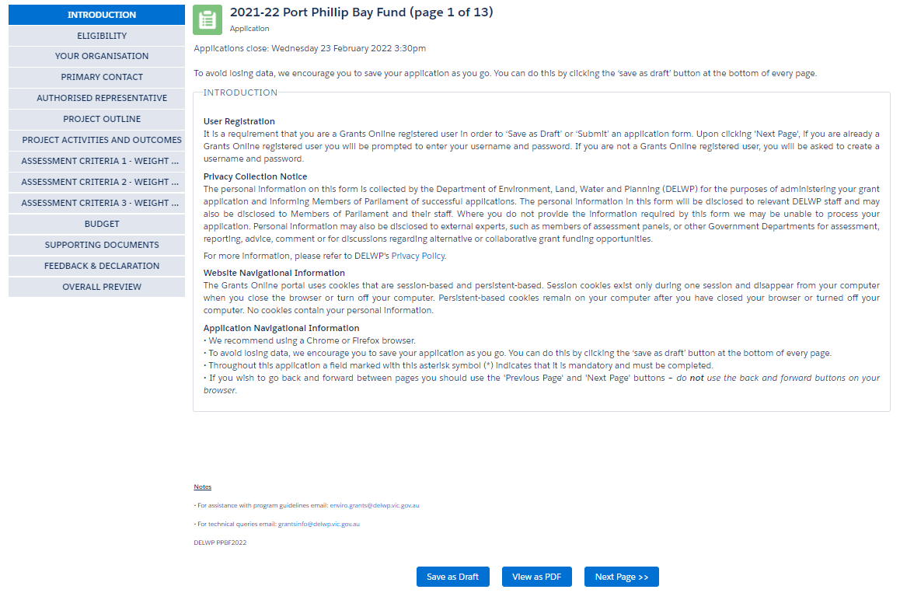

The different sections of the grant application will appear on the left-hand side

This allows you to preview the whole application in a PDF document, you can do this before you commence an application

Save your application as a draft and return to it later

To access a saved application, return to <https://delwp1.force.com/GrantsPortallogin>, all your commenced applications will be listed here, including your previously submitted applications.

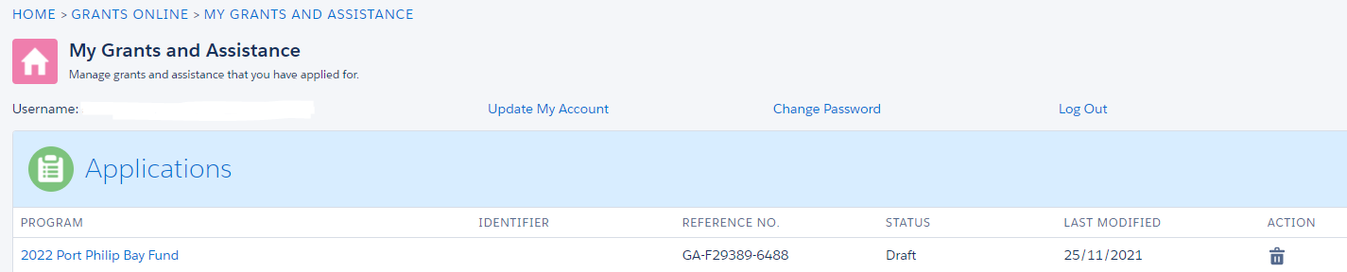

Click this link to access your draft application

This will delete your draft application

This is your grant application number

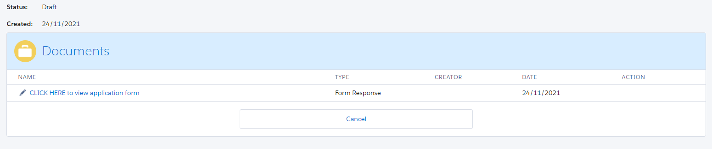

After clicking the program link on the previous page, you will be directed to this page where you can then access your application and continue editing it

## 3. Submitting your application

Once you have completed all fields and uploaded all attachments and supporting documentation, review your application in its entirety before you press **submit**. You will be prompted to do this on the **Feedback & Declaration** page of the application.

Once submitted, you will only be able to view your application form the Grants Online portal: <https://delwp1.force.com/GrantsPortallogin>. You **cannot edit** your application once submitted.

**Note -** supporting documents that are emailed after the grant closing time may not be considered as part of your application, so don’t leave your application to the last minute to submit.



You must preview your application in its entirety before the submit button will appear.



After reviewing your application, you will be able to click submit.

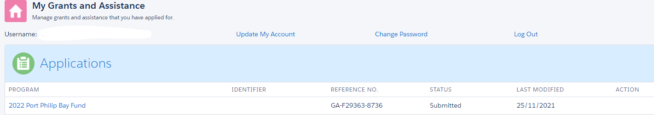

## 4. What happens next?

Once submitted, your application will be collated with all other applications and undergo a completeness and eligibility check. Then Independent Assessors will evaluate all the applications against selection criteria which involves scoring and ranking.

It may take several months for the grants team to undertake the assessment process, so please be patient. All applicants will be notified once grants have been approved.

# Contact us

## Program enquiries

|  |  |
| --- | --- |
| © The State of Victoria Department of Energy, Environment and Climate Change 2023  Creative Commons BYThis work is licensed under a Creative Commons Attribution 4.0 International licence. You are free to re-use the work under that licence, on the condition that you credit the State of Victoria as author. The licence does not apply to any images, photographs or branding, including the Victorian Coat of Arms, the Victorian Government logo and the Department of Energy, Environment and Climate Change (DEECA) logo. To view a copy of this licence, visit http://creativecommons.org/licenses/by/4.0/  ISBN 978-1-76105-853-0 (**pdf/online/MS word**)  **Disclaimer**  This publication may be of assistance to you, but the State of Victoria and its employees do not guarantee that the publication is without flaw of any kind or is wholly appropriate for your particular purposes and therefore disclaims all liability for any error, loss or other consequence which may arise from you relying on any information in this publication | Accessibility  If you would like to receive this publication in an alternative format, please telephone the DEECA Customer Service Centre on 136186, email customer.service@delwp.vic.gov.au or via the National Relay Service on 133 677 www.relayservice.com.au. This document is also available on the internet at www.deeca.vic.gov.au |

If you have any queries, or require more information, please contact the Community Programs team via email at [enviro.grants@delwp.vic.gov.au](mailto:enviro.grants@delwp.vic.gov.au) or contact the DEECA Customer Contact Centre on 136 186 during normal business hours. Please quote your application number and the grant program in your communications with DEECA.

## Technical difficulties

If you require technical assistance submitting your application online email [grantsinfo@delwp.vic.gov.au](mailto:grantsinfo@delwp.vic.gov.au) or call the DEECA Customer Contact Centre on 136 186 during normal business hours. Please quote your application number and the grant program in your communications with DEECA.