delwp.vic.gov.au

Unpublished Client Report for

|  |
| --- |
| 2023 PORT PHILLIP BAY FUND  GUIDELINES |
| A seadragon floating on the vegetated sea bed of Port Phillip Bay. |
| January 2023 |

|  |  |
| --- | --- |
|  |  |

|  |  |  |  |
| --- | --- | --- | --- |
|  |  |  |  |
|  |  |  |  |

**Warning: Health and safety is paramount**

You must put in place relevant Work Health Safety policies and procedures to ensure the safety of those undertaking grant activities. You must comply with any government measures and requirements in relation to COVID-19. Stay up to date at [coronavirus.vic.gov.au](https://www.coronavirus.vic.gov.au/)

Photo credit

Marcia Riederer

|  |
| --- |
| Acknowledgments  We acknowledge and respect Victorian Traditional Owners as the original custodians of Victoria's land and waters, their unique ability to care for Country and deep spiritual connection to it. We honour Elders past and present whose knowledge and wisdom has ensured the continuation of culture and traditional practices.  We are committed to genuinely partner, and meaningfully engage, with Victoria's Traditional Owners and Aboriginal communities to support the protection of Country, the maintenance of spiritual and cultural practices and their broader aspirations in the 21st century and beyond. |
| © The State of Victoria Department of Energy, Environment and Climate Action, 2023  LogoThis work is licensed under a Creative Commons Attribution 4.0 International licence. You are free to re-use the work under that licence, on the condition that you credit the State of Victoria as author. The licence does not apply to any images, photographs or branding, including the Victorian Coat of Arms, the Victorian Government logo and the Department of Energy, Environment and Climate Action (DEECA) logo. To view a copy of this licence, visit <http://creativecommons.org/licenses/by/4.0/>  Disclaimer  This publication may be of assistance to you but the State of Victoria and its employees do not guarantee that the publication is without flaw of any kind or is wholly appropriate for your particular purposes and therefore disclaims all liability for any error, loss or other consequence which may arise from you relying on any information in this publication.  Accessibility  If you would like to receive this publication in an alternative format, please telephone the DEECA Customer Centre on 136 186, email [customer.service@delwp.vic.gov.au](mailto:customer.service@delwp.vic.gov.au) or via the National Relay Service on 133 677 [www.relayservice.com.au](http://www.relayservice.com.au). This document is also available on the internet at [www.delwp.vic.gov.au](http://www.delwp.vic.gov.au). |

Contents

1. What is Port Phillip Bay Fund? 3

1.1 Introduction 3

1.2 Objectives 3

2. Program Priority for 2023 3

2.1 Priority Activities 3

3. What are the Funding details? 5

3.1 Available Funding and Streams 5

3.2 Co-contribution 5

4. What are the eligibility criteria for PPBF? 6

4.1 Where can projects be located? 6

4.2 Who can apply? 6

4.3 Do we need an auspice? 6

4.4 Who can act as an auspice if we need one? 6

4.5 Who aren’t eligible to apply? 7

4.6 What are the eligible expenditure? 7

4.7 What are the Ineligible Expenditure? 7

5. What are the Assessment Criteria? 8

5.1 Assessment Criteria 8

5.2 Supporting Evidence 9

6. Funding conditions 10

6.1 Funding agreements 10

6.2 Legislative and regulatory requirements 10

6.3 Tax implications 10

6.4 Acknowledging the Victorian Government’s support 10

6.5 Payments 10

6.6 Monitoring 11

6.7 Privacy 11

7. What is the application process? 11

7.1 How to apply? 11

7.2 Attaching required documents: 11

7.3 Where to find help? 11

8. What is the notification process? 12

9. Key Dates 12

10. Factsheets 12

11. Checklist 12

Appendix 1 - Extent of the Port Phillip Bay Fund Project (inland to 5 km) 13

Appendix 2 – Coastal Habitat Priorities within 5 Km Extent 14

# What is Port Phillip Bay Fund?

## Introduction

The Port Phillip Bay Fund (PPBF) is a grant program supporting Traditional Owners, community groups, schools, local councils and organisations working to protect and conserve Victoria’s iconic bay.

Port Phillip Bay (the Bay) is one of the most unique and precious natural ecosystems that supports rich and diverse marine life, provides a wide range of community uses and brings significant benefits to local businesses and the state economy.

Maintaining the health of the Bay’s marine life, habitats and water quality is critical and requires a coordinated effort from the government, community and organisations.

In 2023, the Victorian Government will invest $1.4 million to support community driven projects in protecting and improving coastal habitats and marine ecosystem for their biodiversity values through partnership and engagement with on-ground activities.

The Program is designed to align with the [*Marine and Coastal Act 2018*](https://www.marineandcoasts.vic.gov.au/marine-and-coastal-act), delivering priority actions in the [Port Phillip Bay Environmental Management Plan 2017-2027](https://www.marineandcoasts.vic.gov.au/coastal-programs/port-phillip-bay) (PPB EMP) as well as meeting the goals of [*Protecting Victoria’s Environment -* *Biodiversity 2037*](https://www.environment.vic.gov.au/biodiversity/biodiversity-plan?_ga=2.59005029.955985607.1674423555-1493060692.1663225074) and [*Victorians* *Volunteering for Nature – Environmental Volunteering Plan*](https://www.environment.vic.gov.au/__data/assets/pdf_file/0035/394883/VVfN-Environmental-Volunteering-Plan_WEB.pdf?_ga=2.59005029.955985607.1674423555-1493060692.1663225074).

## Objectives

The objectives of the 2023 PPBF are shown below

|  |  |  |  |
| --- | --- | --- | --- |
| **2022-23 Port Phillip Bay Fund objectives** | | | |
| Open hand with plant outline**Value** | **Wave outline Conserve &**  **Restore** | Users with solid fill **Engage** | **Partnerships** |
| ***Improving the understanding of Victoria’s iconic Bay and ensuring it is healthy and actively cared for through on-ground actions*** | ***Conserving and restoring coastal habitat and marine life and enhancing the marine environment*** | ***Engaging and involving urban communities in on-ground actions that aim to protect and care for the health of the Bay*** | ***Improving collaboration and partnerships across a range of interested groups and organisations to protect and enhance the health of the Bay*** |

To be considered, projects must:

* meet one or more of the objectives of the 2023 PPBF
* be located within the Port Phillip Bay itself or within 5km of the Bay’s high-tide mark (see Appendix 1)
* demonstrate a clear link and direct benefit to the Bay and Program Priority (see Appendix 2)
* meet the eligibility requirements
* have on-ground activities with community involvement.

# Program Priority for 2023

## Priority Activities

|  |  |  |  |
| --- | --- | --- | --- |
| **Priority Actions** | | **Stream 1 Project** | **Stream 2 Project** |
|  | **Improve understanding of the Bay’s values by:**   * Providing opportunities to connect the community with nature through on-ground biodiversity management activities that will protect and increase the community’s knowledge of the Bay. * Delivering education, monitoring, and citizen science activities (Note - education activities will only be considered as part of a broader project with direct on-ground outcomes). * Working with Aboriginal groups to improve understanding of Aboriginal cultural values and interests in the Bay and support connections to Country. | Strongly recommend proposed project includes this priority as a core project or as one of the project deliverables | Strongly recommend proposed project includes this priority as one of the project deliverables |
|  | **Improve collaboration and partnerships across community, industry, and government by:**   * Empowering the broader community to get actively involved in caring for Victoria’s iconic Bay, developing innovative tools to support citizen science and on-ground community action. * Leveraging new and existing partnerships to develop and deliver innovative solutions. | Strongly recommend proposed project includes this priority as one of the project deliverables | Strongly recommend proposed project includes this priority as one of the project deliverables |
|  | **Conserve and restore coastal habitat, for example by:**   * Restoring coastal habitats such as saltmarshes, mangroves, coastal links and biodiversity assets. * Conserving and protecting coastal habitat (e.g., revegetation, weed control, erosion control and fencing).   Refer to priority locations in **Appendix 2**. | Strongly recommend proposed project includes this priority as a core project or as one of the project deliverables | Strongly recommend proposed project includes this priority as a core project or as one of the project deliverables |
|  | **Conserve and restore marine habitats and marine life, for example by:**   * Restoring marine ecosystems such as seagrasses, and removal of marine weed or pest control. | Recommend collaboration with the expert | Strongly recommend proposed project includes this priority as a core project or as one of the project deliverables |
|  | **Ensure nutrient and sediment loads do not exceed current levels and pollutant loads are reduced where practicable, for example with:**   * Actions that directly reduce the amount of sediment and nutrients that enter the Bay (e.g., riparian revegetation, restore coastal wetland systems to slow/treat storm water and reduce sediment load). | Recommend proposed project includes this priority as a core project or as one of the project deliverables | Strongly recommend proposed project includes this priority as a core project or as one of the project deliverables |
|  | **Reduce litter loads to the Bay, for example by:**   * Identifying and prioritising litter sources and pathways. * Taking action to prevent litter entering the Bay. * Encouraging stewardship and leadership in litter reduction.   Note - All litter data collected must be uploaded to [LitterWatch](https://www.litterwatchvictoria.org.au/). | Strongly recommend proposed project includes this priority as a core project or as one of the project deliverables | Recommend propose project includes this priority as a one of the project deliverables |

# What are the Funding details?

## Available Funding and Streams

A total of $1.4 million is allocated in 2023 in the form of competitive grants. There are two types of grants available:

|  |  |  |
| --- | --- | --- |
| **Funding** | **Stream 1** | **Stream 2** |
| **Amount** | Up to $25,000 per annum | Up to $100,000 per annum |
| **Project Duration** | Up to 13 months | Multi-year: up to 24 months |
| **Requirement** | Standard | Innovative |
| **Project Budget & Risk** | Use the appropriate Budget and Risk template provided. Any modifications to the template will be deemed ineligible.  You must address the risk in the template.  For more information about how to complete the budget and activities spreadsheet please refer to [Factsheet 6 - Budget and Risk template instructions](https://www.marineandcoasts.vic.gov.au/__data/assets/pdf_file/0028/554608/Fact-sheet-6-Budget-and-Risk-template-instructions.pdf). | |

## Co-contribution

Applicants are required to match their requested funding in a 1:1 funding ratio. For example, if you request $10,000, you need to demonstrate that you have at least $10,000 in matching funding from other sources.

The matched funding can include a combination of:

* volunteer time dedicated to the project (including planning, designing and organising)
* in-kind support (e.g., access to a photocopier, free loan of equipment, donation of materials, venue)
* staff time allocated to manage the project, where the salary comes from another source
* funding from other sources (e.g., donations, philanthropic grant programs, other grant programs).

**Example of matched funding**

|  |  |  |  |
| --- | --- | --- | --- |
| **Grant requested from the Fund excluding GST** | **$** | **Matched funding from other sources** | **$** |
| 500 Indigenous tubestock and tree guards | 4,000 | Staff time on project management | 3,000 |
| Site Preparation including weed control and equipment hire | 3,800 | Printing donated by AX Office Supplies | 250 |
| Safety equipment | 200 | Volunteer time (150 volunteer hours x $40 per hour) | 6,000 |
| Consultant (cultural heritage) | 2,000 | Local government (Venue hire donated by local council) | 750 |
|  | **10,000** |  | **10,000** |

**Calculating the value of your volunteer contribution**

All volunteer contributions must be calculated using the rate of $40 per hour and the number of hours per day should be reasonable.

**EXAMPLE:**

12 volunteers x 5 hours per day x 5 days (project duration) x $40 = $12,000 in volunteer time contribution

# What are the eligibility criteria for PPBF?

## Where can projects be located?

Projects must be located within the Bay itself or within 5km of the Bay’s high-tide mark. See Appendix 1 for a map of the boundary, which shows 5km from the high-tide mark of the Bay.

## Who can apply?

The 2023 PPBF grants are open to:

* Environmental groups and networks, such as Coastcare, Friends groups and Landcare that is incorporated through Consumer Affairs Victoria
* Volunteer-based recreational and community groups with an interest in the Bay, such as diving and naturalist groups, Scouts, Rotary, Lions, senior citizens and youth clubs and have an ABN with Australian Charities and Not-for-profit Commission registration
* Public Land Committees of Management
* Traditional Owners/Custodians (RAP and non-RAP)
* Kindergartens, Primary and Secondary Schools
* Research institutes, Local Government and other non-profit organisations

In addition, to be eligible for funding applicants must:

* be an incorporated body, cooperative or association (including business associations)
* have $10 million public liability insurance, with enough construction allowance to cover the project
* be financially solvent.

## Do we need an auspice?

Applicants who don’t meet the eligibility criteria set out in 4.2 can partner with another organisation who does meet the criteria, known as an auspice.

The auspicing group or organisation will enter a contract with the Department of Energy, Environment and Climate Actions (DEECA) and will be legally responsible for the project. They will receive the money from us and be responsible for reporting and acquittal (they will likely expect you to help or do this, but the legal requirement is theirs).

You will need to include an email or letter from your auspice in your application, showing that they agree to take on this responsibility for you.

## Who can act as an auspice if we need one?

Potential auspicing organisations include:

* Catchment Management Authorities (CMA) – Corangamite CMA for Geelong and the western edge, and Melbourne Water for the rest of the catchment
* Water corporations and other state government authorities, such as Melbourne Water, Greater Western Water and Parks Victoria
* Umbrella not-for-profit associations, such as Landcare Victoria Inc
* Local councils
* Other volunteer-based environmental community groups and networks

Please note that the auspicing group or organisation must meet the eligibility requirements listed in Section 4.2, 4.4 above and [Fact sheet 2](https://www.marineandcoasts.vic.gov.au/__data/assets/pdf_file/0020/554600/Fact-sheet-2-Eligibility-and-required-supporting-documentation.pdf).

## Who aren’t eligible to apply?

The following organisations and individuals cannot apply for funding:

* Commonwealth and State government departments
* Commercial organisations
* Bodies established for profit-making purposes
* Sole traders
* Individuals

## What are the eligible expenditure?

The Fund will support the following categories of expenditure:

* Materials (e.g. Plants, tree guards, exclusion fencing, seating, and access steps)
* Site preparation (e.g. Equipment hire, security fencing, and for revegetation)
* Personal protective equipment (e.g. Gloves, goggles, and masks)
* Engaging and partnering with your local community, schools, Traditional Owners/Custodians of the project area
* Contractors (e.g. Presenters, surveyors, installers, weed controllers for particularly difficult weeds or sites)
* Communication (e.g. seminars, webinars)
* Citizen science monitoring activities
* Promotional costs directly related to funded activities (e.g. Website update, video and interpretive signage)
* Advertising (costs to advertise in newspapers, posters etc.)
* Training and education that supports the project’s activities (e.g. First aid)
* Project management and coordination (e.g. Staff time to manage the project, budget, coordinate volunteers, and secure approvals), and
* Technical specialist and advisers (e.g. Cultural heritage, cultural practices)

Other types of expenditure may be considered if they are well justified and deemed suitable. You will need to demonstrate that all activities and budget items are essential to the success of the project and that the amounts requested are reasonable. There are no caps or limits for eligible items. **Value for money** will be considered as part of the assessment process.

When developing budgets, you should ensure that activity items (such as equipment, materials and contractor charges) are fully costed. Refer to the Terms and Conditions of the Victorian Common Funding Agreement <https://www.vic.gov.au/victorian-common-funding-agreement-forms-and-templates> for more information.

## What are the Ineligible Expenditure?

The Program will not fund:

* Routine operation or running costs. These are the costs of resources used by an organization just to maintain its existence (e.g. rent)
* Costs and activities that are already funded through another organisation, program or fund source. Your project can build on the success of past or existing projects but must essentially be new work. The grant must fund additional activities that wouldn’t occur without this funding
* Activities that were intended to be your in-kind contribution to another funded project
* Actions or costs associated with native vegetation offset sites or activities. For example, meeting a condition of a planning permit, contract or investment program, Section 173 agreement or offset covenant
* Any activity involving clearing of native vegetation, unless it is a declared environmental weed in your area. In this instance, a permit for removal of vegetation may still be required
* Any activity involving the use of firearms, tranquilisers, traps or explosives. Confinement traps are allowed under permit and expert supervision
* Any illegal activity
* Purchase of goods for competitions, prizes, giveaways, vouchers or alcohol. (e.g. plastic promotional/educational items, pens, sample packs, keep cups, stickers, bags)
* Barbed wire fencing
* Computers, laptops, tablets and smartphones
* Insurance
* Any action that are part of a land manager’s legal duty of care
* Activities that are not focused on the environmental health of the Bay
* Any other item, action or activity determined by the Panel through the assessment process to be an inappropriate or unsuitable use of the funds

# What are the Assessment Criteria?

First, applications will be checked for eligibility to make sure that the applicant and their activity are eligible for funding. After that, eligible applications will be assessed using the criteria listed below. Each criterion is given a percentage weighting to indicate its relative importance in the assessment process. Applications should address all relevant criteria.

## Assessment Criteria

|  |  |  |  |
| --- | --- | --- | --- |
| **Assessment Criteria** | **Weight** | **Outcomes** | **Measures of success** |
| **Project alignment with program objectives and strategic documents** | 20% | The extent to which your project:   * Increases awareness of the Bay’s values * Improves coastal habitat and marine life/ environment * Increases in engaging urban community to undertake on-ground environmental activities * Encourages partnerships across a range of stakeholders, including Traditional Owners/Custodians * Supports and addresses strategic documents | How would you describe the success of your project meeting the program objective, and strategic documents? |
| **Project priority activities** | 50% | The project delivers priority activities through   * Explains the environmental issue the project will address * Details the methodology to address the issue and explains why this methodology is suitable * If you are applying under Stream 2, you should describe how your approach is innovative | How would you describe the success of your project delivering positive outcomes for the Bay? |
| **Capability and capacity to successfully deliver the project** | 20% | Applicant has the capability and capacity including:   * Suitable skills and resources available to deliver the project * Clear, detailed, and reasonable timeframe to deliver the activities * The financial viability of the project, including letters of support for proposed funding contributions * Risk management (e.g., COVID-19, OH&S, Cultural and environmental) * Provision of permits or approvals, if required * Maintenance plan for project deliverables beyond the life of the project | Are you able to successfully deliver your project? |
| **Value for money** | 10% | Value for money include   * The scale of the project and activities versus the funding sought * The contribution of additional cash or in-kind support * Whether the funding sought, and the individual line items identified in the budget are necessary to the successful completion of the project * Whether quotes have been attached for large expenditure items | Describe the contribution of your project to the PPBF? |

## Supporting Evidence

To assist the grant team and assessment panel, the following documentation is required in your application:

* Budget and Risk Template
* insurances - a copy of your public liability insurance certificate of currency
* letters or emails of commitment from each partner
* letters or emails of support from land owner/manager (including Traditional Owners)
* polygon (shapefile) zip folder of your proposed project area generated using [Mapshare](https://mapshare.vic.gov.au/MapShareVic/index.html?viewer=MapShareVic.PublicSite&locale=en-AU)
* pdf map of proposed work area generated using [Mapshare](https://mapshare.vic.gov.au/MapShareVic/index.html?viewer=MapShareVic.PublicSite&locale=en-AU)
* Supporting plans, evidence for project activities

You may also provide any additional documents that would support your application.

# Funding conditions

## Funding agreements

Successful applicants must enter into a funding agreement with DEECA. The Victorian Common Funding Agreement is used for funding agreements with not-for-profit organisations and Local Government Authorities. It is recommended that applicants review the terms and conditions before applying. Information about the Victorian Common Funding Agreement is available on https://www.vic.gov.au/victorian-common-funding-agreement

The activity does not include using the funding for political campaigning or advocacy activities for political parties.

## Legislative and regulatory requirements

In delivering the activity grant recipients are required to comply with all relevant Commonwealth and state/territory legislations and regulations, including but not limited to:

* *The Privacy Act 1988 (Commonwealth)*
* *The Freedom of Information Act 1982 (Vic)*
* *Occupational Health and Safety Act 2004.*

## Tax implications

Applicants should consult the Australian Taxation Office or seek professional advice on any taxation implications that may arise from this grant funding.

Successful applicants without an ABN will need to provide a completed Australian Taxation Office form ‘Statement by a Supplier” so that no withholding tax is required from the grant payment.

## Acknowledging the Victorian Government’s support

Successful applicants are expected to acknowledge the Victorian Government’s support and promotional guidelines ([www.delwp.vic.gov.au/grants](https://www.delwp.vic.gov.au/grants)) will form part of the funding agreement. Successful applicants must liaise with the departmental program area to coordinate any public events or announcements related to the project.

## Payments

Payments will be made as long as:

* the funding agreement has been signed by both parties
* grant recipients provide reports as required, or otherwise demonstrate that the activity is progressing as expected
* other terms and conditions of funding continue to be met.

## Monitoring

Grant recipients are required to comply with project monitoring and reporting requirements as outlined in the funding agreement. This may include progress reports, site inspections, completion reports and acquittal documentation.

## Privacy

Any personal information about you or a third party in your application will be collected by the department for the purposes of administering your grant application and informing Members of Parliament of successful applications. Personal information may also be disclosed to external experts, such as members of assessment panels, or other Government Departments for assessment, reporting, advice, comment or for discussions regarding alternative or collaborative grant funding opportunities. If you intend to include personal information about third parties in your application, please ensure that they are aware of the contents of this privacy statement.

Any personal information about you or a third party in your correspondence will be collected, held, managed, used, disclosed or transferred in accordance with the provisions of the *Privacy and Data Protection Act 2014* and other applicable laws.

DEECA is committed to protecting the privacy of personal information. You can find the DEECA Privacy Policy online at www.delwp.vic.gov.au/privacy.

Requests for access to information about you held by DEECA should be sent to the Manager Privacy, P.O. Box 500 East Melbourne 8002 or by emailing [Foi.unit@delwp.vic.gov.au](mailto:Foi.unit@delwp.vic.gov.au).

# What is the application process?

## How to apply?

Applications are submitted online using the Grants Online portal.

To apply, go to the grant program web page

<https://www.marineandcoasts.vic.gov.au/grants/port-phillip-bay-fund>

From this webpage, follow the instruction on how to apply.

You will be asked to enter your username. If you don’t have one, click on the “Create an Account” button.

Keep a record of your username (email) and password for future reference. Try to choose an email that will not change in the future because over time your account will record your grant history.

To return to a saved draft application, click on the “Access Saved Application’ button.

You will receive an application number when you submit an application online. Please quote this number in all communications with the department relating to your application.  **Note**: No hard copy applications will be accepted. Incomplete applications will not be considered.

## Attaching required documents:

Supporting documents must be in an acceptable file type, such as Word, Excel, PDF, or JPEG. The maximum file size for each file is 10MB.

You will receive an application number when you submit an application online. Please quote this number in all communications with the department relating to your application.

If you have documents to submit that cannot be attached to your online application, you can email them to [grantsinfo@delwp.vic.gov.au](mailto:grantsinfo@delwp.vic.gov.au) quoting your application number. Attach all documents to one email, zipping the files if required.

## Where to find help?

You can contact the DEECA Customer Centre on 136 186.

For questions about the Port Phillip Bay Fund Grant Program, you can email: enviro.grants@delwp.vic.gov.au

For technical issues with the online application, email: grantsinfo@delwp.vic.gov.au

# What is the notification process?

Successful and unsuccessful applicants will be notified in writing after the assessment process is completed. All decisions are final and are not subject to further review. Unsuccessful applicants can ask for feedback on their application.

# Key Dates

|  |  |
| --- | --- |
| Application Open | 24 March 2023 |
| Application close | 4 April 2023 (3pm) |
| Application notified | End of May – Early June 2023 |

# Factsheets

We have developed a range of factsheets to support you in writing your application. The factsheets are designed to be read in conjunction with these Guidelines. The factsheets offer general information that is applicable across all our grant programs – program specific information is listed within these guidelines. You can find the factsheets at the links below:

[1. Building your application](https://www.marineandcoasts.vic.gov.au/__data/assets/pdf_file/0036/554598/Fact-sheet-1-Building-your-Application.pdf)

[2. Eligibility and required supporting documentation](https://www.marineandcoasts.vic.gov.au/__data/assets/pdf_file/0020/554600/Fact-sheet-2-Eligibility-and-required-supporting-documentation.pdf)

[3. Applying for funding](https://www.marineandcoasts.vic.gov.au/__data/assets/pdf_file/0022/554602/Fact-sheet-3-Applying-for-funding.pdf)

[4. Auspicing projects](https://www.marineandcoasts.vic.gov.au/__data/assets/pdf_file/0024/554604/Fact-sheet-4-Auspicing-projects.pdf)

[5. GST and Eligible items](https://www.marineandcoasts.vic.gov.au/__data/assets/pdf_file/0026/554606/Fact-sheet-5-GST-and-Eligible-items.pdf)

[6. Budget and Risk spreadsheet](https://www.marineandcoasts.vic.gov.au/__data/assets/pdf_file/0028/554608/Fact-sheet-6-Budget-and-Risk-template-instructions.pdf)

[7. Mapping instructions for your application](https://www.marineandcoasts.vic.gov.au/__data/assets/pdf_file/0021/554610/Fact-sheet-7-Mapping-instructions-for-your-application.pdf)

[8. Aboriginal Cultural Heritage considerations](https://www.marineandcoasts.vic.gov.au/__data/assets/pdf_file/0023/554612/Fact-sheet-8-Aboriginal-Cultural-Heritage-considerations.pdf)

[9. Monitoring and reporting requirements if your project is successful](https://www.marineandcoasts.vic.gov.au/__data/assets/pdf_file/0025/554614/Fact-sheet-9-Monitoring-and-reporting-requirements-if-your-project-is-successful.pdf)

[10. Strategic documents and useful resources](https://www.marineandcoasts.vic.gov.au/__data/assets/pdf_file/0027/554634/Fact-sheet-10-Strategic-documents-and-useful-resources.pdf)

# Checklist

Read the guidelines and information about this grant program at <https://www.marineandcoasts.vic.gov.au/grants/port-phillip-bay-fund> before applying and complete the following checklist.

Have you:

□ read these guidelines carefully?

□ checked if you are, or your organisation is, eligible for this grant funding?

□ checked that you would be able to comply with all relevant laws and regulations in delivery of your activity?

□ prepared the appropriate supporting data or documents?

# Appendix 1 - Extent of the Port Phillip Bay Fund Project (inland to 5 km)



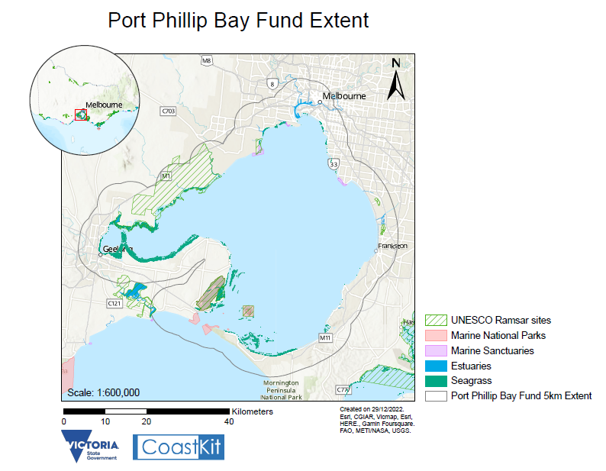

# Appendix 2 – Coastal Habitat Priorities within 5 Km Extent

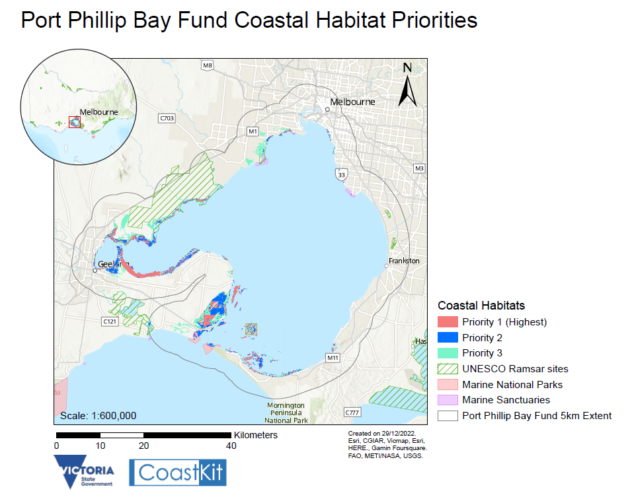

delwp.vic.gov.au