# Coastal and Marine Management Plan Resource Kit – Management Plan Template

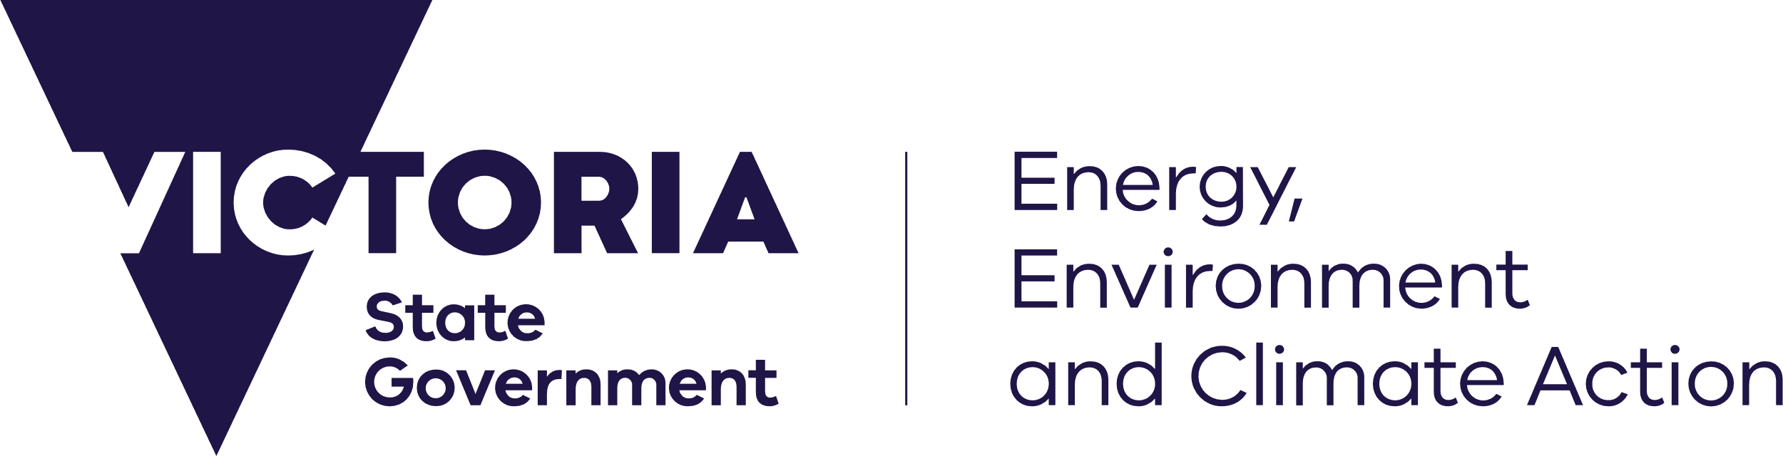



[deeca.vic.gov.au](https://projectsportal.ghd.com/Users/fionadurante/Downloads/deeca.vic.gov.au)

The aim of the Coastal and Marine Management Plan (CMMP) Resource Kit is to provide a collection of tools to guide coastal Crown land managers through the necessary steps of preparing a CMMP.

Drawing from the CMMP Guidelines, managers can determine how best to use this resource kit for their planning process. However, they should consider using the following order:

1. Scope and Scale template: defines the management area
2. Engagement Plan template: to identify and engage all relevant rightsholders and stakeholders
3. MERI Program Logic template: defines what and how objectives, activities, and anticipated outcomes of the CMMP will be delivered
4. Management Plan template: in which insights gathered from the above templates are consolidated
5. MERI Framework template: establishes robust monitoring, evaluation, reporting and improvement criteria

This template can assist with stage three of CMMP preparation.

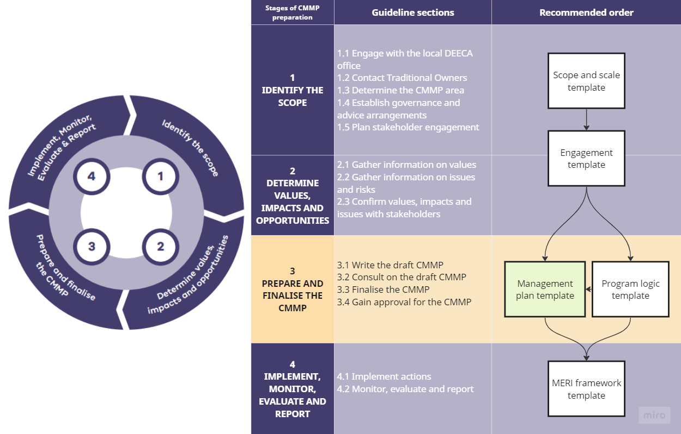

## How to use the template

Use the Coastal and Marine Management Plan (CMMP) Template to:

* Describe the strategic context of the CMMP by summarising relevant marine and coastal legislation and policy.
* Define the purpose of the CMMP.
* Describe key milestones during CMMP development.
* Describe the management context of the marine and coastal area.
* Report on values, impacts and opportunities relating to the marine and coastal area produced through stakeholder engagement.
* Describe the intended five-year management approach, including guiding principles, objectives, actions and business plan.
* Describe the approach to monitoring, evaluation reporting and improvement during action delivery.
* Identify relevant appendices to support the CMMP.

Grey text – guides what to include under each subheading.

Black text – includes generic information that can be included in the CMMP.

# Executive Summary

This should include a high-level summary of the CMMP.

# 1. Introduction

## 1.1 Strategic context

Summarise the supporting legislation and policy guiding the CMMP including:

* *Marine and Coastal Act 2018*
* Marine and Coastal Policy 2020
* Marine and Coastal Strategy 2022

Amend the text below as necessary.

### 1.1.1 Marine and Coastal Act 2018

The *Marine and Coastal Act 2018* (MACA) provides the legislative framework for marine and coastal management in Victoria.

The MACA outlines how to protect and manage the marine and coastal environment and sets objectives and principles to integrate and coordinate planning and management. Implementation of the objectives and principles of the MACA is supported by the Marine and Coastal Policy (MCP) and Marine and Coastal Strategy (MCS). At a local level it is articulated through Coastal and Marine Management Plans (CMMP).

### 1.1.2 Marine and Coastal Policy 2020

The MCP was released in March 2020 and establishes a 15-year vision for: *‘a healthy, dynamic and biodiverse marine and coastal environment that is valued in its own right, and that benefits the Victorian community, now and in the future’* and provides statewide policy direction for planning, management and decision making. The MCP includes a 'Planning and Decision Pathway' that sets out how the objectives and guiding principles of the Act are to be used in decision making for the marine and coastal environment. It also provides for the development of a statewide Marine Spatial Planning Framework (MSP Framework) to achieve integrated and coordinated planning and management of the marine environment.

### 1.1.3 Marine and Coastal Strategy 2022

The MCS identifies actions to achieve the MCP’s vision. It outlines 6 priority action areas for the five-year life of the MCS:

* Action 1: Supporting Traditional Owners to embed their rights and obligations into planning and management of the marine and coastal environment.
* Action 2: Improving the condition and ecological connectivity of habitats and respecting and caring for marine and coastal areas.
* Action 3: Adapting to impacts of climate change.
* Action 4: Supporting sustainable use and development of the marine and coastal environment.
* Action 5: Implementing the Marine Spatial Planning Framework to integrate long-term planning for different uses in the marine environment.
* Action 6: Identifying the resource needs and funding for sustainable marine and coastal management.

## 1.2 [Insert name] Coastal and Marine Management Plan [ insert year]

Define the purpose of the CMMP. Amend the text below as necessary.

CMMPs are local scale strategic plans for the management of marine and coastal Crown land that enable land managers to:

* implement an agreed vision for an area of the marine and coastal environment, consistent with the MCP and other relevant guiding documents;
* prioritise and manage the demand and conflicting uses now and in the future; and
* translate objectives, aspirations and values for an area into on-ground action.

The CMMP and management of the coastal and marine environment is influenced by the following documents:

* [List key influencing documents / plans that guide local, regional and state-wide management. See examples below.]
* Marine and Coastal Policy 2020
* Marine and Coastal Strategy 2022
* Siting and design guidelines for structures on Victorian Coast 2020
* Any Regional and Strategic Partnership applying to the area
* Biodiversity Strategy
* Climate Change Strategy
* Environmental Management Plan
* Boating Plan
* Open Space Strategy
* Master Plan
* Structure Plan
* Catchment Management Strategy
* Regional Plan

You could provide further detail on the CMMP’s purpose by detailing the management issues this plan will address, such as:

* Access
* Recreation
* Regional connectivity
* Vegetation and wildlife management
* Fire management
* Asset management (e.g., maintenance and improvements to infrastructure and facilities)
* Drainage and water quality
* Services (e.g., emergency response)
* Beaching cleaning and litter management
* Zoning, signage and enforcement
* Marine issues (e.g., activities or natural values in or on the water)

## 1.3 Developing the CMMP

Outline key milestones in the development process of the CMMP:

* When did planning commence?
* When was feedback on the CMMP by DEECA and VMaCC received?
* When was the CMMP finalised and submitted?

## 1.4 Engaging the community

Information on planning engagement can be found in section 1.5 ‘Plan stakeholder engagement’ of the CMMP Guidelines.

Provide a brief description of the engagement process:

* Who did you engage? How? When? What was the frequency?
* What engagement approaches did you use on the IAP2 Spectrum of Public Participation?
* Include a report on outcomes of consultation as an appendix if needed.
* How was two-way engagement undertaken, and how was feedback incorporated into the CMMP?

A more detailed summary of engagement activities can be included as an appendix if needed.

# 2. Context

## 2.1 Management context

### 2.1.1 Management responsibility

Details about management responsibility and establishing the CMMP area can be found in Part 2, section 1 ‘Identify the scope’ of the CMMP Guidelines.

Provide a brief description of:

* The management responsibilities of the Council/Committee
* The Council/Committee’s organisational structure
* Jurisdiction boundaries.
* Adjoining land managers
* How management is funded
* Key leases or licenses

Include a map showing the area covered by the CMMP, management jurisdiction and key assets.

### 2.1.2 Working with Traditional Owners

Details about working with Traditional Owners to prepare a CMMP are provided in section 1.2 of the CMMP Guidelines.

Provide a brief description of:

* The Traditional Owner rightsholders/Registered Aboriginal Parties for the area
* The management responsibilities of the relevant Traditional Owner Organisation(s)
* Jurisdiction boundaries
* Aboriginal cultural heritage in the area

### 2.1.3 Governance structure

Guidance on establishing governance and advice arrangements is outlined in section 1.4 of the CMMP Guidelines.

Describe key stakeholders, rights holders and agencies involved or may be interested in management. These might include:

* Council/Committee
* Traditional Owner rights holders
* Parks Victoria
* DEECA
* Melbourne Water
* Surf Lifesaving Clubs/Lifesaving Clubs
* Association of Bayside Municipalities
* Better Boating Victoria
* Local recreational clubs (e.g., yacht, boat)
* Local residents
* Campers

|  |  |
| --- | --- |
| Stakeholder group / Rights holder / Agency | Role |
|  |  |
|  |  |

### 2.1.4 Project area

* Include a map that outlines the boundaries of the marine and coastal area considered in the CMMP.

For complex CMMPs, consider dividing the area covered by the CMMP into management precincts or zones. These precincts or zones can be identified by natural landscape characteristics, by geographical location, by the type and intensity of activity or uses (e.g., commercial/waterfront precincts) and/or by management approaches (e.g., activity and recreation nodes).

Further information on establishing management units and defining activity and recreation nodes can be found in Additional guidance – 3.1 ‘prepare and finalise the CMMP’ in the CMMP Guidelines.

### 2.1.5 Existing conditions

Guidance on understanding current uses and challenges is provide in Section 2 ‘Determine values, impacts and opportunities’ of the CMMP guidelines.

Describe the existing geographical conditions of the marine and coastal area. This might include information on:

* Primary land uses in the surrounding area
* Climate
* Vegetation
* Local wildlife
* Coastal processes

### 2.1.6 Current uses and challenges

Guidance on understanding current uses and challenges is provide in Section 2 ‘Determine values, impacts and opportunities’ of the CMMP guidelines. The challenges and issues identified here can be used in the Monitoring, Evaluation, Reporting and Improvement (MERI) Plan template to develop a program logic for the CMMP.

Describe the current uses of the marine and coastal area. This might relate to:

* Land-based recreation (e.g., dog walking, camping, bird watching, cycling)
* Water-based recreation (e.g., boating, fishing, swimming)
* Industry and development
* Transport and connectivity
* Conservation areas
* Areas of natural values
* Areas of cultural heritage significance
* Existing activity hubs/precincts (e.g., commercial/waterfront precincts)

Describe the current challenges for the marine and coastal area. This might relate to:

* Conflict between uses (e.g., shared user paths)
* Responding to and managing coastal hazards

# 3. Values, impacts and opportunities

## 3.1 Vision and Objectives

The vision and objectives in the CMMP should come from information gained through the strategic context setting and stakeholder engagement. Guidance on developing a vision and objectives for the CMMP can be found in Section 3 ‘Prepare and finalise the CMMP’ of the CMMP Guidelines.

The vision statement from the Marine and Coastal Policy 2020 can be used as a starting point:

*“Our vision is for a healthy, dynamic and biodiverse marine and coastal environment that is valued in its own right, and that benefits the Victorian community, now and in the future”.*

Example: The [insert name] Coastal and Marine Management Plan outlines a 15-year vision: to protect, enhance and care for [insert name] coastal and marine areas, increasing our resilience and providing enjoyment and inspiration for present and future generations.

This vision is supported by [insert number] long term objectives:

* [List key objectives as they relate to the planning and decision pathway of the Marine and Coastal Policy 2020: These are:

Acknowledge Traditional Owners' rights, aspirations and knowledge

Protect and enhance the marine and coastal environment

Respect natural processes

Strengthen resilience to climate change

Use and develop sustainably

Taking a stewardship approach

Building understanding and knowledge

Engaging

Collaborating

## 3.2 Community and stakeholder views

Information on planning engagement can be found in section 1.5 ‘Plan stakeholder engagement’ of the CMMP Guidelines.

This information may come from the stakeholder engagement process. Refer to CMMP Resource Kit “Engagement Plan Template” for how you can go about this.

In line with the Planning and Decision-Making Pathway, land managers should identify community and stakeholder views in a way that:

1. **Takes a stewardship approach** to how we care for and manage the marine and coastal environment.
2. **Builds understanding and knowledge** of the condition and values of the marine and coastal environment.
3. **Engages with a wide variety of communities and user groups** that value the marine and coastal environment.
4. **Collaborates across the breadth of people and organisations** involved in marine and coastal management to deliver an integrated and co-ordinated approach.

### 3.2.1 Acknowledge Traditional Owners’ rights, aspirations and knowledge

|  |  |  |
| --- | --- | --- |
| Values | Concerns | Opportunities |
|  |  |  |
|  |  |  |
|  |  |  |

### 3.2.2 Protect and enhance the marine and coastal environment

|  |  |  |
| --- | --- | --- |
| Values | Concerns | Opportunities |
|  |  |  |
|  |  |  |
|  |  |  |

### 3.2.3 Respect natural processes

|  |  |  |
| --- | --- | --- |
| Values | Concerns | Opportunities |
|  |  |  |
|  |  |  |
|  |  |  |

### 3.2.4 Strengthen resilience to climate change

|  |  |  |
| --- | --- | --- |
| Values | Concerns | Opportunities |
|  |  |  |
|  |  |  |
|  |  |  |

### 3.2.5 Use and develop sustainably

|  |  |  |
| --- | --- | --- |
| Values | Concerns | Opportunities |
|  |  |  |
|  |  |  |
|  |  |  |

# 4. Management Approach

## 4.1 Objectives and Priority Actions

Guidance for setting objectives and priority actions is provided in Section 3 ‘Prepare and finalise’ the CMMP in the CMMP Guidelines.

Define the CMMP’s five-year objectives and corresponding actions. Further detail can be found in Section 4.2 of this template (the Implementation Plan). Include a paragraph on what has driven the actions – e.g., have the actions been generated based directly on feedback during community consultation, or other stakeholder engagement?

Note in developing your actions think of how you can also achieve:

* Taking a Stewardship approach
* Building understanding and knowledge
* Engaging
* Collaborating

The table below is designed to help you align your actions and objectives to the Planning and Decision Pathway For each action and objective, tick the box for the element of the Planning and Decision pathway that is most relevant.

Objectives and actions should be clearly numbered.

|  |  |  |  |  |  |  |
| --- | --- | --- | --- | --- | --- | --- |
| Objective | Actions | Acknowledge Traditional Owners’ rights, aspirations and knowledge | Protect and enhance the marine and coastal environment | Respect natural processes | Strengthen resilience to climate change | Use and develop sustainably |
| Insert objective | Actions for relevant objective |  |  |  |  |  |
|  |  |  |  |  |  |  |
|  |  |  |  |  |  |  |
|  |  |  |  |  |  |  |
|  |  |  |  |  |  |  |

## 4.2 Implementation Plan

Information on developing an implementation plan can be found in Part 3.1.6 ‘Plan for how the actions will be implemented’ of the CMMP Guidelines.

Guidance for implementing the CMMP is provided in Section 4 ‘Implement, monitor, evaluate, report and improve’ of the CMMP Guidelines.

Describe the CMMP’s actions to implement the five-year objectives defined above.

|  |  |  |  |  |  |  |  |  |
| --- | --- | --- | --- | --- | --- | --- | --- | --- |
| Reference | Action | Deliverable | Lead Agency | Partner agencies (if applicable) | Timeframe | Resources Required | Indicative cost | MACA consent required |
| * 1.1 * Five-year objective number. Corresponding action number |  |  |  |  | Year start – year end; ongoing |  | Provide a range |  |
| * 1.2 |  |  |  |  |  |  |  |  |
| * 2.1 |  |  |  |  |  |  |  |  |
| * 2.2 |  |  |  |  |  |  |  |  |

## 4.3 Management Units

For complex CMMPs consider dividing the area covered by the CMMP into management precincts or zones. These precincts or zones can be identified by natural landscape characteristics, by geographical location and/or management approaches e.g., activity and recreation nodes. Further information on establishing management units can be found in Additional guidance – 3.1 ‘prepare and finalise the CMMP’ in the CMMP Guidelines.

Each precinct or zone should include a map showing assets, values, challenges, management context and other locally relevant information. Consider including relevant actions identified in section 3.3 Implementation Plan on the map. Management precinct/zone maps identifying activity and recreation nodes should be included in the body of the CMMP.

## 4.4 MACA consent for use, development or works

At this point consider if any of the CMMP actions identified will require MACA consent. MACA consent for use, development or works identified in the CMMP actions (4.2) can be requested along with the CMMP for approval for small scale and low-risk proposals where enough detail is provided. Further information on the minimum information required to request consent as part of the CMMP approval can be found in the CMMP Guidelines (see Additional Guidance 3.1.7 “Ensure the draft CMMP includes all mandatory content’ on page 39 of the CMMP Guidelines).

## 4.5 Identify resourcing required for current and future activities and needs

Consider each action identified in the CMMP Implementation plan (4.2) above.

For each action identify:

* is it business and usual (e.g. day to day management and maintenance of marine and coastal values and actions)?
* is it a new action (e.g. required to meet the needs associated with growing populations, ageing coastal infrastructure, and building resilience to climate change)?
* the level of service required and performance outcomes for the action (this will assist determining resourcing required)
* if there are opportunities to share and integrate service provision with other marine and coastal managers; and
* identify funding options (e.g. revenue, grants, savings etc).

Further information on identifying funding needs and resourcing options can be found in Additional guidance – 3.1.6 ‘Plan for Implementation” in the CMMP Guidelines.

# 5. **Monitoring, Evaluation, Reporting and Improvement**

Section 4 ‘Implement, monitor, evaluate, report and improve’ of the CMMP Guidelines provides information to support development of this section of the CMMP.

Refer to the Monitoring, Evaluation, Reporting and Improvement (MERI) template spreadsheet and Resource Kit MERI program logic template.

The MERI framework considers:

**Monitoring:** How is the action/activity progressing in terms of timing, cost and change in scope?

**Evaluation:** Has the action/activity led to the desired change and met stakeholder expectations?

**Reporting:** How is the delivery of actions/activities going?

**Improvement:** How can adaptive improvements be integrated into the implementation of an action/activity?

## 5.1 Monitoring and Reporting

Describe the CMMP’s approach to monitoring and reporting by filling out the table below using information from the Resource Kit MERI template spreadsheet. The approach to monitoring and reporting may use the land manager’s existing reporting processes.

|  |  |  |  |  |
| --- | --- | --- | --- | --- |
| Action delivery | Monitoring approach | Success criteria | Responsibility | Frequency of monitoring and reporting |
|  | How will timing, cost and change in scope of actions/activities be monitored? | What does success look like? | Who will be responsible for monitoring and reporting? | How frequently will monitoring take place?  How will information be reported? |
| Acknowledge Traditional Owners’ rights, aspirations and knowledge | | | | |
|  |  |  |  |  |
| Protect and enhance the marine and coastal environment | | | | |
|  |  |  |  |  |
| Respect natural processes | | | | |
|  |  |  |  |  |
| Strengthen resilience to climate change | | | | |
|  |  |  |  |  |
| Use and develop sustainably | | | | |
|  |  |  |  |  |

## 5.2 Evaluation and Improvement

Describe the CMMP’s approach to evaluation and improvement by filling out the table below.

|  |  |
| --- | --- |
| Evaluation | Improvement opportunities |
| Annual monitoring reports  (12 monthly) |  |
| Mid-term evaluation report  (2.5 years) |  |
| Final evaluation report (5 years) |  |

## 5.3 Assumptions and Knowledge Gaps

Describe the CMMP’s assumptions and any knowledge gaps that exist.

# 6. Appendices

Include relevant appendices, such as:

Business Plan

An outline of relevant legislation and policies

A summary of stakeholder engagement activities

# Appendix 1 - Business plan

A business plan is essential for skills-based Committees of Management. This information would also be useful to include for Councils. Councils can also refer to existing business plans rather than filling out this appendix.

## Current financial position

Summarise the Council/Committee’s financial position over the past 3 years by filling out the table below.

|  |  |  |  |
| --- | --- | --- | --- |
|  | Year 3 | Year 2 | Year 1 |
| Income streams | | | |
| Camping fees  Rent from coastal recreation clubs |  |  |  |
| Anticipated grant income – e.g., DEECA beach cleaning, Melbourne Water |  |  |  |
| Gross income |  |  |  |
| Expenditure | | | |
| Insurance  Electricity / Gas  Pest control  Waste management  Vegetation management  Erosion management  Amenity maintenance / upgrades  Employees – Salaries, training |  |  |  |
| Total expenditure |  |  |  |
| Net income |  |  |  |

## Future Financial Position

Provide a brief summary of the Council/Committee’s future financial position during the CMMP’s lifespan:

Estimate whether annual income is expected to increase/decrease/stay the same over the next five years.

Describe anticipated grant income.

Estimate how much the CMMP will likely cost to implement and provide a breakdown of expenses.

Provide an overall indication of the Committee/Council’s future financial position (e.g., financial gain, loss, breakeven) and any plans (if needed) to seek additional funding and/or manage any shortfall.