# Marine Planning Case Study

Marine Spatial Planning and Offshore Wind – Rhode Island USA

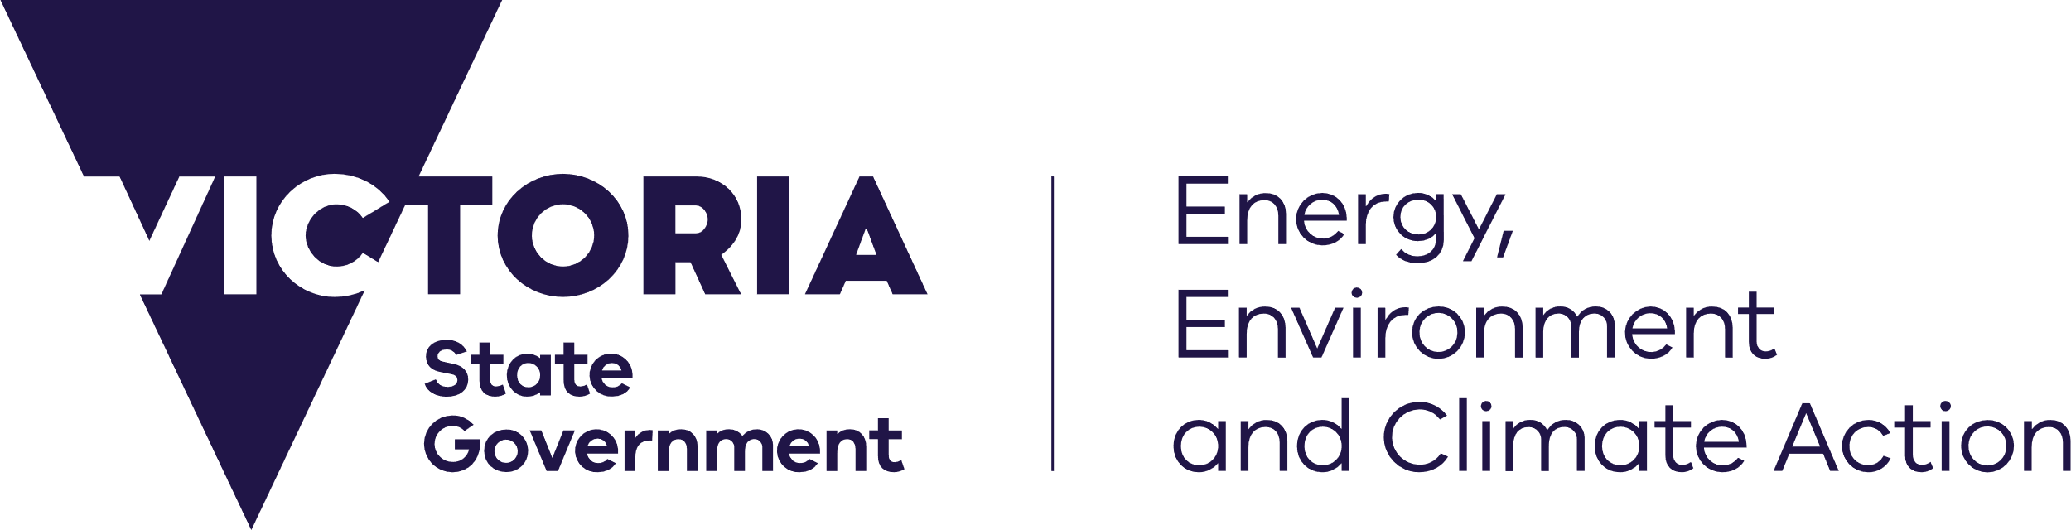

## 

|  |
| --- |
| **What is the Rhode Island Ocean SAMP?**  The Rhode Island Ocean Special Management Plan (SAMP) is a guidance and policy document that provides regulatory oversight. It is an example of the use of Marine Spatial Planning (MSP) to integrate best available science with open public engagement, when assessing and siting renewable energy developments.  The SAMP seeks to promote, protect, enhance, and honour existing human uses and natural resources, while encouraging appropriate marine-based economic development. |

*This case study has been prepared as part of implementation of Victoria’s Marine Spatial Planning Framework.*

|  |  |
| --- | --- |
| **Case Study Snapshot** | |
| **Location** | Rhode Island, USA |
| **Jurisdiction** | State and federally managed marine areas |
| **Area** | Approx. 3,800 km2 |
| **Lead** | Rhode Island Coastal Resources Management Council (CRMC) |
| **Support** | University of Rhode Island (URI) |
| **Key Driver** | Proposed offshore wind farm developments |
| **Output** | Ocean Special Area Management Plan (SAMP) |
| **Funding** | ~USD $8 million, primarily state-funded |
| **Timeline** | 2 years (completed 2010) |

[deeca.vic.gov.au](https://delwpvicgovau.sharepoint.com/Users/fionadurante/Downloads/deeca.vic.gov.au)

## The area

The Rhode Island Ocean SAMP area extends roughly 3,800 km2, from approximately 150 m to 5.5 km offshore (Rhode Island state waters) and into federal waters extending offshore a further 50 km (Figure 1).

The area is biologically and ecologically rich and recognised for its significant cultural and economic value. Evidence of human use in the area dates to approximately 30,000 years (early settlements by the Narragansett Indian Tribe), with important cultural sites submerged within the area.

Today, the area supports a variety of interests spanning commercial and recreational fishing, shipping and ports, naval operations, various marine recreational activities, and renewable energy.

## Policy context

The *Coastal Zone Management Act 1972* (CZMA) provides for the management of the USA’s coastal resources. Under the CZMA, it is a requirement that federal agencies report any activities that are likely to affect the use or natural resources of a state’s coastal zone, to that state. The CZMA includes national programs, such as the National Coastal Zone Management Program, which aims to balance competing land and water issues through state and territorial coastal management.

The state of Rhode Island participates in the National Coastal Zone Management Program, with the Rhode Island Coastal Resources Management Council (CRMC) the statutory state body responsible for implementation and advice to the Governor and the General Assembly. The CRMC comprises of 16 council members with three-year terms, with membership including the Director of the Department of Environmental Management, representation from the general public, from coastal communities, and from state and local government officials. The Ocean SAMP acts as the primary regulatory framework for all proposed developments within the designated area, including federal waters.

## Development

An intensive planning process was undertaken throughout the 2-year development period (2008-2010). SAMP development and project oversight was led by a project management team comprised of representatives from both the lead (CRMC) and supporting agencies (University of Rhode Island).

### Collaboration and engagement

The Narragansett Indian Tribe was engaged at the beginning of the SAMP development. The SAMP formally recognised the tribe's history in the Ocean, and included a requirement that consultation occurs for all future development within the area.

A diverse group of stakeholders were also involved in the process, including state and federal agencies, commercial and recreational fishermen, boaters, divers, renewable energy developers, environmental organisations, and private citizens.

### Governance arrangements

**Map Key**

Proposed Ocean Study Area

State/Federal Waters separation

*Figure 1 – The Ocean SAMP area*

Expert advice was provided through a legal committee, a scientific committee, a stakeholder committee, a state agencies committee, and a federal agency committee. These committees established the goals and guiding principles of the Ocean SAMP, and ensured consistency between policies, regulations and existing frameworks. In addition, a Fisherman’s Advisory Board and a Habitat Advisory Board were established to engage key stakeholder groups in the decision-making process. Technical Advisory Committees comprised of key stakeholders helped write and advise on each chapter of the plan.

## Outcomes and opportunities

Key outcomes of the Ocean SAMP were:

* additional knowledge and data on ecosystems and human uses/activities in the area
* establishment of new stakeholder relationships, and reduction of conflicts (notably between the fishing industry and offshore wind developers)
* successful application of the Ocean SAMP in siting and construction of offshore wind projects
* improved and streamlined regulatory environment, especially for the offshore wind industry.

Implementation of the Ocean SAMP could be improved through long-term formal funding, which would allow for ongoing monitoring, evaluation, and review. Continued stakeholder engagement and support throughout implementation could aid in alleviating concerns raised during the development process.

## Relevance to Victoria

There are several lessons from the Ocean SAMP that may guide the application of MSP in Victoria, including the importance of:

* collaboration and engagement with First Nations, and identifying a clear driver for the process to prompt engagement, focus research efforts and guide the design of clear and effective policies
* ensuring leadership includes stakeholders and a team with diverse skills and expertise
* establishing open, transparent, and inclusive processes to build stakeholder trust and legitimacy of any resulting outputs
* engaging early, regularly, and throughout the MSP process
* creating clear policy tools to support streamlined decision-making (for example, the Ocean SAMP’s Renewable Energy Zone and associated regulations).

|  |
| --- |
| **Ocean SAMP in action**  **Block Island Offshore Wind Farm**  The Block Island Wind Farm, developed by Deepwater Wind (acquired by Ørsted in 2018), was the first commercial offshore wind farm in the United States. The offshore facility is located approximately 5 km off the coast of Rhode Island’s Block Island. Operation began in December 2016, with five turbines producing a combined 30 MW of capacity.  The proposal to develop this facility was the driver behind the preparation of the Ocean SAMP. Under the Ocean SAMP, studies on the physical, biological and social aspects of the area were undertaken (forming the chapters of the Ocean SAMP), to ensure stakeholders were informed and involved, and environmental impacts were minimised prior to development.  The SAMP established a Renewable Energy Zone of approximately 34 km2. This provided clarity on appropriate siting location (area with least conflict between existing uses and the natural environment), streamlined regulatory requirements (including reducing the need for a detailed environmental assessment), and guided decisions made by other agencies (e.g., federal approval processes). |

## More information

The Rhode Island Ocean SAMP is available [here](https://seagrant.gso.uri.edu/oceansamp/samp.html).

For more information on MSP in Victoria, please visit [DEECA Marine and Coasts](https://www.marineandcoasts.vic.gov.au/) or contact the

Marine Spatial Planning Team ([marine.spatial.planning@delwp.vic.gov.au](mailto:marine.spatial.planning@delwp.vic.gov.au)).

|  |  |
| --- | --- |
| © The State of Victoria Department of Energy, Environment and Climate Action 2025  This work is licensed under a Creative Commons Attribution 4.0 International licence. You are free to re-use the work under that licence, on the condition that you credit the State of Victoria as author. The licence does not apply to any images, photographs or branding, including the Victorian Coat of Arms, the Victorian Government logo and the Department of Energy, Environment and Climate Action (DEECA) logo. To view a copy of this licence, visit http://creativecommons.org/licenses/by/4.0/  Disclaimer  This publication may be of assistance to you but the State of Victoria and its employees do not guarantee that the publication is without flaw of any kind or is wholly appropriate for your particular purposes and therefore disclaims all liability for any error, loss or other consequence which may arise from you relying on any information in this publication. | Accessibility  If you would like to receive this publication in an alternative format, please telephone the DEECA Customer Service Centre on 136186, email [customer.service@delwp.vic.gov.au](mailto:customer.service@delwp.vic.gov.au), or via the National Relay Service on 133 677 [www.relayservice.com.au](http://www.relayservice.com.au). This document is also available on the internet at [www.deeca.vic.gov.au](http://www.deeca.vic.gov.au). |