
Overview of values, uses and activities in Victoria’s southwest marine environment
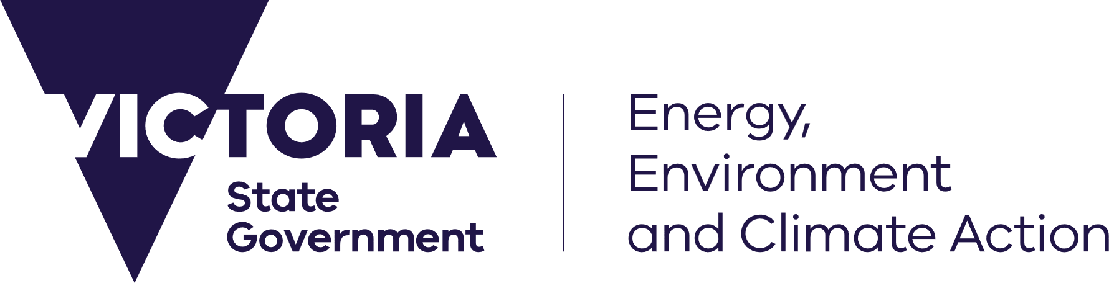

deeca.vic.gov.au





We acknowledge and respect Victorian Traditional Owners as the original custodians of Victoria’s land and waters, their unique ability to care for Country and deep spiritual connection to it.
We honour Elders past and present whose knowledge and wisdom
has ensured the continuation of culture and traditional practices.
DEECA is committed to genuinely partnering with Victorian Traditional Owners and Victoria’s Aboriginal community to progress their aspirations.
© The State of Victoria Department of Energy, Environment and Climate Action March 2026.
Creative Commons
This work is licensed under a Creative Commons Attribution 4.0 International licence, visit the Creative Commons website (http://creativecommons.org/licenses/by/4.0/).
You are free to re-use the work under that licence, on the condition that you credit the State of Victoria as author. The licence does not apply to any images, photographs or branding, including the Victorian Coat of Arms, and the Victorian Government and Department logos.
ISBN 978-1-76176-599-5 (pdf/online/MS word)
Disclaimer
This publication may be of assistance to you but the State of Victoria and its employees do not guarantee that the publication is without flaw of any kind or is wholly appropriate for your particular purposes and therefore disclaims all liability for any error, loss or other consequence which may arise from you relying on any information in this publication.
Accessibility
To receive this document in an alternative format, phone the Customer Service Centre on 136 186, email customer.service@delwp.vic.gov.au, or contact National Relay Service on 133 677. Available at DEECA website (www.deeca.vic.gov.au).

Contents
1 Overview 3
1.1 Purpose 3
1.2 Legislative framework 4
1.3 Marine spatial planning in Victoria 6
2 Southwest marine environment 8
2.1 Rightsholders and stakeholders 9
2.2 Traditional Owner cultural values and uses 10
3 Marine and coastal environment 12
3.1 Oceanographic characteristics and climate drivers 12
3.2 Geology and geomorphology landforms and seabed 13
3.3 Coastal processes 13
3.4 Sediment compartments 13
3.5 Marine habitats 14
3.6 Key Ecological Features (KEFs) 16
3.7 Marine species 16
3.8 Biogeographic units 18
3.9 Conservation and protected areas 19
3.10 Threats and pressures 20
4 Human values, uses and activities 21
4.1 Economic, social, and cultural values 21
4.2 Recreation, leisure, and tourism 22
4.3 Extraction of living resources 22
4.4 Production of living resources 22
4.5 Marine transport 23
4.6 Coastal infrastructure and management activities 23
4.7 Energy generation 23
4.8 Defence and national security 24
4.9 Research 24
4.10 Waste management activities 24
4.11 Extraction and disposal of non-living resources 24
5 Identified data needs to aid strategic planning 26
5.1 Traditional Owner cultural values and uses 26
5.2 Marine and coastal environment 26
5.3 Threats and pressures 27
5.4 Economic, social, and cultural values 28
5.5 Human uses and activities 28
Appendix 1: Legislation, plans, strategies, and guidelines 30
Commonwealth 30
Statewide 30
Regional 31
Local 32
Appendix 2: Tools glossary 33
Appendix 3: Key Ecological Features (KEFs) 34
Appendix 4: Species (MBV map) 35

List of tables
Table 1. Habitats within the southwest marine environment. 15
Table 2. FFG Act and EPBC Act listed species of high priority for data improvement. 27
Table 3. Identified data needs on human uses and activities. 28

List of figures
Figure 1. Victoria's marine planning areas. 7
Figure 2. Southwest marine environment.. 8
Figure 3. MBV map for the southwest marine environment.. 18
Figure 4. Marine National Parks (Victoria), Marine Park (South Australia) and publicly available data on shipwrecks in the southwest marine environment and adjacent Commonwealth waters.. 20
Figure 5. Publicly available data on dive site locations, dive harvesting areas, and aquaculture license areas in the southwest marine environment and adjacent Commonwealth waters. 25
Figure 6. Publicly available data on Commonwealth offshore wind energy declared areas, petroleum titles, petroleum pipelines, and petroleum wells in the southwest marine environment and adjacent Commonwealth waters.. 25

1 Overview
Strategic planning, particularly through tools such as Marine Spatial Planning (MSP), is becoming increasingly important for managing the growing pressures on marine and coastal environments. As use of these areas continues to expand and diversify, coordinating where and how different activities take place is critical. Not all uses are compatible, and some are only suitable in specific locations, making thoughtful planning essential to help avoid or reduce conflicts and minimise impacts on ecosystems and communities. When undertaken effectively, strategic planning can enhance transparency, support early and meaningful stakeholder engagement, and promote the sharing of data and knowledge across sectors. This not only supports the protection of environmental and cultural values but also provides greater certainty and efficiency for uses and the community.

1.1 Purpose
This document has been developed to support the planning, environmental assessment, and regulatory approval of marine and coastal development. It provides a high-level synthesis of available information on values, uses and activities within or relevant to the Victorian marine environment in the southwest (refer to location information in Section 2).
This document focusses on marine and coastal development across the southwest region, regardless of sector or location. Developments may span jurisdictional boundaries and interconnected environmental systems, making it essential to consider the values, uses and activities occurring across Commonwealth, Victorian and South Australian state waters, as well as their connections to the land. This integrated perspective is critical when undertaking planning, environmental assessment, or seeking regulatory approvals.
Note - This document does not outline the full requirements of current regulatory frameworks and should not be considered an exhaustive source of data required for planning or permitting processes. It does not constitute legal advice and is not intended to capture all available information or additional data that may be required or identified through project-specific investigations.
It is not intended to replace or duplicate site-specific assessments that may be required under relevant authorisations (for example, a consent under the Marine and Coastal Act 2018). Rather, it is designed to inform broader, strategic planning related to the southwest region, such as marine spatial planning processes that may be led by government.
This document is also not to be attached to submissions under the Environment Effects Act 1978 assessment process. The information presented may not be complete, current, fit for purpose, or directly applicable in all cases, users should refer to relevant legislation, policies, and plans that guide planning, management, and decision-making in the marine and coastal environment (see Appendix 1).
At the time of publication, no commitment has been made to undertake a strategic planning process in the southwest marine area.

1.2 Legislative framework
Marine and coastal development in Victoria is shaped by a complex legislative and policy frameworks that cover both Commonwealth and state jurisdictions.

1.2.1 Environment Protection and Biodiversity Conservation Act 1999 (Cth)
Under the Environment Protection and Biodiversity Conservation Act 1999 (EPBC Act) any proposed development or activity that may significantly impact a Matter of National Environmental Significance (MNES), such as a nationally significant animal, plant, habitat, or place, must be referred to the Commonwealth Minister for the Environment for a decision. The EPBC Act includes a self-assessment process, whereby project proponents must consider whether their development is likely to significantly impact an MNES. If so, the activity must be referred to the Minister. The Minister will then determine whether the action is deemed a ‘controlled action’ requiring formal assessment and approval under the EPBC Act, ‘not a controlled action’, ‘not a controlled action if undertaken in a particular manner’, or ‘clearly unacceptable’.

1.2.2 Native Title Act 1993 (Cth)
The Native Title Act 1993 (Cth) provides recognition and protection of the rights and interests of Aboriginal and Torres Strait Islander people in land and waters according to their traditional laws and customs. It outlines that when a native title determination is made, native title holders must establish a corporation who manages and protects the native title rights and interests in the relevant area. The future acts regime sets out the procedural requirements for developments that may affect native title rights.

1.2.3 Marine and Coastal Act 2018 (Vic)
The Marine and Coastal Act 2018 (MAC Act) sets out objectives and guiding principles for managing Victoria’s marine and coastal environment. Under this Act, the ‘marine and coastal environment’ includes the area extending up to 5 km inland from the high-water mark and 3 nautical miles, or 5.5 km, to the edge of the State’s jurisdiction. The ‘marine environment’ is defined as the area between the high-water mark and the State’s jurisdiction including all bays, inlets and estuaries, to a depth of 200 m below the seabed. The MAC Act is supported by a set of strategic tools, including the Marine and Coastal Policy 2020 (Policy), which incorporates Victoria’s Marine Spatial Planning Framework (MSP Framework), and the Marine and Coastal Strategy 2022. Together, these tools aim to ensure coordinated and sustainable planning across all levels of government and the broader community. Practical planning and management are further supported through specific tools such as Coastal and Marine Management Plans and the Victoria’s Resilient Coast – Adapting for 2100+ Framework.
Additionally, Section 65 of the MAC Act requires that any use, development, or works on marine and coastal Crown land must have consent from the responsible Minister or their delegate. Defined in Section 4 of the MAC Act, ‘marine and coastal Crown land’ is the area between the outer limit of Victorian coastal waters and 200 m inland of the high-water mark of the sea, to a depth of 200 m below the surface of that land. The term ‘development’ under the MAC Act has the same meaning as in the Planning and Environment Act 1987. To simplify and streamline consents under the Act, the Marine and Coastal (Prescribed Consents) Regulations 2025 (the regulations) have been made and are now in effect. The regulations prescribe consent under the MAC Act for certain activities on marine and coastal Crown land. This means that certain activities on marine and coast Crown land may now proceed without the need to obtain individual consent, provided the activity falls within the scope of the prescribed consent. It is important to note that the prescribed consents in the regulations include conditions that must be adhered to when undertaking an activity outlined in the regulations.

1.2.4 Environment Effects Act 1978 (Vic)
The Environment Effects Act 1978 (EE Act) ensures that projects with the potential for significant environmental impacts, such as marine and coastal developments, are thoroughly assessed. Project proponents may be required to prepare an Environment Effects Statement (EES), environment report, or fulfill other conditions for consideration by the Victorian Minister for Planning. The accompanying Ministerial Guidelines (8th edition) outline the criteria and process for referral and assessment. Assessments are guided by a risk-based, systems approach, with greater scrutiny applied to projects that pose high environmental risks. The Minister determines if a project’s environmental effects are acceptable, or if changes or further investigations are required to proceed. Where a project also requires assessment under the EPBC Act, a bilateral agreement between the Commonwealth and State enables coordinated assessment processes. This streamlines the preparation and consultation of EES and EPBC Act documentation and helps avoid duplication in environmental review.

1.2.5 Aboriginal Heritage Act 2006 (Vic)
The Aboriginal Heritage Act 2006 and Regulations 2018 protect Aboriginal cultural heritage across Victoria, including in marine and coastal areas - regardless of land ownership or whether sites are registered. A Cultural Heritage Management Plan (CHMP) is required for ‘high impact activities’ in areas of cultural heritage sensitivity, which includes marine and coastal Crown land. CHMP’s are also mandatory for projects that require an EES. Permits are required for ‘high impact activities’ likely to harm Aboriginal heritage and areas of cultural heritage sensitivity, such as excavation, rehabilitation, research, or removal of cultural objects. Where a CHMP is required, planning or development approvals cannot proceed without a CHMP that is approved by the Registered Aboriginal Party (RAP) for the area where the activity is proposed.

1.2.6 Flora and Fauna Guarantee Act 1988 (Vic)
The Flora and Fauna Guarantee Act 1988 (FFG Act) is a key framework for protecting Victoria’s biodiversity. For marine and coastal development on public land, authorisation to take or destruct native flora and fauna is required, with factors such as duration, direct and indirect impacts, and cumulative effects all considered. The FFG Act also mandates the preparation of a biodiversity strategy, currently Protecting Victoria’s Environment – Biodiversity 2037, which aims for a new improvement in species outcomes by 2037. Consideration is given to the FFG Act when making decisions likely to impact biodiversity.

1.2.7 Planning and Environment Act 1987(Vic)
The Planning and Environment Act 1987 (P&E Act) provides a framework for land use planning and development in Victoria, including activities that occur within marine and coastal areas. It promotes sustainable development while protecting natural resources and ecological processes. The term ‘development’ is defined under the P&E Act as including:
- the construction or exterior alteration or exterior decoration of a building; and
- the demolition or removal of a building or works; and
- the construction or carrying out of works; and
- the subdivision or consolidation of land, including buildings or airspace; and
- the placing or relocation of a building or works on land; and
- the construction or putting up for display of signs or hoardings.
The P&E Act enables the preparation and implementation of planning schemes, which regulate the use and development of land through zoning and overlays. Clause 12 of the P&E Act is particularly relevant to marine and coastal development. It emphasises the protection of biodiversity, ecological systems, and environmentally significant landscapes, as well as planning for climate change impacts such as coastal inundation and erosion. Under the P&E Act, all land in Victoria is subject to a planning scheme, and many schemes also extend offshore to regulate coastal waters, typically up to 200 or 600 meters from the shore. However, not all marine waters are covered by a planning scheme, with areas beyond this limit managed under separate marine or environment legislation. The Victoria Planning Provisions (VPP) form the basis of all planning schemes and guide decision-making at both the strategic and statutory levels.

1.2.8 Heritage Act 2017 (Vic)
The Heritage Act 2017 (Vic) aims to provide cultural heritage protection and conservation of non-Aboriginal cultural heritage, including buildings, structures, shipwrecks, objects, and archaeological sites. Any potential impacts on the sites and places of historical cultural heritage significance must receive approval. Any part of an area that is protected must not be removed, relocated, demolished, damaged, despoiled, developed, altered or excavated

1.3 Marine spatial planning in Victoria
Victoria’s Marine and Coastal Policy 2020 (Policy) includes Victoria’s Marine Spatial Planning Framework (MSP Framework). The MSP Framework provides guidance and a process for achieving integrated and coordinated planning and management of the marine environment and sets out Victoria’s approach to MSP. The MSP Framework consists of two parts:
- Part A provides an overarching structure and policies to guide planning, management and decision making in the marine environment.
- Part B sets out the process to initiate and undertake MSP in Victoria.
Implementation of the MSP Framework is being led by the Department of Energy, Environment and Climate Action (DECCA), and has commenced through the development of Marine Spatial Planning Guidelines, determination of marine planning areas, partnerships with Traditional Owners and engagement with stakeholders.

1.3.1 Victoria’s marine planning areas
Implementation of Part B of the MSP Framework was commenced via a statewide ‘first-pass’ approach that divided Victoria’s marine environment into 8 marine planning areas (Figure 1). In determining the boundaries and size of the marine planning areas several factors were considered, including the Victorian Environmental Assessment Council’s Assessment of the Values of Victoria’s Marine Environment Atlas (2019). The boundaries of the marine planning areas are indicative, with refinement to occur as part of undertaking a marine spatial planning process. The landward and seaward boundaries of the marine planning areas are defined based on the ‘marine environment’ definition in the MAC Act.
A marine planning area is the area to which a marine plan and its identified management actions (developed and agreed through the completion of a marine spatial planning process) will apply. Given the dynamic and interconnected nature of marine ecosystems, it is essential to consider interactions and connectivity across the land, sea and catchment interface (including Commonwealth waters). Whilst a marine plan applies to an entire marine planning area, there may be locations that require a more intensive focus when undertaking a marine spatial planning process (for example, due to the intensity of uses and activities differing across the marine planning area).
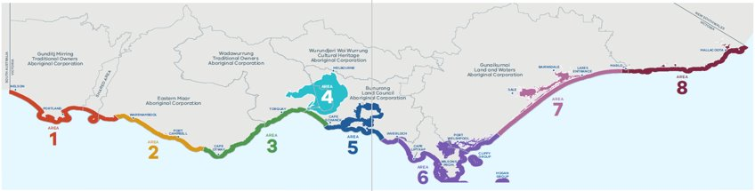
Figure 1. Victoria's marine planning areas.

1.3.2 Marine Spatial Planning Guidelines
The Marine Spatial Planning Guidelines (MSP Guidelines) outline detailed instructions on how to undertake an MSP process in Victoria. Specifically, they:
- Enable Traditional Owners to partner in marine planning and management.
- Guide the preparation, implementation, evaluation, and improvement of strategic plans for the marine environment.
- Support marine sectors, marine users, and the community to participate in marine planning and management.
The MSP Guidelines are designed to be used to undertake a marine spatial planning process once approval has been granted by the lead minister. The key steps in the MSP Guidelines reflect those in the MSP Framework. Tasks outlined in each step may not occur sequentially, as the information gained during one step may highlight the need to revisit a preceding step.
At this stage, there has been no commitment to undertake a full marine spatial planning process, however the steps identified in the MSP Guidelines have been drawn on for this high-level synthesis.

2 Southwest marine environment
The information in this document covers the entirety of marine planning areas 1 and 2, extending from the border with South Australia to west of Cape Otway, including estuaries (Glenelg River, Wattle Hill Creek, Surrey River, Fitzroy River, Lake Yambuk, Moyne River, Merri River, Hopkins River, Curdies River, Port Campbell Creek, Sherbrook River and Gelibrand River) (Figure 2). The focus is on Victoria’s marine environment, however adjacent marine and terrestrial areas, and neighbouring Commonwealth and South Australian waters, are discussed where information is known.
Victoria’s ‘marine environment’ is defined in the MAC Act as extending from the high-water mark for 3 nautical miles, or 5.5 km, to the edge of the State’s jurisdiction. It includes all bays, inlets and estuaries. This extends to a depth of 200m below the seabed, and includes the biodiversity associated with both land and water.
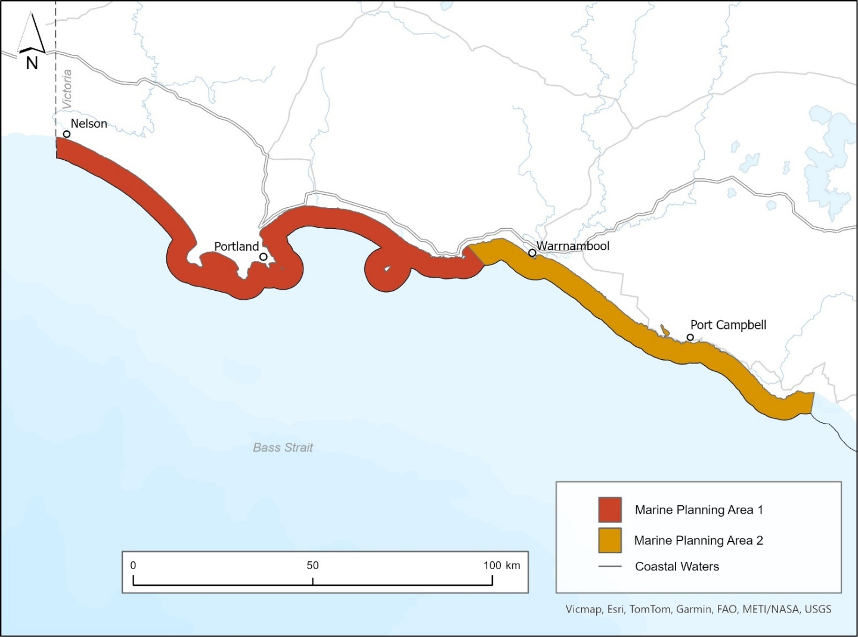
Figure 2. Southwest marine environment. Note: the coastal waters line is the edge of Victoria’s marine environment.

Marine and coastal development - Victoria’s offshore wind program
The Victorian Government has legislated targets of net-zero emissions by 2045 and 95% renewable energy generation target by 2035, including offshore wind targets. Offshore wind energy has a key role contributing to those goals while also helping to secure Victoria’s future energy supply.
As ageing coal-fired power stations prepare to close, offshore wind presents a major opportunity to deliver clean, reliable energy, supporting jobs and growing a competitive, local renewable energy supply chain. Victoria is leading the way in the establishment of an offshore wind sector and is on track to host Australia’s first offshore wind projects.
While all proposed offshore wind projects are in Commonwealth waters, with two declared areas off the Victorian coast (Bass Strait and the Southern Ocean (located in the southwest)), supporting infrastructure will span both Commonwealth and Victorian jurisdictions. Wind turbines and sub-stations will be in Commonwealth waters, but transmission cables and other infrastructure will connect through Victorian coastal waters to the onshore grid. This means that land use planning under Victorian legislation (including the Planning and Environment Act 1987, the Environmental Effects Act 1978 and the Marine and Coastal Act 2018) will play a critical role alongside Commonwealth approvals such as the Offshore Electricity Infrastructure Act 2021 and the Environment Protection and Biodiversity Conservation Act 1999.
The Victorian Government is committed to ensuring that offshore wind development proceeds in a way that aligns with environmental and cultural values. This includes robust environmental assessments, early engagement with Traditional Owners and communities, and clear, coordinated regulation. Regular Offshore Wind Energy Implementation Statements support transparency and stakeholder collaboration. The latest, Implementation Statement 4 (April 2025), outlines progress across key areas such as procurement, transmission, environmental protection, Traditional Owner partnerships, and community engagement.
While offshore wind developments can have localised environmental impacts, they also deliver significant long-term environmental and economic benefits. By reducing reliance on fossil fuels, offshore wind energy contributes to lowering greenhouse gas emissions, contributing to a more stable climate and slowing the warming of our oceans. At the same time, it offers regional economic growth and the creation of skilled jobs, to accelerate Victoria’s transition to a clean energy future.
Note - additional regulatory guidance and information resources are available to support and guide industry and communities participating in the offshore wind rollout.

2.1 Rightsholders and stakeholders
A collaborative approach to marine planning and development allows for proactive identification and reduction of conflicts between uses, and between uses and the environment. As outlined in the MSP Guidelines, Marine Spatial Planning (MSP) is a participatory approach, therefore it is important to identify, contact and partner with rightsholders, and identify and engage stakeholders when conducting strategic planning. For instance, Traditional Owners request when being engaged the concept of free, prior, and informed consent be followed. There should also be a clear understanding of the resources and availability of Traditional Owners to engage from the start, with Traditional Owners self-determining their role and being fairly remunerated for their time, knowledge, and in recognition of their cultural authority.
The MSP Guidelines highlight the importance of partnering with rightsholders as well as considerations for identifying stakeholders. They list examples of those with existing rights by legislation, permit or licence, and suggest engagement and communication approaches (see Step 1 of the MSP Guidelines).

2.1.1 Rightsholders
The importance of Sea Country must be recognised and integrated into marine planning and management through a self-determined approach. Registered Aboriginal Parties (RAPs) (under the Aboriginal Heritage Act 2006) and Registered Native Title Body Corporates (under the Native Title Act 1993) have responsibilities for managing and protecting Aboriginal cultural heritage on Country. In areas where there is no legally recognised RAP, the local Traditional Owner group and/or the Aboriginal Heritage Council should be contacted.
The Traditional Owner groups within the southwest marine environment are:
- Gunditj Mirring Traditional Owners Aboriginal Corporation RNTBC (Prescribed Body Corporate under the Native Title Act 1993).
- Eastern Maar Aboriginal Corporation RNTBC (Prescribed Body Corporate under the Native Title Act 1993).

2.1.2 Stakeholders
Stakeholders with interests in the southwest marine environment include those with existing rights by legislation, permit or licence, marine user groups, industry, non-government groups and peak bodies, researchers, community groups, and planners and managers from local, regional, state, and national levels of government.

2.2 Traditional Owner cultural values and uses
Sea Country is part of the interconnected cultural landscape that includes land (Pareeyt Mirring) and waters (Nyamat Mirring). This interconnected cultural landscape reflects the deep and ongoing relationships Traditional Owners have with Country and recognises the biocultural values they hold, where species such as eels are present across both land and sea. A cultural landscape includes Traditional Owner cultural values and uses for Sea Country, which are deeply held spiritual, cultural, social, economic, environmental, of land and water form, place-based, practice-based, wellbeing, future use, identity connections, and any others as determined by Traditional Owners.
The whole Sea Country of the southwest is highly significant, with large areas of submerged cultural heritage. Some of this is part of the UNESCO World Heritage-listed Budj Bim Cultural Landscape. The Gunditjmara Sea Country Indigenous Protected Area is also located in the southwest. In addition, but not limited to, the following are highly sacred and significant:
- Deen Maar (Lady Julia Percy Island).
- Southern Right Whales (including identified Biologically Important Areas and the Logans Beach nursery) and other culturally significant species such as eels, seabirds, shellfish and seaweeds (for example kelp).
- Point Richie - Moyjil Aboriginal Place.
- Significant intangible cultural heritage associated with the southwest marine environment, including but not limited to elements such as song, dance, stories, places and living bio-cultural values, such as culturally significant plants and animals.
- Many cultural heritage sites including ancestral remains, shell middens, artefact scatters rediscovered through cultural heritage surveys, and many areas yet to be surveyed particularly underwater cultural heritage.

Online mapped information is available on the Aboriginal Cultural Heritage Register and Information System (ACHRIS). This tool highlights if a proposed development site falls within an area of cultural heritage sensitivity, which generally includes landforms or locations with a higher likelihood of containing Aboriginal heritage. However, this mapping is indicative only and does not include all culturally significant sites (especially underwater cultural heritage) values or uses. As such, it is essential that all project developers engage directly with the Traditional Owner groups within the area and consider information within any available country or sea country plan.

2.2.1 Indigenous Cultural and Intellectual Property
Indigenous Cultural and Intellectual Property, or ICIP, refers to all aspects and elements of Indigenous peoples’ cultural heritage, and the rights that Indigenous people hold in relation to that cultural heritage. ICIP is captured under Article 31 of UNDRIP. ICIP incorporates both tangible (sites, objects) and intangible (knowledge, oral stories, performances) elements. Ownership of ICIP rights will remain with the relevant custodians. ICIP rights must be respected and upheld at all times. Any use of ICIP must be in accordance with, and respect, cultural protocols as notified by the relevant custodians. Informed consent must be obtained from the relevant owners or custodians before any use of ICIP.

3 Marine and coastal environment
This section provides an overview of the key characteristics of the southwest marine environment, including available data on the physical features, habitats, conservation areas, and the biodiversity they support. This includes species that are threatened or protected under relevant Commonwealth and State legislation.
Available data on Victorian and adjacent Commonwealth waters is accessible through DataVic (viewable via CoastKit), the Commonwealth funded National Environmental Science Program (NESP) via the Australian Ocean Data Network (AODN), data.gov.au, and Geoscience Australia’s online map-based tool (NationalMap) (see Appendix 2 for a list of data sources). Additional information on the marine and coastal environment of the southwest will is available in the State of Marine and Coastal Environment Report and the State of the Great Ocean Road Coast and Parks report (produced by the Victorian Commissioner for Environmental Sustainability) under the MAC Act and the Great Ocean Road and Environs Protection Act 2020 respectively.
Note: not all data outlined may be complete, current, fit for purpose, available to access, or directly relevant and is being provided solely as an initial high-level synthesis. Therefore, in addition to the data that is referenced in this document, consideration should be given to what further data may be required for assessment and approval processes.
Gunditjmara Biocultural Knowledge
Gunditjmara biocultural knowledge is central to understanding and protecting the marine and coastal environment of the southwest. This knowledge has been carried across generations and connects land, waters, sky, and people. It includes seasonal indicators, stories, cultural practices, and observations that guide how Gunditjmara manage and care for Sea Country.
Biocultural knowledge is not separate from Country but embedded within it. It shapes the way Gunditjmara interact with species such as kooyang (eel), whales, shellfish, and seabirds, and informs practices that sustain balance between people and ecosystems. These knowledge systems provide critical insights into ecosystem health and resilience that cannot be captured by Western science alone.
Protecting Gunditjmara biocultural knowledge means ensuring it is not extracted or used without consent. In line with Indigenous Data Sovereignty, Gunditjmara must determine how cultural information is collected, stored, shared, and applied in marine spatial planning. Any engagement with this knowledge must respect cultural protocols, be guided by Gunditjmara decision-making, and support the continuation of living knowledge systems for future generations.

3.1 Oceanographic characteristics and climate drivers
Information and data on the oceanographic characteristics and climate drivers of the southwest marine environment is available via the AODN. The coastline is among the most exposed in southern Australia, facing persistent westerly to south-westerly winds and long-period ocean swells. These forces shape sediment dynamics and benthic habitat structures across nearshore and subtidal zones. A defining feature of the region is the Bonney Coast Upwelling (part of the Great Southern Australian Coastal Upwelling System), one of the largest and most predictable upwellings in southeastern Australia. It is a seasonal process that brings cold, nutrient-rich water to the surface, fuelling high levels of primary productivity and supporting complex food webs, a key driver for the region’s biodiversity. Examples of available data and information for the area includes, oceanographic conditions, meteorological conditions, physical chemistry (for example, salinity, oxygen, temperature) and hydrology (for example, wave climate upwelling).

3.2 Geology and geomorphology landforms and seabed
Information and data on the geology and geomorphology of the southwest marine environment is available from the Geoscience Australia repository. The coastal and underwater landscape of the area are geologically diverse, featuring steep sedimentary cliffs, sandy embayments, volcanic basalt outcrops around Cape Nelson, and extensive limestone platforms. Offshore ridges and reef systems extend to depths of over 50 metres, creating a varied seafloor that supports a broad array of marine life. Examples of available data and information includes:
- Coastal topography and bathymetry (including the Victorian Coastal Digital Elevation Model).
- Geological sites and geomorphology (including data available at Geoscience Australia repository).
- Submarine canyons (via the Geoscience Australia repository).
- Marine geology and sediments (via the Geoscience Australia repository).

3.3 Coastal processes
The Victorian Government coordinates the Victorian Coastal Monitoring Program (VCMP) to ensure robust coastal data is used to inform coastal hazard management and adaptation planning. The statewide program aims to:
- Increase understanding of how coastlines change over time.
- Assist with managing coasts in the present.
- Provide knowledge to ensure coasts are resilient in the future.
Examples of available data collated as part of this program in the southwest marine environment includes:
- ‘VCMP Sites’ data at three locations (Portland-Dutton Way, Port Fairy and Warrnambool) - shoreline trends and time series based on VCMP drone surveys, aerial imagery, and satellite imagery (Digital Earth Australia).
- ‘VCMP Coastal Erosion Indicators’ at three locations (Portland-Dutton Way, Port Fairy and Warrnambool).
- Wave climate data through wave buoys at Cape Bridgewater, Dutton Way and Port Fairy – used to calibrate a 40-year hindcast wave model and a longshore sediment transport model.

3.4 Sediment compartments
As part of the National Classification of Coastal Sediment Compartments, the coastline of the southwest has been mapped based on landforms and patterns of sediment (sand and other beach material) movement. The primary sediment compartments, based on large landforms and offshore processes, within the southwest marine environment is Western Victorian Coast. The secondary sediment compartments, which link to information on sediment movement and coastal types, within the southwest marine environment are:
- Discovery Bay.
- Portland Bay.
- Warrnambool.
- Port Campbell.

3.5 Marine habitats
The southwest marine environment supports a diverse range of habitat types, including shallow and sublittoral reef systems, deep reef ecosystems, sheltered marine areas (Portland Bay), estuaries, and coastal wetlands and beach habitats,,. Key characteristics of these marine habitats in the southwest marine environment include:
- Shallow and sublittoral reef systems - The nearshore and mid-depth reefs of the southwest marine environment are among the most ecologically significant in Victoria. These reefs host dense kelp forests dominated by Golden Kelp (Ecklonia radiata), Bull Kelp (Durvillaea potatorum), and Crayweed (Phyllospora comosa), alongside remnants of Giant Kelp (Macrocystis pyrifera), particularly around Portland Bay and Cape Nelson. Although these Giant Kelp (Macrocystis pyrifera) beds have declined, they remain ecologically important. Understorey and turf-forming brown and red algae, including thallose red algal assemblages and sub-canopy species (for example, Caulerpa muelleri, Acrocarpia paniculata, and Perithalia caudata) add to the habitat complexity. In areas exposed to high wave energy, crustose and erect coralline algae dominate, supporting highly productive benthic communities. These algal-dominated reef systems form critical habitats for economically and ecologically important invertebrates such as the Southern Rock Lobster (Jasus edwardsii), the Blacklip Abalone (Haliotis rubra) and the Greenlip Abalone (Haliotis laevigata).
- Deep reef systems - At depths of 30 to 80 metres, deeper subtidal reef systems reflect a shift in geomorphology and biological communities. These habitats benefit from relatively stable seabed temperatures driven by upwelling and are characterised by sponge gardens, soft corals, and bryozoans. Crustose coralline algae dominate the substrata in some areas, supporting sparse by distinctive assemblages of sessile invertebrates. These reefs provide essential habitat for a range of benthic fish and invertebrates not typically found in shallower reefs.
- Portland Bay - The sheltered waters of Portland Bay support Wire Weed (Amphibolis antarctica) beds, which serve as important nursery grounds for fish and invertebrates. Portland Bay also contains remnant Giant Kelp (Macrocystis pyrifera) beds and productive abalone habitat, particularly for the Greenlip Abalone (Haliotis laevigata).
- Estuaries – Estuaries are highly productive areas with rich habitats that support diverse communities. They serve as important nursery grounds for many fish and invertebrates and providing critical habitat for migratory fish species such as Estuary Perch (Macquaria colonorum) and Australian Grayling (Prototroctes maraena). Estuaries are also important for threatened species and play a key role in connecting freshwater and marine ecosystems.
- Coastal wetlands and beach habitat - Extensive wetland systems lie inland from the beaches of Glenelg and Discovery Bay. These provide vital habitat for migratory shorebirds, including species protected under international agreements including bilateral migratory bird agreements with Japan (JAMBA) and China (CAMBA). The sand beaches of the southwest also support nesting and roosting sites for the Hooded Plover (Thinornis rubricollis), listed as Vulnerable in Victoria under the FFG Act.

3.5.1 Marine habitat classification scheme
DEECA uses the Combined Biotope Classification Scheme (CBiCS) as a standard method for classifying marine ecosystems. CBiCS defines six hierarchical levels, from major environment types (Level 1) to detailed sub-biotopes (Level 6), enabling scalable habitat descriptions based on species and physical conditions (for example geography, salinity, substratum type).
DEECA has developed a statewide marine habitat map using CBiCS data from Victoria’s waters, enhanced with predictive modelling. This map shows the modelled distribution of 24 Level 3 habitat complexes, which include Level 4-6 biotopes, some unique, rare, or threatened. In the southwest marine environment, there are 15 Level 3 complexes (Table 1) and 242 Level 4 biotope records.
Table 1. Habitats within the southwest marine environment.
Habitat complex | CBiCS Level 3  Biotic code
High energy littoral rock | ba1.1
Moderate energy littoral rock | ba1.2
Littoral sand | ba2.2
Saltmarsh and reedbeds | ba2.5
High energy infralittoral rock | ba3.1
Moderate energy infralittoral rock | ba3.2
High energy open-coast circalittoral rock | ba4.1
Sublittoral coarse sediment | ba5.1
Sublittoral sand and muddy sand | ba5.2
Sublittoral mud | ba5.3
Sublittoral mixed sediments | ba5.4
Sublittoral rhodolith beds | ba5.5
Sublittoral seaweed on sediment | ba5.7
Sublittoral seagrass beds | ba5.8
Non-reef sediment epibenthos | ba5.b

3.5.2 Irreplaceable marine biotopes
In June 2025, DEECA published guidance on Victoria’s irreplaceable marine biotopes to support decision-making on development impacts. This guidance helps planners and developers avoid irreversible damage by considering sensitivity, restoration risk, and the statutory protection status of biotopes or their characteristic species, as listed under the FFG Act, or the EPBC Act, or within protected areas under the National Parks Act 1975. Biotopes are deemed ‘irreplaceable’ or ‘not irreplaceable’ if recovery takes over 25 years, restoration methods are unproven or ineffective, or environmental conditions make restoration unfeasible. Rarity, uniqueness, and limited distribution further increase restoration challenges.
The southwest marine environment contains 189 irreplaceable marine biotopes, identified due to the difficulty, or impossibility, of restoring them once disturbed.

3.6 Key Ecological Features (KEFs)
Key Ecological Features (KEFs) are critical components of the marine ecosystem that support regional biodiversity and ecosystem function. Identified using international scientific criteria for Ecologically or Biologically Significant Marine Areas, KEFs are recognised for attributes such as:
- Uniqueness or rarity.
- Special importance for life-history stages.
- Importance for threatened, endangered or declining species and/or habitats.
- Vulnerability, fragility, sensitivity.
- Slow recovery.
- Biological productivity.
- Biological diversity.
- Naturalness.
Additional considerations include ecological function, structural complexity, representation, regional importance, management commitment, and threatened, endangered or declining features. KEFs may include marine biotopes where these play a key role in ecosystem structure or biodiversity support.
In the southwest marine environment, 59 KEFs have been identified (see Appendix 3), and Commonwealth marine KEFs in adjacent waters are recognised by DCCEEW and described in the South-east marine region profile. Both Victorian and Commonwealth KEFs are accessible here and via CoastKit.

3.7 Marine species
The southwest marine environment supports a diverse range of marine megafauna and ecologically significant species, many of which are protected under the FFG Act, EPBC Act or international agreements (refer to Appendix 4). The southwest marine environment is critical habitat for several species, including but not limited to:
- Whales – critical habitat for several species, including Southern Right Whales (Eubalaena australis) who use sheltered areas along the coast including but not limited to Logans Beach and Portland Bay as important calving and nursery grounds from June to October. Humpback Whales (Megaptera novaeangliae) migrate through the environment from May to June and again from September to November. The environment is also known to be one of only 12 global feeding sites for Pygmy Blue Whales (Balaenoptera musculus brevicauda), seen seasonally between Port MacDonnell (South Australia) and Cape Nelson.
- Dolphins and seals – Common Dolphins (Delphinus delphis) and Bottlenose Dolphins (Tursiops australis) are regularly seen in coastal waters, particularly around reef zones, estuary mouths and sheltered coves. Large breeding colonies of Australian Fur Seals (Arctocephalus pusillus doriferus) are present at Deen Maar (the largest breeding colony in Bass Strait) and Cape Bridgewater, with individual seals and small haul-outs common on offshore reefs and headlands within the area.
- Seabirds and pelagic predators – breeding populations of Short-tailed Shearwaters (Ardenna tenuirostris) and Little Penguins (Eudyptula minor), with Australasian Gannets (Morus serrator), albatross (various species) and petrels (various species) commonly observed feeding offshore particularly during seasonal upwelling events.
- Fish – a diverse range of fish species, including several shark and ray species such as Gummy Sharks (Mustelus antarcticus), School Sharks (Galeorhinus galeus), Port Jackson Sharks (Heterodontus portusjacksoni), various stingrays, and the occasional Great White Shark (Carcharodon carcharias). Critical habitat for migratory fish species such as Estuary Perch (Macquaria colonorum), Australian Grayling (Prototroctes maraena) and Australian Mudfish (Neochanna cleaveri). Popular recreational species found include mulloway (Argyrosomus japonicus), Yellowtail Kingfish (Seriola lalandi) and tuna (various species).
As this is not an exhaustive list, project developers are encouraged to consult the Australian Governments Protected Matters Search Tool to identify all relevant protected marine species, including a wider range of cetaceans and other marine fauna known to occur in the area.

3.7.1 Marine biodiversity values map and species distribution models
DEECA has developed a statewide Marine Biodiversity Values (MBV) map and technical report, providing a spatial overview of biodiversity importance across Victoria’s marine environment. The map will be updated as new data becomes available.
The MBV map highlights biodiversity rich areas statewide but is not tailored to specific activities or developments. Additional assessment is needed to evaluate potential conflicts or impacts on key species or habitats.
As of March 2026, the MBV map includes 263 listed and key marine and coastal biodiversity features. In the southwest marine environment, 131 species with data are identified, including 46 listed under the FFG Act, 43 under the EPBC Act, and 27 under both (Appendix 4).
Biodiversity values on the MBV map are ranked from 0 to 100. High value areas (yellow, Figure 3) are priorities for protection and conservation, while low value areas (dark purple) may reflect:
- Areas where not enough information has been collated to understand the biodiversity in that location.
- Inland areas that may not be particularly valuable for marine and coastal species but are important for terrestrial species.
- Areas where habitats tend to be more homogonous (for example, open sandy areas) and so support fewer species.
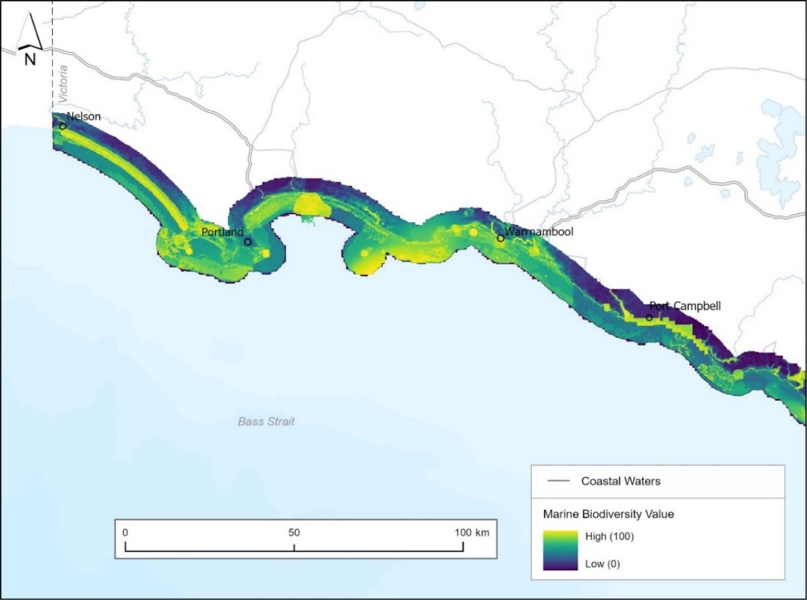
Figure 3. MBV map for the southwest marine environment. Note: Figures are provided for illustrative purposes, with spatial data available via DataVic for download and viewable via CoastKit.

3.8 Biogeographic units
Victoria's marine biogeographical settings provide a framework for describing and mapping biological communities, habitat structures, and ecosystem types across spatial scales. Located within the Temperate Australasian Realm, forming part of the Southeastern Australian Shelf Province, Victoria’s marine environment is structured into a nested hierarchy (including ecoregions, biounits, segments, and habitat zones).
These boundaries were established in 2024, using contemporary data from the CBiCS catalogue and other sources. The 2024 settings build on the 2018 version and replace the earlier Integrated Marine and Coastal Regionalisation of Australia (IMCRA), extending offshore into shelf waters and inland to align with coastal catchments.
The southwest marine environment lies within the Western Bassian ecoregion and includes 4 biounits:
- Glenelg.
- Discovery Bay.
- Cape Nelson.
- Shipwreck Coast.
Biounits are defined by dominant physical features, such as oceanography and geomorphology, and are further divided into segments and habitat zones. Further information is available here.

3.9 Conservation and protected areas
Within the southwest marine environment, ecologically and biologically significant areas include:
- Bonney Coast Upwelling (Commonwealth Key Ecological Feature).
- Biologically Important Areas for protected marine species.
- Coastal Parks (Discovery Bay Coastal Park, Bay of Islands Coastal Park).
- Commonwealth Marine Park (Nelson).
- Great Ocean Road.
- Logans Beach Exclusion Zone.
- Marine National Parks (Discovery Bay Marine National Park, Twelve Apostles Marine National Park) (refer to Figure 4).
- Marine Sanctuaries (Merri Marine Sanctuary, The Arches Marine Sanctuary).
- National Parks (Port Campbell National Park).
- Nelson reefs, Lawrence Rocks, Julia Reef, Noble Rocks, Middle Island, Helen Rock.
- Ramsar sites (Glenelg Estuary and Discovery Bay).
- South Australian Marine Park (Lower South East) (refer to Figure 4).
- Shipwreck sites (refer to Figure 4).
- Victorian Marine Asset Areas.
This list may not be exhaustive and represents the current known areas but may be revised or extended in response to future conservation priorities or policy changes.
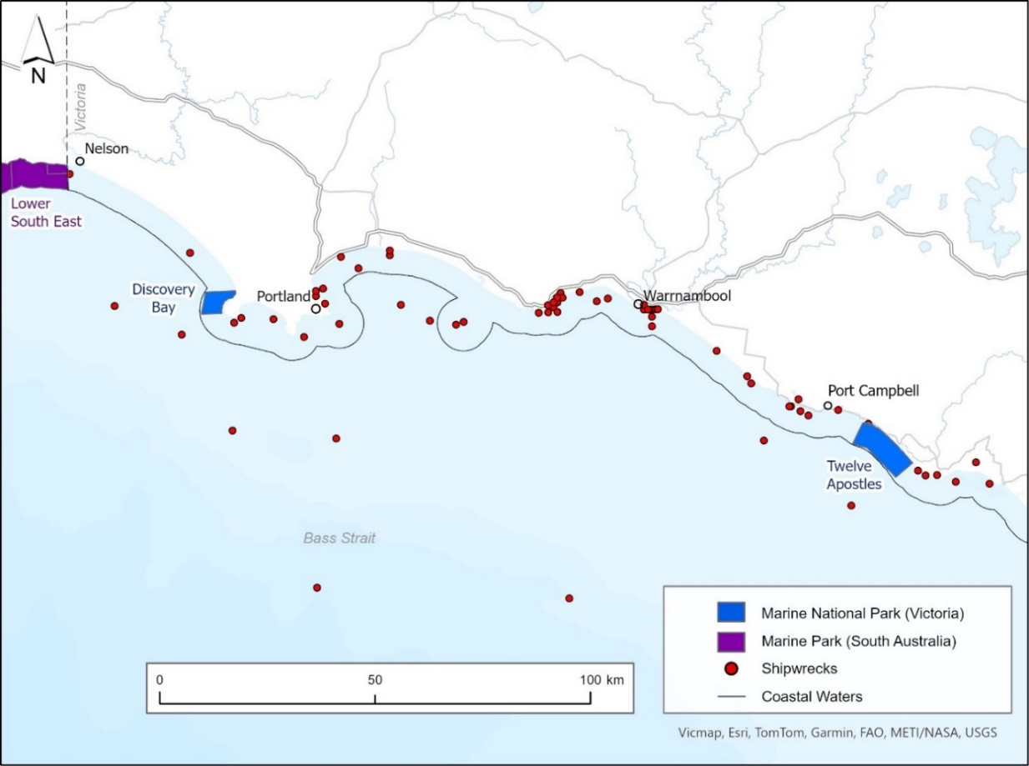
Figure 4. Marine National Parks (Victoria), Marine Park (South Australia)* and publicly available data on shipwrecks in the southwest marine environment and adjacent Commonwealth waters. Note: Figures are provided for illustrative purposes, with spatial data available via DataVic for download and viewable via CoastKit. *data available from the Collaborative Australian Protected Areas Database.

3.10 Threats and pressures
The southwest marine environment faces a range of threats and pressures that can impact ecological health, biodiversity and uses and activities. These threats include natural hazards such as inundation and coastal erosion, biological pressures such as invasive species outbreaks, and anthropogenic impacts including pollution, habitat disturbance, and climate change. Understanding and assessing these is critical for effective planning. Examples of available data that can help assessing threats and pressures within the southwest marine environment include:
- Inundation hazard and risk projections.
- Cliff hazard and risk projections.
- Erosion vulnerability hazard and risk projections.
- Historical occurrence of invasive species and pests (for example, Abalone Viral Ganglioneuritis outbreaks at onshore facilities and within wild populations at Taylors Bay).
- Indicators of ecological condition and change (for example water quality, algal blooms, and biological responses to environmental pressures).
- Climate change predictions (for example, ocean temperatures, ocean acidification).
- Density of foreshore use and infrastructure (for example, residential, and commercial dwellings, population density).
- Anthropogenic impacts such as noise pollution (for example, from oil and gas exploration), vessel traffic, fishing pressure, and marine pollution.

4 Human values, uses and activities
This section presents examples of known data on human values, uses and activities to support impact assessments, risk evaluations, and decision-making processes in marine and coastal planning and management. It highlights the broader socio-economic and cultural dimensions, focusing on the best available data, referred to as ‘examples of available data’.
Human values and uses data and information categories are based on a review of international strategic planning processes and further detailed within the Victoria's marine planning areas document. Information in this section is current as of March 2026 and may change as new data becomes available. In addition, not all data outlined may be complete, current, fit for purpose, available to access, or directly relevant, and is being provided solely as an initial high-level synthesis. Consideration should therefore be given to what further data may be required for assessment and approval processes, in addition to the data that is referenced in this document.
Custodians of available human values and uses datasets within the Victorian Government include, but are not limited to, Department of Energy, Environment and Climate Action, Department of Transport and Planning, Department of Jobs, Skills, Industry and Regions, Department of Premier and Cabinet, Victorian Fisheries Authority (including Better Boating Victoria), Parks Victoria and the Great Ocean Road Coast and Parks Authority. Commonwealth agencies, and local and regional government agencies may also hold additional datasets. Data on Victorian and adjacent Commonwealth waters is available through DataVic (viewable via CoastKit), data.gov.au and Geoscience Australia’s online map-based tool (NationalMap). Consideration for how data is best expressed (for example geographically, temporally) will depend on the data being displayed and the nature of the proposed development.

4.1 Economic, social, and cultural values
Economic, social, and cultural values are important to consider. These include the monetary value and use of marine resources, and intangible values placed by individuals, communities and/or wider society on the natural environment. Beliefs, traditions, and habits are also included in this category. Across Victoria limited information on these values exists, however the following are applicable and should be explored:
- Degree of economic and social reliance on resources.
- Economic value of the ecosystem and services.
- Places of community benefit.
- Places of cultural importance.
- Relationship between offshore development and onshore communities and economies.
- Sense of place.
- Key species.
- Diversity of local livelihoods.

4.2 Recreation, leisure, and tourism
This category focusses on recreational and leisure pursuits and has been separated into 4 sub-categories; shore-based activities (includes beach activities, biking, walking/hiking, camping, hang gliding, horse riding, dog walking/beach access), diving (includes both scuba and free/snorkel), surface-water activities (including recreational fishing, boating use, sailing, surfing, boogie boarding, kayaking, kite surfing, wind surfing, swimming, personal water craft, sporting events), wildlife viewing/sightseeing (includes photography, wildlife and sightseeing).
 | Examples of available data
Shore-based activities | - Coastal/beach activities (hiking tracks, camping sites, caravan parks, life-saving clubs)  - Beach facilities  - Designated dog on/off leash beaches and foreshores  - Beaches and foreshore areas allowing horse riding  - Piers and jetties allowing recreational fishing
Diving | - Dive sites (refer to Figure 5)  - Free/snorkel locations
Surface water activities | - Surf breaks  - Marine tours  - Marine waters where recreational fishing is allowed

4.3 Extraction of living resources
This category focusses on both commercial and recreational fishing.
 | Examples of available data
Commercial fishing | - Catch and effort data of Victorian fisheries  - Management areas, exclusion zones, fishery zones  - Catch and effort data of Commonwealth managed fisheries
Recreational fishing | - Dive harvesting areas (Abalone reefs) (refer to Figure 5)  - Fisheries Reserves  - Fishery zones

4.4 Production of living resources
This category focusses on production (at present only includes aquaculture).
 | Examples of available data
Aquaculture | - Aquaculture leases  - Aquaculture license areas (refer to Figure 5)

4.5 Marine transport
This category focusses on vessel movements or relating to the support of transport activities (including vessel moorings and maritime navigation aids).
 | Examples of available data
Marine transport | - Vessel moorings/anchorages  - Maritime navigation aids  - Shipping channels  - Waterway zones and rules - Vessel Operating and Zoning Rules (VOZR)  - Marine safety incidents  - Live vessel positions  - Vessel hot spots 2017-2022

4.6 Coastal infrastructure and management activities
This category focusses on development and management of coastal infrastructure such as ports and harbours, jetties, and boat ramps, as well as management activities such as marine search and rescue.
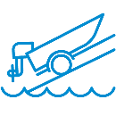 | Examples of available data
Coastal infrastructure and management activities | - Port facilities  - Marinas, wharfs, breakwaters, harbours, jetties, boat ramps  - Coastal protection structures and assets  - Coastal and marine management plans  - Marine search and rescue locations

4.7 Energy generation
This category focusses on the development, operation, maintenance, and decommissioning of structures and wider developments that generate energy or are related to energy generation (including anticipated development).
 | Examples of available data
Renewables | - Commonwealth offshore wind energy declared areas (Figure 6)
Oil and gas | - Oil and gas platforms/facilities  - Current titles, permits and licences (Figure 6)  - Petroleum pipelines  - Petroleum wells (Figure 6)  - Offshore petroleum acreage releases  - Offshore greenhouse gas acreage releases

4.8 Defence and national security
This category focusses on infrastructure and activities associated with defence and national security (including Commonwealth defence areas and prohibited areas).
 | Examples of available data
Defence and national security | - Defence prohibited areas  - Defence aviation area regulations  - Airspace information

4.9 Research
This category focusses on activities relating to the investigation and study of the marine environment for scientific and exploratory purposes (including seismic surveys).
 | Examples of available data
Research | - Victorian Coastal Monitoring Program survey locations and sites  - Research areas and sites (historical and published field studies)  - Current exploratory activities (including seismic survey locations)

4.10 Waste management activities
This category focusses on activities relating to the discharge of waste (for example, sewage and industrial wastewater discharge).
 | Examples of available data
Waste management activities | - Historical sea dumping locations  - Sewage and industrial wastewater discharge locations

4.11 Extraction and disposal of non-living resources
This category focusses on extraction and disposal of non-living resources (including dredging).
 | Examples of available data
Extraction and disposal of non-living resources | - Dredging operations  - Dredge spoil discharge sites
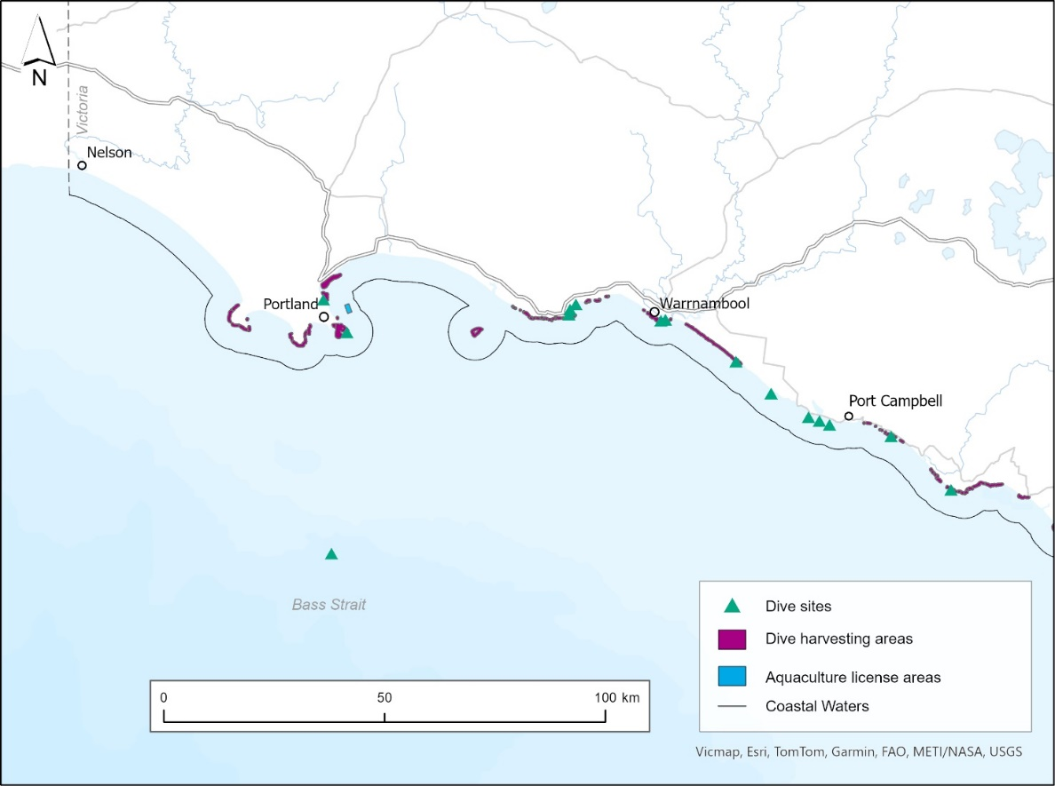
Figure 5. Publicly available data on dive site locations, dive harvesting areas, and aquaculture license areas in the southwest marine environment and adjacent Commonwealth waters. Note: Figures are provided for illustrative purposes, with spatial data available via DataVic for download and viewable via CoastKit.
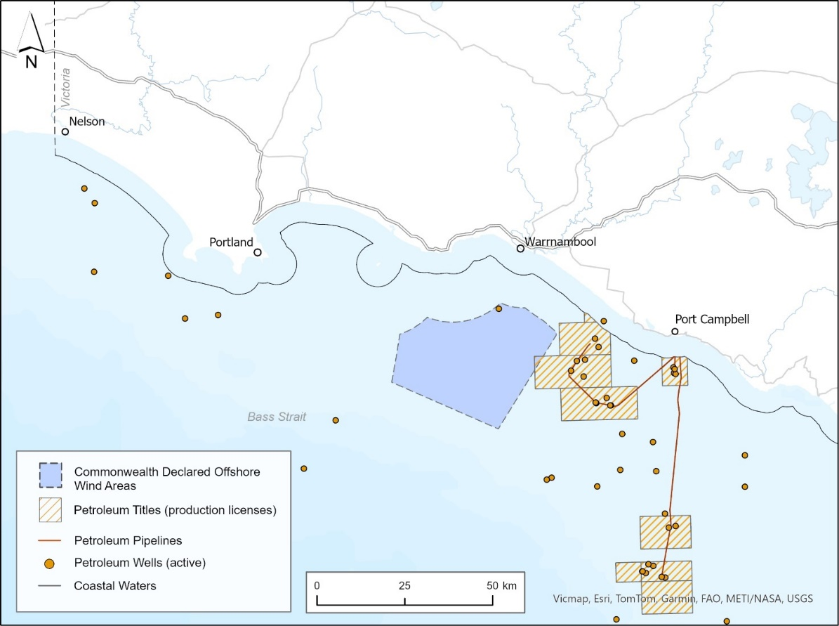
Figure 6. Publicly available data on Commonwealth offshore wind energy declared areas, petroleum titles, petroleum pipelines, and petroleum wells in the southwest marine environment and adjacent Commonwealth waters. Note: Figures are provided for illustrative purposes, with spatial data available via Geoscience Australia and the National Offshore Petroleum Titles Administrator for download. Areas identified for the 2025 Otway Offshore Petroleum Exploration Acreage Release have not been included as public consultation is underway with bidding closing in June 2026.

5 Identified data needs to aid strategic planning
This section identifies additional data needed to support future strategic planning in the southwest marine environment.
Data needs were identified through an initial synthesis drawing on the MSP Guidelines, Victoria’s marine planning areas, input from rightsholders, and advice from Victorian government agencies and departments. The list below is not exhaustive and reflects current data as of March 2026; needs may evolve over time or shift with changing priorities. Data gaps could be filled by government, researchers, or industry, with a strategic approach recommended.
As detailed in the MSP Guidelines, it is important to examine adjacent marine and terrestrial areas when undertaking strategic planning. This includes neighbouring Commonwealth waters and where resources, uses and activities, processes and/or values connect with or impact the area of interest. The extent of adjacent marine and terrestrial areas requiring consideration will depend on the characteristics of the area and the activities proposed.
Additionally, the MSP Guidelines recommend that once all available data has been collected, a data gap analysis is undertaken to identify data that is missing or in poor quality, and what the consequences of this could be. Another important part of the gap analysis includes an assessment of data quality (for example, format, spatial coverage of study area, resolution, uncertainty, previous data processing), whereby available data may need to be improved or excluded on further investigation. The initial data needs identified in this section can act as a starting point for any future gap analysis.

5.1 Traditional Owner cultural values and uses
Any strategic planning process that occurs in the southwest marine environment should be undertaken in partnership with Traditional Owners, with Traditional Owners co-leading or leading the process. Traditional Owners expect that when being engaged the principles of free, prior and informed consent be followed to support Traditional Owner self-determination. To do this, Traditional Owners must be fully resourced to build capacity to self-determine their roles, appropriate protocols, and processes, particularly in relation to Indigenous Data Sovereignty, the representation of cultural landscapes and values, and ensuring that Traditional Owner rights and objectives for Country are meaningfully reflected in both the planning process and resulting outputs.

5.2 Marine and coastal environment
According to the data underpinning the MBV map, 17 species listed under the FFG Act, the EPBC Act, or both are identified as high-priority biodiversity features for data improvement within the southwest marine environment (Table 2). It is important to note that the listed species were not selected based on their likelihood of interacting with or being affected by offshore wind infrastructure or development activities. This information is current as of March 2026, with additional species data needs likely to be identified as further information becomes available (such as Traditional Owner cultural values and socio-economic values). Note, whilst further data on the species listed in Table 2 is a priority, information on all species known to occur within the southwest marine environment is of value.
Table 2. FFG Act and EPBC Act listed species of high priority for data improvement.
Common name | Scientific name | FFG Act status | EPBC Act listed (✔)
Australian Sea-lion | Neophoca cinerea | Endangered | ✔
Blue Whale | Balaenoptera musculus | Endangered | ✔
Common Bent-winged Bat | Miniopterus schreibersii | Critically Endangered
Curlew Sandpiper | Calidris ferruginea | Critically Endangered | ✔
Eastern Curlew | Numenius madagascariensis | Critically Endangered | ✔
Fairy Tern | Sternula nereis | Critically Endangered | ✔
Great Knot | Calidris tenuirostris | Critically Endangered | ✔
Humpback Whale | Megaptera novaeangliae | Critically Endangered | ✔
Leatherback Sea Turtle | Dermochelys coriacea | Critically Endangered | ✔
Loggerhead Sea Turtle | Caretta caretta | n/a | ✔
Northern Royal Albatross | Diomedea sanfordi | n/a | ✔
Orange Bellied Parrot | Neophema chrysogaster | Critically Endangered | ✔
Shy Albatross | Thalassarche cauta | Endangered | ✔
Southern Right Whale | Eubalaena australis | Endangered | ✔
Wandering Albatross | Diomedea exulans | Critically Endangered | ✔
White Shark (great) | Carcharodon carcharias | Endangered | ✔
Wood sandpiper | Tringa glareola | Endangered | ✔
5.3 Threats and pressures
Threats, pressures, and trends of environmental indicators in response to human activities (direct or cumulative) and climate change, are important when assessing and analysing current and future characteristics of an area. Identified data needs that would help assess threats and pressures to support strategic planning include, but are not limited to:
- Coastal hazard and risk projections for the open coast.
- Understanding of coastal change via in-depth monitoring at sentinel sites.
- The ecology, sources and spatial distribution of invasive species and pests.
- Sources and levels of marine pollution (i.e., light, micro- and macroplastics, chemicals).
- Status and trends of environmental indicators.
- Cumulative impacts (especially from ongoing or repeated human activities).
- Species response to pressures and threats, including distribution and migration.
- Occurrence, drivers, and impacts of algal blooms.
Additional data needs may emerge as available data identified in Section 3.10 is investigated.

5.4 Economic, social, and cultural values
Data on economic, social, and cultural values, along with their geographic representation, is a key identified need. Mapping these values can help to identify areas of high economic, emotional, cultural, or social significance, supporting social licence and reducing the risk of late-stage conflicts or approval delays to proposed developments.
Economic values are often assessed through methods such as cost benefit analysis, cost effectiveness analysis and environmental economic accounting. Social and cultural values are typically represented using proxy indicators (for example employment) or identified through stakeholder driven activities such as participatory mapping, questionnaires and/or interviews.

5.5 Human uses and activities
To understand existing and potential areas of spatial conflict, and cross-sectoral risks and dependencies, it is important to consider human uses and activities occurring within an area. Identified data needs on uses and activities from Section 4 have been outlined in Table 3 below. The data needs identified are not exhaustive and over time these needs may change or be subject to priorities.
Table 3. Identified data needs on human uses and activities.
Use/activity category | Identified data need
Recreation, leisure, and tourism | Shore-based beach use intensity and frequency (spatial and temporal)
Recreation, leisure, and tourism | Additional dive sites/locations
Recreation, leisure, and tourism | Recreational usage (swimming, personal watercraft areas, sailing, kayaking, wind/kitesurfing locations)
Recreation, leisure, and tourism | Sporting events
Recreation, leisure, and tourism | Tourism boat/charter locations
Recreation, leisure, and tourism | Wildlife watching, photography and sightseeing locations, use, intensity, and frequency
Energy generation | Proposed renewable energy infrastructure locations, size, and density
Research | Current scientific research areas and sites
Research | Historical exploratory activities’ location, duration, timing, and intensity (including seismic surveys)
Waste management activities | Unmonitored discharge sites

What’s next?
As demand for Victoria’s marine and coastal space continues to grow, the need for clear, strategic planning has never been more important. Sectors such as tourism, shipping, fishing, aquaculture, ports, , and renewable and non-renewable energy generation are all seeking greater access to marine areas, increasing ocean industrialisation and placing increasing pressure on limited coastal and marine resources and space.
At the same time, population growth and climate change are intensifying these pressures, increasing coastal development, accelerating environmental change - and amplifying the need for resilient, adaptive management approaches.
To support sustainable development, the Victorian Government remains committed to working closely with Traditional Owners, rightsholders, and key stakeholders. Collaboration will help identify shared priorities, reduce conflicts between competing uses, and support decision making that balances environmental values, community needs and economic growth.
Effective strategic planning and implementation of marine and coastal planning processes is essential to manage overlapping interests, protect sensitive ecosystems, and guide future activities – from coastal infrastructure and marine tourism to habitat restoration and industry growth.

Appendix 1: Legislation, plans, strategies, and guidelines
The following list identifies some of the key legislation, plans, guidance documents, assessments and international agreements that may guide or impact planning and decision making in the marine and coastal environment, or that may set out requirements additional to those required under the Marine and Coastal Act 2018. This list is not exhaustive and may change as new policies and legislation are enacted or existing ones are updated. This list should be used as a guide only.

Commonwealth
Aboriginal and Torres Strait Islander Heritage Protection Act 1984 (Cth)
Australian Maritime Safety Authority Act 1990 (Cth)
Biosecurity Act 2015 (Cth)
Environmental Protection and Biodiversity Conservation Act 1999 (Cth)
Fisheries Management Act 1991 (Cth)
Maritime Transport and Offshore Facilities Security Act 2003 (Cth)
Native Title Act 1993 (Cth)
Offshore Electricity Infrastructure Act 2021 (Cth)
Underwater Cultural Heritage Act 2018 (Cth)
Underwater Cultural Heritage (Consequential and Transitional Provisions) Act 2018 (Cth)

Statewide
Acts
Aboriginal Heritage Act 2006
Catchment and Land Protection Act 1994
Climate Change Act 2017
Crown Land (Reserves) Act 1978
Emergency Management Act 2013
Energy and Public Land Legislation Amendment (Enabling Offshore Wind Energy) Act 2024
Environment Effects Act 1978
Environment Protection Act 2017
Fisheries Act 1995
Flora and Fauna Guarantee Act 1988
Forests Act 1958
Geothermal Energy Resources Act 2005
Heritage Act 2017
Land Act 1958
Marine Safety Act 2010
Mineral Resources (Sustainable Development) Act 1990
National Parks Act 1975
Offshore Petroleum and Greenhouse Gas Storage Act 2010
Petroleum Act 1998
Planning and Environment Act 1987
Pipelines Act 2005
Pollution of Waters by Oil and Noxious Substances Act 1986
Port Management Act 1995
Traditional Owner Settlement Act 2010
Transport Integration Act 2010
Water Act 1989
Wildlife Act 1975
Regulations
Aboriginal Heritage Regulations 2018
Environment Protection (Ships’ Ballast Water) Regulations 2017
Environment Protection Regulations 2021
Fisheries (Fees, Royalties and Levies) Regulations 2017
Fisheries Regulations 2019
Marine and Coastal (Prescribed Consent) Regulations 2025
Marine Safety Regulations 2012
National Parks Regulations 2013
Offshore Electricity Infrastructure Regulations 2022
Pollution of Waters by Oil and Noxious Substances Regulations 2022
Port Management (Local Ports) Regulations 2015
International Agreements
Agreement on the Conservation of Albatrosses and Petrels 2004 (ACAP)
China-Australian Migratory Bird Agreement 1988
Convention on the Conservation of Migratory Species of Wild Animals 1983 (Bonn Convention)
Convention on Wetlands of International Importance especially as Waterfowl Habitat 1971 (Ramsar Convention)
International Convention for the Control and Management of Ships’ Ballast Water and Sediments 2004
Japan-Australia Migratory Bird Agreement 1981
Republic of Korea-Australia Migratory Bird Agreement 1986
Policies, strategies, and assessments
Climate Change Adaptation Action Plans – Built Environment, Education and Training, Health and Human Services, Natural Environment, Primary Production, Transport, Water Cycle (Climate Change Act 2017)
Coastcare Victoria Strategy 2021-2026
Environment Reference Standard (Environmental Protection Authority, 2021)
Fisheries Management Plans
General Environmental Duty under the Environment Protection Act 2017
Invasive Plants and Animals Policy Framework 2010
Licensing System for Tour Operators and Activity Providers on Public Land in Victoria (Department of Environment, Land, Water and Planning, 2018)
Managing Country Together Framework 2018 (Parks Victoria)
Matters of National Environmental Significance – Significant Impact Guidelines 1.1 (2013)
Offshore Wind Energy Implementation Statements 1-4 (2022-2025)
Planning Policy Frameworks (including State, regional and local policies (municipal planning schemes))
Protecting Victoria’s Environment – Biodiversity 2037 (Department of Environment, Land, Water and Planning, 2017)
Recreational Boating Facilities Framework (Central Coastal Board, 2014)
Sites of Geological and Geomorphological Significance
South-east Commonwealth Marine Parks Network Management Plan 2025 (Director of National Parks, 2025)
State of the Marine and Coastal Environment Reports
State Maritime Emergencies (non-search and rescue) Plan (2016) and Sub-Plan (2024) (Emergency Management Victoria)
Victoria’s Biosecurity Strategy (2023) (Agriculture Victoria, Department of Energy, Environment and Climate Action)
Victoria’s Threatened Species Assessment Reports (FFG Act listed species)
Victorian Aquaculture Strategy 2017 – 2022 (Department of Economic Development, Jobs, Transport and Resources, 2017)
Victorian Cetacean Emergency Plan (Department of Environment, Land, Water and Planning, 2015)
Victorian Climate Science Report 2024
Victorian Climate Change Strategy 2021
Victorian Commercial Ports Strategy 2022 (Department of Transport)
Victorian Fisheries Authority Strategic Plan 2019 – 2024
Victorian Marine Pollution Contingency Plan 1997
Victorian Offshore Wind Energy Implementation Statements 1-4 (Offshore Wind Energy Victoria)
Victorian Recreational Boating Strategy 2021 – 2030 (Department of Transport)
Victorian Traditional Owner Cultural Landscapes Strategy (Federation of Victorian Traditional Owners, 2021)
Victorian Waterway Management Strategy 2013
Water for Victoria – Water Plan 2016 (Department of Environment, Land, Water and Planning)

Regional
Conservation Action Plans
Eastern Maar Aboriginal Corporation Sea Country Plan in preparation
Environmental Management Plans (Marine and Coastal Act 2018)
Estuary Management Plans
Great South Coast regional growth plan 2014 (Department of Transport and Planning)
Gunditjmara Nyamat Mirring Plan 2023 - 2033
Management Plans under the Fisheries Act 1995 and theNational Parks Act 1975
Port of Portland Port Development Strategy 2018 (Port of Portland Pty Ltd)
Ports Safety and Environment Management Plans, Department of Transport
Ramsar management plans
Regional and Strategic Partnership products (Marine and Coastal Act 2018)
Regional Catchment Strategies
Regional Climate Change Adaptation Strategies
Regional Waterway Strategies

Local
Coastal and Marine Management Plans (Marine and Coastal Act 2018)
Coastal hazard risk management and adaptation planning completed as part of Victoria’s Resilient Coast – Adapting for 2100+
Local Council planning strategies, place-based plans and growth area structure plans

Appendix 2: Tools glossary
The data sources and tools identified below are mentioned in this document, however this is not an exhaustive list of all sources and tools available.
Tool/ source | Details
Aboriginal Cultural Heritage Register and Information System (ACHRIS) | Online portal of the Victorian Aboriginal Heritage Register, providing resources and services to various stakeholders throughout Victoria.
Australian Government Department of Climate Change, Energy, the Environment and Water – Environmental Data portal | Catalogue of environment data and applications, including but not limited to Key Environmental Features, Matters of National Environmental Significance and the Protected Matters Search Tool.
Australian Ocean Data Network (AODN) | Interoperable online network of marine and climate data resources.
CoastKit | Knowledge management system and interactive web-mapping portal to centralise marine and coastal data stored on DataVic.
Collaborative Australian Protected Areas Database | A spatial and textual database that provides information on Australia’s protected areas at national, state and territory levels.
DataVic | Platform that provides access to Victorian Government open data.
Data.gov.au | Central source of Australian open government data published by federal, state and local government agencies.
Digital Earth Australia | Program of Geoscience Australia creating free and open satellite data products.
Features Activity Sensitivity Tool (FeAST) | A statewide marine sensitivity and risk assessment tool hosted on CoastKit. Designed for desktop use, FeAST helps users identify potential environmental impacts from proposed development by assessing risks to CBICS Level 3 habitat complexes and estimating the proportion of the top 20% of Marine Biodiversity Values (MBV) that may be affected within a development area.
Geoscience Australia | Australian Government agency housing a repository for Earth science data and knowledge.
NationalMap | Online map-based tool that allows easy access to location-based data from Australian government agencies.
Seamap | Marine decision support tool that brings together seafloor habitat maps with contextual data to facilitate understanding and management of Australia’s marine resources.

Appendix 3: Key Ecological Features (KEFs)
It should be noted that the information below is current as of March 2026. Information may change as new data becomes available, with further information available here and via CoastKit.

Key Ecological Feature (KEF)
Bay of Islands Coast
Belfast Lough Wetland
Big Reef Shelf Reef
Bridgewater Bay Ocean Beach
Cape Bridgewter Headland
Cape Duquesne Offshore Reef Complex
Cape Nelson Headland Complex
Childers Cove Coast
Deen Maar
Discovery Bay Inner Shelf Reef
Discovery Bay Ocean Beach
Discovery Bay Pelagic Area
Discovery Bay Wetlands
Fawthrop Lagoon
Fisherman Cove
Fitzroy River Wetland
Gellibrand Ocean Beaches
Gellibrand River Inlet and Wetland
Georgias Peak
Glenelg Ocean Beach and Entrance
Glenelg Offshore Pelagic Area
Glenelg Wetlands
Griffith Island
Helen Rock and Reef
Hopkins Rocky Bank
Hopkins Rocky Reef
Johanna Ocean Beach
Julia Inshore Rocky Reef
Julia Offshore Rocky Reef
Killarney Shore
Killarney Wetlands
Lion Headland Shore
Logan Beach Whale Nursery
Mepunga Coast
Merri Islands and Reefs
Minerva Rocky Reef
Moonlight Head Headland
Moyne Ocean Beach
Narrawong Ocean Beach
Nelson Rocky Reef
Noble Rocks Ocean Beach
Noble Rocks Rocky Reefs
Peterborough to Point Hesse Coast
Port Campbell Coast
Port Campbell Rocky Reef
Port Fairy Exposed Coast
Port Fairy Whale Rest Area
Portland Rocky Reefs
Shelley Beach Port Campbell
Shipwreck Shelf Coastal Krill
Shipwreck Shelf Reef
The Arches Rocky Reef
The Craigs Rocky Reef
The Gurdies Inlet
Thunder Point Headland
Twelve Apostles Rocky Reef
Tyrendarra Ocean Beach
Yambuk Ocean Beach and Entrance
Yambuk Wetland

Appendix 4: Species (MBV map)
It should be noted that the information below on the Marine Biodiversity Values (MBV) map is current as of March 2026. Information may change as new data becomes available.
Common name | Scientific name | FFG Act  status | EPBC Act listed (✔)
Aldinga Pipefish | Histiogamphelus cristatus |  | ✔
Australasian Bittern | Botaurus poiciloptilus | Critically Endangered | ✔
Australasian Gannet | Morus serrator
Australian Fur Seal | Arctocephalus pusillus doriferus |  | ✔
Australian Grayling | Prototroctes maraena | Endangered | ✔
Australian Gull-billed Tern | Gelochelidon macrotarsa | Endangered
Australian Long-nosed Pipefish | Vanacampus poecilolaemus |  | ✔
Australian Mudfish | Neochanna cleaveri | Endangered
Australian Painted-snipe | Rostratula australis | Critically Endangered | ✔
Australian Sea-lion | Neophoca cinerea | Endangered | ✔
Bar-tailed Godwit | Limosa lapponica | Vulnerable | ✔
Bigbelly Seahorse | Hippocampus abdominalis |  | ✔
Black-browed Albatross | Thalassarche melanophris |  | ✔
Black-eared Cuckoo | Chrysococcyx osculans
Black-faced Cormorant | Phalacrocorax fuscescens |  | ✔
Black-lip Abalone | Haliotis rubra
Blue Petrel | Halobaena caerulea |  | ✔
Blue Warehou | Seriolella brama | Conservation Dependent | ✔
Blue-winged Parrot | Neophema chrysostoma |  | ✔
Broadnose Sevengill Shark | Notorynchus cepedianus
Brown algae | Ecklonia radiata
Brown algae | Phyllospora comosa
Brown Skua | Catharacta skua |  | ✔
Brushtail Pipefish | Leptoichthys fistularius |  | ✔
Campbell Albatross | Thalassarche impavida |  | ✔
Cape Gannet | Morus capensis
Caspian Tern | Hydroprogne caspia | Vulnerable | ✔
Common Bent-winged Bat | Miniopterus schreibersii | Critically Endangered
Common Bottle-nosed dolphin | Tursiops truncatus |  | ✔
Common Diving-Petrel | Pelecanoides urinatrix |  | ✔
Common Greenshank | Tringa nebularia | Endangered | ✔
Common Minke Whale | Balaenoptera acutorostrata |  | ✔
Common Sandpiper | Actitis hypoleucos | Vulnerable | ✔
Common Seadragon | Phyllopteryx taeniolatus |  | ✔
Crested Pipefish | Histiogamphelus briggsii |  | ✔
Crested Tern | Thalasseus bergii
Curlew Sandpiper | Calidris ferruginea | Critically Endangered | ✔
Deepbody Pipefish | Kaupus costatus |  | ✔
Double-banded Plover | Charadrius bicinctus |  | ✔
Draughtboard Shark | Cephaloscyllium laticeps
Eastern Bent-winged Bat | Miniopterus fuliginosus | Critically Endangered
Eastern Cattle Egret | Bubulcus coromandus |  | ✔
Eastern Curlew | Numenius madagascariensis | Critically Endangered | ✔
Eastern Osprey | Pandion cristatus |  | ✔
Eastern Yellow Wagtail | Motacilla tschutschensis |  | ✔
Eelgrass | Heterozostera tasmanica | Endangered
Fairy Prion | Pachyptila turtur |  | ✔
Fairy Tern | Sternula nereis | Critically Endangered | ✔
Fin Whale | Balaenoptera physalus |  | ✔
Flesh-footed Shearwater | Ardenna carneipes |  | ✔
Fork-tailed Swift | Apus pacificus |  | ✔
Great Knot | Calidris tenuirostris | Critically Endangered | ✔
Greater Sand Plover | Charadrius leschenaultii | Vulnerable | ✔
Green Turtle | Chelonia mydas |  | ✔
Green-lip Abalone | Haliotis laevigata
Grey Plover | Pluvialis squatarola | Vulnerable | ✔
Grey-tailed Tattler | Tringa brevipes | Critically Endangered | ✔
Gummy Shark | Mustelus antarcticus
Hairy Pipefish | Urocampus carinirostris |  | ✔
Half-banded Pipefish | Mitotichthys semistriatus |  | ✔
Hooded Plover | Thinornis cucullatus | Vulnerable | ✔
Javelin Pipefish | Lissocampus runa |  | ✔
Killer Whale | Orcinus orca |  | ✔
Knifesnout Pipefish | Hypselognathus rostratus |  | ✔
Latham's Snipe | Gallinago hardwickii |  | ✔
Leatherback Sea Turtle | Dermochelys coriacea | Critically Endangered | ✔
Lesser Sand Plover | Charadrius mongolus | Endangered | ✔
Little Curlew | Numenius minutus |  | ✔
Little Egret | Egretta garzetta | Endangered
Little Penguin | Eudyptula minor |  | ✔
Little Tern | Sternula albifrons | Critically Endangered | ✔
Loggerhead Sea Turtle | Caretta caretta |  | ✔
Long-nosed Fur Seal | Arctophoca forsteri | Vulnerable | ✔
Magpie Goose | Anseranas semipalmata | Vulnerable | ✔
Marsh Sandpiper | Tringa stagnatilis | Endangered | ✔
Mother-of-Pearl Pipefish | Vanacampus margaritifer |  | ✔
New Zealand Wandering Albatross | Diomedea antipodensis |  | ✔
Northern Royal Albatross | Diomedea sanfordi |  | ✔
Orange Bellied Parrot | Neophema chrysogaster | Critically Endangered | ✔
Pacific Golden Plover | Pluvialis fulva | Vulnerable | ✔
Pectoral Sandpiper | Calidris melanotos |  | ✔
Plumed Egret | Ardea intermedia plumifera | Critically Endangered | ✔
Porbeagle | Lamna nasus
Port Jackson Shark | Heterodontus portusjacksoni
Port Phillip Pipefish | Vanacampus phillipi |  | ✔
Pugnose Pipefish | Pugnaso curtirostris |  | ✔
Pygmy Right Whale | Caperea marginata |  | ✔
Rainbow Bee-eater | Merops ornatus |  | ✔
Red Knot | Calidris canutus | Endangered | ✔
Red Pipefish | Notiocampus ruber |  | ✔
Red-capped Plover | Charadrius ruficapillus |  | ✔
Red-necked Avocet | Recurvirostra novaehollandiae |  | ✔
Red-necked Stint | Calidris ruficollis |  | ✔
Ringback Pipefish | Stipecampus cristatus |  | ✔
Risso's Dolphin | Grampus griseus |  | ✔
Ruddy Turnstone | Arenaria interpres | Endangered | ✔
Rufous Fantail | Rhipidura rufifrons |  | ✔
Salvin's Albatross | Thalassarche salvini |  | ✔
Sanderling | Calidris alba |  | ✔
Satin Flycatcher | Myiagra cyanoleuca |  | ✔
Sawtooth Pipefish | Maroubra perserrata |  | ✔
School Shark | Galeorhinus galeus
Sharp-tailed Sandpiper | Calidris acuminata |  | ✔
Short-beaked Common Dolphin | Delphinus delphis |  | ✔
Shorthead Seahorse | Hippocampus breviceps |  | ✔
Short-tailed Shearwater | Ardenna tenuirostris |  | ✔
Shy Albatross | Thalassarche cauta | Endangered | ✔
Silver Gull | Chroicocephalus novaehollandiae |  | ✔
Smooth Pipefish | Lissocampus caudalis |  | ✔
Smooth Stingray | Dasyatis brevicaudata
Soft-plumaged Petrel | Pterodroma mollis |  | ✔
Sooty Shearwater | Ardenna grisea |  | ✔
Southern Bent-winged Bat | Miniopterus orianae bassanii | Critically Endangered | ✔
Southern Bluefin Tuna | Thunnus maccoyii | Conservation Dependent | ✔
Southern Humpback Whale | Megaptera novaeangliae australis | Critically Endangered | ✔
Southern Right Whale | Eubalaena australis | Endangered | ✔
Spiny Pipehorse | Solegnathus spinosissimus |  | ✔
Spotted Pipefish | Stigmatopora argus |  | ✔
Terek Sandpiper | Xenus cinereus | Endangered | ✔
Tucker's Pipefish | Mitotichthys tuckeri |  | ✔
Upside-down Pipefish | Heraldia nocturna |  | ✔
Wandering Albatross | Diomedea exulans | Critically Endangered | ✔
Wedge-tailed Shearwater | Ardenna pacifica
Whimbrel | Numenius phaeopus | Endangered | ✔
White-bellied Sea-Eagle | Haliaeetus leucogaster | Endangered | ✔
White-capped Albatross | Thalassarche steadi |  | ✔
White Shark (great) | Carcharodon carcharias | Endangered | ✔
White-throated Needletail | Hirundapus caudacutus | Vulnerable | ✔
Widebody Pipefish | Stigmatopora nigra |  | ✔
Wood Sandpiper | Tringa glareola | Endangered | ✔
Yellow-bellied Sheathtail Bat | Saccolaimus flaviventris | Vulnerable



Commonwealth of Australia (2013) Matters of National Environmental Significance, Significant impact guidelines 1.1 Environment Protection and Biodiversity Conservation Act 1999.
The State of Victoria Department of Energy, Environment and Climate Action (DEECA) (2023). Marine Spatial Planning Guidelines. Melbourne, Australia.
The State of Victoria Department of Energy, Environment and Climate Action (DEECA) (2023). Victoria’s Marine Planning Areas. Melbourne, Australia.
Ibid.
Victorian Environmental Assessment Council (VEAC) (2019). Assessment of the Values of Victoria’s Marine Environment – Atlas, Melbourne. The VEAC is a statutory body established to conduct investigations, assessments and provide advice as requested by the Victorian Government on environment and natural land matters.
The State of Victoria Department of Energy, Environment and Climate Action (DEECA) (2023). Marine Spatial Planning Guidelines. Melbourne, Australia.
The State of Victoria Department of Energy, Environment and Climate Action (DEECA) (2023). Victoria’s Marine Planning Areas. Melbourne, Australia.
The State of Victoria Department of Energy, Environment and Climate Action (DEECA) (2023). Marine Spatial Planning Guidelines. Melbourne, Australia.
Ibid.
The State of Victoria Department of Energy, Environment and Climate Action (DEECA) (2023). Victoria’s Marine Planning Areas. Melbourne, Australia. Note: Section 2.2 is an excerpt from this document which was written in partnership with Traditional Owners.
Biologically Important Areas for protected marine species (BIAs) designated by DCCEEW.
Eastern Maar Aboriginal Corporation Sea Country Plan (in prep) and Gunditjmara Nyamat Mirring Plan 2023-2033.
United Nations Declaration on the Rights of Indigenous Peoples, GA Res 61/295, UN Doc A/RES/61/295 (2 October 2007, adopted 13 September 2007) (‘UNDRIP’), article 31.
Two versions available – VCDEM (2017) available for download through the AODN and VCDEM (2021) available by contacting the Victorian Coastal Monitoring Team.
Thom, B.G., Eliot, I., Eliot, M., Harvey, N., Rissik, D., Sharples, C., Short, A.D. and Woodroffe, C.D. (2018). National sediment compartment framework for Australian coastal management. Ocean & Coastal Management, 154:103-120.
Edmunds, M., Flynn A., Ferns, L. (2021). Combined Biotope Classification Scheme (CBiCS). A New Marine Ecological Classification Scheme to Meet New Challenges. The State of Victoria Department of Environment, Land, Water and Planning, Melbourne, Australia.
Mazor, T., Watermeyer, K., Hobley, T., Grinter, V., Holden, R., MacDonald, K. and Ferns, L. (2023). Statewide marine habitat map. Habitat complex modelling method (CBiCS Level 3). The State of Victoria Department of Energy, Environment and Climate Action (DECCA), Melbourne, Australia.
Edmunds, M., Ferns, L.W., Macdonald, K. and Suarez-Carvajal, L.M. (2025). Victoria’s irreplaceable marine biotopes: Guidance. Department of Energy, Environment and Climate Action (DEECA), Melbourne, Australia.
Ibid
Mazor, T., Watermeyer, K., Hobley, T., Grinter, V., Holden, R., MacDonald, K. and Ferns, L. (2023). Statewide marine habitat map. Habitat complex modelling method (CBiCS Level 3). The State of Victoria Department of Energy, Environment and Climate Action (DECCA), Melbourne, Australia.
Holden, R. and Macdonald, K. (2023). Feature Activity Sensitivity Tool (FeAST) Guidelines. The State of Victoria Department of Energy, Environment and Climate Action (DEECA), Melbourne, Australia.
Edmunds, M., Ferns, L.W., Macdonald, K. and Suarez-Carvajal, L.M. (2025). Victoria’s irreplaceable marine biotopes: Guidance. Department of Energy, Environment and Climate Action (DEECA), Melbourne, Australia.
Ninth meeting of the Conference of the Parties to the Convention on Biological Diversity, Annex I, Decision IX/20.
Department of Environment, Australia Government (2015). South-east marine region profile: A description of the ecosystems, conservation values and uses of the South-east Marine Region.
Australian Government Department of Climate Change, Energy, the Environment and Water Protected Matters Search Tool.
The State of Victoria Department of Energy, Environment and Climate Action (DEECA) (2024). Marine Biodiversity Values (MBV) Map, Marine Knowledge, Biodiversity Division, Melbourne, Australia.
To note: Of the 311 biodiversity features analysed statewide, only 263 had the minimum data requirements to be assessed, therefore this sample may not be representative of the entire area.
Edmunds, M. (2024). Marine biogeographical settings and ecosystem domains in Victoria. Report to Victorian Department of Energy, Environment and Climate Action. Australian Marine Ecology Report No. 586. Melbourne, Australia.
Edmunds, M. and Flynn, A. (2018). Victorian marine biogeographical settings, Australian Marine Ecology Report No. 559. Report to the Department of Environment, Land, Water and Planning, Melbourne, Australia.
The Commonwealth of Australia (2006). A Guide to the Integrated Marine and Coastal Regionalisation of Australia Version 4.0. Department of the Environment and Heritage, Canberra, Australia.
Biologically Important Areas for protected marine species (BIAs) designated by DCCEEW.
Kent, J. and Jenkins, G.P. (2012). Ecological descriptions of the significant marine environmental assets of Victoria: Interim Report. Fisheries Victoria Technical Report No. 177. Department of Primary Industries, Queenscliff, Victoria, Australia.
The State of Victoria Department of Energy, Environment and Climate Action (DEECA) (2023). Victoria’s Marine Planning Areas. Melbourne, Australia.
Coastkit@deeca.vic.gov.au, Contact DataVic | data.vic.gov.au
Vicmap Planning and Vicmap Transport | data.vic.gov.au
vahr@dpc.vic.gov.au, Heritage Services (FPSR) | https://www.firstpeoplesrelations.vic.gov.au/aboriginal-cultural-heritage
info@greatoceanroadauthority.vic.gov.au
The State of Victoria Department of Energy, Environment and Climate Action (DEECA) (2024). Great Ocean Road Coast and Parks Environmental-Economic Account. Melbourne, Australia.
The State of Victoria Department of Energy, Environment and Climate Action (DEECA) (2023). Marine Spatial Planning Guidelines. Melbourne, Australia.
The State of Victoria Department of Energy, Environment and Climate Action (DEECA) (2023). Victoria’s Marine Planning Areas. Melbourne, Australia.
The State of Victoria Department of Energy, Environment and Climate Action (DEECA) (2023). Marine Spatial Planning Guidelines. Melbourne, Australia.
Ibid.
The State of Victoria Department of Energy, Environment and Climate Action (DEECA) (2024). Marine Biodiversity Values (MBV) Map, Marine Knowledge, Biodiversity Division, Melbourne, Australia.

