Blue Carbon Statement
Table of Contents
Victoria’s Blue Carbon Statement 2
Blue Carbon In Victoria 4
Opportunities 9
Outcome 1 13
Outcome 2 15
Outcome 3 19
Implementing blue carbon initiatives 22
Publication information 24

Victoria’s Blue Carbon Statement
The Victorian Government is committed to improving the condition and ecological connectivity of blue carbon ecosystems in partnership with Traditional Owners, land managers and communities. This includes both maintaining existing ecosystems and restoring those that are degraded or lost. The Blue Carbon Statement sets a statewide direction and approach for leveraging blue carbon opportunities in Victoria.
Victoria’s blue carbon ecosystems include saltmarshes, seagrass meadows and mangroves. They play a vital role in storing carbon and supporting climate change adaptation, while delivering a wide range of other environmental, cultural and economic benefits. However, these ecosystems have been impacted by development, agriculture, invasive species, pollution and climate change. When they’re degraded or lost, centuries’ worth of stored carbon can be released, which reduces their capacity to mitigate climate change, along with many of their other functions.
This Statement sets a coordinated and strategic approach to maintaining and restoring Victoria’s blue carbon ecosystems. It guides government investment and partnerships through three key outcomes that reflect their climate, cultural and economic value.

Outcomes
- Integrating blue carbon ecosystem protection and restoration in policy, planning and management
- Promoting the delivery of blue carbon restoration projects by building capacity
- Facilitating blue carbon projects through access to markets and other financial mechanisms.

Our collective opportunity
We can build a shared understanding, unlock investment, inform policy and strengthen Victoria’s climate resilience and economic growth. This Statement contributes to the implementation of the Marine and Coastal Strategy 2022, and highlights Victoria’s commitment to protecting and restoring coastal wetland habitats and biodiversity. This Statement identifies priorities that will lead to the protection and restoration of blue carbon ecosystems and explores opportunities for a blue carbon market in Victoria. It aims to coordinate efforts across government, rightsholders, land managers, investors and communities, to take practical steps toward improving the condition and ecological connectivity of blue carbon ecosystems.

About this Statement
This Statement was developed by DEECA in collaboration with Traditional Owners, government agencies and stakeholders, through a desktop review and listening tour (covering identified policy barriers, market access issues and roles/responsibilities). This Statement outlines outcomes and priorities for advancing blue carbon ecosystem protection and restoration in Victoria. Outcomes describe the long-term objectives for blue carbon ecosystem protection and restoration. Each outcome includes a list of priorities which highlight key areas for action and collaboration. Some priorities are already being progressed through existing programs and initiatives, while others may be pursued as new funding, partnerships and opportunities arise. The priorities are not intended as fixed or time-bound commitments and can be advanced by any rightsholder or stakeholder.

Blue Carbon In Victoria
Blue carbon is the carbon stored in the plants and soils of coastal and marine ecosystems. Mangroves, saltmarshes and seagrass are recognised as blue carbon ecosystems because they absorb carbon dioxide from the atmosphere and store it in vegetation and soil for long periods. Other ecosystems, including supratidal forests and kelp forests, also store carbon, although their role in long-term carbon storage in Victoria is less understood.

Why are they important?
Blue carbon ecosystems mitigate climate change by storing carbon up to 30–50 times faster than forests, while also protecting coastlines from erosion, flooding, and sea level rise. They support rich biodiversity and livelihoods such as fishing and aquaculture, improve water quality, promote food security, and support cultural values. Altogether, the ecosystem services they provide are estimated to be worth around $120 billion per year.
2.3 million tonnes of carbon is currently stored in coastal vegetation and soils¹

Why protect and restore?
- Secure long-term economic, cultural and environmental benefits.
- Restore wetlands as a nature-based solution to climate change and coastal hazards.
- Addresses significant wetland loss (around 35% globally since 1970) and prevents further decline.
- Supports climate change commitments under the Paris Agreement and the Climate Change Act 2017.
192,000 tonnes of carbon sequestered per year¹

Current protection
- Marine reserves and sanctuaries.
- National and State Parks.
- Wetlands listed under the Ramsar Convention on Wetlands.
- UNESCO biosphere reserves.

Threats
- Habitat loss and degradation from coastal development, land clearing and altered hydrology.
- Pollution limiting growth and reducing carbon storage potential.
- Climate change causing ecosystem loss and die-off through warming, extreme events and sea-level rise.
- Ecosystem degradation or loss that releases stored carbon reducing climate change mitigation capacity and threatening other co-benefits.

Current extent of Blue Carbon¹
- Seagrass 42,812 ha
- Saltmarsh 13,286 ha
- Mangroves 2,313 ha
Figure 1: The current extent of blue carbon ecosystems in Victoria, along with areas of high restoration potential under future sea level rise scenarios.
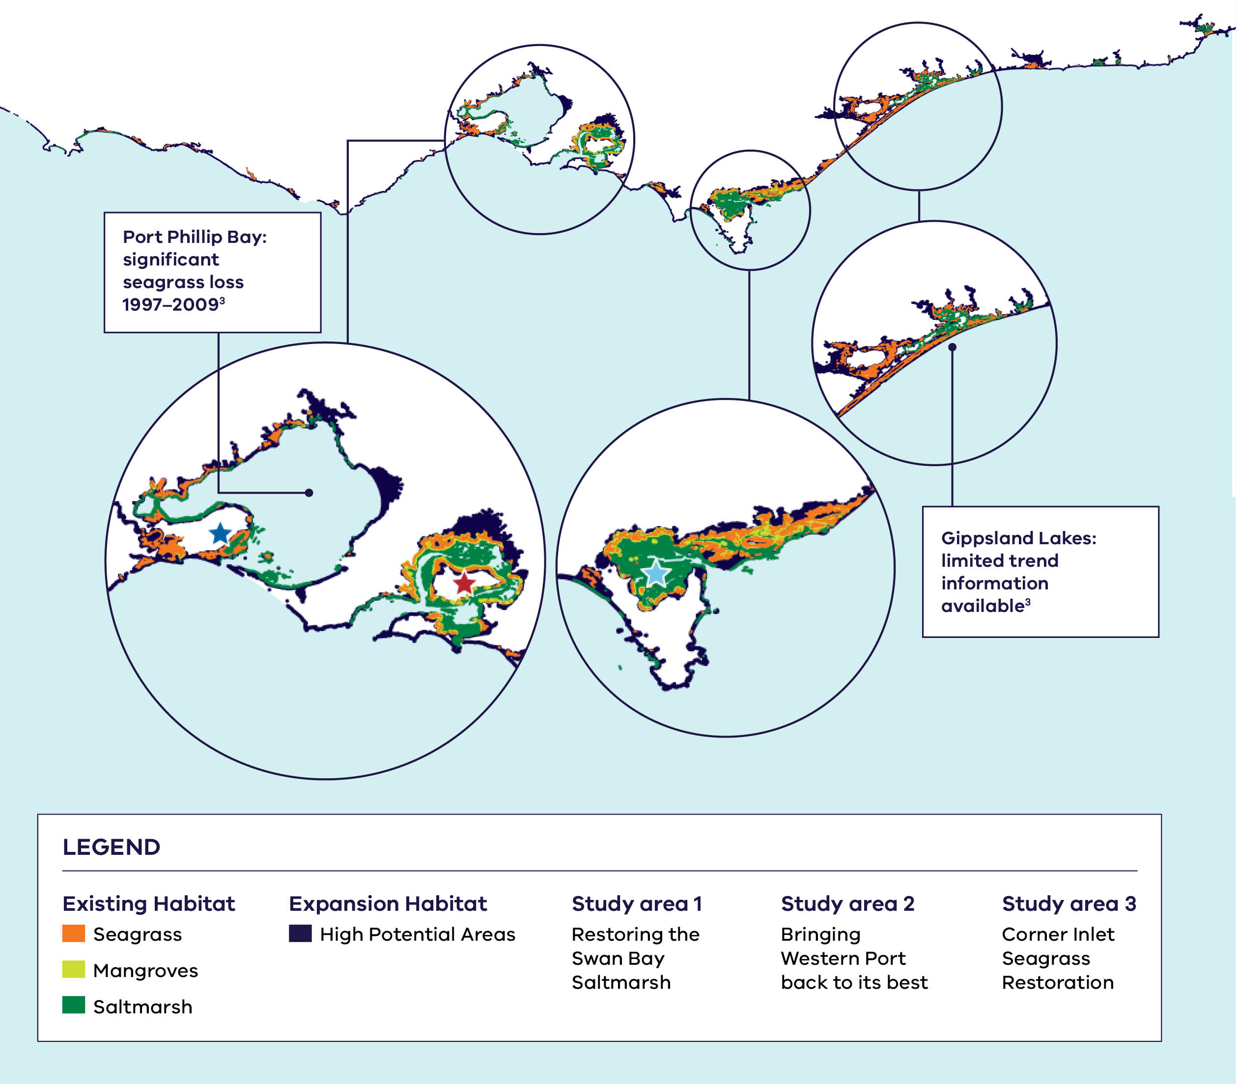
Map data: Mazor, T., Watermeyer, K., Costa, M., Carnell, P., MacDonald, K., Holden, R., Grinter, V., Hobley, T., Ferns, L. (2023) Mapping Victoria’s Blue Carbon, The State of Victoria, Department of Energy, Environment and Climate Action (DEECA)
Figure 1 description: The map shows the current extent of saltmarsh, seagrass and mangrove ecosystems along Victoria's coastline, together with areas of high restoration potential under future sea level rise scenarios. Significant historical losses of saltmarsh and mangrove are concentrated at Lonsdale Lakes, the western shoreline of Port Phillip Bay, Anderson Inlet, Shallow Inlet, Powlett–Kilcunda, Corner Inlet and Nooramunga. Losses reflect long-term change since the mid-19th century, based on the State of the Marine and Coastal Environment 2021 Report and Mapping Victoria's Blue Carbon (2023).

Opportunities
The extent and condition of blue carbon ecosystems can be maintained by protection and improved through targeted restoration on public and private land. Protection is more cost-effective when ecosystems are in good condition, while restoration needs vary in disturbed or threatened areas depending on habitat condition and disturbance levels. Tailoring restoration to site-specific conditions improves resource efficiency and ecosystem benefits. High-potential areas have been mapped to guide restoration, including existing ecosystems and areas suitable for expansion. Where restoration increases carbon sequestration, opportunities may arise to engage with carbon markets and emerging nature finance methods.

Methods to restore
Blue carbon ecosystems can be restored by removing tidal barriers, fencing habitats to prevent trampling and vehicle damage, planting seedlings and enhancing germination in suitable areas, reducing pollution, managing livestock, controlling weed and pest species, and supporting community education and behaviour change.

Shared goals
By preserving long-term carbon stocks and minimising emissions from habitat loss, blue carbon projects can support progress towards Victoria’s net-zero emissions target and Australia’s 30 x 30 Biodiversity Target (protecting 30% of the world’s land and oceans by 2030).

Unlocking nature finance
Nature finance refers to the financial mechanisms and strategies that help fund the protection, restoration and sustainable management of natural ecosystems, while also promoting social and economic benefits. When businesses and the financial sector use these tools, they can contribute to conservation efforts led by governments, non-government organisations, philanthropic organisations and volunteer groups.In Australia, a key finance mechanism to support carbon-focussed restoration projects is the Australian Carbon Credit Unit (ACCU) Scheme. The Scheme supports new projects that reduce emissions or store carbon using approved methods, such as reintroduction of tidal flows, and is administered by the Clean Energy Regulator in accordance with legislation overseen by the Department of Climate Change, Energy, the Environment and Water.

Supporting self‑determination
The Statement provides opportunities to empower Traditional Owner stewardship and incorporate Traditional Owner knowledge into project design and delivery.
Supporting self-determination means creating real opportunities for Traditional Owners to lead, influence, and guide blue carbon projects on their Country that they choose. Recognising the cultural, ecological, and biocultural significance of blue carbon ecosystems helps strengthen stewardship and ensure Traditional Owner knowledge is embedded in project design and delivery.
Traditional Owners have the right to make decisions that reflect their priorities and aspirations, consistent with the Native Title Act 1993 (Cth), Traditional Owner Settlement Act 2010, Aboriginal Heritage Act 2006, the Victorian Charter of Human Rights and Responsibilities Act 2006, and the Statewide Treaty process. Respecting these rights enables self‑determined participation and supports a fair, culturally grounded approach.
By involving Traditional Owners early and transparently in any blue carbon activities, projects can unlock environmental, economic, cultural, and climate co‑benefits. Ensuring Traditional Owners are informed, included, and able to participate on their terms is essential to meaningful partnership.

Why and when a landowner might protect and restore blue carbon ecosystems?
Landowners and organisations might choose to protect or restore blue carbon ecosystems for environmental, financial, or social reasons. This could include increasing improving biodiversity or land condition for future generations, enhancing property amenity and value, or contributing to local conservation efforts. In some cases, blue carbon projects align with broader environmental, philanthropic, or corporate social responsibilities.
A business case often emerges if land has become less productive, or increasingly vulnerable to environmental pressures like flooding, erosion or salinity. In these situations, protection or restoration can provide a viable alternative land use that enhances long-term resilience.
Landowners may benefit through:
- alternative income streams, through carbon and biodiversity markets
- reduced exposure to flood and coastal erosion risks
- improved water quality and habitat values
contribution to local and regional climate mitigation efforts.
Before proceeding, landowners should consider:
- potential changes to existing land uses
- long-term maintenance and monitoring requirements
- approval processes and regulatory requirements
legal or financial obligations, such as conservation covenants and offset agreements.

Challenges for landholders and land managers
While there are many benefits and opportunities linked to restoring blue carbon ecosystems, there are also a range of challenges facing landholders and land managers who want to restore blue carbon ecosystems. These include:
- complex policy and legislative settings, including land tenure rights, application processes and regulatory obligations relating to carbon accounting
- limited industry support, funding and coordinated landholder action
- difficulty accessing reliable information, data (including baseline monitoring), and knowledge gaps in methods for protecting and restoring blue carbon ecosystems
- concern about the impact on historic family farming traditions, or monitoring requirements impacting how landholders manage their property
- understanding the financial risks and opportunity costs associated with blue carbon projects.

Outcome 1

Integrating blue carbon ecosystem protection and restoration into policy, planning and management
Incorporating the protection and restoration of blue carbon ecosystems into Victoria’s policy, planning and management helps safeguard and reinforce their environmental, social and climate benefits. Blue carbon restoration projects face a complex regulatory environment, often navigating the same approval processes as high-impact development proposals. There is an opportunity to clarify, strengthen and streamline legislation, regulatory processes and planning frameworks that better support projects which deliver positive environmental outcomes. This includes those within existing protected areas.

What this outcome enables
- Evidence-based decision making
- Clearer approval processes
Planning for the future of blue carbon ecosystems

Priorities
- Embed Traditional Owner rights, knowledge, and assertions for Sea Country within policy, planning, and regulatory processes, in line with Free, Prior and Informed Consent (FPIC) and genuine partnership from the earliest possible stages. This includes respecting Indigenous Cultural and Intellectual Property (ICIP) practices for blue carbon ecosystem protection and restoration.
- Clarify interactions with rights and property boundaries, to protect blue carbon ecosystems under current regulatory frameworks and future sea-level rise scenarios.
- Explore opportunities to refine and streamline existing legislation and policies, to support blue carbon ecosystem migration and climate adaptation.
- Plan for rising sea levels by incorporating projections into land and sea planning that enable landward migration. This can help to maintain ecosystem health and preserve carbon sequestration potential.
- Support efforts to clarify and simplify the approval process for blue carbon restoration projects, including exploring dedicated pathways that meet regulatory requirements.
- Promote the integration of blue carbon ecosystems into marine and coastal planning (including Coastal and Marine Management Plans and coastal hazard responses guided by the Victorian Resilient Coast Framework), through data and knowledge-sharing.
- Provide guidance and decision-support tools to evaluate the benefits of restoration, including impacts on productive land, flood and erosion protection, and other ecosystem services.

Outcome 2

Promoting the delivery of blue carbon restoration projects by building capacity
The Victorian Government is committed to enhancing the state’s blue carbon ecosystem capabilities. While mapping has identified potential sites across Victoria, large-scale implementation remains constrained by low awareness, limited landholder engagement, a lack of demonstrated projects, inaccessibility of practical information, and complex registration requirements. This outcome aims to strengthen community and private landholder knowledge and skills, through education, engagement, access to science and data and demonstration projects.

What this outcome enables
- Maintained and improved protected areas
- Greater community awareness and involvement
- Knowledge exchange
Stronger engagement by land managers

Priorities
- Support Traditional Owner-led blue carbon ecosystem restoration, through knowledge sharing, capacity building, and access to science and data.
- Progress finer-resolution ecosystems mapping, to identify priority restoration areas, and inform on-ground marine and coastal planning that balances ecological, social and economic outcomes.
- Explore opportunities to quantify the ecosystem services and benefits of habitats, to better understand their value and inform future investment.
- Encourage sharing results from restoration projects, including measurable outcomes such as carbon stocks, biodiversity and restoration extent, to guide future projects.
- Encourage restoration projects on private land through conservation covenants and incentives.
- Raise awareness and understanding of the opportunities and benefits of blue carbon ecosystems among rightsholders and stakeholders, to enable more informed decision-making.
- Explore ways to maintain (and potentially strengthen) support for community groups, volunteer organisations and citizen science programs contributing to blue carbon ecosystem restoration, on both public and private land. This includes collaborating to implement projects in areas with high blue carbon potential and communicating the benefits of restoration.
- Explore more ways to support blue carbon restoration projects at identified demonstration sites.
Support the effective management and spatial analysis of existing protected areas to maintain ecosystems and inform future management.

Bringing Western Port Bay back to its best
Work on Bunurong Country is assessing and planning for blue carbon ecosystem restoration opportunities within Western Port Bay. Western Port Bay and eastern Port Phillip Bay contain an estimated 24% of the state’s coastal blue carbon ecosystems, with the area currently capturing nearly a third of Victoria’s overall blue carbon (31.5%). Several smaller-scale initiatives have taken place across the Western Port Bay region over the last 10 years, including:
- Planting mangrove seeds and seedlings to reduce coastal erosion. A multi-decade effort, led by the Western Port Seagrass Partnership, and championed by many groups including, Bunurong Land Council Aboriginal Corporation, Bass Coast Landcare, OzFish, Western Port Biosphere, local councils and universities.
- Baseline monitoring of seagrass beds and a targeted erosion study at Lang Lang (led by the Western Port Biosphere Foundation).
- Seagrass seed collection efforts and restoration trials, transplanting shoots, cores and seeds (led by Blue Carbon Lab, in collaboration with Deakin’s EcoGenetics lab, Melbourne Water, VRFish and community volunteers).
- Site assessments detailing the extent, condition and restoration potential of blue carbon ecosystems across Western Port’s four local government areas (and French Island). Raising awareness of blue carbon opportunities among private landholders and identifying possible restoration actions (led by Western Port Biosphere Foundation and Bass Coast Landcare Network).
- Trialling direct seeding and transplantation of saltmarsh plants and mangroves into 3D biodegradable structures (led by RMIT Centre for Nature Positive Solutions in collaboration with the Blue Carbon Lab).
Using innovative ‘living shoreline’ techniques at Jam Jerrup to combat coastal erosion, including trialling mangrove seedlings in custom honeycomb concrete planters (led by University of Melbourne and funded by DEECA).
Recently the Western Port Biosphere Foundation, in partnership with RMIT University, launched a three-year initiative to restore critical coastal wetlands. The work, which is supported by funding from The Ian Potter Foundation, aims to restore and protect mangroves and saltmarsh, and monitor ecosystem health. It is also engaging private landholders and the broader community in nature-based climate solutions.

Restoring the Swan Bay Saltmarsh
The saltmarsh at Swan Bay is located on Wadawurrung Country near Queenscliff. It’s a valuable blue carbon ecosystem that supports native wildlife and provides natural protection against climate impacts. Having been degraded over time by agriculture and landscape changes, it’s now being restored by excluding livestock and allowing natural tidal flows and vegetation recovery to take place.
The Swan Bay Saltmarsh Restoration project is making this possible. It’s a collaborative coastal wetland rehabilitation initiative, led by the Blue Carbon Lab (in partnership with the Bellarine Catchment Network and Bellarine Landcare Group, along with support from the Port Phillip Bay Fund). The project is using low-cost, low-impact techniques to restore degraded farmland back to vital coastal saltmarsh ecosystems.
Citizen scientists play a key role in monitoring ecological changes over time, highlighting how important community involvement and cross-sector collaboration can be in restoring coastal ecosystems and improving climate resilience. This project offers a scalable, cost-effective restoration model that can inform future conservation and blue carbon initiatives.

Outcome 3

Facilitating blue carbon projects through access to markets and other financial mechanisms
Blue carbon projects can generate credits under schemes such as the Australian Carbon Credit Unit (ACCU). However, the current methodology has limited application in Victoria and doesn’t currently provide a pathway for Victorian projects to earn ACCUs. Complex administrative and technical requirements add further limitations This outcome aims to strengthen partnerships, improve understanding of existing and emerging market mechanisms, and explore alternative funding pathways. By fostering collaboration, supporting method development and promoting cost-effective approaches, it seeks to lay the groundwork for future crediting opportunities and increase the impact of blue carbon projects.

What this enables
- Access to funding and incentives
- Market and regulatory knowledge
Networks linking landholders, developers and service providers

Priorities
- Partner with Traditional Owners to understand the potential pathways for Traditional Owner-led projects, including registration under the Australian Carbon Credit Unit (ACCU) Scheme.
- Engage with the Commonwealth to explore new market methods that reduce barriers for landowners, while encouraging participation in carbon and nature-based protection schemes such as the ACCU Scheme.
- Collaborate with partners to advance blue carbon methods for future market participation, including livestock exclusion and invasive species management.
- Promote cost-effective approaches that reduce barriers and improve the feasibility of blue carbon restoration projects.
- Communicate opportunities to reduce or regain restoration project costs, to improve the outcomes of viability and feasibility assessments.
- Explore hybrid market approaches, including cost-sharing, incentives and non-market finance mechanisms, to improve project viability for landholders and encourage broader uptake of restoration projects.
- Work with partners (like Water Corporations and Catchment Management Authorities) to identify restoration sites that meet emissions reduction requirements and deliver benefits to both parties.
- Support studies to identify additional restoration methods, feasible sites and efficient monitoring approaches.

Corner Inlet Seagrass Restoration
Corner Inlet on Gunaikurnai Country in Victoria’s south-east is a Ramsar-listed wetland of international importance. Corner Inlet supports extensive seagrass (Posidonia australis) meadows that provide critical habitat for fish, invertebrates and migratory birds, underpinning valuable commercial and recreational fisheries. However, declines in water quality, increased sedimentation and historical disturbance have contributed to significant seagrass loss (up to 90%) in parts of the area. The Corner Inlet Posidonia Partnership, led by OzFish in partnership with the Yarram Yarram Landcare Network and Corner Inlet commercial and recreational fishers, combined scientific expertise and local knowledge to reverse the decline through targeted seagrass restoration.
Restoration focused on collecting naturally released seagrass fruit and storing them under controlled conditions until germination occurred, at which time fresh seeds were returned to restoration sites. To keep seeds in place, restoration sites were prepared with sandbag snakes crafted from biodegradable hessian. This approach, while still experimental, supported the natural recovery process by creating shelter to assist seedlings during establishment.
Community participation was central to the success of the project, with commercial and recreational fishers actively involved. Commencing in August 2022 and finishing in June 2023, the project linked habitat restoration with fisheries stewardship, to demonstrate how collaborative, practical interventions can contribute positively to ecosystem recovery.

Implementing blue carbon initiatives
Victoria’s blue carbon ecosystem priorities will be delivered through existing programs, policy frameworks and partnerships. The Victorian Government will embed blue carbon ecosystem objectives into established and emerging initiatives in-line with marine, coastal, climate and biodiversity outcomes.
Many of the priorities outlined in this Statement will be progressed through:
- Regulatory streamlining, including tools like the Marine and Coastal Act toolkit, for approvals on Crown Land.
- Land use and conservation planning frameworks like the Plan for Victoria (specifically Action 12 – Protect and enhance our canopy trees) and Parks Victoria’s Conservation Action Plans.
- Regional ecosystem and landscape strategies, including the Regional Waterway Strategies and Regional Catchment Strategies developed by Victoria’s Catchment Management Authorities, which guide the integrated management of land, water and biodiversity at a regional scale.
- Integrated marine and coastal planning tools that support coordinated management of marine and coastal environments, including Coastal and Marine Management Plans.
- Data and decision-support platforms like CoastKit and FeAST, which provide the evidence base to guide blue carbon planning and monitoring.
- Site-specific initiatives like the Adapt West Regional and Strategic Partnership, and the Moolap Wetland Environmental Masterplan.
- Policy guidance, such as on coastal-managed transition (retreat), which is being developed through a three-year project (which aims to support the managed transition of property and assets impacted by coastal hazards and rising sea levels).
- Community-led programs, including Coastcare Victoria, which play a key role in local engagement.

Publication information

Acknowledgement of Victorian Traditional Owners
We acknowledge and respect Victorian Traditional Owners as the original custodians of Victoria’s land and waters, their unique ability to care for Country and deep spiritual connection to it.
We honour Elders past and present whose knowledge and wisdom has ensured the continuation of culture and traditional practices.
DEECA is committed to genuinely partnering with Victorian Traditional Owners and Victoria’s Aboriginal community to progress their aspirations.

Copyright
© The State of Victoria Department of Energy, Environment and Climate Action, August 2026.

Creative Commons
This work is licensed under a Creative Commons Attribution 4.0 International licence, visit the Creative Commons website.
You are free to re-use the work under that licence, on the condition that you credit the State of Victoria as author. The licence does not apply to any images, photographs or branding, including the Victorian Coat of Arms, and the Victorian Government and Department logos.
ISBN 978-1-76176-252-9 (pdf/online/MS word)

Disclaimer
This publication may be of assistance to you but the State of Victoria and its employees do not guarantee that the publication is without flaw of any kind or is wholly appropriate for your particular purposes and therefore disclaims all liability for any error, loss or other consequence which may arise from you relying on any information in this publication.

Accessibility
To receive this document in an alternative format, phone the Customer Service Centre on 136 186, email customer.service@deeca.vic.gov.au, or contact National Relay Service on 133 677 or visit the National Relay Service website. This document is available on the DEECA website.
End of document.

Costa, M.D.P., Wartman, M., Macreadie, P., Ierodiaconou, D., Morris, R., Nicholson, E., Pomeroy, A., Young, M., Carnell, P. (2022) Mapping the benefits and costs of management actions for coastal wetlands in Victoria. Report submitted to the Department of Environment, Land, Water and Planning. Deakin University, Australia.
Ramsar Convention on Wetlands. (2018) Global Wetland Outlook: State of the World’s Wetlands and their Services to People. Gland, Switzerland: Ramsar Convention Secretariat. global-wetland-outlook.ramsar.org/gwo-2018
Commissioner for Environmental Sustainability Victoria (2021) State of the Marine and Coastal Environment 2021 Report.
Rasheed, A.R., Greiner, R., Costa, M.D.P., Macreadie, P. and Wartman, M. (2025) Exploring Australian landholders' readiness to restore coastal wetlands: Motivations, challenges and opportunities for blue carbon projects on private land. Journal of Environmental Management 395.
Rowland, P.I., Carnell, P.E. and Wartman, M. (2025) Navigating Permits: A Review of Coastal Wetland Restoration Approvals in Victoria. Ecological Management and Restoration 26(3).
Costa, M.D.P., Palacios, M.M., Macreadie, P. (2022) Blue carbon opportunities at a local scale within Western Port Bay and eastern Port Phillip Bay. Deakin University, Australia.

