DEECA marine and coasts newsletter
Issue 16 September 2023
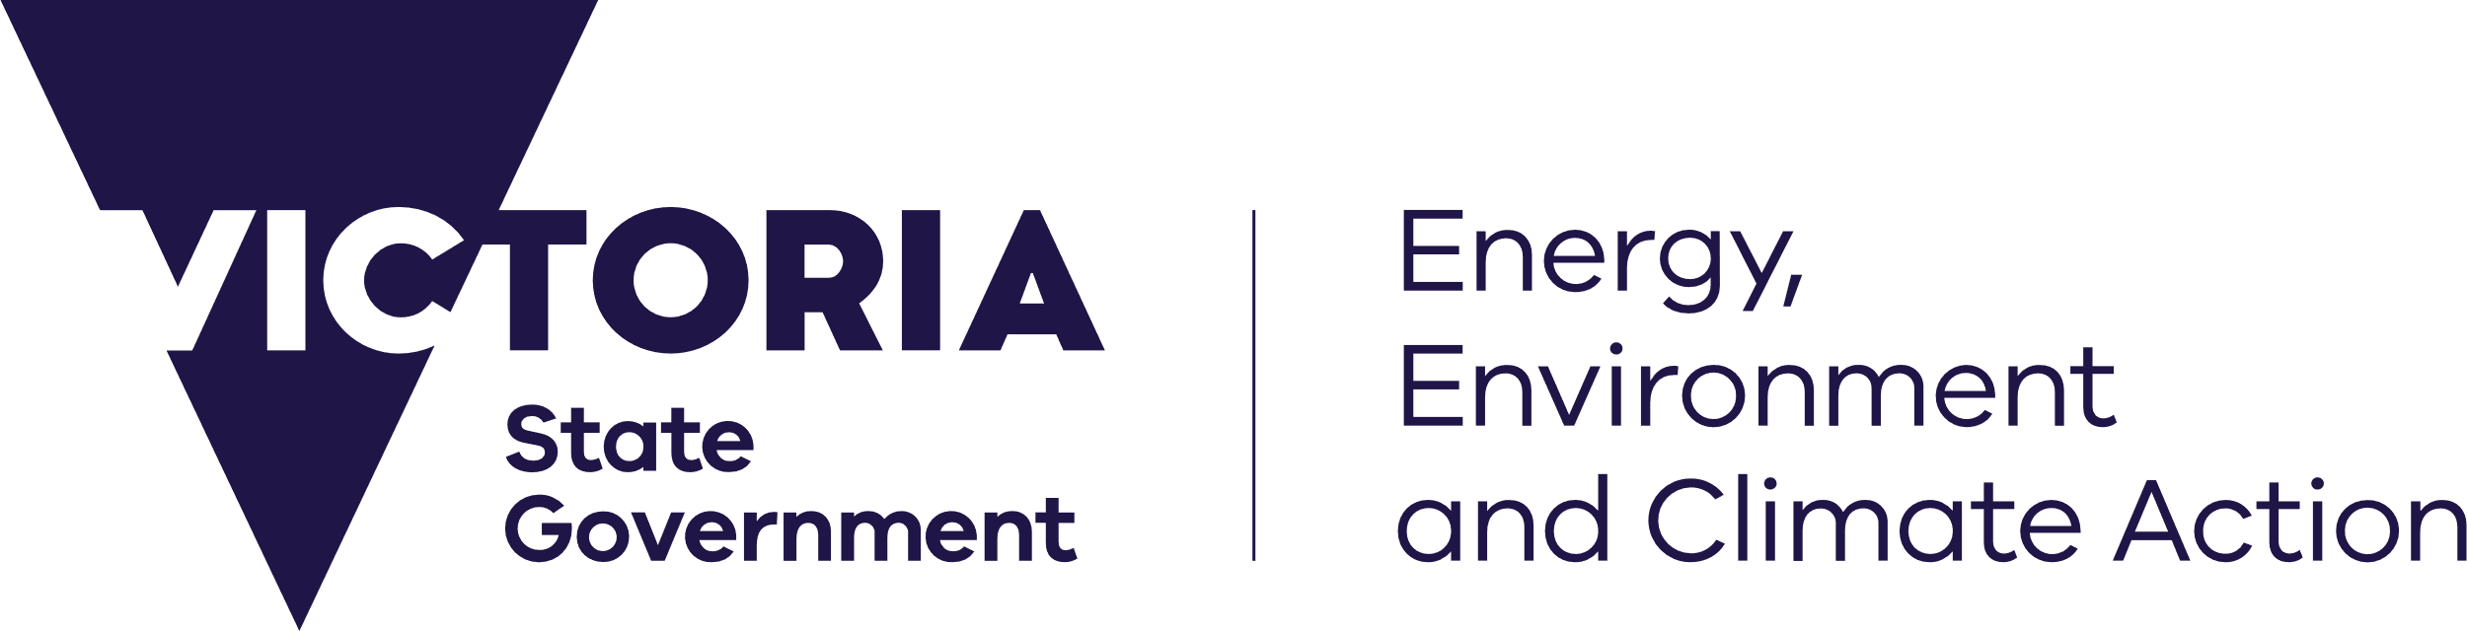
deeca.vic.gov.au

Welcome to the Department of Energy, Environment and Climate Action’s (DEECA’s) marine and coasts quarterly newsletter.

In this issue
- Victoria’s Resilient Coast – Adapting for 2100+ framework and guidelines
- Victoria’s Resilient Coast Grants Round 3 now open
- Consents and world class surf events
- Silverleaves beach nourishment
- Plenty to sea at Port Phillip Bay forum
- Victorian Coastal Monitoring Program research projects update
- Cape to Cape Resilience Project Draft Resilience Plan
- Coastcare Victoria’s ‘Coastline’
Email marine.coasts@delwp.vic.gov.au to subscribe or unsubscribe or for more information.

Marine and coastal reforms

Victoria’s Resilient Coast – Adapting for 2100+ framework and guidelines
The Victoria’s Resilient Coast – Adapting for 2100+ framework and guidelines are now available at: www.marineandcoasts.vic.gov.au/marine-coastal-management/victorias-resilient-coast-adapting-for-2100
The guidelines:
- outline Victoria’s strategic approach to coastal hazard risk management and adaptation
- were developed with collaborative partners across the State over 2021–2022
- are made under the Marine and Coastal Act 2018, and must be followed when planning, assessing and managing coastal hazard risk under the Marine and Coastal Policy (2020).
Also available on the website are three supporting technical reports:
- Coastal hazards extended guideline.
- Adaptation actions compendium.
- An economic approach to inform adaptation.
Thank you to all who contributed to the development of these materials, and to those across our coastal hazards community of practice who are leading the way with implementation.

Victoria’s Resilient Coast Grants Round 3 now open
DEECA’s Resilient Coast team are pleased to share that Round 3 of Victoria’s Resilient Coast Grants Program is now open.
Grants of up to $200,000 are available for land managers to progress strategic coastal hazard risk management and adaptation. This may include technical, engagement, strategic planning and management activities that are aligned to one or more stages of Victoria’s Resilient Coast framework.
Details on the assessment process and eligibility criteria are provided in the application guidelines, at www.marineandcoasts.vic.gov.au/marine-coastal-management/victorias-resilient-coast-adapting-for-2100.
Eligible organisations are encouraged to apply. Applications close 4 pm Friday 17 November 2023.
Applications are submitted via the online portal: https://deeca.my.site.com/publicform?id=a0h8u000000bzeq
For further information please contact the team at vicresilientcoast@delwp.vic.gov.au.

Coastal projects

Barwon South West

Consents and world class surf events
One of the roles of DEECA’s Land and Built Environment (LBE) team in our Barwon South West region is to manage applications for consent to use or develop, or undertake works on, marine and coastal Crown land.
Recently, the LBE team played a pivotal role in the approval process for the World Surf League (WSL) to hold the 2023 Bioglan Bells Beach Longboard Classic at Djarrak (Bells Beach) on Wadawurrung Country, held from 30 August to 2 September 2023.
The team is proud to have worked with the Surf Coast Shire to facilitate the competition, which is the only World Longboard Tour event to be held in Australia. Events like this help showcase the Victorian coastline to a global audience, boosting tourism in the off-peak visitor season and injecting money into local businesses.
If you’d like to know more about consent for use, development and works on marine and coastal Crown land, please visit www.marineandcoasts.vic.gov.au/marine-coastal-management/guidelines.

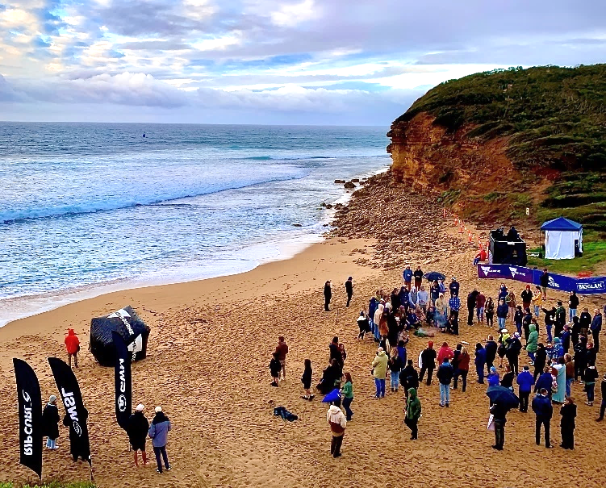
The world’s best longboarders gather for the Welcome to Country and Official Opening Ceremony for the Bells Beach Longboard Classic, 30 August 2023.

Gippsland

Silverleaves beach nourishment
DEECA has worked with the Bass Coast Shire to successfully deliver a beach nourishment at Silverleaves on Phillip Island.
The beach nourishment is an interim response to increased erosion and loss of vegetation and habitat caused by a recent storm event. The works were completed on 25 August 2023.
DEECA is now undertaking a coastal process study to understand the coastal hazards and dynamics along this stretch of coast. This will help inform future adaptation planning for Silverleaves.
Bass Coast Shire and DEECA continue to work together to closely monitor the shoreline at Silverleaves ahead of the coastal process study works.
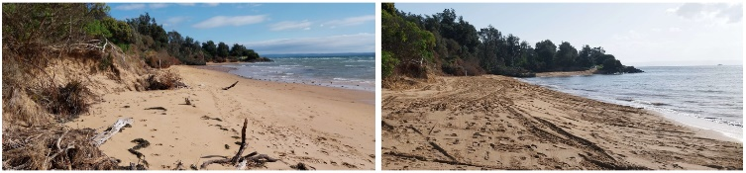
Left: Silverleaves foreshore looking east, prior to beach nourishment, 21 August 2023. Right: Following beach nourishment, 25 August 2023.
Find out more about coastal erosion and beach nourishments at www.marineandcoasts.vic.gov.au/marine-coastal-management/coastal-erosion.

Marine and coastal knowledge

Plenty to sea at Port Phillip Bay forum
DEECA’s Port Phillip Bay Forum at the Melbourne Convention Centre on Wurundjeri Country was a
fin-tastic success! The event had over 90 attendees from across the Bay, with local government, universities, Traditional Owner groups and community organisations all represented.
Organised by DEECA’s Biodiversity Division Marine and Knowledge Unit and Port Phillip Bay Fund teams, the forum was an opportunity for stakeholders to come together, celebrate their achievements and share their knowledge and priorities going forward.
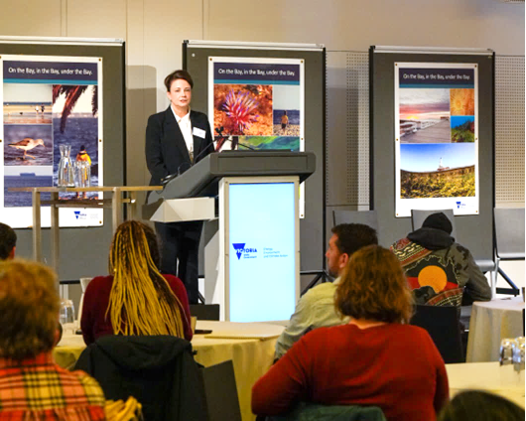
Sara Harbidge, Executive Director Biodiversity opens the Forum. Photo credit: Marcia Riederer.
The presentation from the past and current Warreen Beek Ranger students was a key highlight for many who attended.
Funded in part by the Port Phillip Bay Fund, the Certificate III in Conservation and Ecosystem management course was designed by the Bunurong Land Council Aboriginal Corporation and Wurundjeri Naarap Team for First Nations people. This course has been delivered in partnership with Trust for Nature since 2017. The students reflected on the value of learning traditional land management practices and caring for Country.
Attendees learnt more from the researchers about the Spider Crab project, Port Phillip Bay Seafloor Integrity, Port Phillip EcoCentre’s ‘Marine Pestwatch’ project, Parks Victoria’s Golden Kelp Forest project, and heard from DEECA about environmental volunteering.
Participants then had the opportunity to reflect on their priorities for the Bay and discuss what they see as the key challenges and potential investments needed to protect Port Phillip Bay into the future.
These discussions will contribute to future design of the Port Phillip Bay Fund and 5-yearly evaluation of the Port Phillip Bay Environmental Management Plan.
Feedback for the event highlighted the invaluable connection building, the engaging topics, and the chance to hear new and different perspectives.
Thanks to everyone who helped make the day a success and in particular to Katelyn McAdams and Cara Dowe!
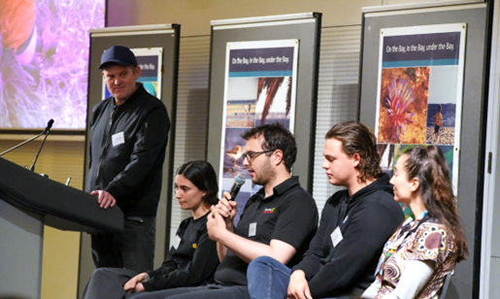
Ben Cullen, Trust for Nature (standing) facilitated discussions with Warreen Beek students (Sara, Andrew, Ben and Chelsea). Photo credit: Marcia Riederer.
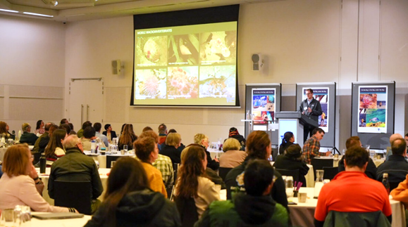
Parks Victoria’s Michael Sams presents on his work restoring Golden Kelp Forests in Port Phillip Bay. Photo credit: Marcia Riederer.

Victorian Coastal Monitoring Program research projects update
The Victorian Coastal Monitoring Program (VCMP) was established in 2017 to monitor waves and coastal changes at priority sites along Victoria’s coastline. A number of recent updates have significantly advanced the VCMP in collaboration with our esteemed partners.
The VCMP team has pioneered the development of essential coastal erosion warning indicators (EWI) and an erosion hotspot detector (EHD) for VCMP sites. This allows us to assess erosion status and automatically identify areas of recent high erosion, respectively.
These standardised indicators serve as indispensable resources for environmental management plans, benefiting land managers, project managers, and the general public by providing crucial insights into coastal conditions.
Our partners at Melbourne University – led by Professor Alexander Babanin – have extended the high-resolution wave-current coupled hindcast models, examining various sea level rise scenarios.
Our collaborators at Tonkin + Taylor – led by Dr. Eddie Beetham – have introduced a groundbreaking 'hybrid' shoreline dynamics model for eastern Port Phillip Bay. This model plays a pivotal role in understanding historical and future coastal dynamics within the context of a changing climate.
These groundbreaking studies garnered immense interest and attention when presented at the Australasian Coasts and Ports Conference 2023, held in August.

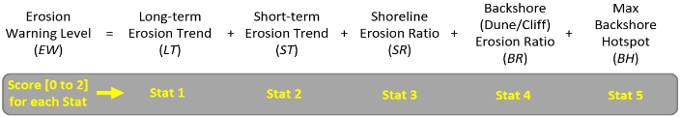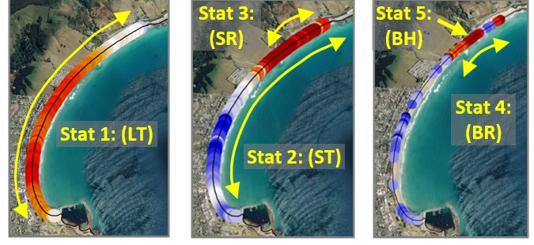
Erosion Warning Indicator (EWI) tool.
For more information, please reach out to the VCMP team at vcmp@delwp.vic.gov.au.

Cape to Cape Resilience Project Draft Resilience Plan
The Cape to Cape Resilience Project is Victoria’s first regional coastal hazard adaption strategy to be developed using the Victoria’s Resilient Coast – Adapting for 2100+ framework and guidelines.
Since our last update, we’ve made significant progress, and the dedicated efforts of the project team and consultants have resulted in the completion of the final draft Cape to Cape Resilience Plan.
The draft Resilience Plan is the culmination of technical work combined with extensive stakeholder and community consultation. It outlines a long term, collaborative, strategic approach to managing the impacts of climate change and coastal hazard on this dynamic coast. It aims to enhance and support the resilience of the region's communities, values and assets in the face of our evolving climate challenges.
In June 2023, we received the Stage 2 Economics Report and Stage 2 Data Update and Adaptation Modelling Report, which looked at other localities in the study area to supplement the work completed in Stage 1. These were used to inform the preferred adaptation pathways in the resilience plan.
In July, we released project update #9, which highlights the progress made since Stage 2 engagement was completed in April 2023.
In August 2023, the Project Control Board endorsed the final draft of the Resilience Plan. The team is actively engaged in briefing project partners, including the two local government authorities and Parks Victoria, ensuring alignment with the broader goals of partner agencies, local communities, and other coastal land managers. These briefings are vital to secure the necessary support and identify how partners will be involved in implementing the actions in the Resilience Plan.
The final draft Resilience Plan will be released for formal public consultation and feedback from community and stakeholders once approved by the Minister for Environment.
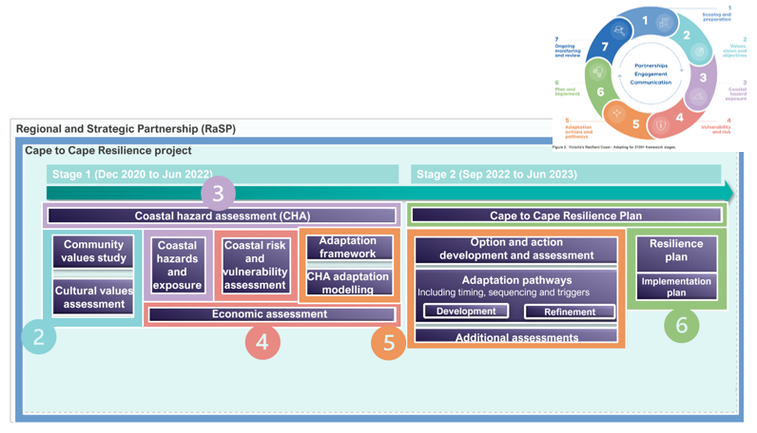 The Cape to Cape Resilience Project aligns with stages of Victoria’s Resilient Coast – Adapting for 2100+ framework. Image: Alluvium, 2023.
The final Resilience Plan will be the ‘product’ of the Inverloch Regional and Strategic Partnership (RaSP), the first RaSP product under the Marine and Coastal Act 2018.
Do you want to know more? Check out the hazard maps and read our latest updates at the project website: www.marineandcoasts.vic.gov.au/coastal-programs/cape-to-cape-resilience-project.
The hazard maps for the Inverloch Coastal Hazard Assessment and now live on CoastKit! To interact with the maps, visit https://mapshare.vic.gov.au/coastkit/
Keep reading for Coastcare Victoria’s ‘Coastline’

In this issue
- Successful applicants for the Coastcare Victoria Community Grants 2023
- Summer by the Sea 2024
- Coastcare Victoria Schools Kit Professional Development
- Engaging diverse groups in Environmental Volunteering webinar
- Caring for Sea Country workshops
- Looking out for our southern right whales

Successful applicants for the Coastcare Victoria Community Grants 2023
Congratulations to the 40 projects that secured funding through this year’s $350,000 Coastcare Victoria Community Grants Program!
The grants program helps volunteers and community groups to continue their work to conserve, restore and protect coastal and marine environments for current and future generations to enjoy.
The list of recipients is at www.marineandcoasts.vic.gov.au/coastal-programs/coastcare-victoria/coastcare-victoria-community-grants
Well done to all grant recipients and thank you to the thousands of passionate and highly valued volunteers who care for Victoria's over 2,000 km of coastline.
The Coastcare Victoria team have been meeting with this year’s grant recipients to discuss project deliverables and identify and workshop challenges early in the process.
The Coastcare Victoria team have found it extremely rewarding to meet such passionate people and we look forward to seeing the outcomes of these incredible and diverse projects.
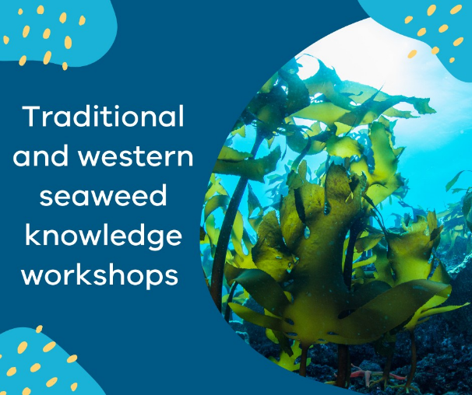
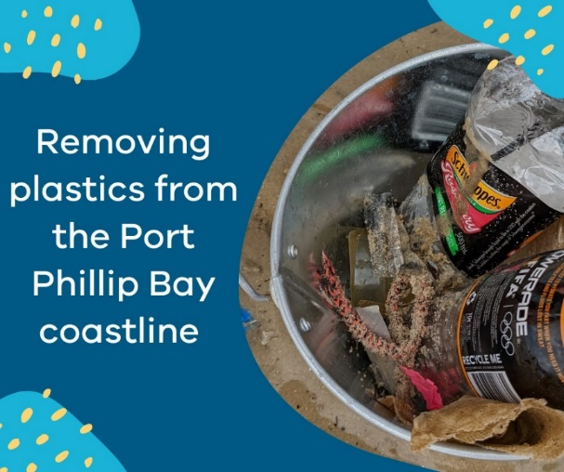
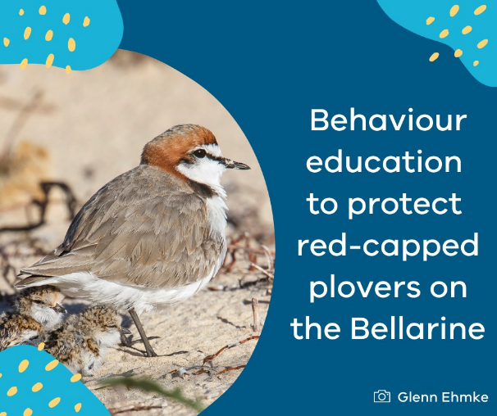
Some of the grants awarded by the 2023 Coastcare Victoria Community Grants Program.

Summer by the Sea 2024
The Coastcare Victoria team has been busy planning for the annual Summer by the Sea program in 2024.
The theme is ‘You, Me and Summer by the Sea’, which is all about bringing community together to care for our marine and coastal environment.
Summer by the Sea will be running from Saturday 6 January to Thursday 25 January 2024.
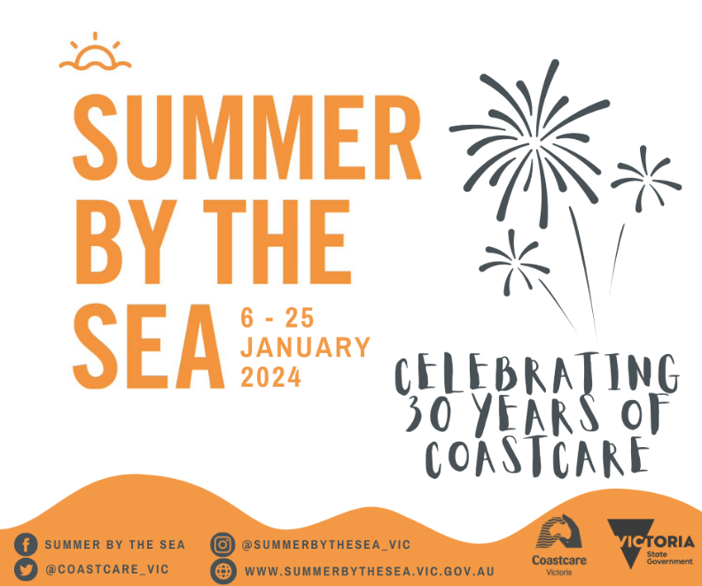
Expressions of Interest from professional providers who can help deliver the program next year have recently closed, and we are so excited to see what activities they will bring!
If you have any questions, please email coastcare.victoria@delwp.vic.gov.au.

Coastcare Victoria Schools Kit Professional Development
Empower your students to become future coastal environmental activists!
Ecolinc and Coastcare Victoria have joined forces to deliver an exciting 2-hour professional development program focused on familiarising and upskilling teachers in the use of the Coastcare Victoria Schools Kit.
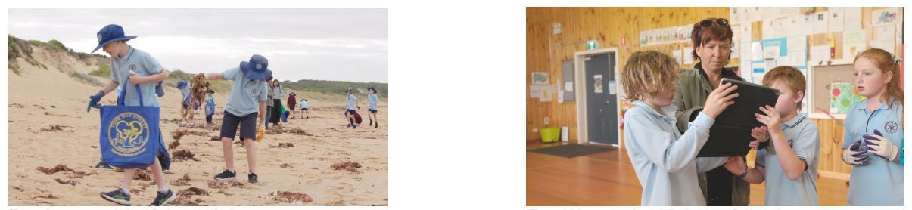
Teachers can register now to attend the 2-hour Coastcare Victoria Schools Kit Professional Development program.
You will:
- understand how the Coastcare Victoria Schools Kit fits into current Department of Education and school priorities, and how to translate coastal and marine conservation into the classroom
- be engaged in hands-on activities provided in the Kit
- learn how to implement the Kit’s activities into the classroom
- learn how to empower your students to volunteer and become active coastal stewards (delivered
by the Museum of Democracy Education team)
- network with other teachers.
Booking details:
- Date: Thursday 12 October 2023
- Time: 2 pm – 4 pm
- Afternoon tea provided
- Venue: Victorian Academy of Teaching and Leadership, 5A Little Ryrie St, Geelong
- To book: Eventbrite

Engaging diverse groups in Environmental Volunteering webinar
Bellarine Catchment Network and Cultura are hosting an online event on 3 October 2023: ‘Engaging diverse groups in Environmental Volunteering’.
Victoria has a strong history of environmental volunteering, with volunteers contributing enormously to improving our environment, our local communities and our economy.
More than 170,000 volunteers are currently volunteering for the environment and this webinar will explore resources and tools for engaging diverse groups.
The presenters will share a resource guide and training video. These explore practical ways to develop environmental volunteering that is inclusive for all people.
Booking details:
- Date: Tuesday 3 October 2023
- Time: 2 pm – 3 pm
- Venue: Online event
- Register here

Caring for Sea Country workshops
Coastcare Victoria recently joined forces with Traditional Owner Corporations across the state to deliver seven hugely popular workshops to our valued marine and coastal volunteers from across Victoria. The sessions were led by Traditional Owners from respective areas and were open to all Coastcare Victoria community networks.
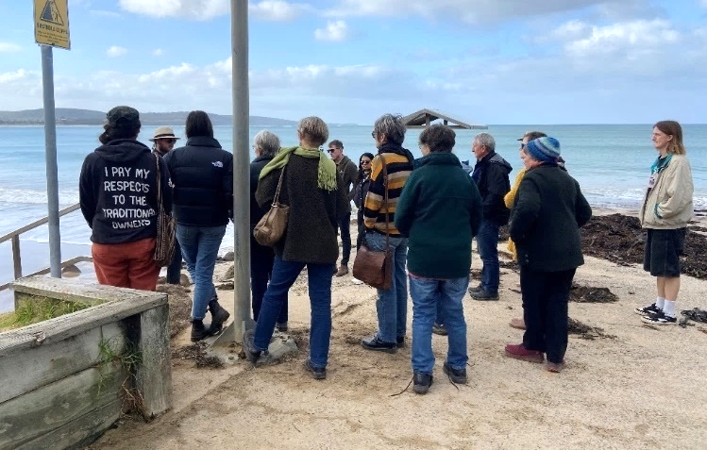
Participants soaking up knowledge from Ash of Wadawurrung Traditional Owners Aboriginal Corporation, near Anglesea.
Participants travelled far and wide to come together on the lands of the Peek Whurrong and Gadubanud people of the Eastern Maar Nation, the Boon Wurrung people of the Kulin Nation, the Tatungalung people of the Gunaikurnai Nation, and the Wathaurong people of the Wadawurrung Nation.
Sessions were held in Point Lonsdale, Anglesea, Warrnambool, Apollo Bay, Frankston, Inverloch, and Lakes Entrance.
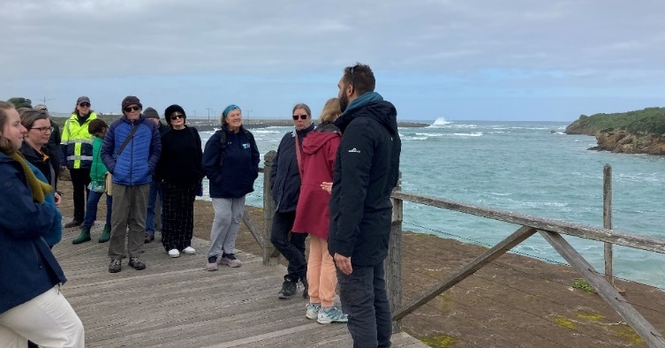
Warrnambool coastal walk, led by Billy from Eastern Maar Aboriginal Corporation.

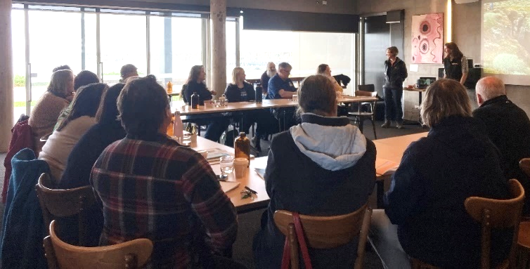
A fabulous mix of participants at Warrnambool.
Volunteers benefited from on-Country walks and cultural heritage knowledge sharing, heard personal accounts of family history, learnt about coastal land management, and had the chance to handle ancient indigenous artefacts.
Sessions were diverse and included important dialogue about assessing and respecting sites of cultural heritage significance and removing barriers to align with Traditional Owner aspirations for Sea Country, so that we as volunteers, community, and environmental stewards can contribute to care for Sea Country.
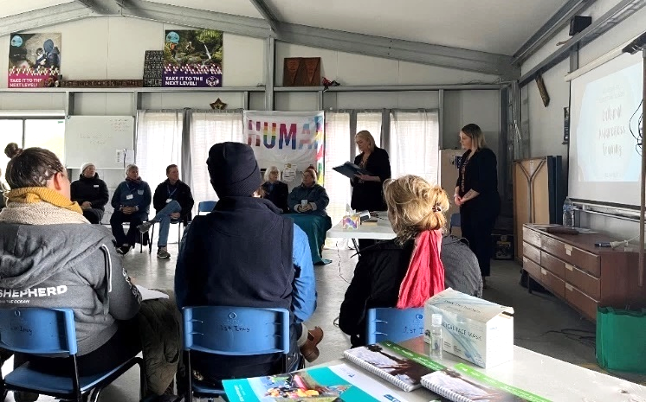
Inverloch participants enjoying the workshop, hosted by Jill, from Nomuckerlener Indigenous Consulting and Mentoring.
The depth and breadth of information shared by the presenters prompted strong reflection and engagement, and Coastcare Victoria thanks all attendees for actively participating. We were thrilled with the immense interest in the workshops, and the opportunity to continue to strengthen partnerships between community volunteer groups and Traditional Owners and develop opportunities to work collaboratively.
These workshops are a component of the ‘volunteer capacity building program’, where Coastcare Victoria listens to the feedback of our coastal volunteer groups to address knowledge gaps and seeks opportunities to support volunteer needs.
It was an absolute pleasure to work with Traditional Owners and these sessions would not have been possible without the time and effort contributed by the following organisations:
- Bunurong Land Council Aboriginal Corporation
- Eastern Maar Aboriginal Corporation and Mana Developments
- Nomuckerlener Indigenous Consulting and Mentoring
- Wadawurrung Traditional Owners Aboriginal Corporation.
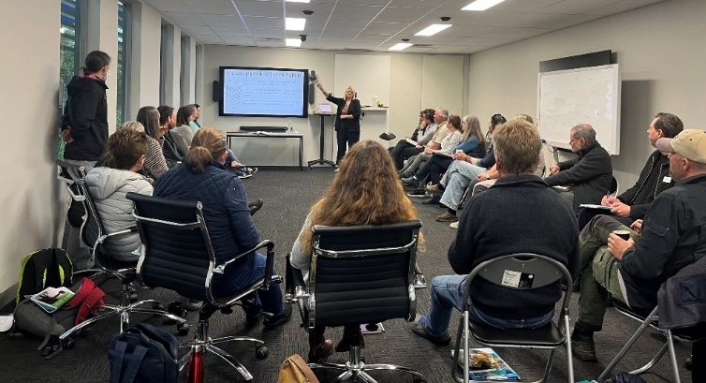
Jill presents at Bunurong Land Council Aboriginal Corporation, following a Welcome to Country and Smoking Ceremony.
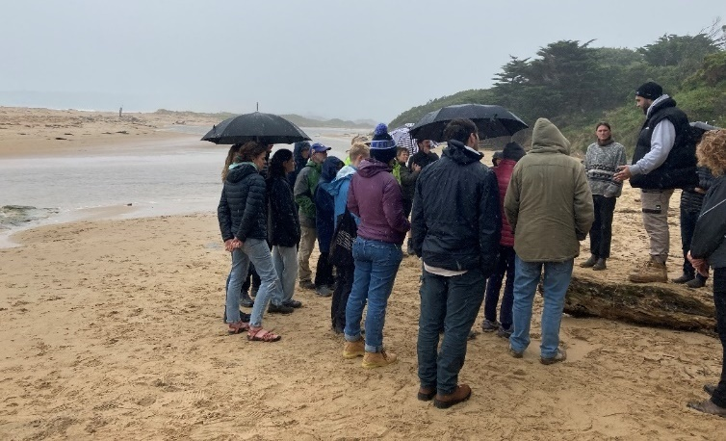
Apollo Bay delivered a beautiful sunny morning, quickly followed by a wet and wintery afternoon.

Looking out for our southern right whales
Boaters are being asked to stay alert as endangered southern right whales make their way back to Victoria’s coastal waters to birth and care for their young.
With just 300 southern right whales estimated to remain in the south-eastern Australian population, the annual breeding season – from May to October – is a crucial time for the species.
Boaters play an important role in protecting these rare and magnificent creatures as disturbance and strikes from boats pose significant threats during this time.
DEECA’s Arthur Rylah Institute for Environmental Research and Conservation Regulator are urging our recreational boating community to follow three simple steps:
- WATCH OUT FOR WHALES: Stay alert, Southern Right Whales can be difficult to spot. These whales have no dorsal fin, so they can look like floating logs as they rest near the surface, often in shallow water close to shore.
- SLOW DOWN TO 5 KNOTS: Within 300 m of a whale you must slow to 5 knots. It's best to travel at speeds less than 10 knots when within 1km of whales to keep vessel noise low. Mothers and calves need rest and quiet as they communicate in whispers to avoid predators.
- KEEP A SAFE DISTANCE: Do not go within 200 m of a whale in a boat, 300 m on a jet ski (legal requirement). Stay out of their way and avoid boxing them in. If you find yourself too close to a whale, put your engine in neutral and let them pass.
The endangered species have traditionally been observed at Warrnambool's Logan Beach, however in recent years mothers and calves have increasingly been seen right along Victoria's coast.
Community members right along the coast can contribute to whale conservation by submitting whale sightings and photos to WhaleFace at https://whaleface.swifft.net.au/.
Community sightings submitted to this platform have allowed DEECA to add new whales to the photo-identification catalogue, to track the return of calving females, and provided crucial information about nursing, resting, and strengthening locations used by southern right whales.
To learn more about the regulations about boating around whales, visit www.wildlife.vic.gov.au/our-wildlife/whales,-dolphins-and-seals/water-safety-around-marine-mammals.
We acknowledge Victorian Traditional Owners and their Elders past and present as the original custodians of Victoria’s land and waters and commit to genuinely partnering with them and Victoria’s Aboriginal community to progress their aspirations.
© The State of Victoria Department of Energy, Environment and Climate Action September 2023.
Creative Commons
This work is licensed under a Creative Commons Attribution 4.0 International licence, visit the Creative Commons website (http://creativecommons.org/licenses/by/4.0/).
You are free to re-use the work under that licence, on the condition that you credit the State of Victoria as author. The licence does not apply to any images, photographs or branding, including the Victorian Coat of Arms, and the Victorian Government and Department logos.
Disclaimer
This publication may be of assistance to you but the State of Victoria and its employees do not guarantee that the publication is without flaw of any kind or is wholly appropriate for your particular purposes and therefore disclaims all liability for any error, loss or other consequence which may arise from you relying on any information in this publication.
Accessibility
To receive this document in an alternative format, phone the Customer Service Centre on 136 186, email customer.service@delwp.vic.gov.au, or contact National Relay Service on 133 677. Available at DEECA website (www.deeca.vic.gov.au).

