# Coastal and Marine Management Plan Resource Kit – Engagement Plan





[deeca.vic.gov.au](https://projectsportal.ghd.com/Users/fionadurante/Downloads/deeca.vic.gov.au)

The aim of the Coastal and Marine Management Plan (CMMP) Resource Kit is to provide a collection of tools to guide coastal Crown land managers through the necessary steps of preparing a CMMP.

Drawing from the CMMP Guidelines, managers can determine how best to use this resource kit for their planning process. However, they should consider using the following order:

1. Scope and Scale template: defines the management area
2. Engagement Plan template: to identify and engage all relevant rightsholders and stakeholders
3. MERI Program Logic template: defines what and how objectives, activities, and anticipated outcomes of the CMMP will be delivered
4. Management Plan template: in which insights gathered from the above templates are consolidated
5. MERI Framework template: establishes robust monitoring, evaluation, reporting and improvement criteria

This template can assist with stages one and two of CMMP preparation.

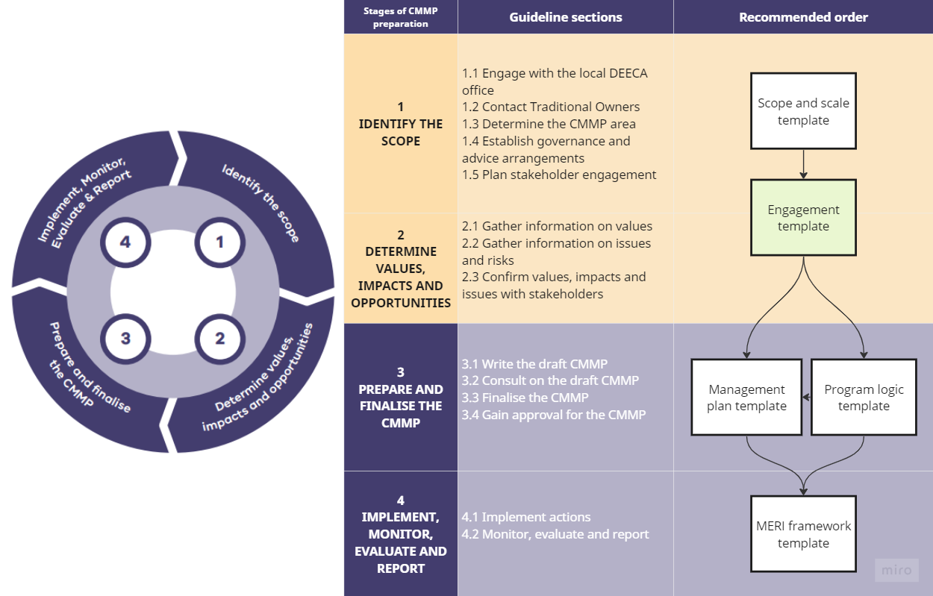

## How to use the template

Use the Engagement Plan Template to:

* Identify people and groups (rightsholders and stakeholders) to engage with for the Coastal and Marine Management Plan (CMMP).
* Identify the appropriate level of engagement with rightsholders and stakeholders using the International Association of Public Participation (IAP2) principles as a guide.
* Plan for appropriate engagement activities to gather information on values, impacts and opportunities.
* Identify resources needed and timing for engagement activities.
* Identify risks associated with engagement and appropriate mitigation.
* Evaluate the engagement undertaken.

Grey text – guides what to include under each subheading.

Black text – includes generic information that can be included in the Stakeholder Engagement Plan.

The Coastal and Marine Management Plan Guidelines 2023 (CMMP Guidelines) will guide the way each section in this Engagement Plan template should be filled in. The relevant sections are referenced.

Note: before attempting to fill in this template, please ensure that the following steps have been completed:

Step 1 – Engage with the local DEECA office (refer to 1.1 in the CMMP Guidelines)

Step 2 – Contact Traditional Owners (refer 1.2 in the CMMP Guidelines)

# 1. Project Area and Scope

Brief description of the area that is covered by the CMMP and the scope of the CMMP.

Refer to section 1.3 of the CMMP guidelines and the “Scope and Scale Template”.

# 2. Purpose of the Engagement Plan

Refer section 1.5 of the CMMP Guidelines “Plan stakeholder engagement”

The purpose of the Engagement Plan (EP) is to outline the process for engaging with rightsholders and stakeholders throughout the four stages of the CMMP:

1. Identify the scope
2. Determine values, impacts and opportunities
3. Prepare and finalise the CMMP
4. Implement, Monitor, Evaluate and Report.

This EP identifies:

* The rightsholders and stakeholders that will be engaged
* How the rightsholders and stakeholders will be engaged
* How the outcomes of engagement will influence the CMMP

# 3. Rightsholders and Stakeholders

A rightsholder has rights to the land and waters

A stakeholder is an individual or group with a specific interest in an issue or area.

In relation to the CMMP:

* Traditional Owners are rightsholders. A CMMP must acknowledge and reflect Traditional Owners’ needs, priorities, assertions, and knowledge of Country.
* a stakeholder is an individual or group with an interest in the coastal and marine area, coastal and marine issues, and any issues identified or addressed in the CMMP. These stakeholders should be engaged during the development of the CMMP.

Refer to section 1.5.1 in the CMMP Guidelines.

Fill in Attachment 1: Rightsholders and Stakeholder Checklist.

# 4. Engagement Actions

Refer to section 1.5.2 of the CMMP Guidelines when filling in this template and to Attachment 2: Key Principles.

The “engagement activity number” provides identification for the different engagement activities planned for stakeholder groups. Adding rows to the table in “Section 5 – Risk Management” auto-populates the first column with the same engagement activity numbers. This enables cross-referencing of engagement actions and risks between the two tables.

|  |  |  |  |  |  |  |  |
| --- | --- | --- | --- | --- | --- | --- | --- |
| Engagement activity number | Stakeholder group | Engagement approach(es) | Engagement tool(s) | Responsibility | Timing | Resources | Pre- and post-engagement communication |
|  |  |  | Think about how you can make engagement inclusive and how you can build value for the stakeholder groups engaged. Refer section 1.5.2 CMMP guidelines | List the lead agency and partner agencies if applicable. | When will engagement occur during CMMP development, e.g., at a particular stage or throughout?  How much time will be spent on each engagement session?  How often will engagement occur? | What resources do you need to support engagement?  This might include a publicly accessible room to hold a workshop in or a printer to print an information notice. | How will you keep stakeholders informed before and after engagement? |
|  |  |  |  |  |  |  |  |
|  |  |  |  |  |  |  |  |
|  |  |  |  |  |  |  |  |
|  |  |  |  |  |  |  |  |

# 5. Risk Management

Consider engagement risks before you undertake engagement activities. Use the examples below as a starting point.

|  |  |  |
| --- | --- | --- |
| Engagement activity number | Potential engagement risks | Mitigation measures |
|  | Lack of response from key stakeholders. | Consider appropriate way to communicate with each stakeholder, allow enough time (2-4 weeks) for a response and follow up with a phone call. |
|  | Information / input / feedback received during engagement that is not relevant / not appropriate / cannot be implemented.  This might include participants that have unrealistic expectations, negative or aggressive attitudes. | Be clear from the outset on what is within the scope of the CMMP and what is negotiable and what is not.  Be clear on your engagement approach and the purpose of engagement.  Take time to listen to participants’ concerns and try to find common ground. |

# 6. Evaluation of the Engagement

Refer section 1.5 of the CMMP Guidelines

Reflect on the effectiveness of your engagement activities and lessons learned:

* Seek feedback from rightsholders and stakeholders on how they have been engaged.
* Seek feedback from Project Team.

Some useful ways of gathering feedback from include:

* A short online survey.
* A short feedback discussion at the end of an engagement activity.
* An anonymous feedback box for participants to contribute written comments (if in person).
* A feedback sheet where participants can use stickers to rate parts of an engagement activity that they liked / did not like (if in person).

# 7. Reporting information and applying engagement outcomes

Following the engagement activity sessions, consolidate engagement information to inform the CMMP. Refer to section 2.3 and 3 of the CMMP Guidelines and the “Management Plan Template” for how to structure reporting on the values, opportunities and challenges.

Think about how to use the engagement information gathered to inform decision-making on the nature of the CMMP’s ten-year objectives, five-year actions and everyday management actions.

# Appendix A: Attachments

## Attachment 1: Rightsholder and Stakeholder Checklist, Matrix and Circle Map

Stakeholder mapping is a key step in tailoring your engagement plan and includes:

* Identifying specific rightsholders and stakeholders, their interests and capacity to influence aspects of decision making at different stages of CMMP development.
* Determining the best engagement approach and tools to meet rightsholder and stakeholder needs and preferences.
* There are several different ways to map stakeholders. Choose one from the selection below (checklist, matrix or circle map) to assist in identifying stakeholders and how to engage with them. For the checklist, delete rows that are not relevant and add additional rows where needed. For the matrix and circle map, use the stakeholder groups in the checklist as a starting point.

The [International Association for Public Participation (IAP2) framework](https://iap2.org.au/resources/spectrum/) provides a guide to five engagement approaches which result in different levels of impact on decision making. Different engagement tools are relevant to each engagement approach.

* **Inform:** Provide balanced and objective information to stakeholders to help them understand issues, opportunities and/or solutions.
* **Consult:** Generate feedback from stakeholders on analysis and/or decisions.
* **Involve:** Work with stakeholders to integrate their aspirations and concerns into decision-making and provide feedback to stakeholders on how their inputs influenced decisions.
* **Collaborate:** Partner with stakeholders in each step of decision-making to incorporate their advice into decisions as much as possible.
* **Empower:** Implement what stakeholders decide.

This [choose the appropriate option – checklist / matrix / circle map] identifies the stakeholders that may have an interest in the development of the [insert name] CMMP and the approach to engagement.

## Engagement checklist

|  |  |  |  |  |  |  |  |
| --- | --- | --- | --- | --- | --- | --- | --- |
| Stakeholder group | Engagement approach | | | | | | Comments:  What is their role or key interest in the CMMP?  Why is the chosen engagement approach appropriate?  At what stage (of the 4 stages of the CMMP) should engagement occur? |
|  |  |  |  |  | Not required |
| Rightsholders – Traditional Owner Registered Aboriginal Parties (RAPs) | | | | | | | |
| Bunurong Land Council Aboriginal Corporation |  |  |  |  |  |  |  |
| Eastern Marr Aboriginal Corporation |  |  |  |  |  |  |  |
| Gunaikurnai Land and Waters Aboriginal Corporation |  |  |  |  |  |  |  |
| Gunditj Mirring Traditional Owners Aboriginal Corporation |  |  |  |  |  |  |  |
| Wadawurrung Traditional Owners Aboriginal Corporation |  |  |  |  |  |  |  |
| Wurundjeri Woi-Wurrung Cultural Heritage Aboriginal Corporation |  |  |  |  |  |  |  |
| Victorian government agencies | | | | | | | |
| Department of Energy, Environment and Climate Action |  |  |  |  |  |  |  |
| Department of Transport and Planning |  |  |  |  |  |  |  |
| Department of Jobs, Skills, Industry and Regions |  |  |  |  |  |  |  |
| Great Ocean Road Coast and Parks Victoria |  |  |  |  |  |  |  |
| VicRoads |  |  |  |  |  |  |  |
| Parks Victoria |  |  |  |  |  |  |  |
| Melbourne Water |  |  |  |  |  |  |  |
| Environmental Protection Authority |  |  |  |  |  |  |  |
| Victorian Fisheries Authority |  |  |  |  |  |  |  |
| Better Boating Victoria |  |  |  |  |  |  |  |
| Catchment Management Authorities |  |  |  |  |  |  |  |
| Victorian Marine and Coastal Council |  |  |  |  |  |  |  |
| Waterway managers, harbour managers and port operators |  |  |  |  |  |  |  |
| Local Government Victoria |  |  |  |  |  |  |  |
| Heritage Victoria |  |  |  |  |  |  |  |
| Ports Victoria |  |  |  |  |  |  |  |
| Emergency Management Victoria |  |  |  |  |  |  |  |
| ountry Fire Authority |  |  |  |  |  |  |  |
| Fire Rescue Victoria |  |  |  |  |  |  |  |
| Any other managers of land or water adjacent to the planning area |  |  |  |  |  |  |  |
| Local Government | | | | | | | |
| Mayors and councillors |  |  |  |  |  |  |  |
| Senior leadership team and relevant advisory committees |  |  |  |  |  |  |  |
| Council / Committee of Management staff |  |  |  |  |  |  |  |
| Neighbouring Councils / Committees of Management |  |  |  |  |  |  |  |
| Association of Bayside Municipalities |  |  |  |  |  |  |  |
| Businesses | | | | | | | |
| Business groups (e.g., tourism operators and restaurants) |  |  |  |  |  |  |  |
| Traditional Owner Organisations |  |  |  |  |  |  |  |
| Local schools |  |  |  |  |  |  |  |
| Community | | | | | | | |
| Landholders – local residents and landholder groups |  |  |  |  |  |  |  |
| Peak environment groups and local environment groups |  |  |  |  |  |  |  |
| Yacht, sailing, boating clubs |  |  |  |  |  |  |  |
| Other recreation-based groups |  |  |  |  |  |  |  |
| Visitors (e.g., campers and visiting non-local recreational users) |  |  |  |  |  |  |  |

## Engagement matrix

**Stakeholder Influence**

**Low**

**High**

|  |  |  |  |
| --- | --- | --- | --- |
| Consult | Collaborate | | Empower |
| Insert stakeholder groups | Insert stakeholder groups E.g. DEECA | | Insert stakeholder groups |
| Inform | | Involve | |
| Insert stakeholder groups  E.g. neighbouring councils | | Insert stakeholder groups | |

**High**

**Stakeholder Interest**

## Engagement circle map

Empower

Collaborate

Involve

Consult

Inform

Low

High

Stakeholder Influence and Interest

[List rightsholder/ stakeholder groups]

[List rightsholder/ stakeholder groups]

[List rightsholder/ stakeholder groups]

[List rightsholder/ stakeholder groups]

[List rightsholder/ stakeholder groups]

[List rightsholder/ stakeholder groups]

[List rightsholder/ stakeholder groups]

[List rightsholder/ stakeholder groups]

## Attachment 2: Key Principles

There are six key principles guiding the design and delivery of engagement during CMMP development which follow the Victorian Government’s [Public Engagement Framework 2021-2025](https://www.vic.gov.au/public-engagement-framework-2021-2025/print-all).

An overview of the six principles is provided in the table below.

|  |  |
| --- | --- |
| Principle | What the principle looks like in practice |
| Meaningful | * The purpose of engagement is clear. * Rightsholders/ Stakeholders have sufficient time, resources and opportunities to participate in the engagement activity. * Rightsholders/ Stakeholders can participate in decision-making that affects them. |
| Inclusive | * Engage in a way that is accessible to rightsholder/stakeholder groups that may require additional consideration. This includes people with disabilities, people with culturally, ethnically or linguistically diverse backgrounds, elderly people, people in remote locations, and Aboriginal and Torres Strait Islanders. * Consider how rightsholder/stakeholder groups want to participant and design the engagement approach accordingly. * Offer several ways for rightsholder/stakeholders to engage. |
| Transparent | * Be clear about what the rightsholder/stakeholder group can and cannot influence and explaining why. * Share background information about the CMMP development process and its purpose. * Seek diverse opinions to have a holistic understanding of rightsholder/stakeholder values, impacts and opportunities. |
| Informed | * Provide relevant information to rightsholder/stakeholder groups in a timely manner. |
| Accountable | * When planning for engagement, be clear on its purpose, scope and objectives. * Understand engagement risks and take steps to mitigate them * Provide the opportunity for rightsholder/stakeholder groups to ask questions and provide feedback. * Address questions and concerns from rightsholder/stakeholder groups as they occur. |
| Valuable | * Build value for rightsholder/stakeholder groups through engagement, such as through the social impact of informing or involving. |