Coastcare Victoria School Kit

Action and Innovation: Litter Watch Worksheets

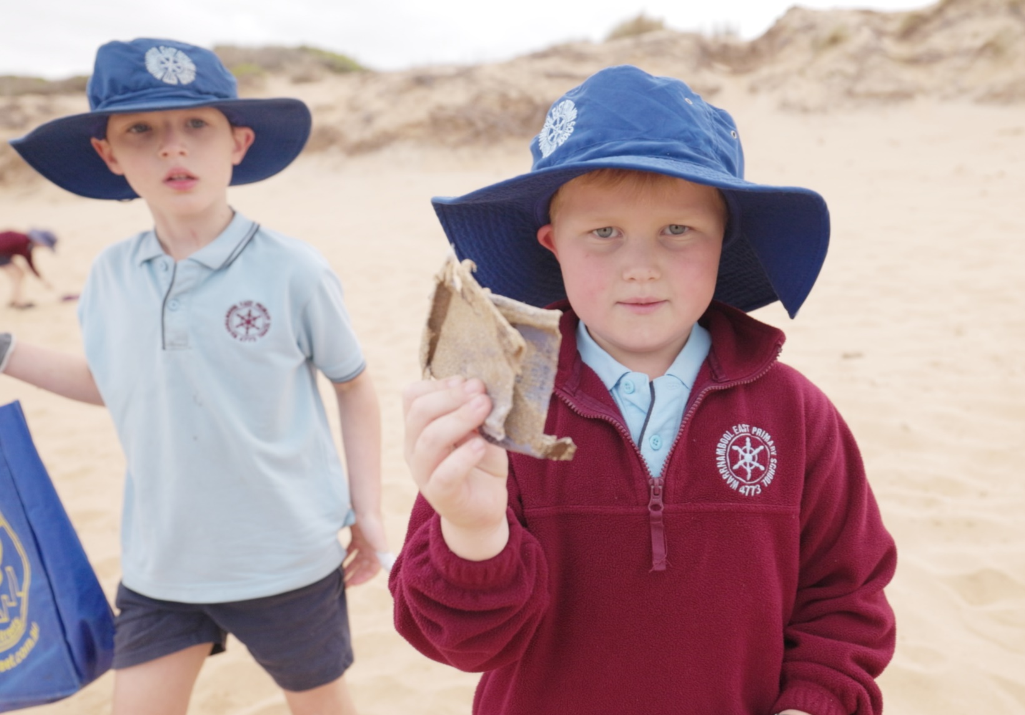
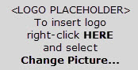

Acknowledgements

Coastcare Victoria would like to acknowledge all our video presenters and individuals who reviewed or assisted with the creation of the Coastcare Victoria School Kit.
Author
Coastcare Victoria and Ocean Imaging.
Photo credit
Ocean Imaging.

Contents
Action and Innovation: Litter Stopper Quiz 2
List of Litter Collected 4
Testing the Solution 5
Pinpointing the problem Investigation 11
Litter Stopper Review Questions 13

Action and Innovation: Litter Stopper Quiz
Circle the correct answers

1.Those traditional lands was this video filmed?
- Wadawurrung
- Maribyrnong
- Peek Whurrong and Gunditjmara
- Wurundjeri

2. What is a problem with plastic on beaches?
- It may harm birds and marine life
- It keeps breaking down into smaller pieces
- It doesn't look nice and can accumulate toxic chemicals
- All of the above

3. What plastic issue first caught Colleen’s attention on local beaches?
- Fishing debris
- Plastic stemmed cotton buds
- Red plastic from lobster pots
- Cigarette Butts

4. Which app were the students using to document the rubbish?
- Rubbish Racer
- Litter Stopper
- Trash Trender
- Waste Watcher

5. How many main item categories are on the frontpage of the App?
- 15
- 20
- 25
- 30

6. What did Colleen say were the most common types of plastics found on local beaches?
- Cigarette Butts
- Fishing Waste
- Plastic Bottles
- Hard Plastic Remnants

7. What was the source of the red pieces of plastic from the video?
- Shopping Trolleys
- Shopping Baskets
- Rock Lobster Pots
- Fishing Nets

8. What did fisher Gary do with his rock lobster pots?
- Designed new ones with less plastic
- Designed new ones with more plastic
- Sold them to other fishermen
- Made them cheaper

9. Where does the data from the Litter Stopper app go?
- A private secret database
- A public statewide database
- Directly to policy makers
- Nowhere, it stays on the app.

10. What is the most powerful way to find out what are the most common litter items in your area?
- Collect data
- Reduce waste
- More recycling
- Protests

List of Litter Collected

- 191 Water Bottles (96 foreign label bottles, 88 unknown bottles and 7 Australian-label bottles)
- 7 bottle labels (Nongfu - China)
- 24 non water bottles
- 9 lobster pot nets, 13 bait baskets, 26 lengths of lobster cane (very long pieces), 6 broken fish crates
- 1 car tyre
- 373 pieces of fishing netting/rope (3 x EXTRA large bags full)
- 146 bottle lids
- 33 glass bottles
- 50 foam packaging, 16 foam buoys
- 6 cans
- 2 plastic tarp
- 2 face masks
- 74 pieces of fabric
- 11 hats
- 15 shoes
- 1573 hard remnants (broken plastic fragments)
- 1 straw, 8 plastic cutlery
- 44 soft plastic remnants
- 6 food packaging
- 2 plastic drums 40 litre
- Jar of rusty nails
- 1 paint tin
- Piece of rusted metal
- 1 large plastic film balloon, 1 rubber balloon
- 2 large garbage bags
- 5 garbage bag knots
- Large piece of tin rusty 1 metre x 1.5 m
- 1 lighter
- 6 large rubber pieces
- 3 x tropics fruit packaging

Testing the Solution
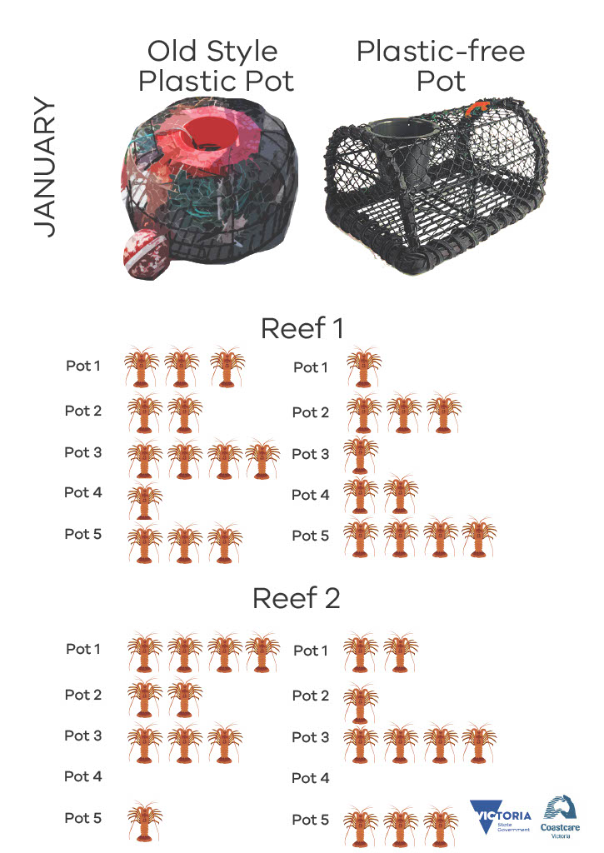
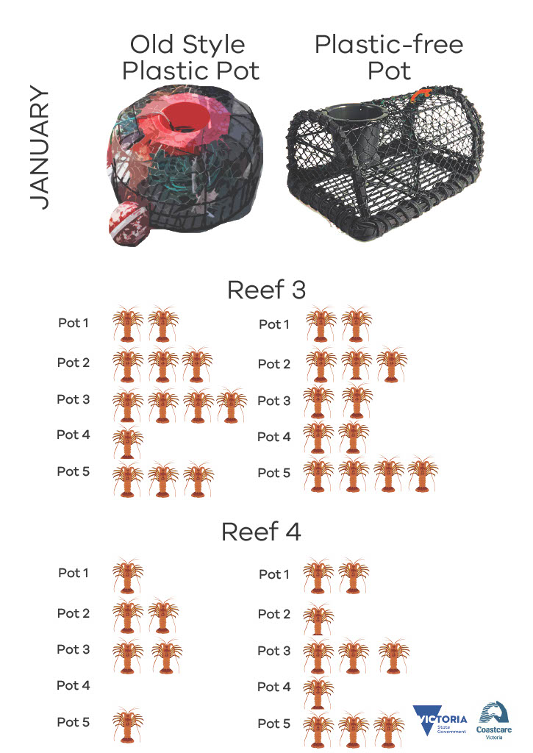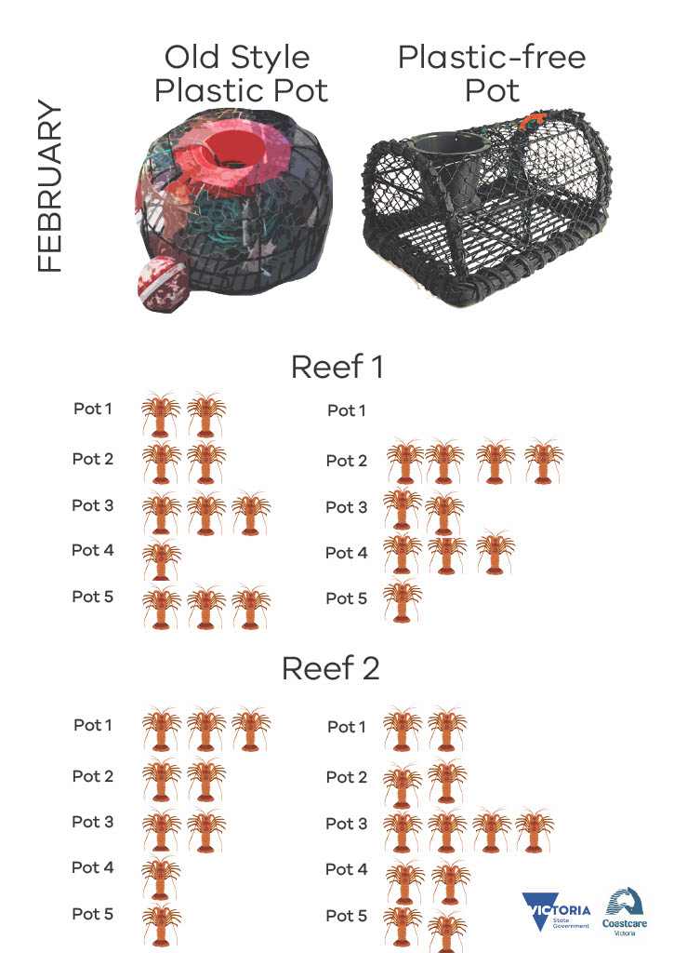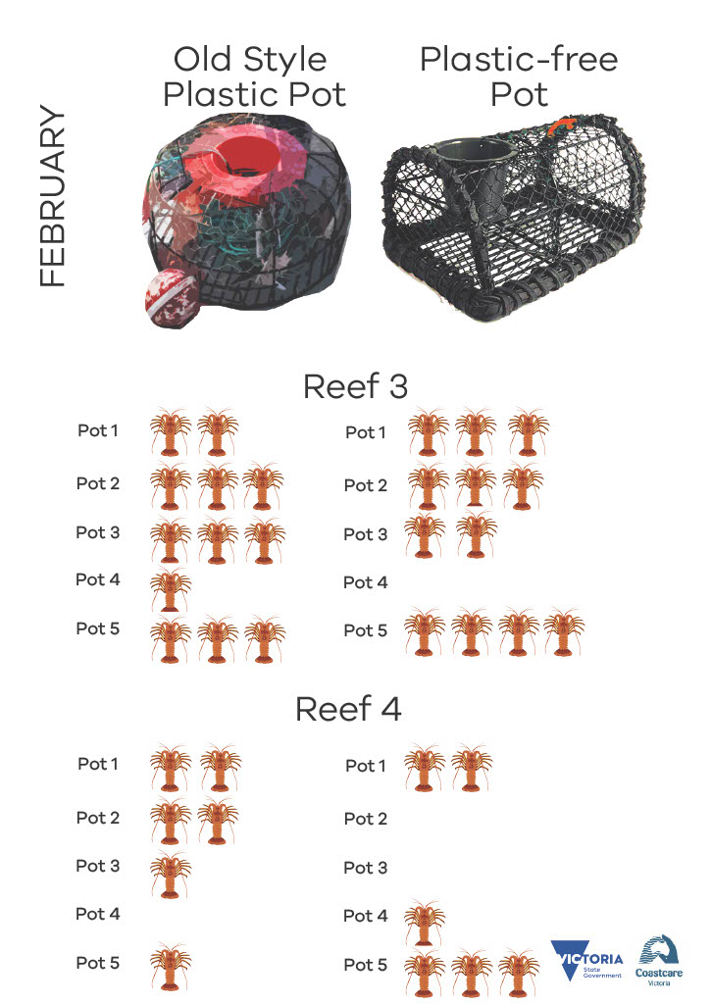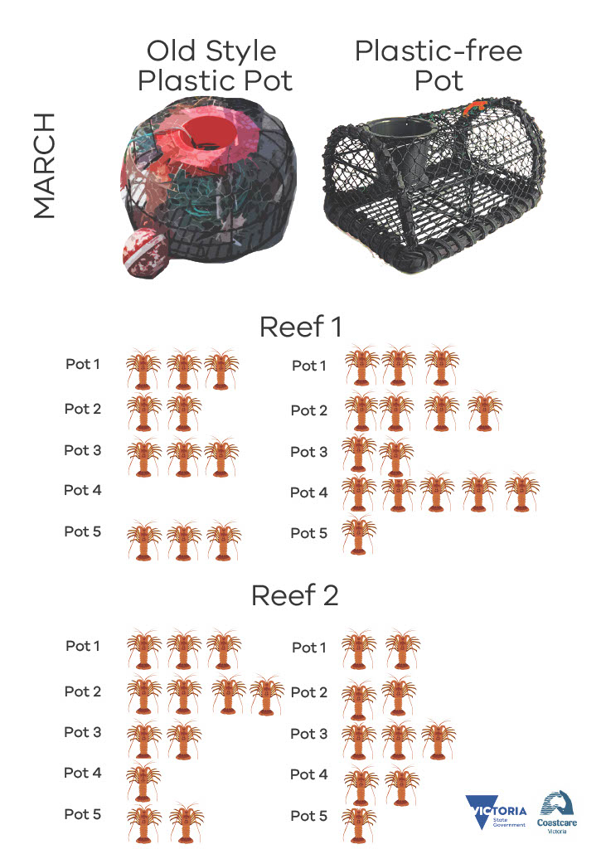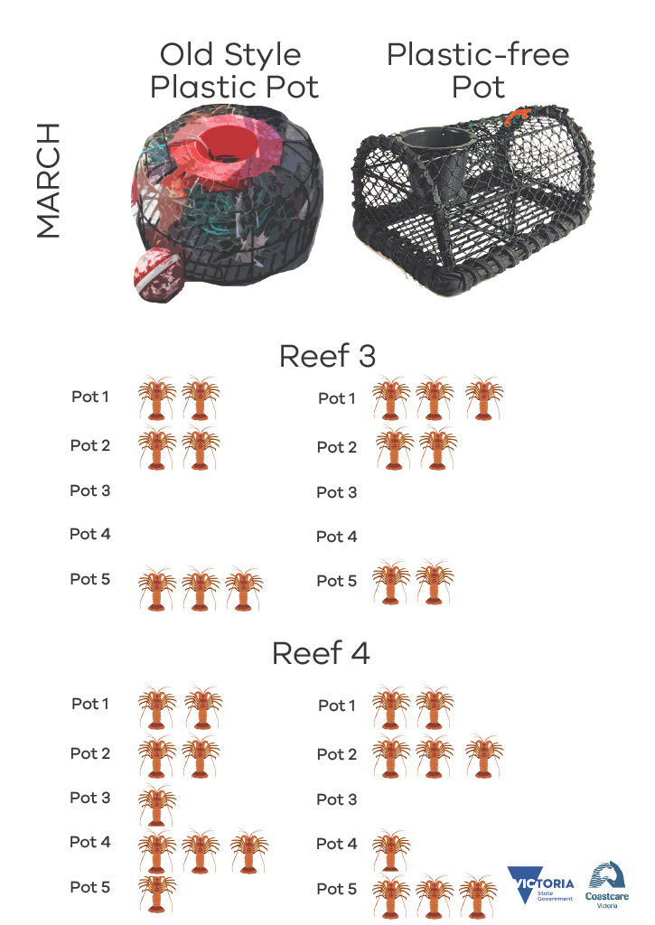

Pinpointing the problem Investigation
In this Investigation, you will use a list of real data collected by volunteers from the Warrnambool area. Data can be found in the Collection Data Spreadsheet. Note you will need to click on the various tabs down the bottom of the excel sheet to access all the data.

- Over what period was the data collected? How long is this?

- From all of the materials collected, what percentage was plastic? Tip: Look in “Basic Stats.”

- What was the most common item?

- What percentage did sanitary items make of the total number of items?

- How many cigarette lighters were found?

- Out of the foreign items (click the foreign item tab) what was the most common item?

- Out of the foreign items (click the foreign item tab) what was the most common country that items came from?

- What brand was the most common Chinese plastic bottle?

- Out of recreational fishing items, what was the trend in fishing lures being found? (Click the selected items tab)

- Which commercial fishing items were the biggest problem?

- What year was commercial rope & net scraps less than 1 metre the highest?

- How many wooden fishing items were found over the whole period?

- Why do you think this number (in response to q12) was so high or low?

- Were more plastic bottles or plastic lids found?

- Why do you think this was the case? (Relating to answer to question 14)

Litter Stopper Review Questions

- Describe how plastic may affect marine and coastal animals.

- A local clean up group were finding lots of plastic toothbrushes on their local beach. Describe what steps could be taken by the group to help drive change in their community.

- Describe how the Litter Stopper app works.

- Describe what happens to a lot of large pieces of plastic over time if they aren’t collected.

- Describe an event by a local volunteer group that you could contribute to help make the place more liveable, or briefly describe a made-up event that may help make your local place more liveable

