|  |
| --- |
| DEECA marine and coasts newsletter |

Welcome to the Department of Energy, Environment and Climate Action’s quarterly marine and coasts newsletter**.**

## In this issue

* Portarlington seawall repairs
* Portland Cliffs Adaptation Plan
* Queenscliff on-water inspections
* 2023 Port Phillip Bay Fund – applications now open
* Coastcare Victoria Community Grants 2022-23 – applications now open
* Successful Coastal Public Access and Risk Grants 2022-23 announced
* Giant Spider Crab ecological and socio-economic assessment in Port Phillip Bay
* ‘Operation Leonina’: southern elephant seal visits Port Phillip Bay
* Cape to Cape Resilience Project – out and about in the community
* Coastcare Victoria’s ‘Coastline’

|  |
| --- |
| Email [marine.coasts@delwp.vic.gov.au](mailto:marine.coasts@delwp.vic.gov.au) to subscribe or unsubscribe to this newsletter and for more information. |

# Coastal projects

## Portarlington seawall repairs

Works to repair the ageing Portarlington foreshore seawall are complete. The seawall, which was built around 80 years ago to protect the cliffs east of Portarlington harbour, has been subject to erosion and storm damage. It was assessed by independent coastal engineers as being in very poor condition.

Portarlington seawall at high tide.


The Portarlington seawall has recently undergone repairs.

As well as interim repairs, temporary rock bags have been installed to address the erosion of the cliff face at the eastern end.

Works were undertaken in consultation with Wadawurrung Traditional Owners Aboriginal Corporation and Bellarine Bayside Committee of Management.

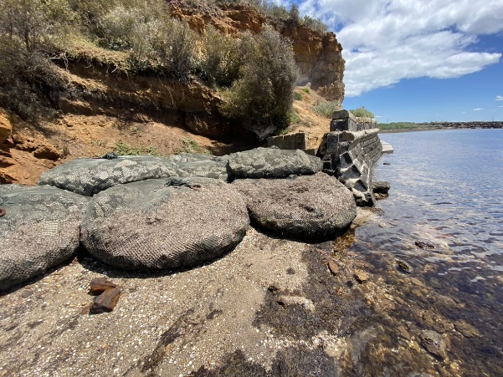

Temporary rock bags address erosion of the Portarlington cliff face at the eastern end.

## Portland Cliffs Adaptation Plan

The Portland community has a long history of living with the risks associated with cliffs. Climate change is accelerating these changes and extensive planning is required to mitigate the risk posed to the public by cliff instability.

Last year DEECA in consultation with Glenelg Shire Council engaged expert consultants to assess cliff instability between Nun’s Beach and Anderson Point. The assessment included geotechnical investigations and found sections of the cliffs were too dangerous for community access, including Anderson Steps which will be removed.

An adaptation plan is being developed to inform the next stage of planning. Currently there is no single solution to retain the valued community loop walk and beach access.

DEECA is now seeking community ideas and thoughts to improve public safety between Nun’s Beach and Anderson Point. You can provide your feedback via Engage Vic, <https://engage.vic.gov.au/portland-cliffs-adaptation-plan>. The outcomes and ideas received will help inform the short and long-term options for the site.

Portland cliffs with exclusion fencing.


**Portland cliffs.**

## Queenscliff on-water inspections

DEECA’s Barwon South West Land and Built Environment team have completed an on-water inspection of coastal assets and development proposals around Queenscliff.

The inspections included ageing wharfs in the Queenscliff Harbour, proposal for a major rubbish removal in the Queenscliff cut, the redeveloped Queenscliff boat ramp, navigational aids at Popes Eye, wildlife challenges at Chinaman’s Hat and a compliance inspection for the dredging activity around the Queenscliff ferry terminal.

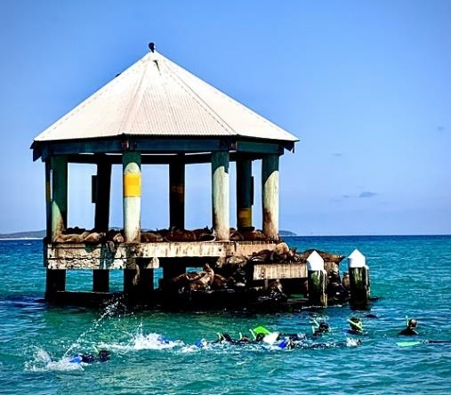

A school group snorkelling with seals at Chinaman’s Hat.

‘Being on the water enabled us to better understand the challenges being faced by coastal managers compared to on land inspections’ said Amanda May, DEECA Program Officer.

‘The inspections help us to quickly assess coastal development proposals on behalf of the government and coordinate future coastal works with these managers’.

DEECA is part of the Borough of Queenscliff’s steering committee to prepare a Coastal and Marine Management Plan from Queenscliff to Point Lonsdale. The Queenscliff foreshore is under increasing pressure from visitation and climate change impacts (such as coastal inundation and erosion) and the plan is being developed to protect the rich cultural, natural and scenic values. It also aims to help better coordinate works by the range of coast managers in the Borough.

To find out more, visit [queenscliffe.vic.gov.au/Your-Council/News-and-projects/Current-projects/Coastal-and-Marine-Management-Plan](https://www.queenscliffe.vic.gov.au/Your-Council/News-and-projects/Current-projects/Coastal-and-Marine-Management-Plan).

# Coastal grants

## 2023 Port Phillip Bay Fund – applications now open

Applications are now open for the 2023 Port Phillip Bay Fund grants.

In this latest round of the Port Phillip Bay Fund, the Victorian Government is contributing $1.4 million to support community efforts to protect and conserve the Bay’s unique coastal habitats and marine ecosystem.

Grants of up to $100,000 are available for innovative, large-scale projects and up to $25,000 for smaller projects.

Projects must be located within the Bay itself, or up to five kilometres inland, to ensure that the project will have a direct benefit to the health of the Bay.

Environmental and community groups, non-government organisations, Traditional Owner groups (Registered Aboriginal Parties [RAP] and non-RAP), research institutes, local councils, and schools are all encouraged to apply.

Applications close Tuesday 4 April at 3pm.

To apply online, or find out more visit [marineandcoasts.vic.gov.au/grants/port-phillip-bay-fund](https://www.marineandcoasts.vic.gov.au/grants/port-phillip-bay-fund)

For questions about the program, please email [enviro.grants@delwp.vic.gov.au](mailto:enviro.grants@delwp.vic.gov.au)

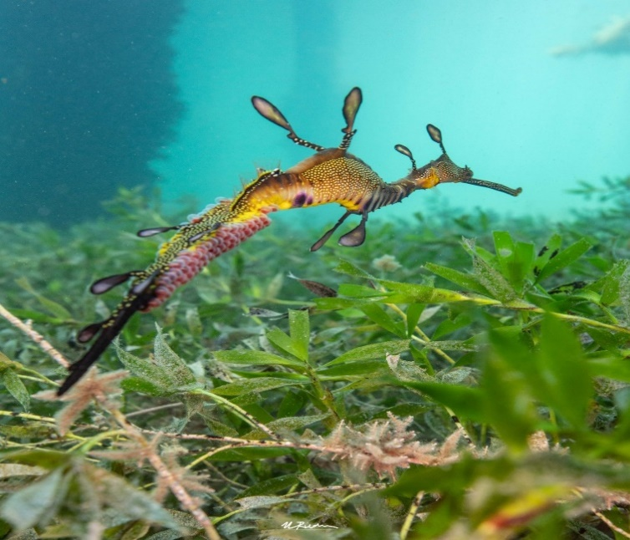

Weedy seadragon. Image: Marcia Riederer.

Since its launch in 2016, the Port Phillip Bay Fund has provided more than $10.8 million in grants across 150 projects that addressed key issues affecting Port Phillip Bay.

## Coastcare Victoria Community Grants 2022-23 – applications now open

Visit the ‘Coastline’ section of this newsletter to find out more.

## Successful Coastal Public Access and Risk grants 2022-23 announced

Minister for Environment, Ingrid Stitt has announced the successful recipients of the $1.1 million Coastal Public Access and Risk Grants program for 2022-23.

The grants will support 16 projects across Victoria and deliver vital safety and access works, including:

* beach access improvements at Ocean Grove, Marengo, Warrnambool, Sandy Point, Seaspray, Phillip Island, Parkdale, Middle Park and Blairgowrie
* safety upgrades to the concrete ramp used by Pier to Pub for water access by over 5,000 swimmers, by repairing the concrete surface and installing secure non-slip matting and signage
* new signage and safety information to help remove Phillip Island Nature Parks beaches from the national drowning blackspot list
* safety assessments and planning work for future improvements at Corio Bay, Walkerville, Dromana and Whitecliffs.

Funds are available each year for projects such as risk assessment and management plans for safer access, re-pair or replacement of paths, stairways, boardwalks and access ramps, installation and improvement of public safety signage and access barriers as well as viewing platforms and lookouts.

The grants program is funded through the $16.9 million VicCoasts initiative.

See the list of funded projects at [marineandcoasts.vic.gov.au/grants/coastal-public-access-and-risk-grants](https://www.marineandcoasts.vic.gov.au/grants/coastal-public-access-and-risk-grants)

# Marine and coastal knowledge

## Giant Spider Crab ecological and socio-economic assessment in Port Phillip Bay

Deakin University are in the final stages of completing the first comprehensive assessment of the Giant Spider Crab (*Leptomithrax gaimardii*).

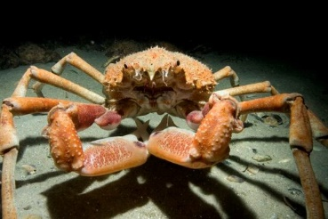

Giant Spider Crab (Leptomithrax gaimardii).

Large numbers of the Giant Spider Crab migrate into Port Phillip Bay from May to July each year to aggregate and moult. They are vulnerable to natural predation and human take during this period. Little is known about population numbers and dispersal patterns.

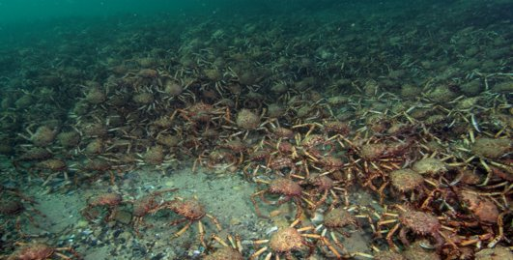

Giant Spider Crab (Leptomithrax gaimardii).

During 2022, the Deakin team worked with citizen scientists to record observations of Giant Spider Crab sightings and monitor their aggregations.

The Spider Crab Watch iNaturalist project – <https://inaturalist.ala.org.au/projects/spider-crab-watch> – was launched March 2021. Fixed cameras were placed at piers where aggregations are known to occur, and divers deployed remote underwater video.

Deakin also used acoustic monitoring stations to track tagged individuals and study their movements once they disaggregate to learn more about their dispersal patterns. We currently don’t know how many stay in the Bay or leave through Port Phillip Heads to return to the offshore waters.

A short video of the project can be found at <https://youtu.be/UGGRqQYtEAI>

A BBC Blue Planet II video can be found at: <https://youtu.be/lQyopA3JoWo>

A complementary project has also been undertaken to determine the socio-economic values of the Giant Spider Crab to the community. This work has focused on three key components:

* Analyse the current and potential future scale of a nature-based tourism industry centred around spider crabs, drawing on a survey of Victorian and interstate residents, interviews, analysis of similar environmental events in Australia and elsewhere around the world.
* Assess the value of the spider crab migration event to the broader Victorian public via a non-market valuation study. This will assess their willingness to pay for the protection of the spider crab aggregation event, or to further enhance this, even if they don’t visit the spider crabs.
* Assess recreational angling expenditure data collected via new surveys to estimate fishing effort, expenditure, catch size and market value of that catch.

A final report will be completed in June 2023.

The Project was supported by DEECA’s Port Phillip Bay Fund and Coastcare Victoria.

## ‘Operation Leonina’: southern elephant seal visits Port Phillip Bay

‘Operation Leonina’, a collaborative conservation effort between DEECA, the Conservation Regulator, and the WhiteCliffs to Camerons Bight Foreshore Reserve Committee of Management, ensured safe, well-managed protection for a southern elephant seal (*Mirounga leonina*), which had recently hauled-out to Port Phillip Bay from Antarctica to moult.

Southern elephant seals and other pinnipeds moult (shedding their outer layer of hair and skin) on land. After an ‘energetic’ stay at Point Lonsdale, the seal found an area of gently sloping beach at Blairgowrie on the Mornington Peninsula to moult, which took around 20 days.

Due to the public safety risk and sensitivity of these seals when approached by humans, a safe zone was quickly set up for the seal, with fencing, signage and community awareness implemented throughout the three weeks.

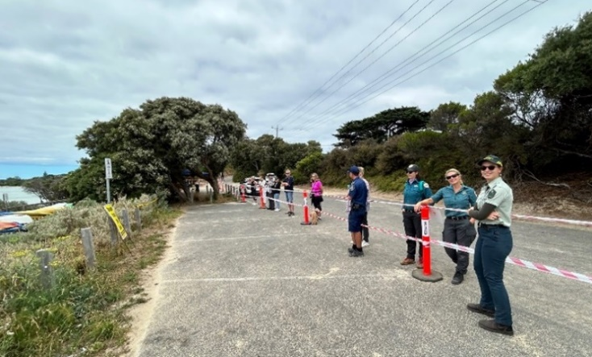

Giving the seal space.

With this far more favourable set of environmental conditions, the seal was successfully able to carry out the rest of its moulting process before starting its journey back to the Southern Ocean.

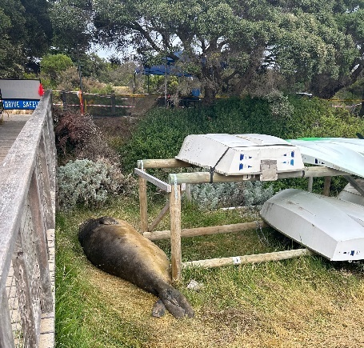

Seal in-situ.

The visit provided a valuable opportunity to retrieve fur samples that can be taken to the lab for further analysis.

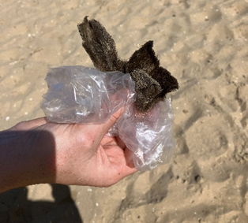

Fur seal sampling for lab analysis.

With the high level of community interest, the visit also provided an opportunity to significantly increase knowledge and understanding of the behaviour and physiology of the species, helping to ensure future conservation and care of the southern elephant seal.

For more information about southern elephant seal please visit, [environment.gov.au/biodiversity/threatened/species/pubs/26-conservation-advice-07122016.pdf](https://www.environment.gov.au/biodiversity/threatened/species/pubs/26-conservation-advice-07122016.pdf)

## Cape to Cape Resilience Project – out and about in the community

Engagement activities for the Cape to Cape Resilience Project were in full swing throughout January and February 2023.

Led by DEECA, this pilot project is helping to pave the way for increasing coastal hazard resilience in Victoria. With more than two years of technical and strategic work completed, the project team is now assessing a number of options for the Cape to Cape Resilience Plan – the first of its kind for Victoria.

Popping up at food truck events, summer twilight markets, farmers markets and beach side, the team has been out and about in Inverloch and Venus Bay, capturing the holiday crowds and speaking to over 500 people over summer!

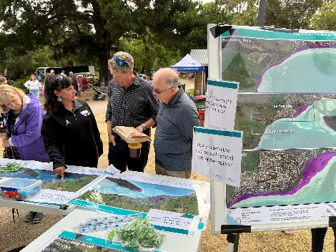

Project Manager, Cassandra Philippou engaging with community members during a pop-up over the summer.

The events over summer have reached a diverse cross section of the community, introducing many to the project and its findings. Conversations have shown there is a huge level of community interest on this topic, reflecting the love for the region’s coast.

Many are acknowledging the importance of planning for climate change. There is also genuine appreciation of making the technical findings more accessible, being able to talk openly about possible future impacts and being given the chance to provide feedback on actions.

Some of the things we are hearing:

‘What a comprehensive piece of work – this type of planning is so important for our region.’

‘Thank you for taking the time to explain these maps and what they actually mean for our region.’

‘We’ve certainly learned something today in talking with you. Thanks!’

‘It’s great to see that climate change and sea level rise is getting this level of attention.’

‘Education is going to be so important. People need to be made more aware.’

Throughout February DEECA have been holding roundtable sessions with targeted stakeholder groups providing an opportunity to discuss adaptation pathways in more detail, as well as welcoming community to view detailed maps, photo montages and project updates at our Open House/Drop-In session.

As the Resilience Plan is being put together in the coming months, you can have a look at the maps, factsheets and plenty of other project content at [marineandcoasts.vic.gov.au/coastal-programs/cape-to-cape-resilience-project](https://www.marineandcoasts.vic.gov.au/coastal-programs/cape-to-cape-resilience-project)

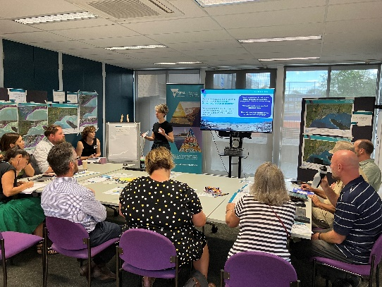

Partner agencies and community members participating in Roundtable focus group discussion.

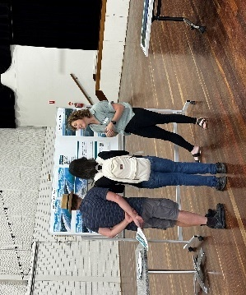

Alluvium consultant, Phebe Bicknell discussing the project with community members at our Open House/Drop-In Session.

Keep reading for Coastcare Victoria’s ‘Coastline’!



## In this issue

* Coastcare Victoria team update
* Coastcare Victoria Community Grants 2022-23 now open
* Summer by the Sea – coastal connected in 2023
* Hoodie Who?

## Coastcare Victoria team update

The Coastcare Victoria team has recently had some exciting changes and new staff!

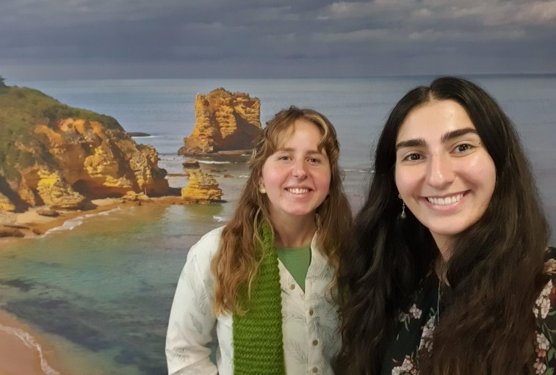

A happy snap of Shaya (left) our new Bellarine and Surf Coast Facilitator, and Joiee (right) our new Coastcare Victoria Coordinator.

We welcome two new incredible facilitators: Shaya to Bellarine and Surf Coast, and Corinne to the Far South West. We also have a new grants officer – Annie.

A few messages from the Coastcare Victoria team:

‘I am thrilled to meet with, learn from, and support the phenomenal volunteers who make up our marine and coastal volunteer network within Victoria. Our coastlines are incredibly important, and so too are the community formations which take place along these coastlines. The work community groups are leading allows for lasting positive improvements to our diverse and valued ecosystems.’

Shaya Kaartinen-Price, Bellarine and Surf Coast facilitator.

‘I'm passionate about the preservation and care of what is Victoria's most remarkable coastline. I look forward to working with the incredible volunteers on their extraordinarily important projects.’

Corinne Donohue, Far South West facilitator

*‘I’m excited to join the Coastcare Victoria team and contribute to the grants process which assists the amazing volunteer groups to do their important work.’*

Annie Moreillon, Coastcare Victoria Community Grants Officer

The Coastcare Victoria Gippsland facilitators have some exciting news. Bethany Hunting, our beloved East Gippsland facilitator, is on a secondment until 30 June 2023. A message from Bethany:

‘Hello Coastcarers!

Just a quick announcement that I will be taking a short break from the Coastcare Victoria team to work with the Biodiversity Response and Recovery team here in DEECA. I am hoping to learn a lot more about bushfire and flood recovery, which is relevant to the work you all do here in East Gippsland.

Keep up the incredible work and I can’t wait to catch up with all of you when I’m back! I may even see some of you out and about – my little dog Leo and I will still be adventuring along the Gippsland coast and may bump into you!

Cheers, Bethany’

In the interim, your South Gippsland facilitator Laura Town-Hopkinson will be welcoming enquiries relating to all of Gippsland.

In December we farewelled our coordinator Jacqui Pocklington:

*’Farewell to all the Coastcare Victoria volunteers, partners and friends, it’s been great to work with so many passionate and caring people the past two years. The work you achieve has been so inspiring and I wish you all well for the future. Hopefully I’ll see you on the ground in future as I return to a research career.*

*Best wishes, Jacqui.’*

Joiee Tachas will be the Coastcare Victoria Coordinator:

‘I’ve learnt so much and met so many wonderful passionate volunteers in my almost a year in the Port Phillip and Western Port facilitator role. With the new, refreshed Coastcare Victoria team, I am excited to look at the program from a statewide perspective and apply my on-ground facilitator knowledge. I look forward to working with you all across the coastline and continuing to support the vital Victorian marine and coastal volunteer network. To my Port Phillip and Westernport friends, please reach out in the meantime if you have any questions and queries!’

Joiee Tachas, Coastcare Victoria Coordinator.

To make sure all our brilliant volunteers know who’s who, here’s the fresh contact list (which can also be found at [marineandcoasts.vic.gov.au/coastal-programs/coastcare-victoria](https://www.marineandcoasts.vic.gov.au/coastal-programs/coastcare-victoria)):

|  |
| --- |
| **Coastcare Victoria Coordinator**  Johanna (Joiee) Tachas  M: 0427 268 169  E: johanna.tachas@delwp.vic.gov.au  **Coastcare Victoria Grants Officer**  Annie Moreillon  E: coastcare.victoria@delwp.vic.gov.au  **Far South West Facilitator**  Corinne Donohue  M: 0456 742 468  E: corinne.donohue@delwp.vic.gov.au  **Bellarine and Surf Coast Facilitator**  Shaya Kaartinen-Price  M: 0436 604 127  E: shaya.kaartinen-price@delwp.vic.gov.au  **Port Phillip Facilitator**  E: coastcare.victoria@delwp.vic.gov.au  **South Gippsland Facilitator**  Laura Town-Hopkinson*  M: 0427 818 683  E: laura.town-hopkinson@delwp.vic.gov.au  **East Gippsland Facilitator**  Contact South Gippsland Facilitator Laura Town-Hopkinson until 30 June 2023. |

*Due to part-time study arrangements, you can contact Laura Monday – Wednesday 9 am – 7 pm; Thursday 11 am – 7 pm and Friday 1 pm – 7 pm

## Coastcare Victoria Community Grants 2022-23 now open

Applications are now open for the 2022-23 VicCoasts Coastcare Victoria Community Grants Program, which supports communities to protect and enhance Victoria’s 2,000 kilometres of coastline.

Local community groups can apply to share in $210,000 of funding through this latest round of grants. Grants of up to $10,000 are available.

Applications for the 2023 program close at 11:59 pm on 30 March 2023.

Volunteer groups that are looking to fund projects that conserve, restore, and rehabilitate Victoria’s coastal and marine environments are encouraged to apply.

This year’s grants program has three funding streams that aim to support community adaptation and improve resilience to climate change and the impacts of coastal erosion:

* Stewardship and Education
* Strengthening our Volunteer Groups
* Supporting Traditional Owner Self-Determination.

Contact your local Coastcare Victoria facilitator now to start a discussion about your potential project!

For more information and to apply, visit [marineandcoasts.vic.gov.au/coastal-programs/coastcare-victoria/coastcare-victoria-community-grants](https://www.marineandcoasts.vic.gov.au/coastal-programs/coastcare-victoria/coastcare-victoria-community-grants)

## Summer by the Sea – coastal connected in 2023

With a program encompassing over 60 in-person events, nine webinars and five videos, it's officially a wrap on Summer by the Sea for 2023!

Summer by the Sea is an annual Coastcare Victoria program that encourages everyone to connect with the coast, wherever they are across the state. The program this year involved a diverse range of in-person and online events.

We were also fortunate to have Traditional Owner-led Welcome to Country and smoking ceremonies at several events.

A special thank you to our incredible partners that supported Coastcare Victoria in delivering the program this year. Participants enjoyed events including:

* guided coastal walks with subject matter experts along the coast from Narrawong to Walkerville
* rockpool tours and dinosaur discoveries
* accessible experiences including snorkelling with a disability, and educational beach access walks
* live online events covering topics such as great white shark ecology, places to go snorkelling this summer, and a panel on ways to help the coast
* videos covering a host of topics from marine mammal diversity research to Bass Coast mangroves.

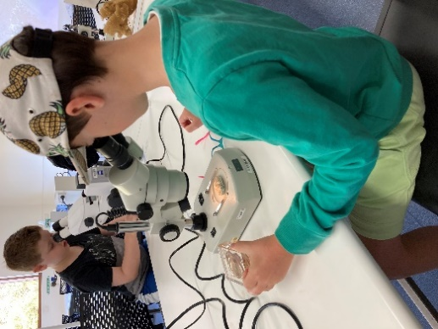

Children discovering marine science – Deakin University.

Some quick wins:

* over 95% of participants left events feeling that they had increased their coastal knowledge
* over 60% of participants are now open to volunteering for Victoria's coastline
* over 60% of participants were new to Summer by the Sea and were enjoying events for their first time!

To access videos, webinar recordings, blog posts and more from this year's Summer by the Sea, visit [summerbythesea.vic.gov.au](http://www.summerbythesea.vic.gov.au/)

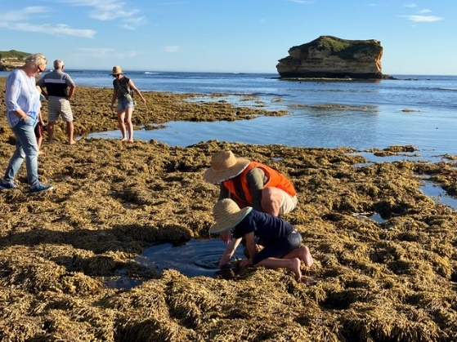

Rockpool Ramble at Crofts Bay – Habitat Connection.

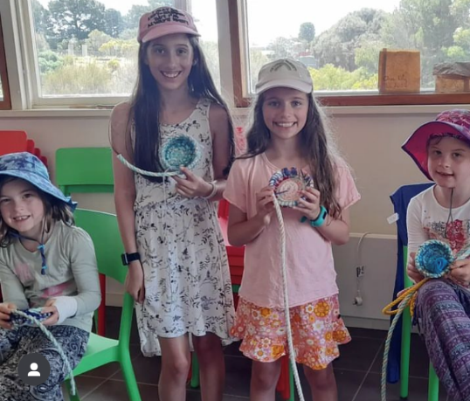

Ghostrope Weaving workshop – Selkie Knots.

## Hoodie Who?

*Article and photo by Lisa Williams, Ranger – West-Southern Peninsula Parks and Reserves, Parks Victoria.*

Parks Victoria rangers and the Friends of the Hooded Plover (Mornington Peninsula) Inc. have been working on an early childhood resource, and it has just materialised!

‘Hoodie Who?’ is a two-part activity for kindergarten to Grade 2 classes. Activities engage children with the life cycle and requirements of the hooded plover – a threatened beach-nesting bird – and guide how children can help the species when they see hooded plover signs and roped-off areas on their local beaches.

A Hoodie Who? kit contains:

* a teacher resource booklet outlining session details, hooded plover 101, and species management 101
* Hoodie Who? Activity 1: Let's Learn
* Hoodie Who? Activity 2: Let's Help
* three polymer clay eggs in a pillow box
* two hooded plover nesting signs attached to a small rope loop
* a USB stick loaded with resource PDFs and extension activities.

Hoodie Who? was developed by Parks Victoria rangers and the Friends of the Hooded Plover volunteers to amplify their educational effort, and to support dedicated Mornington Peninsula teachers with curriculum-relevant and conservation-focused activities.

In the coming months, Hoodie Who? will be released in kindergartens and primary schools on the Mornington Peninsula. Kits will then be available to teachers August though to December annually, so activities coincide with the hooded plover breeding season and children can connect classroom teachings with hooded plover beach management.

This amazing resource was funded by Coastcare Victoria with support from the Victorian Government through the Coastcare Victoria 2022-23 Grant Program.

For more information contact the Friends of the Hooded Plover (Mornington Peninsula) Inc. [hploversmornpen@gmail.com](mailto:hploversmornpen@gmail.com)

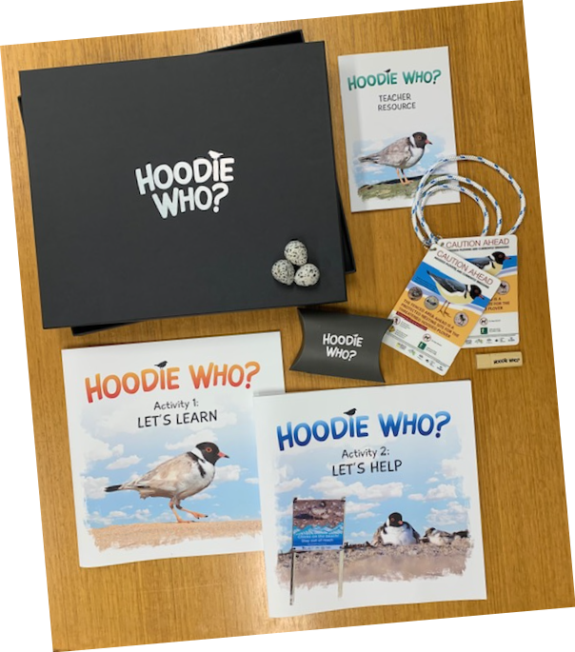

|  |  |
| --- | --- |
| © The State of Victoria Department of Energy, Environment and Climate Action 2023  LogoThis work is licensed under a Creative Commons Attribution 4.0 International licence. You are free to re-use the work under that licence, on the condition that you credit the State of Victoria as author. The licence does not apply to any images, photographs or branding, including the Victorian Coat of Arms, the Victorian Government logo and the Department of Energy, Environment and Climate Action (DEECA) logo. To view a copy of this licence, visit http://creativecommons.org/licenses/by/4.0/  Disclaimer  This publication may be of assistance to you but the State of Victoria and its employees do not guarantee that the publication is without flaw of any kind or is wholly appropriate for your particular purposes and therefore disclaims all liability for any error, loss or other consequence which may arise from you relying on any information in this publication. | Accessibility  If you would like to receive this publication in an alternative format, please telephone the DEECA Customer Service Centre on 136186, email [customer.service@delwp.vic.gov.au](mailto:customer.service@delwp.vic.gov.au), or via the National Relay Service on 133 677 [www.relayservice.com.au](http://www.relayservice.com.au). This document is also available on the internet at [www.deeca.vic.gov.au](http://www.deeca.vic.gov.au). |

The Hoodie Who? resource