DEECA marine and coasts newsletter
Issue 17 December 2023
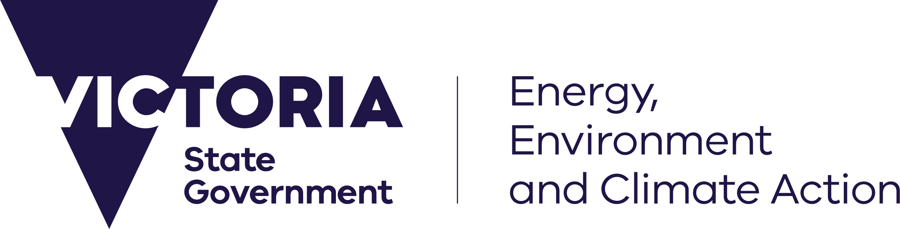
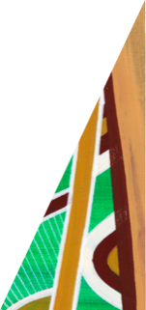
deeca.vic.gov.au

Welcome to the Department of Energy, Environment and Climate Action’s (DEECA’s) marine and coasts quarterly newsletter.

In this issue
- Achieving milestones in implementing the Marine Spatial Planning Framework
- Community engagement for Mounts Bay-Marengo Adaptation Plan
- Black Rock Seawall Remediation Project set to begin
- Release of ‘VCMP Sites’ integrated shoreline data product
- Coastcare Victoria’s ‘Coastline’
Email marine.coasts@delwp.vic.gov.au to subscribe or unsubscribe or for more information.

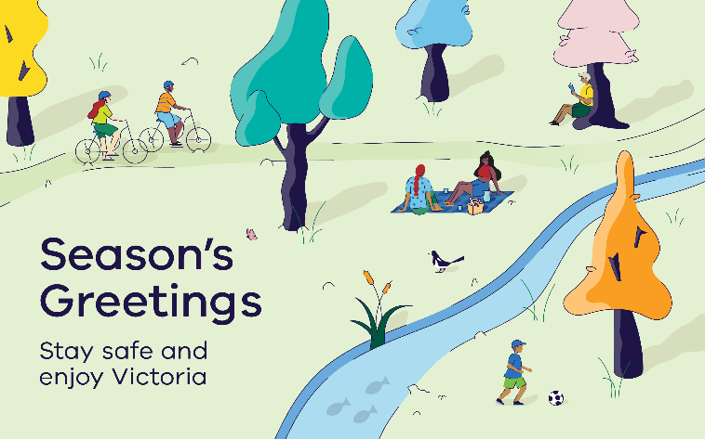

Marine and coastal reforms

Achieving milestones in implementing the Marine Spatial Planning Framework
DEECA’s Land and Environment Policy Division has developed the Marine Spatial Planning Guidelines and Victoria’s Marine Spatial Areas to implement the Marine Spatial Planning Framework, under the Marine and Coastal Policy 2020.
The guidelines and marine planning areas, developed in partnership with Traditional Owner groups and the Victorian Marine and Coastal Council, and in collaboration with key marine and coastal stakeholders, have recently been released on the Marine and Coasts website: marineandcoasts.vic.gov.au/marine-coastal-management/marine-spatial-planning.

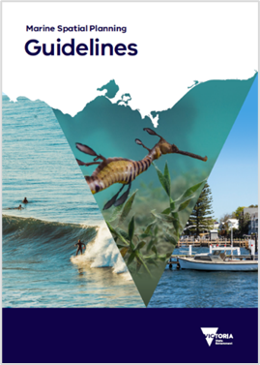
Marine Spatial Planning Guidelines outline detailed instructions and guidance on how to undertake a marine spatial planning process in Victoria.
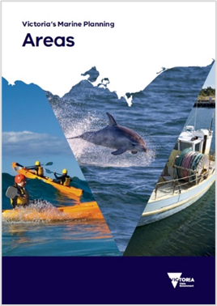
Victoria’s Marine Planning Areas divide the marine environment into eight marine planning areas for future marine spatial planning processes.
These documents are now being used to inform discussions on recognising and integrating cultural landscapes and values into marine planning and management, as well as supporting planning for offshore wind development in Victoria.
The documents will guide marine spatial planning in Victoria and support activities under Action 5 ‘Implement the Marine Spatial Planning Framework’ in the Marine and Coastal Strategy 2022.
For more information on marine spatial planning, watch the video on the Marine and Coasts website.
Feel free to contact the Marine Spatial Planning Team via email marine.spatial.planning@delwp.vic.gov.au for more information.

Coastal projects

Barwon South West region

Community engagement for Mounts Bay-Marengo Adaptation Plan
Mounts Bay (where Marengo meets Apollo Bay) has experienced increased rates of erosion from the 1990s. Repeated beach nourishments and dune stabilisation works have been used to slow dune erosion and prevent damage to the Great Ocean Road. However, these works are becoming less effective with sea level rise and increased coastal storms.
An adaptation plan for Mounts Bay-Marengo is being developed in line with Victoria’s Resilient Coast – Adapting for 2100+ Guidelines, with a focus on the early stages to understand the community values for the beach at Mounts Bay.
On the 10th and 11th of November 2023, Barwon South West DEECA officers Kim Spragg, Fraser Clatworthy and Annie Moreillon held a community engagement drop-in session for the Mounts Bay-Marengo Adaptation Plan, in partnership with the Great Ocean Road Coast and Parks Authority (GORCAPA).
The drop-in session was held at the Apollo Bay Golf Club as part of DEECA and GORCAPA’s first Apollo Bay ‘Coastal Projects Open Day’ (you can watch a video of the open day on GORCAPA’s Facebook page).
We received valuable contributions from a number of locals for more permanent foreshore protection works.
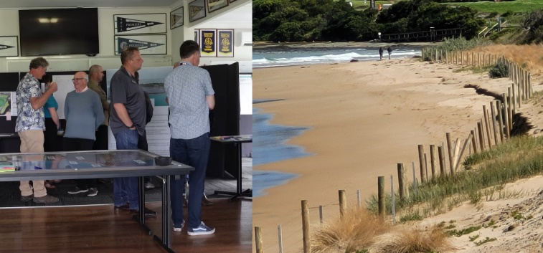
Left: community engagement session at the Apollo Bay Golf Club (10 November 2023). Right: recent coastal erosion at Mounts Bay.
A further online drop-in session was held on 14 December 2023 for those not able to make it on the day.
If you would like to provide feedback or for more information, visit the Mounts Bay Adaptation Plan Engage Victoria site – https://engage.vic.gov.au/mountsbayadaptationplan.

Port Phillip region

Black Rock Seawall Remediation Project set to begin
We are pleased to inform you that repair works are scheduled for the Black Rock masonry seawall, a prominent structure extending from Black Rock Gardens (Balcombe Road) southwards into Ricketts Point Marine Sanctuary.
The seawall, which spans approximately one kilometre, has played a vital role in protecting Beach Road from erosion. It also boasts historical significance as parts of it were constructed using original bluestone from the Old Melbourne Gaol.
The seawall is now well beyond its original design life and has suffered severe damage over time. A recent remediation report highlighted the urgent need for repairs, with about 10% of the seawall in very poor condition.
To address this, our upcoming project will implement a remediation strategy to replace missing bluestone blocks, reinstate capping blocks, and fix grout areas along the seawall.
The remediation works aim not only to ensure the structural integrity of the seawall but also to preserve the popular 2-metre wide path behind it (a key part of the bay trail enjoyed by pedestrians, cyclists, and those with limited mobility).
The works will include site establishment, removal of unsound blocks, and precise reinstatements to match the remediation specifications. We will engage qualified consultants and contractors for the superintendency and construction phases, ensuring that this essential piece of our coastline is preserved for future generations.
We appreciate your understanding and cooperation during this critical phase of maintaining and enhancing the Black Rock seawall. Together, we aim to safeguard both the structural and recreational aspects of this cherished community asset.
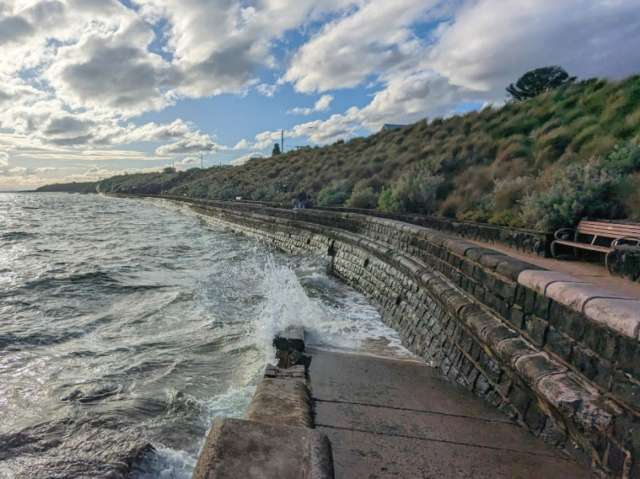
The Black Rock masonry seawall and path.

Marine and coastal knowledge

Release of ‘VCMP Sites’ integrated shoreline data product
The Victorian Coastal Monitoring Program (VCMP) monitors waves and coastal changes at priority sites along Victoria’s coastline.
The VCMP team is releasing a new data product – ‘VCMP Sites’ – containing coastal data for 40 sites across Victoria.
The VCMP Sites product integrates shorelines (drone, satellite, aerial imagery), morphology, coastal structures and baseline elevation data. All datasets are interpolated to the same set of transects, spaced 30-m alongshore.
Why is it useful? The process of obtaining, cleaning and combining all relevant datasets for a coastal processes study would normally take an expert days or weeks. The advantage of VCMP Sites’ is that we have done the hard work, so you don’t have to! This will save time and reduce duplication across Victoria when conducting coastal hazards and adaptation studies.
The data product can be used to interpret historical shoreline changes or to drastically reduce the time required to set up a shoreline change model.
VCMP Sites (in text format) contains the following datasets:
- Transects spaced 30-m alongshore.
- Shorelines for drone data (VCMP, 2018-2023, 667 surveys), satellite data (Digital Earth Australia, annual satellite shorelines, 1988-2021), and aerial imagery (1930 onward, 115 surveys).
- Shoreline time series and linear trends for each shoreline dataset, at each transect.
- Cross-sections from drone data (all transects, all surveys) and the Victorian Coastal Digital Elevation Model (VCDEM, 2022).
- Morphology (SmartLine).
- Coastal structures (DEECA Coastal Asset Management System - CAMS).
VCMP Sites is accessible through the following platforms:
- VicCoastData portal – for access, contact vcmp@delwp.vic.gov.au.
- CoastKit, for viewing and visualisation.
- DataShare, for spatial data formats, search for ‘VCMP Sites’.
- VCMP Sites Metadata Report, includes methods and uncertainty estimates.
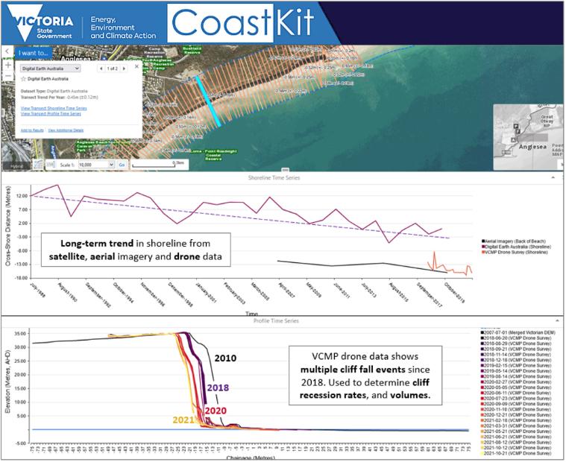
VCMP Sites data product, viewable in CoastKit, downloadable from VicCoastData.
For access, please contact vcmp@delwp.vic.gov.au.
Keep reading for Coastcare Victoria’s ‘Coastline’!

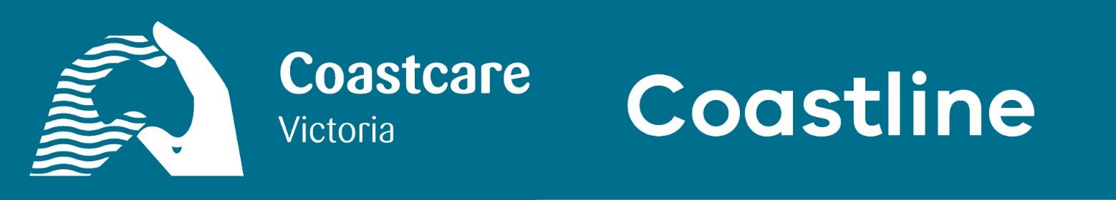

In this issue
- You, Me and Summer by the Sea 2024!
- Opening of the 2024 Coastcare Victoria Community Grants
- Coastcare Victoria Schools Kit learning opportunities

You, Me and Summer by the Sea 2024!
Bookings are now open for more than 60 free activities being delivered across Victoria during Summer by the Sea 2024.
The program runs from 6–25 January 2024, giving people of all ages and abilities the chance to discover the amazing coastal and marine environments where they live or holiday.
The theme for the 2024 program is ‘You, Me and Summer by the Sea’.
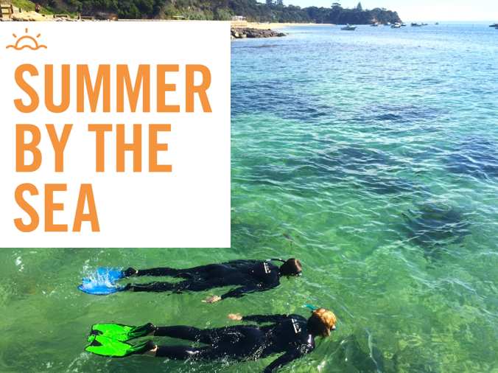
Two snorkellers participating in Summer By The Sea (Wadawurrung Country).
2024 will mark the 30th anniversary of Coastcare Victoria. The theme is designed to engender community networking, place-based engagement, and personal story sharing. It’s a time to celebrate, as well as reflect on years of coastal and marine education and conservation.

Program highlights include:
- Shell surveys at St Kilda.
- Rockpool rambles at Inverloch.
- Snorkelling on the Bellarine Peninsula.
- Guided walks at Lakes Entrance.
- Exploring the Glenelg Estuary.
Summer by the Sea is supported by coastal land managers, community groups and conservation agencies across Victoria.
Anyone who requires assistance to participate in Summer by the Sea can contact Coastcare Victoria to discuss how staff can help them participate.
Visit summerbythesea.vic.gov.au to find out more about the free activities being offered and register to attend.

Opening of the 2024 Coastcare Victoria Community Grants
The Coastcare Victoria team is excited to share that our 2024 Coastcare Victoria Community Grants program is now open. The 2024 grants program is funded by the Victorian Government’s VicCoasts initiative. Grants of up to $10,000 (excluding GST) are available to applicants.
This year our grants are divided into three streams:
- Stewardship and Education.
- Strengthening our Volunteer Groups.
- Supporting Traditional Owner Self-Determination.
Broadly, these streams aim to build community capacity, support Traditional Owner capacity, and support community adaptation and improve coastal ecosystem resilience to climate change.
More information on our streams and the grant program can be found at: marineandcoasts.vic.gov.au/grants/coastcare-victoria-community-grants
The application period will close on Friday 16 February 2024 at 5:00 PM (AEDT). Eligible groups that are looking to fund projects that conserve, restore, and rehabilitate Victoria’s coastal and marine environments are encouraged to apply. Applications can be submitted through the DEECA Grants Online portal.
If you have any questions or wish to discuss a potential project, please contact your Coastcare Victoria Facilitator or email: coastcare.victoria@delwp.vic.gov.au.
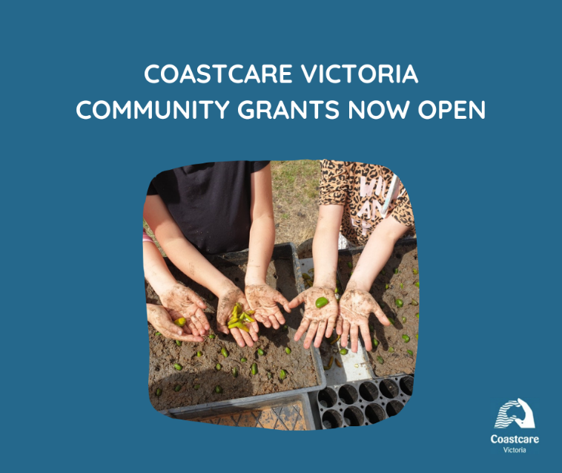
Coastcare Victoria Community Grants are now open.

Coastcare Victoria Schools Kit learning opportunities
Coastcare Victoria and Ecolinc have joined forces to deliver exciting professional learning opportunities that focus on familiarising and upskilling educators in the use of the free online Coastcare Victoria Schools Kit and how to empower students to become coastal environmental activists.
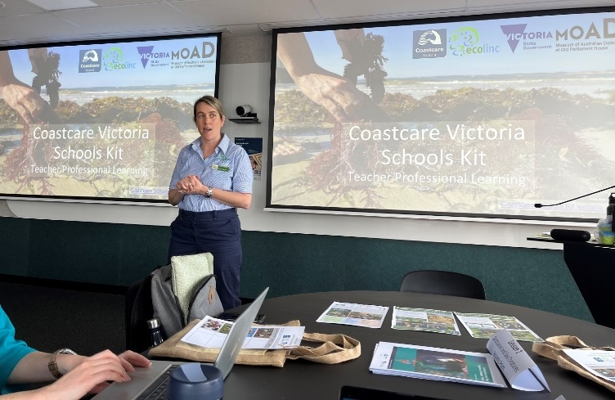
Coastcare Schools Kit Professional Learning 2023 at Geelong, Wadawurrung Country.
These events are specifically designed for schoolteachers, community educators, and government and corporate sustainability educators across Victoria. The professional learning sessions are 2 hours long and available throughout 2024 in locations along the Victoria coast and online:
30 April 2024 | Online  Eventbrite ticket
13 May 2024 | South West (Warrnambool - Brother Fox, Deakin University)  Eventbrite ticket
11 June 2024 | Port Phillip Bay (Melbourne - Port Phillip EcoCentre)  Eventbrite ticket
29 August 2024 | Online  Eventbrite ticket
9 September 2024 | South Gippsland (Phillip Island - Penguin Parade)  Eventbrite ticket
28 October 2024 | East Gippsland (Bairnsdale -Victorian Academy of Teaching and Leadership)  Eventbrite ticket
‘I found the Coastcare PD event well organised and structured, welcoming, informative and the content highly relevant…’ Charlotte Williamson – Education Manager, Werribee River Association

Reach out to the Coastcare Victoria team!
Any questions? Reach out to your local Coastcare Victoria facilitator:

Far South West
Corinne Donohue
0456 742 468
corinne.donohue@delwp.vic.gov.au

Bellarine and Surf Coast
Shaya Kaartinen-Price
0436 604 127
shaya.kaartinen-price@delwp.vic.gov.au

Port Phillip Bay and Westernport
coastcare.victoria@delwp.vic.gov.au

South Gippsland
coastcare.victoria@delwp.vic.gov.au

East Gippsland
coastcare.victoria@delwp.vic.gov.au

Coastcare Victoria Coordinator
Laura Town-Hopkinson
0427 818 683
laura.town-hopkinson@delwp.vic.gov.au
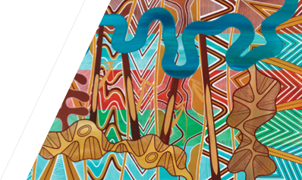
We acknowledge Victorian Traditional Owners and their Elders past and present as the original custodians of Victoria’s land and waters and commit to genuinely partnering with them and Victoria’s Aboriginal community to progress their aspirations.
© The State of Victoria Department of Energy, Environment and Climate Action December 2023.
Creative Commons
This work is licensed under a Creative Commons Attribution 4.0 International licence, visit the Creative Commons website (http://creativecommons.org/licenses/by/4.0/).
You are free to re-use the work under that licence, on the condition that you credit the State of Victoria as author. The licence does not apply to any images, photographs or branding, including the Victorian Coat of Arms, and the Victorian Government and Department logos.
Disclaimer
This publication may be of assistance to you but the State of Victoria and its employees do not guarantee that the publication is without flaw of any kind or is wholly appropriate for your particular purposes and therefore disclaims all liability for any error, loss or other consequence which may arise from you relying on any information in this publication.
Accessibility
To receive this document in an alternative format, phone the Customer Service Centre on 136 186, email customer.service@delwp.vic.gov.au, or contact National Relay Service on 133 677. Available at DEECA website (www.deeca.vic.gov.au).

