# Silverleaves Coastal Adaptation

PROJECT UPDATE #1: August 2024

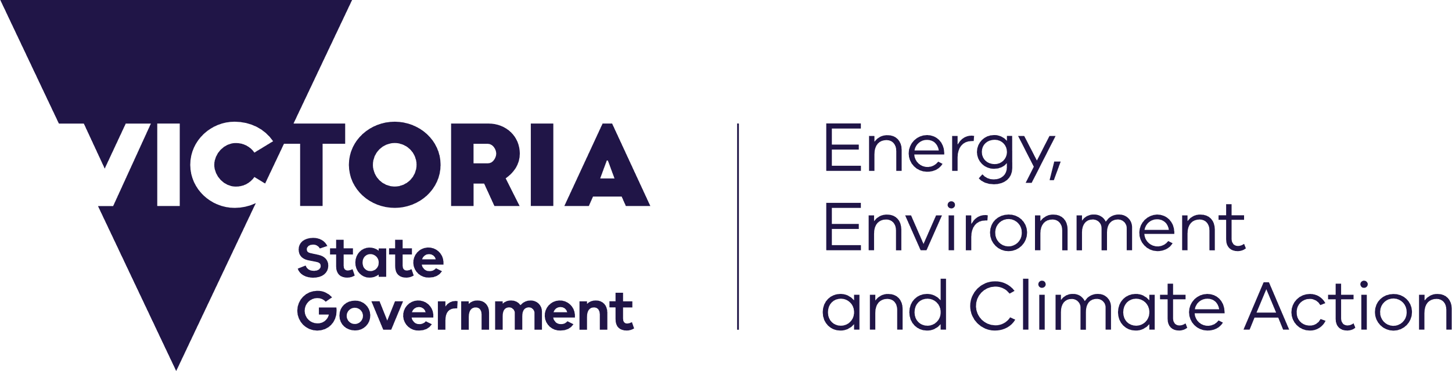

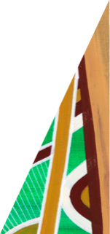

deeca.vic.gov.au

### Over the past two years, the Department of Energy, Environment and Climate Action (DEECA) have been working with Bass Coast Shire Council in response to community concerns about coastal erosion at Silverleaves

#### What is happening at Silverleaves?

In recent years, the coastline at Silverleaves has been affected by coastal erosion. This has resulted in increased shoreline setback and loss of parts of the coastal reserve including established coastal banksias. In addition to the erosion, Silverleaves is also subject to significant storm tide and inundation (coastal flooding) hazards. Much of the potential inundation hazard is likely to originate from Rhyll Inlet.

These flooding events may become more frequent over the coming years due to the impacts of sea level rise and a changing climate.

**Silverleaves beach in February 2024**

In response to community concerns regarding the erosion and changes to the shoreline, DEECA, working with Bass Coast Shire Council have implemented short-term sand renourishment works in August 2023 and engaged consultants FSC Range to undertake a Coastal Processes Study, completed in August 2024.

The study investigates how waves, tides, and winds influence the Silverleaves coastline, with a focus on erosion, inundation, and sediment transport. Its goal is to comprehend the impacts of these processes, sand movement dynamics, and the impact of existing coastal protection structures along the coast.

|  |  |
| --- | --- |
| Information with solid fill | Coastal erosion and inundation are naturally occurring coastal processes that become coastal hazards when they impact places we value and the way we use the coast. |

#### Investigating coastal processes and hazards

Understanding the coastal processes that occur in an area is crucial before considering any work near the coastline. This is to ensure that the potential impacts and extent of any coastal change are appropriately understood and planned for. Completing works without this information could worsen the erosion and move the issue further down the beach.

While further investigative work continues, land management agencies continue to monitor the area with on-site visits and drone monitoring.

#### Adaptation pathways planning

​​With this improved understanding of coastal processes, FSC Range will start working on adaptation pathways planning for the Silverleaves foreshore area.  
  
**Silverleaves beach in February 2024**

The adaptation “pathways approach” helps determine what combinations of adaptation actions might be feasible where and when. This allows us to be planning our adaptation from present day to longer-term, bringing together multiple actions in response to the risks and responding to changes over time.

When considering adaptation pathways, DEECA and other land managers are guided by the [*Marine and Coastal Policy 2020*](https://www.marineandcoasts.vic.gov.au/__data/assets/pdf_file/0027/456534/Marine-and-Coastal-Policy_Full.pdf) and [Victoria’s Resilient Coast Guidelines](https://www.marineandcoasts.vic.gov.au/__data/assets/pdf_file/0022/662503/Victorias-Resilient-Coast-Guidelines-.pdf). Follow these links for more information.

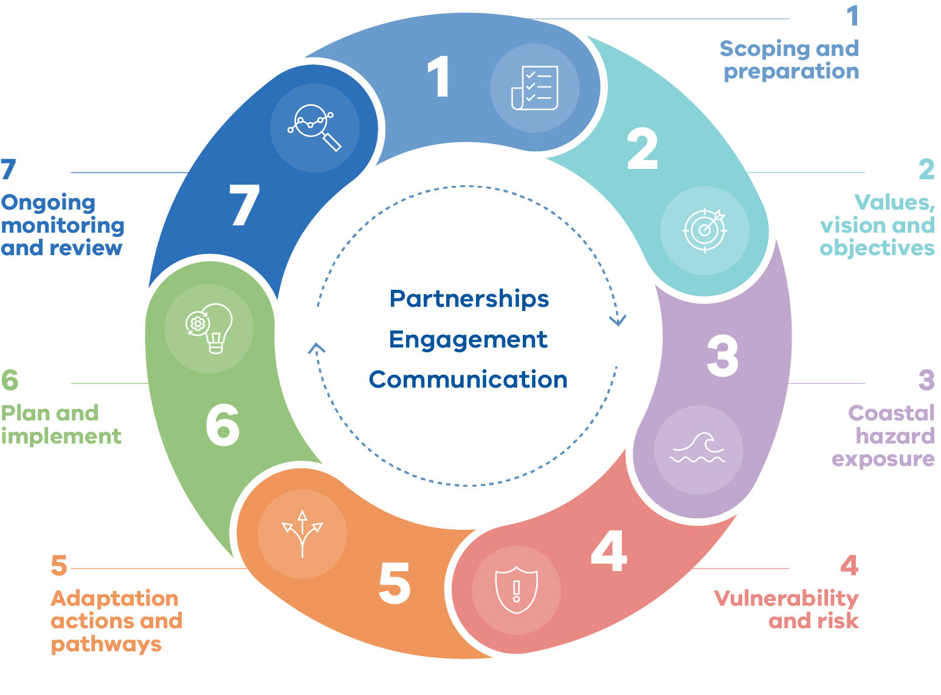

**Figure 1. Victoria’s Resilient Coast - Adapting for 2100+ framework stages, we are at stage 5 and require important values information to progress**

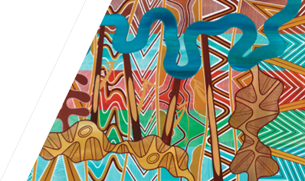

We acknowledge Victorian Traditional Owners and their Elders past and present as the original custodians of Victoria’s land and waters and commit to genuinely partnering with them and Victoria’s Aboriginal community to progress their aspirations.

© The State of Victoria Department of Energy, Environment and Climate Action August 2024.

Creative Commons

This work is licensed under a Creative Commons Attribution 4.0 International licence, visit the [Creative Commons website](http://creativecommons.org/licenses/by/4.0/) (<http://creativecommons.org/licenses/by/4.0/>).

You are free to re-use the work under that licence, on the condition that you credit the State of Victoria as author. The licence does not apply to any images, photographs or branding, including the Victorian Coat of Arms, and the Victorian Government and Department logos.

**ISBN** 978-1-76136-887-5 **(pdf/online/MS word)**

Disclaimer

This publication may be of assistance to you but the State of Victoria and its employees do not guarantee that the publication is without flaw of any kind or is wholly appropriate for your particular purposes and therefore disclaims all liability for any error, loss or other consequence which may arise from you relying on any information in this publication.

Accessibility

To receive this document in an alternative format, phone the Customer Service Centre on 136 186, email [customer.service@delwp.vic.gov.au](mailto:customer.service@delwp.vic.gov.au), or contact National Relay Service on 133 677. Available at [DEECA website](http://www.deeca.vic.gov.au/) (www.deeca.vic.gov.au).

#### Hearing from the community

If you’d like to hear more about the Silverleaves Coastal Processes Study and next steps for adaption, we are holding a drop-in information session on **Friday August 30, from 10am to 12pm** at [Berninneit](https://www.basscoastculturalvenues.com/berninneit-cowes) Cultural Centre, 91-97 Thompson Avenue, Cowes.

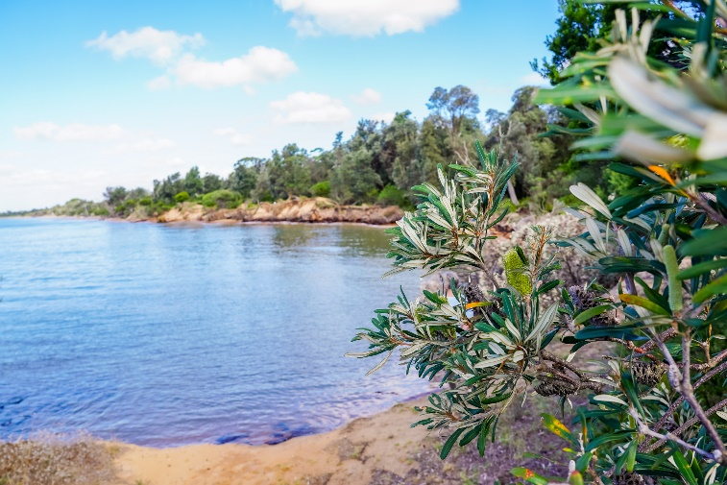

**Silverleaves beach in February 2024**

**Next steps**

If you have questions for the project team, please email us at [gippsland.coastalprojects@deeca.vic.gov.au](mailto:gippsland.coastalprojects@deeca.vic.gov.au)

You can also visit the [Gippsland Coastal Projects](https://delwpvicgovau.sharepoint.com/sites/ecm_204/CoastalProjects/Silverleaves%20Coastal%20Processes%20Study/Keep%20an%20eye%20out%20on%20Engage%20Victoria%20for%20further%20details%20about%20the%20project%20and%20upcoming%20engagement) webpage for more information about this project and any upcoming engagement.