# Cape to Cape Resilience Project Inverloch on-ground works

Initial Dune Reconstruction and Beach Nourishment Concept Design Project Update #1: April 2025

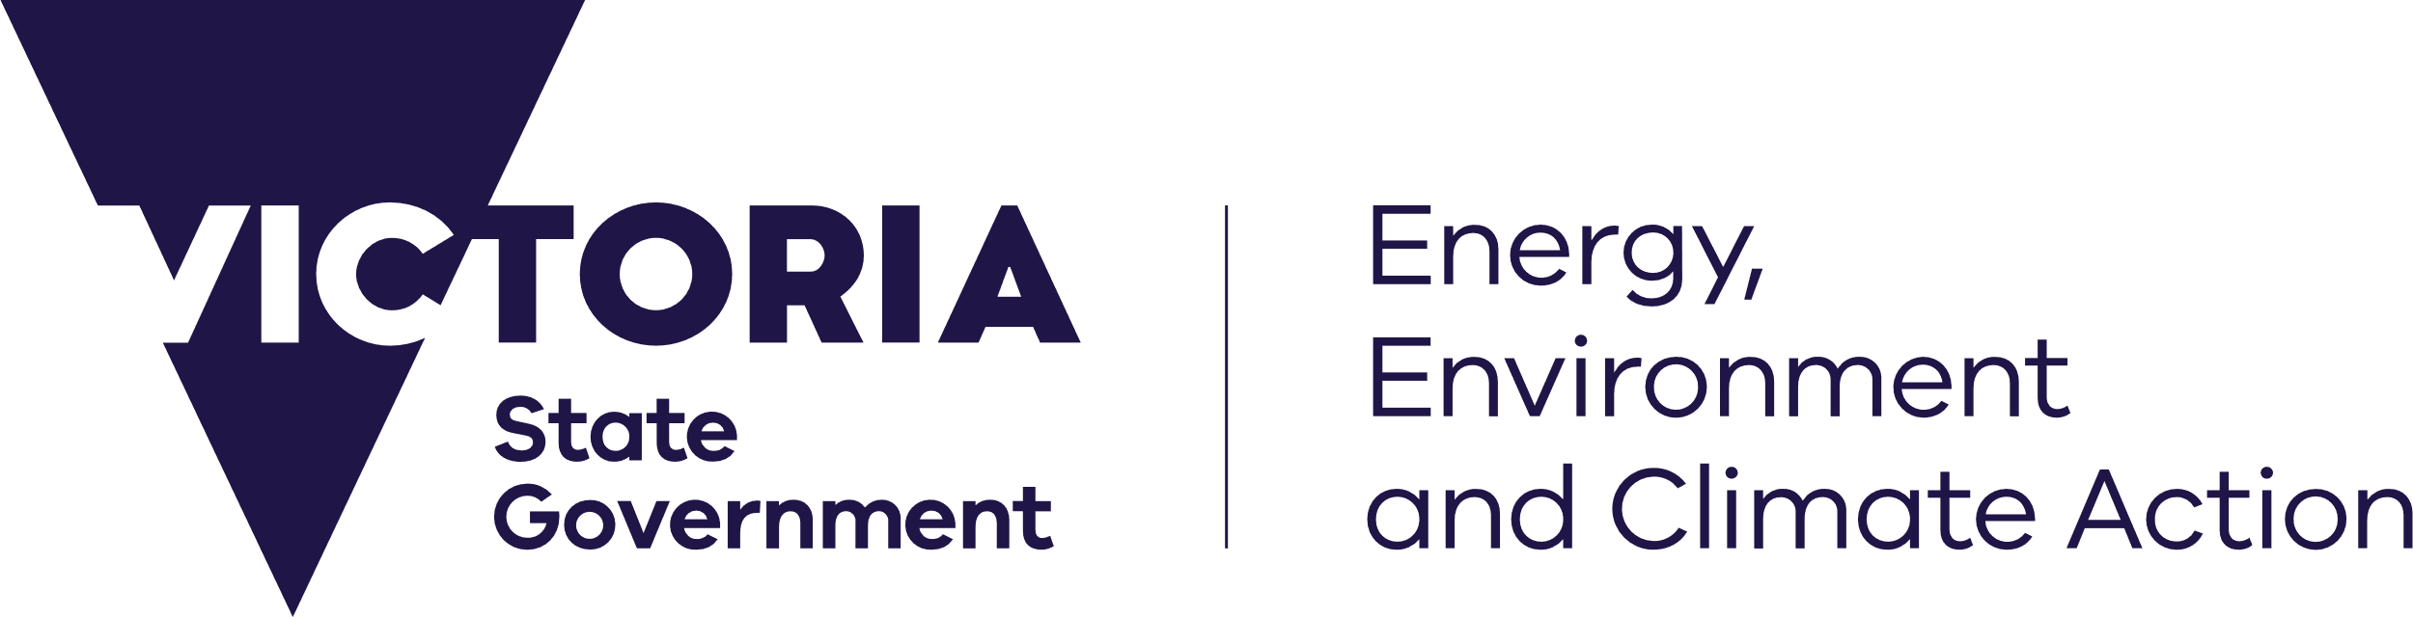

[deeca.vic.gov.au](https://delwpvicgovau-my.sharepoint.com/Users/fionadurante/Downloads/deeca.vic.gov.au)



Inverloch Surf Beach initial dune reconstruction and beach nourishment will retain the natural environmental values and provide a safe, accessible beach.

## What is dune reconstruction and beach nourishment?

The Cape to Cape Resilience Plan has identified dune reconstruction and beach nourishment as the first action in the adaptation pathway to maintain the significant natural and community values of Inverloch Surf Beach.

DEECA was awarded funding of $3.3 million through the Australian Government’s Coastal Estuarine Risk Mitigation Program to commence on-ground works at Surf Beach. The funding is being used for dune reconstruction and beach nourishment capital works, associated designs and approvals.

This project is a large scale, engineered restoration project which aims to rebuild part of the lost sand dune, with the long-term aim of creating safe access to the beach from the Surf Life Saving Club building and Surf Parade.

The initial dune reconstruction will include revegetation to help hold the sand in place, however the sand is not considered permanent. This means it is a buffer of sand in front of the existing dune which can then erode instead of impacting the dune behind it.

## Why do we renourish beaches?

We place sacrificial sand on beaches to protect the public foreshore and public and private assets within and behind the foreshore.

Due to natural processes on a dynamic beach like Inverloch, sand will move with the incoming tides and waves. As it moves, it will have the additional benefit of widening the existing beach as the new dune erodes.

Some sand will be naturally shifted further offshore during larger, higher energy events, and continue its prevailing easterly movement away from the Surf Beach. Some of the sand will settle in the surf zone and will shift back onto the beach (accreting/rebuilding the beach) during lower energy periods.

## Sand Sourcing Study

A sand sourcing study has been undertaken to identify available suitable sand for initial dune reconstruction and beach nourishment.

The aim of the study was to locate suitable sand deposits for a large-scale dune nourishment project between 100,000m3 and 150,000m3. It also assessed opportunities and constraints associated with the different sources of sand and nourishment options.

### Anderson Inlet Sand

Sediment sampling on sand bars inside the inlet has located coarse sand which is better at holding the designed shape of the dune and staying in place on the beach. This would provide a greater level of protection for the dune and foreshore.

### Offshore Sand

Offshore sediment sampling in Venus Bay located much finer sand which is less effective at holding the shape of the dune and staying on the beach. Due to the location of a submarine cable to Tasmania, there are exclusion areas that will restrict anchoring and dredging to provide efficient supply of sand to the nourishment location.

## Where will sand be dredged inside the Inlet?

Following the sand sourcing study, dredging investigations and modelling, it is recommended that sand for the nourishment is sourced from within Anderson Inlet. As the sand from the inlet is coarser, it will create a dune buffer that can better protect the existing dune from high energy storm tides.

Dredging within inlets and estuaries is common on Australia’s east coast, where many estuaries function in a similar way to Anderson Inlet.

The sediment samples were taken from a shallow sand bar in Anderson Inlet inside Point Smythe, but not in the entrance itself. The sandbars inside the inlet are very mobile, frequently being moved around by flows from the Tarwin River and tidal flows through the entrance.

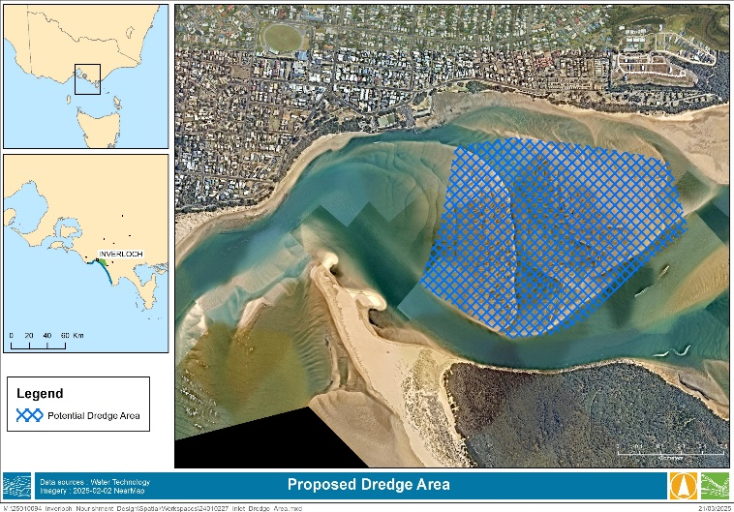

The exact dredge location is still to be decided and further investigation, including core sampling of the sand bars, will help determine the best and safest location. The channels are naturally very dynamic and change in the entrance is expected both before and after dredging. The volume of material to be dredged is a small proportion of the sand present in the intertidal depths within the entrance and is unlikely to change the impact of a large storm or flood event.

## Initial Dune Reconstruction and Beach Nourishment Concept Design Development

Coastal engineers Water Technology have been engaged by DEECA to prepare initial dune reconstruction and beach nourishment concept designs for Inverloch Surf Beach.

These designs are the first step in retaining natural environmental values and providing a safe, accessible beach for the Inverloch community for as long as possible.

## Concept Design Parameters

The concept design parameters have been driven by the specific project parameters, including the available budget, the length of the beach and the height of the existing dune and beach profile.

### Extent of Nourishment

The proposed extent of dune nourishment is close to 1,000m, extending from the rock seawall at Cape Paterson-Inverloch Road at the western extent to the beach opposite Ozone Street in the east.

### Width of the dune

The width of the dune nourishment varies, with more sand to be placed at the western end. The natural processes driving sand east will provide nourished sand eastward over time. The wider nourishment at the western end will also provide enhanced protection to the more vulnerable assets at the western end of the area, including Surf Parade.

### Height of the dune

The height of the dune will also vary, with a higher crest at 4m above sea level in the west to increase the volume of material here and thus increase the level of protection. The concept design crest (top of the dune) width of the dune at the western end is close to 40m. The width of the nourishment will vary with the position of the existing dune and the volume of sand available. The width of the concept design crest west of Ozone Street is 20m and the height is 3m above mean sea level.

### Design Profile

It is important to note the Surf Beach at Inverloch is exposed to high energy waves and is presently mostly inundated during high tide. The on-ground nourishment will adjust immediately to these environmental conditions and the design profile will not remain as constructed for a long period of time following placement. This is not an indication that the nourishment is ineffective, the design is being developed to allow for this natural adjustment by placing more material at the western end of the site and building a dune which can be reprofiled over time to maintain a buffer for the existing dune.

## Image Renders

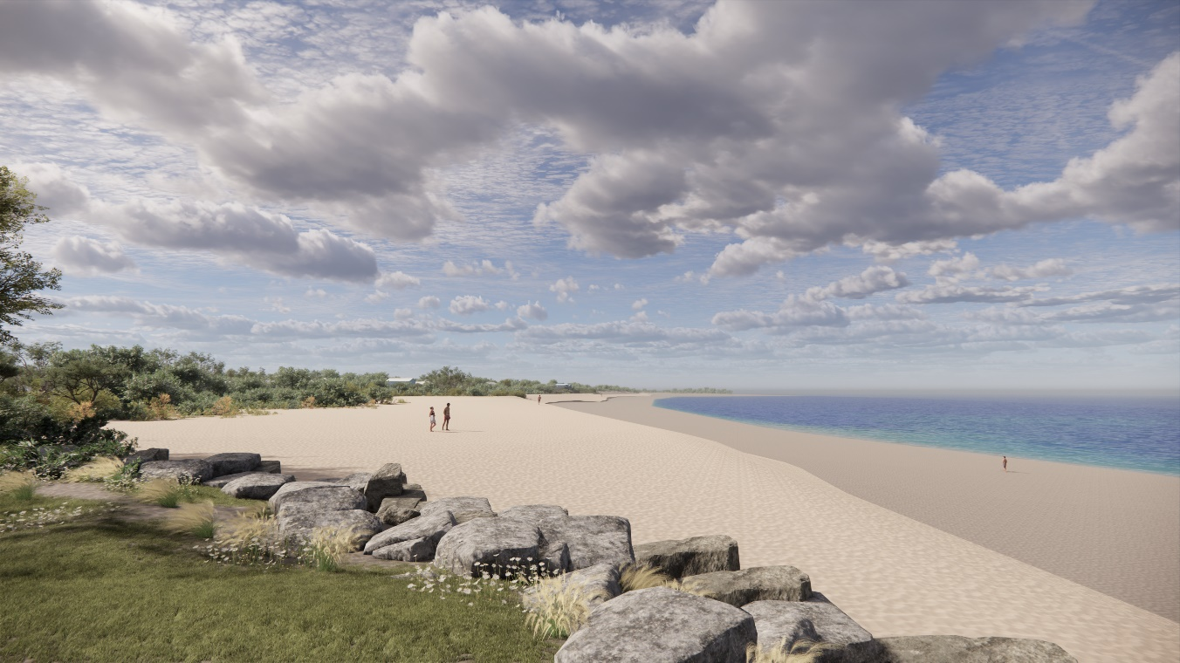

Photo-realistic image: depicting reconstructed dune and nourished beach. View from current Bunurong Rd rock revetment looking east along Surf Beach towards the Surf Club. The width of the nourishment and scarp of the dune will vary over time as waves and tides interact with it.

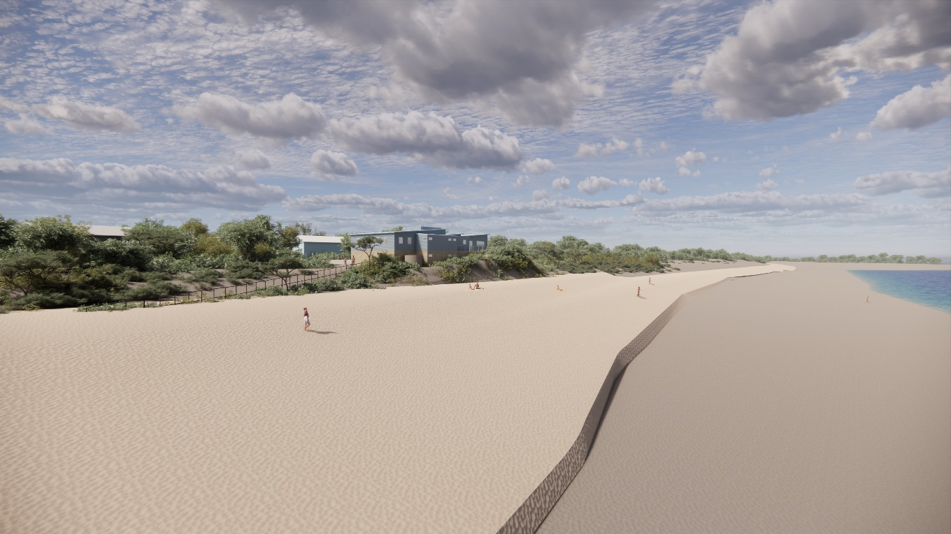

Photo-realistic image: depicting reconstructed dune and nourished beach. View looking east along beach towards pedestrian access track and Surf Club. The width of the nourishment and scarp of the dune will vary over time as waves and tides interact with it.

Photo-realistic image: depicting reconstructed dune and nourished beach. View looking directly at Surf Club from off shore. The width of the nourishment and scarp of the dune will vary over time as waves and tides interact with it.

## Preliminary Concept Design

Plan view of design based on:

* ~110,000m3 of nourishment material
* Greater high and cross section volume in the west decreasing in the east
* Inset images represent approximate design profile at three different locations along the beach (shown as black lines), extending ~100m into intertidal zone. The existing beach is shown in blackish brown and the nourishment is shown in yellow.

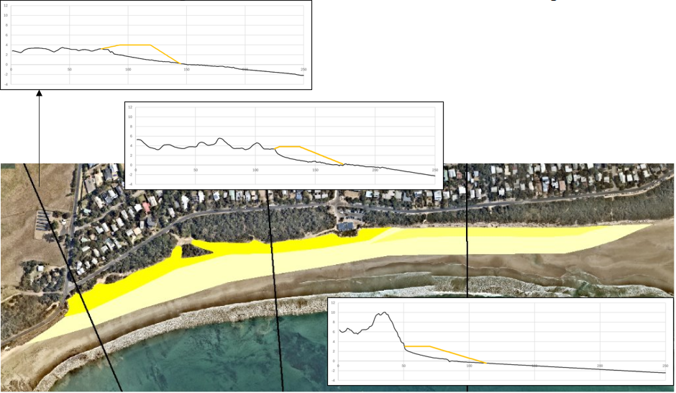

## 

## Cape to Cape Resilience Plan

The draft Cape to Cape Resilience Plan was open for public consultation from 23 August to 13 October 2024. We received feedback through surveys and emails, and targeted conversations were held with key stakeholder groups.

All the feedback has been reviewed and the final Cape to Cape Resilience Plan is being revised taking the feedback into consideration.

An update on the Cape to Cape Resilience Project with an engagement summary report will be issued soon.

## How can I get involved?

* Check out the Plan, technical reports, hazard maps and read our latest updates - visit the project website at [marineandcoasts.vic.gov.au/coastal-programs/cape-to-cape-resilience-project](http://www.marineandcoasts.vic.gov.au/coastal-programs/cape-to-cape-resilience-project)
* Ask a question or sign-up to receive updates – email [capetocape.project@deeca.vic.gov.au](mailto:capetocape.project@deeca.vic.gov.au)



We acknowledge Victorian Traditional Owners and their Elders past and present as the original custodians of Victoria’s land and waters and commit to genuinely partnering with them and Victoria’s Aboriginal community to progress their aspirations.

© The State of Victoria Department of Energy, Environment and Climate Action April 2025.

Creative Commons

This work is licensed under a Creative Commons Attribution 4.0 International licence, visit the [Creative Commons website](http://creativecommons.org/licenses/by/4.0/) (<http://creativecommons.org/licenses/by/4.0/>).

You are free to re-use the work under that licence, on the condition that you credit the State of Victoria as author. The licence does not apply to any images, photographs or branding, including the Victorian Coat of Arms, and the Victorian Government and Department logos.

ISBN 978-1-76176-221-5 (word/pdf)

Disclaimer

This publication may be of assistance to you but the State of Victoria and its employees do not guarantee that the publication is without flaw of any kind or is wholly appropriate for your particular purposes and therefore disclaims all liability for any error, loss or other consequence which may arise from you relying on any information in this publication.

Accessibility

To receive this document in an alternative format, phone the Customer Service Centre on 136 186, email [customer.service@delwp.vic.gov.au](mailto:customer.service@delwp.vic.gov.au), or contact National Relay Service on 133 677. Available at [DEECA website](http://www.deeca.vic.gov.au/) (www.deeca.vic.gov.au).