Frequently Asked Questions (FAQs)
Inverloch Dune Reconstruction and Beach Nourishment Works Community Information Session, October 2025









deeca.vic.gov.au

- What is involved in the dune reconstruction and beach renourishment works at Inverloch Surf Beach?
The initial dune reconstruction and beach renourishment at Inverloch Surf Beach is the first on-ground action to be delivered under the Cape to Cape Resilience Plan, in February 2026.
This project is a large-scale engineering project aimed at maintaining safe access to Inverloch Surf Beach and rebuilding part of the lost sand dune. In feedback received during the project’s community consultation (various surveys, drop-in sessions, pop-ups, markets, and roundtables), the local community expressed strongly that the natural beach and coastal landscape of Inverloch is what they value the most about Inverloch’s coast. It is a significant recreational and tourism asset, and losing the beach would have wide ranging negative impacts on the town’s amenity, liveability and economy. A rock revetment, like the one at Cape Paterson-Inverloch Road, will cause erosion in front of it, lowering the beach level. It will not help sand to stay on the beach. This would mean that Inverloch Surf Beach is only useable at low tide. The ends of the wall would behave just like the sandbag seawall, eroding the dune either side during storm events. Extending the wall to make it longer would just move the problem further either side because there is no natural hard headland to tie it into.
It is important to note the Surf Beach at Inverloch is exposed to high energy waves and is presently mostly inundated during high tide. The on-ground nourishment will adjust immediately to these environmental conditions and the design profile will not remain as constructed for a long period of time following placement. This is not an indication that the nourishment is ineffective, the design is being developed to allow for this natural adjustment by placing more material at the western end of the site and building a dune which can be reprofiled over time to maintain a buffer for the existing dune.
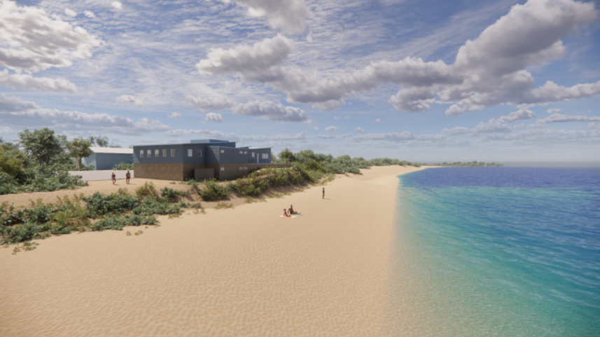
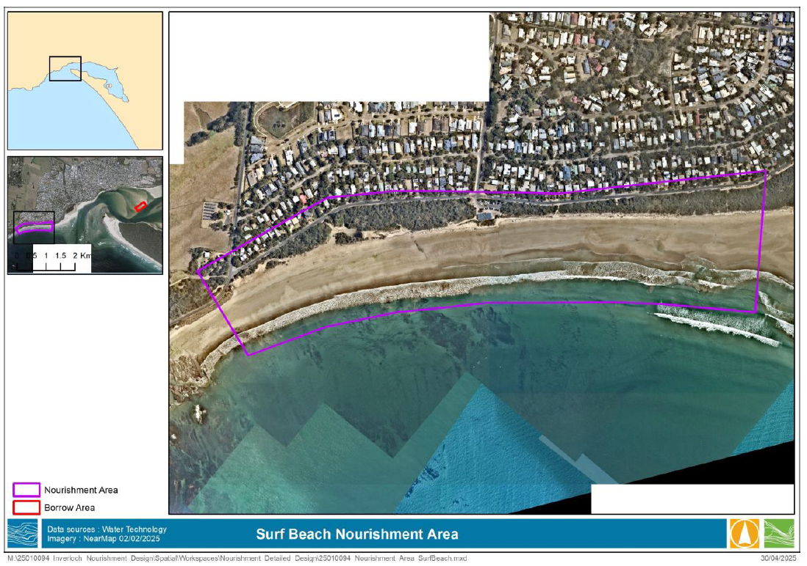
- Will there be a visible beach at high and low tide immediately after the dune reconstruction, and when will a stable beach profile be re-established?
Yes, there will be a dry, sandy beach at high tide. The new beach profile will be visible immediately, though it will take time for waves and tides to shape it naturally. Within a few months, the beach will reach a more stable form.
- How long will the works offer protection?
The dune reconstruction and sand nourishment works are designed to provide protection for approximately a 10% Annual Exceedance Probability (AEP) coastal event - meaning a storm event with about a 1-in-10 chance of occurring in any given year. While this approach offers an effective short- to medium-term buffer against erosion and storm impacts, the placed sand will naturally adjust to ongoing wave and tidal conditions, gradually reducing over time. This is expected and reflects how nourishments function within dynamic coastal systems. The design accounts for this adjustment by using coarser sand that holds its position better and by building a dune that can be reprofiled as conditions change, maintaining a natural buffer in front of the existing dune.

- Where will the sand be sourced from? Will any equipment such as dredge pipelines remain for future use?
Anderson Inlet has been identified as the source of sand for the dune reconstruction, following an extensive sand sourcing study which looked at offshore and land-based sand sources. The sand bars inside the inlet have coarse sand which is better at holding the designed shape of the dune and staying in place on the beach.
The desire for a dune nourishment, with steeper slopes and a greater resistance to storm erosion resulted in selection of the Anderson Inlet source for the nourishment.
All equipment, including pipelines, will be removed once the project is finished.

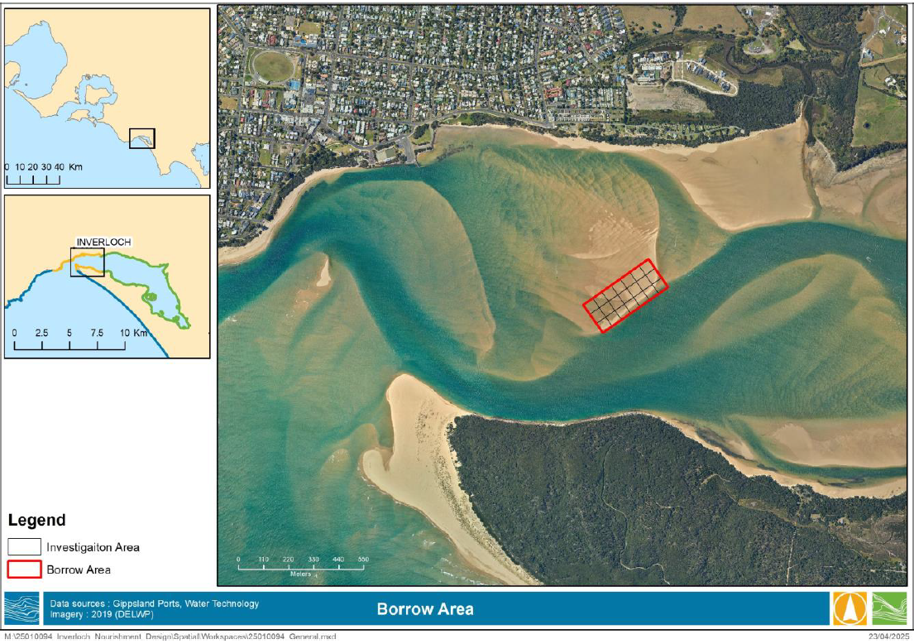

- What measures are in place to ensure that dredging within Anderson Inlet does not alter the channel’s position further toward Venus Bay or impact coastal dynamics near Inverloch?
Comprehensive environmental assessments have been completed to ensure dredging can occur safely and sustainably. These include assessments are informed by the Feature Activity Sensitivity Tool (FeAST assessment) a targeted ecological survey of the dredge and nourishment areas, additional inlet modelling, and Coastal Acid Sulphate Soils testing. An Environmental Improvement Plan has also been prepared to manage key environmental risks during the works.
Currents within the entrance channels of Anderson Inlet are strong (often exceeding 1 m/s) and mainly driven by tides. These strong tidal flows naturally cause the channels to realign over time, with current strength and direction varying daily. Because of this constant movement, the volume of sand to be dredged (100,000 m³) represents only a small portion of the total sand within the inlet and is not expected to alter the natural behaviour of the tidal channels or increase storm or flood impacts.
- Does dredging in Anderson Inlet cause sand loss from other beaches in the region, and how is sediment movement being monitored to avoid negative impacts elsewhere?
The dredging areas and sand placement have been carefully chosen to avoid drawing sand away from other beaches. Sediment movement will continue to be monitored to ensure no negative impacts occur elsewhere.
- How much sand will be dredged?
The nourishment design allows for at least 100,000m3 of sand to be placed on the beach. This volume is constrained by funding. 100,000m3 of sand would require well over 4,500 truckloads of sand to be transported which would be unsuitable and inefficient. Therefore, using a dredge and pumping a water and sand slurry from Anderson Inlet to Surf Beach is the preferred method.
- What protective measures are being used to stabilise the renourished sand, and how effective will dune vegetation be in preventing erosion?
DEECA is considering a range of natural strategies to stabilise the renourished sand and to support vegetation establishment including placing wood, spreading of brush matting and tree heads to trap sand and deter access. Shore-deposited kelp, legally sourced Coast Tea Tree and fallen logs above the wave zone can act as micro windbreaks to shelter revegetation and provide habitat. Access may also need to be deterred by standard fencing supported by appropriate signage.
Dune vegetation plays a crucial role in stabilising dunes by reducing wind erosion, trapping sand to build and maintain dune structure, and supporting natural recovery after storms. It also provides habitat for native fauna and can adapt to gradual dune movement over time.
- When will the works be completed?
DEECA has engaged a contractor for the delivery of dune reconstruction and beach nourishment works, scheduled to commence in February 2026 and is due for completion by mid-June.
These works were initially scheduled for Spring 2025, however, timing of on-ground works has been influenced by contractor vessel and machinery availability, and careful consideration given to avoiding undertaking works during the peak school holiday period and to avoid nesting shorebirds.
DEECA is now working closely with the contractor to finalise the details of the works. We are committed to keeping the community informed and will share further updates as planning progresses.
- What impacts will the works have upon public access to Inverloch Surf Beach?
During construction period sections of the beach will be closed in stages to minimise disruption to the public and enable continued use and access to the beach. Appropriate fencing and barriers will be installed to prevent public access into the construction site. A fenced construction compound will be set-up for larger equipment including the sand dredge, booster pump and bulldozer.
Effective noise barriers will be in place. An Environmental Management Plan in accordance with EPA noise protocol provisions will outline site specific noise limits, with suitable controls to achieve those limits.
The works have been designed and engineered by independent coastal engineers to protect the dune from further coastal erosion whilst also increasing the beach area. A cutter suction dredge will be used to recover sand from within Anderson Inlet, the sand will then be pumped along the beach to nourishment locations.
- What works are proposed to take place to the current Sandbag Seawall in front of the Surf Life Saving Club?
The sandbag seawall in front of the Inverloch Surf Life Saving Club building on Surf Beach will be repaired and extended to address damage resulting from the significant storm event in spring last year.
As expected with hard structures against sand dunes, there has been terminal scour at the ends of the wall and Bass Coast Shire Council has been regularly backfilling this area to maintain ongoing protection, while preparations continue for seawall repair and extension. DEECA has provided $778,000 of funding for the seawall works, and detailed designs are now complete.
The sandbag seawall repair and extension construction works will be delivered by Bass Coast Shire Council (BCSC) on behalf of DEECA. This will deliver greater protection for the Surf Life Saving Club building. The sandbag seawall will be buried under the reconstructed dune and major beach nourishment, and DEECA will be working with BCSC to ensure collaborative delivery for all on-ground works. The works are set to commence in December, prior to Christmas.

- Have other erosion control measures such as artificial reefs, wet sand fences, rock walls, or concrete tetrapods been considered, and why were they not chosen for this project?
Hard structures like rock walls or artificial reefs were assessed but not chosen because they can affect nearby beaches and the natural character of the coastline. Sand renourishment and dune restoration offer a more natural and flexible protection method. More information about how these options were considered is available on our webpage by scrolling down to the ‘Resilience Plan Frequently Asked Questions’ section in Stage 2 of the project.
- How does this sand renourishment project fit into the broader long-term coastal protection strategy for Inverloch, and what future works or monitoring are planned after the initial renourishment?
The Inverloch dune reconstruction and renourishment project is an evidenced-based, nature-focused intervention. These major on-ground works are the first step in a pathway of adaptation actions to provide a safe, accessible beach for the Inverloch community and retain environmental and community values as identified in the Cape to Cape Resilience Plan. It will be followed by structured, regular monitoring and a clear decision pathway for when and how to apply further works. Please see our webpage for more information.
- How will the sand renourishment works affect public access to the main surf beach, including temporary closures, restricted areas for swimming and surfing, dredge and pipeline locations, use of booster pumps, and the overall duration of construction works?
Sections of the beach will be temporarily fenced off while sand is pumped ashore and shaped. Access to other parts of the beach will remain open wherever possible. Signage and fencing will clearly show safe areas. Any pipelines or booster pumps will be located and secured to minimise disruption, and temporary closures will be lifted as soon as it’s safe.
- Who is responsible for maintaining Wreck Creek’s outlet to the sea, and how will flood risks to nearby properties be managed during and after the works?
Wreck Creek’s outlet and nearby drainage are managed by the West Gippsland Catchment Management Authority in collaboration with Bass Coast Shire Council and Parks Victoria. Both branches of Wreck Creek have been considered during the nourishment design which has been developed to mitigate coastal flood risks. Conditions will be monitored to reduce flood risk during and after the works.
For more information:
- https://ew-data.waterwatch.org.au/estuary/wgcma/304
- https://wgcma.vic.gov.au/explore-the-catchment/estuaries/

- Why has the project design profile changed from earlier fact sheets, and how are updates on design and protection measures being communicated to the community?
Designs are updated as new surveys, environmental findings, and safety requirements emerge. The final layout reflects the most current data and best practice following independent peer review by registered coastal engineers.
The best way for community members to keep up-to-date with the work at Inverloch is by being a part of our stakeholder email list which you can join by sending an email through to capetocape.project@deeca.vic.gov.au We also develop project updates hosted on the Cape to Cape Resilience Project webpage and will run another online information session before the works commence.
- How much funding is being provided to completely fix or restore the beach?
The works are funded through a $3.3 million contribution from the Australian Government’s Coastal and Estuarine Risk Mitigation Program, with an additional $2 million from the Victorian Government to ensure the project meets the full scope of the approved design. The project focuses on reconstructing the dune and undertaking beach nourishment to reduce coastal erosion risks and protect public values and assets.
Active monitoring will continue through DEECA’s Victorian Coastal Monitoring Program, and planning for post-nourishment dune revegetation is underway with Bass Coast Shire Council and the South Gippsland Conservation Society, scheduled for Spring 2026 and funded by DEECA.
Separately, the sandbag seawall in front of the Inverloch Surf Life Saving Club will be remediated and extended, supported by $778,000 in Victorian Government funding. These works, delivered by Bass Coast Shire Council, will enhance protection for the Surf Life Saving Club and integrate with the reconstructed dune and nourishment works.
- How were the community engaged in the development of the adaptation pathway for Inverloch?
Community engagement for the Cape to Cape Resilience Plan was undertaken in stages from 2021 to 2024 and the feedback informed the Plan including Inverloch’s adaptation pathway and the dune reconstruction and beach nourishment works. The engagement methodology was carefully designed to ensure accessible, flexible participation and genuine opportunities for community input.
We had responses and conversations involving over 1200 people via online surveys, face to face engagement, pop ups, drop-in sessions, round tables, expos and fetes. Those we spoke with held many different viewpoints and aspirations for the beach, and overwhelmingly the feedback indicated that the natural, accessible beach was of the highest value to the broader Inverloch community and visitors. A Stakeholder Reference Group which included a range of individuals from the Inverloch community supported Stage 1 of the work, and nearly 6000 individuals accessed resources via Engage Victoria and the project webpage.
The full details about this engagement are publicly available on the Cape to Cape Resilience Project webpage.

