|  |
| --- |
| DELWP marine and coasts newsletter |

Welcome to the Department of Environment, Land, Water and Planning’s (DELWP’s) quarterly marine and coasts newsletter**.**

# In this issue…

* Marine Spatial Planning in Victoria
* Coastal protection projects across the state
* Feature Activity Sensitivity Tool (FeAST) – Victoria’s new marine evidence-based tool for decision-making
* Completion of Coastal Asset Condition Inspection Program
* Abalone disease update
* Coastcare Victoria’s ‘Coastline’

|  |
| --- |
| Email [marine.coasts@delwp.vic.gov.au](mailto:marine.coasts@delwp.vic.gov.au) to subscribe or unsubscribe to this newsletter and for more information. |

# Marine and coastal policy reforms

## Marine Spatial Planning in Victoria

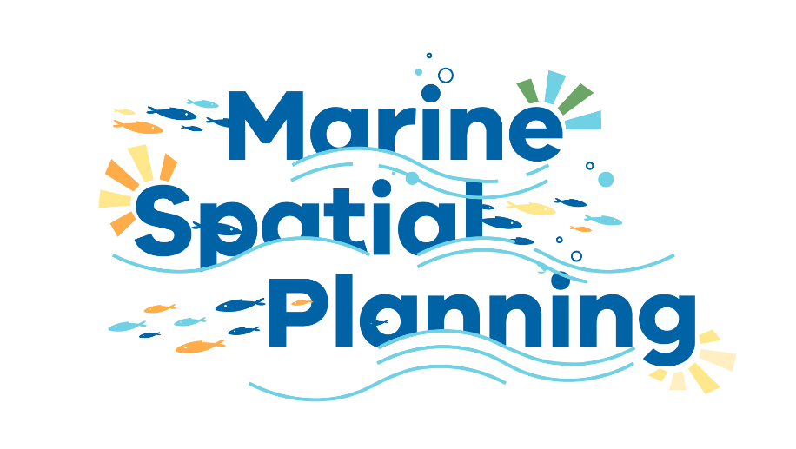

Watch the Marine Spatial Planning animation at [marineandcoasts.vic.gov.au/marine/marine-spatial-planning](https://www.marineandcoasts.vic.gov.au/marine/marine-spatial-planning)

Victoria’s marine environment supports a variety of activities and uses as well as a diverse range of habitats and species. As such, maintaining the health of the marine environment is important to Victorians and crucial to the Victorian economy.

Marine Spatial Planning (MSP) is a practical way to organise marine space, and the interactions among human uses and between these uses and the marine environment.

MSP can have significant benefits including proactively identifying and reducing conflicts and protecting values linked to the marine environment. MSP is increasingly used worldwide, providing an integrated approach to marine planning and management.

Victoria’s Marine and Coastal Policy 2020 includes a Marine Spatial Planning Framework (MSP Framework) which sets out Victoria’s approach to MSP.

DELWP’s Land Management Policy Division is leading implementation of the MSP Framework and will be working with Traditional Owners and engaging with a range of marine stakeholders as work progresses.

A Statewide Assessment that identifies marine planning areas and priorities, and MSP Guidelines that will provide instructions on how to undertake MSP, are now being completed.

Following this, the first marine spatial planning process in a priority area identified through the Statewide Assessment will be scoped and progressed.

For more information including an animated overview of the MSP, please visit [marineandcoasts.vic.gov.au/marine/marine-spatial-planning](https://www.marineandcoasts.vic.gov.au/marine/marine-spatial-planning) or contact the Marine Spatial Planning Team, [marine.spatial.planning@delwp.vic.gov.au](mailto:marine.spatial.planning@delwp.vic.gov.au).

# Coastal protection projects

## Northern Bellarine beach renourishment

Approximately 40,000 cubic metres (m3) of sand will be dredged and deposited at four popular beaches on the northern Bellarine Peninsula this winter as part of the Victorian Government’s $8 million Port Phillip Bay Beach Renourishment Program.

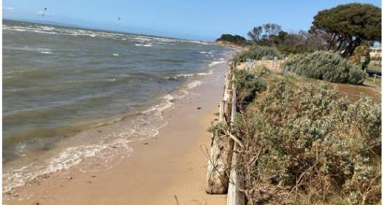

St Leonards North will be renourished in July 2021 with sand increasing beach width and improving coastal resilience from storm surges.

DELWP will deliver the works to address coastal erosion and improve beach amenity. The expected lifespan of the works is 10 years.

Sites include Wrathall Reserve, Taylor Reserve North (Salt Lagoon) and South St Leonards (Lower Bluff Road). Works at Anderson’s Reserve were completed last year.

Anderson’s Reserve, Indented Heads post-renourishment.


Anderson’s Reserve, Indented Heads was renourished in December 2020, significantly improving beach width and amenity.

Expert consultants were engaged to locate a sand source that matched a similar texture and quality of the existing beaches. A sandbar directly north of St Leonards Harbour was identified as the ideal source. Location and dredging operations beginning in July 2021 will bring the sand ashore. Approximately 25,500 m3 will remain at the northern site and the remainder transported by trucks to the respective beach locations, where the sand will be shaped and profiled.

Beach and walking track access will be restricted during the works, as trucks and large earthmoving equipment deliver and shape the new sand over several weeks.

Keep up to date by visiting [marineandcoasts.vic.gov.au/coastal-programs/bellarine-renourishments](https://www.marineandcoasts.vic.gov.au/coastal-programs/bellarine-renourishments).

## Eastern View coastal adaptation

The occurrence and intensity of storms affecting Victoria’s coastline is increasing under a changing climate. This leads to reduced sand on beaches, damage to coastal infrastructure and the loss of habitat for native fauna and flora.

To plan for and mitigate these impacts, DELWP and the Great Ocean Road Coast and Parks Authority (GORCAPA) are working together to develop a Coastal Adaptation Plan for the area on the Great Ocean Road between Devil’s Elbow and Coalmine Creek (Memorial Arch).

Eastern View has experienced erosion and action is required to avoid further damage to assets such as car parks, a boat ramp, beach access points, power poles and the Great Ocean Road itself.

The project is utilising the recently developed pathways approach identified in the Marine and Coastal Policy 2020, community consultation and the most up to date scientific data to explore short and long-term adaptation measures.

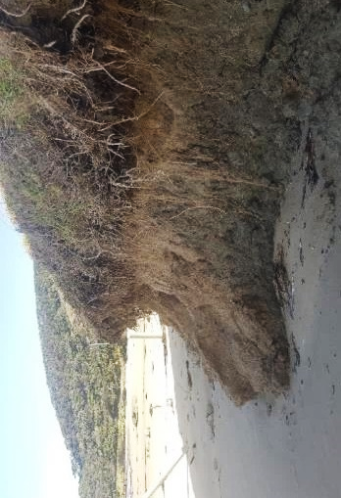

Increasing storm activity and a changing climate is leading to considerable erosion along the Great Ocean Road.

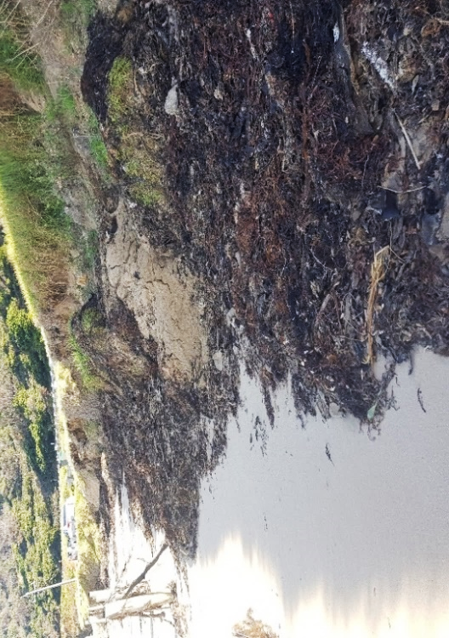

Temporary solutions such as the placement of seaweed can help to dissipate wave energy and ameliorate the erosion by reducing the surface area from wave energy.

## Mallacoota Foreshore seawall replacement – Stage 1

Construction is underway to build a 160-metre long concrete panel seawall to protect the foreshore at the Mallacoota Foreshore Holiday Park, as part of the Victorian Government’s investment from the Building Works package.

This stage of the project will replace the northern section of the structure which has degraded and is a safety risk to the public.

Steel piles have been installed and approximately half of the concrete panels fitted. The project will be completed by the end of August 2021.

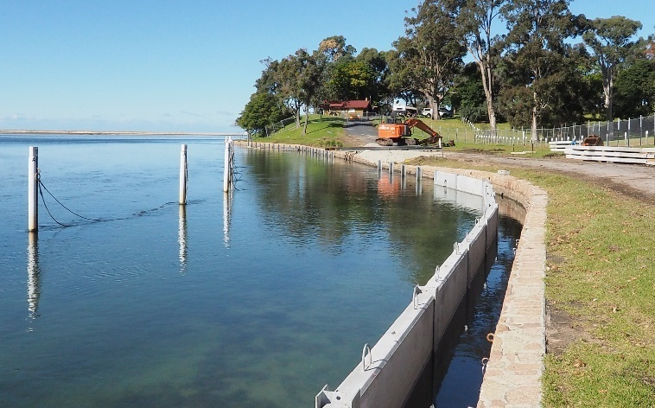

Construction underway for the Mallacoota Foreshore seawall replacement.

## Bullock Island North Arm seawall – Stage 1

Construction on the Bullock Island North Arm seawall has begun. The new seawall in Stage 1 will extend from the breakwater at North Arm westward to the Bullock Island fuel jetty, to protect the Bullock Island North Arm foreshore, and prevent further damage to the area.

This project is aligned with the Bullock Island Master Plan, managed by the East Gippsland Shire Council.

The project will be completed by the end of August 2021.

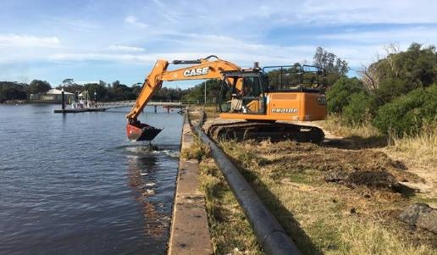

Construction underway on the Bullock Island North Arm seawall.

## Port Phillip Bay beach renourishments

Beach renourishments at Dromana and McCrae were successfully completed in mid-May 2021.

Following an unfortunate run of weather which led to over a month of delays, the contractors have now demobilised from the sites, having dredged approximately 23,000 m3 of sand to Dromana and 20,000 m3 to McCrae and reprofiled both beaches to the required levels.

The contractors have now relocated their dredge and pipeline to Sandringham to complete the beach renourishments at Edward Street Beach and Half Moon Bay. Works are expected to conclude by the end of June 2021, pending weather conditions.

During winter, wave action during storms will cut back into the beaches from time to time, leaving a small escarpment at the edge of the beach. This is a natural occurrence during such storm events and the beach slope will normalise again.

For more information, please visit [marineandcoasts.vic.gov.au/coastal-programs/beach-renourishment](https://www.marineandcoasts.vic.gov.au/coastal-programs/beach-renourishment).

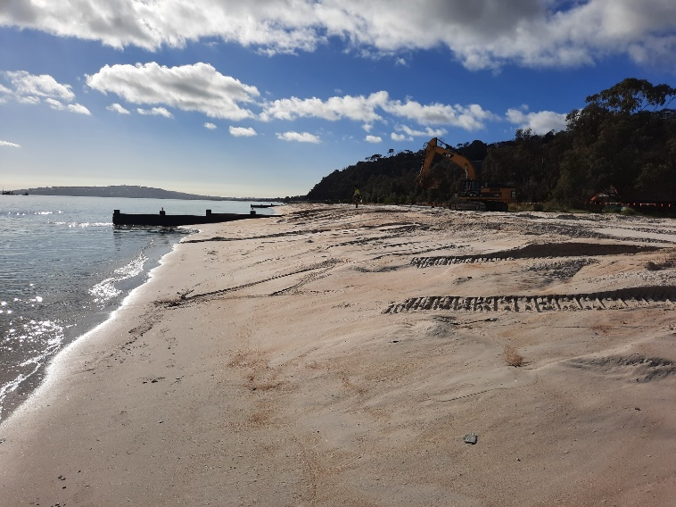

Renourishment works nearing completion at McCrae in May 2021.

# Marine and coastal knowledge

## Feature Activity Sensitivity Tool (FeAST) – Victoria’s new marine evidence-based tool for decision making

DELWP’s Marine Biodiversity Policy and Programs team in collaboration with Australian Marine Ecology and Fathom Pacific have developed a new marine sensitivity and risk assessment tool called the Feature Activity Sensitivity Tool (FeAST).

Inspired by pioneering thinking and methods applied across the United Kingdom and Europe, this new sophisticated tool sets out to quantify the nature and scale of potential impacts on the marine environment arising from anthropogenic activities.

The FeAST application operates as a data workflow undertaking a four-step evaluation process that synthesises the best available scientific information stored in a centralised cloud database.

Employing the precautionary principle, users can interrogate the data, generate reports, and conduct a rapid first-pass assessment of the responses of natural values to human-induced pressures.

Hosted on the marine and coastal web mapping portal [CoastKit](https://www.marineandcoasts.vic.gov.au/coastal-programs/coastkit), this system supports the provision of information available for desktop reviews and scoping investigations as delivered by developers, planners, conservation advisors, and policymakers.

The application is set to be integrated and released on CoastKit in the coming months.

For more information please contact [lawrance.ferns@delwp.vic.gov.au](mailto:lawrance.ferns@delwp.vic.gov.au) or [rhiannon.holden@delwp.vic.gov.au](mailto:rhiannon.holden@delwp.vic.gov.au).

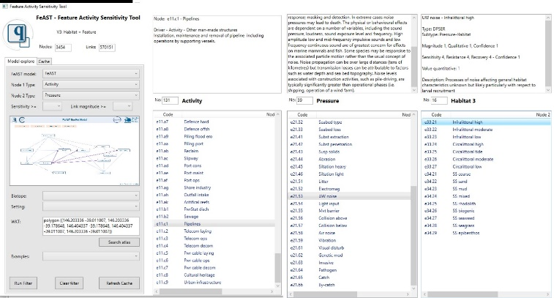

The FeAST application tool in action displaying the relationship and sensitivity score between the activity to pressure to habitat. Built by Matt Edmunds (Australian Marine Ecology)

## Completion of Coastal Asset Condition Inspection Program

The field work for the condition inspection program for coastal protection structures has been completed, with final assessments and reporting to be finalised this month.

Over the past four months, a total of 1,517 seawalls, revetments, groynes and breakwaters located on coastal Crown land have been assessed for overall condition and visible defects. This includes 78 structures which had not been previously recorded.

The most prevalent damage recorded has been categorised as missing materials – typically planks missing from timber groynes or masonry rocks displaced from seawalls. Cracking, together with rot, decay and rust, are also typical defects prevalent in ageing structures.

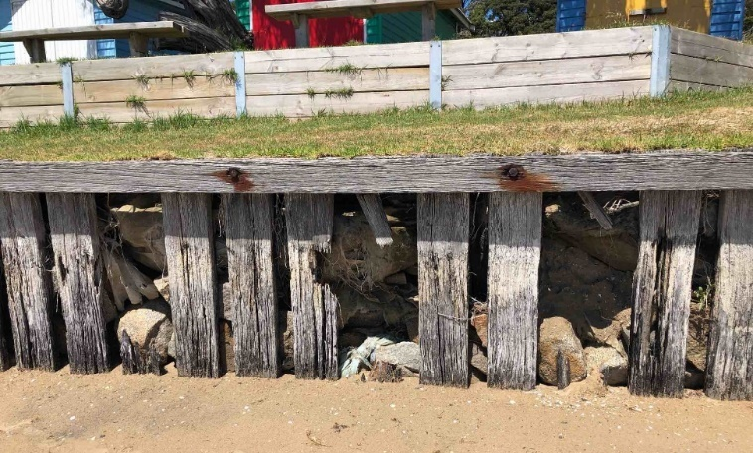

Typical missing material and decay, common in older structures.

As part of this program, surveyors have now collected Australia Height Datum (AHD) height surveys at 7,295 locations atop coastal protection structures adjacent to many communities along the Victorian coastline.

This information will provide a benchmark to measure any future structural movement and will also provide a framework for future overtopping estimates. Overtopping is just one characteristic which determines the ultimate lifecycle of coastal protection assets, before refurbishment, replacement or retreat becomes inevitable under the constant pressures of erosion, storms and sea level rise.

The condition reports and Australia Height Datum will be used to inform DELWP’s coastal works program in the coming years.

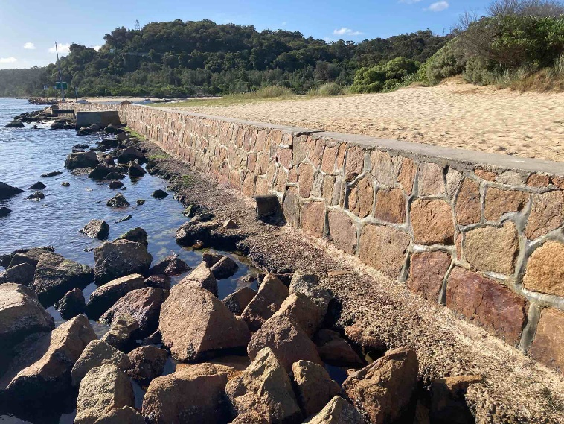

Older structures, when well maintained, continue to provide many years of coastal protection.

# Abalone disease update

Agriculture Victoria is working closely with the Victorian Fisheries Authority to respond to the detection of Abalone Viral Ganglioneuritis (AVG), also known as abalone disease – a viral disease which affects the nervous system of abalone and results in curling of the foot, swelling of the mouth, leading to weakness and death of abalone.

A Control Area has been implemented past Lower Cape Bridgewater in the west to past Narrawong in the east between 2 and 10 kilometres offshore, to assist in limiting the spread of disease through restrictions on fishing, and anchorage of boats.

For current information and restrictions for the Control Area, please visit <https://agriculture.vic.gov.au/biosecurity/animal-diseases/abalone-disease>.

The Emergency Animal Disease Watch Hotline (1800 675 888) is operating 24/7 for suspect disease reports. Please call 136 186 for any other general questions.



# In this issue of Coastline…

New faces at Coastcare Victoria

Coastcare Victoria strategy 2021-2026

National Volunteer Week

Warrnambool strains the drains

Spotlight on BERG Mount Martha’s coast team

Sharing the Love 5

Coastcare Victoria Community Grants 2021

# New faces at Coastcare Victoria

We’ve got some new faces on the Coastcare Victoria team we’d like to introduce to you.

### Coastcare Victoria Coordinator



Dr Jacqui Pocklington, new Coastcare Victoria Coordinator.

Dr Jacqui Pocklington has taken over the reigns as our new statewide coordinator. With a background in marine research, management and coordination of programs, citizen science and natural resource management, Jacqui brings a broad perspective to the team.

### Coastcare Victoria Grants Officer

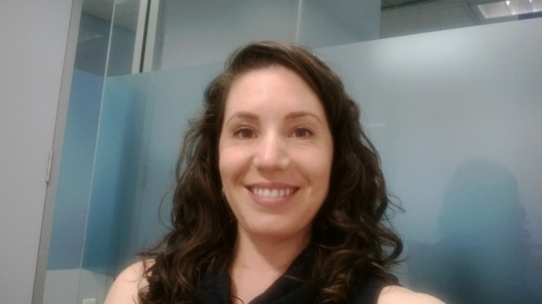

Ally Hughes, Coastcare Victoria Grants Officer.

Ally Hughes has started in our new position of grants officer, made possible with funding from the Victorian Great Outdoors initiative. Ally comes to us with a background in Landcare and local government environmental and community management and support, as well as education, consultancy, and executive administration. She’s already hit the ground running and will be an essential support to the team in managing our grants program.

### Coastcare Victoria Facilitator, Port Phillip and Westernport region

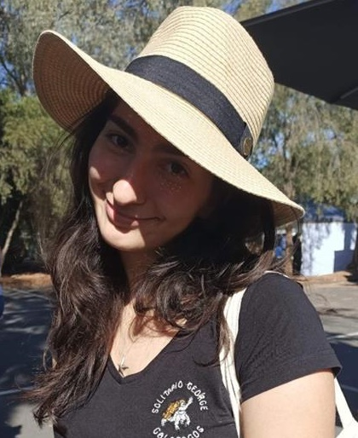

Joiee Tachas, Coastcare Facilitator for the Port Phillip and Westernport region.

Johanna (Joiee) Tachas has been doing an amazing job supporting groups and working on multiple behind the scenes tasks while Phil Wierzbowski has been having some ‘R&R’.

Joiee studied marine and coastal ecology at the University of Melbourne and the Australian National University (ANU) and has had multiple writing and social media support gigs including at ‘Remember the Wild’ and the ‘Connected to Port Phillip’.

Joiee is a current DELWP Science and Planning graduate. Luckily, we’ve been able to keep her a bit longer during our busy grants period to keep things running smoothly.

Visit the [Coastcare Victoria website](https://www.marineandcoasts.vic.gov.au/coastal-programs/Coastcare-Victoria) for all facilitator contact details and further information.

# Coastcare Victoria strategy 2021-2026

The new Coastcare Victoria strategy is complete!

Following a participatory-engagement process, the strategy aims to strengthen and support community-based volunteers with the information and resources they need to continue their work protecting and restoring Victoria’s amazing coastal and marine environment. This includes providing grant funding, training, facilitating networks, connecting communities with citizen science opportunities, and enabling Traditional Owner self-determination.

We introduce our key strategic pillars:

1) Marine and Coastal Stewardship

2) Thriving Community Groups and Networks, and

3) Victorians Valuing the Coast.

You can access the Strategy here: [marineandcoasts.vic.gov.au/coastal-programs/Coastcare-Victoria](https://www.marineandcoasts.vic.gov.au/coastal-programs/Coastcare-Victoria), or if you’d like a printed copy, please email [coastcare@delwp.vic.gov.au](mailto:coastcare@delwp.vic.gov.au).

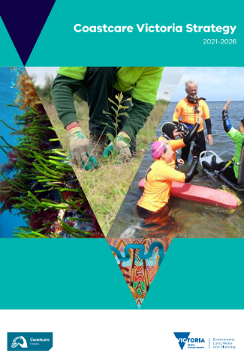

# National Volunteer Week

From 17-23 May 2021, we celebrated National Volunteer Week.

Victoria has an estimated 186,508 environmental volunteers, with many working along our beautiful coastline. We extend another massive thank you to all of our inspirational and dedicated volunteers and recognise your incredible work!

On our [Victorians Volunteering for Nature](https://www.environment.vic.gov.au/volunteering#toc__id_0_national) website this year, we featured a couple of our Coastcare Victoria volunteers who have demonstrated that volunteering is for all ages and abilities.

[The Sanctuary Mallacoota Youth Group](https://www.facebook.com/SanctuaryMYG/?__cft__%5b0%5d=AZWNqLXrqywgtj1dJbey6k21XPMXTOFAvXS3jNreIblZhhAuqIz4s9pnDjdhIu9c5ro0z0FsykQ2M-Pk--VNHDj6pGXkG_BOl2pw1DgbqvEBYBMDC5Hy-1LBmoupJXgeqxJDTL_ONE-2pfH-J-pOuikU1tuU0isfShnycCCaig0h9T86cypHjGqe_bmpGvzkCzQ&__tn__=kK-R) is working to remove invasive weeds from their coastline with the help of a Coastcare Victoria Community Grant. After realising that some coastal areas could use some improvement, the Youth Group formed a partnership with the Friends of Mallacoota to create the Wilderness Coast Project. On the last Saturday of each month, around 30 kids and teens turn out around Bastion Beach to help restore the coastline through weeding, revegetation, litter auditing and other works.

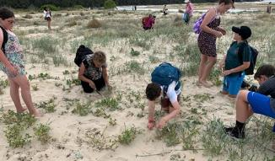**Sanctuary Mallacoota Youth Group, weeding.**

We also featured the incredible Eulalie Brewster. At 94 years old, Eulalie is living proof that you’re never too old to join in and make a difference! In 2020, the Inverloch great-grandmother was awarded Australia’s highest honour – the Order of Australia medal – for her volunteering work, including preserving nature over eight decades with the South Gippsland Conservation Society that she helped create.

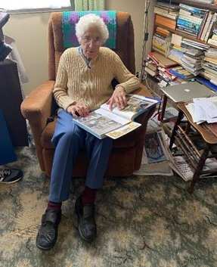

Environmental volunteer Eulalie Brewster, looking through old photos.

To find out more about these awesome volunteers, head to [environment.vic.gov.au/volunteering](https://www.environment.vic.gov.au/volunteering#toc__id_0_national).

We appreciate each and every one of our hard-working volunteers and can’t wait to see what tremendous projects you come up with next!

# Warrnambool strains the drains

Let’s Strain the Drains – Warrnambool, is the second monitoring project for stormwater drain related marine debris in Victoria, following the model established in Port Phillip Bay.

Being a significant transport pathway for pollutants, stormwater is a key piece of the marine debris puzzle as it acts as an outflow point for litter in urban runoff.

To address the increasing amount of litter washing up on Warrnambool beaches, 10 stormwater drain traps (Drain Buddies) were installed by the Cleanwater Group in consultation with the Warrnambool City Council. In order to obtain land-use relevant data, five traps were placed in two different land-use type areas: Central Business District (CBD) and Industrial Precinct.

The traps will be emptied by the Cleanwater Group every 8 weeks and the contents of the traps are then sorted and counted together with local community volunteers in open audit events.

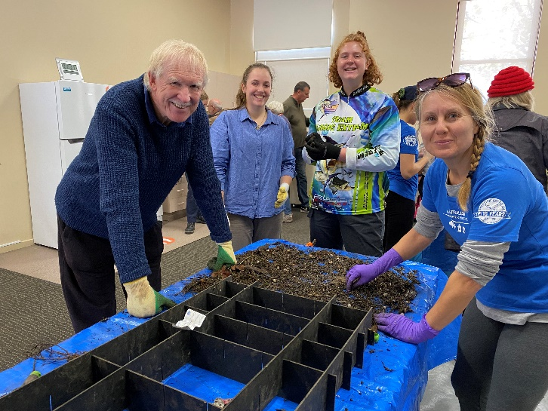

Volunteers auditing litter from the traps in Warrnambool and sorting into categories.

The data from the audits is submitted to the Australian Marine Debris Initiative (AMDI) Database, which is used to identify specific information on the sources and distribution of litter originating from both urban areas that would normally flow through the stormwater system into the ocean.

The outcomes will be presented at an open community forum at the end of the project to assist in the development of local source reduction plans that aim to mitigate the types of litter documented.

The first audit took place last month and captured a total of 50.9 kilograms of litter (including organics) found in the traps. The top 10 items were: polystyrene balls (155), cigarette butts (108), broken hard plastic (94), broken glass (81), plastic film remnants (80), broken polystyrene (65), paper remnants (63), pieces of foil (42), plastic food packaging (23), and bricks / cement (19).

This innovative project is delivered by Tangaroa Blue Foundation and Cleanwater Group with support from the Warrnambool City Council and supported by the Victorian State Government through a Coastcare Victoria Community Grant.

The next audit will take place in Archie Graham Community Centre (Warrnambool) on Saturday 10 July 2021.

For more information about Let’s Strain the Drain – Warrnambool, head to the [Facebook event](https://www.facebook.com/events/852364172021790), and to register, please email [melissa@tangaroablue.org](mailto:melissa@tangaroablue.org).

# Spotlight on BERG Mount Martha’s coast team

Balcombe Estuary Reserves Group Mount Martha (BERG Mt Martha) has a long history of coastal and marine environmental volunteering.

Formed in 1987 to protect the Balcombe Estuary and its surrounds from development, the group has flourished into a network of over 450 members, 110 active volunteers and many business partners.

They continue to preserve and rehabilitate what is now the largest unspoilt estuary on the eastern side of Port Phillip Bay, home to many unique and vulnerable coastal environments. They also play a large role in educating and communicating the value of the Balcombe Estuary environment to the local Mount Martha community.

Coastcare Victoria has been privileged to support BERG Mt Martha’s environmental and community works for many years through our Coastcare Victoria Community Grants Program.

BERG Mt Martha has made a significant contribution to their local environment and community, and beyond, through numerous projects over these years including foreshore restoration of threatened ecological vegetation classes such as Coastal Banksia Woodland, vegetation surveys and monitoring, and weed removal.

The group is using their current 2020 Coastcare Victoria Community grant to mentor their next generation of volunteer leaders and improve the capacity of the organisation. Through the innovative LONI – ‘Look outwards not Inwards’ approach, they are redirecting their focus to the changing needs of the environment and community, while also continuing their on-ground volunteer bushland activities.

Read more about BERG Mt Martha in their monthly newsletter, [The Creek](https://www.berg.org.au/newsletters/).

# Sharing the Love 5

Coastcare Victoria Facilitators Bethany and Ally were fortunate enough to attend the fifth Sharing the Love Forum in Anglesea recently, which was hosted by Parks Victoria with support from the Coastcare Victoria team.

It was wonderful to see so many familiar faces, some we haven’t seen in close to 18 months, and to meet some new people!

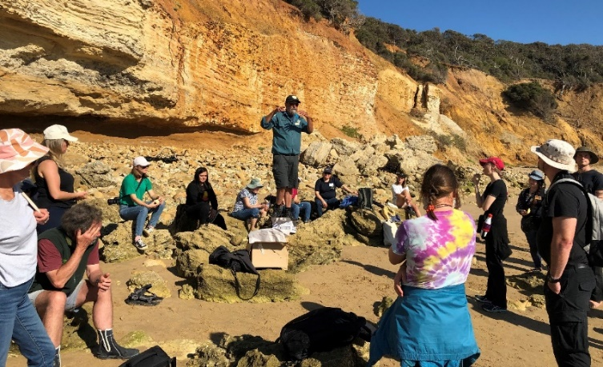

Mark Rodrigue (Parks Victoria) briefs volunteers on the afternoon’s field trips at Point Addis (Image by: Bethany Hunting).

Sharing the Love is an incredible opportunity for volunteers to network and share stories, with several groups having the opportunity to showcase some snapshots. The forum is also an opportunity to expand your knowledge through workshops and fieldtrips on a variety of topics including Cultural Heritage, the Sea Slug Census, grant writing, using citizen science databases, recycling plastics, using drones for coastal monitoring, EstuaryWatch and much more.

We cannot recommend these forums enough and we hope to see more new and familiar faces at the next one!

# Coastcare Victoria Community Grants 2021

The Coastcare Victoria Community Grants program aims to support community projects that conserve, restore and rehabilitate Victoria’s coastal and marine environments.

This year, Coastcare Victoria has more than $640,000 available within two tiers of funding: one for small projects up to $5,000, and one for larger scale projects between $5,000 and $30,000.

Projects will fit into one of three streams including Stewardship and Education, Strengthening our Volunteer Groups, and Supporting Traditional Owner Self-Determination.

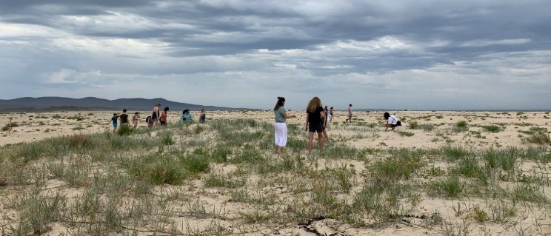

Volunteers from The Sanctuary Mallacoota Youth Group pulling weeds at Bastion Beach, with the support of Friends of Mallacoota (Image: The Sanctuary Mallacoota Youth Group).

Projects under the Stewardship and Education stream focus on activities that conserve, rehabilitate, and restore coastal and marine ecosystems. This stream encourages activities that support community participation, engagement, and education to enhance community knowledge and understanding of coastal and marine management.

The Strengthening our Volunteer Groups stream encourages community groups to consider ways to expand, diversify volunteer bases and create opportunities to engage youth and volunteers from different backgrounds, cultures, nationalities and abilities, and encourage group succession planning. This stream is seeking projects that will rethink volunteering to capitalise on the different ways people want to volunteer and improve volunteer recruitment and retention.

The Supporting Traditional Owner Self-Determination stream focuses on recognising Traditional Owners’ knowledge and connection to Country, as well as supporting their role in leading healing and ongoing care and use of Country. This stream seeks to enable Traditional Owners to restore marine and coastal cultural knowledge and practice and enable two-way capability and capacity building to improve effectiveness of working relationships and shared understanding between Traditional Owners and other marine and coastal land managers.

If you have a grant idea, please get in touch with your local regional Coastcare Victoria Facilitator to discuss – we’re here to support you with your grant application.

Please pass this on to other groups you know of that might be interested in applying.

This program is funded by the Victorian Government’s Sustainability Fund which seeks to build community capacity, support community adaptation and improve ecosystem resilience to climate change.

Applications are now open and close at 5pm on Wednesday 23 June 2021.

For more information and to apply, visit the [Coastcare Victoria Community Grants](https://www.marineandcoasts.vic.gov.au/coastal-programs/Coastcare-Victoria/coastcare-victoria-community-grants) website.

|  |  |
| --- | --- |
| © The State of Victoria Department of Environment, Land, Water and Planning 2021  LogoThis work is licensed under a Creative Commons Attribution 4.0 International licence. You are free to re-use the work under that licence, on the condition that you credit the State of Victoria as author. The licence does not apply to any images, photographs or branding, including the Victorian Coat of Arms, the Victorian Government logo and the Department of Environment, Land, Water and Planning (DELWP) logo. To view a copy of this licence, visit http://creativecommons.org/licenses/by/4.0/  Disclaimer  This publication may be of assistance to you but the State of Victoria and its employees do not guarantee that the publication is without flaw of any kind or is wholly appropriate for your particular purposes and therefore disclaims all liability for any error, loss or other consequence which may arise from you relying on any information in this publication. | Accessibility  If you would like to receive this publication in an alternative format, please telephone the DELWP Customer Service Centre on 136186, email [customer.service@delwp.vic.gov.au](mailto:customer.service@delwp.vic.gov.au), or via the National Relay Service on 133 677 [www.relayservice.com.au](http://www.relayservice.com.au). This document is also available on the internet at [www.delwp.vic.gov.au](http://www.delwp.vic.gov.au). |