|  |
| --- |
| DELWP marine and coasts newsletter |

Welcome to the Department of Environment, Land, Water and Planning’s (DELWP’s) quarterly marine and coasts newsletter**.**

## In this issue

* Victoria’s first Marine and Coastal Strategy
* First Sea Country Indigenous Protected Area granted
* Guidelines for the management of existing bathing boxes and boatsheds on marine and coastal Crown land
* VicCoasts – Victorian State Budget 2022-23
* Port Phillip Bay Beaches Renourishment Program
* Managing coastal erosion at Queenscliff’s Dog Beach
* Port Fairy landfill project tipped for success
* Lakes Entrance Ocean Rescue seawall replacement
* Mallacoota foreshore seawall replacement –Stage 1b
* Victorian Coastal Monitoring Program beach renourishment research projects in the Bay
* Investigating Apollo Bay’s ocean floor
* Cape to Cape Resilience Project - Stage 1 nearing completion
* Coastcare Victoria’s ‘Coastline’

|  |
| --- |
| Email [marine.coasts@delwp.vic.gov.au](mailto:marine.coasts@delwp.vic.gov.au) to subscribe or unsubscribe to this newsletter and for more information. |

# Marine and coastal policy reforms

## Victoria’s first Marine and Coastal Strategy

DELWP is delighted to announce the release of Victoria’s first [Marine and Coastal Strategy](https://www.marineandcoasts.vic.gov.au/coastal-management/marine-and-coastal-strategy).

The strategy sets out the department’s priority actions to ensure the management and protection of more than 2,500 kilometres of coastline and around 10,000 square kilometres of marine waters.

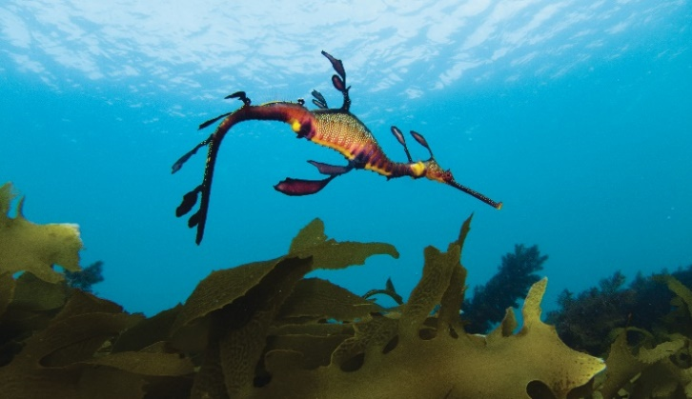

Weedy Seadragon (Phyllopteryx taeniolatus). Image by Parks Victoria.

This is the first of three five-year strategies that will help ensure we achieve the 15-year vision of the [Marine and Coastal Policy 2020](https://www.marineandcoasts.vic.gov.au/coastal-management/marine-and-coastal-policy) for a healthy, dynamic and biodiverse marine and coastal environment that is valued in its own right, and that benefits the Victorian community, now and in the future.

The Strategy will:

* Enable Traditional Owners to integrate cultural values, uses and practices in the healing and ongoing management of Country.
* Build the foundations for long-term climate adaptation and environmental protection in Victoria’s marine and coastal environment.
* Improve integration and coordination across governments, industries and communities when planning and managing marine and coastal areas.
* Build the skills and capability of Traditional Owners, communities, managers and governments to effectively plan and manage for a healthy and resilient marine and coastal environment.

The Strategy sets out six actions with supporting activities to achieve these objectives and includes an important message from Victorian coastal Traditional Owners.

DELWP has worked closely with Traditional Owner groups and the Victorian Marine and Coastal Council to develop the Strategy, and consulted with local government, marine and coastal managers, peak bodies and communities with marine and coastal interests.

To read the Strategy, visit [Marine and Coastal Strategy (marineandcoasts.vic.gov.au)](https://www.marineandcoasts.vic.gov.au/coastal-management/marine-and-coastal-strategy).

## First Sea Country Indigenous Protected Area granted

Approximately 175,000 hectares (ha) of coastal country was declared an Indigenous Protected Area in May 2022.

Gunditj Mirring Traditional Owners Aboriginal Corporation and Eastern Maar Aboriginal Corporation in southwestern Victoria, and Gunaikurnai Land and Waters Aboriginal Corporation in Gippsland, had their proposals of 19,000 ha and 155,300 ha respectively granted.

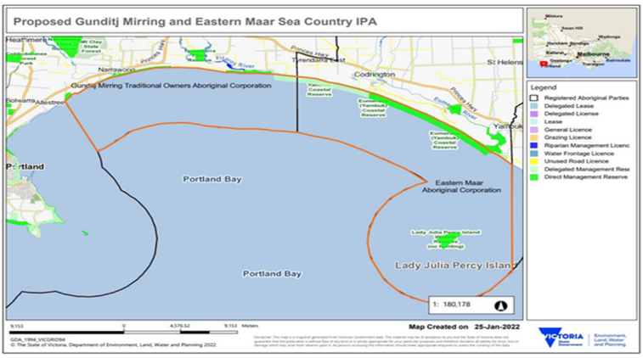Gunditj Mirring and Eastern Maar Sea Country IPA.

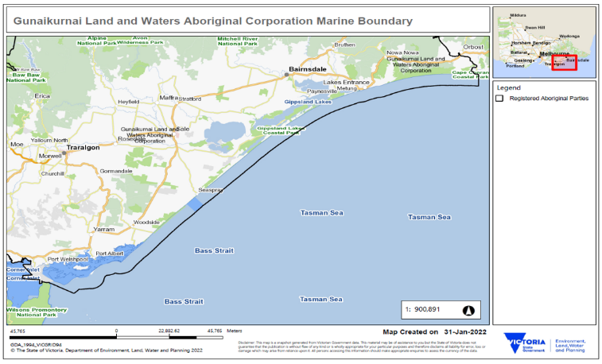

Gunaikurnai Land and Waters Aboriginal Corporation marine boundary.

Indigenous Protected Areas (IPAs) are areas of land and sea managed by Indigenous groups as protected areas for biodiversity conservation through voluntary agreements with the Australian Government.

IPAs are an essential component of Australia’s National Reserve System, which is the network of formally recognised parks, reserves and protected areas across Australia.

There are currently 78 dedicated IPAs over 74 million ha. These account for more than 46 per cent of the National Reserve System.

The IPA system protects the cultural values of Original Custodians’ and their assertions about country. This dovetails with the Victorian Government’s newly released Marine and Coastal Strategy 2022 and the underlying policy reforms of Marine Spatial Planning and Victoria’s Resilient Coast.

To find out more, visit the [Sea Country Indigenous Protected Areas Program](https://www.awe.gov.au/agriculture-land/land/indigenous-protected-areas) webpage.

## Guidelines for the management of existing bathing boxes and boatsheds on marine and coastal Crown land

Bathing boxes and boatsheds are often seen as an iconic part of Victoria’s coastline and their European heritage significance can often be located alongside Aboriginal cultural heritage sites.

Today there are approximately 2,000 bathing boxes and boatsheds in Victoria, predominantly located around the eastern and southern shores of Port Phillip Bay and Western Port, Gippsland Lakes and Corner Inlet.

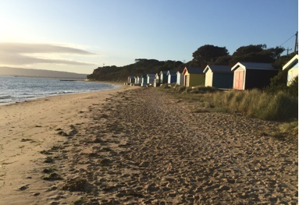

Bathing boxes are often seen as an iconic part of Victoria’s coastline.

These existing structures face many challenges due to their location and are at high risk of suffering damage by storms, erosion and inundation.

To support implementation of the Marine and Coastal Policy 2020, the ‘Guidelines for the management of existing bathing boxes and boatsheds on marine and coastal Crown land (March 2022)’ has been developed and approved under the *Marine and Coastal Act 2018*.

These guidelines provide direction to land managers, decision-makers and bathing boxes and boatsheds licensees about the management and maintenance of these existing structures located on marine and coastal Crown land.

You can find the Guidelines at [Guidelines (marineandcoasts.vic.gov.au)](https://www.marineandcoasts.vic.gov.au/coastal-management/guidelines).

# VicCoasts – Victorian State Budget 2022-23

The VicCoasts funding initiative has been allocated $16.9 million as part of the Victorian State Budget for 2022-23.

This investment is guided by the new Marine and Coastal Strategy 2022 and will work towards building a safer, healthier and more resilient marine and coastal environment through:

* Strengthening and implementing coastal protection at high-risk locations, and continued support for land managers through the Coastal Public Access and Risk grants program.
* Continued investment in Coastcare Victoria and community stewardship activities, building capability of volunteers to respond to climate change.
* Stronger partnerships with Traditional Owners, local community, businesses and all levels of government.
* Building foundations for long-term climate adaptation by continuing the implementation of a statewide coastal hazard adaptation framework and guidelines ([Victoria’s Resilient Coast project](https://www.marineandcoasts.vic.gov.au/coastal-management/victorias-resilient-coast-adapting-for-2100)).
* Improving research and monitoring of coastal processes and frameworks through the [Victorian Coastal Monitoring Program](https://www.marineandcoasts.vic.gov.au/coastal-programs/victorian-coastal-monitoring-program) to build adaptation and resilience of local communities.
* Enhancing the [Marine and Coastal Knowledge Framework](https://www.marineandcoasts.vic.gov.au/coastal-programs/marine-and-coastal-knowledge-framework) by integrating all marine and coastal data, systems and tools into a central repository.

For more information visit [Budget 2022-23 (delwp.vic.gov.au)](https://www.delwp.vic.gov.au/our-department/budget-2022-23).

# Coastal projects

## Port Phillip Bay Beaches Renourishment Program

The Port Phillip Bay Beaches Renourishment program has delivered 12 beach renourishments over four years.

In March this year, approximately 5,000 m3 of sand was distributed at Whitecliffs/Rye.

In April 2022, approximately 9,800 m3 of sand was distributed at Tootgarook, and 3,000 m3 of sand at St Leonards South.

The renourishments contribute towards the ongoing viability of coastal communities by protecting vulnerable areas of the coast from erosion and inundation.

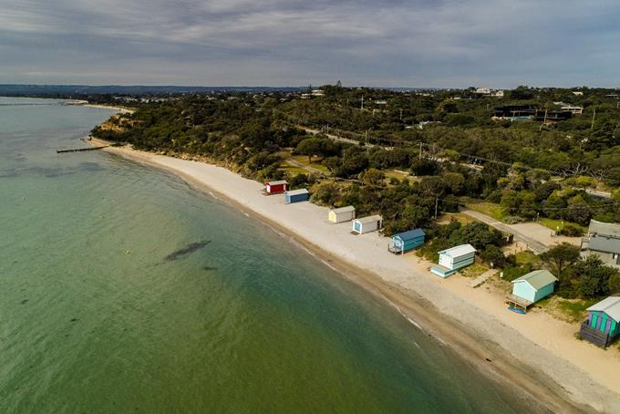

Whitecliffs/Rye beach renourishment (image by FSC Range)

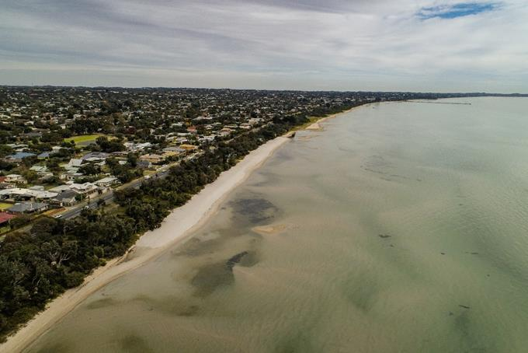

Tootgarook beach renourishment (image by FSC Range)

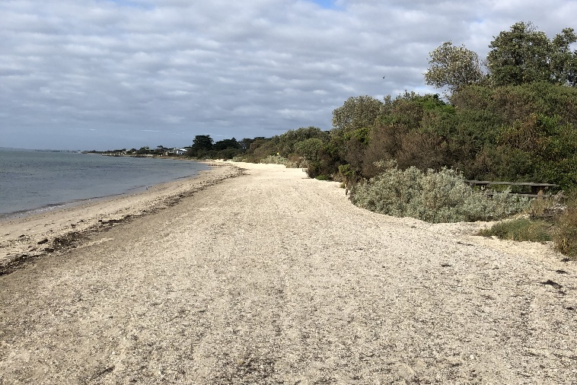

St Leonards South beach renourishment

## Managing coastal erosion at Queenscliff’s Dog Beach

DELWP and the Borough of Queenscliff (BoQ) are developing a Coastal Adaptation Plan for ‘Dog Beach’, Queenscliff.

At Dog Beach, erosion is impacting the dune system that forms part of the thin piece of land known as the ‘Narrows’ which links Queenscliff with the Bellarine Peninsula.

To plan for and mitigate these impacts, DELWP is working with the BoQ and key stakeholders to better understand the hazards, risks, and adaptation options for the site.

To inform the development of management actions, the project will follow the ‘Planning and Decision Pathway’ approach identified in the Marine and Coastal Policy 2020.

The works will include an investigation of the coastal processes, asset vulnerability and hazard maps and an adaptation options assessment. Appropriate trigger points will be identified that will prompt realistic short and longer-term adaptation actions for authorities to manage over time.

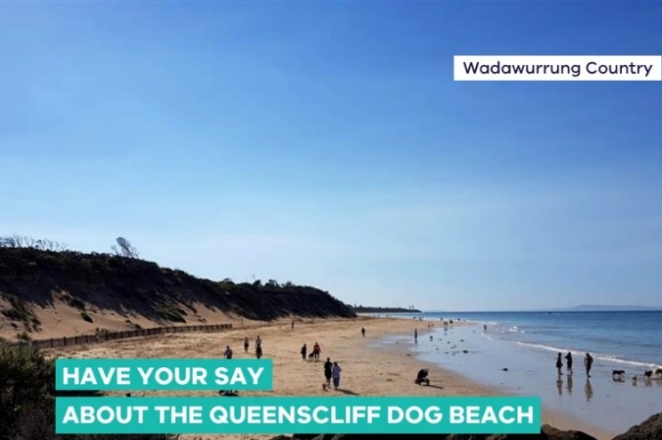

Through consultation events held in March and May 2022, the community provided valuable insights as to how they use and value the area, how this coastal environment has changed over time, as well as thoughts on the first pass options assessment.

For more information and to have your say, visit [Dog Beach Coastal Adaptation Plan – Point Lonsdale | Engage Victoria](https://engage.vic.gov.au/dog-beach-coastal-adaptation-plan-point-lonsdale).

## Port Fairy landfill project tipped for success

DELWP is working with the Moyne Shire Council and the community to manage two decommissioned landfill sites in sand dunes on Port Fairy's East Beach.

The sites were used for night soil and municipal waste. Waste was exposed and caused pollution following large storms in 2012 and 2015.

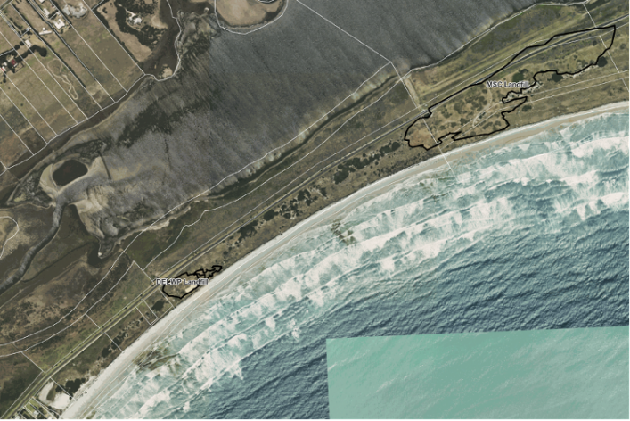

Aerial image showing location of decommissioned landfills, East Beach, Port Fairy.

This project is driven by community concerns about dune erosion from storms and sea level rise.

Tetra Tech Coffey recently completed drilling on both sites to collect samples for soil and geotechnical testing.

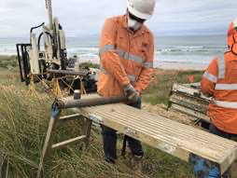

Sample drilling, Moyne Shire Council landfill, Port Fairy (2022).

The results will help us understand the type and extent of the contamination, risk to human health and the environment and to complete assessments of options for long-term management of the old landfills, including the potential to remove the waste from the sand dunes.

East Beach is home to an important population of Hooded Plovers, which are listed as threatened under the *Environmental Protection and Biodiversity Conservation Act 1999*.

Any work and long-term treatment options for the sites must not affect the Hooded Plover. Volunteers from the Friends of the Hooded Plover monitor the birds and provide invaluable advice for the project.

Citizen scientists in the Port Fairy Coastal Group are assisting by monitoring the beach. This was a catalyst for establishing the Victorian Coastal Monitoring Program, which provides important data and modelling of future climate impacts from rising sea levels.

The project must conform with the new *Environment Protection Act (2017)* and policy, the DELWP Contaminated Land Management policy and program and the *Marine and Coastal Act (2018)* and related policies.

Following community consultation, it is expected that DELWP and the council will determine a long-term treatment option later this year.

## Lakes Entrance Ocean Rescue seawall replacement

Replacement of the Lakes Entrance Ocean Rescue masonry seawall is nearing completion.

All seawall piles and panels have been installed and the concrete header beam poured. Next steps will include the installation of a stainless-steel handrail, then landscaping and site demobilisation.

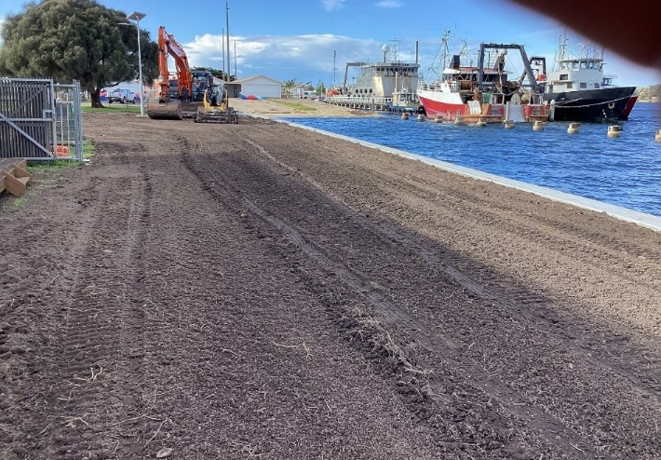

Lakes Entrance Ocean Rescue seawall replacement.

The new seawall will provide protection for the foreshore reserve, Australian Volunteer Coast Guard buildings and infrastructure and allow for safer public recreation.

## Mallacoota foreshore seawall replacement –Stage 1b

Construction to replace a 66-metre-long concrete panel seawall at Mallacoota is nearing completion. This is Stage 1b of a multi-stage project along the foreshore adjacent to the Mallacoota Foreshore Holiday Park.

This stage of the project replaces the northern section of the structure which is failing and is a safety risk to the public.

Stage 1b was funded through the Victorian State Budget 2020-21.

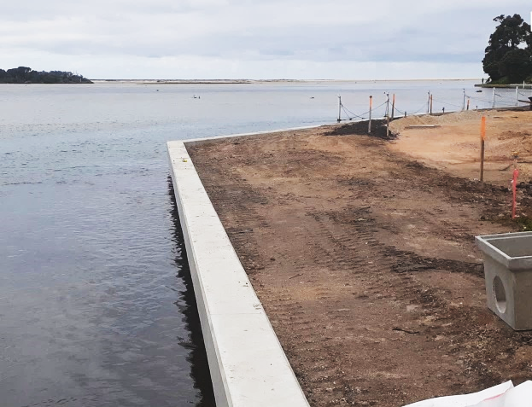

Mallacoota Foreshore seawall replacement.

# Marine and coastal knowledge

## Victorian Coastal Monitoring Program beach renourishment research projects in the Bay

The Victorian Coastal Monitoring Program (VCMP) is leading targeted research projects in Port Phillip Bay to determine sediment availability and quantify sand transport dynamics, necessary to improve our ability to implement beach renourishments, and manage our shorelines.

The VCMP is a collaboration between DELWP, Deakin University and University of Melbourne, monitoring the state’s coastlines with a variety of methods, including drone surveys (Figure 1), wave buoys and seabed surveying and has three components:

1. expanding coastal monitoring capacity, including adding new drone monitoring sites along the Mornington Peninsula and around the Western Treatment Plant
2. mapping the distribution and volume of sand deposits around the bay, to determine borrow sites and availability for future renourishments, including accounting for sea level rise and
3. development of shoreline-morphodynamic models to investigate how renourishments behave during storms and how long they will last, using extensive high-resolution observations collected through the VCMP (Figure 1).

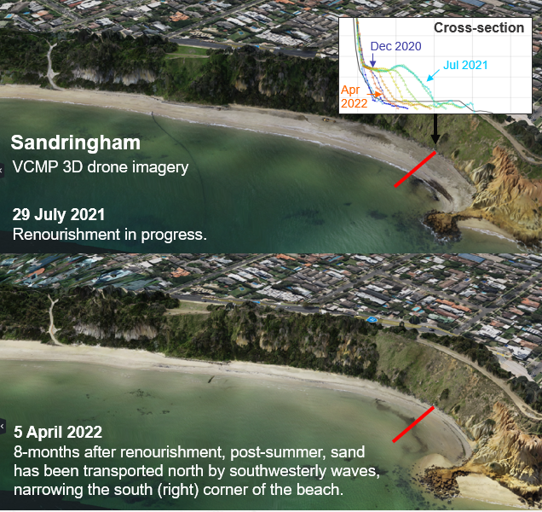

Figure 1. 3D-orthomosaics of Sandringham beach, generated from VCMP drone imagery, with inset of beach profile cross-sections.

All research projects will be completed over the next 12-months and will provide vital insights to plan and predict the performance of beach renourishments, to help maintain the beaches in the Bay over coming decades.

## Investigating Apollo Bay’s ocean floor

In May this year, Stage 2 of the Apollo Bay Foreshore Protection project was completed. This included a 700 m rock revetment and three rock groynes to reduce the impact of storms and waves.

To date, the works have been successful in mitigating severe coastal erosion to the foreshore, walking paths and Great Ocean Road, however the cause of the accelerated erosion has been relatively unknown.

Investigations began by undertaking 3D LiDAR topographic (shoreline) and bathymetric (sea floor) surveys to identify changes around Apollo and Marengo Bay (Figure 1).

This was followed up by collecting multi-beam backscatter data using specialised boats to paint a detailed picture of the sea floor.

Previous surveys indicate that areas of the seabed are highly variable, eroding and accreting by up to 1 m caused by waves moving sand on and offshore. When there is a net loss of sand over time, this results in shoreline recession.

While results are still being analysed and models are being developed, this investigation may provide key insights into what is driving erosion in Apollo Bay and assist in future planning.

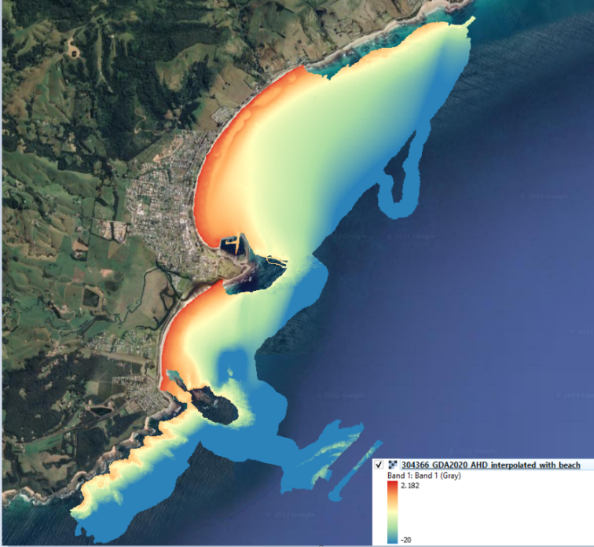

Figure 1. A complete bathymetric survey was undertaken to understand the driving forces behind accelerated erosion of Apollo and Marengo Bay. This involved using highly specialised boats that can capture images of the sea floor.

## Cape to Cape Resilience Project – Stage 1 nearing completion

The Inverloch Regional and Strategic Partnership’s ‘Cape to Cape Resilience Project – Stage 1’ is due to be completed by the end of June 2022.

This year has been extremely productive, with hazard modelling and maps finalised and released to the community during six weeks of community engagement in March and April 2022.

Cape to Cape Resilience Project team ready for engagement! From left to right, Steph Doumtsis (Alluvium), Elise Lawry (Water Technology), Phebe Bicknell (Alluvium) and Kirsty Hannan (DELWP).

The maps were produced by Michelle Worsley, the Gippsland region’s DELWP GIS officer. Michelle worked closely with the coastal engineering consultants, engagement consultants and project team to develop a DELWP mapping style for coastal hazards that can be used in future projects across Victoria. It looks great and is easy to understand, so we hope other teams get value from them.

Our 2022 consultation and engagement is hosted on Engage Victoria. We have lots of fact sheets and updates, a survey on coastal adaptation, and in addition we ran several pop-up and drop-in sessions and workshops with our key stakeholders.

This research fed into a bespoke multi-criteria analysis to help select preferred adaptation options for the Inverloch coast. The community completed 66 surveys, and there were over 2,000 page views on Engage Victoria during April 2022.

An economics assessment for the project has been completed, including development of a best practice methodology for the Victoria’s Resilient Coast 2100+ Framework. This assessment is assisting with prioritisation of adaptation options and will be used in the Cape to Cape Resilience Plan.

Visit [Cape to Cape Resilience Project | Engage Victoria](https://engage.vic.gov.au/cape-cape-resilience-project) to find out more.



# In this issue

Farewell Tracey

Coastcare Victoria volunteer forums

First aid training wraps up

Coastcare Victoria Community Grants

Solving spider crab mysteries in our blue backyard

Phillip Island Land Alliance

## Farewell Tracey

Our wonderful South Gippsland facilitator Tracey Miller-Armstrong is leaving us to take up a new opportunity with DELWP’s Land and Built Environment team.

Tracey has worked with us since July 2020 and been a great support to volunteers in the South Gippsland-South East Western Port region as well as the whole state. We wish her all the best for the future.

A message from Tracey:

I would like to take this opportunity to thank all of the wonderful volunteers for the great work they do in continuing to protect and educate the community of the importance of our marine and coastal environments.

I may not have had the opportunity to meet all of you, however being able to support you with your on-ground projects has been one of the best parts of the job.

I wanted to reach out to let you know that I've so enjoyed the chats we have had, it's been a true pleasure getting to know you better!

To my fellow Coastcare Victoria team colleagues, without your friendship, support and collaboration, my time here would not have been the same. It has been a pleasure working with each one of you, and I wish you all nothing but the best.

Thank you and good luck

Tracey 😊

In our next newsletter, we hope to introduce you to our new facilitator for South Gippsland. Until then, please contact the team via [coastcare@delwp.vic.gov.au](mailto:coastcare@delwp.vic.gov.au) and we will be in touch to help.

## Coastcare Victoria volunteer forums

Coastcare Victoria has been busy delivering a series of forums to celebrate volunteers who contribute to the health of the state’s marine and coastal environment.

Over 150 enthusiastic volunteers, land managers, and agency representatives from across the state attended the hybrid events in May and June 2022.

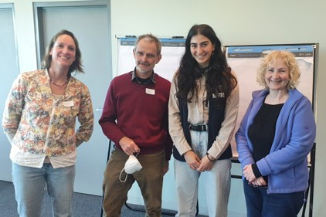

Marine Care Ricketts Point volunteers at the Port Melbourne forum. From left to right: Nicole, Ian, and Elizabeth, with the Port Phillip and Westernport facilitator Joiee.

The diverse range of attendees represented over 50 volunteer groups including Coastcare, Landcare, ‘Friends of’ groups, and many more.

The forums allowed for some great opportunities to reconnect, build relationships, collaborate, and share knowledge after years of remote engagement.

The three forums featured views of beautiful Bunurong Country in Port Melbourne and Inverloch and magnificent Eastern Maar Country in Warrnambool.

We were privileged to hear from the local Registered Aboriginal Parties - Bunurong Land Council Aboriginal Corporation in Port Melbourne and Inverloch, and Eastern Maar Aboriginal Corporation in Warrnambool. They provided valuable lessons about the importance of cultural heritage and insights into the challenges in protecting cultural heritage along the coastline.

Presentations and workshops from a variety of regional volunteer groups gave attendees a snapshot of the rich assortment of on-ground and education-based marine and coastal projects.

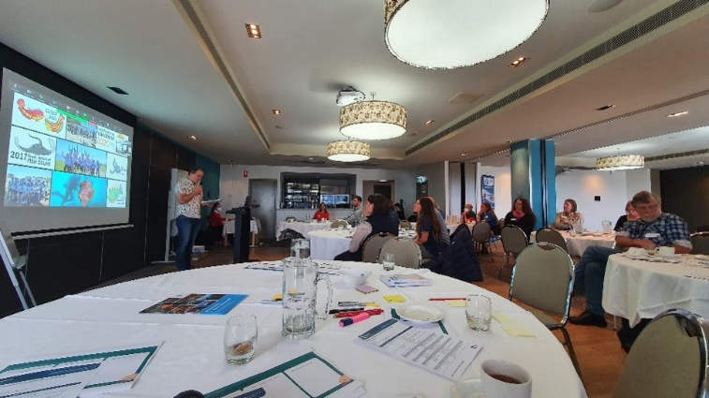

Kade from Victorian National Parks Association presenting at the Warrnambool forum.

Feedback has been overwhelmingly positive. Attendees left the forums feeling inspired by the wonderful keynote speakers with new skills and capacity to engage volunteers in the digital space. The new relationships created at these forums will help volunteers solve current and future coastal challenges together.

We would like to thank all volunteers who attended and contributed to the forums and look forward to the next Coastcare Victoria Forum in the years to come.

## First Aid training wraps up

Thank you to the volunteers who attended the first aid training funded by Coastcare Victoria.

Almost 100 volunteers are now up to date with first aid and CPR, having recently attended face-to-face and online training sessions across the state.

The Coastcare Victoria program are committed to volunteer safety – we know how important it is for our volunteers to have a qualified first aider available when delivering Coastcare Victoria funded activities.

The availability of this training has ensured volunteer and community groups now have up to date first aiders for project job safety planning, grants and Summer by the Sea.

The opportunity to access this training has ended for 2022, however we will have future volunteer capacity opportunities available.

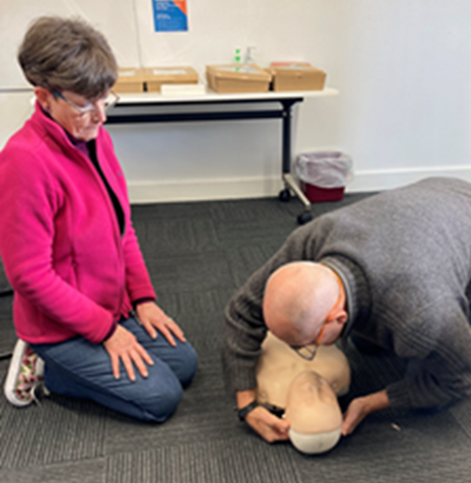

Richard and Maryanne Bennet attending first aid training in Bairnsdale.

We encourage you to touch base with your [local Coastcare Victoria facilitator](https://www.marineandcoasts.vic.gov.au/coastal-programs/Coastcare-Victoria) if you have any suggestions for training or workshops.

Thank you again for all the hard work you do in nurturing our marine and coastal environments.

## Coastcare Victoria Community Grants

June is an exciting time for the Coastcare Victoria Community Grants program, with successful applicants for this year’s (2022-23) round scheduled to be announced by the Minister for Energy, Environment and Climate Change, The Hon. Lily D’Ambrosio.

Last year’s (2021-22) round included both short projects – finishing June 2022 – and long projects – finishing May 2023, and we are now seeing the inspiring stories and lovely images arriving from those grant recipients in the form of project progress and completion reports.

Keep an eye on our [Coastcare Victoria Facebook page](https://www.facebook.com/CoastcareVictoria#Coastcare%20Victoria%20Page) to help us celebrate these projects and our groups delivering them.

We have started planning for the next annual grants round, so chat to your [local Coastcare Victoria facilitator](https://www.marineandcoasts.vic.gov.au/coastal-programs/Coastcare-Victoria) about your Coastcare Victoria funded project idea now.

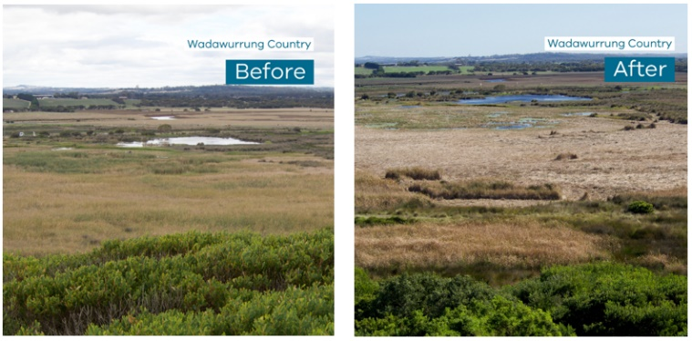

Before and after photo of the freshwater reed weed control at Breamlea Flora and Fauna Reserve.

Here’s a great example. As part of their Coastcare Victoria Community grant, Breamlea Coastcare, with the help of Aquatic Technologies, undertook weed control of freshwater reeds in the Breamlea Flora and Fauna Reserve in April 2022. A Mobitrac (amphibious harvester) was used to cut the reeds on the water surface.

The group have already seen positive change since the Typha control started, with swans and swamp hens enjoying the new open space in the wetlands. It is hoped that once the creek opens the increased salinity levels will inhibit any new seeds from germinating.

Breamlea Coastcare will continue monitoring the reserve and will be noting any new growth.

## Solving spider crab mysteries in our blue backyard

*Article by Elodie Camprasse, Research Fellow in spider crab ecology at Deakin University*

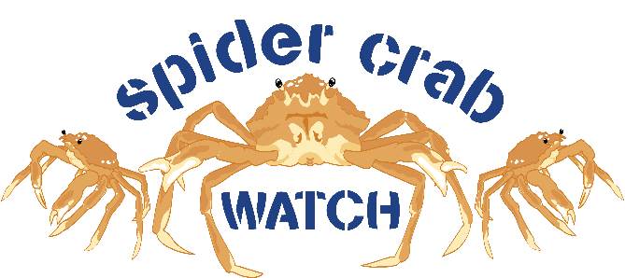

Spider crab watch citizen science program logo

Great spider crabs (*Leptomithrax gaimardii*) and their aggregations in Port Phillip Bay have fascinated locals and attracted tourists from far and wide to our marine environments for years.

This unique natural phenomenon has been featured in renowned documentaries like BBC Blue Planet II. Despite this, we know very little about the spider crab aggregations, which are unfolding in Port Phillip Bay in May/June.

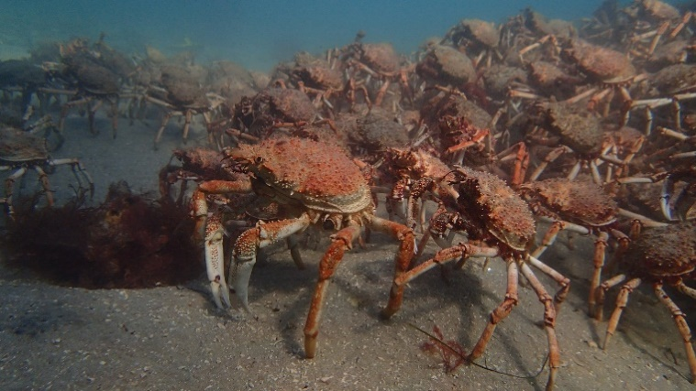

Spider crab aggregations.

Thanks to funding from the Port Phillip Bay Fund and Coastcare Victoria, a citizen science program has been launched to solve the mysteries surrounding those aggregations.

The Spider Crab Watch program, run by Deakin University, has two components:

* An invitation for marine enthusiasts to report when and where they see spider crabs when they are out and about exploring the marine environment. All you need is to create an iNaturalist account via [Spider Crab Watch · iNaturalist](https://www.inaturalist.org/projects/spider-crab-watch) – logging information only takes a few minutes!
* A call out to the broader community to help analyse photos taken with timelapse cameras at aggregation sites to count spider crabs and identify predators. Stay tuned for more updates after aggregations.

Your sightings will help us find out what spider crabs get up to!

To receive the latest Spider Crab Watch updates, complete the [Sign Up Form (deakin.edu.au)](https://redcap.deakin.edu.au/surveys/?s=F3FYD9MCD9CDD3DY).

## Phillip Island Land Alliance

*Article prepared by David Rooks, Chairperson of PILA and President of Phillip Island Landcare Group*

Phillip Island is recognised for its sensitive and unique landscapes. It’s important they are protected and enhanced.

To further this cause, a newly formed group has developed named Phillip Island Land Alliance (PILA).

PILA’s vision is ‘A connected community who respects and protects the unique and biodiverse environment of Phillip Island’.

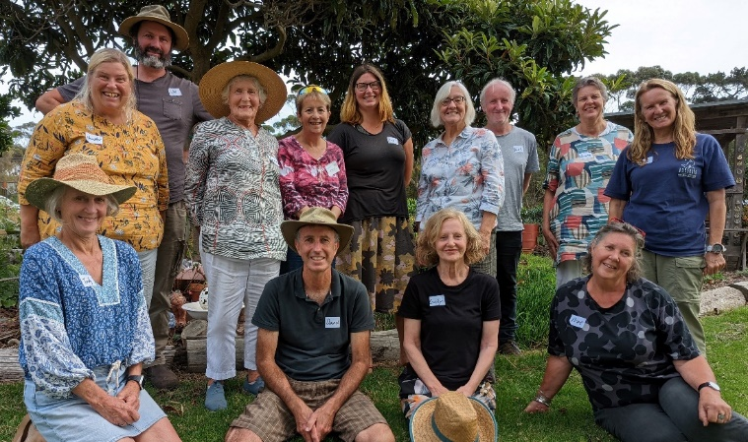

PILA Workshop 2 participants. Front row, left to right: Judy Glover, David Rooks, Carolyn Atherton, Prue Adamson. Back row, left to right: Heather Liney, Luke Frickie, Anne Davie, Carmen Bush, Zoe Geyer, Marilyn Shaw, Keith McDougall, Laura Brearly, Gayle Seddon. Image by Bhavani Rooks.

The inaugural alliance members include all nine coastal community volunteer groups that manage their respective areas of the Phillip Island coast, in addition to Phillip Island Landcare Group and Phillip Island Conservation Society.

The idea of the alliance began through a 2020-21 Coastcare Victoria Community Grant, applied for by Phillip Island Landcare Group in partnership with five Coast Action/Coastcare groups.

The thinking was to bring together community groups that care for the land to share knowledge and resources.

The name ‘PILA’ represents a strong voice, like a pillar represents a strong structure. Our terms of reference say, ‘We communicate with a unified voice and common objectives, to provide opportunities for networking, and a platform for a coordinated approach to funding applications and island wide environmental care’.

We come together to educate, connect and engage our community with the natural environment for the health and wellbeing of all, now and into the future. Individual community group membership varies from 10 to 100 people.

|  |  |
| --- | --- |
| © The State of Victoria Department of Environment, Land, Water and Planning 2022  LogoThis work is licensed under a Creative Commons Attribution 4.0 International licence. You are free to re-use the work under that licence, on the condition that you credit the State of Victoria as author. The licence does not apply to any images, photographs or branding, including the Victorian Coat of Arms, the Victorian Government logo and the Department of Environment, Land, Water and Planning (DELWP) logo. To view a copy of this licence, visit http://creativecommons.org/licenses/by/4.0/  Disclaimer  This publication may be of assistance to you but the State of Victoria and its employees do not guarantee that the publication is without flaw of any kind or is wholly appropriate for your particular purposes and therefore disclaims all liability for any error, loss or other consequence which may arise from you relying on any information in this publication. | Accessibility  If you would like to receive this publication in an alternative format, please telephone the DELWP Customer Service Centre on 136186, email [customer.service@delwp.vic.gov.au](mailto:customer.service@delwp.vic.gov.au), or via the National Relay Service on 133 677 [www.relayservice.com.au](http://www.relayservice.com.au). This document is also available on the internet at [www.delwp.vic.gov.au](http://www.delwp.vic.gov.au). |

As an alliance, PILA’s membership voice totals around 400, providing a significantly stronger platform to achieve its objectives.

On 12 May 2022, PILA shared its launch with the release of the new Phillip Island Rabbit Strategy. As project managers of the rabbit strategy, the Bass Coast Landcare Network realised the value of the alliance in helping achieve the objectives of the strategy.

PILA believe it will be of interest to other key stakeholders on the Island, including Phillip Island Nature Parks, Bass Coast Shire Council, Bunurong Land Council Aboriginal Corporation, DELWP, Totally Renewable Phillip Island and Western Port Water.

A big thanks to the Victorian State Government and Coastcare Victoria for their support through the 2020-21 Coastcare Victoria Community Grant. This was the impetus that provided the opportunity for PILA to begin.

As of 19 April 2022, the inaugural member organisations include:

* Phillip Island Conservation Society
* Ventnor Coast Care Association Inc.
* Surf Beach Sunderland Bay Coastcare Group
* Cowes Coastcare Group
* Red Rocks Saltwater Creek Coastcare
* Silverleaves Conservation Association
* Cape Woolamai Coast Action
* Rhyll Coast Action
* Friends of Scenic Estate
* Phillip Island Landcare Group
* Newhaven Coast Action Group.