Coastal processes and hazards
Factsheet 3
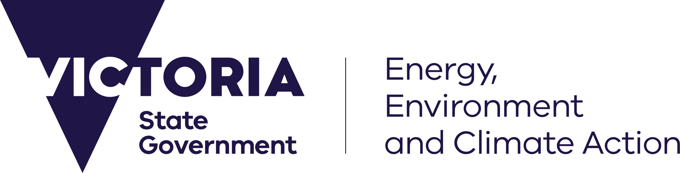
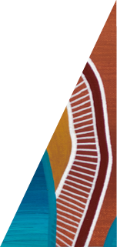
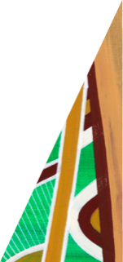

deeca.vic.gov.au

This fact sheet provides a summary of the coastal landscape context, processes and hazards considered in adaptation planning.
These factors inform technical modelling and options assessments for managing coastal processes in the short and longer-term.

The coastal landscape
Coastal zones are dynamic and picturesque parts of the landscape, where the land meets the sea. Across the Gippsland region, the coastal landscape features:
- Open coast, including beaches, dunes, cliffs, rock platforms and foreshores
- Dynamic estuaries and tidal mudflats
- Upstream waterways and inland groundwater connections.
One of the more challenging aspects of the coastal landscape is that it experiences constant and sometimes rapid change. Drivers of change such as wind, waves and tides continually work to move sand and shape the shoreline and adjacent coastal land.
Actions we take to manage coastal processes may have significant implications for environmental, cultural and economic values of coastal areas. Understanding the key drivers of landscape change is the first step to developing a plan to balance values and land use, both now and into the future.

Drivers of change include:
 | Tides: The periodic rise and fall of the daily tide moves sand off and onshore, into and out of tidal channels and along the coast. This shapes the beach and near-shore environment as well as impacting groundwater levels and coastal wetlands.
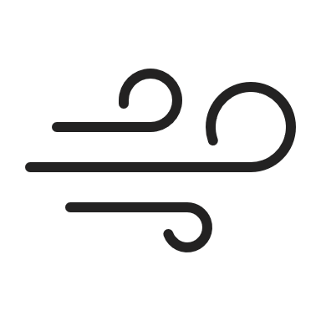 | Wind and waves: Waves are generated by wind blowing across the water, both locally and across long distances. Wind, combined with the morphology (shape) of the sea floor, drives the size, frequency, duration and energy of waves. Wave energy has the potential to move sand off-shore, on-shore, along the coastline and into and out of inlets. Wind and wave direction also affects the direction sand is moved along the coast.
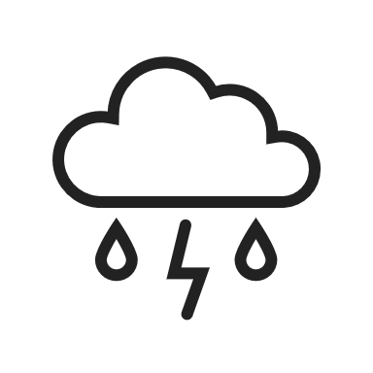 | Climate patterns: Local climate conditions (e.g. dominant wind patterns), as well as extreme events (e.g. flooding), will influence how the coastal landscape develops and changes over time. Extreme weather events such as storms can cause major coastline changes in a short period of time, due to coastal erosion. Beaches typically rebuild gradually between extreme events over years/decades unless sediment supply changes.
 | Sediment supply: Sediment (sand) is delivered to coastlines from catchments, rivers, dunes and offshore environments. When historical sediment supplies reduce or cease, affected coastlines will be prone to erosion. But, when sediment supply is abundant, coastlines will tend to remain stable or build seaward.

Coastal hazards

Natural coastal processes such as short- and long-term erosion and inundation shape the diverse features of the coastal zone. These processes are often referred to as coastal hazards when they impact on coastal values and uses, including infrastructure. Coastal hazards considered in adaptation planning include coastal erosion, storm tide inundation, permanent inundation, and groundwater intrusion.

Storm tide inundation
Storm tide inundation is the temporary inundation (flooding) of low-lying coastal land from a locally elevated sea level (storm tide). The storm tide is caused by the combined influence of:
- The predicted tide
- Low pressure air systems causing increases in sea level (storm surge)
- High wind-generated waves associated with a severe storm.
Storm tides inundate low-lying land for periods of hours to days, including coastal wetlands, marshes, inlets and estuaries.
Storm tide inundation can also combine with catchment flooding from severe rainfall events, increasing the extent or depth of inundation in some areas, and the event duration.

Permanent inundation
Permanent inundation occurs when low-lying areas become regularly inundated as part of the local tidal cycle, up to and including the Highest Astronomical Tide (HAT). Increases in mean sea level over time will influence the extent of permanently inundated areas.

Saline groundwater intrusion
Saline groundwater intrusion is the movement of saline groundwater into fresh aquifers over time. Increased salinity can affect water quality, including for drinking water and irrigation.
Saline intrusion can occur in many ways, including vertical movement of the water table, and lateral movement of coastal waters. Changes in land use, coastal processes, and mean sea level over time can influence the extent of saline groundwater intrusion.

Coastal erosion

Sandy coasts
Natural dune systems go through periods of erosion and accretion. Dune vegetation has a key role in assisting dune growth, by helping trap sand.
Erosion can occur when winds, waves and coastal currents shift sediment away or along the shoreline, sometimes just offshore. Short term erosion (storm bite) is associated with big storms.
In calm conditions, wind and waves act to transport sand onshore, building up the dune. For a stable beach, all the sand moved offshore in a storm eventually moves back onto the beach, and overall shoreline position stays the same over time.
In some cases, changes in sediment supply or climate conditions (such as bigger or more frequent storms), means the beach may not rebuild fully between storm events.
With less sand retained on the beach over time, long-term erosion (recession) may occur; this means the shoreline position (e.g. vegetated dunes and high tide beach) moves incrementally landward (over several decades).

Rocky coasts
Over geological timescales (thousands of years), softer sediments are eroded away, exposing hard rocky coasts. These coasts are more common in areas of high energy (strong wave action).
Hard rock
Hard rock cliff slopes are susceptible to deep-seated mass movements (i.e. cliff fall) that may be initiated by a combination of surface processes (rain, surface runoff) and/or due to marine influences at the base of the cliff (e.g. toe undercutting).
Hard rock erosion can occur with little or no warning.
Where a sandy beach is ‘perched’ on a rock platform at the base of a cliff, increasing sea levels and wave energy can result in sand loss, due to limited sand volumes and increased wave reflection off the rocky coast.
Soft rock

Some rocky coastal areas have softer, more erodible rock. These coasts can be more vulnerable to erosion from both surface processes and cliff toe undercutting.

Erosion of soft, rocky coasts can occur as both cliff falls and slumping (material movement down its slope).
Rocky coastlines do not ‘recover’ after erosion like sandy coasts do. However, as they have some resistance, they also erode less frequently.

Low earthed cliff

Low earthed cliffs are common in low energy environments like Anderson Inlet. Erosion processes are similar to soft rock coastlines, with surface processes and undercutting due to waves driving shoreline recession (moving its position further landward).

The recovery (rebuilding) of a low earthed cliff is limited by the available sand in nearshore areas or being moved along the coast. These coastlines are likely to be more susceptible to rising sea levels than rocky coastlines. Being lower in elevation, sea level increases may inundate the landward edge of the cliff, leading to long-term erosion (landward recession) of the coastline.

Tidal channels
The rise and fall of the offshore tide pushes and pulls water into and out of Anderson Inlet. This water exchange results in deep channels forming as water rushes in and out of the Inlet.
The inlet channels move around in the sand within the entrance. Different conditions - such as tidal stages (spring vs neap tides), waves and storm surges and flood flows from the Tarwin River - change the water volume of each tide and the strength and direction of currents which move sediment.
The movement of tidal channels can result in the coastline receding or accreting at different times and places.
Tidal range - the difference between the water level at high tide and previous or following low tide water level.
Spring tide – larger tides, when the tide's range is at its maximum. Occur on full or new moon phases.
Neap tide – smaller tides, when the tide's range is at its minimum.
Highest astronomical tide (HAT) – highest water level predicted to occur under average meteorological conditions.

Coastal hazards and climate change
With a changing climate, coastal hazards are likely to have an increased impact on the Cape to Cape region in the future.
Expected future impacts of climate change on the Gippsland region include:
- Temperatures to continue to increase year-round
- More hot days and warm spells
- Fewer frosts
- Less rainfall in winter and spring
- More frequent and intense downpours
- Harsher fire weather and longer seasons
- Rising sea level
- More frequent and extreme sea level events
- Warmer and more acidic seas
Improving our understanding of coastal processes and expected changes in climate allows us to be better informed to make decisions on short term actions, and plan for the future.
The next factsheet in this series will describe how we use computer models and measurements to understand current and potential future coastal processes and hazards, and to assess the suitability of different adaptation options.
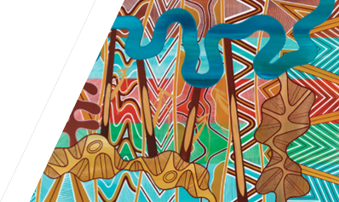
We acknowledge Victorian Traditional Owners and their Elders past and present as the original custodians of Victoria’s land and waters and commit to genuinely partnering with them and Victoria’s Aboriginal community to progress their aspirations.
© The State of Victoria Department of Energy, Environment and Climate Action February 2024.
Creative Commons
This work is licensed under a Creative Commons Attribution 4.0 International licence, visit the Creative Commons website (http://creativecommons.org/licenses/by/4.0/).
You are free to re-use the work under that licence, on the condition that you credit the State of Victoria as author. The licence does not apply to any images, photographs or branding, including the Victorian Coat of Arms, and the Victorian Government and Department logos.
ISBN 978-1-76136-567-6
Disclaimer
This publication may be of assistance to you but the State of Victoria and its employees do not guarantee that the publication is without flaw of any kind or is wholly appropriate for your particular purposes and therefore disclaims all liability for any error, loss or other consequence which may arise from you relying on any information in this publication.
Accessibility
To receive this document in an alternative format, phone the Customer Service Centre on 136 186, email customer.service@delwp.vic.gov.au, or contact National Relay Service on 133 677. Available at DEECA website (www.deeca.vic.gov.au).
For more information and further fact sheets in this series, please visit www.marineandcoasts.vic.gov.au/coastal-programs/gippsland-projects

