|  |
| --- |
| Cape to Cape Resilience Project  PROJECT UPDATE 2: July 2021 |

Over the past few months, the Cape to Cape Resilience Project team has continued to build our understanding of local coastal processes and learn more about your experiences of the region’s coastal zone.

## Technical work update

The Coastal Hazard Assessment team has been progressing through data gathering and gap analysis, a geomorphological assessment of the region and have started building computer models.

### Data gathering

With the help of stakeholders, reference groups and various other sources, the project team has gathered and collated a wide range of relevant information and data to use in the Coastal Hazard Assessment and for adaptation and resilience planning.

This has included:

* + Land and seabed shape and elevation (topography and bathymetry), including drone survey
  + Aerial imagery and photographs (current and historic)
  + Geology and coastal geomorphology
  + Ocean and coastal processes (e.g. wave and tide conditions and measurements)
  + The environment and climate (e.g. wind conditions)
  + Catchment and stormwater flows
  + Groundwater
  + Existing coastal protection and structures

This has involved working with many stakeholders to pull together all the available information, so we thank those involved for their time.

### Gap analysis

There are key (“critical”) items of information needed to inform a Coastal Hazard Assessment and adaptation planning. Sorting through the data and information, potential data/information gaps were identified. We’ve worked to fill these by gathering new data, including:

* + LiDAR (aerial elevation) survey of the study site
  + Survey of all existing coastal protection structures
  + Underwater (bathymetric) survey of the entrance
  + Sediment (sand) sampling

Filling some of the critical data gaps has been delayed due to COVID19 restrictions, but we expect them to be completed soon. We are still able to continue with other assessment work in the meantime.

### Geomorphological assessment

The region’s coastline has been split into over 200

sections based on geomorphology (See ). Each section has been described in terms of coastline type (beaches, cliffs, reefs), material (sediment, rock type) and resistance to coastal processes (erosion, flooding).

This helps us understand the expected response of each section of coast, both in the short- and long-term, following storm events or due to sea level rise. We use this to estimate expected shoreline changes and coastal erosion extents.

Aerial photos and satellite imagery from 1950 to present day has also been reviewed and analysed. This has provided us with a long-term record of observed coastal change and response to storm and flood events.

|  |  |
| --- | --- |
| Information with solid fill | Coastal geomorphology is the physical shape, processes and patterns associated with the coast, including landforms, soils, geology and the factors that influence them. |

### Building the coastal model

We’ve begun building our computer models of the region, including the open coast, Anderson Inlet and the entrance. We’ll be releasing a factsheet about what a coastal model is and how they help us plan for the future. We’ll send an update when this is available on our website.

## Engagement update

### Project launch

In early May, we held a project launch for the RaSP partners and our Stakeholder Reference Group (SRG).

We met at Inverloch Surf Beach and started our discussions looking at some foreshore locations that have recently experienced change. We then headed to the Inverloch Community Hub where the project team gave an update and presented technical work to date.

Figure 1. RaSP partner representatives and members of the SRG walking together at Inverloch surf beach.

Our discussions continued, reflecting on coastal change and capturing some of the past events and drivers that have shaped the Cape to Cape coastline. We also explored what our stakeholders think the coast should look like in the future and ideas for increasing resilience. Some themes discussed at the project launch were:

* The natural environment is a key drawcard, bringing people to the coast.
* Many different cultural, social, environmental and economic factors influence how the coast has changed over time.
* Management of our coastline needs to balance various interests and values.
* Our management approach must be sustainable and work with the natural processes.

These discussions will help inform our technical work and approach to adaptation. The broader community will also have a chance to build on these initial perspectives through upcoming consultation.

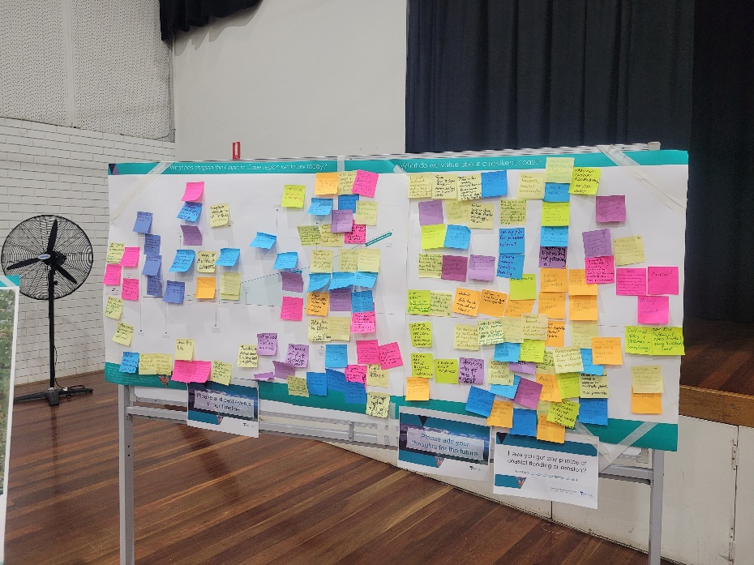

Figure 2. Capturing initial perspectives from the RaSP partners and SRG members.

**Community engagement**

Due to recent COVID19 restrictions, we’ve had to delay our in-person community consultation. During August, we will be running two community events online:

* Wednesday 11 August 5:30 to 7:00pm [**(Registration link Wed 11th)**](https://www.eventbrite.com.au/e/cape-to-cape-resilience-project-online-session-1-wednesday-11-august-tickets-165379649985)
* Monday 16 August 12:00 to 1:30pm [**(Registration link for Mon 16th)**](https://www.eventbrite.com.au/e/cape-to-cape-resilience-project-online-session-2-monday-16-august-tickets-165379333037)

These sessions aim to provide more opportunities for the Cape to Cape community to learn about the project, and further contribute to this important work. You’ll also have a chance to talk with the project team.

If you’re interested in joining the session, please register at the links above.

We have also launched our online consultation via Engage Victoria:

|  |
| --- |
| [engage.vic.gov.au/cape-cape-resilience-project](http://www.engage.vic.gov.au/cape-cape-resilience-project) |

](https://engage.vic.gov.au/cape-cape-resilience-project)

There are lots of ways to get involved:

|  |  |
| --- | --- |
| Clipboard Partially Checked with solid fill | **Complete the survey** - share with us how you use the coast, what you value about the coast, your experiences of coastal hazards and the changes you’ve seen over time. |
| Map with pin with solid fill | **Add a pin to the map** – share what you love, your ideas for the future and your memories of how the coast has changed. |
| Images with solid fill | **Tell us your coastal stories** – share your past experiences or a photo of what you love about the Cape to Cape region. |
| Raised hand with solid fill | **Register for our webinars** – we’ll be sharing more information about the project and hosting some activities to capture what you love about the coast. |

Your valuable input will help inform the values and risk and vulnerability studies for the project, which will be used to determine our priorities, potential adaptation options and long-term adaptation pathways.

**Next steps**

Over the next few months, we’re focussing on gathering community perspectives to inform our Community Values Study. We’ll also be progressing the Coastal Hazard Assessment and building our coastal models.

|  |
| --- |
| How can I get involved? To ensure you keep up to date with the Cape to Cape Resilience Project and upcoming events and activities:   * Visit the project website at [marineandcoasts.vic.gov.au/coastal-programs/cape-to-cape-resilience-project](http://www.marineandcoasts.vic.gov.au/coastal-programs/cape-to-cape-resilience-project) * Sign-up to receive progress updates and notifications – email [capetocape.project@delwp.vic.gov.au](mailto:capetocape.project@delwp.vic.gov.au) * Read our latest factsheets via the website * Ask us a question – email [capetocape.project@delwp.vic.gov.au](mailto:capetocape.project@delwp.vic.gov.au) |

|  |  |
| --- | --- |
| © The State of Victoria Department of Environment, Land, Water and Planning 2021  LogoThis work is licensed under a Creative Commons Attribution 4.0 International licence. You are free to re-use the work under that licence, on the condition that you credit the State of Victoria as author. The licence does not apply to any images, photographs or branding, including the Victorian Coat of Arms, the Victorian Government logo and the Department of Environment, Land, Water and Planning (DELWP) logo. To view a copy of this licence, visit http://creativecommons.org/licenses/by/4.0/  **ISBN** 978-1-76105-572-0 **(pdf/online/MS word)**  Disclaimer  This publication may be of assistance to you but the State of Victoria and its employees do not guarantee that the publication is without flaw of any kind or is wholly appropriate for your particular purposes and therefore disclaims all liability for any error, loss or other consequence which may arise from you relying on any information in this publication. | Accessibility  If you would like to receive this publication in an alternative format, please telephone the DELWP Customer Service Centre on 136186, email [customer.service@delwp.vic.gov.au](mailto:customer.service@delwp.vic.gov.au) or via the National Relay Service on 133 677 [www.relayservice.com.au](http://www.relayservice.com.au). This document is also available on the internet at [www.delwp.vic.gov.au](http://www.delwp.vic.gov.au). |