Coastcare Victoria School Kit

Volunteering for Threatened Flora Worksheets

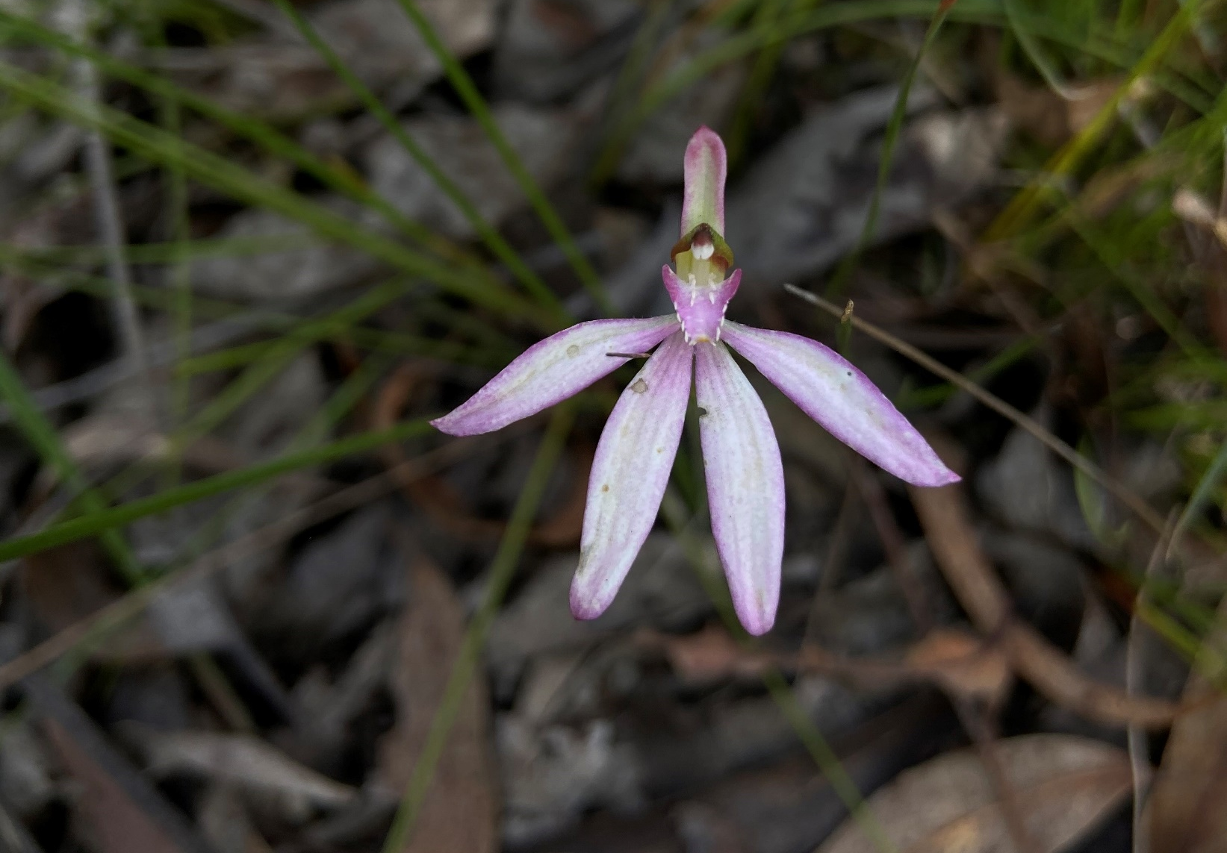

Acknowledgements

Coastcare Victoria would like to acknowledge all our video presenters and individuals who reviewed or assisted with the creation of the Coastcare Victoria School Kit.
Author
Coastcare Victoria and Ocean Imaging.
Photo credit
Ocean Imaging.

Contents
Volunteering for Threatened Flora Quiz 2
Binomial Nomenclature Activity 4
Natives and Weeds Investigation 5
Traditional Uses of Native Plants 8
Gardens for Wildlife Investigation 10
Volunteering for Threatened Flora Review Quiz 11

Volunteering for Threatened Flora Quiz
1.Which of these wasn’t a step Naomi gave to protect the habitat?
- Always stick to paths
- Leave only footprints
- Always go in a large group
- Consider volunteering to help

2. Coastal Moonah woodland is a ___________plant community
- Large
- Threatened
- Resilient
- Critically endangered

3. What are one of the biggest threats that the Moonah woodland faces?
- Invasive woody weeds
- Invasive birds
- Pollution
- Poor soil quality

4. Polygala myrtifolia is a
- Native species
- Non- invasive species
- Woody weed
- None of the above

5. Polygala myrtifolia drops how many seeds each year?
- Hundreds
- Thousands
- Millions
- Billions

6. Invasive weeds compete with natives for
- Soil and Water
- Fruits and seeds
- Carbon Dioxide and Air
- Light, Nutrients and Space
7. What were the volunteers doing in the video?
- Removing weeds
- Removing native plants
- Planting native plants
- Planting weeds

8. What did volunteer Marvyn see once the Polygala was removed?
- Small native trees and shrubs coming through
- In season orchids
- More weeds
- Both a and b

9. Why is this work especially important in this area?
- A lot of land clearing in the area so not much native vegetation left.
- Few animals live in the area
- Remote and hard to get to.
- The area is regularly visited by many people

10. What was one of the other benefits of volunteering that was mentioned?
- Takes a lot of time
- Can be hard work
- Good for mental health
- Make a lot of money

Binomial Nomenclature Activity
In biology, binomial nomenclature is how species are named. The name of a species is made of two parts: one indicating the genus and one indicating the species. Binomial nomenclature means "two-part name" or "system of two-part names".

In this activity, you will use the scientific names of 8 plant species to research the common name or names and if they are native or introduced to Australia. Note many of these species will have several common names. (12 marks)
Species Name | Common name(s) | Native or introduced?
Melaleuca lanceolata
Spinifex sericeus
Tetragonia implexicoma
Alyxia buxifolia
Polygala myrtifolia
Aparagus asparagoides
Chrysanthemoides monilifera
Ulex europaeus

2. What is one advantage of using binomial nomenclature? (1 mark)

3. What are two problems with using common names only? (2 marks)

4. What does the first name in binomial nomenclature stand for? (1 mark)

5. True or false, a genus can include more than one species. (1 mark)

Natives and Weeds Investigation
Common name | Scientific name | Native or Weed | Plant type | Plant size | Flowering Season | Unique features
Moonah
Hairy Spinifex
Bower Spinach
Sea Box
Myrtle-leaf Milk-wort
Bridal Creeper
Boneseed
Gorse

Moonah
Hairy Spinifex
Bower Spinach
Sea Box
Myrtle-leaf Milk-wort
Bridal Creeper
Boneseed
Gorse
 | Jan | Feb | Mar | April | May | Jun | Jul | Aug | Sep | Oct | Nov | Dec

Botanical Illustration
Please refer to Volunteering for Threatened Flora PDF worksheets for activity

Traditional Uses of Native Plants
Aboriginal Australians are more well known for their close relationship to native plants. In this activity, use the Uses for native plants of the Mornington Peninsula PDF to research the uses of some indigenous plants. Bonus points for the last box on seaweed as the answer is not in the PDF.

Plant Name | Food/Drink | Medicine | Tools | Ceremony
Blackwood
Water Plantain
Sea Celery
Silver Banksia
Hop Bush
Coastal Manna-gum
Burgan
Native Raspberry
Bower Spinach
Seaweed

Gardens for Wildlife Investigation
Establishing a natural habitat garden helps you encourage native animals like birds, bats, lizards, frogs, butterflies, and other insects to your garden. Native gardens can also help reduce garden maintenance costs, decrease gardening, and time commitments, conserve local native plants and animals, and make our urban areas more ecologically sustainable.

Watch the video “Make your garden wildlife friendly” by Gardening Australia. Students should create a short list of tips to make a garden more wildlife-friendly. There are other videos in the playlist which also may help with the task.

- Native groundcovers and grasses - food and shelter
- Dense shrubbery - protection for creatures
- Planting natives and a diverse range of plants
- Variety of habitats and layers
- Water source

Visit the Gardens for Wildlife Victoria website and click on Elements of a Wildlife Garden as well as the online article Make your garden a wildlife haven. Your task is to research locally native species in your area and design a native garden for your school or home. Use the basic ingredients listed on the site and create a plan for your garden. For extra inspiration on a design students may also like to view the Creating a wildlife friendly garden PDF.

Use the 6 Ds for this lesson.

- Define - What is your challenge? Read your brief carefully and write a definition of the tasks and challenges.
- Discover - What makes a good garden for native wildlife? Which species could be selected?
- Dream - What features would the ultimate garden have?
- Design - How will the components of the garden come together? How might the garden look?
- Deliver - Draw a plan for your garden. Label the sections and describe the features and benefits.
Debrief - What have you learned from this task? How did your garden compare to others?

Volunteering for Threatened Flora Review Quiz

- What makes a good botanical illustration? (3 marks)

- What are the four main categories of the traditional uses of native plants by Indigenous Australians? (4 marks)

- What makes invasive weeds a problem in native habitats? (2 marks)

- What can volunteers do to help threatened flora? (2 mark)

- Describe the benefits of a native garden (4 marks)

