Loch Sport Foreshore Coastal Processes & Options Assessment

Customer |  | Department of Environment Land Water and Planning
Project |  | A11347
Deliverable |  | 001
Version |  | 02

Document Control

Document Identification
Title | Loch Sport Foreshore Coastal Processes & Options Assessment
Project No | A11347
Deliverable No | 001
Version No | 02
Version Date | 23 May 2022
Customer | Department of Environment Land Water and Planning
Classification | DRAFT

Author | Taylor Rubinstein, Lindsey Gilbert
Reviewed By | Christian Taylor
Project Manager | Christian Taylor

Amendment Record
The Amendment Record below records the history and issue status of this document.
Version | Version Date | Distribution | Record
00 | 11 February 2022 | Department of Environment, Land, Water and Planning | Draft report
01 | 08 April 2022 | Department of Environment, Land, Water and Planning | Final report
02 | 23 May 2022 | Department of Environment, Land, Water and Planning | Final report – table 3.3 corrected

Executive Summary

Background
Loch Sport, located on the southern shore of Lake Victoria, has a history of erosion and the lakeshore has been heavily modified by coastal engineering interventions including revetments, gabion walls, beach nourishment and, most commonly, groyne which trap sand travelling along the shore from west to east, creating stable pockets of beach. The study area - the eastern half of the town lakefront - has many groynes and other protection structures in poor or very poor condition which are not functional or effective. This has led to areas of increased erosion and damage to the foreshore walking path, the loss of beaches and concerns that continued erosion will considerably lower the amenity of the area.
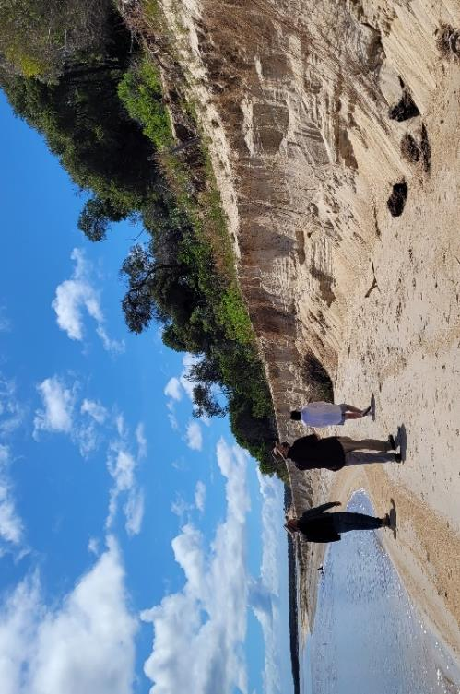
Erosion at the toe of the high dune bluff

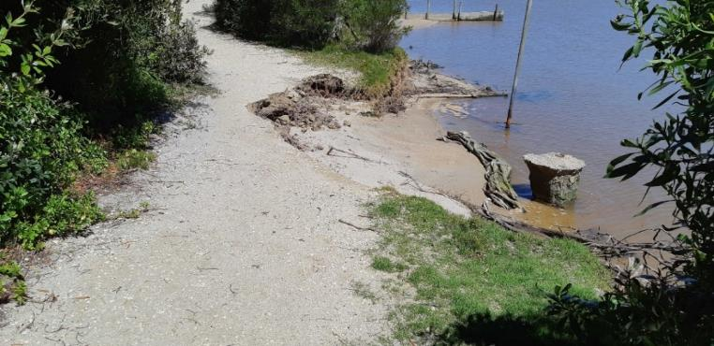
Erosion of the foreshore walking path

DELWP have commissioned BMT to undertake this coastal process and options assessment study for Loch Sport to review available options/measures to manage erosion and respond to sea level rise within an ‘Adaptation Pathways’ framework in accordance with the Victorian Marine and Coastal Policy 2020 (VMACP).

Coastal Inundation
Around half the foreshore reserve is below the current 10% Annual Exceedance Probability (AEP) flood level, and 34 private blocks are wholly or partially below this level. With sea level rise this is predicted to increase to around 60% of the reserve and 59 private blocks by 2100.
Many of the public assets in the foreshore reserve are resilient to occasional inundation and no immediate adaptation actions are proposed (e.g., walking path, beach access, boat ramps, toilet blocks). When these assets reach the end of their life and are upgraded options to raise levels or relocate should be considered.
For the private properties the level of vulnerability is not known as there is no data on floor levels available. There are no effective measures that can be implemented on the foreshore reserve that will remove this hazard. Because the soil in the area is predominantly sand, water can flow underneath and around any levees or barriers that are constructed.
The only viable short-term measure for responding to the inundation hazard is to build community resilience through education about the risks and planning for emergency response. It the longer-term landowners may accommodate their properties to the flood hazard by filling blocks, raising floor levels or moving dwellings to higher parts of the block (where possible).

Coastal Erosion and Recession
Sediment transport on the Loch Sport lakeshore is dominated by west to east alongshore transport driven by westerly wind waves. An important feature of Loch Sport shore is a series of mobile sand ‘spits’ moving eastward along the shore at between 20 and 90 meters per year. These features provide effective erosion protection to the backshore area behind the spit, however this effect is temporary as the sand spits move away.
Storm erosion and recession are the most immediate coastal hazard on the Lake Victoria shore at Loch Sport, and the figure below shows the assets/values which have been identified as currently at risk of erosion in the short term, based on the current position of sand spits and their predicted movement in the next 1 year. The large sand spit in the centre of the study area is currently protecting a bluff cut into a high dune with the walking path and private residences at the crest. However, in a short time (2 to 10 years), this spit will have moved on and the high dune bluff will be exposed to wave erosion at the base once more.
In the longer term (10 to 30 years) multiple sand spits will move along the lake shore causing alternating cycles of erosion and accretion, but the overall trend is towards erosion leading to long term recession, and this will likely accelerate with sea level rise. So, the entire shoreline will likely experience erosion at some time and will require adaptation interventions to manage the impacts of coastal hazards.
Without effective adaptation measures, by 2050 we expect that the walking path will be cut in many places, boat ramps could be impacted by erosion and some private property may be impacted by erosion. Between 2050 and 2100 the full width of the foreshore reserve could be eroded in many places and the number of private properties impacted will increase.

Coastal Cliff and Slope Instability
A high bluff is located in the centre of the study area where the current coastline cuts through an old parabolic dune. There are walking paths, roads, and properties on top of this bluff and further geotechnical investigations are required to quantify the level of risk posed by erosion at the toe of the bluff.
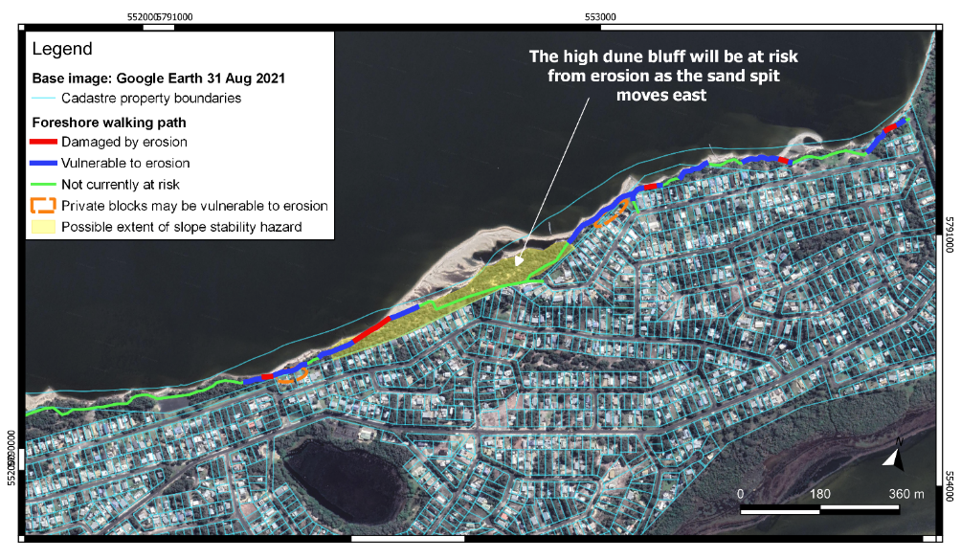
Study area and infrastructure/assets at risk from erosion in the short-term

Options and Adaptation Pathways
This study has considered a range of options in accordance with the hierarchy of responses set out in the VMACP:
VMACP Order of consideration | Adaptation Measure | Comment
1. Non-Intervention | Minimum intervention consistent with public safety | Not recommended. Will not preserve the usage and values of the site
2. Avoid | Place new infrastructure outside hazards zone | Not effective - existing infrastructure at risk
3. Nature-Based Methods | Small-scale nourishment for a limited area | Effective for small areas but will need to be repeated every few years
 | Large-scale ‘sand motor’ nourishment - place a very large sand spit at one end of study area and let natural processes spread it along the coastline to protect entire foreshore | May be effective for a wide area and effective long-term if repeated every decade or so
 | Offshore shellfish reefs | Untried, but could be effective over the long-term on small or large areas. Trials and staged approach needed.
4. Accommodate | Convert sections of foreshore walking path to boardwalk | Effective in the short to medium term for sections of the foreshore path. Could be designed using durable materials (FRP or similar) to minimise required maintenance).
5. Retreat | Relocate sections of foreshore walking path landward | Effective in the short to medium term for sections of the foreshore path, cheaper than boardwalk.
6.Protect | Groynes | Proven method for stabilising the shoreline at Loch Sport. Very expensive.
 | Rock revetment | Effective at preventing erosion and slightly cheaper than groynes but higher impact on beach use and amenity. Good option for protection of small areas with assets at risk that cannot be moved

Multiple feasible erosion control options and adaptation pathways has been identified for Loch Sport.
Immediate action is required for several short sections of the walking path that have been impacted by erosion. These should be relocated landward or, where that is not possible, replaced with a board walk. Revetments or other protection structures for these areas are not recommended as these treatments are relatively expensive and may not be needed when the longer-term adaptation measures are implemented. The exception is areas where the foreshore reserve is particularly narrow (<10m) and other assets are at risk from erosion. This approach aligns with the VMACP which requires that adapt (boardwalks) and retreat (relocation) options are considered before protection (revetment). The cost estimate for the immediate actions is $176k, refer section 5 and Annexure 1 for more details.
Although the current issues seem minor, over time erosion, inundation, and the threat to assets will increase and larger adaptation responses will be required. Further investigations, community consultation and option trials will be needed before the big decisions on the long-term adaptation strategy are made.
Large-scale sand nourishment and/or offshore shellfish reefs are promising long-term measures to manage erosion that could be much cheaper than groynes. Shellfish reefs in particular offer a range of co-benefits for habitat, biodiversity, and water quality. However, this type of hybrid living-engineered structure is relatively new in coastal engineering and further studies, including a trial, are recommended to confirm feasibility and effectiveness in this location.
Planning and studies to inform the selection of the long-term measures should begin immediately as they will take several years, and the high dune bluff will need protection from wave attack within the next 5 years. These have been listed in short term (within 2 years) recommendations, with an estimated cost of $90k.
A trial of the large scale ‘sand-motor’ nourishment and shellfish reef is recommended in medium term (2 to 5 years) with an estimated cost in the order of $1.5 million, which should provide erosion protection for around 10 years.
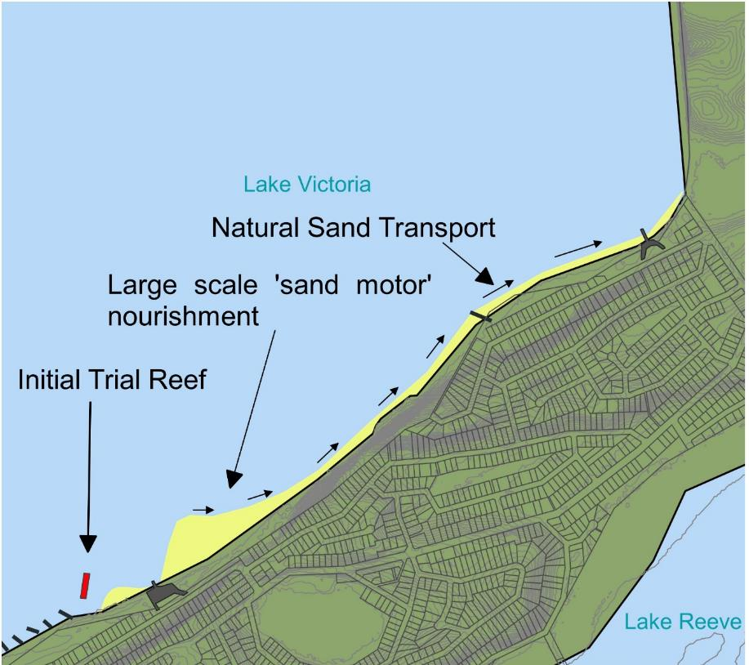
Medium-Term Concept – trial shellfish reef and large-scale ‘sand motor’ nourishment.

Contents

Coastal Cliff and Slope Instability 5
1 Introduction 12
1.1 Project Introduction 12
1.2 Study Area 12
1.3 Existing Coastal Protection Structures 20
1.4 Historic Dredging and Beach Nourishment 21
1.5 Previous Studies 21
Coastal Engineering Solutions (CES) (2002) Gippsland Lakes Shore Erosion & Revegetation Strategy 21
Ethos NRM (2009) Loch Sport Crown Reserve Management Plan 22
Ethos/NRM (2011) Loch Sport Foreshore Erosion: Investigations and Recommendations 22
Oldfield Consulting Australasia (2012) Loch Sport Seagull Drive Boat Ramp Access - Stage 1 Investigation 22
Water Technology (2014) Gippsland Lakes / Ninety Mile Beach Local Coastal Hazard Assessment 23
Oldfield Consulting Australasia (2017) Loch Sport Public Pathway Coastal Investigation 23
Oldfield Consulting Australasia (2021) Loch Sport Foreshore Erosion Investigation Report 23
2 Coastal Hazards 25
2.1 First Pass Hazard and Risk Screening 25
2.2 Coastal Processes 25
Geomorphology 25
Wind and Wind Waves 30
Water Levels 31
Currents 31
Climate Change and Sea Level Rise 31
Sediment Transport 33
2.3 Erosion Hazard 37
Storm Erosion 37
Coastal Recession Due to Sediment Loss 37
Coastal Recession Due to Sea Level Rise 39
Predicted Erosion Hazard Zones 40
2.4 Coastal Slope or Cliff Instability 44
2.5 Inundation Hazard 44
2.6 Vulnerability 48
Foreshore Walking Path 48
Seagull Drive Boat Ramp Precinct 50
The Boulevard Boat Ramp Precinct 51
Passive Open Space – Native Vegetation 52
Private Property 53
Erosion Vulnerability Summary 54
3 Adaptation Measures Assessment 56
3.1 Option 1 – Minimal Intervention Consistent with Public Safety 56
3.2 Option 2 – Beach Nourishment 58
3.3 Option 3 – Offshore Shellfish Reef 60
3.4 Option 4 – Modify Foreshore Walking Path into Boardwalk 62
3.5 Option 5 – Relocate Foreshore Walking Path 64
3.6 Option 6 – Groynes 66
3.7 Option 7 – Rock Revetment 68
4 Adaptation Pathways 70
4.1 Adaptation Pathways 70
Beach Nourishment Adaptation Pathway 70
Shellfish Reef Adaptation Pathway 72
Groyne Adaptation Pathway 74
4.2 Adaptation to Inundation 76
5 Recommendations 77
5.1 Immediate Actions 77
5.2 Short Term Actions 78
5.3 Medium Term Actions 79
6 References 82
Annex A: Short term works A-1

Tables
Table 1.1 Existing Coastal Protection Structures 20
Table 2.1 First Pass Coastal Hazard Assessment Summary 25
Table 2.2 Annual recurrence interval flood-water levels for Paynesville (Water Technology, 2014) 31
Table 2.3 Modelled peak flood-water levels for Loch Sport under ARI10 and ARI100 year floods (Water Technology, 2014). 33
Table 2.4 Shore-Parallel movement of the sand spits 35
Table 2.5 Longshore sediment transport rates from area change of the sand spits 36
Table 2.6 Recession components and theoretical recession hazards. 40
Table 2.7 Theoretical erosion hazard line setback from current shoreline without shoreline protection works. 40
Table 2.8 Foreshore walking path erosion and inundation vulnerability. 48
Table 2.9 Erosion Hotspot* Risk Identification 48
Table 2.10 Seagull Drive Boat Ramp precinct erosion and inundation vulnerability*. Total precinct area = 3716 m². 50
Table 2.11 The Boulevard Boat Ramp Precinct Erosion and Inundation Vulnerability. Total area = 1340 m². 51
Table 2.12 Passive Open Space Erosion and Inundation Vulnerability. Total area = 71,000 m². 52
Table 2.13 Private Property Predicted Vulnerability to Coastal Hazards 53
Table 3.1 Assessment of Option 1 – Minimal Intervention 57
Table 3.2 Assessment of Option 2 – Beach Nourishment 59
Table 3.3 Cost Estimate for Option 2 – Beach Nourishment Options 59
Table 3.4 Assessment of Option 3 – Offshore Shellfish Reef 61
Table 3.5 Cost Estimate for Option 3 - 6 x 100m shellfish reefs 61
Table 3.6 Assessment of Option 4 - Boardwalk 63
Table 3.7 Cost Estimate for Option 4 – 1km of boardwalk 63
Table 3.8 Assessment of Option 5 – Relocate Path 65
Table 3.9 Cost Estimate for Option 5 – 1.4km of crushed rock path. 65
Table 3.10 Assessment of Option 6 – Groynes 67
Table 3.11 Cost estimate for Option 6 – Construction of 28 rock groynes 67
Table 3.12 Assessment of Option 7 – Rock Revetment 69
Table 3.13 Indicative Cost estimate for Option 7 – 200m of rock revetment shoreward of both boat ramps. 69
Table 5.1 Recommendations for Immediate Actions 77
Table 5.2 Recommendations for Short-Term Actions (next 2 years) 79

Figures
Figure 1.1 Loch Sport Study Area Site Map 13
Figure 1.2 Conceptual Study Site Profile 14
Figure 1.3 Erosion of Area 1 downdrift of geotextile groynes 15
Figure 1.4 Area 2 - Erosion of foreshore path 200m east of Seagull Drive boat ramp. 16
Figure 1.5 Area 3 – Houses at risk shoreward of Toorak Avenue 16
Figure 1.6 Area 4 – High erosion scarp. 17
Figure 1.7 Area 5 – High sand dune bluff currently protected by wood groynes and mobile sand spit. 18
Figure 1.8 Area 7 – Low crested, ineffective gabion basket wall protecting foreshore walking path edge. 19
Figure 1.9 Area 8 – Foreshore path erosion (looing west). 19
Figure 1.10 Area 9 – Erosion East of The Boulevard boat ramp. 20
Figure 1.11 Erosion protection works recommended by Oldfield (2021) within the current study area. 24
Figure 2.1 Extent of the former lagoon system (during high sea level period 2.6 million – 12,000 years ago) bounded by the current marginal bluffs/sea cliffs shown by the dotted line (Rosengren, 2009). 26
Figure 2.2 Image showing how the complex barrier system of the Gippsland Lakes formed in steps. Note the predominant wind direction marked in the bottom-most panel (Boon, Rosengren, Frood, Oates, & Reside, 2014). 27
Figure 2.3 Conceptual Sediment Transport and Shoreline Evolution Model 29
Figure 2.4 Seasonal Wind Roses for East Sale Airport (Australian Bureau of Meteorology, 2021) 30
Figure 2.5 Sea level rise predictions for East Gippsland (CoastAdapt, 2021). 32
Figure 2.6 Long Shore Transport occurs maximally when waves impact shorelines at 45 degrees to normal. 33
Figure 2.7 Map showing the longshore transport and formation of sand bars from Feb 2005 to September 2021 34
Figure 2.8 Measured distance along shore of the leading edge of the West spit from 25 Aug 2019 to 1 Apr 2021 35
Figure 2.9 Measured distance along shore of the leading edge of the East spit from 1 Apr 2021 to 28 Sept 2021 36
Figure 2.10 Parabolic Dunes on the Inner Barrier. 39
Figure 2.11 Erosion hazard map – Seagull Drive Boat Ramp 41
Figure 2.12 Erosion hazard map – The Boulevard 42
Figure 2.13 Erosion hazard map – The Boulevard Boat Ramp 43
Figure 2.14 Inundation hazard map 10% AEP MSL 45
Figure 2.15 Inundation hazard map 10% AEP 2050 SLR 46
Figure 2.16 Inundation Hazard Map 10% AEP 2100 SLR 47
Figure 2.17 Eroding foreshore walking path in Hazard Area 8. 49
Figure 2.18 Seagull drive boat ramp precinct shoreline erosion. 50
Figure 2.19 Erosion immediately east of The Boulevard Boat Ramp approach – Erosion Hazard Area 9 51
Figure 2.20 Erosion of vegetation onto beach cutting access along the foreshore via the beach 52
Figure 2.21 2022 Vulnerability Summary 55
Figure 3.1 Current foreshore walking path erosion – Photo: Bill Storer – 22/11/2021 56
Figure 3.2 Option 2 – Beach Nourishment 58
Figure 3.3 Option 3 – Offshore Shellfish reef breakwaters 60
Figure 3.4 Option 4 – Modify foreshore walking path into boardwalk 62
Figure 3.5 Option 5 – Relocate Path 64
Figure 3.6 Option 6 – Groynes 66
Figure 3.7 Option 7 – Rock Revetment 68
Figure 4.1 Beach Nourishment Adaptation Pathway 71
Figure 4.2 Shellfish Reef Adaptation Pathway 73
Figure 4.3 Groyne Adaptation Pathway 75
Figure 5.1 Medium-Term Concept – trial shellfish reef and large-scale ‘sand motor’ nourishment. 81

Introduction

Project Introduction
Loch Sport is situated on the southern shore of Lake Victoria, in the Gippsland Lakes and Wellington Shire, Eastern Victoria. It is approximately 3.5 hours east of Melbourne. The Study site extends from the existing geotextile tube groynes in the centre of the town lakefront to the eastern end of town at National Park Road (Figure 1.1). The area is currently managed predominantly by the Loch Sport Foreshore Committee of Management which is overseen by the Department of Land, Water and Planning (DELWP). Some small reserves within this study area are also owned and managed by Wellington Shire Council.
The Lake Victoria shoreline of Loch Sport has a history of erosion and has been considerably modified by coastal engineering interventions including revetments, gabion walls, beach nourishment and, most commonly, groynes which 'trap' sand travelling along the shore from west to east, creating stable sections of beach. The study area has many groynes and other protection structures of which many are in poor or very poor condition. These structures have not been effective in preventing and controlling erosion and there is evidence of increased erosion and damage to the foreshore walking path, the loss of high tide beaches, and fears that continued erosion will considerably lower the amenity of the area.
DELWP have commissioned BMT to undertake this coastal process and options assessment study for Loch Sport to review available options/measures to manage erosion and respond to sea level rise within an ‘Adaptation Pathways’ framework in accordance with the Victorian Marine and Coastal Policy (VMACP) (DELWP 2020).
The study considers both short- and long-term measures and maps their interdependencies. Objectives of this study are to:
- Assess a range of management options/adaptation measures based on current understanding of coastal hazards and how these will change over time due to sea level rise,
- Recommend short term measures for the management of erosion that are consistent with the VMACP and do not constrain possible long-term options for the site,
- Map possible adaptation pathways for the long-term adaptation of the site to 2100 and beyond, to inform community consultation, further studies, and management decisions for the site.

Study Area
Loch Sport is situated on a sandy spit which was formerly a dune barrier system between the lakes and the ocean. As such, the landforms of the Loch Sport region consist of vegetated dunes comprised of unconsolidated to moderately consolidated sand. These are generally highly erodible. The area of interest for this study is the Lake Victoria frontage in the eastern half of the town, stretching from the eastern-most geotextile tube groyne (approximately 250 m west of the Seagull Drive boat ramp) to the eastern-most boundary of Loch Sport at the junction of National Park Road and the Lake Victoria foreshore (Figure 1.1).

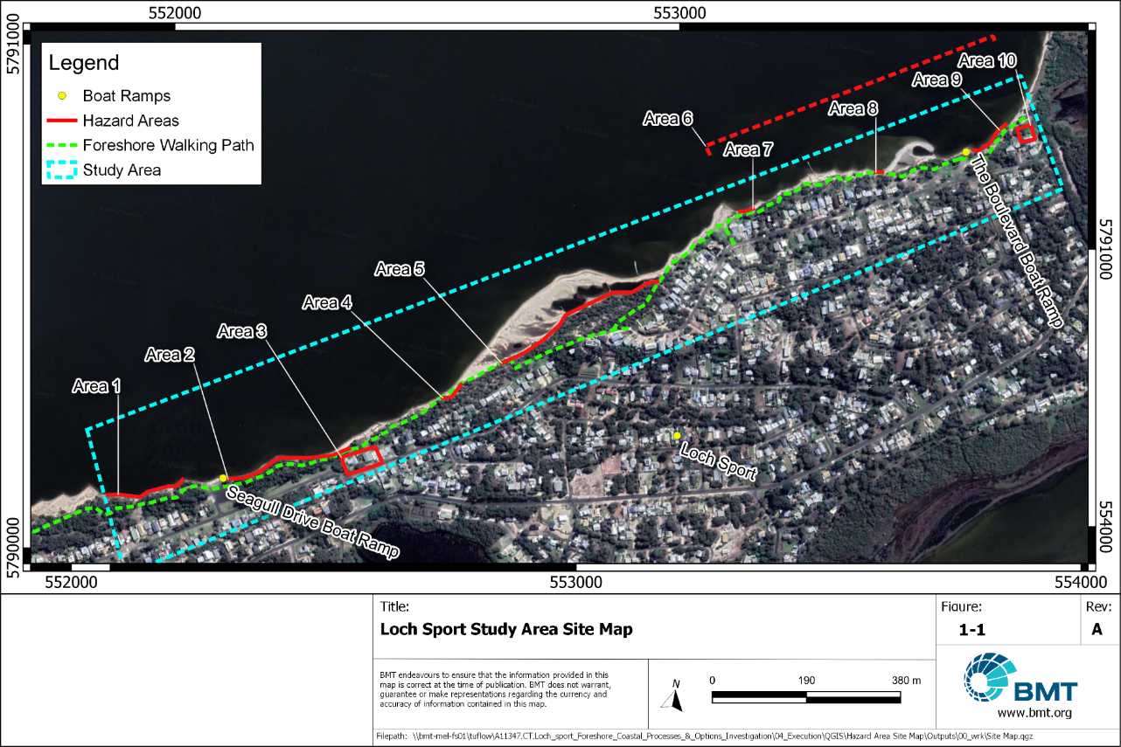
              - Loch Sport Study Area Site Map

The coast in this region consists of variously eroding and accreting sandy beaches with many coastal protection structures (rock timber and brush groynes, informal rock armouring and gabion baskets). In most areas, the beach is backed by an erosion scarp generally between 0.5 – 2.5 m high. In one section shoreward of The Boulevard, this erosion scarp forms the base of a 25 m high dune bluff. This high dune spans the whole study area, however, is situated behind a low-lying coastal plain of varying width in the east and west of the study site (Figure 1.2). A strip of public coastal foreshore reserve runs along the foreshore between the beach and private property boundaries. In the nearshore area there is a series of mobile sandy spits.
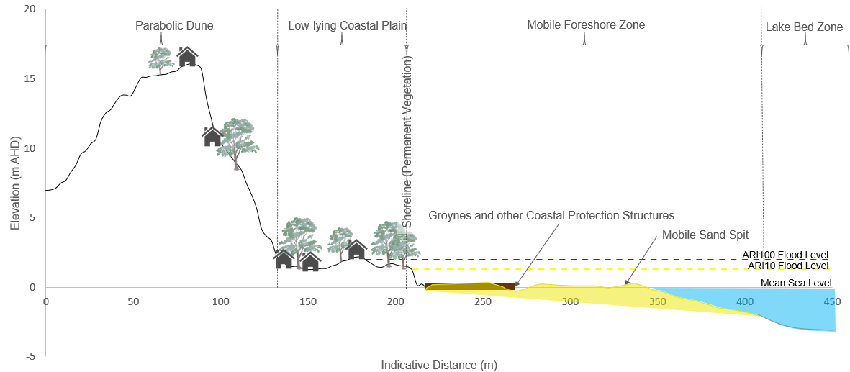
              - Conceptual Study Site Profile

Key factors relating to coastal processes at the site, identified from review of background material and discussions with DELWP, include:
- A highly dynamic coastline dominated by west to east longshore transport driven by wind waves
- A shallow nearshore area with large mobile sand spits moving along shore. Currently two large sand spits within the study area
- Limited cross shore transport of sand into sandbars under storm conditions
- Wind-blown transport of sand from the beach back into the foreshore reserve and residential areas
- Wave induced erosion of the beach and foreshore reserve in areas surrounding the Seagull Drive boat ramp
- A history of groyne construction and beach nourishment.
Key values/assets at the site are understood to be:
- Foreshore reserve walking path which runs the length of the study area
- Beach amenity
  - Pedestrian access to and along the beach
  - Mostly used in summer for swimming, sunbathing
  - In calm weather, small boats moor on the beach
- Boat launching and retrieval
  - Boating access to Lake Victoria at two boat ramps, primarily Seagull Drive and a secondary ramp at The Boulevard. (Note: the Charles Street boat ramp to the west and outside of the current study area is the main boat ramp used in Loch Sport).
  - Access for boat mooring to the two jetties (Deacon’s and Poppies (Figure 1.1)
- Natural Values
  - Coastal foreshore reserve vegetation supporting diverse local terrestrial ecology
  - Views of the lake from houses fronting the foreshore reserve.
- The coastal reserve provides an erosion buffer to private property.
Based on the site inspection and discussion with DELWP, we understand the 10 current issues/areas of concern arising from coastal hazards are as listed below and shown on Figure 1.1:
- Area 1 – Erosion is ongoing in this area downdrift (eastward) of the geotextile tube groynes (constructed 2009), with an estimated rate of 5m recession in the last 2 years. The foreshore path was cut by erosion and consequently rerouted further landward in April 2021.
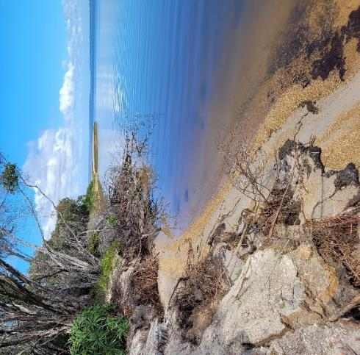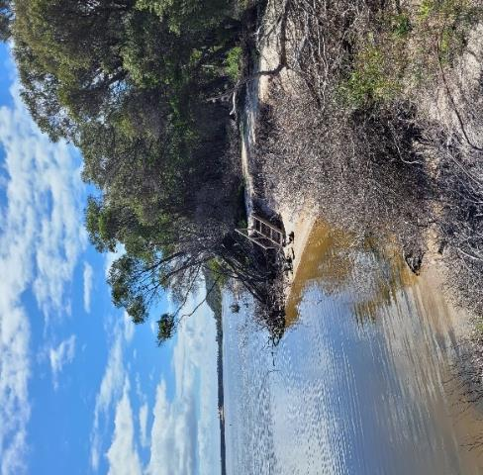
Geotextile Tube Groyne outside of study area
              - Erosion of Area 1 downdrift of geotextile groynes
There are no erosion control structures in Area 1 apart from the geotextile tube groyne at the western border of the area (outside of the study area).

- Area 2 – Ongoing erosion in the area east of the Seagull Drive boat ramp. Picnic tables have been removed at the ramp and walking path is close to erosion escarpment.
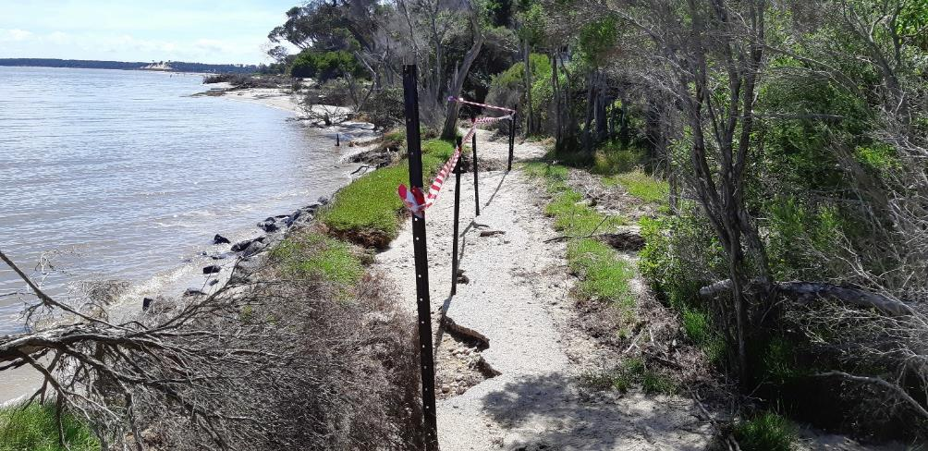
              - Area 2 - Erosion of foreshore path 200m east of Seagull Drive boat ramp.
There are no existing erosion control structures in Area 2.
- Area 3 – The western-most 3 houses on the foreshore side of Toorak Ave are currently at risk of inundation. One house is reported to have had been flooded previously.
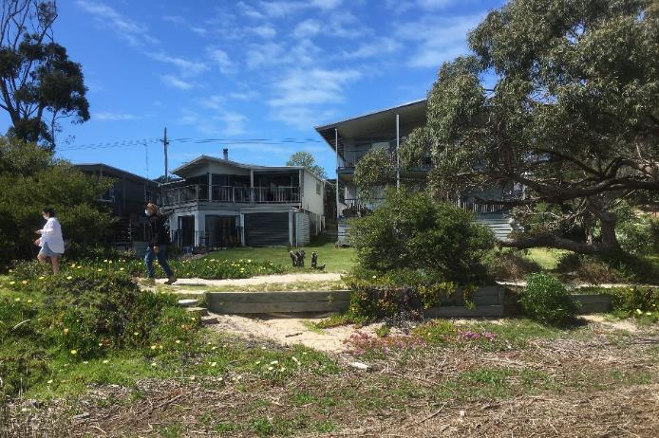
              - Area 3 – Houses at risk shoreward of Toorak Avenue

Erosion control structures in Area 3 include:
  - Timber seawall/retaining wall immediately shoreward of the foreshore walking path (Figure 1-5)
  - Multiple brush/tree branch groynes in various states of functionality.
- Area 4 – Eroding beach with 2m high erosion scarp. The beach also serves as the foreshore path in this area, but erosion has made the beach very narrow and impassable at times of high water levels.
              - Area 4 – High erosion scarp.
There are no erosion control structures in Area 4.
- Area 5 – High dune bluff above beach (up to 25m). This area is currently protected by a wide sand spit and a series of three timber groynes, but the toe of the bluff has historically been exposed to wave erosion. Continued protection of this area in the future, when the sand spit migrates, is a priority to maintain the stability of the bluff.
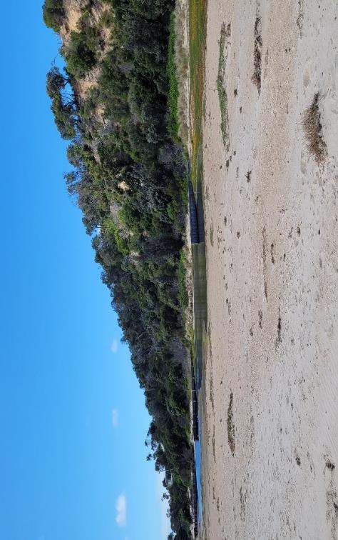
              - Area 5 – High sand dune bluff currently protected by wood groynes and mobile sand spit.
Erosion control structures in this area include:
  - 3 timber groynes.
- Area 6 - The Boulevard foreshore all the way from the large rock groyne (no. 66 The Boulevard) to National Park Road, crown land reserve is very narrow. This is a wider area of concern raised by DELWP and encompasses the current erosion hotspots Areas 7, 8 and 9. For the purpose of this study, Area 6 will refer to the sections not explicitly covered by Areas 7, 8 or 9.
- Area 7 – this area is on the down-drift side of a large rock groyne and is persistent erosion trouble spot. Gabion Baskets have previously been used to armour the path edge. These were placed at low elevations and waves have subsequently overtopped them and caused erosion of the path edge. Erosion is also occurring at the eastern end of the gabions exposing rock rubble below the path.
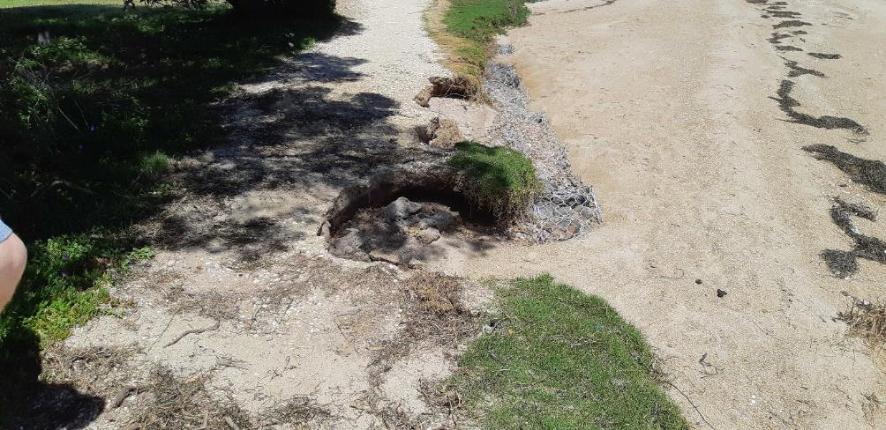
              - Area 7 – Low crested, ineffective gabion basket wall protecting foreshore walking path edge.
- Area 8 – An approximate 6 m long section of the path has been eroded away to approximately half the path width. East of the erosion the path is protected by an informal rubble revetment, although the crest level is too low to be entirely effective.
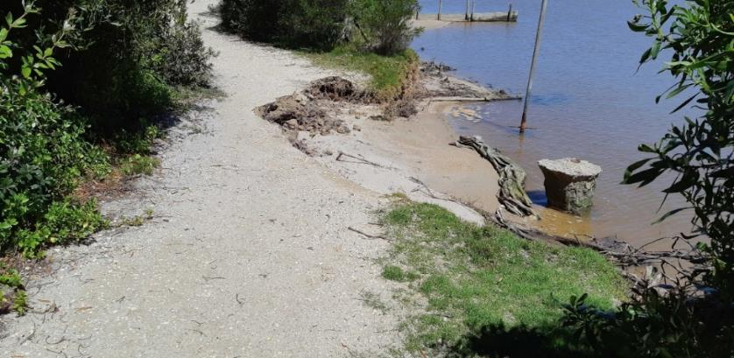
              - Area 8 – Foreshore path erosion (looing west).
- Area 9 – This are covers the foreshore from the Boulevard boat ramp east to national Park Rd (the edge of town). There is an actively eroding scarp up to 2.5m high. Foreshore path moved further inland in April 2021.
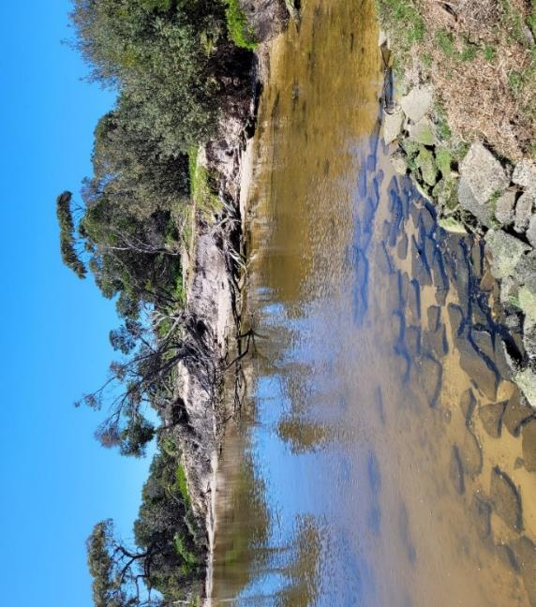
              - Area 9 – Erosion East of The Boulevard boat ramp.
There are no erosion control structures in Area 9.
- Area 10 – The eastern-most houses on National Park Road are low-lying and is predicted to be at risk of inundation by 2040.

Existing Coastal Protection Structures
A number of coastal protection structures have previously been constructed along the Loch Sport foreshore. These vary from large, engineered structures such as rock and timber groynes to more informal structures such as tree branch groynes and informal rubble revetments. Informal structures are generally constructed of random placement without engineered layering or interlocking. As such, they are usually unauthorised constructions, not built to a standard, and are at risk of being or becoming a safety issue.
The existing structures have had varying level of success noting that four groynes are currently buried under a sand spit. Table 1.1 lists the count of each of the currently known structures. A detailed inventory of the existing coastal protection structures was conducted by Oldfield Consulting Australasia in 2021 (see Annex A:of the Loch Sport Foreshore Erosion Investigation).
            - Existing Coastal Protection Structures
Coastal Protection Structure | Construction Material | Count
Groyne | Timber | 14
 | Informal Brush (tree branches) | 2
 | Rock | 1
 | Unknown (buried) | 4
Jetty/Jetty and Groyne | Timber | 2
Revetment | Rock | 3
Seawall Wall / Retaining Wall | Timber | 3
Gabion Basket seawall | Rock | 2
DELWP listed structures not identified during site visit or the 2021 inventory | Unknown | 3
*Note the geotextile tube groynes mentioned previously are outside of the study area immediately to the west.

Historic Dredging and Beach Nourishment
A detailed history of dredging and beach nourishment activities has not been located, but anecdotally (based on conversations with DELWP officers) there have been at least 4 major campaigns in the last 30 years. During (approximately) the last decade, although not currently an issue, sand accretion at both boat ramps has prevented safe launching and cut off access to the lake, requiring Seagull Drive Boat ramp to be dredged to retain access.
Gippsland Ports carried out many of these campaigns and may hold more detailed records.
- 1990s – several beach nourishment campaigns placing sand in front of high bluff (Areas 4 and 5). Using different sand sources. Finer sand was rapidly transported to the east.
- c.2005 to 2015 – Dredging of the sand spit in front of Seagull Drive boat ramp several times to maintain boating access. Sand was placed on the shoreline to the east.
- c.2009 - Nourishment of the compartments between the geotextile tube groynes west of Seagull Drive ramp (immediately adjacent to the study area - Figure 1.1) using fine sand from the lakebed just offshore. Sand washed away rapidly, and area was renourished with coarser sand from further offshore 6 months later.
- 2018 – nourishment at the western end of The Boulevard (between Areas 5 and 7) using fine sand from lakebed. A significant fraction of the placed sand was lost from the beach within a few weeks due to wind transport into the backshore area where it collected on roads and in private yards.

Previous Studies
Numerous studies of coastal processes and erosion have previously been undertaken in both the Gippsland Lakes overall and Loch Sport specifically, as summarised below.

Coastal Engineering Solutions (CES) (2002) Gippsland Lakes Shore Erosion & Revegetation Strategy
Since the creation of a permanent opening to the Gippsland Lakes, there has been a loss of fringing reedbed in many areas of the Lakes. These reeds absorb wave energy and protect the shore from erosion; hence the loss is a contributing factor to erosion around much of the Lakes foreshore. The Strategy examines the shores of the Gippsland Lakes but explicitly excludes the Loch Sport foreshore.
The strategy recommended the ‘Do Nothing’ option for the majority of the shoreline on the basis that key infrastructure assets or sites of biological significance were not threatened. Terrestrial revegetation in areas of erosion was recommended with the objective of slowing the rate of erosion. At sites where high value infrastructure is threatened or there is a risk of large change to the ecological character or estuarine process, a variety of engineering solutions are recommended to stop further erosion.

Ethos NRM (2009) Loch Sport Crown Reserve Management Plan
The Loch Sport Reserve Management Plan was a strategic guide for the future management of the Crown Reserves in Loch Sport. The plan included establishing an overarching vision and management objective, detailing the natural, recreational, and cultural values within the area, identifying the management issues, outlining strategies to address the issues, and assigning responsibility for the implementation of the recommended strategies. The extensive list of recommendations included
- Wellington Shire Council to be responsible for the construction and maintenance of the entire foreshore track
- Continue to maintain and dredge the Seagull Drive and The Boulevard boat ramps
- Annual monitoring of erosion
- Restricting construction of further groynes near The Boulevard due to potential impact on the foreshore of the national park.
- Providing educational material to the residents including ‘Creeping Backyards’ and ‘Grow Me Instead’, to educate residents on inappropriate or illegal planting and pruning along the foreshore.

Ethos/NRM (2011) Loch Sport Foreshore Erosion: Investigations and Recommendations
This study was completed as a targeted investigation of the erosion issues along the Loch Sport foreshore from the western end of Seagull drive to the western boundary of The Lakes National Park. Areas of erosion were identified and varied from isolated sites to extended lengths of the foreshore. The observed erosion was typical vertical faces cut into the sand along the shoreline and varied from 400mm to over 1000mm high.
The study outlined 5 options for remediation ranging from ‘do nothing’ to building groynes or revetments and recommended three levels of intervention:
- Short term – soft engineering options (namely coir logs) and beach renourishment to address immediate threats
- Medium Term – addressing the imbalance in sediment supply by repair and remediation work to existing groyne structures and investigating (and subsequently implementing) options to provide sediment downdrift of the main groyne field
- Long term - installation of additional groynes and implement a sand supply program, to nourish the embayments between the groynes with sand sourced from nearby.

Oldfield Consulting Australasia (2012) Loch Sport Seagull Drive Boat Ramp Access - Stage 1 Investigation
This study focusses on the issue of providing access to the lake from the Seagull Drive boat ramp through the large sand spit offshore of the ramp. Stage 1 consisted of the detailed investigation of the navigation issues and the development and assessment of options to solve the problem.
A number of options were considered and short listed to two options for further consideration:
- Dredging a small channel at the western end of the spit and installing a geotextile tube groyne to protect it from further deposition.
- Removing the entire sand spit by dredging.

Water Technology (2014) Gippsland Lakes / Ninety Mile Beach Local Coastal Hazard Assessment
The objective of the Water Technology Coastal Hazard Assessment was to identify and assess the current and future coastal erosion and inundation hazards within Gippsland Lakes and Ninety Mile Beach.
The study produced five reports with Report 1 being the overall summary report.
The study focused on five representative locations which included the Loch Sport foreshore which was deemed to be susceptible to inundation and shoreline erosion. It was identified that the existing shoreline protection structures at Loch Sport mitigate the erosion hazard to a significant extent but if the structures are not maintained or removed the shoreline would be susceptible to erosion.
The study identified Loch Sport as having a low to moderate erosion susceptibility rating with an erosion rate of 0.1m/y (based on Sjerp et al, 2002). Additionally, as mean sea level rises, the peak flood levels were predicted to increase at approximately 0.65 times the rise in mean sea level.
Report 2 focuses on inundation hazard and details the predicted future water levels which have been used within our study.
Report 4 focuses specifically on the shoreline erosion hazard. The detailed report explains the susceptibility rating approach, the assessments that were undertaken and maps areas of erosion hazard. There is not detailed erosion hazard mapping for the Loch Sport foreshore.

Oldfield Consulting Australasia (2017) Loch Sport Public Pathway Coastal Investigation
This study was undertaken to investigate re-establishing the public foreshore pathway focussing on the area from the Seagull Drive Boat Ramp to approx. 600m East along the shoreline. Some of the path in this area had been lost as the shoreline eroded and further erosion of the beach was expected.
For the first 275m, (from the western end) of the 600m study area, it was expected that the area could suffer from collapse due to erosion within the next couple of years. Six erosion mitigation options were considered, rock seawall/revetment, car tyre sea wall, sand containers, rock gabions, beach nourishment and groynes. Construction of a rock revetment and at least two timber groynes was recommended.
For the eastern, approximately 300m of the study area, where the path is across sand that is expected to erode, the two options considered were a boardwalk supported on piles and a rock seawall/revetment with a wide enough crest for the footpath. The study recommendation was a rock seawall.

Oldfield Consulting Australasia (2021) Loch Sport Foreshore Erosion Investigation Report
This study investigated the extent of erosion along the foreshore from the Charles Street Boat Ramp to National Park Road, with extra focus on the area of erosion from Seagull Drive Boat Ramp to the eastern end of the study area. This included the assessment of the existing erosion control structures, especially the groynes.
The investigation identified four main issues: ineffective groynes due to deterioration of the structure, localised erosion on the downdrift side of some groynes, a sand spit east of the seagull drive boat ramp, burying/enclosing some of the groynes, and foreshore erosion impacting the walking track.
The report recommends coastal protection works to stabilise the foreshore including:
- Replace existing groynes that have deteriorated
- Rock armouring to protect isolated areas between groynes
- New timber groynes in between some existing groynes to reduce the spacing
- Ten new timber or rock groynes encompassing the shoreline around seagull drive boat ramp.
- Beach renourishment with a trial section to demonstrate long-term effectiveness.
- Removal of redundant groynes.
The proposed works for the current study area are shown below.
              - Erosion protection works recommended by Oldfield (2021) within the current study area.

Coastal Hazards

First Pass Hazard and Risk Screening
Informed by our review of the relevant coastal process background documents, we have undertaken a first-pass assessment of the coastal hazards (as per the Victoria's Resilient Coast – Adapting for 2100+ Pilot Guidelines) which will drive adaptation planning at Loch Sport.
            - First Pass Coastal Hazard Assessment Summary
Coastal Hazard | Importance at Loch Sport study area
Short-term erosion: Event-based erosion of sediment (storm-bite) and recovery | High (storm erosion occurs throughout the site)
Long-term erosion (recession): Progressive retreat of shoreline position over time | High (sea level rise may accelerate shoreline recession)
Accretion: Short or long-term build-up of sediment in a localised area | High (accretion occurs throughout the site)
Storm tide inundation: Temporary event-based inundation | Medium (has occurred previously in limited areas of the site)
Permanent inundation Regular or persistent inundation by the regular tidal cycle | Low
Estuary dynamics: Changes in form and processes associated with estuarine and tidal areas | Low
Off-shore sediment dynamics: Changes in form and processes associated with offshore bathymetry and sediment transport | High (Sand lobes have formed and moved along the site)
Saline intrusion: Movement of saltwater into freshwater aquifers / groundwater | Low

According to this assessment, we have focused our assessment of coastal processes at Loch Sport on the following hazards which will drive management decisions:
- Short term (storm) erosion of beach
- Longer term shoreline fluctuations and recession
- Coastal inundation (due to catchment flooding, storm surge, wave runup and sea level rise).

Coastal Processes

Geomorphology
The geomorphology of the Gippsland lakes region is directly related to rising and falling sea levels during the last 1 – 3 million years. To understand the geomorphic setting of Loch Sport, it is important to first understand the geologically recent geomorphology of the whole Gippsland lakes system. The following sections outline first a broad summary of the formation of the Gippsland Lakes, followed by an assessment of the local Loch Sport geomorphology specifically relevant to this study.

Gippsland Lakes
During Pleistocene (2.6 million - ~12,000 years ago) times there was an interglacial period where sea levels were significantly higher than they currently stand. During this period, fluvial sandy river plains gently sloped from the foot of what is now the Snowy River National Park down to the sea. During this period of high sea levels, the shoreline of these planes eroded forming sea cliffs in and around the river valleys from various tributary rivers to the Lakes. This formed a great lagoon in the river planes as shown in Figure 2.1 (Rosengren, 2009). These sea cliffs form the back of the current Gippsland lakes configuration (e.g., at Jemmys Point Lookout Bluff, Lakes Entrance).
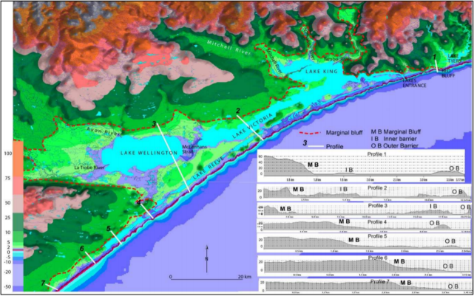
              - Extent of the former lagoon system (during high sea level period 2.6 million – 12,000 years ago) bounded by the current marginal bluffs/sea cliffs shown by the dotted line (Rosengren, 2009).
After this time, sea levels receded gradually during the late Pleistocene forming two consecutive, separate barrier dune systems across the entrance to the lagoon shown in Figure 2.1. The first of these systems is called the Prior Barrier and can be found presently closest to the old sea cliffs which form the back wall of the Gippsland Lakes on the North Side of Lake Wellington, the Banksia Peninsula, Raymond Island and possibly at Tambo Bluff (Figure 2.2).
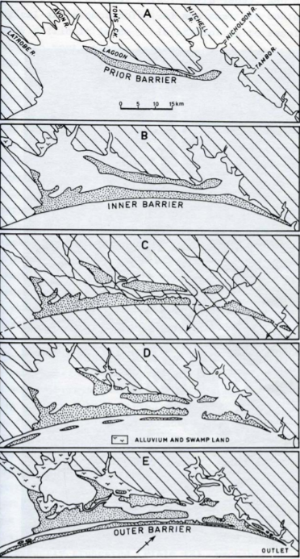
              - Image showing how the complex barrier system of the Gippsland Lakes formed in steps. Note the predominant wind direction marked in the bottom-most panel (Boon, Rosengren, Frood, Oates, & Reside, 2014).
The second barrier sand dune system to form during the late Pleistocene period (~12,000 years ago) is called the Inner Barrier. This began as an elongated spit in the South-West near Dutson when higher than current sea levels were still evident in the late Pleistocene. The spit grew in a North-Easterly direction as further parallel dunes formed until it stretched from west to east across the entrance to the lagoon shown in Figure 2.2. At some point during the late Pleistocene or early Holocene (~10,000 years ago), sand was blown by a predominant westerly wind into parabolic dunes up to 25-30 m high with low-lying swampy deposits in their centre. These can be seen both on Sperm Whale Head and throughout Loch Sport. After the barrier dune systems were formed, sea levels receded, and the lagoon drained of water. During this period, the La Trobe, Thomson, Mitchell, Nicholson and Tambo rivers flowed up against, broke through, and dissected these barrier dune systems leaving behind some of the recognisable landforms we see today. Since this time, areas of the inner barrier have also subsided leaving behind swampy areas at current lake levels (e.g., the lake in Loch Sport Town).
The Pleistocene age of both the Prior and Inner barrier dune systems is demonstrated by the presence of consolidated, lightly cemented red/brown coffee rock illuvial horizon beneath long standing sand dunes. This horizon is reportedly near mean sea level to the east of Loch Sport (Bird, 1965).
The outer barrier dune system is the most recent in the Gippsland Lakes region and is known as ninety-mile beach. This comprises a series of 6-10-metre-high, closely spaced, parallel dunes running the length of Ninety Mile Beach. The barrier is widest at Letts Beach in the Southwest; with the width decreasing to the North East and to the South West of Letts beach with each end of the Barrier having only 2 parallel dunes. These dunes are distinctly younger than both the Prior and the Inner barrier, as evidenced by the lack of coffee rock at depth. This supports the theory of a Holocene formation which is thought to have coincided with the Holocene Ocean ingression lasting from approximately 20,000 years ago until 6,000 years ago, when sea levels reached current levels.

Loch Sport Study Area
Loch Sport is situated on the inner barrier dune system shown in Figure 2.2. In line with the general discussion of the geomorphology of the Gippsland Lakes above, the following specific geomorphological features are evident in the study area:
- A cut-off parabolic dune ridge up to 25 m AHD in elevation running parallel to shore through Loch Sport, east to west.
- Likely to be well consolidated coffee rock beneath this dune ridge due to rainfall infiltration causing precipitation of harder rock at depth (Bird, 1965).
- Low lying areas in the east (around the Seagull Drive boat ramp) and west (near National Park Road) of the study area. Area of considerably higher elevation in the centre of the study area where the elevated dune ridge is immediately adjacent to the shoreline.
- Considerable long-shore sand transport creating large mobile sand spits moving west-east along the study area shoreline.
When waves impact a sandy shoreline obliquely, they act to push sediment along the shore (longshore transport) (Figure 2.6). Waves in Lake Victoria are only caused by local winds (Section 2.2). Comparing the predominant Westerly wind direction (Figure 2.4) to the Loch Sport, and surrounding Lake Victoria coastline shows that waves would impact westward facing shores and cause high rates of west to east longshore transport.
The west-to-east longshore transport is thought to be the dominant process driving coastal change at Loch Sport (and on the southern shore of Lake Victoria more generally). Where the rate of transport changes erosion or accretion occurs. For example, at several headlands on the lake shore, accretion is occurring because of the higher rate of sediment arriving from the west than is departing to the east. This is due to the eastern side of the headland being sheltered from the dominant wave direction (Figure 2.3).
The presence of groynes along much of the Loch Sport coastline also influences the rate of longshore transport. Large groyne fields in the western half of the town lake front have effectively stabilised the shoreline and limited the longshore transport to the small amount that arrives from further west and bypasses the groynes. The result is a sediment deficit and erosion in the Study Area where there are few effective groynes to arrest the longshore transport.
This is a classic example of the well documented phenomenon of increased erosion downdrift of a groyne field.
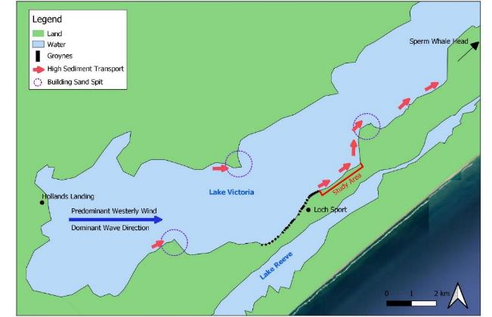
              - Conceptual Sediment Transport and Shoreline Evolution Model

Wind and Wind Waves
Wind in the study area is charachterised by a prevailing west – north westerly wind. Wind from this direction blows across Lake Victoria from approximately Hollands Landing to Loch Sport (fetch of over 11 km). Strong westerly winds can occur during any season, however, NW winds are more likley to occur during Autumn and Winter months.
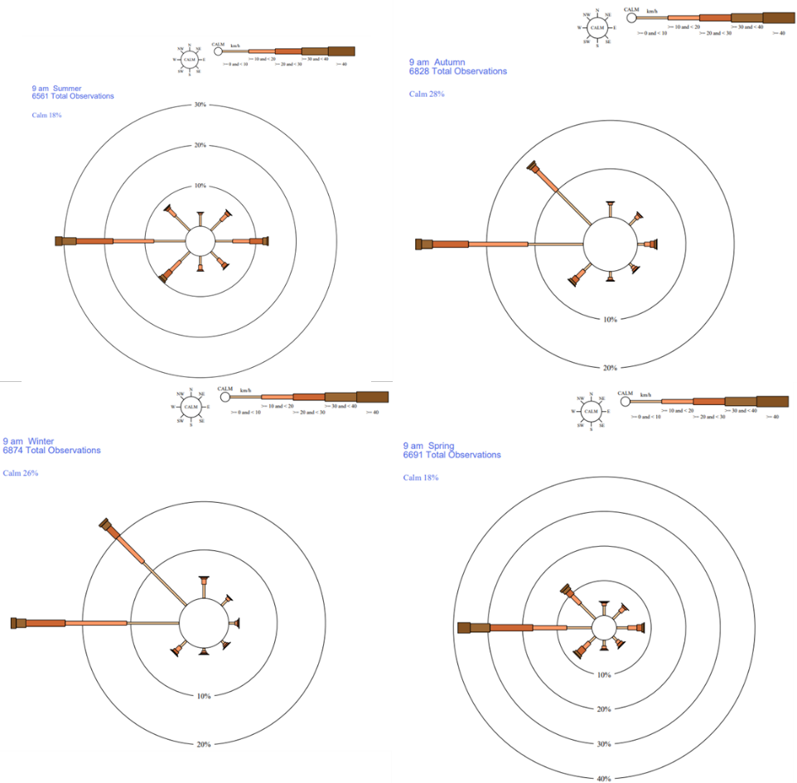
              - Seasonal Wind Roses for East Sale Airport (Australian Bureau of Meteorology, 2021)
When wind blows over water, waves are formed. The size of a wave depends on many factors including wind speed, the fetch distance (length of water the wind blows over), water depth and bathymetry. Because of the long fetch in the direction of prevailing winds, the Study Area coastline has been deemed 'Semi-Protected' in the Local Coastal Hazard Assessment (WT 2014). This classification of the shoreline exposure is characterised by average shoreline incident wave power in the top 25% - 50% of shorelines in the Gippsland Lakes according to results of a spectral wave model conducted by Water Technology in the LCHA. Actual significant wave height model results are not available for Loch Sport from this model.
Estimated significant wave heights up to 0.5 m have been reported during winter storm conditions (Oldfield 2017; Oldfield 2021). This estimate of significant wave height has been successfully used numerous times for the construction of shoreline protection groynes, suggesting its validity.

Water Levels
The impact of astronomical tides in the Gippsland Lakes differs relative to the distance of a certain location from the lake entrance. Loch Sport is approximately 35 km west of the entrance and separated from it by multiple narrow 'pinch point' water passages including The Entrance channel, Reeves Channel and Hopetoun Channel. These features act to considerably constrict the volume of water able to move into, out of and between the lakes. The tidal range at Loch Sport is between approximately ±0.2 m (Metung) and ±0.03 m (Lake Wellington) (WT 2014).
Many factors contribute to water level elevations in the Gippsland Lakes. The key factor is catchment flooding when high volumes of water travel down the La Trobe, Thomson, Mitchell, Nicholson and Tambo rivers and enter the lake system. When multiple catchments have simultaneous high rainfall events, water levels can overtop lake banks and cause flooding of low-lying coastal areas (e.g., Seagull Drive boat ramp area).
Peak flood-event water level data for the Gippsland lakes was used in the Gippsland Lakes LCHA (WT 2014) to determine the inundation hazard for coastal lake-shore regions. An extreme value analysis of this data determined water levels with various return intervals as shown in Table 2.2.
            - Annual recurrence interval flood-water levels for Paynesville (Water Technology, 2014)
ARI Event(year) | Peak Water Level (m AHD)
10 | 1.3
20 | 1.5
50 | 1.7
100 | 2.0

Currents
Currents in the Gippsland Lakes are caused by a combination of tidal movements, wind driven circulations and river inflows can also cause shoreline erosion. The study area is classified as 'Protected' to 'Very Protected' from currents which may cause shoreline erosion (Water Technology, 2014). As such, shoreline erosion caused by currents is not assessed further in this report.

Climate Change and Sea Level Rise
The Gippsland Lakes LCHA also modelled the impact of rising sea levels on high-water level events within the Gippsland Lakes. A 2D hydrodynamic model was set up for the entire lake system using the data shown in Table 2.2 for calibration. This calibrated model was used to predict high flood-water levels for AR10 and ARI100 year events under nominal 0 m, 0.2 m, 0.4 m, and 0.8 m of sea level rise: and 0 m and 0.2 m of sea level rise respectively (Table 2.3).
We assume the nominal sea level rise values used in the 2014 LCHA were modelled as increases above the mean sea level of 2014. Comparison of these sea level rise values to sea level rise predictions valid in 2014 (Figure 2.5) allowed us to estimate the timeframes these sea levels will likely be reached (Table 2.3). It should be noted there is uncertainty in these dates due to specific information on sea level rise values not supplied in the LCHA, because subsequent sea level rise forecasts by the IPCC (2021) have included faster sea level rise than previous predictions and because sea level rise predictions are inherently highly uncertain. As such, these dates are estimates only and high-water levels may be reached earlier (likely) or later (unlikely) than stated in Table 2.3.
The Gippsland Lakes LCHA also estimated small increases in tidal fluctuations within the lakes under sea level rise scenarios. These are not included in the water level estimations in Table 2.3, however, due to their relatively small magnitude (up to 0.05 m increase for 0.8 m sea level rise) compared to the uncertainty inherent in the water level predictions.
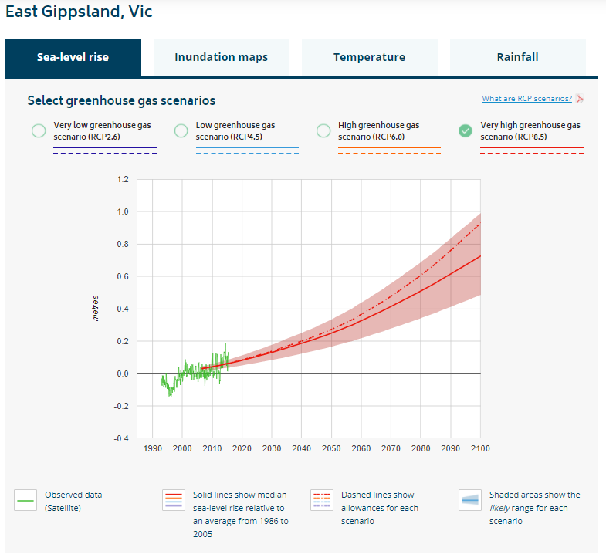
              - Sea level rise predictions for East Gippsland (CoastAdapt, 2021).

            - Modelled peak flood-water levels for Loch Sport under ARI10 and ARI100 year floods (Water Technology, 2014).
Approximate Year | Sea Level Rise from 2014 MSL (m) | ARI10 Year Event | ARI100 Year Event
 |  | Peak Water Level (m AHD)
2014 | 0 | 1.59 | 1.71
2050 | 0.2 | 1.71 | 1.84
2070 | 0.4 | 1.85 | -
2100 | 0.8 | 2.12 | -

Sediment Transport
Sediment transport refers to the movement of sand due to waves, wind and/or currents on a sandy coastline. At Loch Sport, sand transport is dominated by two processes, along shore transport and cross-shore transport, described separately below.
Wind transport can also occur with strong northerly winds blowing sand from exposed spits and beaches into the backshore areas.

Along-Shore Transport
Alongshore (or longshore) transport refers to the movement of sediment parallel to the shoreline. It occurs when waves approach a beach at an angle. The wave action causes sediment to become suspended which is then transported along the shoreline in the direction of the resulting longshore current. The greatest rate of longshore transport occurs when the waves arrive at the beach at a 45-degree angle to the shoreline. When the longshore current dissipates, the sediment is deposited causing sand spits or bars to form. As longshore currents are a result of the approaching waves, transport can occur in both directions and at different rates depending on the wind and wave direction.
At Loch Sport the waves are predominantly wind driven waves across Lake Victoria. As Westerly winds are the most dominant (Figure 2.4) the waves are also most frequently from the west and the net sediment transport is in a west to east direction.
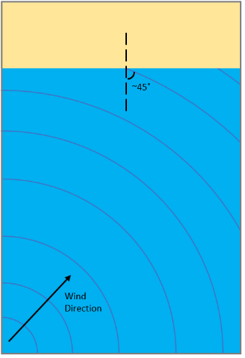
              - Long Shore Transport occurs maximally when waves impact shorelines at 45 degrees to normal.

There are currently two distinct sand spits that have formed along the shoreline at Loch Sport (Figure 2.7). Aerial photographic images showing the evolution of these spits have been collated from Google Earth, along with two drone images supplied by DELWP, to quantify the rate of spit movement and the underlying rate of longshore sediment transport. It is worth noting however that estimates taken from these photos do not factor in any dredging or beach nourishment activities, so the estimates should be treated as approximate only.
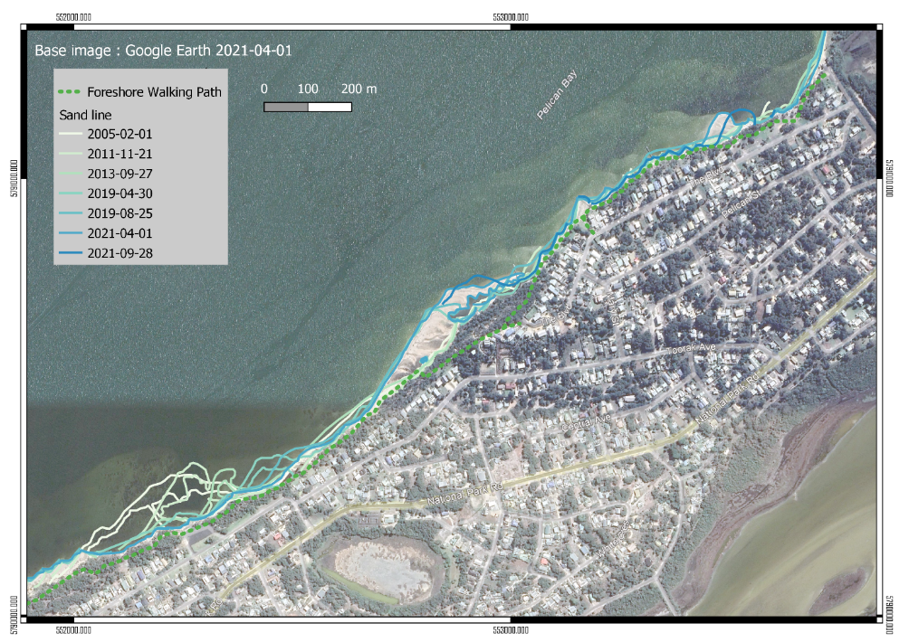
West spit
Previous boat ramp spit
East spit
              - Map showing the longshore transport and formation of sand bars from Feb 2005 to September 2021

To estimate how far along the shore the sediment is being transported each year, we have compared the leading edge of the sand spits across the different photos. An example is shown in Figure 2.8 and the full list in Table 2.4. The eastward movement ranges from 22 to 120 metres per year with a mean rate of 77 metres per year. This is substantially more than was estimated in the Oldfield 2012 report where it was estimated that the easterly movement of the spit is about 20 to 25 metres per year, although it was noted that the rate had accelerated towards the end of the period.

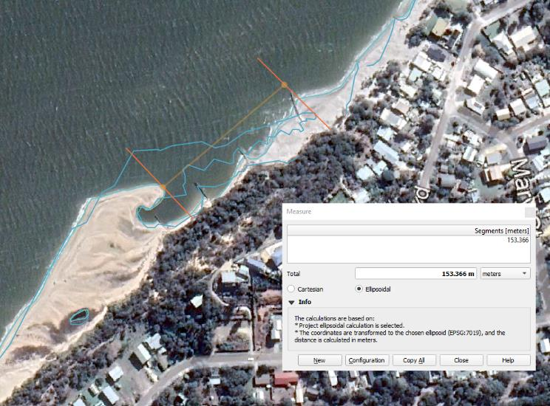
              - Measured distance along shore of the leading edge of the West spit from 25 Aug 2019 to 1 Apr 2021

            - Shore-Parallel movement of the sand spits
Measurement No. | 1 | 2 | 3 | 4 | 5
Spit | West Spit | West Spit | East Spit | West Spit | East Spit
Start date | 30/04/2019 | 25/08/2019 | 25/08/2019 | 1/04/2021 | 1/04/2021
End date | 25/08/2019 | 1/04/2021 | 1/04/2021 | 28/09/2021 | 28/09/2021
Number of days | 117 | 610 | 610 | 180 | 180
Progression of leading edge (m) | 38 | 153 | 37 | 31 | 44
Average rate per day (m/d) | 0.33 | 0.25 | 0.06 | 0.17 | 0.25
Average rate per year (m/y) | 120 | 92 | 22 | 62 | 89

To estimate the volume of sediment that is being transported along the shore each year, we have compared the area of change, across the different photos, and multiplied this by an assumed average depth of 1.2m (measured at the leading edge of the west spit in 2021). An example of this is shown in Figure 2.9 and the full list in Table 2.5.
The measurements range from 2,187 to 5,297 cubic metres per year with a mean rate of 3,426 cubic metres per year. This is lower than previously estimated in the Coastal Erosion Management Strategy (SEM 1998) that is referenced in Oldfield 2012, where the estimate was 4000 - 5000 cubic meters per year.
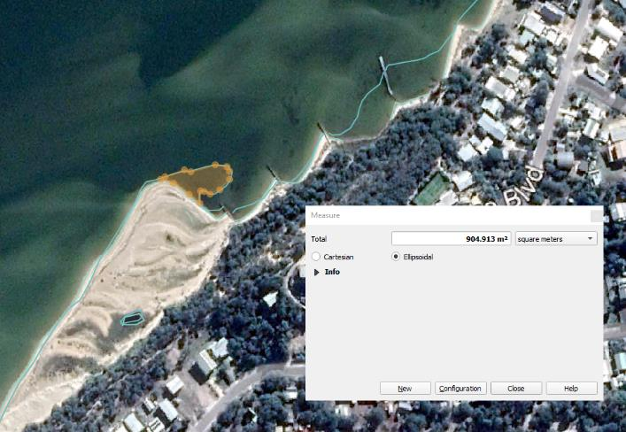
              - Measured distance along shore of the leading edge of the East spit from 1 Apr 2021 to 28 Sept 2021
            - Longshore sediment transport rates from area change of the sand spits
Measurement No. | 1 | 2 | 3 | 4 | 5
Spit | West Spit | East Spit | West Spit | East Spit | East Spit
Start date | 30/04/2019 | 30/04/2019 | 25/08/2019 | 25/08/2019 | 1/04/2021
End date | 25/08/2019 | 25/08/2019 | 1/04/2021 | 1/04/2021 | 28/09/2021
Number of days | 117 | 117 | 610 | 610 | 180
Area (m²) | 905 | 859 | 4240 | 3046 | 2177
Volume (m³) | 1086 | 1031 | 5088 | 3655 | 2612
Rate per day (m³/d) | 9.28 | 8.81 | 8.34 | 5.99 | 14.51
Rate per year (m³/y) | 3388 | 3216 | 3044 | 2187 | 5297

Cross Shore Transport
Cross shore transport of sediment is a cyclical process whereby sand is moved between the beach/dune profile and offshore sandbars. During storm conditions strong winds and high-water levels cause large waves to impact and erode sediment from the beach. This sand is then deposited on sandbars some distance from the shore. Under more frequent low-wave ambient conditions the considerable and predominant longshore transport builds mobile sand spits from these sandbars (as described above) which are pushed along the shore west-east. When infrequent strong northerly winds occur, sand can be blown from these mobile spits back onto the shore eastward of where it initially eroded creating dunes. This cycle continually repeats, and sand is moved between shoreline dunes, offshore sandbars, mobile sand spits and back to shoreline dunes.
At Loch Sport, storm cut of the beach and dunes can occur at any time of the year when strong NW – WSW winds blow across Lake Victoria toward Loch (Figure 2.4).

Erosion Hazard

Storm Erosion
There are no surveys taken directly before and after a storm which allow us to quantify the storm bite for a single extreme storm at Loch Sport. However, multiple air photos with periods of rapid erosion are available. Assessment of aerial photos has shown that between the 30 April 2019 and 25 August 2019, the shoreline (vegetation line) west of Seagull Drive boat ramp retreated by an average of 5.4m during that 117-day period, with the maximum retreat being 7.45m (and downdrift of the existing groyne field). Based on this assessment and local anecdotal evidence, it is plausible that a single extreme storm event could cause up to 5m erosion and a series of storms over 1 year could cause up to 10m of erosion in the worst effected location.

Coastal Recession Due to Sediment Loss
Long-term coastal recession can occur for a number of reasons including sea level rise and sediment deficit. A sediment deficit occurs on a beach when there is more sand being removed from the area than is being returned (e.g., through long-shore drift or cross shore transport). Although shoreline position often fluctuates on shorter time scales (e.g., seasonally), a sediment deficit can be identified through a variety of methods including aerial imagery comparison and analysis of the geomorphological context of a site.
Reliable numerical estimation of coastal recession due to sediment loss is difficult at Loch Sport due to the confounding nature of the mobile sandy spit systems, limited historic aerial imagery for this site and the lack of previous studies. An estimate of recession due to sediment loss at Loch Sport is thus calculated in this study via comparison of results from the three methods outlined below.

Previous Studies
CES (2002) in a study of the Gippsland lakes found that the majority of shorelines in the Gippsland lakes are receding at approximately 0.1 m/year. This study however, notably excluded Loch Sport and recession varied between 0.1 – 0.5 m/year.

Aerial Imagery Comparison
Aerial imagery is publicly available for the past 16 years at Loch Sport. Further aerial imagery back to 1970 may be available upon request to authorities, however, these were not assessed in this report. Sixteen years of aerial imagery is not generally assumed to be a long enough time period for reliable calculation of long-term shoreline recession due to sediment loss. In spite of this, and in light of limited other available data, shoreline recession in m/year was calculated for Loch Sport in regions with minimal coastal protection structures for the previous 16 years.
This analysis yielded an approximate recession rate of 0.1 m/year.

Geomorphological Context
The third assessment of long-term shoreline recession due to sediment loss undertaken in this study focusses on the geomorphological context of the site. Long -term recession of the Loch Sport Lake Victoria shoreline is evidenced by the presence of a 25 m high erosion scarp in the arm of a late Pleistocene – early Holocene parabolic dune at the western end of The Boulevard, in Loch Sport.
Similar dunes are also found immediately to the east of Loch Sport on Sperm Whale Head (Bird, 1965) (Figure 2.10). These dunes have their highest elevations at the apex of the dune, with elevation slowly tapering down as the arms extend (westward in Figure 2.10). Maximum elevations of dune apex points of parabolic dunes on Sperm Whale Head are approximately 30 m AHD.
The 25 m AHD erosion scarp crest on the Loch Sport shoreline at The Boulevard thus, seems to show that the current shoreline is immediately beneath, or near what was once the apex point of a parabolic dune. If this is the case, the arms of the dune have eroded as the shoreline has receded. The distance between the apex points and arm ends of similar dunes on Sperm Whale Head is approximately 1000 m. This suggests the shoreline at Loch Sport may have eroded similar distances between the formation of these dunes and present times.
Assuming the 25 m AHD dune scarp is the apex point of a relic parabolic dune and that this began eroding immediately after formation (approximately 10,000 years ago in early Holocene), 1000 m of easterly shoreline recession yields a recession due to sediment loss value of approximately 0.1 m recession per year.
Each of the three estimates of shoreline recession due to sediment loss support a value of 0.1 m/year. We have adopted this value moving forward for erosion hazard mapping.

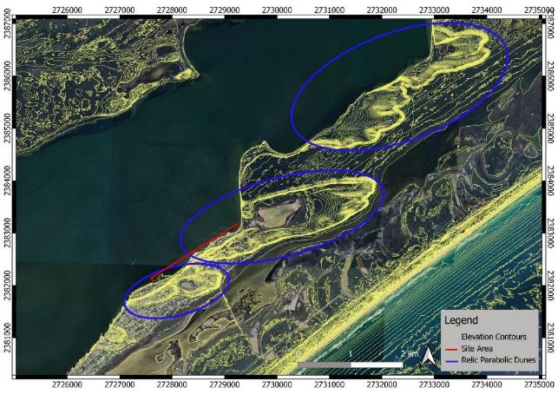
              - Parabolic Dunes on the Inner Barrier.

Coastal Recession Due to Sea Level Rise
Coastal recession can also occur due to sea level rise (SLR) as SLR increases the water depth near the beach and allows larger waves to reach the shore. This recession is inherently difficult to predict due to fine scale variability of beach structure, e.g., sediment type and the presence (or not) of underlying rock and/or coastal protection structures. As such, any prediction of shoreline retreat due to SLR has a high degree of uncertainty.
To assess the likely extent of shoreline retreat due to SLR, we use the Brunn rule to calculate a recession rate (m recession/ m of SLR). The Brunn rule assumes the beach profile is in equilibrium with the water level and will rise as the sea level rises. For this to occur, the beach profile must also shift landward due to the finite volume of sediment available. This landward movement may be halted or slowed by erosion resistant material such as the coffee rock possibly present beneath the high dunes (Section 2.2). With no definitive evidence for or against the presence of this rock, we have conservatively opted to not include it in this estimate.
The Brunn rule calculates recession as the product of SLR and the shoreline slope. In this study, the slope was calculated using an approximation elevation of the top of the active beach profile at 2.1 m AHD and a depth of closure of -3 m AHD. This yields an approximate shoreline recession value of 50 m recession per 1m of SLR.
As previously mentioned, there is a high level of uncertainty in this prediction. This is especially so at Loch Sport as the Brunn rule is intended for use on sandy open coasts. As such, application of the Brunn rule on sandy eroding lake shores is likely to yield conservative estimates of recession rates. None the less, the Brunn rule is the best method available for estimating recession due to sea level rise and provides and appropriately conservative rate for use in future adaptation planning.
Regarding the following erosion options analysis, this uncertainty will have little impact on the selection of short-term adaptation measures. For long-term measures, the time frame is indicative only and may differ from the predicted times by years to decades.

Predicted Erosion Hazard Zones
The erosion hazard zones for Loch Sport were calculated by combining the estimates of storm erosion, coastal recession due to sediment loss and coastal recession due to sea level rise as summarized in Table 2.6. This enabled estimation and mapping of the possible location of the shoreline under various SLR scenarios.
            - Recession components and theoretical recession hazards.
Erosion Type | Estimate
Storm Erosion | 10 m
Coastal Recession Due to Sediment Loss | 0.1 m/year
Coastal Recession Due to Sea Level Rise | 50 m recession / m SLR*
*This is likely a conservative estimate.
Erosion hazard lines have been calculated and mapped as follows:
- 1 Year Erosion Hazard – Maximum plausible erosion in one year - estimated from analysis of shoreline change during a 4-month period at western end of the study area.
- 2050 Erosion Hazard – Combination of single storm erosion, coastal recession due to sediment loss, and coastal recession due to sea level rise.
- 2100 Erosion Hazard - Combination of single storm erosion, coastal recession due to sediment loss, and coastal recession due to sea level rise.
            - Theoretical erosion hazard line setback from current shoreline without shoreline protection works.
Timeframe | Setback behind 2021 shoreline (m)
2022 Erosion Hazard | 10
2050 Erosion Hazard (0.2 m SLR) | 18
2100 Erosion Hazard (0.8 m SLR) | 53

All hazard lines are mapped in Figures 2-11, 2-12 and 2-13 below represent a worst-case scenario and the maximum inland extent of erosion. The erosion is not predicted to reach these lines in all areas, some areas will be less effected, and some may not erode at all.

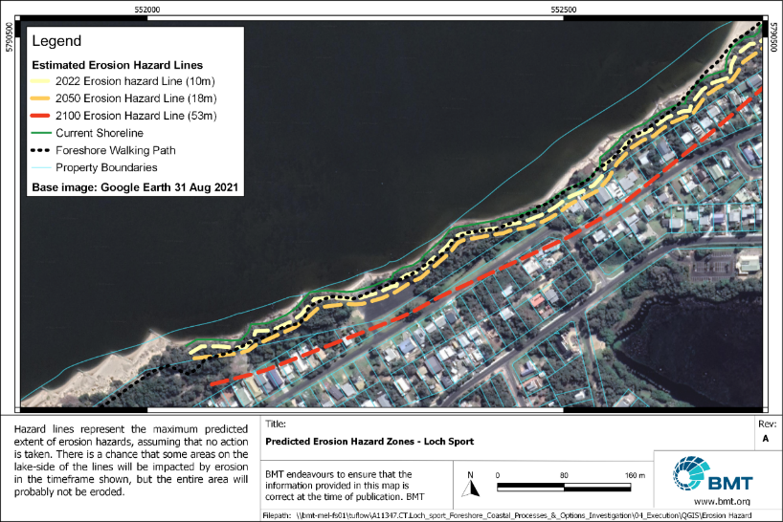
              - Erosion hazard map – Seagull Drive Boat Ramp
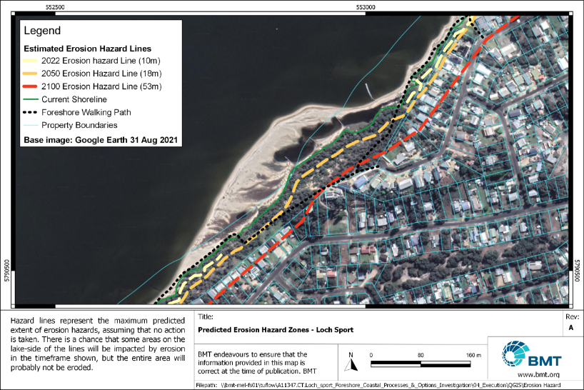
              - Erosion hazard map – The Boulevard
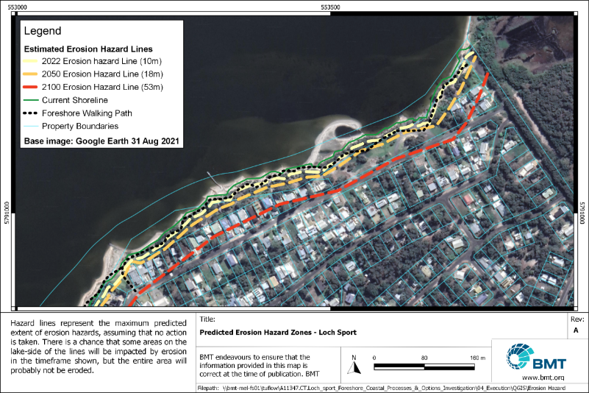
              - Erosion hazard map – The Boulevard Boat Ramp

Coastal Slope or Cliff Instability
Where the current coastline cuts across a high parabolic dune (Areas 4 and 5 in the centre of the study area) there are steep buffs right on the lake shore. There are roads, walking paths and private properties at the top of these bluffs. These slopes may become unstable and slump if drainage is directed towards the slope from above or coastal erosion cuts into the toe of the slope from below, as is currently occurring in Area 4. The bluff extends into Area 5 but in this area a large sand spit protects the toe of the bluff. The bluff is currently well vegetated, and this will reduce the risk of slumping.
Possible Hazard areas from coastal slope or cliff instability are mapped below on the vulnerability summary map (Figure 2.21).
The internal structure of the dune is not well known – e.g. the level of compaction or the presence of dune calcarenite – which would significantly reduce the risk level. A geotechnical investigation and slope stability/land slide risk assessment by a geotechnical engineer is required to estimate the actual level of risk that the erosion at the toe poses to the area at the top of the bluff.

Inundation Hazard
The inundation of sections of coastline occurs when coastal sea/lake levels are elevated. At Loch Sport this predominantly occurs due to catchment floodwaters entering the Gippsland Lakes through the various tributary rivers (Section 2.2), but can also be impacted by storm surge, and more locally by wave set up and wave runup. Because Lake Victoria is permanently connected to the ocean via The Entrance, these extreme water level events are forecast to increase into the future as sea levels rise (note: extreme water levels in the Gippsland Lakes are predicted to increase by only approximately 60% of the magnitude of sea level rise under any given sea level rise scenario. This is due to increasing lake storage volumes as lake levels rise (Water Technology, 2014)).
To map current and future extreme water levels at Loch Sport, we used the values summarized in Table 2.3 as calculated in the Gippsland Lakes Local Coastal Hazard Assessment (Water Technology, 2014). For predictions of future extreme water levels (Table 2.3), modelled AEP 10% water levels were combined with MSL, 2050 SLR, 2070 SLR and 2100 SLR predictions respectively. The predicted extents of inundations for these water levels are mapped below in Figure 2.14, Figure 2.15, and Figure 2.16.

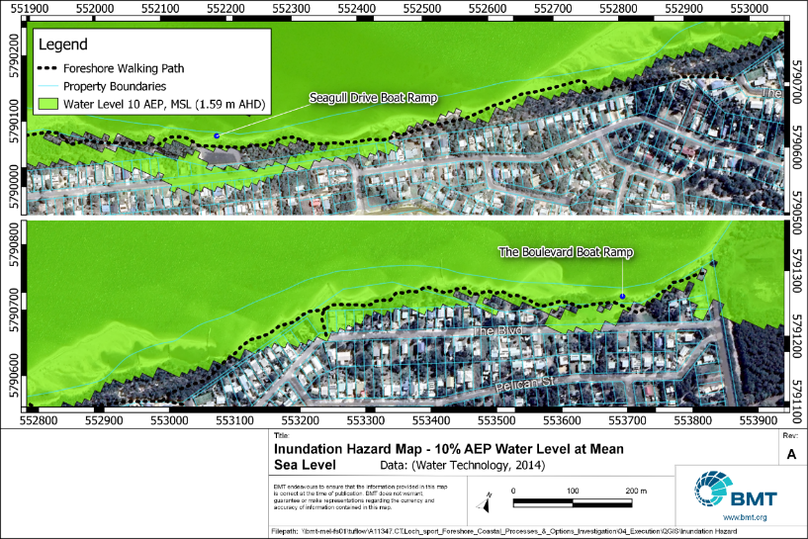
              - Inundation hazard map 10% AEP MSL
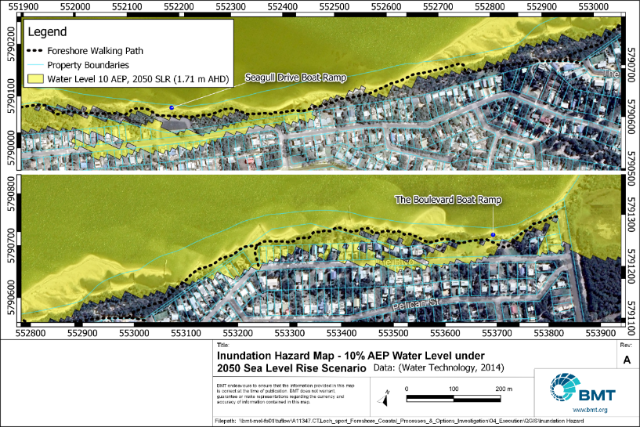
              - Inundation hazard map 10% AEP 2050 SLR
, Data: (Water Technology, 2014)
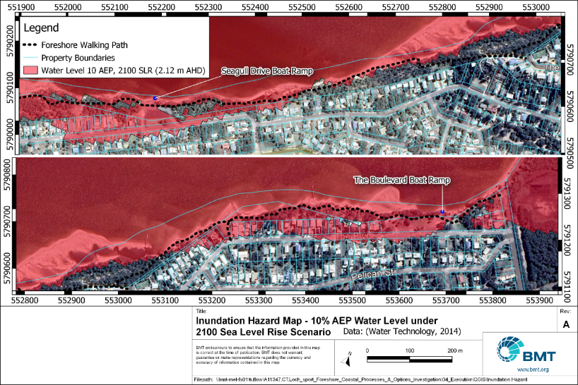
              - Inundation Hazard Map 10% AEP 2100 SLR

Vulnerability

Foreshore Walking Path
The foreshore walking path is currently being impacted by erosion at various locations along the study area (Figure 2.17). As sea levels rise, coastal erosion is predicted to increase, putting the path at greater risk of erosion, undermining and inundation. Table 2.8 shows the length of the path (out of a total length of 2436m) vulnerable to both erosion and inundation currently, and in the future.
            - Foreshore walking path erosion and inundation vulnerability.
Timeframe | Predicted length of Foreshore Path Vulnerable to Erosion | Predicted Length of Foreshore Path Vulnerable to Inundation⁺
Current | 1267 m* | 1511 m
2050 | 1814 m | 1581 m
2100 | 2122 m | 1766 m
*Of which approximately 100 m is currently actively eroding.
⁺Under a water level of 10% Annual Exceedance Probability in the given year.
Comparison of the erosion hazard maps (Figure 2.11, Figure 2.12, Figure 2.13) and inundation hazard maps (Figure 2.14, Figure 2.15,and Figure 2.16) to the initial erosion hotspot map (Figure 1.1) allowed an assessment of short-term and long-term risk of undermining and inundation of the foreshore path for each erosion hotspot. This is outlined in Table 2.9 below.
            - Erosion Hotspot* Risk Identification
Erosion Hotspot  (Refer map in Figure 1.1) | Short-Term Risk of Foreshore Path being undermined or inundated | Long-Term Risk of foreshore path being undermined or inundated
Area 1 | Low | High
Area 2 | High | High
Area 4 | High | High
Area 5 | Low | High
Area 6 (outside of areas 7,8, and 9) | Medium - High | High
Area 7 | High | High
Area 8 | High | High
Area 9 | Low | High
*Area 3 and 10 not included as these do not relate to the foreshore walking path.
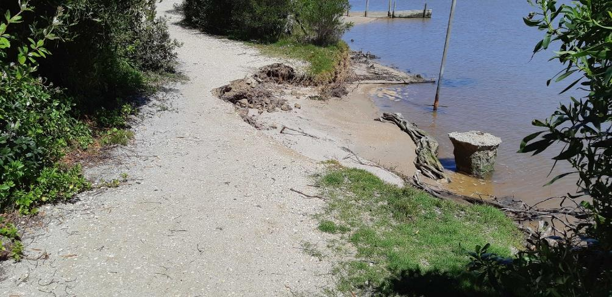
              - Eroding foreshore walking path in Hazard Area 8.

Seagull Drive Boat Ramp Precinct
The seagull drive boat ramp facility is currently being impacted by erosion with up to 5 m of lawn and native vegetation eroded in recent years. As such there is little protection to the car park edge and once the remaining buffer erodes the car park will be vulnerable to erosion.
Long-term, shoreline recession may continue, increasing the risk of erosion, undermining and inundation to the carpark, toilet block, and other assets as outlined in Table 2.10.
            - Seagull Drive Boat Ramp precinct erosion and inundation vulnerability*. Total precinct area = 3716 m².
Timeframe | Predicted area of Seagull drive boat ramp precinct vulnerable to erosion | Predicted area of seagull drive boat ramp precinct vulnerable to inundation⁺
Current | 540 m² | 810 m²
2050 | 1100 m² | 910 m²
2100 | 2600 m² | 2180 m²
⁺Under a water level of 10% Annual Exceedance Probability in the given year.
The boat ramp is made of a blanket of interlocked concrete modules turned down at the sides to prevent undermining. So far this appears to have been effective and the ramp itself may be less vulnerable to erosion in the short term. The approach to the ramp from the carpark is more vulnerable and erosion in this area would narrow the roadway causing a hazard to ramp users. Erosion at the toe of the ramp may also be an issue causing a high step at the bottom of the ramp down to lakebed level.
Inundation of the boat ramp precinct, from a 10yr ARI flood level, may cause deep pools of standing water between Seagull drive and the carpark with depth and frequency increasing with sea level rise.
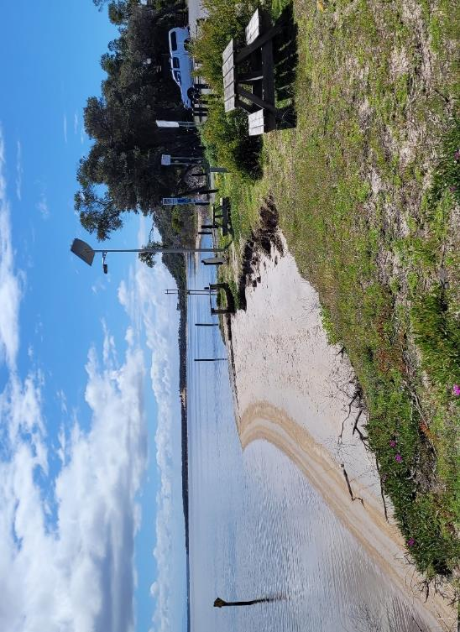
              - Seagull drive boat ramp precinct shoreline erosion.

The Boulevard Boat Ramp Precinct
The Boulevard Boat Ramp Carpark has a wider buffer of native vegetation between the carpark edge and the shoreline than the Seagull Drive Precinct, which will minimise erosion impact in the short term. Long-term shoreline recession may still impact the carpark as outlined in Table 2.11.
            - The Boulevard Boat Ramp Precinct Erosion and Inundation Vulnerability. Total area = 1340 m².
Timeframe | Predicted area of The Boulevard boat ramp precinct vulnerable to erosion | Predicted area of The Boulevard boat ramp precinct vulnerable to inundation⁺
Current | 100 m² | 880 m²
2050 | 470 m² | 910 m²
2100 | 1340 m² (whole precinct) | 1004 m²
⁺Under a water level of 10% Annual Exceedance Probability in the given year.
Like the Seagull Drive boat ramp, the ramp is made of a blanket of interlocked concrete modules turned down at the sides to prevent undermining. Again, this appears to have been effective so far and the ramp itself may be less vulnerable to erosion in the short term. The approach to the ramp is more vulnerable, there is little, or no scour protection and it is already eroding.
Continuing erosion in this area would initially undermine the ramp approach, then the seaward edge of the carpark, and possibly the ramp itself, cutting access for boat launching.
The boat ramp, approach and much of the carpark is subject to nuisance inundation from a 10yr ARI flood level, but the depth and frequency of this inundation will increase with sea level rise.
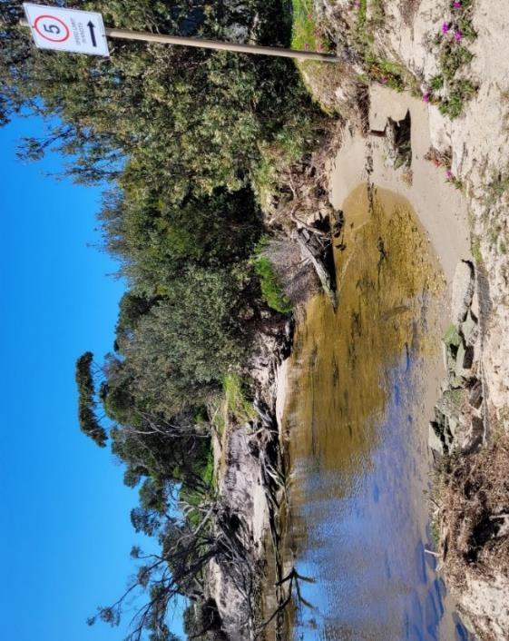
              - Erosion immediately east of The Boulevard Boat Ramp approach – Erosion Hazard Area 9

Passive Open Space – Native Vegetation
Passive open space along the Lake Victoria Loch Sport shoreline includes road verges, the foreshore reserve and lawn/picnic areas adjacent to the boat ramp precincts. These areas are predominantly low-lying and are thus at risk from both undermine caused by erosion and inundation. The extents of these risk are outlined in Table 2.12.
            - Passive Open Space Erosion and Inundation Vulnerability. Total area = 71,000 m².
Timeframe | Predicted area of Passive Open Space vulnerable to erosion | Predicted area of passive open space vulnerable to inundation⁺
Current | 16,000 m² | 36,000 m²
2050 | 53,000 m² | 39,000 m²
2100 | 70,000 m² | 41,000 m²
⁺Under a water level of 10% Annual Exceedance Probability in the given year.
The current and future risk of both erosion and inundation of passive open space on the loch Sport Lake Victoria foreshore is high.
Continued erosion of the foreshore reserve will destroy vegetation, cause trees to fall onto the beaches, cut access along the foreshore where the beach acts as the foreshore walking path and make access to the beach difficult. Inundation of passive open space may cause increased salinisation of soils and vegetation dieback, lowering the environmental and recreational value of the area.
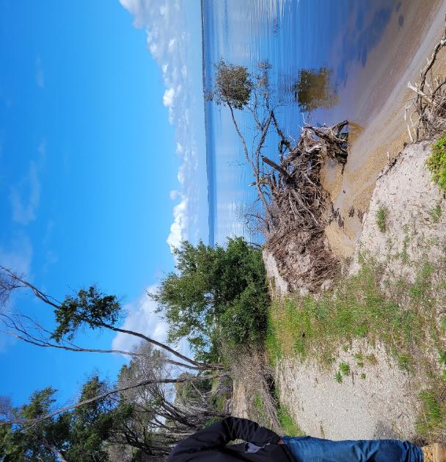
              - Erosion of vegetation onto beach cutting access along the foreshore via the beach

Private Property
There are 7 private blocks which currently may be vulnerable to erosion in a series of severe storms (3 immediately west of The Boulevard Rock Groyne and 4 at the western end of Toorak Avenue Figure 2.21). It is only the yards which are currently vulnerable, not the buildings which are located further back with an adequate buffer (10 to 60m) to the lake shore. If erosion progresses as predicted and without any mitigation, then this buffer will be reduced and buildings in their current locations may be vulnerable from around 2050, with the number of vulnerable buildings then increasing over time (Table 2.13).
Private residential blocks are predicted to become increasingly at risk of inundation during extreme water level events. Inundation of private blocks is predicted to occur in low lying areas surrounding the Seagull Drive Boat Ramp, and low-lying areas of The Boulevard, east of the high dune. Of the 34 private blocks predicted to currently be at risk of inundation, only the three westernmost houses on Toorak Avenue are reported to have been inundated previously.
Estimates of numbers of private blocks inundated are based on water levels calculated in the Local Coastal Hazard Assessment (Water Technology, 2014). If any part of the block is below the flood level then the block is counted as impacted by inundation. Building floor levels were not surveyed in this study, hence we have not attempted to quantify the number of buildings inundated.
            - Private Property Predicted Vulnerability to Coastal Hazards
Timeframe | Number of private blocks potentially vulnerable to coastal erosion | Number of buildings on private blocks potentially vulnerable to coastal erosion | Number of private blocks partially of fully Inundated under flood water levels with a 10% Annual Exceedance Probability*
Current | 7 | 0 | 34
2050 | 19 | 7 | 45
2100 | 78 | 65 | 59
* Note this study has not compared floor levels of buildings to flood levels
Some of the blocks at the top of the high dune bluffs may also be at risk from slope instability in the future if the toe of the bluffs is eroded. Further geotechnical investigations would be required to clarify the extent of this hazard and the level of risk, which will be affected by the internal structure of the dune.

Erosion Vulnerability Summary
Erosion is the most immediate coastal hazard on the Lake Victoria shore at Loch Sport, and Figure 2.21 below shows the assets/values which have been identified as currently at risk of erosion in the short term based on the current position of sand spits and their movement in the next 1 year.
An important feature of Loch Sport is the mobile sand spits moving eastward along the shore at around 20 to 90m per year. These features provide effective erosion to the backshore behind them, for example the large sand spit in the centre of the study area is currently protecting the high dune face. However, in a short time (2 to 10 years) this spit will have moved on and the high dune bluff will be exposed to wave erosion at the base once more. When this occurs, the walking path and properties at the top of the bluff may be vulnerable to slope instability (further geotechnical investigations are required to assess the extent of vulnerability) (See Section 2.2).
In the longer term (10 to 30 years) sand spits will move along the lake shore causing alternating cycles of erosion and recession but the overall trend is towards recession, and this will likely accelerate with sea level rise. So, the entire shoreline will likely experience erosion at some time and will require adaptation interventions to manage the impacts of coastal hazards.
Without effective adaptation measures, by 2050 we expect that the walking path will be cut in many places, boat ramps could be impacted by erosion and some private property may be impacted by erosion. Between 2050 and 2100 the full width of the foreshore reserve could be eroded in many places and the number of private properties impacted will increase.

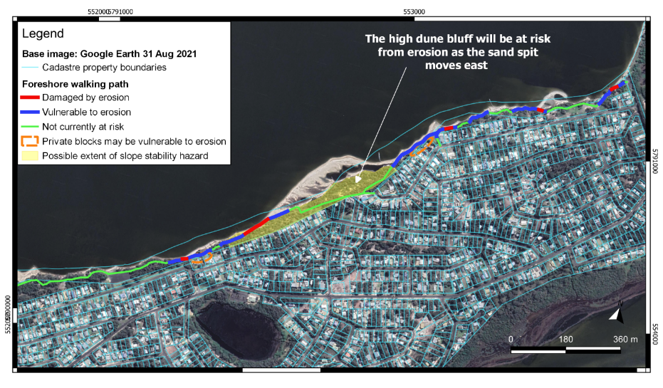
              - 2022 Vulnerability Summary
*

Adaptation Measures Assessment

Option 1 – Minimal Intervention Consistent with Public Safety
This option is essentially the ‘Do Nothing’ approach and is included as a point of comparison to the other options. This approach uses a risk management approach and would involve decommissioning assets when they present a hazard to public safety.
Much of the foreshore walking path is currently being impacted by shoreline erosion with the seaward edge falling into Lake Victoria in multiple sections. This is creating hazard to path users who may fall from the eroded sections to the beach. Erosion is also impacting native vegetation in the foreshore reserve predominantly around the Seagull Drive boat ramp and The Boulevard boat ramp. This vegetation is predominantly mature coastal trees and shrubs which support the diverse birdlife and other fauna of the area. Loss of this habitat may cause the loss of biodiversity in the region.
This option would allow erosion to naturally impact shorelines into the future and decommission the foreshore walking path when erosion cuts the trail. This further erosion would likely cause trees and shrubs to fall onto the beach, also cutting access along the beach. Into the future, this option would allow erosion to progressively impact private properties fronting the foreshore reserve and may put buildings at risk, particularly on the higher dune bluffs.
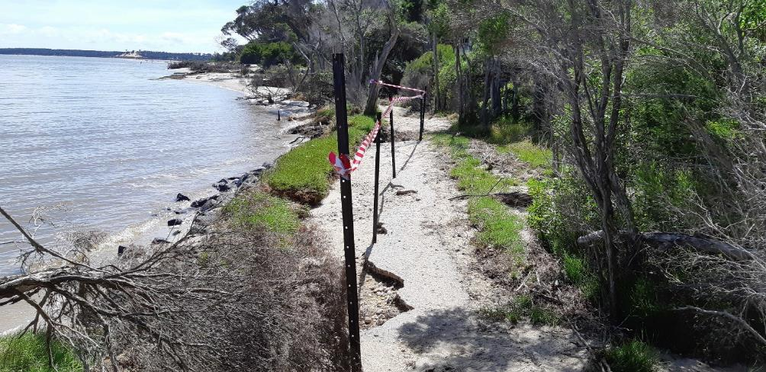
              - Current foreshore walking path erosion – Photo: Bill Storer – 22/11/2021

This option is not recommended for Loch Sport because it would fail to maintain the foreshore walking path and access and amenity values along the foreshore. It would also likely lead to unmanageable safety risks to residents of properties fronting the foreshore reserve.
            - Assessment of Option 1 – Minimal Intervention
Assessment Criteria | Comment
Technical feasibility/effectiveness | Strongly Negative – This option would not maintain the values surrounding the foreshore walking path, beach amenity and boat launching and retrieval.
Timeframe | Strongly Negative – Erosion and inundation are already negatively impacting assets and values along the foreshore. Sea level rise will increase volume and frequency of inundation and may increase erosion.
Relative cost | Strongly Positive – Minimal Cost
Social/economic impact | Strongly Negative – loss of foreshore walking path, boat ramps and beach would lower foreshore amenity. This may reduce tourist attraction of Loch Sport
Impact on coastal processes and environment | Neutral
Governance, alignment with VMACP | Non-intervention is in line with the VMACP

Because this option is not recommended for Loch Sport, a detailed cost analysis is not undertaken here. Nominally however, this option would include regular (e.g., monthly) evaluations of the site by workers to identify at-risk areas and/or asset failure. Where necessary, fencing should also be installed. This could cost approximately $10,000 - $20,000 per year.

Option 2 – Beach Nourishment
This option involves dredging sand from the lakebed using a cutter suction dredge and placing it on the beach or in the nearshore zone where it provides a buffer against erosion. The high rate of sediment transport (See Section 2.2) at Loch Sport means that sand would migrate quickly eastward along the shore so nourishment will only be effective for a limited time.
There are two approaches that could be taken:
  - nourishment with a relatively small volume, e.g., 3500m³, to protect 100m of coast, which would need to be repeated annually.
  - “Sand Motor” (also known as a "Sand Engine") - large scale nourishment using a large volume of sand, e.g., 70,000m³ to create a large mobile sand spit immediately eastward of the Seagull Drive boat ramp (Figure 3.2). This sand would then naturally migrate eastward creating wider beaches along the coast and would need to be repeated approximately every 10 years. This concept has been successfully trailed in the Netherlands (Stive, et al., 2013) (Results of 10 years Building with Nature, n.d.).
Placement of sand eastward of the Seagull Drive boat ramp would minimise the risk of sediment impaction on the ramp. The Boulevard boat ramp would, however, eventually be impacted as sand migrates along the shore. This could be managed by allowing beach launching or dredging.
Previous nourishment of beaches at Loch Sport has shown that fine lakebed sand washes away very quickly when placed on the shoreline while the coarser lakebed sand is more stable. It is imperative that all sand nourishment using dredged lakebed sand are proceeded by a sand source identification investigation to find suitable coarse lakebed sand for nourishment.
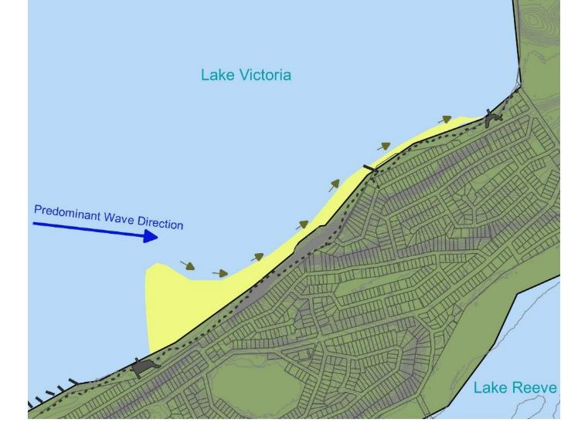
              - Option 2 – Beach Nourishment

            - Assessment of Option 2 – Beach Nourishment
Assessment Criteria | Comment
Technical feasibility/effectiveness | Strongly Positive – This option has been implemented effectively in Australia. The high sediment transport rate makes this option feasible here.
Timeframe | Strongly Positive – May be effective for decades depending on sand volume.  Sea level rise may increase the frequency of required nourishment in the long term.
Relative cost | Strongly Negative – High relative cost (approximately 70,000 m³ for approximately $1.3m)
Social/economic impact | Positive – Wide beaches increase beach amenity and protect the foreshore walking path. May cause problems for The Boulevard boat ramp use.
Impact on coastal processes and environment | Positive – Mirrors and uses natural coastal processes to protect values and assets.
Governance, alignment with VMACP | Beach nourishment can be considered either a 'Nature-based' option and/or a 'Protect' option in the VMACP

            - Cost Estimate for Option 2 – Beach Nourishment Options
 | Item | Unit | Qty | Rate | Total
Approach A - Small Volume Annual Nourishment protecting 100m of foreshore only

1.0 | Nourishment
 | Supply and Place Sand | m^3 | 3,500 | $11 - $15 | $38,500 - $52,500
2.0 | Allowances
 | Approvals and permits, design, contractor overheads, contingency, Engineering, and supervision |  |  | - | $15,400 - $45,000
 | Total Annual Costs (excluding GST) |  |  |  | $54,000 - $97,500
 | Annual Cost Per m Shoreline Protected (excluding GST) |  |  |  | $540 - $975
Approach B - Large Volume ‘Sand Motor’ Nourishment – protects approximately 1600m of shoreline for approximately 10 Years
1.0 | Nourishment
 | Supply and Place Sand | m^3 | 70,000 | $11 - $15 | $770,000 - $1,050,000
2.0 | Allowances
 | Approvals and permits, design, contractor overheads, contingency, engineering and supervision | % | 15% | - | $115,500 - $157,500
 | Total Cost every 10 years (excluding GST) |  |  |  | $885,500 - $1,207,500
 | Annual Cost per m Shoreline Protected (excluding GST) |  |  |  | $55 - $75

Option 3 – Offshore Shellfish Reef
It is thought that Shellfish reefs may have been broadly distributed in the Gippsland Lakes prior to colonial settlement (Ford & Hamer, 2016). This option involves establishing shellfish reefs seaward of Loch Sport in the form of offshore breakwaters (Figure 3.3). These would create local areas of low wave energy landward of the reefs where sand would accrete, and erosion potential would be reduced. These reefs would most likely include an engineered core (possibly rock, shellfish shells or similar) with seeded shellfish growing on the outer surface of the structure.
The sand spits or ‘salients’ forming behind the reefs would create areas of wide beach which would in turn protect the foreshore walking path and other shoreline values from erosion. Wide beaches also increase beach amenity. Establishing shellfish reefs also increase the biodiversity by providing habitat for marine life. Shellfish also filter water as they feed, cleaning the water of any potentially harmful bacteria/algae. These structures have a rock of shell base, making them effective as low crested breakwaters even before any shellfish have grown on them. With the large volumes of sand that are transported along the coast at Loch Sport, they would reduce wave impact and begin to form protective salients immediately.
This option, if successful, would have considerable impacts on local coastal processes locking up sediment on the Loch Sport foreshore and reducing sediment supply to the national park to the east, potentially leading to increased erosion (note this would be the case for any shore protection measures except ongoing nourishment).
With good design, this option may last many years. This is because shellfish reefs are able to adapt to rising sea levels by 'growing' as subsequent shellfish generations attach to the shells of previous generations, increasing the breakwater crest height.
This type of hybrid nature-based structure is fairly new and has not been used in the Gippsland Lakes for coastal protection before. More work is needed to assess feasibility, effectiveness, and cost at this site. A trial is recommended before construction of multiple reefs.
We have assumed the option could involve staged construction, of one 100m initial trial reef and five subsequent 100 m long shellfish reef breakwaters as shown in Figure 3.3. Implementation would involve design review and any necessary modification after the initial trial reef and staged implementation if successful. There is a high level of uncertainty in the costing.
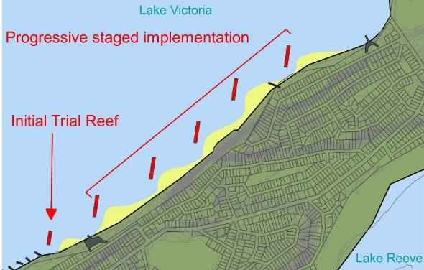
              - Option 3 – Offshore Shellfish reef breakwaters

            - Assessment of Option 3 – Offshore Shellfish Reef
Assessment Criteria | Comment
Technical feasibility/effectiveness | Neutral – This option has been effectively implemented at one location in Port Phillip, but has not been trialled in the Gippsland Lakes
Timeframe | Strongly Positive – Shellfish reefs start to be effective immediately and can adapt to rising sea levels to remain effective for longer periods of time than typical rock breakwaters.
Relative cost | Strongly Negative – High relative cost (e.g., $450,000 excluding design, rock supply and permit application costs)
Social/economic impact | Strongly Positive – Wide beaches increase beach amenity and preserves community assets such as the foreshore walking path.
Impact on coastal processes and environment | Neutral – High impact on local coastal processes causing sediment lock up and potentially increased downstream erosion. However, restoring natural habitat increases local biodiversity and shellfish clean the water.
Governance, alignment with VMACP | This option is considered a hybrid 'Nature-based' and 'Protect' option according to the hierarchy in the VMACP. These should be considered before options that are purely classed as 'Protect' in the hierarchy, such as groynes.

            - Cost Estimate for Option 3 - 6 x 100m shellfish reefs
 | Item | Unit | Qty | Rate | Total
1.0 | Site establishment
 | Site establishment | Item | 1 | $5,000 - $10,000 | $5,000 - $10,000
2.0 | Works
 | Rock Supply | tonne | 14040 | $50 - $70 | $702,000 - $982,800
 | Rock Transport | tonne | 14040 | $90 - $100 | $1,263,600 - $1,404,000
 | Rock Placement | m^3 | 5400 | $60 - $70 | $324,000 - $378,000
 | Shellfish seeding | m^2 | 2500 | Unknown | Unknown
3.0 | Allowances
 | Approvals and permits | % | 10% | - | $229,460 - $277,480
 | Design fees | % | 10% | - | $229,460 - $277,480
 | Engineering and supervision | % | 3% | - | $68,838 - $83,244
 | Contractor overhead | % | 5% | - | $114,730 - $138,740
 | Contingency | % | 15% | - | $344,190 - $416,220
 | Total Cost 6 x 100m long shellfish reef (excluding GST) |  |  |  | $3,281,500 - $3,968,000
 | Cost per 100m long shellfish reef (excluding GST) |  |  |  | $546,917 - $661,333
 | Cost Per m shoreline protected (excluding GST) |  |  |  | $2,000 - $2,500

Option 4 – Modify Foreshore Walking Path into Boardwalk
This option would replace vulnerable sections of the foreshore walking path with a boardwalk (Figure 3.4). This would enable the foreshore path to accommodate a degree of shoreline erosion and accretion while maintaining its current alignment. The boardwalk could be created from wood, recycled plastic, or fibre-reinforced polymer (FRP) and would have foundations below 1 m AHD elevation.
With good design, this option could be effective at maintaining the path alignment for decades. This option does not, however, address the shoreline erosion and will allow the coast to recede. By approximately 2050 (with no intervention) (Figure 2.11), the coast may recede to a point where any sections of boardwalk would be situated either on the beach, or in/above the water. The boardwalk would need replacing after approximately 15 – 20 years, at which point the deck level and alignment could be changed to suit the alignment of the eroded coast. This may be a good option for adaptation of the foreshore walking path, but it does not address the risk to vegetation, beach amenity or private property from erosion.
This option would progressively construct a total of nominally 1km of boardwalk in areas currently at risk of being undermined by erosion. Construction of each section would occur when each section of the path begins to be impacted by erosion. (Figure 3.4).
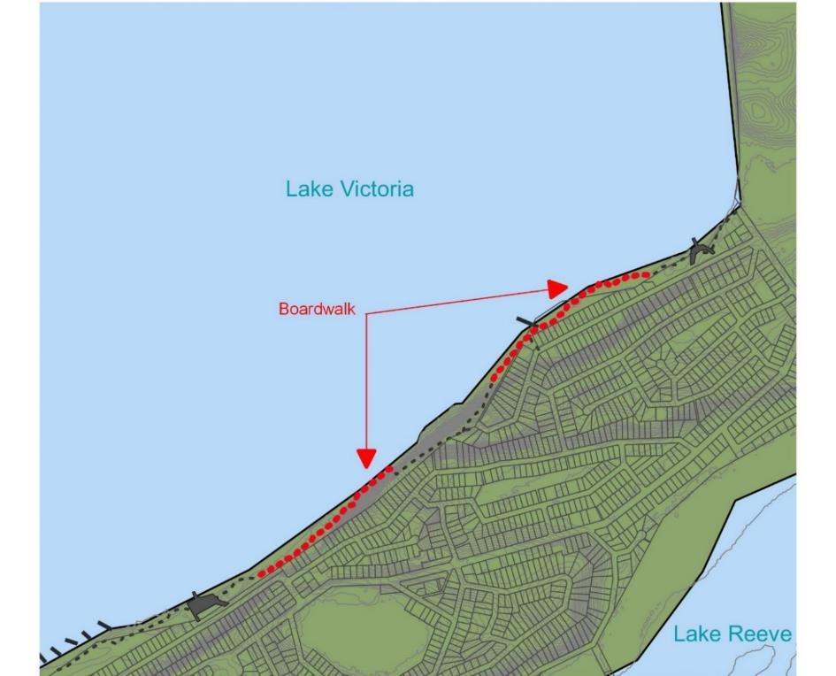
              - Option 4 – Modify foreshore walking path into boardwalk

            - Assessment of Option 4 - Boardwalk
Assessment Criteria | Comment
Technical feasibility/effectiveness | Positive – Effective boardwalk beach access stairs and foreshore walking paths are widely distributed throughout Victoria in locations with much higher exposure to coastal processes than Loch Sport. Although this is effective at maintaining access along the foreshore, it is not effective at protecting other assets and values. Ongoing maintenance of boardwalks would likely be required.
Timeframe | Positive – This option may last up to 15 years.  Sea level rise will cause boardwalks to suffer from inundation and limit the timespan of this option.
Relative cost | Negative – High relative cost
Social/economic impact | Neutral – This option would enable the foreshore walking path to remain in its current alignment maintaining community values. This option is not effective at protecting values/assets other than the path.
Impact on coastal processes and environment | Positive – Minimal impact on coastal processes and environment
Governance, alignment with VMACP | This option is an 'Accommodate' measure according to the VMACP hierarchy and should be considered before 'Retreat' and 'Protect' options.

            - Cost Estimate for Option 4 – 1km of boardwalk
 | Item | Unit | Qty | Rate | Total
1.0 | Site Establishment
 | Site Establishment | Item | 1 | $5,000 - $10,000 | $5,000 - $10,000
2.0 | Construction
 | Construct Raised Boardwalk | m | 1000 | $500 - $1,500* | $500,000 - $1,500,000
3.0 | Allowances
 | Approvals and permits | % | 3% | - | $15,150 - $45,300
 | Design fees | % | 5% | - | $25,250 - $75,500
 | Engineering and supervision | % | 3% | - | $15,150 - $45,300
 | Contractor overhead | % | 5% | - | $25,250 - $75,500
 | Contingency | % | 15% | - | $75,750 - $226,500
 | Total Cost 1km of Boardwalk (excluding GST) |  |  |  | $661,500 - $1,978,000
 | Cost Per m of Boardwalk (excluding GST) |  |  |  | $662 - $1,978
 | Cost for initial construction of 380m of Boardwalk⁺ (excluding GST) |  |  |  | $251,370 - $751,640
 | Cost Per Year Construction and Maintenance Phases (10m per year) # (excluding GST) |  |  |  | $6,000 - $20,000
*Low range cost estimate is for timber boardwalk; high range cost estimate is using FRP mesh deck. ⁺Approximately 380m of foreshore path would require boardwalk immediately. #Following this, it is estimated approximately 100m of foreshore path may need replacing with boardwalk per year, for 6 years. After this time, rolling repairs to boardwalks would be required annually (approx. 10m per year).

Option 5 – Relocate Foreshore Walking Path
This option would move the foreshore walking path landward, within the foreshore reserve, in areas vulnerable to erosion and inundation (Figure 3.5). This would maintain access along the foreshore while allowing natural coastal processes to continue. The new path would be constructed of compacted crushed rock, similar to the current path. Path relocation has been used recently at Loch Sport, west of the Seagull Drive boat ramp and East of The Boulevard boat ramp.
This option would progressively relocate 1.4km of the foreshore walking path landward where possible. Relocation could occur reactively after erosion cuts the path, or proactively to lower community anxiety about losing the path. Where path relocation would have little benefit due to space limitations, other options could be utilised (e.g., Boardwalks – Option 4, Sand nourishment – Option 2 etc.). There is approximately 550m of path unable to be relocated due to limited space within the foreshore reserve.
The width of the foreshore reserve differs along the Loch Sport Lake Victoria shoreline. There is 1.4km of shoreline where the foreshore path is at risk, and the reserve is wide enough for the path to be relocated to areas predicted to be safe from potential erosion risk until 2050. There is approximately 550m of shoreline where the reserve is too narrow and/or steep to effectively relocate the path further landward. In some areas, the entire reserve and the shoreward edges of private blocks are at immediate risk from erosion (Table 2.13).
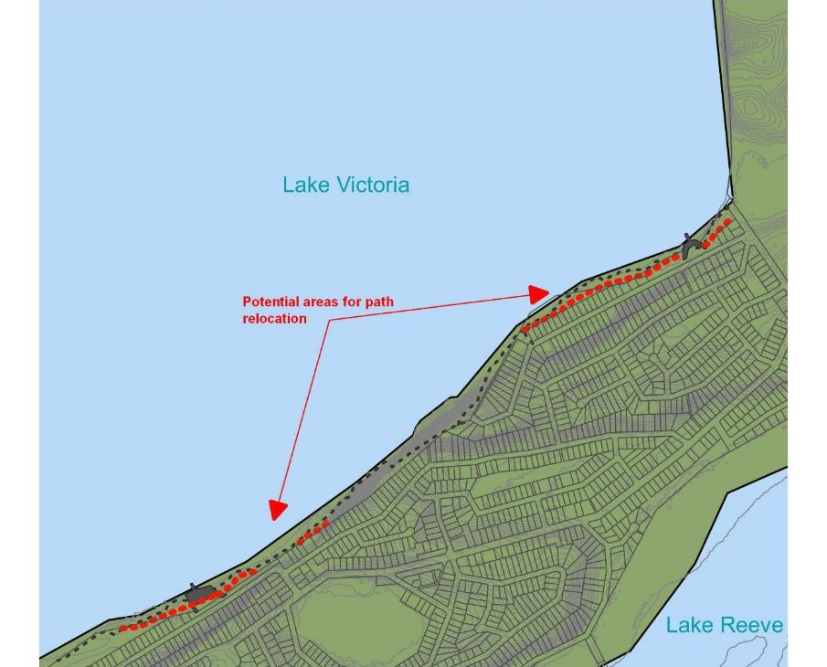
              - Option 5 – Relocate Path

            - Assessment of Option 5 – Relocate Path
Assessment Criteria | Comment
Technical feasibility/effectiveness | Neutral – Relocation would be an effective way of preserving the foreshore walking path only where there is sufficient room to do so. Although it is not effective at protecting the other assets, values or uses.
Timeframe | Neutral – This option may be effective for 20 - 30 years in some areas.  Sea level rise may cause a relocated path to suffer inundation depending on the terrain height
Relative cost | Positive – Moderate relative cost
Social/economic impact | Positive – Relocation of the foreshore reserve walking path maintains pedestrian access along the foreshore. Some community members may be unhappy with the path being relocated closer to houses.
Impact on coastal processes and environment | Positive – This option has minimal impact on local coastal processes
Governance, alignment with VMACP | This option is considered a 'Retreat' option in the VMACP hierarchy and is to be considered before 'Protect' options such as groynes.

            - Cost Estimate for Option 5 – 1.4km of crushed rock path.
 | Item | Unit | Qty | Rate | Total
1.0 | Site Establishment
 | Site Establishment | Item | 1 | $5,000 - $10,000 | $5,000 - $10,000
2.0 | Construction
 | Construct Crushed Rock Path | m | 1400 | $130 - $150 | $182,000 - $210,000
3.0 | Allowances
 | Approvals and permits | % | 5% | - | $9,350 - $11,000
 | Design fees | % | 8% | - | $14,960 - $17,600
 | Engineering and supervision | % | 3% | - | $5,610 - $6,600
 | Contractor overhead | % | 5% | - | $9,350 - $11,000
 | Contingency | % | 15% | - | $28,050 - $33,000
 | Total Cost 1.4km of Gravel Path (excluding GST) |  |  |  | $254,500 - $299,000
 | Cost Per m of Gravel Path (excluding GST) |  |  |  | $180 - $210

Option 6 – Groynes
Groynes built from rock, timber, or geofabric sand containers are present along most of the Loch Sport Lake Victoria shoreline. They are currently very effective at protecting the shore from erosion in the Western half of town. Well designed and constructed groynes should be effective in the current study area as well. Groynes in the study area are mostly dilapidated or poorly designed (excluding the one rock groyne at the Boulevard. These would most likely be removed before new groynes are installed.
To be effective and long-lasting groynes should be constructed from rock or timber. In general rock is preferred because it is longer lasting (50+ years) and more resilient to minor damage. Rock may be more expensive due to transport distances and difficult sit access. Timber groynes can last up to 50 years with appropriate treatment, are lighter and cheaper, but are more vulnerable to damage and may require more maintenance.
Groynes could be a long-term solution to coastal recession at Loch Sport if many groynes were built at regular spacing along the entire study area. Groynes can be used to protect an isolated area, but they would tend to locally increase erosion to the east. To adequately address the erosion hazard and protect all shoreline uses/values 50m-long rock groynes would need to be spaced approximately 60-70m apart depending on shoreline orientation (Oldfield Consulting Australasia, 2021). This equates approximately 28 groynes along the Loch Sport study area foreshore (Figure 3.6). If fewer groynes are desired with greater spacing, rock scour protection could be used in combination for at-risk sections between groynes. Impacts to downdrift areas could be minimised by building progressively from the east to west, and by pre-filling groyne compartments with dredged sand. Staged construction would also minimise upfront construction costs (e.g., constructing 3 groynes/year for 10 years).
Access to the foreshore for groyne construction may be an issue, especially where steep, high dunes or valuable native vegetation restrict access to the beach. Construction of groynes could either be performed from the water using a barge (very expensive) or an access road could be constructed with dredged sand along the foreshore for material delivery and construction plant access. This sand access road could then be reshaped to fill the groyne compartments after construction.
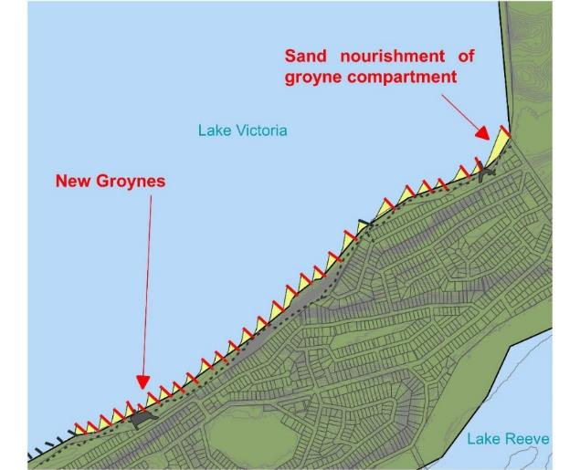
              - Option 6 – Groynes

            - Assessment of Option 6 – Groynes
Assessment Criteria | Comment
Technical feasibility/effectiveness | Positive – Groynes have been successful at protecting coastal uses and values along much of the Loch Sport Lake front for many years. Site access for construction may be challenging.
Timeframe | Positive – This option should be effective for 50+ years  Sea level rise is unlikely to impact the effectiveness of groynes within the next 50 years as long as crest level is sufficient
Relative cost | Strongly Negative – Very high relative cost
Social/economic impact | Positive – Protecting the coastline with groynes would maintain the amenity of the beach and the foreshore reserve, as well as access along the coast.
Impact on coastal processes and environment | Negative – This option would simultaneously protect the foreshore reserve vegetation and habitat, and cause sediment lockup and downdrift increased erosion in the National Park.
Governance, alignment with VMACP | This option is considered a 'Protect' option in the VMACP hierarchy and is to be considered after all other options.
            - Cost estimate for Option 6 – Construction of 28 rock groynes
 | Item | Unit | Qty | Rate | Total
1.0 | Site establishment
 | Site establishment | Item | 1 | $10,000 - $30,000 | $10,000 - $30,000
2.0 | Access Works*
 | Construct Sand Road | m^3 | 1500 | $11 - $15 | $16,500 - $22,500
3.0 | Rock Works
 | Rock Supply | tonne | 21548.8 | $50 - $70 | $1,077,440 - $1,508,416
 | Rock Transport | tonne | 21548.8 | $90 - $100 | $1,939,392 - $2,154,880
 | Rock Placement | m^3 | 8288 | $30 - $45 | $248,640 - $372,960
 | Fill Groyne Compartments with Sand | m^3 | 28000 | $11 - $15 | $308,000 - $420,000
3.0 | Allowances
 | Approvals and permits | % | 10% | - | $359,997 - $450,876
 | Design fees | % | 8% | - | $287,998 - $360,700
 | Engineering and supervision | % | 3% | - | $107,999 - $135,263
 | Contractor overhead | % | 5% | - | $179,999 - $225,438
 | Contingency | % | 30% | - | $1,079,992 - $1,352,627
 | Total Cost 28 Rock Groynes (excluding GST) |  |  |  | $5,599,500 - $7,011,000
 | Cost Per Groyne (excluding GST) |  |  |  | $200,000 - $250,500
 | Cost Per m Shoreline Protected (excluding GST) |  |  |  | $2,900 - $3,600
 | Cost per Year (excluding GST)⁺ |  |  |  | $600,000 - $751,500
*The total cost estimation in this table includes construction of an access sand road because many groyne locations are difficult to access. If groynes were constructed only in easily accessible areas this cost would not be required. ⁺Staged construction over multiple years could be approximately 3 groynes per year for 10 years.

Option 7 – Rock Revetment
This option would use an engineered, two-layer rock revetment (seawall) constructed along the shoreline to prevent erosion and recession. Revetments are already present and effective in places along the Loch Sport shoreline, predominantly to the west between groynes where spacing is large and sand does not fill the whole compartment. Rock revetments are a long-term solution to coastal recession with effective lifetimes of 50+ years.
Revetments could be used to protect the entire foreshore; however, groynes would likely be equally as effective here and have a number of advantages over revetments: groynes maintain a wider and more natural beach with easier access. Revetments tend to form a barrier between the backshore and the beach, and there would be times when there is no beach at all in front of the revetment. Revetments would be more suited for smaller areas with acute erosion problems rather than broadscale erosion protection, and if used, should be in combination with other measures.
Site access may be an issue for construction, especially where steep, high dunes are immediately adjacent to the beach. Construction of revetment could either be performed from the water using a barge (very expensive) or an access road could be constructed with dredged sand along the foreshore
Currently, much of the shoreline west of the large sand spit is eroding with areas of the foreshore reserve and walking path being lost. By 2050, the entire 2km of shoreline may potentially be at risk from erosion and would require protection. In line with the fact that rock revetments are best suited to isolated high-risk areas at Loch Sport, implementation of 200m of rock revetment immediately shoreward of both the Seagull Drive boat ramp and the Boulevard boat ramp are costed below. If groynes are constructed for the protection of the broader shoreline (Section 3.6), further sections of rock revetment may be constructed between the groynes (as has been implemented in the west of Loch Sport). It is likely that these sections would be more expensive to construct as access is limited along much of the shoreline requiring the construction of a dredged sand road along the shore.
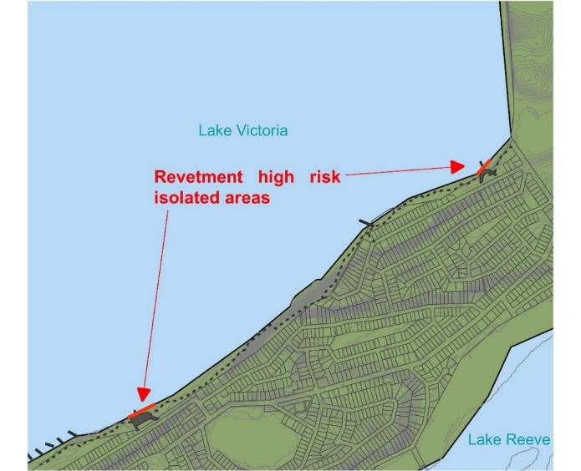
              - Option 7 – Rock Revetment

            - Assessment of Option 7 – Rock Revetment
Assessment Criteria | Comment
Technical feasibility/effectiveness | Positive – Revetments have been successful at protecting coastal uses and values along the Loch Sport Lake Victoria coast for many years. Site access for construction in locations may be challenging.
Timeframe | Positive – This option may be effective for 50+ years.  Sea level rise is unlikely to impact the effectiveness of rock revetments within the next 50 years as long as this is a consideration during the design phase.
Relative cost | Strongly Negative – Very high relative cost
Social/economic impact | Positive – Protecting the coastline with a revetment would maintain the amenity of the foreshore reserve, as well as access along the coast. Increased scour at wall toe would not appreciably impact beach width due to high long-shore transport rate.
Impact on coastal processes and environment | Negative – This option would simultaneously protect the foreshore reserve vegetation and habitat, and cause sediment lockup and downdrift increased erosion in the National Park.
Governance, alignment with VMACP | This option is considered a 'Protect' option in the VMACP hierarchy and is to be considered after all other options.
            - Indicative Cost estimate for Option 7 – 200m of rock revetment shoreward of both boat ramps.
 | Item | Unit | Qty | Rate | Total
1.0 | Site establishment
 | Site establishment | Item | 1 | $10,000 - $30,000 | $10,000 - $30,000
2.0 | Access Works (Total cost estimations do not include costs for access works)⁺
 | Construct Sand Road | m^3 | 1500 | $11 - $15 | ($16,500 - $22,500)⁺
3.0 | Rock Works
 | Rock Supply | tonne | 1797.12 | $50 - $70 | $89,856 - $125,798
 | Rock Transport | tonne | 1797.12 | $90 - $100 | $161,741 - $179,712
 | Rock Placement | m^3 | 691.2 | $30 - $45 | $20,736 - $31,104
4.0 | Allowances
 | Approvals and permits | % | 3% | - | $8,965 - $11,673
 | Design fees | % | 8% | - | $23,907 - $31,129
 | Engineering and supervision | % | 3% | - | $8,965 - $11,673
 | Contractor overhead | % | 5% | - | $14,942 - $19,456
 | Contingency | % | 30% | - | $89,650 - $116,734
 | Total Cost 200m Rock Revetment (excluding GST) |  |  |  | $429,000 - $557,500
 | Cost Per m rock revetment (excluding GST) |  |  |  | $2,000 - $3,000
⁺The total cost estimation in this table does not include construction of an access sand road because the costed rock revetment is for sections adjacent to boat ramps with easy access. If rock revetments were constructed in areas with limited access a sand road would be required, and this would be an additional cost as per pricing.

Adaptation Pathways

Adaptation Pathways
The VMACP 2020 defines a pathways approach as a decision-making strategy made up of a sequence of manageable steps and decision points over time. According to the policy, a pathway approach also includes:
- Consideration of the impacts of climate change on the marine environment using best available and conservative coastal process understanding,
- A comprehensive list of all available and relevant management options,
- Identification of relevant coastal hazards and prediction of how hazards will change over time,
- A list of thresholds or triggers for when new decisions need to be made,
- Recommendations of future decision points in light of the above information and considering costs, effectiveness, benefits, impacts and path dependency of adaptation actions.
Three possible pathways for coastal adaptation at Loch Sport have been developed (see sections below). Each pathway uses similar short-term measures to protect uses and values currently at risk but a different approach to long-term adaptation. Further engagement with the community, and trials of different measures are recommended before long term decisions are made.

Beach Nourishment Adaptation Pathway
In this pathway large scale ‘sand motor’ beach nourishment is used as the primary measure to prevent recession long-term (see Option 2b) This is potentially the cheapest of the long-term measures and the one with the lowest impact on coastal processes.
The ‘sand motor’ concept involves placing a large volume of sand at the western end of the study area, which is subsequently moved east by natural processes over several years. This would be repeated every 10 years or so. The recommended trigger for this nourishment is the sand spit moving away from the high bluff areas (areas 4 and 5 on Figure 1.1, and the area in between) and exposing the toe of these bluffs to wave attack.
The protective effect of this type of nourishment is not immediate in all areas, so other short-term measures would still be needed in limited areas – i.e., relocating the walking path or conversion to a boardwalk. Small sections of rock revetments may be needed in critical areas such as around the boat ramps. The trigger for commencement of these works would be erosion impacting on the path or ramps – which is already occurring.
After the nourishment the shoreline should be regularly monitored to record the movement of sand. When all of the placed sand has moved east, or sections of the foreshore are again experiencing erosion, the performance of the sand motor concept should be assessed, and a decision made to either repeat the large-scale nourishment or switch to a different long-term strategy.
This pathway is shown in Figure 4.1 below.
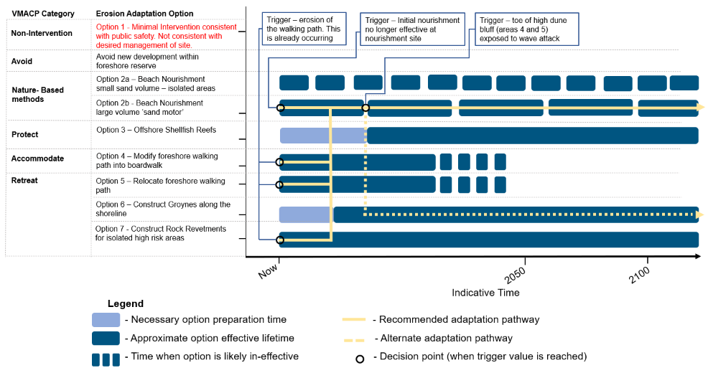
              - Beach Nourishment Adaptation Pathway

Shellfish Reef Adaptation Pathway
In this pathway a series of offshore selfish reefs are used as the primary measure to prevent long-term recession (see Option 3). This is potentially a cost-effective long-term measure and one with co-benefits for biodiversity, water quality and fish stocks.
This type of hybrid nature-based structure is fairly new and has not been used in the Gippsland Lakes before. More work is needed to assess feasibility, effectiveness, and cost at this site. As such, a trial is recommended before construction of multiple reefs. The trial should commence immediately as it will take several years to design, construct, monitor, and assess, and the high dune bluffs will need to be protected in the short to medium term.
While the trial is conducted other short-term measures will still be needed in limited areas – i.e., relocating the walking path or conversion to a boardwalk. Small sections of rock revetments may also be needed in critical areas such as around the boat ramps. The trigger for commencement of these works would be erosion impacting on the path or ramps – which is already occurring.
Once a trial reef has been constructed and monitored for several years the effectiveness should be assessed and a decision made to either build more reefs or switch to a different long-term strategy.
This pathway is shown in Figure 4.2 below.

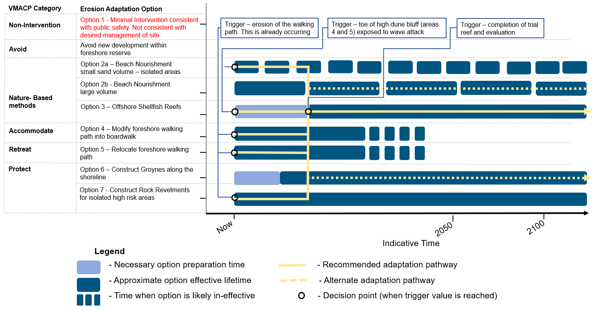
              - Shellfish Reef Adaptation Pathway

Groyne Adaptation Pathway
In this pathway a field of rock groynes is used as the primary measure to prevent recession long-term (see Option 6) This is a proven effective protection measure, providing good beach amenity, although very expensive.
While the groyne field is planned and constructed other short-term measures may still be needed in limited areas – i.e., relocating the walking path or small-scale nourishment. Small sections of rock revetments may also be needed in critical areas such as around the boat ramps. The trigger for commencement of these works would be erosion impacting on the path or ramps – which is already occurring.
This pathway is shown in Figure 4.3 below.

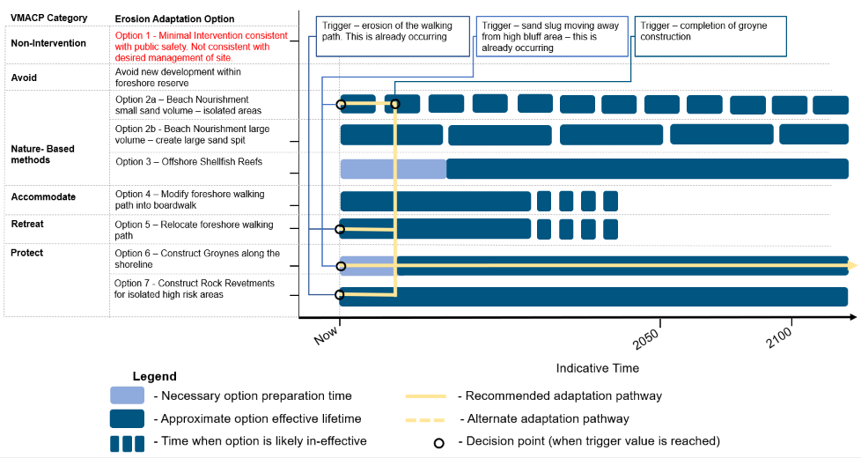
              - Groyne Adaptation Pathway

Adaptation to Inundation
Around half the foreshore reserve is below the current 10% AEP flood level, and 34 private blocks are wholly or partially below this level. With sea level rise this predicted to increase to around 2/3 of the reserve and 59 private blocks by 2100.
Many of the public assets in the foreshore reserve are resilient to occasional inundation and no immediate adaptation actions are proposed (e.g., walking path, beach access, boat ramps, toilet blocks). When these assets reach the end of their life and are upgraded options to raise levels or relocate should be considered.
For the private properties the level of vulnerability is not known as there is no data on floor levels available. There are no effective measures that can be implemented on the foreshore reserve that will remove this hazard. Since the soil in the area is predominantly sand, water can flow underneath and around any levees or barriers that are constructed.
The only viable short-term measure for responding to the inundation hazard is to build community resilience through education about the risks and planning for emergency response. It the longer-term landowners may accommodate their properties to the flood hazard by filling blocks, raising floor levels or moving dwellings to higher parts of the block (where possible).

Recommendations

This study has identified multiple feasible adaptation options and pathways for Loch Sport. Recommendations for immediate actions are given below. Although the current issues seem minor, over time erosion, inundation, and the threat to assets will increase and larger adaptation responses will be required. Further investigations, community consultation and option trials will be needed before the big decisions on the long-term adaptation strategy are made.

Immediate Actions
Immediate actions are needed to maintain the along-shore walking path that has been damaged by coastal erosion. The recommendations in this section are limited to the currently damaged sections of path only. There are many more areas that are vulnerable to erosion, but these risks may be addressed by the longer-term adaptation actions
There are three viable options to address damage to small sections of pathway. These are, in order of preference:
- Move the path landwards away from the erosion – this is the cheapest option with least impact on coastal processes.
- Construct a boardwalk that can accommodate erosion and shoreline movement – more expensive but least impact on vegetation. Suitable for areas where it is difficult to move path landward, e.g., steep slopes or areas of sensitive vegetation.
- Protect the path with rock revetment – more expensive again, negative impact on beach amenity, but provides effective erosion protection to shore. Suitable for areas where the foreshore reserve is very narrow (<10m) and other assets are at risk from erosion.
Revetments or other protection structures (e.g., groynes) for these areas are not preferred as these treatments are relatively expensive and may not be needed when the longer-term adaptation measures are implemented. This approach aligns with the VMACP which requires that adapt (boardwalks) and retreat (relocation) options are considered before protection (revetments, groynes).
The recommendations for immediate actions are given in the Table below, and shown on the maps in Annex A:. These are concept-level recommendations only, focusing on what should be done, where and when. Further work is needed to refine designs and costing.
            - Recommendations for Immediate Actions
Area | Recommendation | Estimated Cost (excl. GST)
All | detailed survey and photography to support detailed design of immediate actions | $8,000
Area 1 | While area 1 has experienced recent erosion, the path was relocated in 2021 and is not at immediate risk. No immediate action recommended. | $0
Area 2 | There appears to be room to re-route the path landward around the damaged section, a distance of approximately 60m, subject to a vegetation assessment. If this is not feasible then a boardwalk or rock revetment should be considered. | $12,000  (to relocate path)
Area 3 | A sand spit currently protects this area from erosion, although private blocks in area 3 are at risk of inundation. No immediate actions recommended | $0
Area 4 | In this area there is no constructed path, the walking track runs along the beach and access along the path is difficult with high waves or water levels. Erosion is eating into the beach and toe of the dune which is steep and high at this location. A boardwalk or rock revetment with path on the crest could be constructed to provide a continuous walking path, requiring approximately 100m (cost $200k -$300k). The boardwalk would be cheaper, but the revetment would also provide erosion protection to the dune. Future large-scale foreshore adaptations measures may make either of these short-term measures unnecessary. The immediate recommendation is to conduct a geotechnical investigation to determine the erodibility of the dune and slope stability assessment to determine the land slide risk to properties on top of the dune. This will determine what level of erosion can be tolerated at the toe of the dune and whether protection is a priority. | $40,000
Area 5 | This area is currently protected by a large spit and no immediate action is recommended. This area will be exposed to increasing erosion hazard as the sand spit moves east. To inform future planning this area should be included in the geotechnical/slope stability investigation described for area 4. | $0
Area 6 | This is a broad area covering the stretches of coast in between the erosion hotspot of areas 7,8, and 9.  no immediate action recommended | $0
Area 7 | This area is on the down-drift side of a large groyne and hence is a persistent erosion trouble spot. There is limited room for relocation of the path, The existing gabion baskets are deteriorating and ineffective. The recommendation for this area is to construct an approximately 40m rock revetment over the top of the existing gabion baskets to protect the path. Access for construction and rock supply is relatively easy from the west. | $80,000
Area 8 | At area 8 there is sufficient room to re-route the path around the damaged section, with a new path length of approximately 80m. | $16,000
Area 9 | At area 9 the path is eroding on top of a 2m high escarpment. There is sufficient room to relocate the path further landward, with a length of new path required up to 100m, depending on alignment chosen. | $20,000
Area 10 | Several private blocks at risk from inundation. No immediate action on public land recommended | 0$
 | Total for immediate actions | $176,000

Short Term Actions
There is a long-term erosion trend at Loch Sport and much of the foreshore reserve and walking path is vulnerable to erosion. Further adaptation measures will be required in the short to medium term to manage coastal erosion hazards at Loch Sport, beyond the immediate action recommended above.
In the short term (the next 2 years), the following actions are recommended, in order of priority:
            - Recommendations for Short-Term Actions (next 2 years)
Area | Recommendation | Estimated Cost (excl. GST)
Areas 4 and 5 | Re-assess vulnerability and the need for protection works along the high dune bluff based on the geotechnical investigation. Implement if necessary | $10,000 assessment  ($200,000 implementation, if required)
All | Community, stakeholder, and traditional owner consultation should be carried out to seek input on the adaptation options and pathways, i.e., the use of beach nourishment, shellfish reefs or groynes for long term adaptation. This will allow refinement of the preferred adaptation pathway, and also build capacity within the community to understand, respond and adapt to increasing coastal hazards. | $20,000
All | Educate residents on appropriate management of the foreshore reserve, native vegetation and impacts of their gardens. Example material could include "Grow me instead" (https://www.growmeinstead.com.au/region/victoria.aspx) and "Creeping Backyards" (http://bridportwalkingtrack.com.au/wp-content/uploads/2013/01/Creeping-Backyards-Brochure_Generic1.pdf)\ | by DELWP
All | Build community capacity to deal with coastal hazards, in particular coastal inundation (flood) risk. Educate residents about flooding risks in the town and emergency response procedures and evacuation routes. | by DELWP
All | Further feasibility investigations of the shellfish reef and sand motor concepts should be carried out with an aim of designing a trial of both at the site. These measures have the potential to provide cost-effective long-term protection with many co-benefits. This approach aligns with the VMACP which requires that nature-based methods (shellfish reefs, nourishment) are considered before retreat and protection | $50,000
boat ramps | A more detailed assessment of the vulnerability of the boat ramps and associated infrastructure (car parks, toilets, etc) should be made once the longer-term strategy is determined. This assessment would confirm if retreat or adaptation are feasible or if rock revetment is justified in these areas. Any future upgrade of the ramps needs to consider the coastal hazards identified in this Coastal Adaptation Plan. Similarly, future coastal protection works need to consider the functionality of the boat ramps. | $10,000
 | Total for short-term actions  (+ $200k if toe protection for high bluff if required) | $90,000

Medium Term Actions
Within 2 to 5 years, implement a trial of offshore shellfish reefs and large scale ‘sand motor’ nourishment. In combination, these measures have the potential to provide long term and cost-effective erosion protection to most of the Loch Sport foreshore without construction of considerably more expensive groynes and revetments.
A preliminary concept for the trial is shown below (Figure 5.1). The ‘sand motor’ concept involves placing a large volume of sand at the ‘up drift’ end of the area and allowing natural processes to distribute it along the shoreline over several years. We estimate around 70,000 m³ would be required to provide protection for around 10 years. This sand motor would be best placed east of the Seagull Dr Boat Ramp so that the eastward moving sand does not interfere with the ramp operation.
The shellfish reef could be trialled to the west of the Seagull Dr Boat Ramp, so that its effects are clearly separated from the sand motor. This reef should capture sand on the lee side, reducing erosion at area 1 and reducing sand accumulation at the boat ramp.
Monitoring the effectiveness of the trial should involve regular (every 2 to 6 months) drone-based aerial survey and aerial photography of the entire study area. This could be undertaken by the Victorian Coastal Monitoring Program which uses local volunteers.
Implementation of these trials is expected to cost in the order of $1.5 million.
Within 5 to 15 years the areas protected by the sand nourishment may be vulnerable again as the sand moves into the national park foreshore to the east. At this point there should be sufficient data to thoroughly evaluate performance of the trial and plan for the next phase of adaptation. This could involve additional shellfish reefs, repeat of the ‘sand motor’ nourishment, construction of groynes, revetments, or a combination of these.
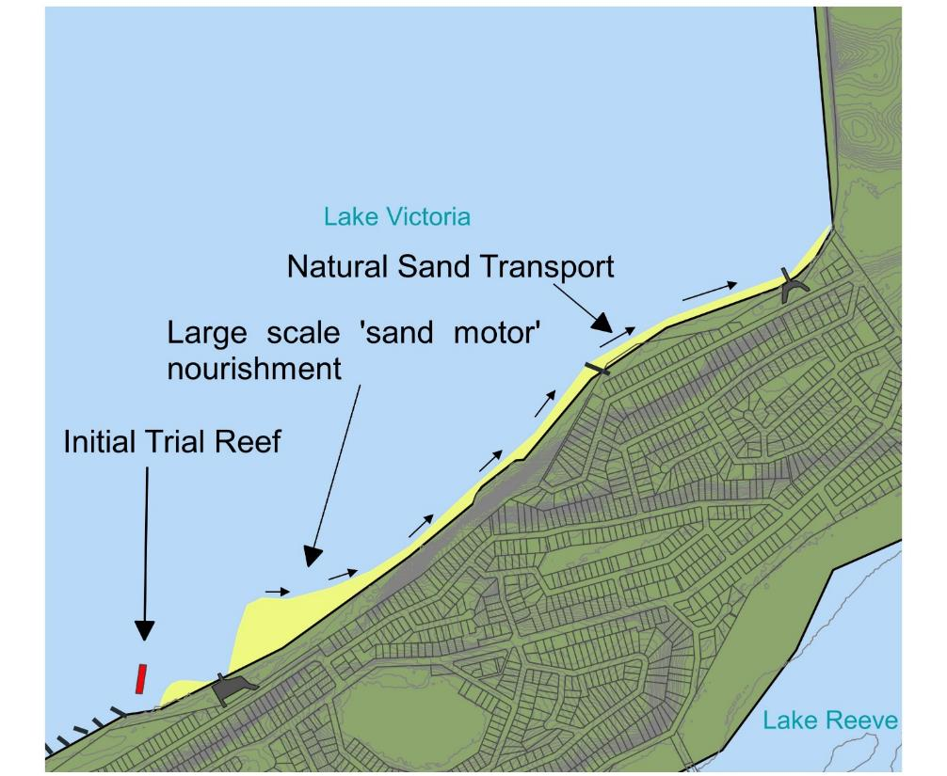
              - Medium-Term Concept – trial shellfish reef and large-scale ‘sand motor’ nourishment.

References

Australian Bureau of Meteorology. (2021). Wind Roses for Selected Locations in Australia. Australian Government.
Bird, E. (1965). The geomorphology of the Gippsland Lakes. Australian National University.
Boon, P., Rosengren, N., Frood, D., Oates, A., & Reside, J. (2014). Shoreline geomorphology and fringing vegetation of the Gippsland Lakes. Footscray: Victoria University.
CoastAdapt. (2021). Sea-level rise and future climate information for coastal councils. Australian Government.
Coastal Engineering Solutions (CES). (2002). Gippsland Lakes Shore Erosion and Revegetation Strategy.
Ethos NRM. (2009). Loch Sport Crown Reserves Management Plan.
Ethos NRM. (2011). Loch Sport Foreshore Erosion: Investigation and Recommendations.
Ford, J. R., & Hamer, P. (2016). The Forgotten Shellfish Reefs of Coastal Victoria: Documenting the Loss of a Marine Ecosystem Over 200 Years. The Royal Society of Victoria, 128, 87–105 .
IPCC. (2021). AR6 Climate Change: The Physical Science Basis. IPCC.
Moris, R. L., Bishop, M. J., Boon, P., Browne, N. K., Carley, J. T., Fest, B. J., . . . Swearer, S. E. (2021). Australian Guidelines for the Implementation of Nature-Based Methods for Coastal Hazard Risk Reduction. Melbourne: University of Melbourne.
Oldfield Consulting Australasia. (2012). Loch Sport Seagull Drive Boat Ramp Access Stage 1 Investigation.
Oldfield Consulting Australasia. (2017). Loch Sport Public Pathway Coastal Investigation .
Oldfield Consulting Australasia. (2021). Loch Sport Foreshore Erosion Investigation.
Results of 10 years Building with Nature. (n.d.). Retrieved from dezandmotor: https://dezandmotor.nl/en/results/
Rosengren, N. (2009). Ninety Mile Beach - geomophology, evolution, dynamics. Notting Hill.
Stive, M. J., de Schipper, M. A., Luijendijk, A. P., Aarninkhof, S. G., van Gelder-Maas, C., van Thiel de Vries, J. S., . . . Ranasinghe, R. (2013). A New Alternative to Saving Our Beaches from Sea-Level Rise: The Sand Engine. Journal of Coastal Research 29(5), 1001-1008. Retrieved from https://bioone.org/journals/journal-of-coastal-research/volume-29/issue-5/JCOASTRES-D-13-00070.1/A-New-Alternative-to-Saving-Our-Beaches-from-Sea-Level/10.2112/JCOASTRES-D-13-00070.1.short
Water Technology. (2014). Gippsland Lakes Local Coastal Hazard Assessment:Report 2 Inundation Hazard.
Water Technology. (2014). Report 2: Inundation Hazard Gippsland Lakes/90 Mile Beach Local Coastal Hazard Assessment Project. Melbourne: Department of Environment and Primary Industries.

BMT is a leading design, engineering, science and management consultancy with a reputation for engineering excellence. We are driven by a belief that things can always be better, safer, faster and more efficient. BMT is an independent organisation held in trust for its employees.
Level 5
99 King Street
Melbourne
VIC 3000
Australia
+61 (0) 3 8620 6100
Registered in Australia
Registered no. 010
Registered office
Level 5, 348 Edward Street,
Brisbane QLD 4000 Australia
For your local BMT office visit www.bmt.org

Contact us

enquiries@bmtglobal.com

www.bmt.org

Follow us

www.bmt.org/linkedin

www.bmt.org/youtube

www.bmt.org/twitter

www.bmt.org/facebook

downstream in the direction of longshore transport

