Coastcare Victoria Summer By The Sea Grants – Grants Online Instructions

2026





deeca.vic.gov.au



We acknowledge and respect Victorian Traditional Owners as the original custodians of Victoria’s land and waters, their unique ability to care for Country and deep spiritual connection to it.

We honour Elders past and present whose knowledge and wisdom   
has ensured the continuation of culture and traditional practices.

DEECA is committed to genuinely partnering with Victorian Traditional Owners and Victoria’s Aboriginal community to progress their aspirations.

© The State of Victoria Department of Energy, Environment and Climate Action August 2025.

Creative Commons

This work is licensed under a Creative Commons Attribution 4.0 International licence, visit the [Creative Commons website](http://creativecommons.org/licenses/by/4.0/) (<http://creativecommons.org/licenses/by/4.0/>).

You are free to re-use the work under that licence, on the condition that you credit the State of Victoria as author. The licence does not apply to any images, photographs or branding, including the Victorian Coat of Arms, and the Victorian Government and Department logos.

Disclaimer

This publication may be of assistance to you but the State of Victoria and its employees do not guarantee that the publication is without flaw of any kind or is wholly appropriate for your particular purposes and therefore disclaims all liability for any error, loss or other consequence which may arise from you relying on any information in this publication.

Accessibility

To receive this document in an alternative format, phone the Customer Service Centre on 136 186, email [customer.service@deeca.vic.gov.au](mailto:customer.service@deeca.vic.gov.au), or contact National Relay Service on 133 677. Available at [DEECA website](http://www.deeca.vic.gov.au/) (www.deeca.vic.gov.au).

Contents

DEECA Grants Online 2

Registration & login 2

Starting a new application 3

Accessing existing draft & submitted applications 3

Site navigation 3

Communicate with Program representatives 4

## DEECA Grants Online

DEECA Grants Online - for Community Users. The DEECA Grants Online Portal ‘GEMS’ is used to accept applications for the Coastcare Victoria Community Grants. This Portal is used across all DEECA grants programs.

### Registration & login

If you will be creating/submitting grant applications on behalf of your community group, it is highly recommended that you register an account with an organisational generic email address, so that account login details can be shared across the organisation.

### Starting a new application

The ‘Create new application’ link will be available from the relevant DEECA website, as well as the Grants Victoria website, for example:

### Accessing existing draft & submitted applications

A unique application reference number is generated by the system when your application is saved as a draft. The application number starts with “GA-F” and looks like “GA-F12345-1234”. It is important that you include your application reference number in any communication regarding the grant program.

There are three ways to access existing draft and submitted applications:

1. Login to <https://deeca.my.site.com/>  to access all your draft and submitted applications.
2. Using the link provided on the Coastcare Victoria Summer By The Sea webpage and this document under “How to apply” section
3. Using the link provided in notification email you received after creating a new draft.

### Site navigation

1. The side navigation bar helps you to quickly navigate to the page you have worked on. The navigation bar colour changes from grey to green once the page is completed.  And you can only jump to a page that is in green colour. A blue circle will be visible to indicate which page you are on.
2. When you click on **Save as Draft** button, your application form is saved.
3. When you click on **View as PDF** button, you can view the entire application form.
4. When you click on **Next Page** button, the previous page content is saved automatically.

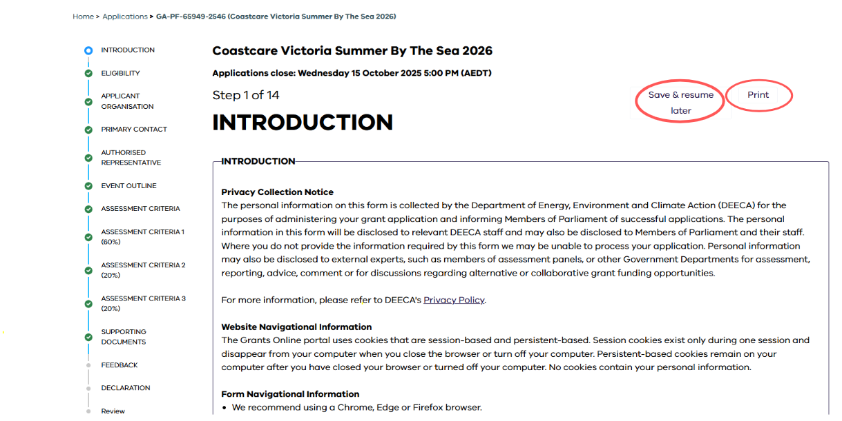

### Communicate with Program representatives

When communicating with program representatives (Coastcare officer), for example, emailing [coastcare.victoria@deeca.vic.gov.au](mailto:coastcare.victoria@delwp.vic.gov.au), please include the program name abbreviation, your application reference number, and program staff name if known in the subject line.