# Marine Spatial Planning Factsheet

What is the Marine Spatial Planning Framework?

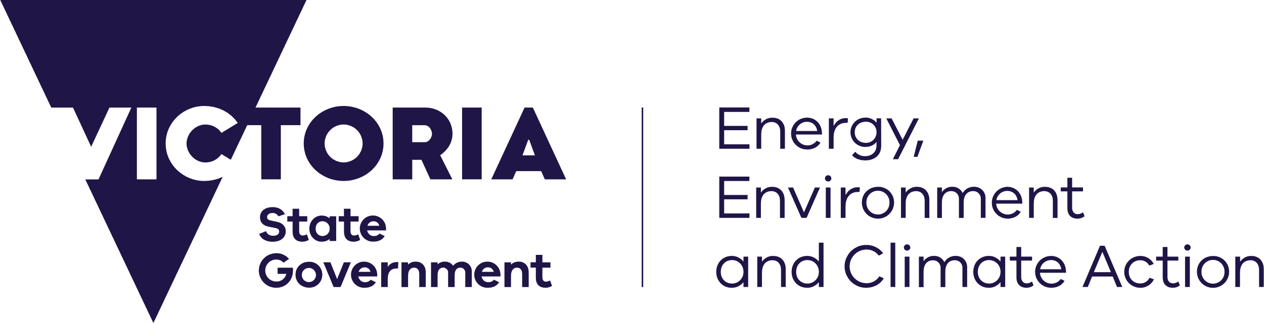

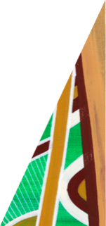

deeca.vic.gov.au

## Background

Victoria’s *Marine and Coastal Act 2018* (the Act) sets objectives and guiding principles for the planning and management of the State’s marine and coastal environment. Under the Act, the Marine and Coastal Policy 2020 (the Policy) details the policies for achieving these objectives.

The Policy includes a Marine Spatial Planning Framework (MSP Framework). The MSP Framework provides guidance and a process for achieving integrated and coordinated planning and management of the marine environment. It sets out Victoria’s approach to Marine Spatial Planning (MSP).

The Department of Energy, Environment and Climate Action (DEECA) is leading implementation of the MSP Framework, engaging with Traditional Owners and Aboriginal communities, industry, the wider community, and government agencies during the process.

DEECA is also leading implementation of the Marine and Coastal Strategy 2022 (the Strategy) which is a five-year action plan for implementing the Policy. It sets out six actions to achieve this, with Action 5 focussing on Implementing the Marine Spatial Planning Framework.

## What is Marine Spatial Planning (MSP)?

MSP is a practical way to organise marine space, and the interactions among human uses and between these uses and the marine environment.

While not all marine planning and management may require an MSP process, it can be beneficial where decision making is likely to be complex, challenging or where managing individual activities and uses may be inadequate.

MSP provides a process for assessing where activities and uses may be compatible or incompatible, and where activities and uses (either individually or cumulatively) conflict. Undertaking an MSP process can have significant benefits including proactively identifying and reducing conflicts between uses, and between uses and natural values, to help protect economic, social, cultural, and environmental values linked to the marine environment. It can be used to support sustainable growth of Victoria’s blue economy and climate adaptation planning.

The output of an MSP process is a Marine Plan, which is a strategic document that helps to structure and guide management decisions in the area to which the plan applies.

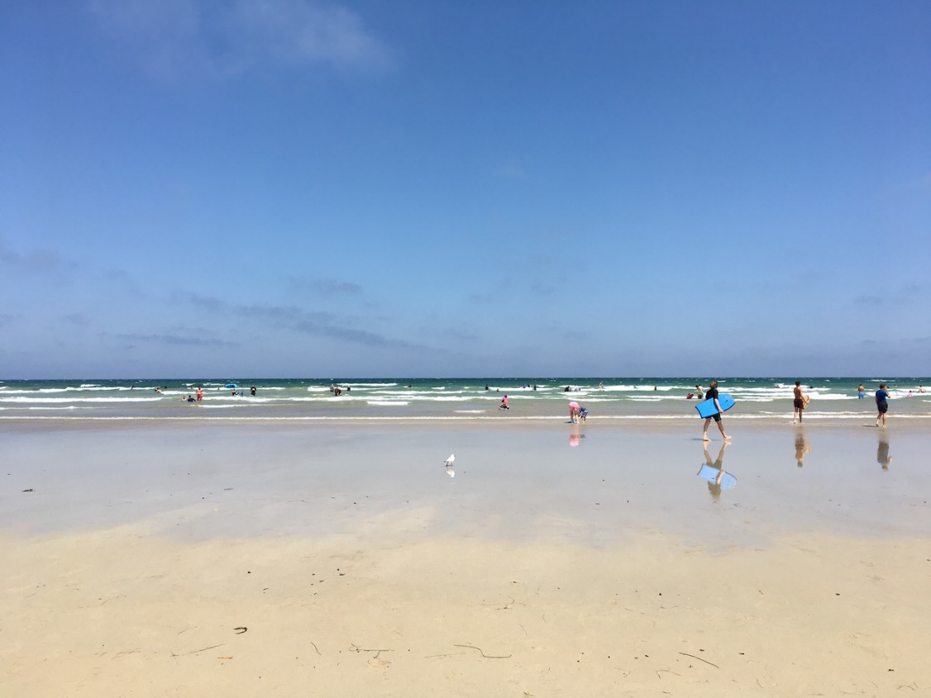

## What is the purpose of the MSP Framework?

The MSP Framework provides an overarching structure to guide planning, management and decision making by marine sectors. It has three key purposes:

* To support integrated and coordinated planning and management across marine sectors, the land-sea interface, and jurisdictions.
* To support Traditional Owners, marine sectors, marine users and the community to participate in marine planning and management.
* To provide a process for determining where and when MSP is needed, and for initiating, approving, and undertaking MSP.

It does not replace, remove, or duplicate the requirements of existing legislation.

## Where does the MSP Framework apply?

*The MSP Framework applies across Victoria’s marine environment. The ‘marine environment’ is defined in the Act as extending from the high-water mark for 3 nautical miles, or 5.5 km, to the edge of the State’s jurisdiction. It includes all bays, inlets, estuaries, and the Gippsland Lakes. This extends to a depth of 200 m below the seabed, and includes the biodiversity associated with both the land and water.*

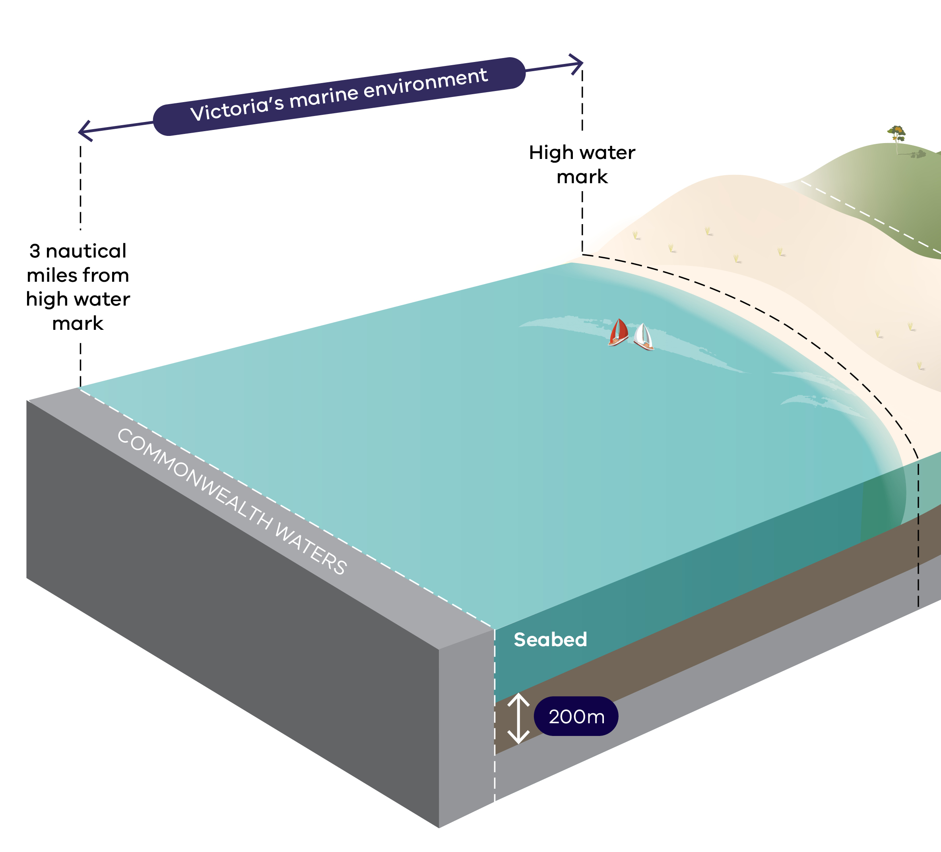

## How is the MSP Framework structured?

The MSP Framework consists of two parts that complement the other content of the Policy:

* **Part A** provides guidance and policies for marine planning and management decisions in Victoria.
* **Part B** outlines the process for initiating, approving, and undertaking MSP in Victoria.

## What is the process for MSP in Victoria?

The three-step process for MSP in Victoria is set out in Part B of the MSP Framework:

* Step 1: determine marine planning areas and identify priorities for marine spatial planning
* Step 2: seek approval to undertake MSP using a mechanism in the *Marine and Coastal Act 2018*
* Step 3: undertake MSP.

|  |  |
| --- | --- |
| © The State of Victoria Department of Energy, Environment and Climate Action 2023  LogoThis work is licensed under a Creative Commons Attribution 4.0 International licence. You are free to re-use the work under that licence, on the condition that you credit the State of Victoria as author. The licence does not apply to any images, photographs or branding, including the Victorian Coat of Arms, the Victorian Government logo and the Department of Energy, Environment and Climate Action (DEECA) logo. To view a copy of this licence, visit http://creativecommons.org/licenses/by/4.0/  Photo credit: Tiffany Sih  ISBN 978-1-76105-414-3 (print)  ISBN 978-1-76105-417-4 (pdf/online/MS word)  Disclaimer  This publication may be of assistance to you but the State of Victoria and its employees do not guarantee that the publication is without flaw of any kind or is wholly appropriate for your particular purposes and therefore disclaims all liability for any error, loss or other consequence which may arise from you relying on any information in this publication. | Accessibility  If you would like to receive this publication in an alternative format, please telephone the DEECA Customer Service Centre on 136186, email [customer.service@delwp.vic.gov.au](mailto:customer.service@delwp.vic.gov.au), or via the National Relay Service on 133 677 [www.relayservice.com.au](http://www.relayservice.com.au). This document is also available on the internet at [www.deeca.vic.gov.au](http://www.deeca.vic.gov.au). |

Implementation of Step 1 occurred through a statewide ‘first-pass’. Steps 2 and 3 are supported by MSP Guidelines that provide instructions on how to undertake MSP.

The statewide ‘first-pass’ and MSP Guidelines provide a consistent and clear approach to support MSP in Victoria.

DEECA will continue to implement the MSP Framework through Action 5 of the Strategy.

## More information

For more information please visit [DEECA Marine and Coasts](https://www.marineandcoasts.vic.gov.au/) or contact the Marine Spatial Planning Team ([marine.spatial.planning@delwp.vic.gov.au](mailto:marine.spatial.planning@delwp.vic.gov.au)).