|  |
| --- |
| DEECA Biodiversity Environment and Community Grants |
| Fact Sheet 6 of 10  Budget and Risk template instructions |

This Fact Sheet will guide you through how to complete the Budget and Risk template for a Biodiversity Environment and Community Grants application.

As part of your application, we require you to complete the Budget and Risk template for your proposed project and include this as an attachment to your application.

**These instructions will show you how to complete the following sections:**

1. Worksheet Tab 1 – Budget Summary **(see page 1)**
2. Worksheet Tab 2 – Project Budget **(see page 2)**
3. Worksheet Tab 3 – In Kind Support **(see page 3)**
4. Worksheet Tab 4 – Risk **(see page 4**)

## A. Worksheet Tab 1 – Budget Summary

1. Make sure you select the appropriate budget template in the application form and do not modify the template. There is one spreadsheet for funding up to $25,000 and separate spreadsheet for funding up to $100,000.
2. Open up the spreadsheet to the first **Worksheet Tab 1 – Budget Summary**.

Enter the amount that you are requesting from this program

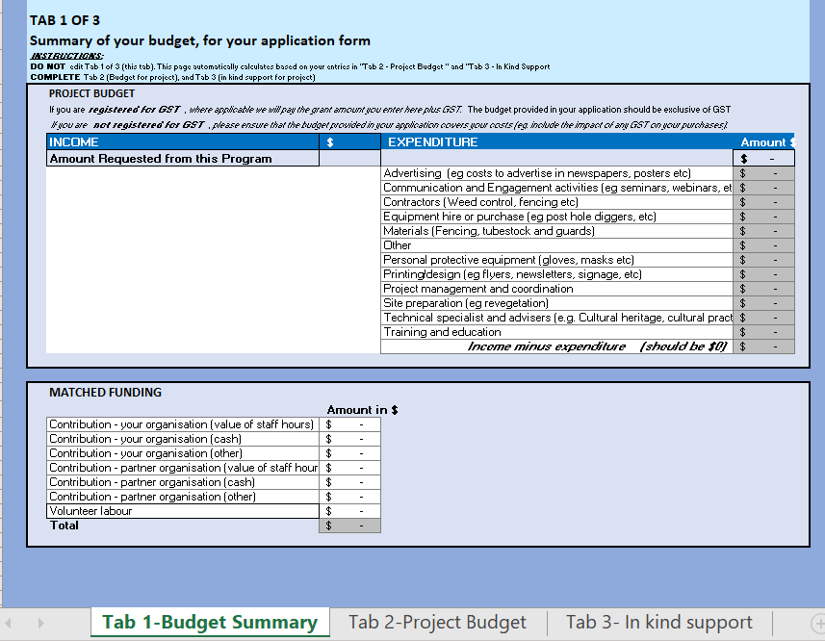

These columns are auto populated. You need to go to **Tab 2-Project Budget** and select your project expenditure in the dropdown list.

This amount should be zero when you complete populating **Tab 2-Project Budget**.

These columns are auto populated from **Tab 3 – In Kind Support.**

This amount should equal the amount you are requesting.

## B. Worksheet Tab 2 – Project Budget

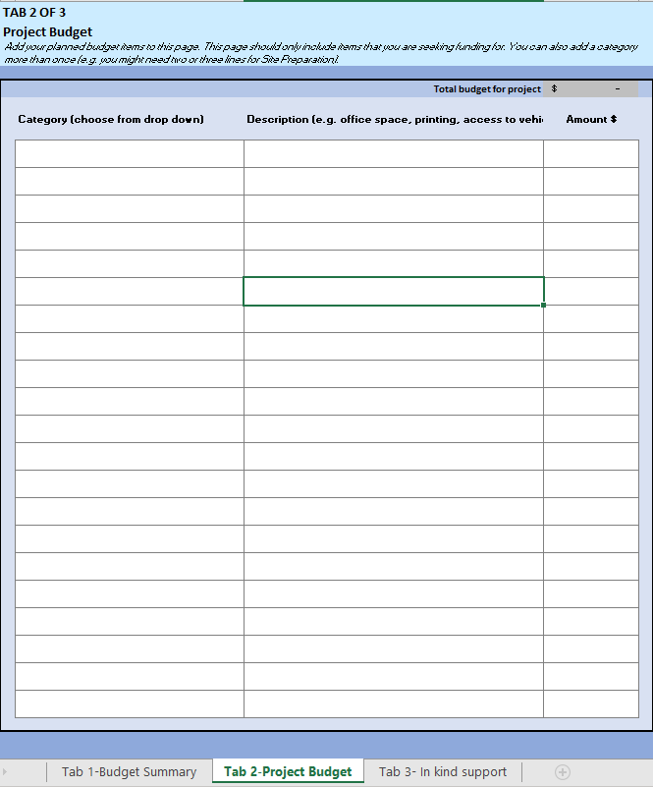

A drop-down list is available to select the type of expenditure for your project.

**For example:** Equipment hire. You need to provide brief description of the type of equipment and provide the amount.

If it is a contractor, you may need to supply a quote for the proposed works if the value is greater than $2,000.

**Note:** you can choose same category more than once.

Make sure your total budget is the same as your requesting amount and does not exceed the funding amount.

## C. Worksheet Tab 3 – In Kind Support

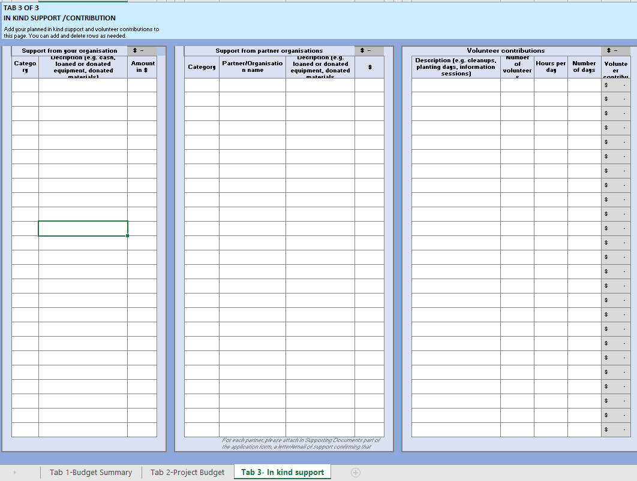

This section is “In kind contribution” from the partner organisations. Under the Category, a dropdown list of Staff hours, Cash or others are available to select.

Do include the name of all the partner organisations. If there is cash contribution, please submit a letter of support.

This column is “In kind contribution” from the community. Please provide detail description of the works and number of volunteers.

Hours per day must be reasonable (not beyond normal working hours).

**For example**, clean ups day is one day but 20 volunteers spent 2 hours of their time doing the work.

Volunteer hour is calculated at $40 per hour. It is auto- calculated.

This column is “In kind contribution” from your organisation. Under the Category, a dropdown list of Staff hours, Cash or others

## Budget categories

* Advertising (eg costs to advertise in newspapers, posters etc)
* Communication and Engagement activities (eg seminars, webinars, etc)
* Contractors (Weed control, fencing etc)
* Equipment hire or purchase (eg post hole diggers, etc)
* Materials (Fencing, tubestock and guards)
* Other
* Personal protective equipment (gloves, masks etc)
* Printing/design (eg flyers, newsletters, signage, etc)
* Project management and coordination
* Site preparation (eg revegetation)
* Technical specialist and advisers (e.g. Cultural heritage, cultural practises)
* Training and education

## Additional budget considerations

Your application must fully and clearly define project costs required to deliver your project (for example nursery plants or contractor services). We encourage applicants, where possible, to provide quotes from contractors and/or quotes for large items to support your application.

## D. Worksheet Tab 4 – Risk

Before completing the Risk Matrix, please consider how risks may impact of affect the delivery of your project.

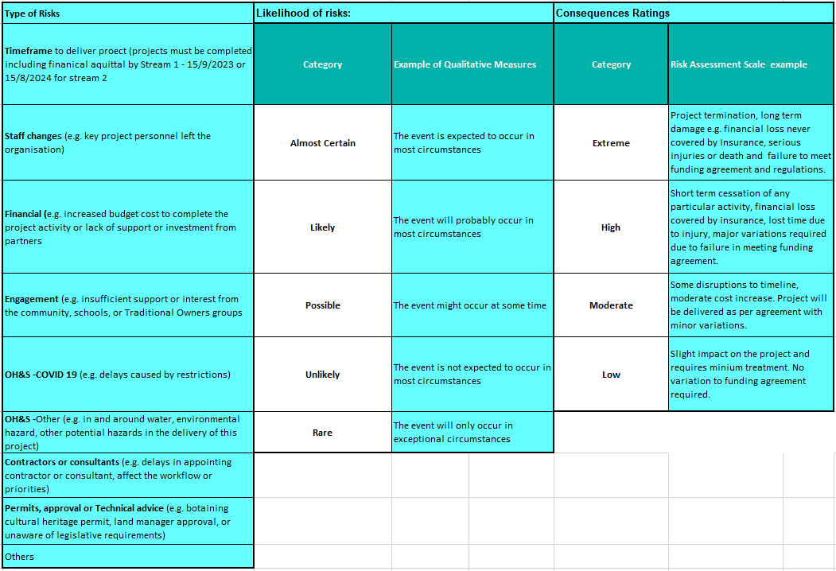

2. This cell is where you can explain more about your risk and the consequences to your project

1. Click on the drop-down arrow to choose a **risk category**.

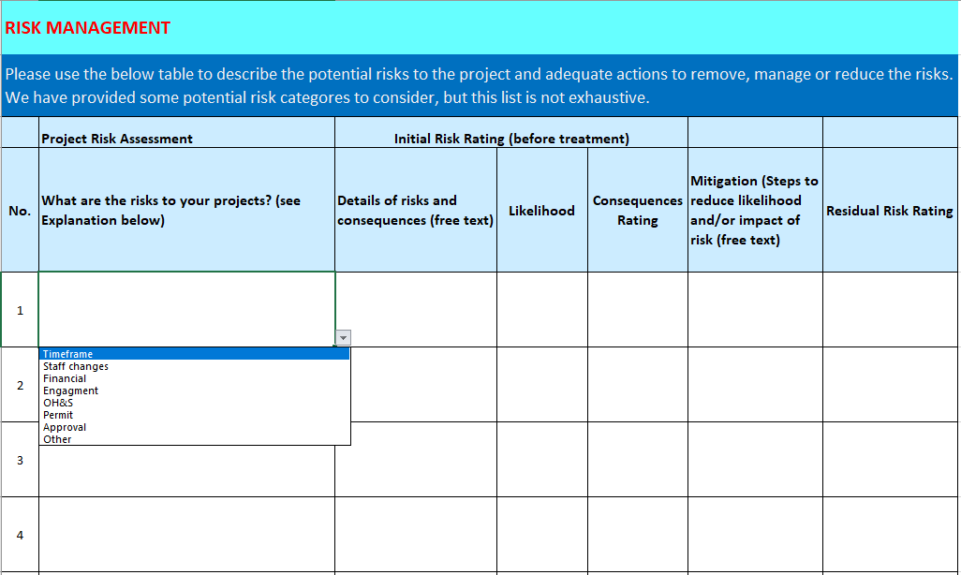

3. Click on the drop-down arrow to choose the **Likelihood** of this risk occurring.

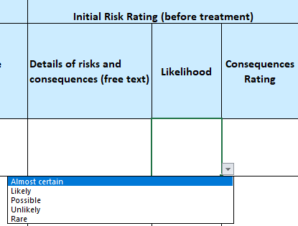

4. Click on the drop-down arrow to choose the **Consequence rating** of this risk occurring.

6. The last step is to Click on the drop-down arrow to choose the **Residual Risk rating** of this risk occurring.

5. This cell is where you can explain what steps you will take to reduce the risks to your project.

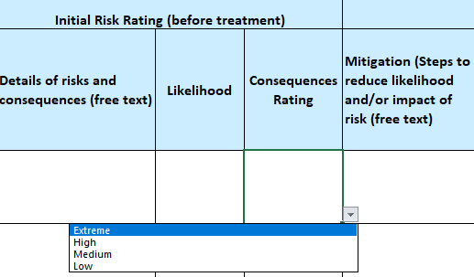 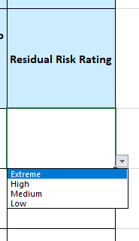

**Note –** please repeat these steps for every risk you have identified for your project.

# Contact us

## Program enquiries

If you have any queries, or require more information, please contact the Community Programs team via email at [enviro.grants@delwp.vic.gov.au](mailto:enviro.grants@delwp.vic.gov.au) or contact the DEECA Customer Contact Centre on 136 186 during normal business hours. Please quote your application number and the grant program in your communications with DEECA.

|  |  |
| --- | --- |
| © The State of Victoria Department of Energy, Environment and Climate Change 2023  Creative Commons BYThis work is licensed under a Creative Commons Attribution 4.0 International licence. You are free to re-use the work under that licence, on the condition that you credit the State of Victoria as author. The licence does not apply to any images, photographs or branding, including the Victorian Coat of Arms, the Victorian Government logo and the Department of Energy, Environment and Climate Change (DEECA) logo. To view a copy of this licence, visit http://creativecommons.org/licenses/by/4.0/  ISBN 978-1-76105-853-0 (**pdf/online/MS word**)  **Disclaimer**  This publication may be of assistance to you, but the State of Victoria and its employees do not guarantee that the publication is without flaw of any kind or is wholly appropriate for your particular purposes and therefore disclaims all liability for any error, loss or other consequence which may arise from you relying on any information in this publication | Accessibility  If you would like to receive this publication in an alternative format, please telephone the DEECA Customer Service Centre on 136186, email customer.service@delwp.vic.gov.au or via the National Relay Service on 133 677 www.relayservice.com.au. This document is also available on the internet at www.deeca.vic.gov.au |

## Technical difficulties

If you require technical assistance submitting your application online email [grantsinfo@delwp.vic.gov.au](mailto:grantsinfo@delwp.vic.gov.au) or call the DEECA Customer Contact Centre on 136 186 during normal business hours. Please quote your application number and the grant program in your communications with DELWP.