|  |
| --- |
| Cape to Cape Resilience Project  PROJECT UPDATE 1: April 2021 |

In partnership with the community, the Cape to Cape Resilience Project will inform long-term coastal management and help to build coastal resilience.

## What is the Cape to Cape Resilience Project?

The Cape to Cape Resilience Project is a long-term coastal hazard adaptation project. It covers the coastal areas between Cape Paterson and Cape Liptrap on the Bass Coast, Gippsland. Overseen by the Inverloch Regional and Strategic Partnership (RaSP), the project includes:

* new research via a Coastal Hazard Assessment,
* extensive community engagement,
* a coastal risk and vulnerability assessment, and
* coastal resilience planning.

The final output of the project will be the Cape to Cape Coastal Resilience Plan. It will include an action plan for priority adaptation activities over the next 5-10 years and pathways to plan adaptation into the future, aligning with the Victorian Marine and Coastal Policy.

Formed in August 2020, the Inverloch RaSP is led by the Department of Environment, Land, Water and Planning, with Traditional Owners, the Bunurong Land Council Aboriginal Corporation and eight other management agencies.

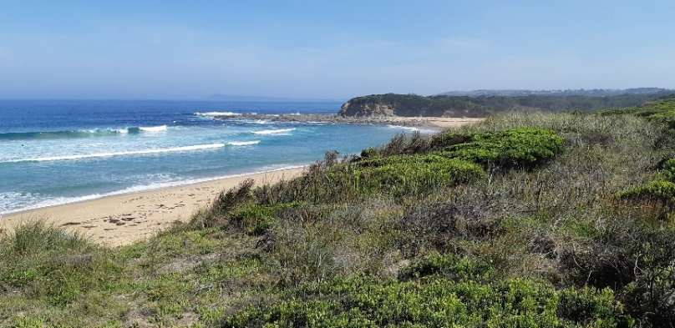

## What’s already happened?

Late last year, we appointed two consultants to support the RaSP and deliver this project. Water Technology will complete the Coastal Hazard Assessment. Alluvium Consulting will lead the stakeholder and community engagement and help to shape our adaptation approach. We are committed to working together and with the community to respond to local coastal management challenges.

Building on our existing understanding of the region, we are reviewing previous assessments and visiting key sites. We’ve also been planning our engagement, bringing together key stakeholders and community members into a Stakeholder Reference Group (more details below).

## Understanding the region

The project team has been compiling and reviewing background information for the region. This includes:

* previous projects and assessments on coastal and catchment processes, resilience and adaptation, and regional values
* information from the Victorian Coastal Monitoring Program (VCMP), and
* historic documents, data and imagery.

This information helps to build the story of what has happened along the coast and provides signs of what might happen in the future. We’re also identifying possible data gaps and where more information may be needed, finalising our project scope.

A site visit and a site flyover during January 2021 has provided our team with further context of present-day local coastal processes and notable management challenges, helping to shape the technical work.

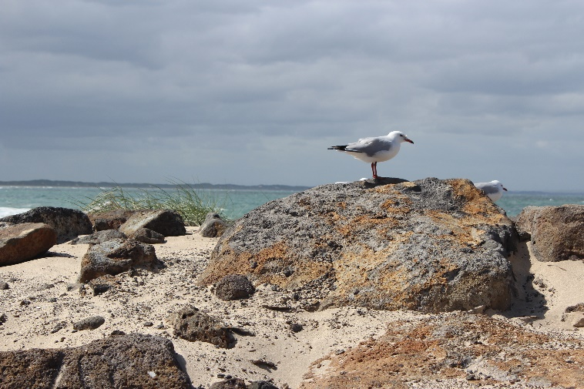

## Forming the Stakeholder Reference Group

During recent months, we have been developing a plan which outlines our engagement for this project. We also established a Stakeholder Reference Group (SRG). The SRG will support the Cape to Cape Resilience Project and ensure representation of community views and needs.

The SRG includes key stakeholder organisations and community members, selected through an expression of interest process. We received an impressive number of high-quality applications, which also showed the level of interest in the future management of our coast and surrounding areas.

In March, we finalised our SRG members and held a virtual meet and greet. We’re looking forward to getting to know the members as the project progresses.**Next steps**

Our RaSP partners and other stakeholders will be invited to a project launch in the coming weeks.

Inverloch, Venus Bay and surrounding Bass Coast communities will also be able to start sharing your ideas, values and aspirations for the coast. Listening to your experiences of coastal hazards will help us shape the direction of the assessment.

There will be many opportunities to get involved including online surveys and activities, and face to face meetings and events.

Find more details and register at the links below to stay informed about upcoming events and activities.

|  |
| --- |
| How can I get involved? To ensure you keep up to date with the Cape to Cape Resilience Project, read the latest facts sheets and view upcoming events and activities:   * Visit the project website at [marineandcoasts.vic.gov.au/coastal-programs/cape-to-cape-resilience-project](http://www.marineandcoasts.vic.gov.au/coastal-programs/cape-to-cape-resilience-project) * Sign-up to receive progress updates and notifications – email capetocape.project@delwp.vic.gov.au * Ask us a question – email capetocape.project@delwp.vic.gov.au |

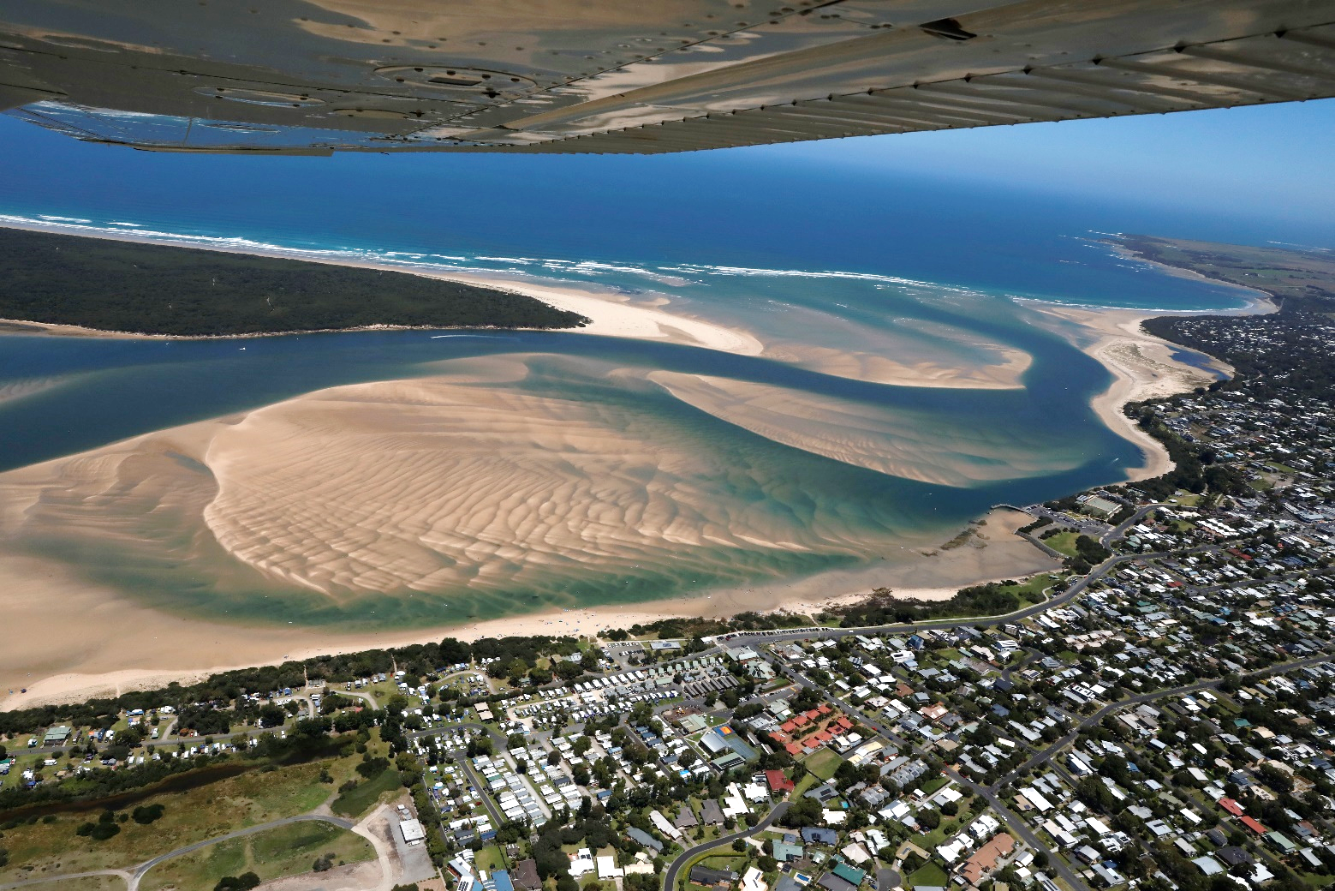

|  |  |
| --- | --- |
| © The State of Victoria Department of Environment, Land, Water and Planning 2022  LogoThis work is licensed under a Creative Commons Attribution 4.0 International licence. You are free to re-use the work under that licence, on the condition that you credit the State of Victoria as author. The licence does not apply to any images, photographs or branding, including the Victorian Coat of Arms, the Victorian Government logo and the Department of Environment, Land, Water and Planning (DELWP) logo. To view a copy of this licence, visit http://creativecommons.org/licenses/by/4.0/  **ISBN** 978-1-76105-572-0 **(pdf/online/MS word)**  Disclaimer  This publication may be of assistance to you but the State of Victoria and its employees do not guarantee that the publication is without flaw of any kind or is wholly appropriate for your particular purposes and therefore disclaims all liability for any error, loss or other consequence which may arise from you relying on any information in this publication. | Accessibility  If you would like to receive this publication in an alternative format, please telephone the DELWP Customer Service Centre on 136186, email [customer.service@delwp.vic.gov.au](mailto:customer.service@delwp.vic.gov.au), or via the National Relay Service on 133 677 [www.relayservice.com.au](http://www.relayservice.com.au). This document is also available on the internet at [www.delwp.vic.gov.au](http://www.delwp.vic.gov.au). |

The SRG has 16 members. Members of the SRG are listed in Table 1.

Table 1. Stakeholder Reference Group members

|  |  |
| --- | --- |
| **Representative** | **Group / organisation** |
| Rohan Henry | Bunurong Land Council Aboriginal Corporation (BLCAC) |
| Lisa Hocking | Gunaikurnai Land and Waters Aboriginal Corporation (GLaWAC) |
| David Tournier | Boon Wurrung Foundation |
| Abbie Argus-Smith | South Gippsland Yacht Club |
| Alyson Skinner | Venus Bay Community Centre |
| David Kennedy | Victorian Coastal Monitoring Program (VCMP) – University of Melbourne |
| David Sutton | Community member |
| Deirdre Griepsma | Community member |
| Iain Harrison | Community member |
| Ian Gunn | Tarwin Landcare Group |
| Jenny Wilson | Community member |
| John Trigt | Bass Coast Residents and Ratepayers |
| Max Wells | Inverloch Tourism Association |
| Neil Taylor | Community member |
| Phillip Heath | South Gippsland Conservation Society |
| Warren Cook | Inverloch Surf Lifesaving Club |

