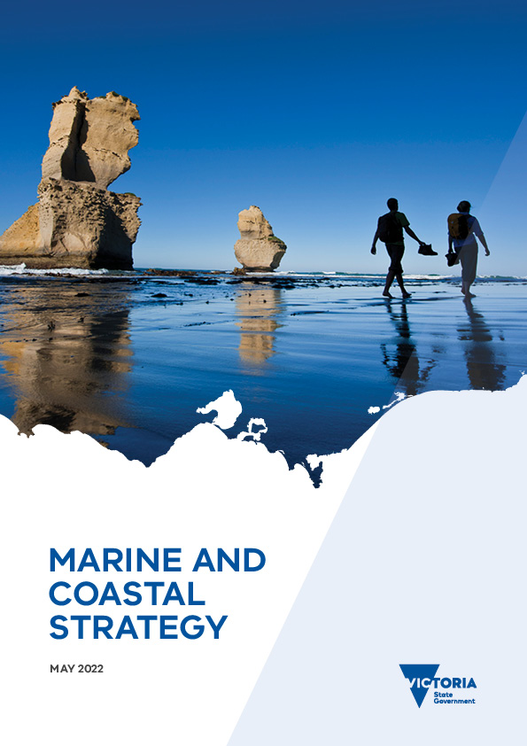

Marine and Coastal Strategy

May 2022
Photo credits:
- Cover – Gibson Steps, Eastern Maar Country. Credit: Parks Victoria
- Page 7 – Pair of Bigbelly Seahorses, Hippocampus abdominalis. Credit: Parks Victoria
- Page 25 – Jawbone Marine Sanctuary Boardwalk, Bunurong Country. Credit: Parks Victoria
- Page 33 – Sail boats on the beach, Bunurong Country. Credit: Gia Oris via Unsplash
- Page 41 – Grattan Mullet, GM of Culture at GLaWAC, takes in the view on the Gippsland Lakes, Gunaikurnai Country. Credit: Gunaikurnai Land and Waters Aboriginal Corporation
- Page 45 – Mangroves at Jawbone Marine Sanctuary, Bunurong Country. Credit: Parks Victoria
- Page 48 – Stridulating Hermit Crab, Strigopagurus strigimanus. Credit: Parks Victoria
- Page 58 – Seaford Surf Life Saving Club, Bunurong Country. Credit: John Gollings
© The State of Victoria Department of Environment, Land, Water and Planning 2022
This work is licensed under a Creative Commons Attribution 4.0 International licence. You are free to re-use the work under that licence, on the condition that you credit the State of Victoria as author. The licence does not apply to any images, photographs or branding, including the Victorian Coat of Arms, the Victorian Government logo and the Department of Environment, Land, Water and Planning (DELWP) logo. To view a copy of this licence, visit http://creativecommons.org/licenses/by/4.0/
Printed by Finsbury Green (Melbourne)
ISBN 978-1-76105-960-5 (Print)
ISBN 978-1-76105-961-2 (pdf/online/MS word)
Disclaimer
This publication may be of assistance to you but the State of Victoria and its employees do not guarantee that the publication is without flaw of any kind or is wholly appropriate for your particular purposes and therefore disclaims all liability for any error, loss or other consequence which may arise from you relying on any information in this publication.
Accessibility
If you would like to receive this publication in an alternative format, please telephone the DELWP Customer Service Centre on 136186, email customer.service@delwp.vic.gov.au, or via the National Relay Service on 133 677 www.relayservice.com.au. This document is also available on the internet at www.delwp.vic.gov.au

Acknowledgement of Traditional Owners
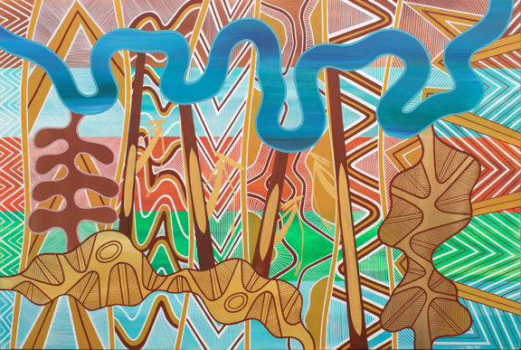
Traditional Owners have never surrendered rights to Country. The Victorian Government acknowledges Aboriginal people as Australia’s first people, and as the Traditional Owners and custodians of the land on which we work and live. We recognise the strength of Aboriginal people and the need for reconciliation and genuine partnerships to address the negative impacts of the past.
Traditional Owners have an unbroken custodianship of the land and seas that extends back tens of thousands of years. Their knowledge, understanding, and relationships to Country are fundamental to the health of the environment and the success of any strategy to manage that environment.
We recognise and value the ongoing contribution of Aboriginal people and communities to Victorian life and how this enriches us all. We recognise that Aboriginal cultures and communities are diverse, and the value we gain in celebrating these cultures and communities. We embrace the spirit of reconciliation, working towards the equality of outcomes and ensuring an equal voice. We have distinct legislative obligations to Traditional Land Owner groups that are paramount in our responsibilities in managing Victoria’s resources.
The following Registered Aboriginal Parties (RAPs)/Traditional Owners have contributed to the development of this first Marine and Coastal Strategy:
- Bunurong Land Council Aboriginal Corporation
- Eastern Maar Aboriginal Corporation
- Gunaikurnai Land and Waters Aboriginal Corporation
- Gunditj Mirring Traditional Owners Aboriginal Corporation
- Wadawurrung Traditional Owners Aboriginal Corporation
- Wurundjeri Woi Wurrung Cultural Heritage Aboriginal Corporation.
Note: This document has used the term Traditional Owners in reference to all Traditional Owners/RAPs along the Victorian coast. Where there is a specific place-based activity, we have referred to the recognised RAP/Traditional Owner.
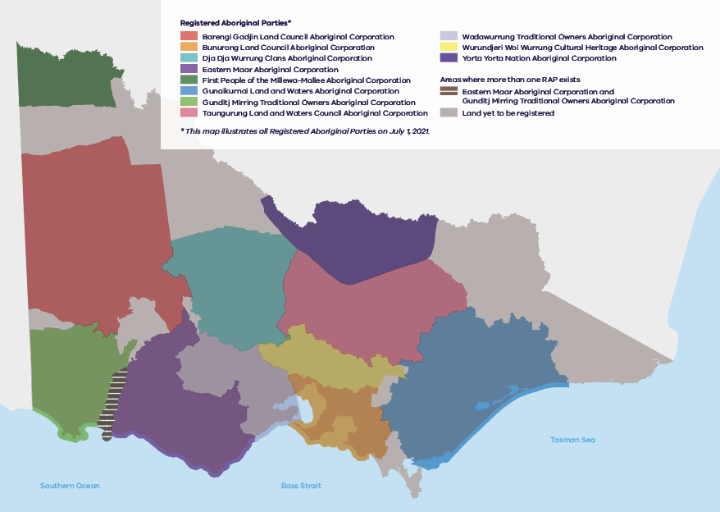
Figure 1: Registered Aboriginal Parties (RAP) boundaries
Victorian RAP boundaries extend into marine waters to state limits (3 nautical miles). The Native Title Traditional Owner Settlement Act 2010 boundaries extend 200 metres into marine waters.

Contents
Acknowledgement of Traditional Owners 1
A Message from Traditional Owners 3
Introduction 4
Marine and Coastal Strategy 5
Action 1. Traditional Owners determine how their rights and obligations are embedded into planning and management of the marine and coastal environment 6
Action 2. Improve the condition and ecological connectivity of habitats and respect and care for our marine and coastal areas 8
Action 3. Adapt to climate change 14
Action 4. Support sustainable use and development of the marine and coastal environment 22
Action 5. Implement the Marine Spatial Planning Framework 30
Action 6. Identify resource needs for sustainable marine and coastal management 33
Implementing and evaluating the Strategy 37
Roles and responsibilities 38
Appendix A: Strategy Development 40
Appendix B: Abbreviations 42
Appendix C: Strategy links to the Policy 44
Appendix D: Glossary 45
Appendix E: Other policies and strategies 52

A Message from Traditional Owners
We acknowledge and pay respect to our Ancestors.We note the strength and resilience they maintained during their time, the sacrifices they made, and the suffering caused to them at the hands of invading peoples.
Our families have been connected to Victoria’s marine and coastal Country for over 60,000 years. Since colonisation, our Country was unlawfully and unjustly taken from us.
Impacts included numerous and well documented massacres, the introduction of disease, dispossession from our lands and waters, and assimilation policies and practices that forcibly removed our people to government reserves and missions. These places prohibited our languages and cultural practices. All aspects of our peoples’ lives were controlled by the foreigners, including having our children taken from their families for the purposes of forced assimilation.
We fought hard to maintain our rights and responsibilities - to keep our families, culture, languages, and Country intact and healthy. We succeeded in keeping connection to Country and to each other strong. But we suffered, and suffer to this day great losses to our people, languages and culture.
Connection to Country is at the core of who we are today, always have been and always will be. Country is who we are and it is home.
Moving forward, it’s about taking back the control of our inheritance, our Country. Let’s respect that. It was severed from colonial times – inheritance to Country and to those cultural landscapes were interfered with. It’s cultural property that we’re talking about here.
This is why our message is urgent to those of you who also care for Victoria’s fragile marine and coastal Country. We need to make things right and better for us all.
The time is now – to speak, listen and act with courage; to make decisions together and transparently that are in the interests of our oceans, coastlines, connected landscapes and waterways for generations to follow.
We must forge a future together to make things better.
Our understanding of cultural seasons, through application of traditional ecological knowledge and use of cultural environmental management practices were critical in caring for Sea Country – coastlines and marine environments. They were kept in a pristine condition for centuries and sustained our families. This knowledge and our traditional ecological knowledge systems and practices remain critical today.
Our knowledge must be respected alongside other knowledge systems for managing marine and coastal Country for a sustainable future.
It is our assertion that this Marine and Coastal Strategy needs to be a living document. The Marine and Coastal Strategy provides a roadmap for the conversations and transparent decision making Traditional Owners, government and the broader Victorian community need to make together.
Managing Country is not a hobby for us, it is an obligation and a responsibility. We must be at the table as equal partners with government and the broader community when knowledge is being shared, and decisions are being debated and agreed.
We must all remember the past, with our back to it looking forward.
Country needs our help. Our knowledge systems, and efforts to heal and protect Country in the face of climate change, pollution, and the impacts of poor management practices need to be a priority. There is no time to waste.
We do this in the interests of many generations going forward – it is all our children and grandchildren who will suffer or thrive as a result of the decisions we make now about our precious marine and coastal environments. We need to work together to change and adapt to the current environmental, social and political climate.
This is our message: work with us to achieve justice and dignity for our people in accordance with our Ancestors’ vision, and our self-determined aspirations as this Marine and Coastal Strategy is implemented over the next five years.

Introduction
Victoria’s marine waters are home to more than 12,000 species of animals and plants, most of which are found only in the waters of south-eastern Australia. Victoria’s islands and mainland coasts, bays, inlets and estuaries are important fish nurseries, and support shorebirds and provide habitat for many coastal animals and plants. Vegetation, including coastal Moonah woodland and other heathlands, is central to our coastal landscape.
In addition to its intrinsic value and beauty, the marine and coastal environment provides enormous benefits to the Victorian community.
Aboriginal Victorians have been connected to Victoria’s marine and coastal Country for over 60,000 years. Their caring for Sea Country, coastlines and marine environments, through application of traditional ecological knowledge and use of cultural environmental management practices was critical in keeping Country in pristine condition for centuries and for sustaining their families.
Victorians love to live near, visit and experience our coast and ocean. Coastal and marine-dependent industries such as fishing, tourism, ports and shipping make significant contributions to local and regional economies. Our coasts and marine waters are also a core part of our shared cultural identity, whether visiting or living near city beaches, smaller seaside towns or remote areas. These environments can also protect us from extremes of weather through natural coastal defences and carbon storage.
These benefits are only possible when the marine and coastal environment is healthy and resilient. Clean water, diverse species, and sufficient space for shorelines to shift and change are integral for us to continue enjoying these environments.
The health of the marine and coastal environment is under threat from multiple sources, including climate change, growth in towns and cities and industries that interact with local marine and coastal ecosystems. Drivers of change such as population growth, climate change and ageing infrastructure exacerbate existing threats and bring new challenges.

The Wave 5 Marine and Coastal Community Attitudes and Behaviours report
The Wave 5 Marine and Coastal Community Attitudes and Behaviours report, developed for the Department of Environment, Land, Water and Planning (DELWP) in 2019 found that the marine and coastal environment is important to Victorians for the following reasons:
- place to experience nature
- place to spend leisure time and opportunities for recreation
- physical buffer to protect natural environment
- tourism
- cultural heritage
- place to live
- a source of food and jobs.

Marine and Coastal Strategy
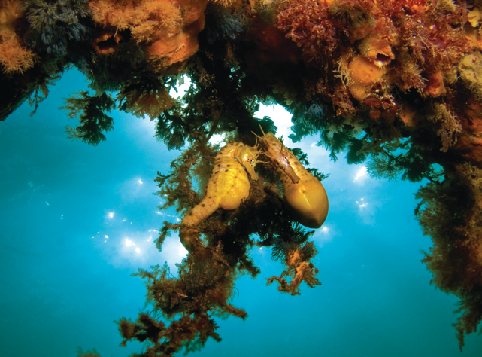
The Marine and Coastal Act 2018 (the Act), the Marine and Coastal Policy 2020 (the Policy) and this Marine and Coastal Strategy (the Strategy) each play a lead role in managing and maintaining the health of Victoria’s marine and coastal environment.
The Act outlines principles and objectives for planning and management, to ensure that the marine and coastal environment is cared for so that future generations may also experience and enjoy its multiple benefits.
The Policy was released in March 2020. It sets a 15-year vision for ‘a healthy, dynamic and biodiverse marine and coastal environment that is valued in its own right, and that benefits the Victorian community, now and in the future’ and provides strategic direction and specific considerations for planning, management and decision making.
This Strategy identifies actions to achieve the Policy’s vision, and is the first of three, five-year strategies. It outlines priority actions for the next five years that lay the foundations to achieve the intended outcomes of the Policy over the next 15 years. It also outlines timeframes and responsibilities for delivery.
This Strategy will:
- enable Traditional Owners to fully integrate cultural values, uses and practices in the healing and ongoing management of Country
- build the foundations for long-term climate adaptation and environmental protection in Victoria’s marine and coastal environment
- improve integration and coordination across governments, industries, and communities when planning and managing marine and coastal areas
- build the skills and capability of Traditional Owners, communities, managers, and governments to effectively plan and manage for a healthy and resilient marine and coastal environment.
It will do this through six actions:
- Action 1: Supporting Traditional Owners to embed their rights and obligations into planning and management of the marine and coastal environment.
- Action 2: Improving the condition and ecological connectivity of habitats and respecting and caring for marine and coastal areas.
- Action 3: Adapting to impacts of climate change.
- Action 4: Supporting sustainable use and development of the marine and coastal environment.
- Action 5: Implementing the Marine Spatial Planning Framework to integrate long-term planning for different uses in the marine environment.
- Action 6: Identifying the resource needs and funding for sustainable marine and coastal management.
The time is now – to speak, listen and act with courage; to make decisions together and transparently that are in the interests of our oceans, coastlines, connected landscapes and waterways for generations to follow.
We must forge a future together to make things better.
The Strategy provides a roadmap for the conversations and transparent decision making Traditional Owners, government and the broader Victorian community need to make together.
— Traditional Owner Message
Note: Some actions and activities in this Strategy are funded or partially funded. Additional funding to implement other actions and activities will be subject to budget and service delivery priorities.

Traditional Owners determine how their rights and obligations are embedded into planning and management of the marine and coastal environment
Activities under Action 1 progress the following Policy outcomes:
- Current and future generations of Traditional Owners care for and respect Country through self-determination.
- Traditional Owners are actively engaged and empowered to care for, protect and improve the marine and coastal environment.
- Traditional Owners collaborate to take care of, and deliver integrated and coordinated planning and management of, the marine and coastal environment.
- Cultural values and sites of heritage significance
are protected for current and future generations.
- Quality science and knowledge is used to inform evidence-based decision making and to evaluate the effectiveness of decisions.

Purpose
This action aims for the full integration of Traditional Owner values, uses and practices in the rehabilitation and ongoing management of Country. This will enable the continuance of Traditional Owner cultures, knowledge, and practices to heal our coastal and marine environment for current and future generations.
The cultural and human rights of Traditional Owners must be respected. This action and all others in the Strategy aim to support Traditional Owners to determine how their rights and obligations are embedded in planning and management.

Our families have been connected to Victoria’s marine and coastal Country for over 60,000 years.
Since colonisation, our Country was unlawfully and unjustly taken from us.
Connection to Country is at the core of who we are today, always have been and always will be. Country is who we are and it is home.
Country needs our help. Our knowledge systems, and efforts to heal and protect Country in the face of climate change, pollution, and the impacts of poor management practices need to be a priority. There is no time to waste.
— Traditional Owner Message

Why this is needed
Traditional Owners are rights holders in the marine and coastal environment and have a long-held connection to Country. As explained in the Traditional Owner Message on page 2, their rights, views and knowledge have not been appropriately considered in planning and management activities in the marine and coastal environment since colonial settlement.
Traditional Owner management of Country is a time-tested application of knowledge about environmental management. Both access to and management of Country enables self-determination of Aboriginal people and promotes environmental sustainability and connected Country outcomes. Country and Victorians will benefit from the full participation of Traditional Owners in the management of the marine and coastal environment.

Action focus
This action uses a range of approaches to support Traditional Owners to determine how their rights, obligations and assertions are embedded into marine and coastal planning and management.
Traditional Owners will be supported to:
- assess bio-cultural values and monitor impacts from land use and climate change and other pressures across Sea Country – coastlines and marine environments
- apply objectives and assertions for Country in regional and local planning
- resource and realise their ongoing obligations to care for Country
- manage marine and coastal areas and resources
- monitor, evaluate and inform future policy and planning directions at local and state level.
Table 1: Activities
Activity | Lead* | When
To enable Traditional Owners to embed their rights and obligations into planning and management of the marine and coastal environment, we will:
- Resource Traditional Owner groups to:  - regularly assess cultural values  - visit Country and undertake practices  - undertake cultural mapping  - store and manage cultural knowledge and records – including systems and system maintenance  - control and manage their cultural intellectual property and maintain data sovereignty  - share knowledge, as culturally appropriate, across traditional cultural, scientific and citizen science practice for marine and coastal management including regulation, compliance and community activities  - support Traditional Owner Elders to access Country  - practice intergenerational knowledge sharing  - develop relationships and agreements with private landowners who wish to support the management of cultural assets on freehold land. | Lead: RAPs, DELWP  Collaborate: TfN | 2022–27  ongoing
- Understand needs, and consider options and opportunities for, ongoing funding for Traditional Owners to exercise rights and cultural practices for marine and coastal planning and management. | Lead: RAPs, DELWP  Collaborate: DTF | 2022–24
- Support Traditional Owners to:  - undertake risk assessments of bio-cultural values of Country  - lead research and documentation of traditional land management practices. and the revitalisation of knowledge and practices within communities  - monitor the impacts from climate change and land use on cultural values and uses in marine and coastal areas  - undertake mapping and, where appropriate, protection, salvage or relocation of cultural material affected by climate change  - incorporate bio-cultural management, planning, and policies into management of Country. | Lead: RAPs, DELWP, PV, LG, CoM**  Collaborate: TfN | 2022–27  ongoing
- Support Traditional Owners to apply objectives and assertions for Country through:  - the development of appropriate mechanisms including Country plans  - partnering in marine and coastal regional and local planning, such as Coastal and Marine Management Plans (CMMPs), adaptation plans, marine spatial planning, local government coastal planning and zoning. | Lead: RAPs, DELWP, PV, LG, CoM, GORCAPA** | 2022–27  ongoing
- Support Traditional Owners to manage marine and coastal areas and resources by:  - developing and/or expanding Sea Country ranger programs  - enabling Traditional Owner Corporations to be appointed as land managers  - recognising Traditional Owner rights on Sea Country to harvest wild resources within sustainable limits for non-commercial purposes  - training, placements and mentorships to empower and increase capacity for individuals and Traditional Owner organisations to care for Country and participate in management, planning and policy development. | Lead:  DELWP/RAPs  DELWP/RAPs  RAPs, VFA, PV, CoM, LG, GORCAPA**  DELWP/RAPs | 2022–26
* The full names are included in the Abbreviations list (Appendix B).
** For respective areas of interest and management responsibility.
Table 2: Activity timing
Activity | 2022–23 |  | 2023–24 |  | 2024–25 |  | 2025–26 |  | 2026–27
1.1 | Start |  |  |  |  |  |  |  |  | End
1.2 | Start |  |  |  | End
1.3 | Start |  |  |  |  |  |  |  |  | End
1.4 | Start |  |  |  |  |  |  |  |  | End
1.5 | Start |  |  |  |  |  |  |  | End

Improve the condition and ecological connectivity of habitats and respect and care for our marine and coastal areas
Activities under Action 2 progress the following Policy outcomes:
- Marine and coastal ecosystems are functioning, resilient and connected.
- Quality science and knowledge is utilised to inform evidence-based decision making and to evaluate the effectiveness of decisions.
- Community and user groups are actively engaged and empowered to care for, protect and improve the marine and coastal environment.
- Marine and coastal ecosystems are valued in their own right.
- Traditional Owners, marine and coastal managers, and
community and user groups collaborate to take care of and
deliver integrated and coordinated planning and management
of the marine and coastal environment.
- Marine and coastal ecosystems provide valued goods and
services to Victorians now and in the future.

Purpose
The purpose of this action is to improve marine and coastal ecosystem condition and connections that are critical their function and health. It will empower Victorians to connect with and care for our marine and coastal areas. Action 2 acknowledges the intrinsic value of our marine and coastal environment, and how the health of these areas is the basis for our personal and economic wellbeing, and for safeguarding and protecting traditional culture.
Our understanding of cultural seasons, through application of traditional ecological knowledge and use of cultural environmental management practices were critical in caring for Sea Country – coastlines and marine environments. They were kept in a pristine condition for centuries and sustained our families. This knowledge and our traditional ecological knowledge systems and practices remain critical today.
— Traditional Owner Message

Why this is needed
Victoria’s marine and coastal areas are threatened by impacts from increasing pressures caused by population growth, human use and climate change. The increasing pressures on land use and development have fractured and reduced the extent of natural habitats. Pollution of waterways and soils, introduction of invasive species and extraction of food and resources disrupt ecosystem processes and threaten native biodiversity.
Climate change is adding further stress to our marine and coastal ecosystems. Increasing sea and air temperatures are causing marine species to shift from their historic habitats in search of more favourable conditions. Rising sea levels are changing coastal erosion processes and built environments form barriers for species movements. Coastal ecosystems such as mangroves and saltmarsh are being squeezed between rising seas and urban and agricultural developments, leaving no room for them to adapt to a changing climate.

Action focus
This action prioritises activities to improve habitat condition and restoration. It encourages Victorians to respect and care for our marine and coastal areas. Habitat mapping across public and private land will identify where connectivity improvements can be made. State-wide, regional and local strategic planning tools will be used to implement the most cost-effective mix of actions to benefit marine and coastal species and their habitats, manage threats, and balance access and use with environmental values.
Frameworks that drive collaboration and accountability as well as economic incentives will be used to create opportunities for protection and restoration of ecosystems on public and private land. Education, volunteering and citizen science programs will provide opportunities for the Victorian community to learn about and participate in caring for our marine and coastal environment.
Activities in this action complement other policy and strategy work that is happening across Victoria to manage the impacts from population growth and climate change (Appendix E).

Table 3: Activities
Activity | Lead* | When
To ensure marine and coastal habitats can remain healthy, diverse and functioning, valued in their own right, and provide benefits for the future, we will improve the condition and connectivity of marine and coastal habitats by:
- Identifying and mapping habitat linkages across public and private lands that are required for future migration, restoration, and protection of marine and coastal habitats including:  - under future climate change scenarios, which consider such impacts as sea level rise, sea temperature changes and changing sediment dynamics  - identifying habitat linkages required to protect threatened species and species at risk  - identifying areas for rehabilitation using nature-based methods  - identifying areas of Victoria with high potential for blue carbon. | Lead: DELWP, TfN**  Collaborate: LG, CoM, CMAs, GORCAPA, RAPs | Mapping 2022–24
- Enabling protection of existing and expanded habitat linkages that are required for future migration of marine and coastal habitats (identified in Activity 2.1) by:  - updating strategic plans  - applying statutory controls through planning schemes. Action via data driven updates to planning policy and schemes (see Activity 3.10)  - supporting permanent protection agreements on private land. | Lead: LG, CoM, CMAs, GORCAPA, DELWP**  Collaborate: DELWP, RAPs, TfN, PV  Lead: DELWP, LG  Collaborate: CMAs, MW, LG, TfN  Lead: TfN | Update plans and controls 2024–26 — needs to be ongoing and adaptive as required
- Applying fair and equitable economic and policy instruments to incentivise:  - the migration of coastal and near-shore habitats across public and private land  - adoption of nature-based options for climate change adaptation (such as rehabilitation of wetlands and mangroves, ecological engineering and living shorelines)  - landowners to restore blue carbon ecosystems on their property  - uptake of conservation and farmland covenants. | Lead: DELWP, TfN  Collaborate: CMA, LG, DTF | 2024–26
- Enabling a blue carbon market in Victoria by:  - establishing a framework to assess blue carbon restoration values in the marine and coastal environment  - adjusting legal and policy mechanisms to provide land managers access to the economic benefits of blue carbon  - supporting scalable research and initiatives that explore blue carbon protection/restoration opportunities and benefits of a blue carbon market. | Lead: DELWP  Collaborate: MW, LG, CMAs, VMaCC, DTF, TfN, PV | 2023–26
- Implementing Conservation Action Plans for coastal and marine parks and reserves (including private reserves held by Trust for Nature) to maintain and/or restore the core natural and cultural values and resilience of protected areas and culturally important and threatened species of flora and fauna. | Lead: PV, GORCAPA, TfN**  Collaborate: DELWP, CMAs, RAPs, DJPR, LG | 2022–24
- Implementing actions under the Port Phillip Bay Environmental Management Plan 2017–27 including:  - the five-yearly evaluation in 2022–23  - develop and roll out Port Phillip Bay Fund grant programs to address priority actions detailed in the plan. | Lead: DELWP  Collaborate: LG, CoM, MW, LSV, PV, EPA, RAPs, DJPR, TfN  Lead: DELWP  Collaborate: MW, EPA, PV, LG, ABM, RAPs | 2022–26  2022–26
- Setting strategic directions that support the recovery and enhancement of marine and coastal habitats across public and private land in Regional Catchment Strategies (RCS), Regional Waterway Strategies (RWS) (specifically for estuaries and coastal wetlands) and other strategic plans (e.g. Trust for Nature’s Statewide Conservation Plan). | Lead: CMAs, MW, TfN**  Collaborate: DELWP, RAPs, LG | RCS 2021–27  RWS 2025
- Exploring where Environmental Management Plans (under section 49(2) of the Act) may be able to improve the condition and ecological connectivity in bays and inlets across Victoria to help achieve environment reference standards. | Lead: DELWP, EPA | 2022–27
To ensure that Victorians are engaged and empowered to care for, protect and improve the health of the marine and coastal environment, we will improve respect and care for marine and coastal habitats by:
- Partnering to deliver education, extension and interpretation programs that:  - promote community respect and care for all marine and coastal areas including marine protected areas and national parks  - encourage respectful learning from Traditional Owners in culturally appropriate situations  - encourage public compliance with rules and regulations. | Lead: PV, CoM, LG, DELWP, DJPR, TfN**  Collaborate: VMaCC  Lead: RAPs  Lead: VFA, LG, PV, DJPR, GMA** | 2022–27
- Supporting volunteer participation, engagement and action on local needs and broader systemic issues by:  - implementing the Coastcare Victoria Strategy 2021–26 and evaluate to develop the next strategy in 2025–26  - supporting community involvement in other relevant marine and coastal volunteer programs, e.g. Fishcare, OzFish and Landcare  - providing integrated citizen science program opportunities that engage the community and provide useful data to actively contribute to marine and coastal management. (e.g. the citizen science drone monitoring program). | Lead:  DELWP  DELWP, VFA, PV**  DELWP, CMAs, VFA, PV, LG, CoM** | 2022–27
- Enabling and recognising outstanding respect and care for marine and coastal areas by:  - building leadership capacity in the community to care for our marine and coastal environment (e.g. mentoring program for coastal and marine leaders)  - acknowledging private landholders and public lease and licence holders who demonstrate good marine and coastal stewardship (e.g. by creating a category in VMaCC’s Victorian Marine and Coastal Awards). | Lead: DELWP/ VMaCC  Collaborate: LG DELWP, CoM, CMAs, TfN, PV | 2022–25
- Investigating the next round of the longitudinal study (Wave 6 - Marine and Coastal Community Attitudes and Behaviour) to understand community attitudes and values to marine and coastal ecosystems. | Lead: VMaCC, DELWP | 2024–25
* The full names are included in the Abbreviations list (Appendix B).
** For respective areas of interest and management responsibility.
Key participants in delivering these activities include Landcare networks, VRFish, universities, MAV, ABM, PPBBA and other relevant industry peak bodies, non-government organisations (NGOs), and community groups.
Table 4: Activity timing
Activity | 2022–23 |  | 2023–24 |  | 2024–25 |  | 2025–26 |  | 2026–27
2.1 | Start |  |  |  | End
2.2 |  |  |  | Start |  |  |  |  |  | End
2.3 |  |  |  | Start |  |  |  |  |  | End
2.4 |  |  | Start |  |  |  |  | End
2.5 | Start |  |  | End
2.6 | Start |  |  |  |  |  |  |  |  | End
2.7 | Start |  |  |  |  |  |  |  |  | End
2.8 | Start |  |  |  |  |  |  |  |  | End
2.9 | Start |  |  |  |  |  |  |  |  | End
2.10 | Start |  |  |  |  |  |  |  |  | End
2.11 | Start |  | End
2.12 |  |  |  |  |  |  | End
Nature-based adaptation methods
Nature-based methods use the creation or restoration of coastal habitats for coastal hazard risk reduction. This can be done through restoring the habitat alone (‘soft’ approach), or in combination with hard structures that support habitat establishment (‘hybrid’ approach).
Natural ecosystems contribute to coastal hazard risk reduction through ecosystem processes such as increased bed friction, local shallowing of water, sediment deposition and building of vertical biomass. These processes can create a change in shore profile and elevation relative to sea level, and alter wave intensity, which in turn mitigates coastal hazards. As a living, growing system, nature-based methods are adaptive to a changing climate, and can usually self-repair after storm events.
Nature-based methods can have significant co-benefits including environmental, cultural, social, amenity and economic.

Blue carbon
Blue carbon is the carbon that is captured and stored in coastal and marine ecosystems such as seagrass meadows, saltmarshes, mangroves and kelp forests. These ecosystems are carbon sinks that accumulate and retain carbon in the plants and the soils below.
The rationale for investing in the restoration and protection of blue carbon ecosystems is the multiple ecosystem services and benefits that they provide, including:
- reducing greenhouse gas (GHG) emissions
- coastal protection against the impacts of rising sea levels and storm surges
- nutrient recycling and sediment trapping
- maintenance and enhancement of fish species and populations through protection of habitats that are core for many species of conservation importance
- self-determination and management outcomes for Traditional Owners.
DELWP will develop a framework for optimising future investment in the protection and restoration of blue carbon ecosystems. We are also examining various management scenarios for coastal landscapes across Victoria. These scenario-based evaluations consider how carbon could accumulate or be lost under different restoration strategies and will assess the value of these changes.
Under the national Emissions Reduction Fund (ERF), all states and territories are encouraged to develop blue carbon methods to connect ecosystem restoration efforts to carbon markets and to unlock available financial incentives for blue carbon projects. The first blue carbon method developed under the ERF in Victoria will be the reintroduction of tidal flows to restore mangroves and tidal marsh ecosystems. Other methods will follow over the next five years.

Adapt to climate change
Activities under Action 3 progress the following Policy outcomes:
- Building resilience and adaptation capability in ecosystems, communities and built assets to climate change is a core component of planning and managing the marine and coastal environment.
- Natural coastal processes operate as part of a dynamic and constantly changing system.
- Risks from coastal hazards are understood and planned for.
- The impacts of climate change are understood and adverse impacts on values of the marine and coastal environment are minimised.
- Quality science and knowledge is utilised to inform evidence-based decision making and to evaluate the effectiveness of decisions.
- Marine and coastal managers have the knowledge, skills and capacity to manage current and future challenges.

Purpose
This action builds the foundations for long-term climate adaptation in Victoria’s marine and coastal environment. It focuses on delivering key Policy outcomes, such as: increasing our understanding of coastal hazard risks and climate change impacts; strengthening our capability and capacity to respond to coastal hazards and climate change; and embedding adaptation as a core component of planning in the marine and coastal environment.
We do this in the interests of many generations going forward — it is all our children and grandchildren who will suffer or thrive as a result of the decisions we make now about our precious marine and coastal environments. We need to work together to change and adapt to the current environmental, social and political climate.
— Traditional Owner Message

Why this is needed
Change is a constant in the marine and coastal environment. Change occurs over several time cycles: the daily tides, the seasons, the advance and retreat of the sea over millennia. Aboriginal people experienced times when they could walk across what is now Bass Strait, and the loss of access to large areas of land that are now submerged Sea Country. Natural processes, climate change, population growth or a combination of these factors all cause change in the marine and coastal environment. The way we access, use and develop the marine and coastal environment needs to respect these changes. Impacts - such as inundation, and erosion of cliffs and beaches - are considered coastal hazards when they threaten things we value and use.
The impacts of climate change are already being felt across Victoria and are likely to increase in frequency and intensity over the coming years. There will be a heightened risk of inundation, erosion and algal blooms due to rising sea levels, and changes to flood regimes and wave dynamics. Many developments on land in the past weren’t designed with natural processes in mind, resulting in infrastructure and coastal uses that conflict with natural coastal processes. The impact of climate change is also threatening natural and cultural values by altering ecosystems and damaging sites of cultural significance.
Climate change adaptation is the process of adjusting to the current and expected changes in our environment caused by climate change and considering the impacts that interventions may have on other values and uses in an area. The aim of climate change adaptation is to proactively manage or avoid harm and use new opportunities to ensure our communities and environment stay resilient. By adapting, we will be better prepared for changes to temperatures, erosion rates, storms and inundation, while also reducing conflict between different uses of the marine and coastal environment. For example, avoiding situations where the construction of a sea wall would have significant impacts on wildlife through loss of habitats and population displacement, or cause the loss of significant cultural landscapes.

Action focus
This action supports planners and decision makers to adapt by improving our understanding of climate change impacts and coastal hazard risks, embedding long-term climate change adaptation into planning and management frameworks and tools, and building the capacity of land managers to adapt.

Better information sharing
Understanding the risks posed by coastal hazards and climate change is the basis for adaptive planning and management. This action collates and shares existing knowledge and identifies the remaining gaps that we need to address, particularly in relation to coastal hazards, marine environments and Traditional Owner knowledge. The Victorian Coastal Monitoring Program will continue to monitor changes to wave, wind and sediments and provide information on coastal conditions, changes, hazards, and expected impacts to facilitate evidence-based decisions.

Helping communities prepare and adapt
Communication on climate change often conveys uncertainty, technical complexity and alarming information. To successfully adapt to climate change and its impacts, we need to openly and clearly discuss with local communities the challenges and opportunities that climate change will bring.
Strengthening our capability and capacity through communities of practice and communication tools will guide courageous engagement with Victorian communities about climate change. The aim is to help people understand the risks and feel confident in making decisions about where they can live, work, play and invest.

Strategic planning
Action 3 embeds adaptation as a core component of planning and management in the marine and coastal environment using a range of state-wide and local approaches. Updated projections and benchmarks for sea level rise and other climate change drivers and impacts will be incorporated into state-wide land use planning tools and policies so they remain responsive to changing circumstances. The Victoria’s Resilient Coast – Adapting to 2100+ project (VRC) develops a state-wide adaptation framework for long-term coastal hazard adaptation and the Marine Spatial Planning Framework (MSP Framework) will embed adaptation as a core component of planning in the marine environment (see Action 5). A range of tools, including Regional and Strategic Partnerships (RASPs), CMMPs, Environmental Management Plans (EMPs), marine plans (where developed) and statutory planning mechanisms will be used to embed adaptation at a local and regional level.
Activities in this action will complement other policy and strategy work that is happening across Victoria to support the state to adapt to climate change, such as the Climate Change Strategy 2021 and the seven sector Adaptation Action Plans (Appendix E).
Table 5: Activities
Activity | Lead* | When
Coastal hazard risks and impacts from climate change are understood and planned for by:
- Continuing and expanding the Victorian Coastal Monitoring Program (on-ground monitoring and community education) and ensuring that data is used to inform coastal hazard mapping and projections, erosion advice, emergency responses and adaptation planning (linked to Activities 3.4, 3.5, 3.7 and 3.12). | Lead: DELWP  Collaborate: CoM, LG, PV, DELWP, RAPs, DJPR, CMAs | 2022–26
- Information collection and sharing including:  - collating and sharing the latest climate change information relevant for Victoria for:  - sea temperature changes  - water quality changes  - extreme heat events  - changes to invasive species and marine pests  - vegetation changes  - changes to currents  - changes to species abundance and distribution  - changes in flows into estuaries.  - collating and sharing emerging science and cultural perspectives on impacts of climate change, including impacts on cultural landscapes and cultural values  - using this information to inform coastal hazard mapping and projections, erosion advice, emergency responses and adaptation planning. | Lead: DELWP, RAPs  Collaborate: VFA, PV, VMaCC, DJPR, TfN, CMAs | 2022–24  (Update in line with best available science and information)
- Identifying and prioritising gaps in knowledge and research needs based on collated climate change projections and Traditional Owner knowledge. | Lead: DELWP, RAPs VMaCC, CMAs  Collaborate: TfN | 2023–25
- Deliver priority coastal hazard data and maps to fill known gaps along the coast, which enable:  - fit for purpose coastal hazard risk assessments  - adaptation planning  - emergency response and recovery planning across public and private land. | Lead: DELWP  Collaborate: CoM, LG, PV, DELWP, RAPs, DJPR, CMAs, TfN, DOT | 2022–24
Communities, land managers and decision makers have the capability and capacity to respond to coastal hazards and climate change by:
- Establishing coastal erosion advisory support for Victoria through:  - developing a process for the provision of coastal erosion hazard advice  - developing processes and systems that enable this advice to be used by stakeholders for long-term planning, management and adaptation responses  - building capacity for relevant agencies to deliver the advice  - testing the process (including all tools, data and systems). | Lead: DELWP  Collaborate: MW, CMAs, RAPs, LG, PV | 2022–26
- Developing a communications pack in collaboration with local government and marine and coastal managers to assist climate conversations with local communities. The pack will focus on:  - understanding climate change impacts on values and uses of our marine and coastal environment  - options for how we can adapt as individuals in communities (e.g. adaptation pathways approach, using the Victoria’s Resilient Coast guidelines, restoration and protection of existing coastal environmental values on private and public land)  - respecting Traditional Owner rights and values  - adaptation benefits from restoration and protection of existing coastal environmental values on private and public land  - understanding responsibilities and obligations of individuals, marine and coastal managers and governments  - the positive outcomes from mitigating risks to people, adapting our assets and protecting ecosystems. | Lead: DELWP  Collaborate: LG, PV, CoM, GORCAPA, VMaCC, RAPs, DJPR, TfN, CMAs | 2022–24
- Reviewing and strengthen coastal hazard warning services to include consideration of coastal erosion events as contributing factors in landslides and inundation. | Lead: VicSES, DELWP  Collaborate: PV | As come up for review
- Establishing (or leveraging through existing groups or partnerships) a community of practice for marine and coastal managers to share information, experiences and expertise in managing and planning for climate change impacts. | Lead: DELWP, RAPs  Collaborate: VMaCC, PV, LG, CMAs, MW, CoM, GORCAPA, DJPR, TfN | 2022–23
Adaptation is embedded as a core component of planning in the marine and coastal environment by:
- Reviewing and updating planning benchmarks:  - for rises in sea level based on the latest and best available science (Intergovernmental Panel for Climate Change (IPCC) reports)  - establish a process for future reviews and updates of planning benchmarks so that they are aligned with the findings of future IPCC reports and assessments. | Lead: DELWP  Collaborate: VMaCC | In line with IPCC reports  2022–23
- Undertaking timely, data-driven planning scheme amendment processes to protect coastal habitat linkages, and reflect sea level rise, coastal hazard, and other relevant projections related to climate change (see Activity 2.2). | Lead: DELWP, LG  Collaborate: VMaCC, RAPs, MW, CMAs, TfN | 2022–26
- Updating or amending planning responses to coastal hazards to consider climate adaptation pathways and apply best available science and data consistent with state policy and strategy in:  - planning controls (e.g. overlays/zones)  - guidance (e.g. practice notes)  - processes (e.g. planning scheme and settlement boundary reviews). | Lead: DELWP  Collaborate: LG, MAV, VMaCC, RAPs, MW, CMAs | 2022–24
- Applying the VRC state-wide adaptation framework and guidelines, including:  - for all coastal hazard risk management and adaptation planning  - rolling out grant programs to support implementation across the state. | Lead: DELWP  Collaborate: PV, LG, CoMs, CMAs, MW, RAPs, TfN, VMaCC | a. 2022–26  b. First grant round complete 2023
- Supporting Traditional Owner self-determination to decide:  - how they participate in climate change adaptation  - how objectives for Country will be considered and reflected in adaptation responses (Activity 1.3c). | Lead: DELWP, RAPs  Collaborate: PV, LG, CoM, TfN | 2022–26
- Completing and evaluating RASP projects:  - complete the adaptation-focused RASP projects in Port Phillip Bay and Inverloch (Cape to Cape Resilience Project)  - evaluate insights from the RASP pilots and develop guidance for the establishment of future RASPs  - encourage RASPs to form where they provide a forum for integrated planning to tackle adaptation issues across multiple jurisdictions, consistent with the Policy, the MSP Framework and VRC Framework. | Lead: DELWP  Collaborate: RAPs (Bunurong, Wadawurrung), LG, CMAs MW, CoM, PV, TfN, VMaCC  Lead: DELWP  Collaborate: VMaCC  Lead: DELWP  Collaborate: potential RASP partners (will vary for each RASP), VMaCC | a. 2022–26  b. 2024–25  c. 2022–27
* The full names are included in the Abbreviations list (Appendix B).
In delivering these activities, key participants include universities, MAV, ABM, and other relevant industry peak bodies, NGOs, and community groups.
Table 6: Activity Timing
Activity | 2022–23 |  | 2023–24 |  | 2024–25 |  | 2025–26 |  | 2026–27
3.1 | Start |  |  |  |  |  |  |  | End
3.2 | Start |  |  |  | End
3.3 |  |  | Start |  |  |  | End
3.4 | Start |  |  |  | End
3.5 | Start |  |  |  |  |  |  |  | End
3.6 | Start |  |  |  | End
3.7 |  |  |  |  |  |  | Start |  |  | End
3.8 | Start |  | End |  |  |  |  |  |  | End
3.9 | Start | End
3.10 | Start |  |  |  |  |  |  |  | End
3.11 | Start |  |  |  | End
3.12 | Start |  |  |  |  |  |  |  | End
3.13 | Start |  |  |  |  |  |  |  | End
3.14a | Start |  |  |  |  |  |  |  | End
3.14b |  |  |  | Start |  |  | End
3.14c | Start |  |  |  |  |  |  |  |  | End

Victoria’s Resilient Coast – Adapting for 2100+
DELWP led the development of the VRC project, a state-wide approach for coastal hazard resilience and adaptation. It includes a framework, guidelines and support for Local Government, land managers and communities to:
- enable place-based, leading practice and long-term coastal hazard adaptation
- build on the directions in the Policy.
The framework and guidelines include minimum standards and best practice guidance on:
- scoping adaptation needs, including communication and engagement planning
- assessing current and future coastal hazards
- understanding social, economic and environmental values, vulnerabilities and risks
- determining priority sites for adaptation planning
- exploring and evaluating the range of adaptation options, including socio-economic assessments
- applying an adaptation pathways approach to address adaptation needs from present day to 2100
- implementation of actions, monitoring, evaluation and review
- Traditional Owner perspectives and knowledge.
The development and implementation of the state-wide approach will be informed by collaboration with Traditional Owners, Local Government, other land and asset managers and communities. Expert advice from the VMaCC, academia, industry, and national networks will also inform the approach.

Examples of climate conversation topics
- How our access to recreational and related opportunities can be adapted for climate resilience.
- How impacts of climate change may affect social, cultural, recreational and economic values and activities in marine and coastal areas over time.
- The vulnerability and resilience of different landscapes (coastal, estuarine and marine environments, and their distinct values) to impacts of climate change.
- How ecosystems may be affected by changes in habitats.
- How climate change may require renewal and relocation of built assets over time.
- Impacts of climate change on insurance.
- The role of nature-based solutions to dynamic coastal impacts from climate change.
- The role of stewardship in enhancing resilience.
- How our communities can adapt to climate change.
- Traditional Owner perspectives and knowledge.
Communication will be tailored to different audiences. It will employ known and tangible examples and explore the use of new technologies to enable visualising future scenarios and projections, with a focus on the positive outcomes from mitigating the risks to people, adapting our assets and protecting ecosystems.
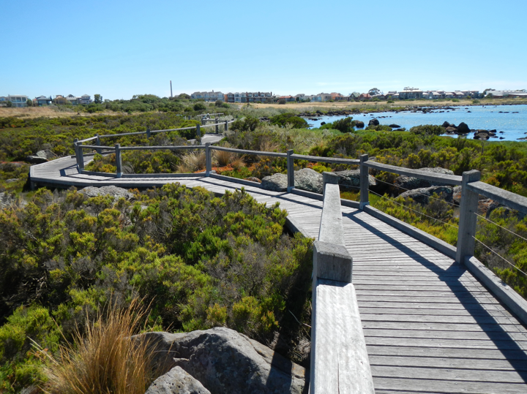

Support sustainable use and development of the marine and coastal environment
Activities under Action 4 progress the following Policy outcomes:
- The marine and coastal environment hosts a diverse range of uses and experiences strategically located to be safe and sustainable now and in the future.
- Access to marine and coastal Crown land is safe for the public, with facilities located to protect environmental and cultural values.
- Use of the marine and coastal environment by industry is ecologically, socially and economically sustainable.
- Ecologically sustainable and equitable use of the marine
environment provides social, cultural and economic benefits and minimises negative impacts on values.
- The benefits of marine and coastal Crown land are available to current generations without compromising the ability of future generations to enjoy such benefits.
- Quality science and knowledge is utilised to inform evidenced-based decision making and to evaluate the
effectiveness of decisions.
- Marine and coastal managers have the knowledge skills and capacity to manage current and future
challenges.

Purpose
This action ensures that one use doesn’t unfairly impact the marine and coastal environment or other users and uses, now and in the future. This action will provide long-term strategic planning and capacity building to keep use and development in Victoria’s marine and coastal environment sustainable.
The time is now — to speak, listen and act with courage; to make decisions together and transparently that are in the interests of our oceans, coastlines, connected landscapes and waterways for generations to follow.
We must forge a future together to make things better.
— Traditional Owner Message

Why this is needed
Victorians enjoy our marine and coastal environment for its natural and cultural value, and recreational opportunities. To maintain these, we need to ensure development and coastal use is sustainable. A healthy environment allows us to enjoy activities such as swimming, surfing, fishing and boating. Equally, it supports jobs and livelihoods for Victorians.
Coastal and marine areas have ongoing cultural significance to Traditional Owners. Over thousands of years, Traditional Owners have used their knowledge to practice sustainable management of Country. Development of the coast over the last 200 years has added new chapters to the stories of these places, but the cultural significance remains. To retain this significance and heal Country, Traditional Owners’ knowledge needs to be incorporated in future planning for new and existing developments.
The health of the marine and coastal environment that we rely on needs to be prioritised and protected when we plan for and manage the impacts of different uses. We must strive to be ecologically, socially and economically sustainable in how we use and impact this unique environment.
As Victoria’s population grows, more people are choosing to enjoy, visit, live and work in our marine and coastal environment. We need to manage the increased use and access demands to protect the health of these areas, and reduce conflicts between uses and users. For example, high visitation along the Great Ocean Road is leading to impacts such as traffic congestion, overloaded parking areas, and damage to vegetation. This is causing conflict between visitors and locals, and adversely affecting habitats, values and experiences.
Access to marine and coastal areas is provided by assets and structures such as boat ramps, jetties, ports, lifesaving clubs, stairways and paths. Many of these assets and structures are ageing, intensively used, and were not built to be resilient to climate change. Improved, well-sited and maintained assets and structures are necessary to deliver safe access and protect environmental and cultural values.
As we adapt to sea level rise, sea temperature increases and other impacts of climate change, how and where we access, use and enjoy marine and coastal areas may have to change. Many existing buildings and structures were built when marine and coastal processes and the impacts of climate change were not known or well-understood. Investment in new and existing assets, buildings and structures that support industry, tourism and recreation opportunities should be strategically planned and located to ensure they are safe and sustainable now and in years to come.

Action focus
This action enables sustainable use and development of the marine and coastal environment by facilitating long-term strategic planning for Crown land management and recreation and industry uses. To ensure this planning is followed through with best practice on the ground, the knowledge, skills and capacity of Victoria’s marine and coastal managers will be a priority.

Crown land use
A key focus of this action is ensuring that marine and coastal Crown land is accessible and allows for a range of recreation and tourism experiences, while protecting environmental and cultural values now and in the future. This will be achieved through local-scale CMMPs, frameworks for coastal infrastructure investment and monitoring of visitor carrying capacity. The state-wide Recreational Boating Strategy will be implemented in line with the Policy and will integrate with these place-based management plans.

Industry use
Long-term strategic planning will be used to encourage industry uses to be ecologically, socially and economically sustainable. The marine and coastal environment supports many existing industries such as shipping, tourism, fishing, aquaculture and oil and gas extraction. It also provides opportunities for new and emerging industries such as ocean and offshore wind energy. The MSP Framework (see Action 5) is a key mechanism to support sustainable use of the marine and coastal environment by industry and other users. Application of the MSP Framework is supported by strategic planning by marine sectors at a state-wide scale (e.g. offshore wind, and local and commercial ports as identified through the port reform process) that incorporates the guidance in the MSP Framework and the approach and processes of marine spatial planning. To assist industries to improve their sustainability, best practice guidance on dredging and marine pest management are also identified.

Capability development
To implement these strategic plans, marine and coastal managers need the knowledge, skills and capacity to make informed decisions that address current and future challenges. The Victorian Government has developed a variety of online tools to support analysis and participatory processes in decision making and planning. These tools include CoastKit, the Marine and Coastal Knowledge Framework, NaturePrint and Strategic Management Prospects. Digital Twin Victoria is also currently in development. This will provide training, guidance and access to a hub of expertise to optimise the use of these tools and information.
Activities in this action will complement other policy and strategy work being implemented across Victoria aimed at ensuring marine and coastal industries and uses are sustainable (see Appendix E).
Table 7: Activities
Activity | Lead* | When
To ensure that Victorians can access marine and coastal Crown land safely, enjoy a range of recreational and tourism experiences and protect environmental and cultural values now and in the future, we will promote integrated and coordinated strategic planning to encourage sustainable and adaptable recreational and tourism activities by:
- Supporting the preparation, review and implementation of CMMPs:  - that align with Traditional Owner needs, priorities and assertions  - in accordance with guidelines  - for priority coastal compartments as identified consistent with the Act. | Lead: DELWP LG, CoMs, PV**  Collaborate: MW, RAPs, DJPR | 2022–27
- Trialing and evaluating a coastal infrastructure investment framework:  - trial the implementation of a coastal infrastructure investment framework for management of built assets on Crown land (e.g. includes toilet blocks/change rooms, coastal trails, walking tracks, recreation reserves, art works, playgrounds, historic sites and interpretive signage) across three coastal managers spanning from Portarlington to Marengo  - evaluate the trial and revise as needed to roll out across the state or trial in different coastal locations. | Lead: GORCAPA, BBFCoM, BCCoM  Collaborate: DELWP, PV, LG, RAPs (Wadawurrung and Eastern Maar)  DELWP | 2022–24  2024–27
- Continuing to strengthen the oversight of coastal protection assets by implementing a strategic asset management approach that identifies priority assets for maintenance, replacement or removal that:  - meets requirements for the Victorian Asset Management Accountability Framework  - uses the Coastal Asset Management System (CAMS) – the centralised repository for coastal protection asset information  - complements the state-wide approach to coastal hazard risk management and adaptation planning (VRC) | Lead: DELWP  Collaborate: LG, VFA, CoM, PV, RAPs | 2022–27
- Investigate a system to monitor carrying capacity high-use areas:  - pilot a system to assess and monitor the carrying capacity and visitor experience in high-use areas of the Great Ocean Road Coast and Parks, which will include factors such as visitor numbers and behaviour, and impacts of visitation on the (aesthetic, biodiversity and cultural) values of these areas  - evaluate the piloted system and apply in planning and management of other high-use marine and coastal areas in Victoria (e.g. Mornington Peninsula, Gippsland Lakes). | Lead: GORCAPA  Collaborate: DELWP, PV, DOT, Regional Tourism Boards, DJPR, RAPs  Lead: DELWP  Collaborate: DELWP, PV, DOT, Regional Tourism Boards, DJPR, RAPs, CoM, GORCAPA | 2022–24  2024–27
- Implementing the Victorian Recreational Boating Strategy (2021–30) consistent with the Policy and:  - in alignment with Traditional Owner objectives and assertions for Country  - incorporating climate change adaptation responses  - integrating with regional and local place-based plans (e.g. management and adaptation plans)  - optimising environmental and ecologically sustainable development outcomes. | Lead: VFA (BBV)  Collaborate: CoM, PV, DELWP, RAPs, DOT, DJPR, LG, Ports Victoria, CMAs | 2022–27
- Implementing the Sustainable Local Ports Framework that:  - aligns with Traditional Owner objectives and assertions for Country  - seeks a funding model that balances asset renewal and management, and fiscal sustainability  - reflects best practice environmental management consistent with the Act and Policy for each location  - applies a place-based and adaptive approach to support economic, recreational and tourism values and emergency management response  - incorporates stakeholder engagement in precinct planning to deliver agreed outcomes  - applies the guidance, approach and processes in the MSP Framework. | Lead: DOT  Collaborate: CoM, LG, PV, DELWP, RAPs, DJPR, Ports Victoria | 2022–24
To encourage industry to be ecologically, socially and economically sustainable we will:
- Develop and implement a Victorian Commercial Ports Strategy that:  - sets a state-wide strategic 30-year vision for the commercial ports sector  - clearly articulates the economic and security priorities for port operations  - applies the guidance, approach and processes in the MSP Framework  - charts an adaptation pathway to a thriving future for the sector  - aims to achieve best practice environmental management consistent with the Policy for each location  - supports Victoria’s transition to achieving net zero emission targets. | Lead: DOT  Collaborate: PV, DELWP, LG, DJPR, RAPs, Ports Victoria | Plan finalised 2022  Implement 2023–27
- Implement the Victorian Offshore Wind Strategy 2022–29 that:  - aligns with Traditional Owner objectives and assertions for Country  - applies the guidance, approach and processes in the MSP Framework  - incorporates visual impact and marine and airborne noise assessments  - aims to achieve best practice environmental management consistent with the Policy  - acknowledges the needs of other marine users including shipping, fisheries and military  - works collaboratively with the Commonwealth Government, AEMO, VicGrid, port authorities, offshore wind developers and industry participants  - supports Victoria’s transition to achieving net zero emission target. | Lead: DELWP  Collaborate: RAPs, PV, LG, DJPR, DOT | 2022–27
- Identify opportunities to reduce the impacts of marine pests in areas where they have already established, consistent with Invasive Marine Pests, Module 2 under the Invasive Plants and Animals Policy Framework. | Lead: DELWP  Collaborate:PV, VFA, DJPR, Ports Victoria | 2022–25
- Review and update the Victorian Guidelines for Dredging to include risk-based environmental, human health and cultural protection practice and support their implementation. | Lead: EPA, DELWP  Collaborate: LG, DJPR, PV, DOT, VFA, RAPs | 2022–25
To ensure Victorians have the knowledge, skills and capacity to make informed evidence-based planning and management decisions that address current and future challenges, we will provide access to information and build skills of decision makers by:
- Determining feasibility of a marine and coastal hub of knowledge and expertise to:  - connect marine and coastal managers to the latest science, research, technical expertise, traditional ecological knowledge and to each other  - support planning and management of the marine and coastal environment  - link with similar national initiatives. | Lead: DELWP  Collaborate: VMaCC, LG, CoM, PV, DJPR, RAPs, CMAs | 2022–25
- Designing training, building capacity and increasing knowledge by:  - developing a training and capacity building program for management of the marine and coastal environment in Victoria, with topics such as:  - how to apply the Policy and its principles in decision making  - how to apply relevant guidelines and plans (e.g. Siting and Design Guidelines for Structures on the Victorian Coast, CMMP Guidelines)  - operational matters such as undertaking risk assessment and mitigation (e.g. for tree falls, cliff collapse and land slips) and applying safety guidelines  - how to understand and apply science-based concepts and information (e.g. ecosystem-based management; the cumulative, synergistic, indirect and cross-boundary impacts of human activities) to effectively manage our environment  - how to embed climate change adaptation principles in decision making processes  - responsibilities of management and adaptation responses (e.g. the role of insurance, risk and liability).  - supporting Traditional Owners to deliver cultural awareness programs that build the capacity of government and marine and coastal managers to partner with Traditional Owner groups  - working with coastal and marine managers to identify other skill and knowledge needs. | Lead: DELWP, RAPs  Collaborate: GORCAPA, LG, CoM, PV, CMAs | 2022–26
* The full names are included in the Abbreviations list (Appendix B).
** For respective areas of interest and management responsibility.
In delivering these activities key participants include PPBBA, LSV, BIAV, VRFish, AOEG, MAV, ABM and other relevant industry peak bodies, NGOs, and community groups.
Table 8: Activity Timing
Activity | 2022–23 |  | 2023–24 |  | 2024–25 |  | 2025–26 |  | 2026–27
4.1 | Start |  |  |  |  |  |  |  |  | End
4.2a | Start |  |  | End
4.2b |  |  |  |  | Start |  |  |  |  | End
4.3 | Start |  |  |  |  |  |  |  |  | End
4.4a | Start |  |  |  | End
4.4b |  |  |  | Start |  |  |  |  |  | End
4.5 | Start |  |  |  |  |  |  |  |  | End
4.6 | Start |  |  |  | End
4.7 | Start |  |  |  |  |  |  |  |  | End
4.8 | Start |  |  |  |  |  |  |  |  | End
4.9 | Start |  |  |  |  |  |  |  |  | End
4.10 | Start |  |  |  |  |  | End
4.11 | Start |  |  |  |  |  | End
4.12 | Start |  |  |  |  |  |  |  |  | End
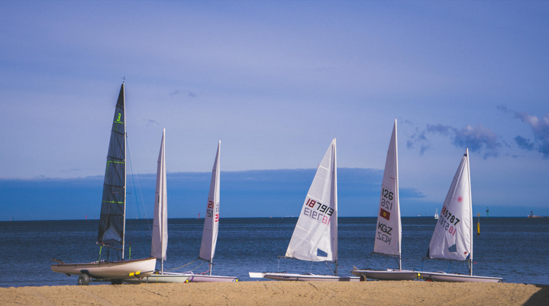

Implement the Marine Spatial Planning Framework
Activities under Action 5 progress the following Policy outcomes:
- Marine ecosystems are healthy, resilient and functional, retaining their intrinsic value while also providing ecosystem goods and services.
- Ecologically sustainable and equitable use of the marine environment provides social, cultural and economic benefits, while minimising negative impacts.
- Marine planning and management are integrated and coordinated; inclusive, collaborative and transparent; proactive, future oriented and adaptive; and evidence-based, utilising scientific, social, cultural and economic knowledge and information.
- Traditional Owners, marine and coastal managers, and community and user groups collaborate to take care of and deliver integrated and coordinated planning and management of the marine and coastal environment.
- Community and user groups are actively engaged and empowered to care for, protect and improve the marine and coastal environment.
- Quality science and knowledge is utilised to inform evidence-based decision making and to evaluate the effectiveness of decisions.
- Use of the marine and coastal environment by industry is ecologically, socially and economically sustainable.
- Industries sustainably use marine and coastal resources.

Purpose
The Policy includes an MSP Framework that provides guidance and a process for integrated and coordinated planning, management and decision making by marine sectors. The MSP Framework consists of two parts: Part A provides guidance and policies for marine planning and management; Part B outlines Victoria’s approach to marine spatial planning.
This action outlines the activities required to implement the MSP Framework.
Managing Country is not a hobby for us, it is an obligation and a responsibility. We must be at the table as equal partners with government and the broader community when knowledge
is being shared, and decisions are
being debated and agreed.
— Traditional Owner Message

Why this is needed
Victoria’s marine environment is an active place and how we use it continues to grow and change. Marine spatial planning can be used to integrate planning and management and aid in finding a balance between the needs of different users, while also supporting cultural, economic, social, and environmental values. It is a participatory approach that involves rightsholders, marine and coastal stakeholders and communities to identify actions and solutions.
Undertaking marine spatial planning can have significant benefits, including identifying marine habitats that can be recovered or enhanced, supporting the growth of Victoria’s blue economy, promoting environmental and socio-economic resilience, and supporting climate change adaptation responses across marine sectors. These benefits support long-term planning for existing marine industries (e.g. fishing, boating, oil and gas extraction) and emerging industries (e.g. offshore wind and ocean energy).

Action focus

Embedding marine spatial planning
This action identifies the mechanisms and governance frameworks required to undertake marine spatial planning and create a marine plan. As part of this process, Traditional Owners will be supported to determine their role in marine spatial planning and how bio-cultural landscapes and values are considered.

Building capability in marine spatial planning
Victoria’s Marine and Coastal Knowledge Framework and CoastKit will be updated to support the evidence-base applied during marine spatial planning. This action will also develop guidance and tools to support planners and managers in applying the MSP Framework. These activities will support the completion of Victoria’s first marine spatial planning process.
Activities in this action will also complement other policy and strategy work being implemented across Victoria that plan for the future of the state’s marine environment (Appendix E).
Table 9: Activities
Activity | Lead* | When
To achieve integrated and coordinated planning and management of the marine environment, the MSP Framework will be implemented by:
- Determining the mechanism, governance framework and funding approach to give effect to marine spatial planning and resulting marine plans. | Lead: DELWP  Collaborate: RAPs, VFA, DJPR, DOT, GORCAPA, PV, EPA, VMaCC, Ports Victoria | 2022–24
- Supporting Traditional Owners to self-determine:  - their role in marine spatial planning  - appropriate protocols and processes for Indigenous Data Sovereignty and how it is embedded in marine spatial planning  - how bio-cultural landscapes and values, Traditional Owner rights and objectives for Country are considered and reflected in marine spatial planning and resulting marine plans. | Lead: RAPs, DELWP** | 2022–27
- Enhancing knowledge to support planning through:  - updating Victoria’s Marine and Coastal Knowledge Framework and CoastKit to support evidence-based marine planning and management  - identifying targeted research to quantify spatially explicit values of key marine and coastal ecosystems to support marine spatial planning. | Lead: DELWP  Collaborate: RAPs, VFA, DJPR, DOT, GORCAPA, PV, CoM, LG, EPA, VMaCC | 2022–27
- Developing guidance and tools to:  - build marine and coastal manager understanding of the MSP Framework and capacity for its application  - integrate marine planning with land-based planning (including planning across jurisdictions, Commonwealth and other states)  - effectively undertake marine spatial planning. | Lead: DELWP  Collaborate: RAPs, VFA, DJPR, DOT, GORCAPA, PV, CoM, LG, EPA, VMaCC, Ports Victoria | 2022–27
- Undertaking marine spatial planning in an area as identified through the state-wide approach. | Lead: DELWP  Collaborate: RAPs, VFA, DJPR, DOT, GORCAPA, PV, CoM, LG, EPA, VMaCC, Ports Victoria | 2023–27
* The full names are included in the Abbreviations list (Appendix B).
**For respective areas of interest and management responsibility.
In delivering these activities, key participants include CMAs, peak industry and community groups and other marine stakeholders.
Table 10: Activity Timing
Activity | 2022–23 |  | 2023–24 |  | 2024–25 |  | 2025–26 |  | 2026–27
5.1 | Start |  |  |  | End
5.2 | Start |  |  |  |  |  |  |  |  | End
5.3 | Start |  |  |  |  |  |  |  |  | End
5.4 | Start |  |  |  |  |  |  |  |  | End
5.5 |  | Start |  |  |  |  |  |  |  | End
Marine spatial planning in Victoria
DELWP is leading the implementation of the MSP Framework, engaging with Traditional Owners and Aboriginal communities, industries, marine users and government agencies. A state-wide approach is being used to determine marine planning areas and will consider where multiple activities, uses and values overlap and potentially conflict, and where marine spatial planning may be useful.
Guidelines are also being prepared to provide instructions on how to undertake marine spatial planning in a planning area. The activities in Action 5 will build on this work.

Identify resource needs for sustainable marine and coastal management
Activities under Action 6 progress the following Policy outcomes:
- Planning and management of marine and coastal Crown land is strategically funded and resourced to manage current and future challenges effectively.
- Improved knowledge and understanding of the marine and coastal environment is used to inform evidence-based decision making and evaluate the effectiveness of those decisions.

Purpose
The actions proposed in this Strategy require funding and resourcing. This action aims to understand where funding and resources are generated and invested and use this information to guide long-term investment plans and explore new funding options.
It is our assertion that this Marine and Coastal Strategy needs to be a living document. The Strategy provides a roadmap for the conversations and transparent decision making Traditional Owners, government and the broader Victorian community need to make together.
— Traditional Owner Message

Why this is needed
A strong focus of the Policy is to set the direction for a strategic and sustainable approach to funding the planning and management of marine and coastal Crown land. The Policy states that funding is a shared responsibility across all levels of government, beneficiaries and users of the marine and coastal environment. Collaboration is essential to achieve this.

Action focus

Identifying funding sources – existing and needed for the future
This action will determine the resources required and funding options for sustainable marine and coastal management by establishing what funding we already have, and what funding we still need, to effectively manage current and future challenges. We will use this information to determine options for funding and create strategic long-term investment plans.

Maximising return on investment
These activities in this first Strategy lay the foundations for the implementation of further reforms in future strategies – ensuring we have a coordinated and efficient use of resources. As marine and coastal management and adaptation will come at a significant cost, it is important that we provide support to those that need it, share our insights and identify opportunities to maximise the impact of our investment.
Table 11: Activities
Activity | Lead* | When
Identify resource needs for planning and sustainable management of marine and coastal Crown land to address current and future challenges by:
- Getting a clear understanding of existing funding sources and systems to ascertain where funding is generated and invested by:  - considering all sources of funding generated from, or applied to management of, the marine and coastal environment (including volunteer and private funding)  - building on work completed for the Financing the Coast project (which had a limited focus on coastal Crown land)  These results will help to determine funding options (Activity 6.4), build stronger investment plans (Activities 6.5, 6.6) and ultimately, help secure additional funding. | Lead: DELWP  Collaborate: DJPR, DOT, VMaCC, RAPs, DTF, LG, NGOs, PV, Ports Victoria | 2022–23
- Collating state-wide funding needs identified through regional and local plans (e.g. CMMPs, adaptation plans, Regional Catchment Strategies). | Lead: DELWP  Collaborate: PV, LG, COM, MAV, GORCAPA, CMAs** | 2024 and 2026  Review biannually
- Exploring funding options for marine and coastal management that:  - are consistent with the Policy  - consider Traditional Owner rights and interest, and self-determination  - enable adaptation and resilience building  - are equitable and efficient  - consider alternate approaches  - model the needs of different marine and coastal managers  - take a whole-of-marine-and-coast perspective  - consider all levels of government, users and beneficiaries. | Lead: DELWP  Collaborate: DJPR, DOT, PV, LG, CoM, MAV, RAPs, GORCAPA, VMaCC, CMAs, DTF | 2023–26
- Progressing long-term state-wide investment plans for marine and coastal management that focus on elements such as:  - Traditional Owner rights and assertions (Activity 1.4)  - habitat connectivity (Activities 2.1–2.7)  - coastal hazard and erosion advice (Activities 3.5,3.7,3.8)  - adaptation responses (Activities 3.12,3.13)  - marine spatial planning (Activities 5.2, 5.3, 5.5)  - recreation and tourism infrastructure (Activities 4.1,4.2,4.4,4.5)  - research to support decision making (Activities 2.1, 3.1–3.4). | Lead: DELWP, DJPR**  Collaborate: LG, MAV, CoM, PV, RAPs, DOT, Ports Victoria, MW, CMAs** | 2022–25
- Progressing a long-term state-wide investment plan for nature-based and other coastal protection asset management that:  - aligns with the state-wide approach to coastal hazard risk management and adaptation planning (VRC)  - identifies priority assets for maintenance, repurposing  or removal  - meets requirements for the Victorian Asset Management Accountability Framework  - considers climate adaptation and mitigation benefits. | Lead: DELWP  Collaborate: LG, VFA, CoM, PV, Ports Victoria, RAPs** | 2022–25
Improve knowledge and understanding of the marine and coastal environment to inform evidence-based decision making and evaluate the effectiveness of those decisions by:
- Progressing an environmental economic account for the marine and coastal environment (by building on the account that was developed for the Great Ocean Road Coast and Parks) to understand the value of marine and coastal ecosystems and the goods and services they provide. | Lead: DELWP  Collaborate: PV, LG, CoM, MAV, DTF, GORCAPA, RAPs | 2022–25
* The full names are included in the Abbreviations list (Appendix B).
** For respective areas of interest and management responsibility.
Table 12: Activity Timing
Activity | 2022–23 |  | 2023–24 |  | 2024–25 |  | 2025–26 |  | 2026–27
6.1 | Start |  | End
6.2 |  |  |  | Start | End |  |  | Start | End
6.3 |  | Start |  |  |  |  |  |  | End
6.4 | Start |  |  |  |  |  | End
6.5 | Start |  |  |  |  |  | End
6.6 | Start |  |  |  |  |  | End
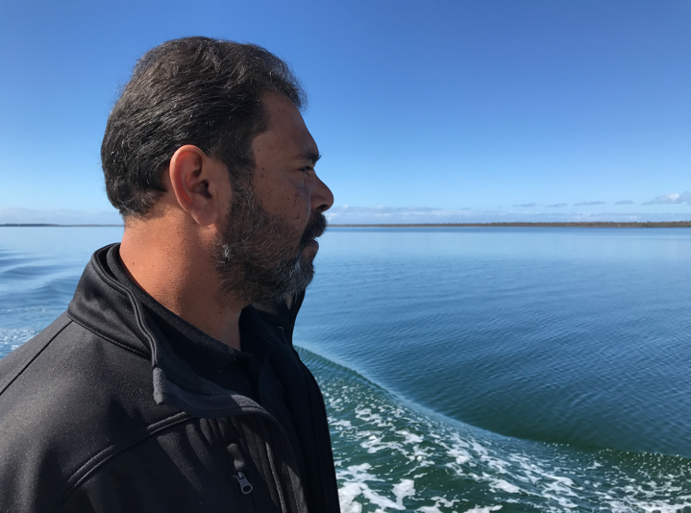

Implementing and evaluating the Strategy
The diversity of organisations, issues and interests in marine and coastal management means that no single entity can deliver the whole-of-landscape response that is needed. Formal and informal collaboration arrangements will be vital for effective and integrated delivery of this Strategy.
The Strategy includes an outline of timeframes and responsibility for delivery of the activities under the six actions. DELWP is required to report annually on its implementation. An Interagency Implementation Committee will be established to oversee implementation of the Strategy and facilitate reporting processes.
This Strategy will guide investment over the next five years, including the development of business cases. While the Strategy includes some actions and activities with committed funding, others will require future commitment as a whole, or part of an integrated package of priority actions and activities. As the first of three strategies under the Policy, this Strategy establishes the foundations for investment in the Policy’s second and third five-year cycles, which will be critical to achieving the vision and intended outcomes of the Policy.
A monitoring, evaluation, reporting and improvement framework will be developed to evaluate if this Strategy is achieving the intended outcomes of the Policy.
Table 13: Activities to implement and evaluate the Strategy
Activity | Lead* | When
- Oversee implementation of the Strategy across government. | Interagency Implementation Committee | 2022–27
- Apply this Strategy to inform business cases for future funding needs.  The business cases should highlight the environmental, cultural, social as well as economic benefits of implementing the Strategy. | Lead: DELWP, DOT, DJPR  Collaborate: LG, MAV, CoM, PV, RAPs | 2022–27
- Evaluate the implementation of this Strategy against the intended outcomes of the Policy, incuding:  - an assessment of the resources required to manage our marine and coastal environment as envisaged in the Policy  - inputs and changes into the next Strategy  - a review of how the Strategy has met Traditional Owner requirements. | Lead: VMaCC, DELWP, RAPs | Mid-term evaluation 2024  Final evaluation 2027
* The full names are included in the Abbreviations list (Appendix B).

Roles and responsibilities
The Victorian Government, Traditional Owners, marine and coastal managers, communities and individuals are all involved in planning, managing and caring for the marine and coastal environment. All stakeholder groups have important roles and responsibilities in the joint implementation of this Strategy.
Victorians all have responsibility to care for the environment, understand risks from climate change, apply the best available information and knowledge, and participate in engagement processes that guide decision making to achieve our collective vision. Victorians also have a shared responsibility to consider the guiding principles outlined in the Act and the Policy, take a stewardship approach to build understanding and knowledge, and to engage and collaborate in the implementation of this Strategy.
Traditional Owners hold a unique status under Victorian law and inalienable rights under Australian law. Their connection to Country is more than one of stewardship: Traditional Owners are part of Country and are fundamental to the healing and ongoing management of both land and sea Country. Traditional Owners have responsibilities to protect the vast array of cultural heritage that is woven across the landscape on all tenures (see DELWP’s Pupangarli Marnmarnepu: Aboriginal Self-Determination Reform Strategy 2020-25).
Connection to Country is at the core of who we are today, always have been and always will be. Country is who we are and it is home.
— Traditional Owner Message
Managing Country is not a hobby for us, it is an obligation and a responsibility. We must be at the table as equal partners with government and the broader community when knowledge is being shared, and decisions are being debated and agreed.
— Traditional Owner Message
Government and institutions have roles and responsibilities that are legislated, including management of specific marine and coastal areas. The Policy outlines roles and responsibilities for coastal climate change adaptation responses and ensuring the efficient and effective resourcing of management activities. It also emphasises the importance of stakeholder and community participation if marine spatial planning is to
be effective.

Responsibilities for each action in the Strategy
Each of the six actions list activities identifies who is the lead responsible for delivery and who are the important collaborators. The activities also outline the time frames for delivery.
The leads and collaborators identified are Registered Aboriginal Parties (rights holders) or agencies with a legislated role to manage aspects of the marine and coastal environment.
Table 14: Responsibilities of activity leads and collaborators
Who | Responsibilities (note this list is not exclusive)
Lead | - Facilitate the activity to occur/make it happen  - Project management  - Reporting  - Delivery/implementation  - Consult with identified collaborator rights holders/agencies  - Consult with all relevant stakeholder according to IAP2 spectrum of public participation
Collaborator | - Provide input and viewpoints to make sure activity meets best standard  - Ensure that the activity delivers on the needs from the collaborator’s perspective  - Promotes connections  - Complements other work  - Guides delivery  - Agencies who should be engaged by the Lead to ensure integration and collaboration
Many other organisations, including peak community, interest and industry groups, community groups, non-government agencies and research institutions play a significant role in the planning and management of the marine and coastal environment. In developing the Strategy, many of these organisations identified activities they would like to be engaged in. Where relevant, these groups have been specifically identified at the end of each action table.
The collaborators listed within each actions are not exclusive. Each lead agent should consider which peak bodies, community groups, non-government agencies and research institutions can also collaborate in its delivery.
Figure 2 identifies the roles associated with the actions in this Strategy for state and Local Government, marine and coastal managers (which include Local Government, CoM, Parks Victoria, CMAs, port authorities), and individuals and communities.
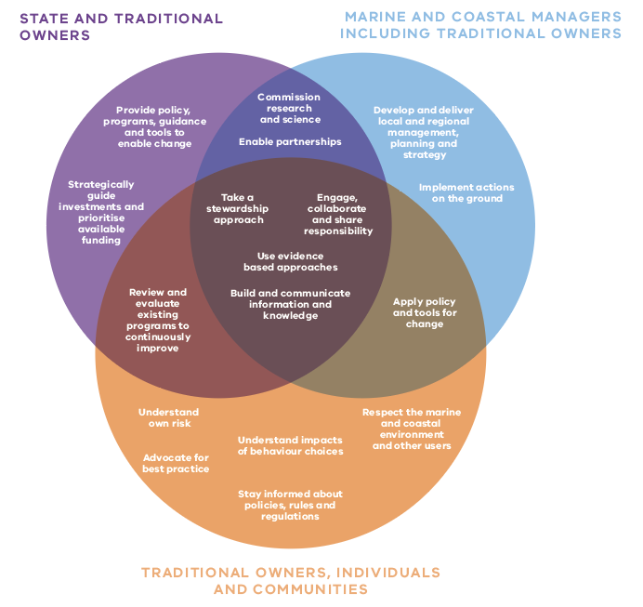
Figure 2: Roles and responsibilities in marine and coastal planning and management. Traditional Owners have roles in all areas.
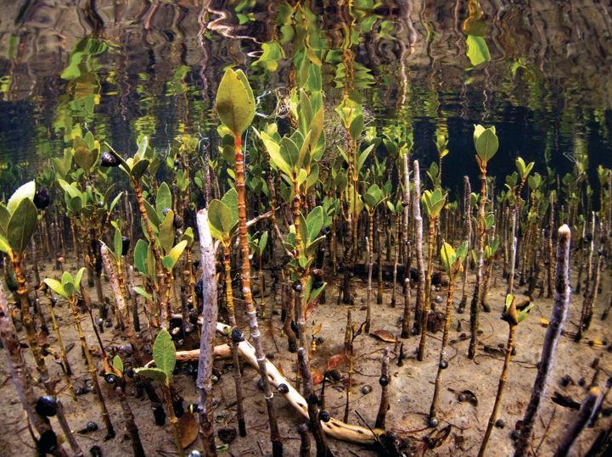

Appendix A: Strategy Development
The Act establishes the guiding principles and objectives for planning and managing the state’s marine and coastal environment. It also creates the ability to make a Marine and Coastal Policy and a Marine and Coastal Strategy. The Policy has been developed and came into effect on 6 March 2020. The Policy outlines the direction for planning, management and sustainable use of the marine and coastal environment for the next 15 years.
This Strategy is the first of three consecutive strategies to be delivered during the 15-year life of the Policy (Figure 3). It sets the direction and outlines a collective action plan for the next five years by allocating timeframes and responsibilities for delivery of priority actions. This establishes how we will work together to achieve the Policy’s vision.
Our vision is for a healthy, dynamic and biodiverse marine and coastal environment that is valued in its own right, and that benefits the Victorian community now and in the future.
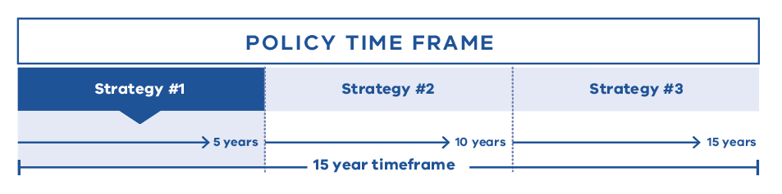
Figure 3: There will be three, five-year strategies during the 15-year life of the Policy.

How the Strategy was developed
This Strategy was developed by DELWP, working closely with Traditional Owners and VMaCC.
State government departments, local government, marine and coastal managers, and peak bodies with marine and coastal interests were consulted throughout 2020 and 2021 to gather ideas and identify priority actions (Figure 4). Following consultation, DELWP made changes to the draft Strategy to incorporate what was heard before final release of the Strategy.
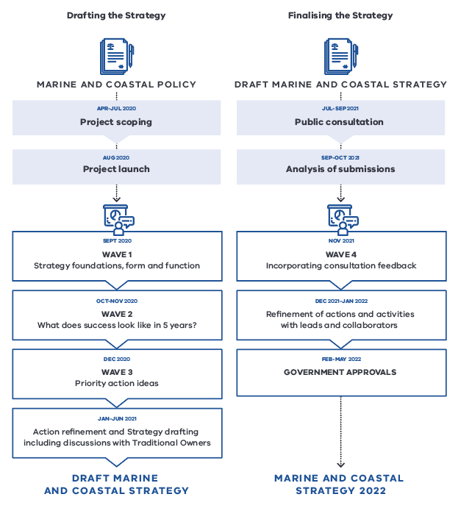
Figure 4: Development of the Strategy.
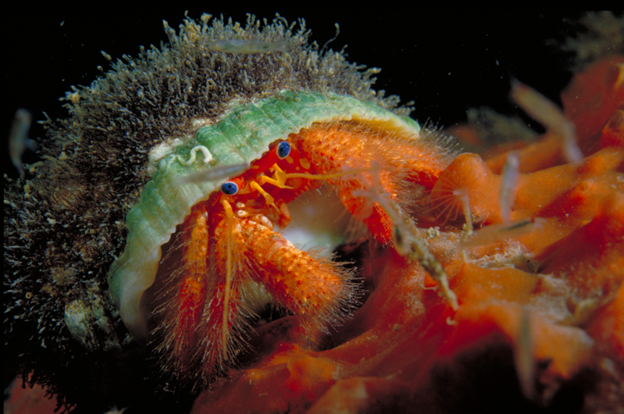

Appendix B: Abbreviations
Table 15: Abbreviations used in the Strategy
Abbreviation | Full title
ABM | Association of Bayside Municipalities
AEMO | Australian Energy Market Operator
AOEG | Australian Ocean Energy Group
BCCoM | Barwon Coast Committee of Management
BBFCoM | Bellarine Bayside Foreshore Committee of Management
BBV | Better Boating Victoria
BIAV | Boating Industry Association Victoria
CMA | Catchment Management Authority (refers to those CMAs with coastline)
CMMP | Coastal and Marine Management Plan
CoM | Committees of Management
DELWP | Department of Environment, Land, Water and Planning
DJPR | Department of Jobs, Precincts and Regions
DOT | Department of Transport
DPC | Department of Premier and Cabinet
DTF | Department of Treasury and Finance
EMP | Environmental Management Plan
EPA | Environment Protection Authority
ERF | Emissions Reduction Fund
GMA | Game Management Authority
GORCAPA | Great Ocean Road Coast and Parks Authority
IPCC | Intergovernmental Panel on Climate Change
MAV | Municipal Association of Victoria
MW | Melbourne Water
LG | Local Government
LSV | Life Saving Victoria
MW | Melbourne Water
PPBBA | Port Phillip Beach Box Association
PV | Parks Victoria
RAP | Registered Aboriginal Party
RASP | Regional and Strategic Partnership
RCS | Regional Catchment Strategy
RWS | Regional Waterway Management Strategy
TfN | Trust for Nature
VICSES | Victorian State Emergency Services
VFA | Victorian Fisheries Authority
VMaCC | Victorian Marine and Coastal Council
VRFish | Victorian Recreational Fishing Peak Body

Appendix C: Strategy links to the Policy
Table 16: Strategy links to chapters of the Marine and Coastal Policy 2020
 |  | Strategy Actions
 |  | 1.  Traditional Owners determine how their rights and obligations are embedded into planning and management of the marine and coastal environment | 2.  Improve the condition and ecological connectivity of habitats and respect and care for our marine and coastal areas | 3. Adapting to climate change | 4.  Support sustainable use and development of the marine and coastal environment | 5.  Implement the Marine Spatial Planning Framework | 6.  Identify resource needs for sustainable marine and coastal management
Policy Chapters | Traditional Owner rights, aspirations, and knowledge | YES | YES | YES | YES | YES
 | Ecosystems and habitats | YES | YES | YES | YES
 | Natural features and landscapes |  |  | YES | YES
 | Cultural values and heritage sites | YES |  | YES | YES | YES
 | Values of marine and coastal Crown land | YES |  |  | YES | YES | YES
 | Managing coastal hazard risk | YES | YES | YES | YES | YES | YES
 | Emergency response and preparedness | YES |  | YES | YES | YES | YES
 | Coastal settlements |  | YES | YES | YES
 | Marine and coastal industries |  |  |  | YES | YES
 | Recreation and tourism |  |  | YES | YES | YES
 | Buildings, structures, and access | YES |  | YES | YES | YES
 | Marine Spatial Planning Framework | YES | YES | YES | YES | YES | YES
 | Stewardship and collaborative management | YES | YES | YES | YES | YES
 | Funding for sustainable management of marine and coastal Crown land |  |  |  |  |  | YES

Appendix D: Glossary
Term | Meaning
adaptation | Adaptation, as defined by the IPCC, is ‘the process of adjustment to actual or expected climate and its effects’. This definition differentiates between human and natural systems. In human systems, adaptation seeks to moderate or avoid harm or exploit beneficial opportunities. In some natural systems, human intervention may facilitate adjustment.
blue carbon | Carbon that is stored in a solid state in marine and coastal ecosystems, which prevents its release into the atmosphere and thus avoids increased levels of carbon dioxide.
blue carbon market | Aims to acknowledge the value of blue carbon ecosystems and incentivise land managers/owners to protect these systems.
blue economy | The World Bank defines the blue economy as the sustainable use of ocean resources for economic growth, improved livelihoods and jobs and ocean ecosystem health.
Caring for Country plan, Whole-of-Country plan or Country plan | A plan — sometimes titled in an Aboriginal language — developed by a Traditional Owner group that expresses their vision, assertions, strategies and actions for Country. Country Plans support Traditional Owners to communicate their rights, cultural authority or interest in Country.
CoastKit | CoastKit is a knowledge management system that provides coastal and marine managers and the public with decision support tools and access to marine biodiversity and environmental data through knowledge portals.
coastal compartment | A section of coastline that is defined by certain landform and sediment transportation processes. Primary, secondary and tertiary compartments are identified for different planning and management purposes.
coastal hazards | Natural coastal processes that may negatively impact on the marine and coastal environment, including impacts on human use, values, property or infrastructure. Hazards include coastal erosion and inundation (flooding) due to storm tide and sea level rise. For further detail on the definition of different hazards please refer Table 17 – Victorian coastal hazard definitions.
coastal infrastructure investment framework | A framework developed by DELWP Barwon South West Regions to assist land managers to manage built assets on Crown land and embody holistic thinking into their initial strategic planning to assess what assets require investment. The framework encourages land managers to consider a range of criteria that cover social, environmental, heritage and economic aspects.
Coastal and Marine Management Plan | This plan is defined in the Marine and Coastal Act 2018 (Part 7, Division 1) as a plan on matters relating to and affecting marine and coastal Crown land.
Conservation Action Plan | A plan, developed by Parks Victoria, that adapts and refines the Conservation Action Plan framework first developed by the Nature Conservancy and based on the Open Standards for the Practice of Conservation.
cumulative effects | The accumulation of impacts on the environment over time and across space in combination or through interactions, including impacts that are reasonably foreseeable in the future.  Reasonably foreseeable impacts in the future include future permitted activities (i.e. activities that are allowed without requirement for consent), activities for which consent has been granted but the activities have yet to be implemented, and environmental change (e.g. climate change impacts).
decision support tools | These tools are the wide range of computer-based tools (simulation models, techniques and methods) developed to support decision analysis and participatory processes.
ecological connectivity | Ecological connectivity is the unimpeded movement of species and the flow of natural processes that sustain life on Earth.  Ecological connectivity is an essential part of nature. It is necessary for the functionality of ecosystems, is key for the survival of wild animals and plant species and is crucial to ensuring genetic diversity and adapting to climate change across all biomes and spatial scales.  Connectivity conservation (maintaining, enhancing or restoring connectivity) is a direct response to the destruction and fragmentation of vegetation, habitats and loss of Earth’s species. It is a key tool for the safeguard and management of habitats, biodiversity and ecosystem functions such as migration, hydrology, nutrient cycling, pollination, seed dispersal, food security, climate resilience and disease resistance. (IUCN, 2020).
economic and policy instruments | Economic and policy Instruments may be:  - Coastal tender (market-based incentives)  - Planning controls (zones, overlays)  - Leases agreements  - Land for wildlife  - 173 agreements on land titles  - Government buying areas of land for migration
ecosystem | All living things in a given area, as well as their interactions with each other and with their non-living environments (e.g. weather, earth, sun, soil, climate, atmosphere).
environmental economic accounting | Environmental economic accounting is a framework for organising statistical information to help decision makers better understand how the economy and the environment interact.
Environmental Management Plan | This plan is defined in the Marine and Coastal Act 2018 (Part 6, Division 2) as a plan on matters relating to and affecting Port Phillip Bay or in relation to any other areas of the marine environment.
Environmental sustainability | Avoidance of the depletion of natural resources to maintain an ecological balance.
habitat | A place or type of site where an organism or population occurs naturally.
habitat migration | The tropicalisation of marine ecosystems or the movement of locations where the conditions are appropriate for a species, due to climate change.
Indigenous data sovereignty | Indigenous data sovereignty is the right of Aboriginal peoples to govern the collection, ownership and use of data about their communities, peoples, land and resources.
invasive species | A species that, because of human activities, occurs beyond its accepted normal distribution and threatens valued environmental, agricultural or other social resources because of the damage it causes.
marine and coastal Crown land | Land defined in the Marine and Coastal Act 2018 as all Crown land and waters between the outer limit of Victorian coastal waters and 200 metres inland of the high-water mark of the sea, including:  - Crown land (whether or not covered by water) to a depth of 200 metres below the surface of that land  - any water covering the land referred to in paragraph (a) from time to time.  In addition, marine and coastal Crown land includes Crown land that extends more than 200 metres inland of the high-water mark of the sea where it has been reserved under the Crown Land (Reserves) Act 1978 for the purposes of the protection of the coastline.  For this purpose, it includes land (whether or not covered by water) and any water covering that land to a depth of 200 metres below the surface of that land.
marine and coastal environment | Environment defined in the Marine and Coastal Act 2018 as the following between the outer limit of Victorian coastal waters and 5 kilometres inland of the high-water mark of the sea:  - the land (whether or not covered by water) to a depth of 200 metres below the surface of that land  - any water covering the land referred to in paragraph (a) from time to time  - the biodiversity associated with the land and water referred to in paragraphs (a) and (b).
Marine and Coastal Knowledge Framework | The Marine and Coastal Knowledge Framework (MACKF) has been developed by DELWP to inform better choices when protecting our marine and coastal ecosystems. It includes standards for data collection, management, and analysis to feed back into our conservation and adaptation decision making. It is informed by policy requirements and principles, best-available technology, science, and the application needs for management, planning, evaluation and reporting.
marine and coastal processes | The physical, chemical and biological processes that occur in marine and coastal environments over long and short timescales; for example, the natural accretion and erosion of beaches, nutrient cycling and soil formation processes, the structure and functioning of ecological communities.
marine environment | Environment defined in the Marine and Coastal Act 2018 as the following between the outer limit of Victorian coastal waters and the high-water mark of the sea:  - the land (whether or not covered by water) to a depth of 200 metres below the surface of that land  - any water covering the land referred to in paragraph (a) from time to time  - the biodiversity associated with the land and water referred to in paragraphs (a) and (b).
marine spatial planning | Marine spatial planning is a practical way to organise marine space, and the interactions among human uses and between these uses and the marine environment. It provides a process for assessing where activities and uses may be compatible or incompatible, and where activities and uses conflict.
Marine Spatial Planning Framework | A framework (required under the Marine and Coastal Act 2018) in the Marine and Coastal Policy 2020 that provides guidance and a process for achieving integrated and coordinated planning and management of the marine environment.
marine sectors | Means different sectors according to distinct marine ecosystem characteristics, and according to distinct society/economic characteristics (e.g. ports, recreation, maritime industry, transport, tourism and development industry).
Regional Catchment Strategy | This strategy is the primary integrated and strategic planning mechanism for the management of land, water and biodiversity resources in each Victorian region. It is prepared under the Catchment and Land Protection Act 1994.
Regional and Strategic Partnership | This partnership is defined in the Marine and Coastal Act 2018 (Part 6, Division 1) as a partnership of two or more entities to respond to identified regional issues relating to or affecting the marine and coastal environment.
Regional Waterway Strategy | A regional Waterway Strategy (RWS) is a single planning document for river, estuary and wetland management in each region, and implements the management approach outlined in the Victorian Waterway Management Strategy.
resilience | Resilience is the capacity of systems (social, economic and environmental systems) to cope with or ‘bounce back’ following a hazardous event or disturbance. Resilience means system capacity to respond or reorganise to maintain essential functions, identities and structures while also maintaining the capacity to adapt and transform.
Registered Aboriginal Party | The Victorian Aboriginal Heritage Act 2006 recognises Registered Aboriginal Parties (RAP) as the primary guardians, keepers and knowledge holders of Aboriginal Cultural Heritage. RAPs are the primary source of advice and knowledge on matters relating to Aboriginal places or Aboriginal objects in their region.
sustainable use and development | Sustainable development is the overarching paradigm of the United Nations. The concept of sustainable development was described by the 1987 Brundtland Commission Report as ‘development that meets the needs of the present without compromising the ability of future generations to meet their own needs’.  There are four dimensions to sustainable development – society, environment, culture and economy – which are intertwined, not separate. Sustainability is a paradigm for thinking about the future in which environmental, societal and economic considerations are balanced in the pursuit of an improved quality of life. For example, a prosperous society relies on a healthy environment to provide food and resources, safe drinking water and clean air for its citizens.
Traditional Owners | People who, through membership in a descent group or clan, have responsibility to care for particular Country. A Traditional Owner is authorised to speak for Country and their heritage as a senior Traditional Owner, as an Elder or, in more recent times, as a registered native title claimant.
Victorian coastal waters | This term has the same meaning as the term ‘coastal waters of the State’ in the federal Coastal Waters (State Powers) Act 1980, as applied to Victoria.
vulnerability to climate change | The degree to which a system, sector or social group is susceptible to the adverse effects of climate change. Vulnerability depends on the nature of the climate change(s) to which the system is exposed, the system’s sensitivity to those changes and its adaptive capacity.

Table 17: Victorian coastal hazard definitions, taken from the pilot Victoria’s Resilient Coast Guidelines (DELWP, 2022)
Category | Process/hazard | Setting/classes include |  | Mechanisms
Erosion | Short-term erosion  Event-based erosion of sediment (storm-bite) and recovery  Long-term erosion (recession)  Progressive retreat of shoreline position over time | Sandy shorelines | Sandy coasts/embayments, beach ridge systems, barrier systems, and sandy spits. | Erosion generally associated with storms or with elevated water levels. Can be driven by ocean or localised wind waves or tidal currents, as well as overland flow/drainage. Susceptible to short and long-term erosion.
 |  | Low-earth scarp | Wide intertidal flats, silty sand or peats and muds. Narrow sandy beach may exist. | Erosion primarily associated with a low active scarp cut into soft, poorly consolidated sediment. May also be influenced by overland flow and drainage. Erosion is typically long-term recession.
 |  | Soft rock | Soft rock cliffs with and without a beach. | Erosion associated with combined terrestrial processes and wave action causing weathering, undercutting, slumping, slope failures (landslip).
 |  | Hard rock | Hard rock cliffs with and without a beach. | Erosion associated with terrestrial processes and wave action causing weathering, undercutting, slope failures (landslip) and cliff-falls.
Accretion | Build-up of sediment in a localised area | All shoreline types | Shoreline, dunes and intertidal zone | Localised build-up of sand, typically driven by long-shore sediment transport and well as influenced by erosion processes.
Inundation | Permanent inundation  Regular or persistent inundation by the regular tidal cycle | All low-lying coastal land | Low-lying shoreline areas, coastal floodplains, estuary margins | Occurs when low-lying areas are regularly flooded due to tidal processes. Understanding the scale of inundation and associated impacts is required over various sea level rise scenarios.
 | Storm tide inundation  Temporary event-based inundation | All low-lying coastal land | Low-lying shoreline areas, coastal floodplains, estuary margins | Caused by a combination of predicted tides, storm-surges, and high wave action during severe storm events. Results in elevated water levels (storm surge), wave setup and wave runup causing overtopping and inundation.
Estuary dynamics | Changes in form and processes associated with estuarine and tidal areas | Estuary/tidal areas | Estuaries, Intermittently Open and Closed Lakes or Lagoons (ICOLLs), river or creek mouths, coastal lakes, natural and constructed drains. | Highly dynamic sediment environment in response to tides, sea level, storm events and catchment runoff. Resultant variations in channel alignments, sandy spits and entrance opening and closure.
Off-shore sediment dynamics | Changes in form and processes associated with off-shore bathymetry and sediment transport | Up to 3 nautical miles offshore | Off-shore sea-bed beyond the intertidal zone, including channels and sediment slugs. | Dynamic submarine sediment transport environment offshore, influenced by tides, sea level, and storm events. Resulting variations in sea-bed bathymetry and sediment dynamics.
Saline intrusion | Movement of saltwater into freshwater areas/ groundwater | Up to 5km inland from high water mark | Freshwater aquifers, springs, and systems in low-lying coastal areas. | Rising sea levels may result in movement of seawater inland, including elevated groundwater and extension of salt water.
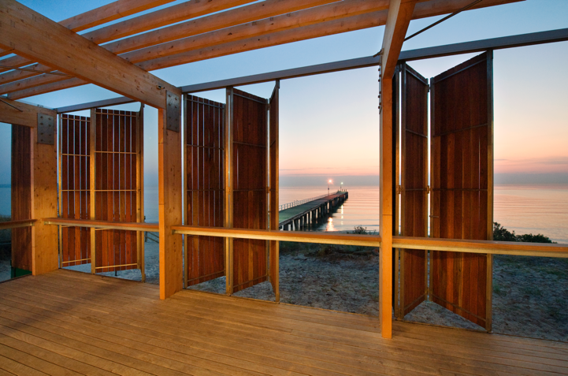

Appendix E: Other policies and strategies
This Strategy complements other policies and strategies that exist to support the management and proection of Victoria’s marine and coastal environment. An outline of the key strategies, plans and tools that will contribute to achieving the Policy vision, and which this Strategy complements, is provided in Table 18.
Table 18: Strategies, plans and data tools that contribute to improved marine and coastal management.
Title | Responsible organisation | Vision/Purpose
2050 Port Development Strategy | Port of Melbourne | By working together, we can plan for and develop Port capacity and supply chain efficiencies that enhance the competitive position of Victoria and liveability of greater Melbourne.  This document describes a plan to meet the following development objectives across the next three decades:  - working with tenants to optimise on-port productivity  - delivering on-port capacity to respond to demand growth  - supporting delivery of off-port supply chain productivity  - promoting environmental and social awareness within and around the Port  - creating value for all port stakeholders.
Biodiversity 2037 | DELWP | Victoria’s biodiversity is healthy, valued and actively cared for.
Built Environment Climate Change Adaptation Action Plan 2022–2026 | DELWP | Our cities, towns, homes, buildings and essential infrastructure are located and designed to support safe, vibrant and healthy communities in a changing climate.
Climate Change Strategy | DELWP | Our 2050 vision is for Victoria to be climate resilient, prosperous and liveable. 2050 objectives: climate-resilient built and natural environments; prosperous, liveable and healthy communities; an orderly and just adaptation process.
Coastcare Strategy 2020–25 | DELWP | Coastcare Victoria’s Strategy 2020–25 vision is for ‘thriving community groups and networks providing stewardship for a healthy, valued marine and coastal environment’.  Strategic pillars:  - Marine and Coastal Stewardship  - Thriving Community Groups and Networks  - Victorians Valuing the Coast.
CoastKit | DELWP | CoastKit is an online data repository for the community to explore and use Victoria’s marine and coastal information. CoastKit promotes standardised data classification for collection, reporting, monitoring, assessment and evaluation.
Distinctive areas and landscapes | DELWP | Victoria is home to a number of unique and sensitive landscapes and distinctive places that are highly valued for their environmental, social, cultural and economic assets. These areas (Bellarine Peninsula, Surfcoast, Bass Coast and Macedon ranges) are vital to the functioning of our urban areas, providing people with clean air, drinking water, food, resources and recreational opportunities.  They are under increasing pressure for development because of their attractiveness, accessibility and proximity to our cities, and because of environmental factors like the impacts of climate change.  These areas are being protected so that they can continue to be enjoyed by current and future generations.
Go Fishing Victoria plan | VFA | Go Fishing Victoria plan aims to get more people fishing, more often, in more places.
Great Ocean Road Regional Strategy (2004–24) | DELWP | The Great Ocean Road Region will be vibrant, prosperous and beautiful. Its diverse natural and built environment will be universally recognised, protected and enhanced. It will continue to be a prime visitor destination with world-class standing. A strong, sustainably based economy will be the foundation for its continued prosperity. The changing lifestyle needs of the community will be acknowledged and accommodated.
Invasive Plants and Animals Policy Framework | DJPR | Victoria’s wealth, wellbeing and biodiversity will be protected and enhanced by reducing the impact of invasive species.  Invasive species management will help achieve Victoria’s goals of a thriving economy and a healthy environment. This will be achieved by contributing to the following policy objectives:  - an increase in Victoria’s competitiveness and productivity  - the enhanced condition of our land and water environments, including biodiversity.
LitterWatch | DELWP, Sustainability Victoria and Federation University | The project’s vision is a public state-wide dataset of litter. This will be easy to access and use for reporting, planning, policy making and engagement. Data from LitterWatch Victoria supports priority actions in the State Government’s Port Phillip Bay Environmental Management Plan 2017–2020.
Local planning schemes | Local government | To implement state planning policies in local government areas.
Melbourne’s Future Planning Framework | DELWP | Created under Plan Melbourne to guide strategic land-use and infrastructure development for next 30 years. Provides a means of aligning state and local planning strategies.
Metropolitan Open Space Strategy | DELWP | Melbourne is a city in nature with a flourishing and valued network of public open space that is shared and accessible by everyone.
National Climate Resilience and Adaptation Strategy | Federal Government – Department of Agriculture, Water and the Environment | The purpose of the National Climate Resilience and Adaptation Strategy is to set out what the Australian Government will do to support efforts across all levels of government, business and the community, to better anticipate, manage and adapt to the impacts of climate change.  The strategy details three objectives to enable more effective adaptation across Australia:  - drive investment and action through collaboration  - improve climate information and services  - assess progress and improve over time.
National Marine Science Plan | National Marine Science Committee | This plan will help Australia realise the triple-bottom-line benefits of our marine estate, while protecting the values and natural assets we all hold so dearly.
Natural Environment Climate Change Adaptation Action Plan 2022–2026 | DELWP | Victoria's natural environments are already experiencing early impacts of a changing climate, and these are expected to increase dramatically.  There is a need to act now to respond to these challenges to help minimise consequences to our economy, society, and our environment.  The Natural Environment Adaptation Action Plan will iteratively guide adaptation efforts over the next five years and lay vital foundations in a systematic way to facilitate adaptation.
Nature Print and Strategic Management Prospects | DELWP | Nature Print products and tools are designed to help make effective investment and management decisions to deliver Biodiversity 2037.  The Strategic Management Prospects (SMP) tool is designed to help biodiversity managers consider and compare which management actions to do where. SMP helps identify actions that will have the greatest benefit to most species at the least cost.
Parks Victoria Land Management Strategy (draft Sept 2021) | Parks Victoria | Victoria’s parks will be resilient, inclusive and valued; conserving nature and cultural heritage; supporting Traditional Owner aspirations; and contributing to healthy communities.  Using the guiding principles and implementing the priorities set out in this strategy will help achieve the following eight integrated, long-term outcomes:  - Traditional Owner self-determination is advanced through managing Country together.  - High value natural systems, cultural values and landscapes are protected and restored.  - The impacts of climate change are responded to by planned adaptation, mitigation and, where necessary, accepting irreversible changes to some natural and cultural values and landscapes.  - Visitors enjoy high quality experiences and are empowered to make informed decisions about where they go and what they do in parks.  - Partnerships increase park management capability and capacity and enable management across boundaries and at the landscape scale.  - Communities and people of all backgrounds and abilities value and are advocates for parks.  - Regional economies and parks benefit from healthy parks and nature-based tourism.
Plan Melbourne 2017–50 | DELWP | The vision for Melbourne: A global city of opportunity and choice.
Port Phillip Environmental Management Plan (EMP) | DELWP | The EMP's vision of 'a healthy Port Phillip Bay that is valued and cared for by all Victorians', and the following three main goals will guide future action and investment over the next 10 years:  - Stewardship of the Bay is fostered across community, industry and government.  - Water quality is improved to ensure environmental health and community enjoyment of the Bay (including reducing litter loads to the bay).  - The Bay's habitats and marine life are thriving.
Primary Production Adaptation Action Plan 2022–2026 | DJPR | In 2026 the primary industries are better adapted to the climate being experienced, have begun to transition to more resilient models of food and fibre production and have improved their capacity to adapt.
Pupangnarli Marnmarnepu ‘Owning Our Future’ Aboriginal Self-Determination Reform Strategy 2020–2025 | DELWP | DELWP will enable self-determination by creating an environment that understands and respects the rights and dignity of Traditional Owners and Aboriginal Victorians.
Recycling Victoria:  A new economy | DELWP | The Victorian Government’s circular economy policy and plan, Recycling Victoria: a new economy outlines our sweeping plan of reform to establish a recycling system that Victorians can rely on. It transforms how our economy uses materials and how our state reuses, repairs and recycles.
Regional Catchment Strategies  Corangamite CMA , East Gippsland CMA, West Gippsland CMA  Glenelg Hopkins CMA, Port Phillip and Western Port CMA/Melbourne Water | DELWP/CMAs | Healthy, sustainable and productive land, water and biodiversity maintained by Integrated Catchment Management that is strongly community based, regionally focussed and collaborative.
Regional Floodplain Management Strategies | DELWP/CMAs | Victorian communities, businesses and government agencies are aware of flooding and are actively taking measures to manage their flood risks to minimise the consequences to life, property, community wellbeing and the economy.
Regional Waterway Strategies made under the Water Act 1989 | CMAs | The regional Waterway Strategies (RWSs) are a single planning document for river, estuary and wetland management in each catchment region and drive implementation of the management approach outlined in the Victorian Waterway Management Strategy.
Siting and Design Guidelines for Structures on the Victorian Coast | DELWP | The Siting and Design Guidelines for Structures on the Victorian Coast aim to inspire a creative and innovative approach to development in the marine and coastal environment that is considerate of the natural and cultural values in response to climate change challenges and population growth.
Traditional Owner Cultural Landscape Strategy | Federation of Victorian Traditional Owner Corporations/DELWP/PV | We have the enabling conditions to heal country and culture through the application of our knowledge and practice in the contemporary expression of living bio-cultural landscapes.
Victoria’s Environment Protection Act 2017 framework, including:  - Environment Protection Regulations 2021  - The Environment Reference Standard | DELWP and the Environment Protection Authority (EPA) | The Environment Protection Act 2017 came into effect on 1 July 2021, along with its subordinate legislation, which include the Environment Protection Regulations 2021 and the new Environment Reference Standard (ERS).  The framework introduces new environmental protections for all Victorians. It includes new obligations and enhances the powers of the EPA to prevent risks to the environment and human health.
Victoria’s framework for protecting threatened species – The Flora and Fauna Guarantee Act 1988 | DELWP | Victoria’s biodiversity target is a net improvement in the outlook for all species by 2037. The Flora and Fauna Guarantee Act 1988 (the FFG Act) is a key tool in achieving this target.  It is the key piece of Victorian legislation for the conservation of threatened species and communities and for the management of potentially threatening processes.  The FFG Act places importance on prevention to ensure that more species do not become threatened in the future. The Act emphasises the importance of cooperative approaches to biodiversity conservation and recognises that all government agencies and the community need to participate in the conservation effort.  The Act aims to conserve all of Victoria's native plants and animals.
Victoria’s offshore Wind Strategy 2022‑29 | DELWP | Ensures that cost-effective and appropriately sited and sized offshore wind projects will come online in an orderly fashion so Victorians will continue to enjoy not only a reliable, but ever increasing environmentally responsible supply of energy.
Victorian Aquaculture Strategy 2017–2022 | DJPR | A vision for the future of aquaculture in Victoria is a productive, growing and sustainable aquaculture industry valued by the community.
Victoria Planning Provisions – Planning Policy Framework | DELWP | To provide a clear and consistent framework within which decisions about the use and development of land can be made. To express state, regional, local and community expectations for areas and land uses. To provide for the implementation of state, regional and local policies affecting land use and development.
Victorian Recreational Boating Strategy | VFA | Victorian boaters will be provided with a better boating experience through the provision of boating facilities that perform to a high standard, have adequate capacity, are well maintained, safe and provide improved accessibility for all.
Victorian Waterway Management Strategy | DELWP | The vision for Victoria’s waterways is that Victoria’s rivers, estuaries and wetlands are healthy and well-managed; supporting environmental, social, cultural and economic values that are able to be enjoyed by all communities.  This Victorian Waterway Management Strategy provides the framework for government, in partnership with the community, to maintain or improve the condition of rivers, estuaries and wetlands so that they can support environmental, social, cultural and economic values for all Victorians.
Water Cycle Climate Change Adaptation Action Plan 2022–2026 | DELWP | To help build resilience to the impacts of climate change and proactively support the water sector to harness opportunities that may arise through climate action.
Water for Victoria – Water Plan | DELWP | Water is fundamental to our communities. We will manage water to support a healthy environment, a prosperous economy and thriving communities, now and into the future.

As noted in the Policy, the sea level rise planning benchmark will be updated as necessary and supported by modelling that places global projections into the Victorian context. In parallel to the development of this Strategy, the sea level rise planning benchmark is being reviewed with consideration of the latest projections and how they relate to the coast of Victoria from the IPCC as outlined in the ‘Special Report on the Ocean and Cryosphere in a Changing Climate’ (SROCC) released in 2019. Revised modelling of the extent of these projections is currently occurring. Any government approved changes to the benchmark will be reflected in the Policy.
While some actions in this Strategy are funded, additional funding to implement other actions will be subject to budget and service delivery priorities.
To be released 2022.

