# DEECA marine and coasts newsletter

Issue 19 June 2024

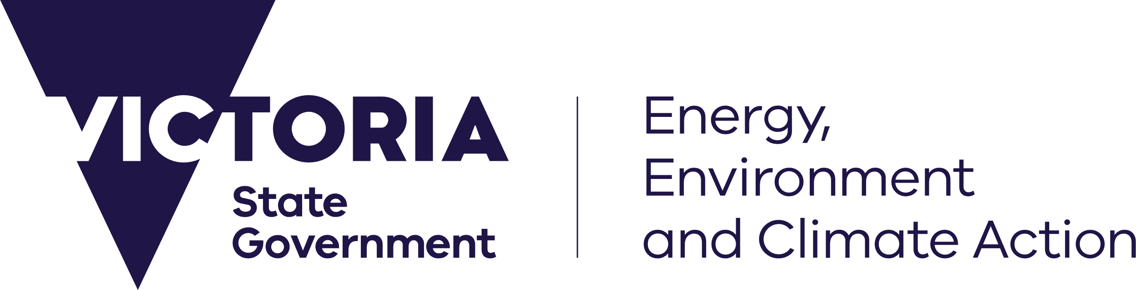



[deeca.vic.gov.au](https://delwpvicgovau.sharepoint.com/Users/fionadurante/Downloads/deeca.vic.gov.au)

Welcome to the Department of Energy, Environment and Climate Action’s (DEECA’s) marine and coasts quarterly newsletter.

## In this issue

* Victorian Budget 2024/25
* Coastal hazard adaptation is progressing across Victoria
* Adapt West – Shaping our Shores
* Port Phillip Bay Environmental Management Plan update
* Barwon South West inspections
* Mounts Bay nourishment works
* Coastcare Victoria’s ‘Coastline’

Email [marine.coasts@deeca.vic.gov.au](mailto:marine.coasts@deeca.vic.gov.au) to subscribe or unsubscribe or for more information.

## Victorian Budget 2024/25

The Victorian Government has allocated $1 million to continue the [Coastcare Victoria](https://www.marineandcoasts.vic.gov.au/coastal-programs/coastcare-victoria) program, the state’s flagship coastal volunteer program (now in its 30th year), to promote stewardship of Victoria’s marine and coastal environment and support community organisations and volunteer groups to help maintain Victoria’s marine and coastal environments.

The funding will be used to deliver the annual Summer by the Sea program, provide educational experiences using the Coastcare Victoria Schools Kit to engage students in caring for the coast and provide grants to support volunteers to care for Victoria’s coastal and marine environment.

## Marine and coastal reforms

### Coastal hazard adaptation is progressing across Victoria

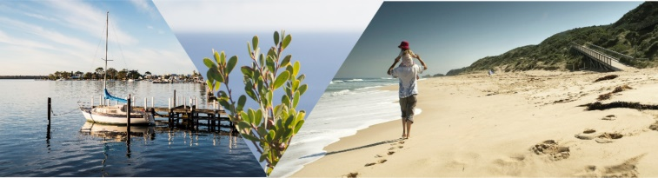

DEECA has recently awarded $1 million across eight local councils and land managers to progress planning for the impacts of coastal climate change.

These grants are part of [Victoria’s Resilient Coast – Adapting for 2100+ program](https://www.marineandcoasts.vic.gov.au/marine-coastal-management/victorias-resilient-coast-adapting-for-2100), which provides a strategic approach to coastal hazard risk management and adaptation. This is the third year of these grants, with a total of $2.8 million of coastal adaptation projects funded since 2022 and more than 25 projects underway across the State.

The grants will help recipients explore, evaluate, and adapt to the risk of coastal hazards such as erosion and inundation, using [Victoria’s Resilient Coast framework and guidelines (2023)](https://www.marineandcoasts.vic.gov.au/marine-coastal-management/victorias-resilient-coast-adapting-for-2100).

The round three grant recipients are:

* Bellarine Bayside Committee of Management – Northern Bellarine Coastal Adaptation Plan (Part 2)
* City of Greater Geelong – Point Lonsdale Hydrodynamic Modelling
* Glenelg Hopkins Catchment Management Authority – Estuarine Wetland Habitat Mapping study
* Glenelg Hopkins Catchment Management Authority – Distribution, health and restoration capacity of seagrass meadows (Part 2)
* Melbourne Water – Western Treatment Plant Coastal Hazard Assessment
* Mornington Peninsula Shire Council – Our Coast Our Future
* South Gippsland Shire Council – Waratah Bay Coastal Hazard Assessment and Adaptation Plan
* Warrnambool City Council – Wild Coast Climate Resilience Project
* Great Ocean Road Coast and Parks Authority – Point Grey Coastal Hazard Adaptation Plan

Additional supporting materials for coastal hazard adaptation are also now available on the website, including:

* [Adaptation pathways template guide](https://www.marineandcoasts.vic.gov.au/marine-coastal-management/victorias-resilient-coast-adapting-for-2100)
* [Blue Carbon and Sea Country Opportunities Report](https://www.marineandcoasts.vic.gov.au/marine-coastal-management/victorias-resilient-coast-adapting-for-2100)

Coastal adaptation guidance, materials and further information is available at [marineandcoasts.vic.gov.au/marine-coastal-management/victorias-resilient-coast-adapting-for-2100](https://www.marineandcoasts.vic.gov.au/marine-coastal-management/victorias-resilient-coast-adapting-for-2100)

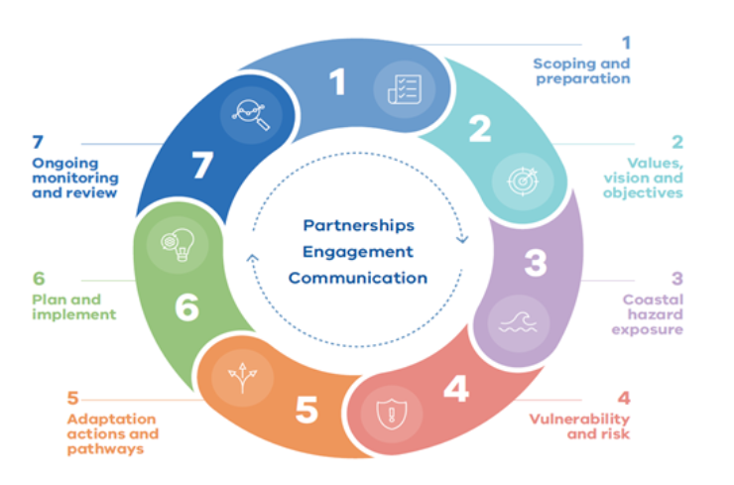

Victoria’s Resilient Coast provides a staged approach to the technical, strategic and engagement elements of risk management and adaptation.

### Adapt West – Shaping our Shores

DEECA is leading *Adapt West – Shaping our Shores* to respond to climate change and coastal hazard impacts on marine and coastal values of the Port Phillip Bay western shoreline.

*Adapt West* is being delivered by the Port Phillip Bay Western Shoreline Regional and Strategic Partnership (RASP). The 9 RASP partners are:

* Bunurong Land Council Aboriginal Corporation
* Wadawurrung Traditional Owners Aboriginal Corporation
* City of Greater Geelong
* Hobsons Bay City Council
* Wyndham City Council
* Melbourne Water
* Parks Victoria
* Corangamite Catchment Management Authority
* Department of Energy, Environment and Climate Action.

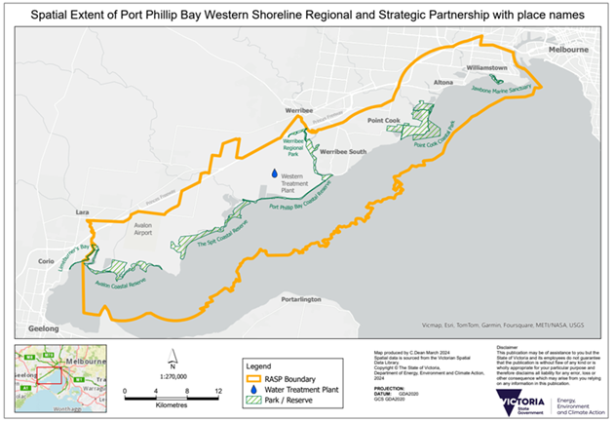

Spatial extent of Port Phillip Bay Western Shoreline Regional and Strategic Partnership with place names.

The Port Phillip Bay western shoreline is a unique part of the bay landscape with diverse marine and coastal values. These include Traditional Owner values and connection to country, internationally significant ecosystems such as Ramsar listed wetlands, parks and reserves, and a marine sanctuary.

The area is home to key facilities such as the Werribee agriculture precinct, Western Treatment Plant, oil refineries, Avalon Airport, and strategic national defence sites. It is also one of the fastest growing populations in Victoria.

Sea level rise projections show this area faces some of the highest risk for flooding of residential and industrial land across Victoria’s coast.

In 2024 the project is focussed on engagement with communities and interested parties, and assessments of ecological, cultural, community/social and economic values of the project area to inform coastal hazard adaptation planning for the area.

For more information and project updates visit [marineandcoasts.vic.gov.au/coastal-programs/port-phillip-bay-western-shoreline-regional-and-strategic-partnership](https://www.marineandcoasts.vic.gov.au/coastal-programs/port-phillip-bay-western-shoreline-regional-and-strategic-partnership)

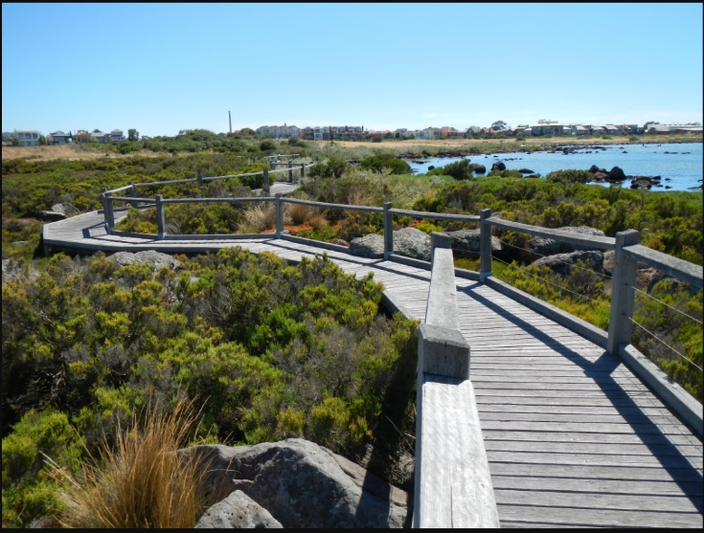

Boardwalk at Jawbone Flora and Fauna Reserve and Marine Sanctuary. Credit: Parks Victoria

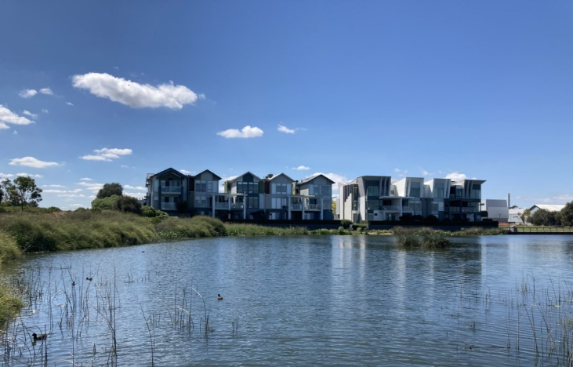

Cheetham Wetlands. Credit: Rachel Marchbank DEECA

## Marine and coastal knowledge

### Port Phillip Bay Environmental Management Plan update

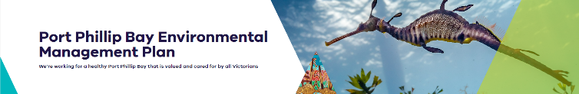

The Port Phillip Bay Environmental Management Plan 2017-2027 has recently released our 2021-2022 Annual Report and Delivery Plan on our renovated webpage [marineandcoasts.vic.gov.au/port-phillip-bay-emp](https://www.marineandcoasts.vic.gov.au/port-phillip-bay-emp).

It is incredible to see across our 277 listed activities, investment of more than $138 million which includes in-kind contributions, such as 255,000 volunteer hours.

The activities around the Bay are increasing in diversity while focussing on Victorian’s contribution to ensuring activities promoting the health of the Bay have a lasting impact.

We have published our final three indices (Eutrophication, Litter and Marine Biosecurity) to assist in simplifying complex data for reporting. These indices join our Marine and Coastal Stewardship Index, Pathogens, Water Quality Index, Marine Biodiversity and Index of Estuarine Condition, providing the basis for our annual report cards.

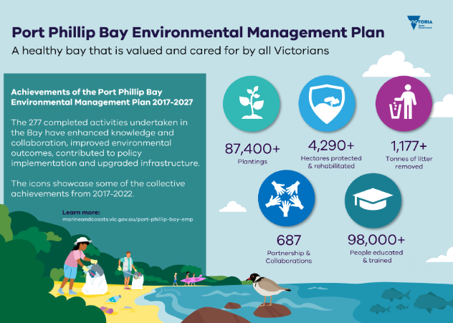

Infographic detailing some highlights listed in the 2021-2022 Annual Report.

We are currently finalising our 2022-2023 Annual Report and Delivery Plan, which will be released alongside our Monitoring, Evaluation, Reporting and Improvement (MERI) evaluation report. We have had incredible contributions from the community and look forward to sharing these responses with all.

If you’re interested in being notified of the release of the Annual Report, Delivery Plan and MERI evaluation, please contact [bay.plan@deeca.vic.gov.au](mailto:bay.plan@deeca.vic.gov.au). These and all future reports will be published to our website if you’re interested in following along with our reporting around the Bay.

## Coastal projects

### Barwon South West inspections

DEECA Land and Built Environment (LBE) continue to identify and monitor high risk coastal protection structures in need of repair.

The Barwon South West region features historic structures around the Northern Bellarine Peninsula, some of which were constructed in the 1930s.

The region also includes the Great Ocean Road, which is 240 kilometres long and includes the Twelve Apostles (limestone stacks) and the iconic Bells Beach. Tourism in the Great Ocean Road region is an important contributor to the regional and Victorian economy with over 6 million visitors per year.

Coastal risks in the region include ‘…long-term, widespread erosion (e.g., Portland), frequent soft cliff falls (e.g., Anglesea) and erosion trends that threatens the Great Ocean Road where it runs along foredunes behind the active beach (e.g., Apollo Bay, Marengo). (McCarrol, J, R et al ’Design and application of coastal erosion indicators using satellite and drone data for a regional monitoring program’, Ocean and Coastal Management 253, 2024).

In April 2024, the LBE team visited structures along the Barwon River and at Point Lonsdale where there are coastal protection structures needing repair.

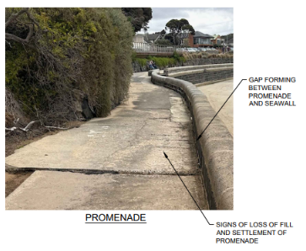

Inspection notes for Point Lonsdale seawall and promenade.

DEECA’s regional staff work with local governments, coastal managers and other stakeholders including Catchment Management Authorities to improve resilience to coastal hazards through an integrated planning approach guided by [Victoria’s Resilient Coast framework and guidelines (2023)](https://www.marineandcoasts.vic.gov.au/__data/assets/pdf_file/0022/662503/Victorias-Resilient-Coast-Guidelines-.pdf).

### Mounts Bay nourishment works

DEECA’s Land and Built Environment (LBE) team in partnership with the Great Ocean Road Coast and Parks Authority (GORCAPA) have delivered sand shifting works to the Mounts Bay and Skenes Creek areas in response to coastal erosion over the last few months.

Since February 2024, 13,845 cubic metres (m3) of sand has been deposited using sand carting from a local sand source at Point Bunbury.

The works were guided by data collected by the [Victorian Coastal Monitoring Program](https://www.marineandcoasts.vic.gov.au/marine-and-coastal-knowledge/victorian-coastal-monitoring-program) (VCMP). The VCMP is monitoring sand levels at Mounts Bay following summer storm events that exacerbated coastal erosion in the Apollo Bay area.

The works provide a critical buffer to the Great Ocean Road, Great Ocean Walk and other reticulated infrastructure located within the road footprint whilst adaptation planning continues for Mounts Bay.

The extra sand in the erosion hotspots should provide a buffer for several months as we come into winter with the potential for larger storm swell events. DEECA’s LBE team and GORCAPA will continue to work with the VCMP and closely monitor the area.

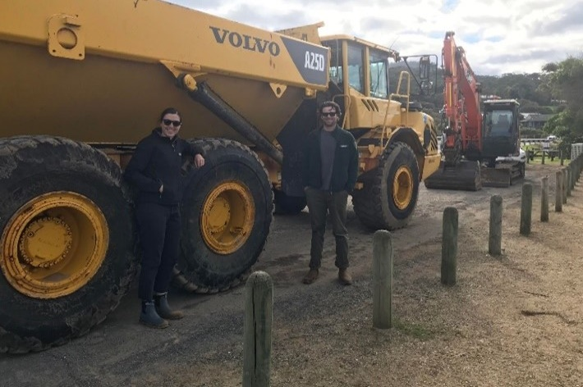

LBE Coastal Program Officers Kim Spragg and Fraser Clatworthy with some of the nourishment vehicles.

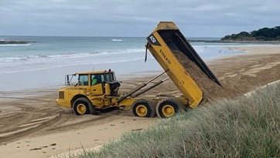

Truck depositing sand at the Southern end of Mounts Bay.



## In this issue

* Coastcare Victoria celebrates 30 years!
* Coastcare Victoria team update
* Free Schools Kit training opportunity!
* National Volunteer Week

### Coastcare Victoria celebrates 30 years!

During National Volunteer Week, Coastcare Victoria celebrated its 30-year milestone with an extremely successful forum that brought together over 100 attendees – both in person on Bunurong Country on the coast in Naarm (Port Melbourne), and online.

The event was a vibrant gathering of the Coastcare Victoria community, celebrating and honouring three decades of unwavering volunteer dedication to the protection and enhancement of Victoria's marine and coastal environments.

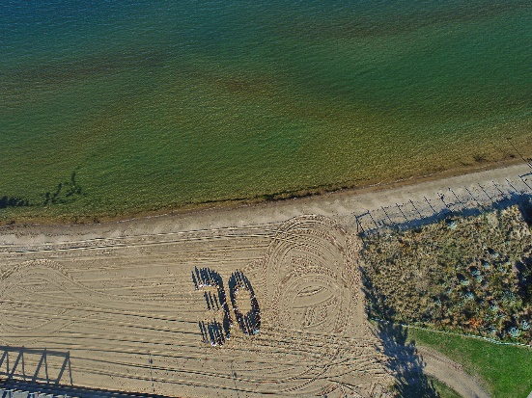

Over 100 volunteers gathered in person and online to celebrate coastal volunteering, forming a 30 on the beach and listening to inspiring presentations.

With the theme of ‘Looking back to look forward’, the forum not only celebrated the past but provided inspiration for future actions. Volunteers, community groups and organisations, Traditional Owners, agency partners, past Coastcare Victoria staff and expert presenters delivered a series of engaging presentations and workshops that highlighted the collective efforts, challenges and successes in preserving the natural beauty and health of our coastlines.

The atmosphere was energetic, filled with insightful discussions, new connections, reconnections, and most importantly a shared passion for the marine and coastal environment, making it a hugely enjoyable and successful event, as evidenced by the following feedback:

*‘Thank you for a most informative and well organised 30th anniversary celebration of Coastcare forum.*

*The array of speakers were diverse and engrossing…This has been the most organised and well thought out event I have ever attended and I appreciate all your effort to make this happen.*

*Thank you so much, Teresa, The Friends of Tyrone Foreshore.’*

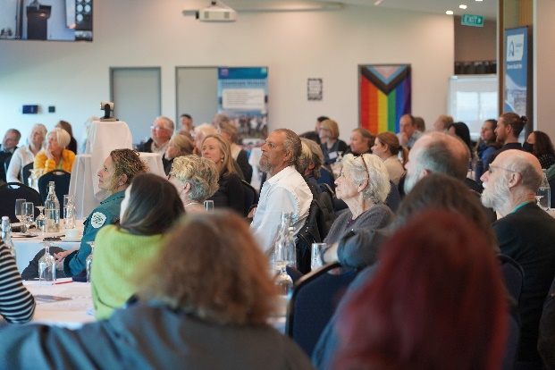

Over 100 volunteers gathered in person and online to celebrate coastal volunteering, forming a 30 on the beach and listening to inspiring presentations.

### Coastcare Victoria team update

There have been a few changes to the Coastcare Victoria team as we welcome Program Manager Lindy Mills, wish Corinne Donohue all the best for a period of parental leave (with two new girls!), and thank Matt Mitchell for his contribution while on a DEECA Science Graduate Program rotation for the past 8 months.

Laura and Shaya continue doing exceptional work in their officer roles, currently supporting groups across the state.

A few messages from the team:

*‘I’m thrilled and honoured to join the incredible Coastcare Victoria team! I have a strong passion for the coast, and I’m fortunate to live on the Bellarine Peninsula, where I witness the remarkable efforts of our volunteers daily.*

*I’m committed to working in programs that contribute to improved environmental and educational outcomes, having managed projects to increase renewable energy (Solar on Public Buildings) improve healthy eating habits (Jamie’s Ministry of Food), all in collaboration with dedicated volunteers.*

*I look forward to getting to know you and continuing to support the amazing work that you do. Please get in touch at any stage.*

*With gratitude, Lindy.’*

*‘During my time in Coastcare Victoria, I worked in the background to aid the team in preparing the next round of grants and to help organise the Coastcare Victoria 30 Year Forum. I also managed to sneak away from the computer to join a few of the brilliant Summer by the Sea activities.*

*It has been an immense privilege to learn about the incredible work being done along Victoria’s coastline. I have been repeatedly humbled and inspired by the passion and dedication of volunteers and those in the Coastcare Victoria team. I wish you all the very best and hope to cross paths and continue to learn from you in the future.*

*See you again, Matt* **😊*’***

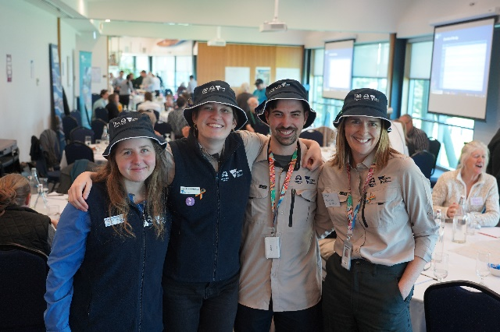

The Coastcare Victoria team, from left to right: Shaya Kaartinen-Price, Laura Town-Hopkinson, Matt Mitchell and Lindy Mills.

Coastcare Victoria Program Manager

Lindy Mills

0473 848 101

[lindy.mills@deeca.vic.gov.au](mailto:lindy.mills@deeca.vic.gov.au)

**Coastcare Victoria Barwon South West Officer**

Shaya Kaartinen-Price

0436 604 127

[shaya.kaartinen-price@deeca.vic.gov.au](mailto:shaya.kaartinen-price@deeca.vic.gov.au)

**Coastcare Victoria Port Phillip and Westernport Officer**

[coastcare.victoria@deeca.vic.gov.au](mailto:coastcare.victoria@deeca.vic.gov.au)

**Coastcare Victoria Gippsland Officer**

Laura Town-Hopkinson

0427 818 683

[laura.town-hopkinson@deeca.vic.gov.au](mailto:laura.town-hopkinson@deeca.vic.gov.au)

### Free Schools Kit training opportunity!

Coastcare Victoria and Ecolinc have joined forces to deliver an exciting professional learning opportunity that focuses on familiarising and upskilling educators in the use of the free online Coastcare Victoria Schools Kit and how to empower students to become coastal environmental change makers.

This event is specifically designed for school teachers, community educators, and government and corporate sustainability educators across Victoria.

The professional learning sessions will be 2 hours long (from 4-6 pm) and available throughout 2024 in locations along the Victoria coast and online:

* 29 August 2024: Online, [register through Eventbrite](https://www.eventbrite.com.au/e/coastcare-victoria-professional-development-online-tickets-771250540127?aff=oddtdtcreator)
* 9 September 2024: South Gippsland, [register through Eventbrite](https://www.eventbrite.com.au/e/coastcare-victoria-professional-development-phillip-island-tickets-771233679697?aff=oddtdtcreator)
* 28 October 2024: East Gippsland, [register through Eventbrite](https://www.eventbrite.com.au/e/coastcare-victoria-professional-development-bairnsdale-tickets-771240700697?aff=oddtdtcreator)

Feel free to pass these opportunities on to interested groups, or via your social media!

*‘I found the Coastcare PD event well organised and structured, welcoming, informative and the content highly relevant …’*

Charlotte Williamson – Education Manager, Werribee River Association

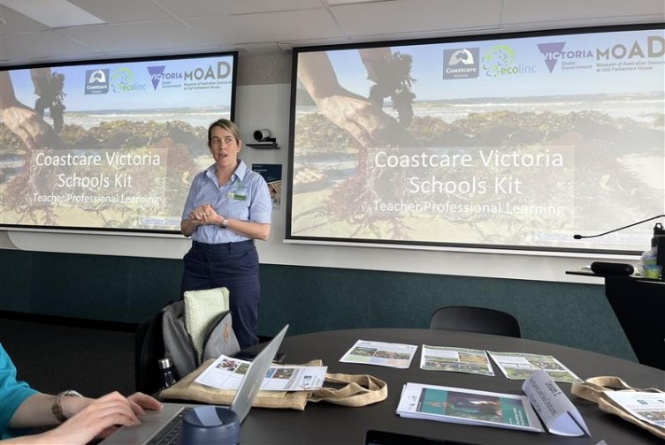

Ecolinc hosting a Coastcare Victoria Schools Kit Professional Development training opportunity in Geelong, Wadawurrung Country, 2024.

### National Volunteer Week

As part of National Volunteer Week, Coastcare Victoria wants to recognise all the ways Victorians volunteer to help protect the state’s environment and biodiversity. A huge thank you to each and every single marine and coastal environmental volunteer who works to care and protect our shared landscapes.

With this year’s theme for National Volunteer Week being ‘Something for Everyone’, Coastcare Victoria is committed to creating inclusive and supportive volunteering spaces for all.

Learn more about volunteering for the environment in Victoria and find out how you can get involved: [environment.vic.gov.au/volunteering](https://www.environment.vic.gov.au/volunteering).

To further recognise and celebrate volunteers, Volunteer Victoria’s Volunteering Awards 2024 are now open for nominations. The Volunteering Awards are an opportunity to recognise and thank Victorian volunteers for the incredible contributions they make to our state and local communities.

To nominate someone special, either in the individual category, or organisation category, visit [volunteeringvictoria.org.au/events/awards/](https://www.volunteeringvictoria.org.au/events/awards/)

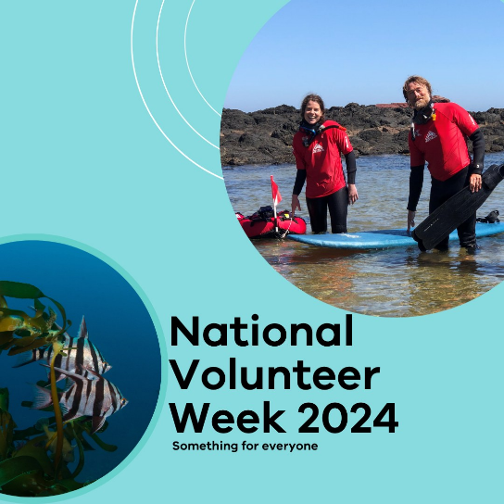

Victorian National Park Authority’s Great Victorian Fish Count event, funded in part by Coastcare Victoria. Credit: Ian Scholey.



We acknowledge Victorian Traditional Owners and their Elders past and present as the original custodians of Victoria’s land and waters and commit to genuinely partnering with them and Victoria’s Aboriginal community to progress their aspirations.

© The State of Victoria Department of Energy, Environment and Climate Action June 2024.

Creative Commons

This work is licensed under a Creative Commons Attribution 4.0 International licence, visit the [Creative Commons website](http://creativecommons.org/licenses/by/4.0/) (<http://creativecommons.org/licenses/by/4.0/>).

You are free to re-use the work under that licence, on the condition that you credit the State of Victoria as author. The licence does not apply to any images, photographs or branding, including the Victorian Coat of Arms, and the Victorian Government and Department logos.

Disclaimer

This publication may be of assistance to you but the State of Victoria and its employees do not guarantee that the publication is without flaw of any kind or is wholly appropriate for your particular purposes and therefore disclaims all liability for any error, loss or other consequence which may arise from you relying on any information in this publication.

Accessibility

To receive this document in an alternative format, phone the Customer Service Centre on 136 186, email [customer.service@deeca.vic.gov.au](mailto:customer.service@deeca.vic.gov.au), or contact National Relay Service on 133 677. Available at [DEECA website](http://www.deeca.vic.gov.au/) (www.deeca.vic.gov.au).