Frequently Asked Questions
2025 Port Phillip Bay Fund









deeca.vic.gov.au

Section A – Key Information
Description | Date
Applications open | Wednesday 17 September AEST
Applications close | 3:30 pm Wednesday 12 November 2025 AEST
Applicants notified | January - February 2026
Activities commence | From January - February 2026

Section B – General Questions

Q. What is the Port Phillip Bay Fund Program?
The Port Phillip Bay Fund (PPBF) is a grants program provided by the Victorian Government, funding projects that aim to protect and preserve the environment of the Bay.
- For more information around the funding details, eligibility, assessment criteria and the application process, please refer to the 2025 Port Phillip Bay Fund Guidelines.
- If you have further questions, please email enviro.grants@deeca.vic.gov.au and include “2025 Port Phillip Bay Fund” in the subject.

Q. What activities will be given priority in 2025 PPBF?
The priorities for 2025 PPBF are on-ground environmental activities with the aim to protect and enhance coastal habitats or conditions. These priority activities include:
- Foreshore and coastal habitat restoration such as blue carbon type activities.
- Marine environment (particularly projects addressing knowledge gaps).
If you are unsure whether your project meets the funding criteria, please email your project proposal to enviro.grants@deeca.vic.gov.au .

Q. We have received a grant during a previous PPBF round, can we still apply?
Yes, you can still apply if you’ve already received a grant in a previous round. Your project can build on the success of past projects but must essentially be new work. The grant must fund additional activities that are not included in the previous project plan.
Previous recipients who have failed to comply with PPBF or broader DEECA funding agreements including submission of all reports are not eligible to apply.

Q. Can I seek the support of auspicing organisation to apply for grants?
If you have previously use an auspicing organisation, you need to provide supporting documentation from your auspice in your application to demonstrate they agree to take on the responsibilities for your application.
Auspicing organisations are recommended to ensure the requesting organisation has the relevant environment skills and knowledge to undertake the works.
Q. What can I do if I have issues accessing/using Grants Online Portal?
Grant Online Portal Tips:
- We recommend you use Edge, Chrome, Firefox and other browsers instead of Internet Explorer as it can be unstable with the Grants Online Portal.
- When you register, note down the email and password you used. You will need it to access your application later.
- After you start your application, you will receive a notification email with a link to return to the application form. It is easiest to continue accessing your application via this link.
- Two people logging into the same grant application may cause issues such as data loss. You are encouraged to only have one person working in the application at any one time.
If you come across any technical issues when using the Portal, please email grantsinfo@deeca.vic.gov.au and include “2025 Port Phillip Bay Fund” in the subject.

Q. Can we submit applications for Stream 1 & Stream 2?
Yes, eligible organisations (or auspice if applicable) can apply for both funding streams. We recommend applicants seek appropriate funding that is within their capacity and capability.

Q. Can we apply for more than one project?
For both funding streams, you may submit more than one application. However, if one of your projects is funded, preference will be given to unfunded applicants over your other lower-ranking projects.
Projects will not be accepted if:
- They are dependent on another project getting funded.
- They are scaled versions of the same project.

Q. What type of in-kind support can I include in my co-contribution?
Your co-contribution or matched funding can include a combination of:
- volunteer time or dedicated to the project (including planning, designing and organising)
- in-kind support (e.g. free loan of equipment, donation of materials)
- staff time allocated to completing the project, where the salary comes from another source
- funding from other sources (e.g. donations, philanthropic grants) that deliver above and beyond funded activities.

Q. What might not be funded?
The program will not fund:
- Waste and recycling activities (such as domestic, business and market waste products (Refer to other grants program).
- Activities that were intended to be your in-kind contribution to another funded project
- Routine operation or running costs. These are the costs of resources used by an organisation just to maintain its existence (e.g. rent)
- Costs and activities that are already funded through another organisation, program or fund source.
- Actions or costs associated with native vegetation offset sites or activities. For example, meeting a condition of a planning permit, contract or investment program, Section 173 agreement for offset covenant.
- Any activity involving clearing of native vegetation, unless it is a declared environmental weed in your area. In this instance, a permit for removal of vegetation may still be required.
- Any activity involving the use of firearms, tranquilisers, traps or explosives. Confinement traps are allowed under permit and expert supervision.
- Any illegal activity
- Purchase of goods for competitions, prizes, giveaways, vouchers or alcohol. (e.g. plastic promotional/educational items, pens, sample packs, keep cups, stickers, bags)
- Barbed wire fencing
- Computers, laptops, tablets and smartphones
- Insurance
- Interstate or international travel & accommodation, conference registration
- Any actions that are part of a land manager’s legal duty of care or responsibilities.
- Political campaigning or advocacy activities for political parties
- Any other item, action or activity determined by the Panel through the assessment process to be an inappropriate or unsuitable use of the funds.

How do I calculate the value of our volunteer contribution?
The value of the contribution will be dependent on what category the volunteer falls under. See table below:
Volunteer | $ per hour
Community Members | $40
Students (on excursion or completing coursework) | $0

Q. Should I include GST in my budget?
If you are registered for GST:
The budget provided should be exclusive of GST. Where applicable, the Department of Energy, Environment and Climate Action (DEECA) will pay the grant amount plus GST.
If you are not registered for GST:
The budget provided should be inclusive of GST. Ensure that the budget in your application covers your total costs so you are not out of pocket.

Q. How do I obtain land manager consent?
Applicants will need to demonstrate that land managers, both public and private, support the project being carried out on the land they manage. A short letter or email of support from the land manager must be attached to your application.

Q. Should I engage with Traditional Owners of the Land?
Yes. Traditional Owners have legal rights and interests across their Country. It is important to engage with the Traditional Custodian of the land at the earliest opportunity of all new projects or activities. To find out more about please refer to https://www.firstpeoplesrelations.vic.gov.au/engaging-traditional-owners . A project may also require a Cultural Heritage Permit or Management Plan. Please refer to this weblink Cultural Heritage Permits | firstpeoplesrelations.vic.gov.au

Q. Does my project require Marine and Coastal Act Consent?
If any of your project activities will be carried out on Marine and Coastal Crown land you may require approval under the Marine and Coastal Act 2018: https://www.marineandcoasts.vic.gov.au/marine-and-coastal-act .
Before commencing any works, you must obtain approval to use or develop marine and coastal Crown land. You must comply with the conditions of any consent provided.
Permit application takes time. You must allow for sufficient time in your project planning and timeline.

Section C: Mapshare Victoria

Q. How do I Map my activity using Mapshare?
- Open MapshareVic in your Google Chrome browser using the following URL https://mapshare.vic.gov.au/MapShareVic/
- Agree to the disclaimer (see image below)
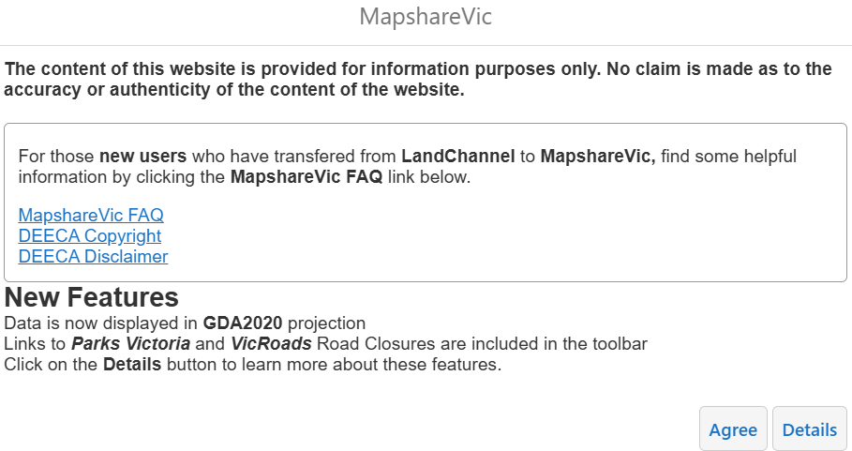
- Find your project location by:
  - Zooming in to the project location using your mouse scroll wheel, or
  - Entering the address into the search bar at the top of the window
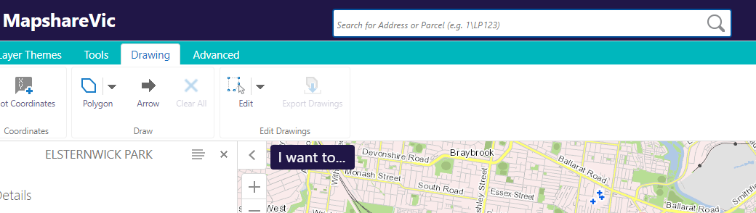
- Once you have found your project area, you are ready to map your project location. At this stage you can change the map to the satellite view if that is easier for you to visually see your project area. To do this, you will need to go to the bottom ribbon, click on ‘Vicmap Cartographical’, this will extend the menu to the right of the screen, you can then select the ‘Vicmap Overlay’ base map option.
- The base layer of your map should now have changed to ‘Vicmap Overlay’.
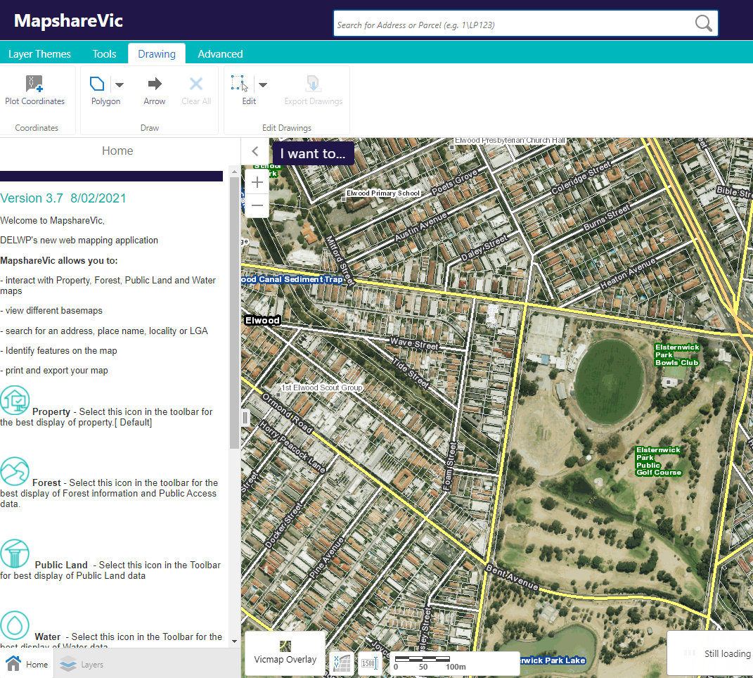
- Click the 'Drawing' tab on the top green bar.
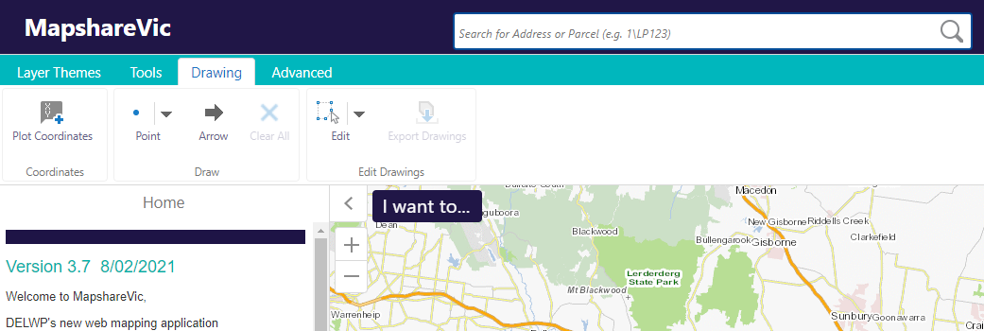
- Click the drop-down arrow next to 'Point' and select 'Polygon' to draw a custom shape on the map.
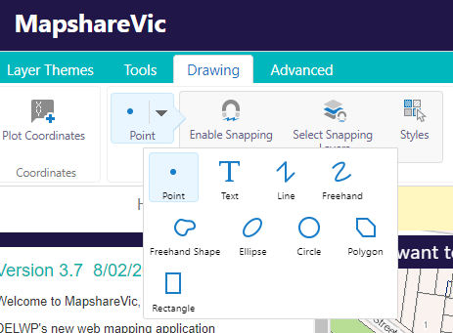

- Left click the boundaries of your project area to define the polygon shape. Remember to select the entire outline of your project area. You will need to double click to ‘finish’ your shape. As you can see in my example, I have used four clicks to draw the boundary of my project area.
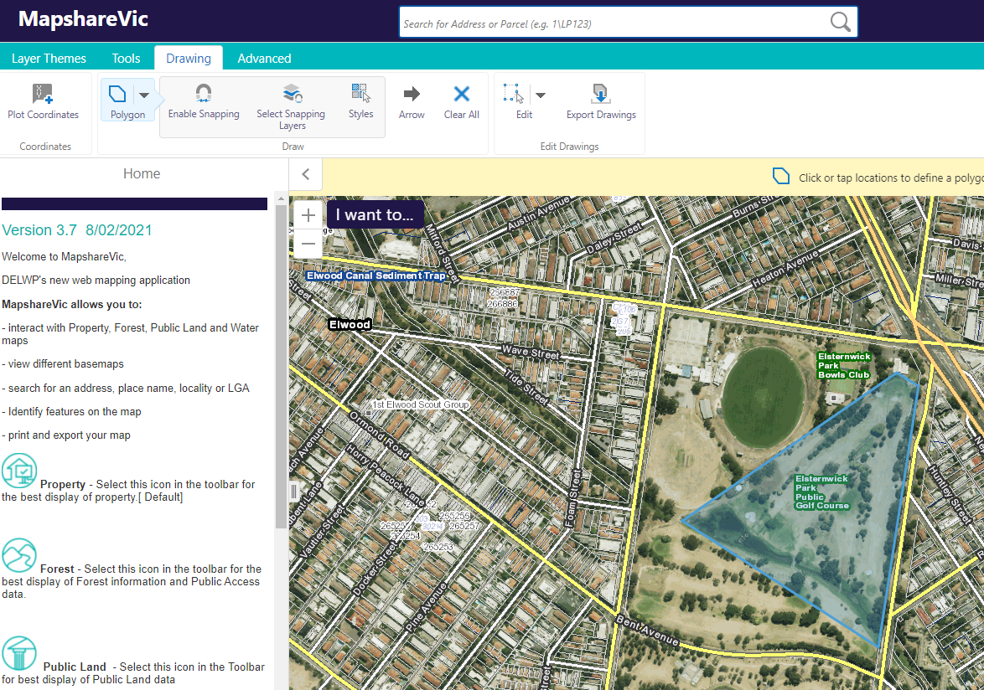
- To erase a polygon, left click the drop-down arrow next to the ‘edit’ icon and then select ‘erase’ from the menu that pops up.
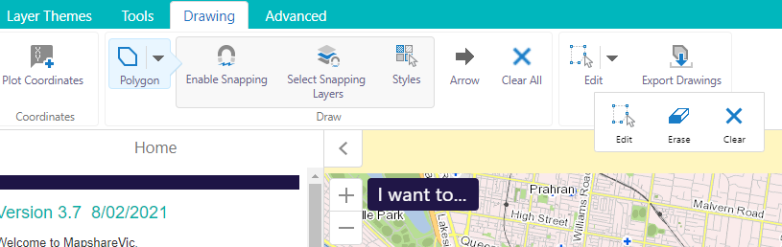
- Once you have selected ‘erase’ you can left click on any polygon you wish to remove, and it will be erased.
- You have now finished drawing your polygon. It should capture the geographic location of your project area.
- To Save your map as shapefile.
- Click “export Drawings’ on the Drawings Toolbar.
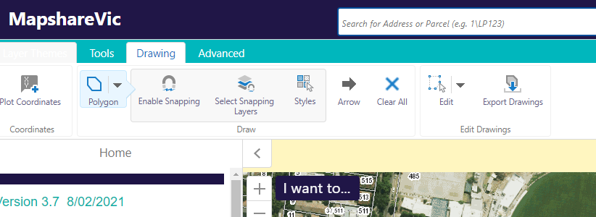
- Click ‘OK’ on the pop-up. This will download a zipped folder to your device containing the shapefiles you have just created.
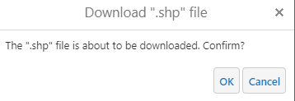

- You should see a zipped folder appear in the bottom ribbon of your internet browser titled ‘Export.zip’. If you do not see this, check your ‘Downloads’ folder on your desktop to see if the folder is there or try our troubleshooting tips at the start of this document.
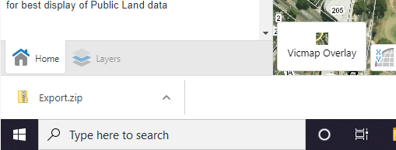

- Rename the zipped folder to [ApplicationNumber]_shapefiles.zip – e.g., GA-F12345-6789_shapefiles.zip. You will need to rename the folder in your ‘Downloads’ folder on your desktop.
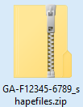
- The zipped folder is now ready to be attached to your application.
- If you wish to come back and view the shapefile you have just created at a later date, right-click on the ‘upload data’ icon under the ‘tools’ tab.
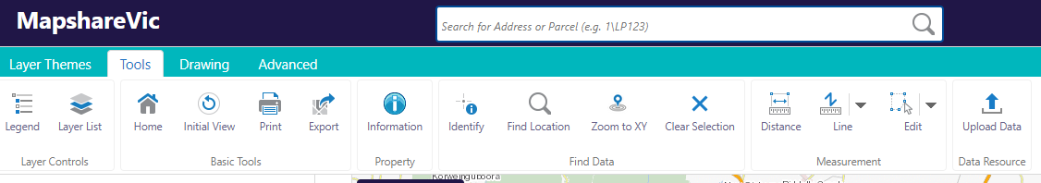
- A pop-up box will appear. Right-click ‘choose files’ and select the zipped folder you created in Step 1-6 above. Then select ‘upload’. Once loaded, you can view your shapefile.
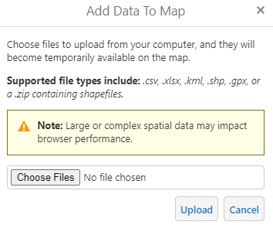
- To save your map as a PDF. Go to “Tool”
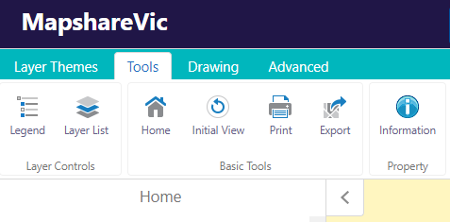

- Click the ‘Print’ button underneath the top green bar, a ‘Print Map’ pane should appear to the left of the window once clicked.

- Zoom in to the extent of your project area (i.e., the polygon you just mapped).
- From the drop-down options in the ‘Print Map’ pane to the left of the window, select the following options under the relevant headings:
- Select Layout: A4 Landscape – DEECA
- Output Format: Pdf
- Resolution: High (216dpi)
- Grid: Latitude / Longitude
- Map Scale: Current Extent
- Title: [ApplicationNumber]
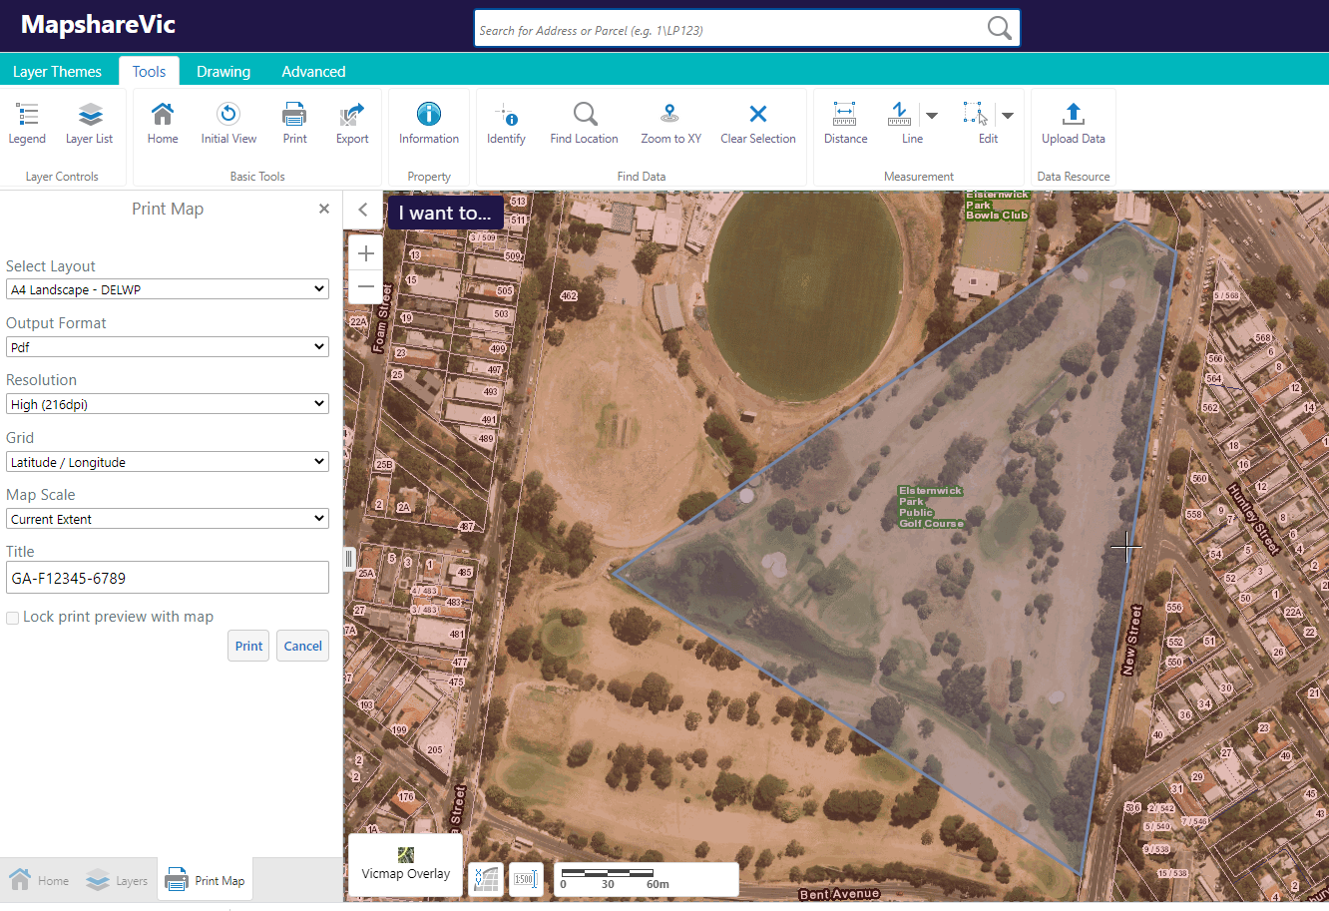
Insert your application number which you will be given when you start your application.
- Print’ – this will generate a PDF map document.
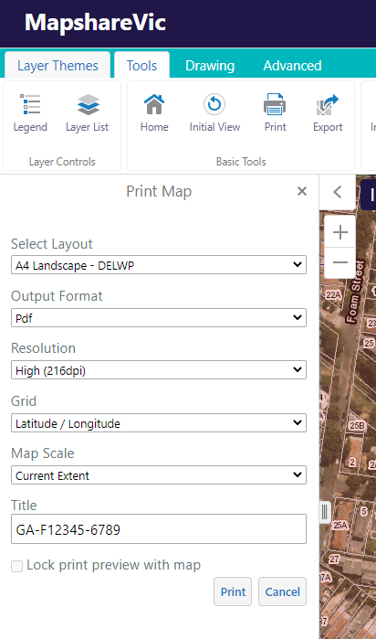
- It can take a couple of minutes for the map to generate. Once the map has generated, you will be able to click ‘Open File’. This will open the PDF map in a new tab.
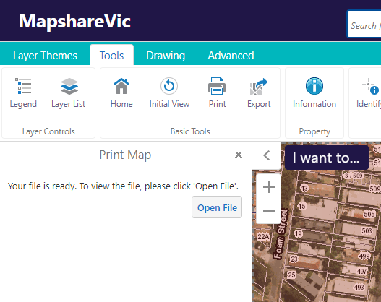

- The completed map should look something like this example.
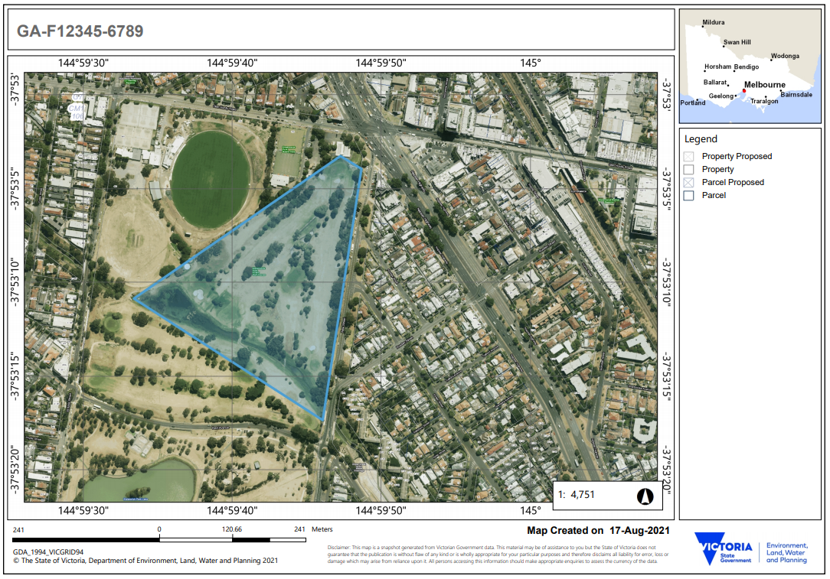
Application number
Longitude / latitude
- Download your PDF map
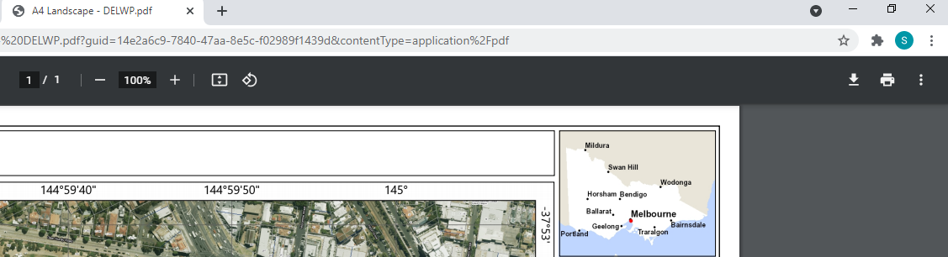
- Rename the PDF to [ApplicationNumber]_Map.pdf – e.g., GA-F12345-6789_Map.pdf. The PDF copy of your map is now ready to be uploaded to your application.


Section D: Budget and Risk

Complete all the tabs in the Spreadsheet and attach to the application.

Tab 1- Budget Summary – enter the amount you are requesting.
Ensure total budget is the same as amount you are requesting
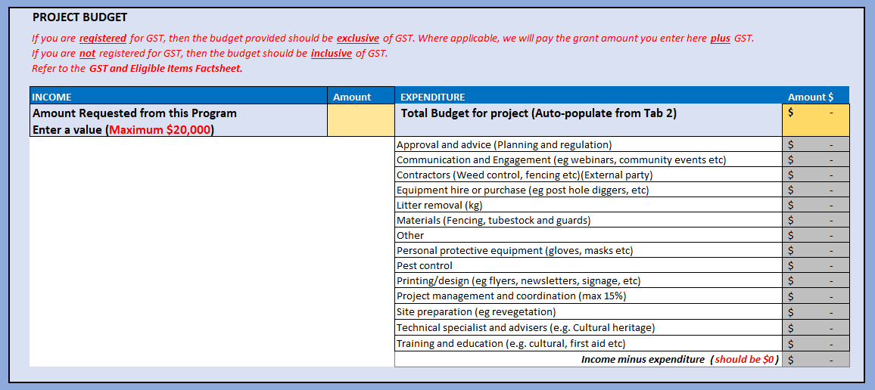
Enter the amount that you are requesting from this program
These columns are auto populated. You need to go to Tab 2 - Project Budget and select your project expenditure in the dropdown
This amount should be zero when you finish populating Tab 2 - Project Budget.

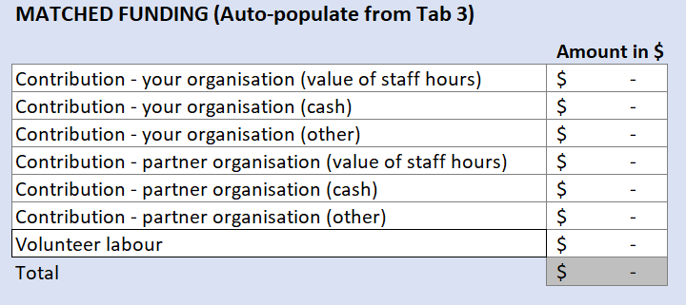
These columns are auto populated from Tab 3 – In Kind Support.

Tab 2- Project Budget
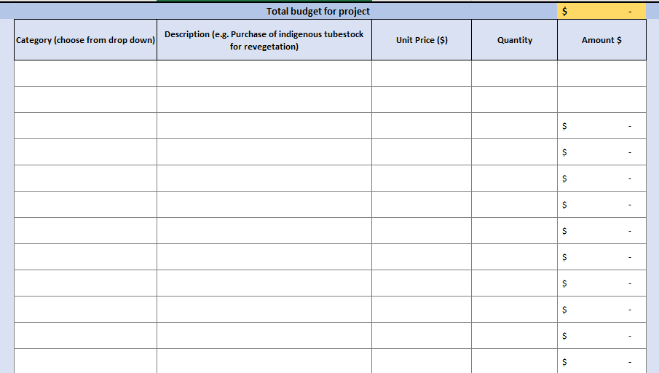
Make sure your total budget is the same as your requesting amount and does not exceed the funding amount.
A drop-down list is available to select the type of expenditure for your project.
For example: Equipment hire. You need to provide brief description of the type of equipment and provide the amount.
You may need to supply a quote for the proposed works if the value is greater than $2,000.
Note: you can choose the same category more than once.

Tab 3 – In kind Support/Contribution
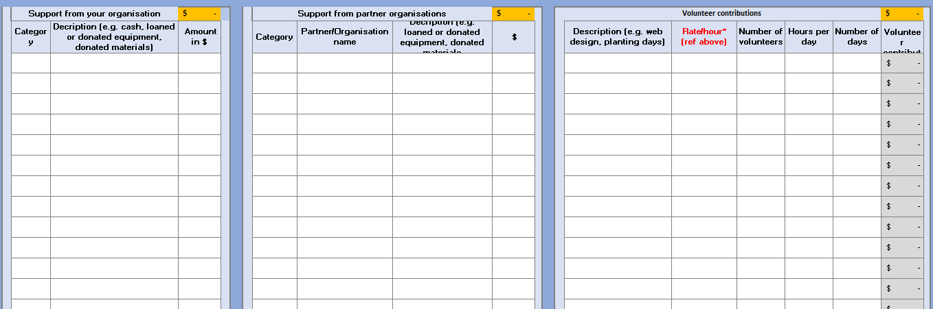
This column is “In kind contribution” from the community. Please provide detail description of the works and number of volunteers.
Hours per day must be reasonable (not beyond normal working hours).
For example: clean ups day is one day but 20 volunteers spent 2 hours of their time doing the work.
Do not include students on excursion or as part of their course work

This section is “In kind contribution” from the partner organisations. Under ‘category’ will be a dropdown list of staff hours, cash or other.

Include the name of all current partner organisations. If there is cash contribution, please submit a letter of support.
This column is “In kind contribution” from your organisation. Under ‘category’ will be a dropdown list of staff hours, cash or other.
You can deidentified staff name and provide $/hour

Tab 4 – Risk Assessment
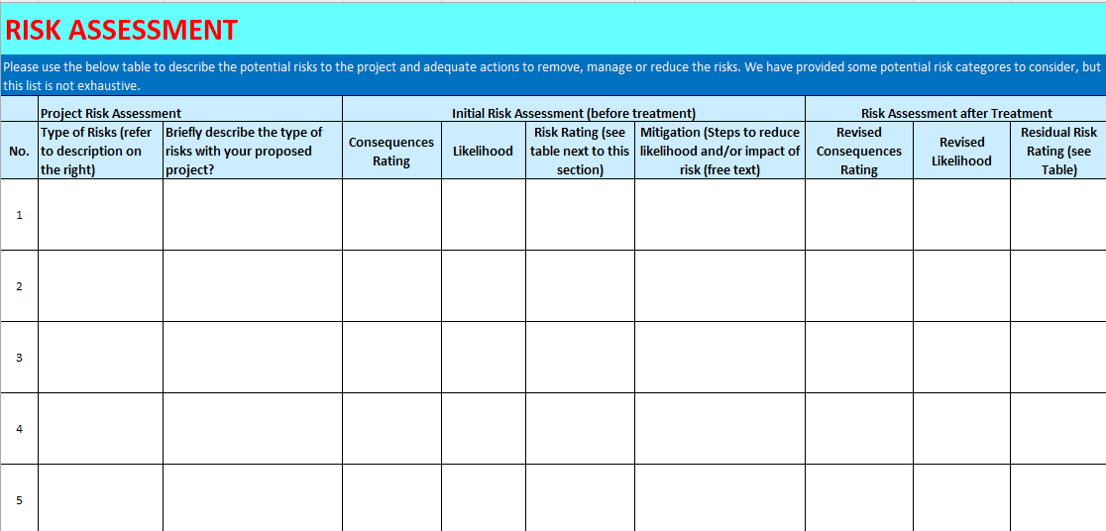
1. Identify & describe the type of risks of your project, assess the consequences and mitigating measures before and after treatment

Contact us
Program enquiries
If you have any queries, or require more information, please contact the Programs and Partnerships team via email at enviro.grants@deeca.vic.gov.au or contact the DEECA Customer Contact Centre on 136 186 during normal business hours.
Please quote your application number and the grant program in your communications with DEECA.
Technical difficulties
If you require technical assistance submitting your application online email grantsinfo@deeca.vic.gov.au or call the DEECA Customer Contact Centre on 136 186 during normal business hours.
Please quote your application number and the grant program in your communications with DEECA.

