Northern Bellarine
Beach Renourishment Program

Beach renourishment to begin at St Leonards
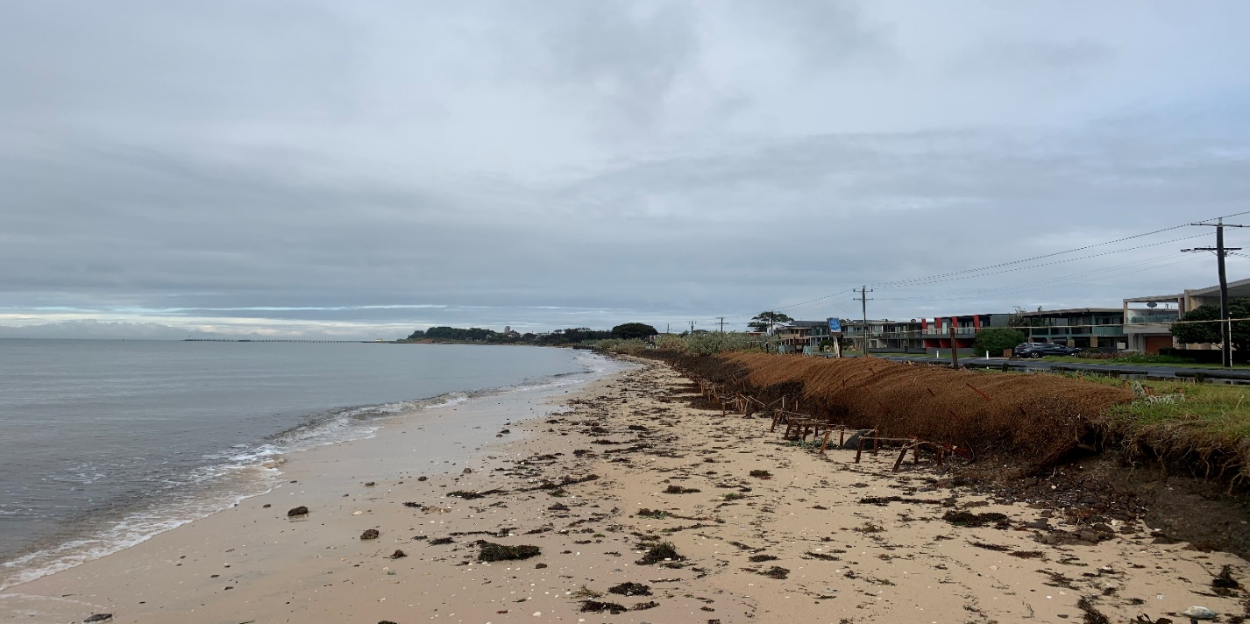

Have you heard?

The Department of Environment Land Water and Planning (DELWP) is delivering a series of beach renourishments on the northern Bellarine Peninsula, as part of the Victorian Government’s $8 million Port Phillip Bay Beaches Renourishment Program.

Sections of the Bellarine Peninsula are experiencing erosion due to natural processes, storms and climate change, with impacts on foreshore assets and recreational values.

DELWP will deliver the St Leonards North Beach Renourishment over the coming months to address coastal erosion. The newly harvested sand will also be used to replenish other locations along the Bellarine Peninsula at:

- St Leonards’ southern beach
- Taylor Reserve, Indented Head

These areas were identified as a top priority for beach renourishment following an independent assessment of Port Phillip Bay beaches in 2019.

The Northern Bellarine beach renourishment program spans across 6 km of active coastline and includes a strategy to manage the sand supply, including monitoring, maintenance, and renewal of the beach assets for the next 10 to 15 years. Stage one of this program was completed at Anderson Reserve in 2020.

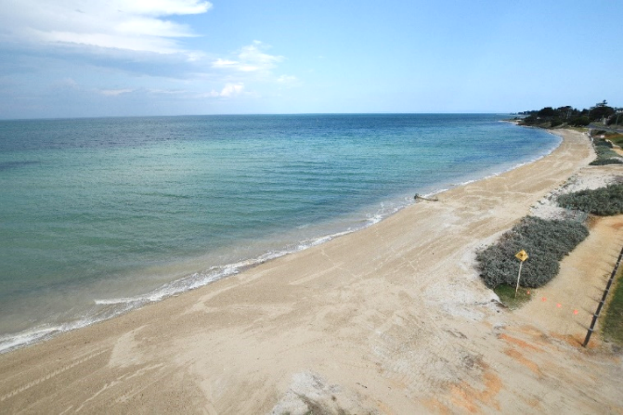
Fig. 1 Completed works at Anderson Reserve, Intended Head

Planning and Design
DELWP engaged coastal engineers to plan and design the sand harvesting operation and worked together with Bellarine Bayside Committee of Management to implement the project in line with heritage advice from the Wadawurrung Traditional Owners Corporation.

Community consultation was undertaken in 2020, in which residents were invited to provide input on the locations of the beach renourishments, and the type of sand that could be used in the works.

What can you expect to see?
Stage two will commence shortly in front of Salt Lagoon along the Esplanade in St Leonards.

Approximately 35,000m3 of sand will be pumped onshore and 25,000m3 will be used to construct the beach profile (See Fig. 2) while the remaining sand will be used to replenish beaches at Indented Head and St Leonards. Previous testing has shown the sand source to be free of seagrass meadows, contaminants and to have a similar grain size to that onshore. Modelling also indicates there will be no significant impact to water quality from the works.

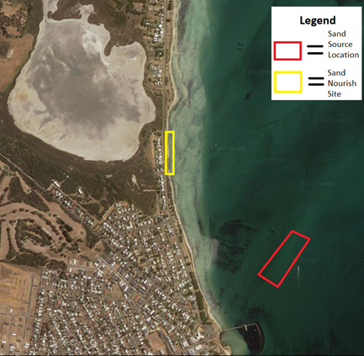
Fig. 2 Site map, St Leonards’ northern beach.

The sand harvesting will take place over several months. A sand sourcing vessel will be stationed approximately 800m offshore, in front of Salt Lagoon alongside the Esplanade.

The primary construction area will consist of temporary fencing, office facilities and a pipeline deployment zone.

During this time, beach and walking track access may be restricted as trucks and earthmoving equipment will shape the new sand over a few months.

The newly constructed beach will provide an immediate buffer to storms and rising sea levels and safeguard key assets and coastal infrastructure.

Post Renourishment

The distribution of sand along each beach is expected to change following sand renourishment, possibly creating sandbars and erosion scarps in the short-term. This will stabilise over time as coastal processes reshape the newly formed beaches under the action of wind, waves and tides.

The sand deposited at the sites will naturally move over time and benefit other areas along the Bellarine Peninsula. As a result of natural coastal processes over the next ten years, the additional sand will move along and around the coastline, increasing the width of Bellarine beaches and providing foreshore protection.

An ongoing monitoring program will be established to better understand coastal processes such as erosion hot spots and patterns in sand movement. Additional top ups of sand may be required to manage coastal erosion at these areas.

Further information
Thank you for your patience and understanding while we carry out this work to better protect communities and the environment from the impacts of climate change.
For further information about the works, please visit https://www.marineandcoasts.vic.gov.au/coastal-programs/bellarine-renourishments

Should you require further information on this project, please contact the Planning Team at
BSW.planning@delwp.vic.gov.au

