Coastcare Victoria School Kit

Seaweed Solutions for Sustainable Futures Worksheet

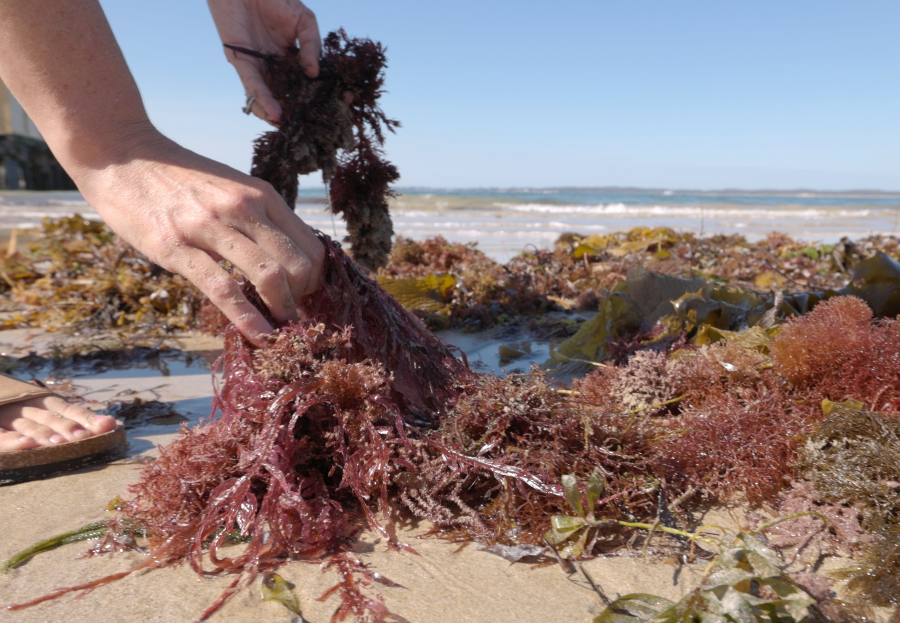

Acknowledgements

Coastcare Victoria would like to acknowledge all our video presenters and individuals who reviewed or assisted with the creation of the Coastcare Victoria School Kit.
Author
Coastcare Victoria and Ocean Imaging.
Photo credit
Ocean Imaging.

Contents
Activity 1:Seaweed Solutions for Sustainable Futures Quiz 2
Activity 2: Local Languages 4
Activity 3:Seaweed Biodiversity 5
Activity 4: Profile Worksheet 8
Invesitgation 1: Modern Uses of Seaweed 9
Investigation 2: International Use of Edible Seaweed 10
Seaweed Review Quiz 11

Seaweed Solutions for Sustainable Futures Quiz

- Aunty Judy explained that seaweeds were important because they
- Provide food for fish
- Feed the environment
- Clean the waterways
- All of the above

- Zoe talks about Aboriginal uses of seaweeds. Which of these was not listed?
- Food and medicine
- Building houses
- Packaging products
- Clothing and ceremony

- What animals were fed seaweeds in the video?
- Chickens
- Cows
- Pigs
- Horses

- Aunty Judy’s knowledge was passed on through her
- Ancestors
- Friends
- Grandpa
- Connection to country

- What advantage might there be in using seaweed instead of plastic?
- Cheaper
- Biodegrades faster
- Faster to make
- All of the above
- Finish this sentence from the video. “Each piece of land has a unique ______”
- Smell
- Taste
- Culture
- Temperature

- What did Zoe think wasn’t already a big part of the Australian identity?
- Being beach lovers
- Having lots of seaweed
- Surfing fans
- Beautiful natural clean environment

- Why did Lichen Kelp start the portable seaweed library?
- To keep fit
- There wasn’t much information on the internet
- She wasn’t much of a reader
- Research as a group would be more fun

- Lichen Kelp liked to think of her portable seaweed library as a
- Ocean portal
- Wormhole
- Fast ride
- Seafood database

- What type of food was being made from seaweed in the video?
- Seaweed pasta
- Seaweed pizza
- Seaweed burger
- Seaweed fries

Local Languages
Step 1: Who are the Traditional Owners of the lands that you are learning on today?

Step 2: Visit the 50 words project website to find and write the spelling for Australian Indigenous words for these five English words in the boxes on the left.

Step 3. Use the website to listen to the pronunciation of the words. In the boxes on the right, write how these words sound to you.

Word | Australian Indigenous Spelling | Sounds Like
Hello
Let’s go
Fish
Water
Sky

Seaweed Biodiversity
1. Visit the Port Phillip Bay Taxonomists Toolkit.
2. Click species and under the species group list on the left click "seaweeds and seagrasses"
3. There are three main types of seaweeds. What is the main colour of these groups?
Chlorophyta

Ochrophyta

Rhodophyta

4. Choose one seaweed species from each group and answer the following questions. You may need to click "View Scientific Details" for more information.
A)

Common name
Scientific Name
Phylum
Maximum Size
Habitat
Diet

B)

Common name
Scientific Name
Phylum
Maximum Size
Habitat
Diet

C)

Common name
Scientific Name
Phylum
Maximum Size
Habitat
Diet

5. What do all three species have in common?

6. Write two new words from the website and look up their definitions.

Profile Worksheet
Name:
Future Job title:
Organisation:

What might you love about this job?

Who might be a good mentor?

How might you get your job?

How could volunteering help your career?

How does sustainable thinking impact what you do?

Why is having a healthy environment important to you?

Modern Uses of Seaweed
In this investigation, you will visit the websites of several seaweed organisations to find out what seaweed species are being used, what products are being made, and the benefits of these products to people and/or the environment.
There is also a blank space for you to find information about two other organisations utilising seaweed.

Organisation | Seaweed Type | Products | Benefits
Sea Forest
Phyco Health
Notpla

International Use of Edible Seaweed

Many cultures around the world have had a long history of consuming seaweed in their cuisine. In this activity, you will research the various seaweed dishes and species used from around the world.

Seaweed Name | Food Uses | Country of Origin | Seaweed type and species name
Nori
Wakame
Kombu
Dulse
Irish Moss
Cochayuyo

Seaweed Review Quiz

- What are the three main seaweed groups? (3 marks)

- What are three things that all seaweeds have in common? (3 marks)

- Which species of seaweed grows right across southern Australia and helps form the Great Southern Reef? (1 mark)

- Describe two ways that Aboriginal Australians traditionally used seaweed. (2 marks)

- Describe three ways that seaweeds are being used in emerging modern industries in Australia. (3 marks)

