# Marine Spatial Planning Factsheet

Implementing Marine Spatial Planning in Victoria

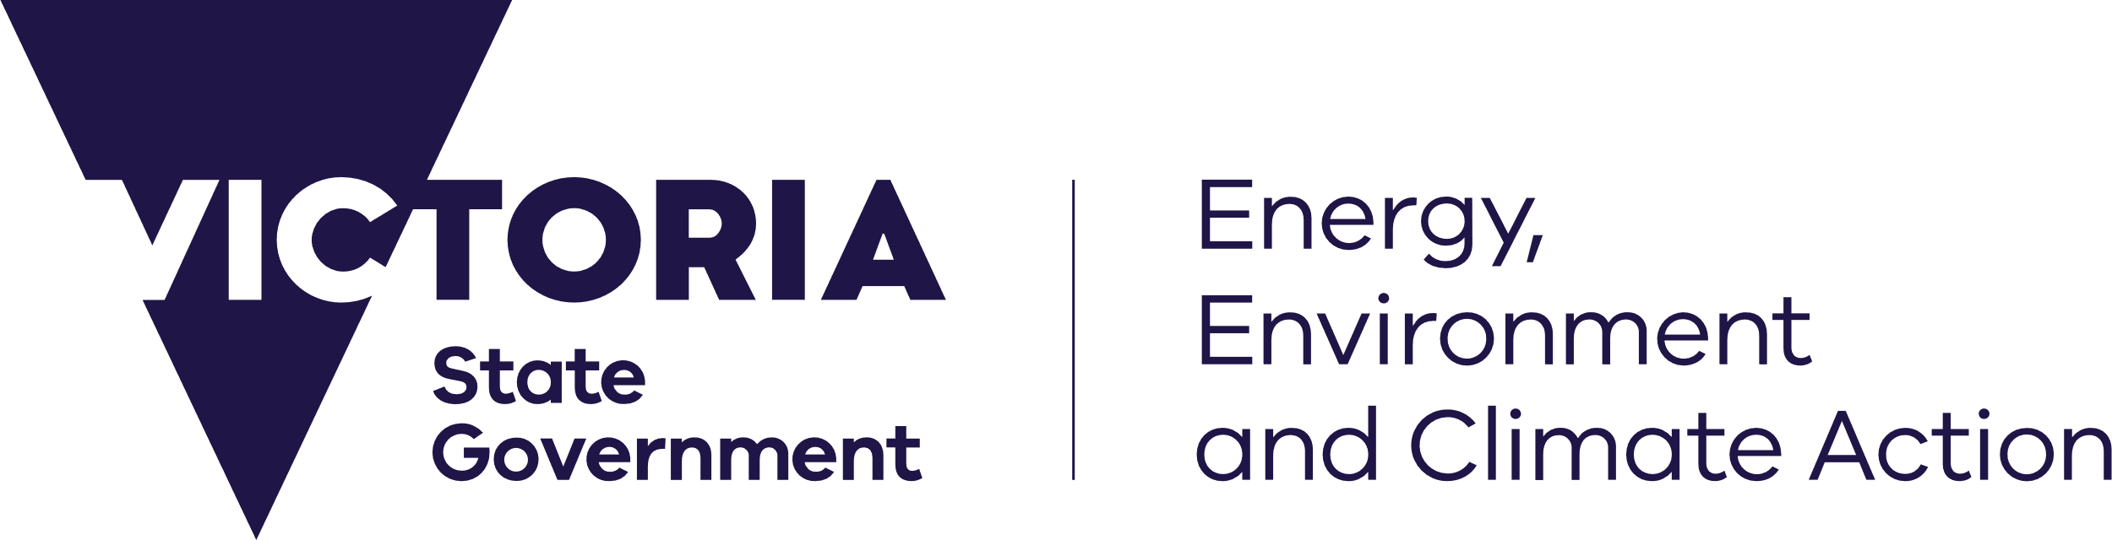

## Marine Spatial Planning

deeca.vic.gov.au

Marine Spatial Planning (MSP) is a practical way to organise marine space, and the interactions among human uses and between these uses and the marine environment.

While not all marine planning and management may require an MSP process, it can be beneficial where decision making is likely to be complex, challenging or where managing individual activities and uses may be inadequate.

MSP provides a process for assessing where activities and uses may be compatible or incompatible, and where activities and uses (either individually or cumulatively) conflict.

Undertaking an MSP process can have significant benefits including proactively identifying and reducing conflicts between uses, and between uses and natural values, to help protect economic, social, cultural, and environmental values linked to the marine environment.

It can be used to support sustainable growth of Victoria’s blue economy and climate adaptation planning.

The output of an MSP process is a Marine Plan, which is a strategic document that helps to structure and guide management decisions in the area to which the plan applies.

How will MSP be undertaken in Victoria?

The Department of Energy, Environment and Climate Action (DEECA) is leading implementation of MSP in Victoria, engaging with Traditional Owners and Aboriginal communities, industry, the wider community, and government agencies during the process.

The process for initiating, approving, and undertaking MSP in Victoria is outlined in the Marine Spatial Planning Framework (MSP Framework), part of the Marine and Coastal Policy 2020.

The three-step process consists of:

* Step 1: determine marine planning areas and identify priorities for marine spatial planning
* Step 2: seek approval to undertake MSP using a mechanism in the *Marine and Coastal Act 2018*
* Step 3: undertake MSP.

Implementation of Step 1 occurred through a statewide ‘first-pass’, with Steps 2 and 3 supported by the development of guidelines (MSP Guidelines) that provide instructions on how to undertake MSP.

## 

## What did the statewide ‘first-pass’ involve?

The statewide ‘first-pass’ divided Victoria’s marine environment into marine planning areas, building on the Victorian Environmental Assessment Council’s (VEAC) 2019 *Assessment of the Values of Victoria’s Marine Environment*.

In determining marine planning areas, previously defined bioregions and biounits, physical and biological attributes, jurisdictional boundaries, distribution and extent of use and activity, and associated values and threats, were considered.

## What are the MSP Guidelines and who are they for?

The MSP Guidelines provide instructions on how to undertake an MSP process in a marine planning area. These instructions further detail the steps outlined in the MSP Framework, including how to:

* plan and organise an MSP process
* set a vision, goals, and objectives
* assess the characteristics of an area and analyse conflicts, compatibilities, and impacts
* select management approaches and develop a Marine Plan; and
* implement, monitor, and refine a Marine Plan.

The MSP Guidelines outline each step in the process to provide a minimum standard or approach. The MSP Guidelines are primarily intended to support those responsible for planning and management of marine and coastal areas, resources and uses.

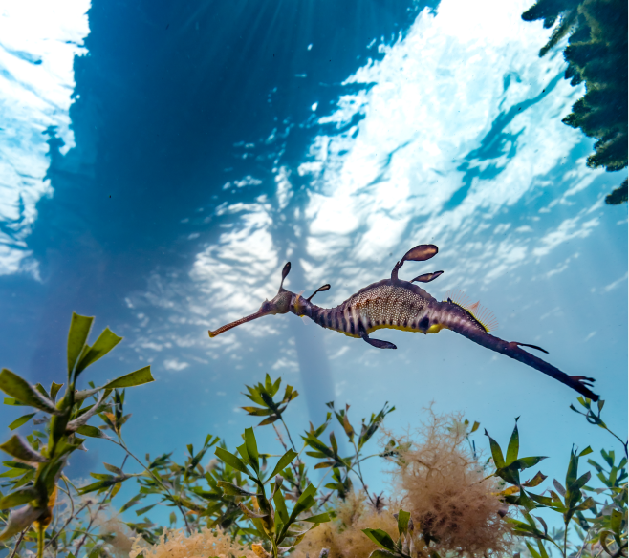

## Next steps

DEECA will continue to implement the MSP Framework through Action 5 of the Marine and Coastal Strategy 2022.

## More information

For more information please visit [DEECA Marine and Coasts](https://www.marineandcoasts.vic.gov.au/) or contact the Marine Spatial Planning Team ([marine.spatial.planning@delwp.vic.gov.au](mailto:marine.spatial.planning@delwp.vic.gov.au)).

|  |  |  |
| --- | --- | --- |
| © The State of Victoria Department of Energy, Environment and Climate Action 2023  LogoThis work is licensed under a Creative Commons Attribution 4.0 International licence. You are free to re-use the work under that licence, on the condition that you credit the State of Victoria as author. The licence does not apply to any images, photographs or branding, including the Victorian Coat of Arms, the Victorian Government logo and the Department of Energy, Environment and Climate Action (DEECA) logo. To view a copy of this licence, visit http://creativecommons.org/licenses/by/4.0/  Photo credit: Marcia Riederer  ISBN 978-1-76105-413-6 (print)  ISBN 978-1-76105-418-1 (pdf/online/MS word)  Disclaimer  This publication may be of assistance to you but the State of Victoria and its employees do not guarantee that the publication is without flaw of any kind or is wholly appropriate for your particular purposes and therefore disclaims all liability for any error, loss or other consequence which may arise from you relying on any information in this publication. | Accessibility  If you would like to receive this publication in an alternative format, please telephone the DEECA Customer Service Centre on 136186, email [customer.service@delwp.vic.gov.au](mailto:customer.service@delwp.vic.gov.au), or via the National Relay Service on 133 677 [www.relayservice.com.au](http://www.relayservice.com.au). This document is also available on the internet at [www.deeca.vic.gov.au](http://www.deeca.vic.gov.au). |  |