‘What We Heard’

Ocean Grove Coastal Adaptation Plan

Community Consultation
  - As part of consultation, listening posts were held at Hodgson St, Ocean Grove on 26 and 30 June 2021.

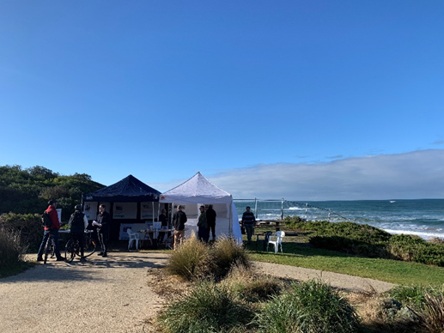

Participants were asked to comment on the existing and foreseeable challenges facing the immediate area around Hodgson Street carpark.

Ten coastal adaptation options were presented, and respondents commented on the most effective options to reduce the impact of erosion and storm surge.

This is what we heard

There was a clear understanding of the environmental pressures facing Hodgson Street, Ocean Grove.

Some of the issues identified included sea level rise, climate change and erosion of the foreshore.

Participants indicated the site was highly valued, had strong support for nature-based options and preferred long-term over short-term options to ensure Hodgson Street remains accessible to the local community.

The Coastal Adaptation Options were presented in a pathways approach as described in the Marine and Coastal Policy 2020 (little or no intervention through to hard engineering options).

The following is feedback about each option.

Sand Nourishment

Participants highlighted this option was environmentally more sensitive to the landscape, however identified it was a short-term measure with potentially ongoing costs. Concerns were shared about the ongoing need to source additional sand and where this sand source would be coming from.
“Not a permanent fix. Need to identify suitable sand source ongoing”

Sand Scraping

This option was similarly answered by sand nourishment respondents. There was consensus that this option would provide short term benefits, but unsuitable to implement due to ongoing costs. There were also environmental concerns that wildlife may be impacted, and that minimal intervention was preferred.

Dune Management
This option received the most positive support. Participants said dune and vegetation management is the most natural, is a proven method for erosion control in the long-term as well as provided habitat for native wildlife. However, it was identified that this option would only be successful if increased signage and compliance was implemented to ensure vegetation could become established.
“Dune management has been done more than 40 years ago and proven to be effective”

“Offers both a near term fix with long term benefits, and clearly makes sense”

Increase Beach Access Capacity
This option was identified as a sensible and strategic option that maintained beach access over the short to medium-term while not significantly impacting the natural environment. Participants highlighted the importance of all abilities beach access but conceded the accommodate option did not address the issue of erosion.

Retreat of Shared Coastal Trail from Bluff Edge
There was general support for this option among most participants. Participants suggested that natural processes should be respected but recommended this option should be used in conjunction with other coastal adaptation management options such as dune management.

“At some point this will be a reality, but what are the costs to the environment?”

Reconfigure Carpark (retreat)
Participants identified that this option (as proposed by design provided) may be required in the future and could be a useful measure in conjunction with other options. Most participants however did not support this idea identifying a significant risk of removing native vegetation that wildlife depends on for food and shelter.

Temporary Rock Bag Protection
Temporary Rock Bag protection did not have any positive support from respondents citing amenity values would be lost and the potential reduction in public safety. Participants were influenced by the appearance of this option more than any other factor.

Patch Up Existing Revetment
Participants identified that this informal patch repair works were aesthetically appealing and provided short to medium term protection from coastal erosion. Participants also suggested that this option could be used in conjunction with other measures such as dune management.

Engineered Revetment or Seawall
There was consensus among participants that this option would be effective, provide long-term protection, however the natural environment is likely to be negatively impacted in the process by causing problems elsewhere through end scouring processes.
There was consensus that if this was the preferred adaptation option then natural rock in comparison to
cement or concrete should be used in the construction process.
“This Is the most expensive options, but it seems the most effective option to address long term impacts”

Engineered Wave Reduction and Sand Retention Techniques
This option had very little support citing intervention should be comparative to the risk. Participants identified that the impact to the surf, marine life and natural environment would be too great to warrant this measure of coastal adaptation management.
“Changing the natural tide through the dumping of sand or hard engineering solutions is only going to transfer the problem to other sections of the coast”

Other Comments
Participants also provided additional comments which included the following:
- Respecting natural processes
- Cautioning intervention relative to the risk
- Alternative adaptation options as seen in other countries
- Consideration of traditional owner values
- A holistic approach to understand the pros and cons associated with each short and long-term option
- Maintaining the existing environmental and recreational values of the area
- Prioritising maintenance of existing structures before creation of new structures

Next Steps
DELWP thanks the participants who provided valuable feedback. This information is being used in future planning decisions.
The site is currently being monitored and the community will be alerted when a preferred management option is chosen.
For information, please visit https://www.marineandcoasts.vic.gov.au/coastal-programs/coastal-adaptation-plans

