|  |
| --- |
| DELWP marine and coasts newsletter |

Welcome to the Department of Environment, Land, Water and Planning’s (DELWP’s) quarterly marine and coasts newsletter**.**

## In this issue:

Apollo Bay Foreshore Protection Project

St Leonards North beach renourishment

Mallacoota Foreshore seawall replacement

Bullock Island North Arm seawall

Cape to Cape Resilience Project

Coastcare’s ‘Coastline’



|  |
| --- |
| Email [marine.coasts@delwp.vic.gov.au](mailto:marine.coasts@delwp.vic.gov.au) to subscribe or unsubscribe to this newsletter and for more information. |

# Coastal projects

## Apollo Bay Foreshore Protection Project

The Victorian Government is helping to manage the impacts of coastal erosion at Apollo Bay with $7.4 million to deliver priority works.

Construction for Stage 2 of the Apollo Bay Foreshore Protection Project is nearing completion.

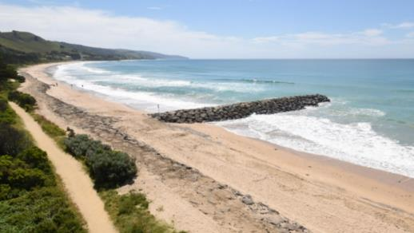

Apollo Bay Foreshore Protection Project

The northern revetment now joins the southern revetment that was completed during Stage 1 works. Approximately 630 metres of rock seawall has been built along the foreshore north of Milford Street to reduce the impact of waves during storm activity and rising sea levels.

The final groyne is complete, and sand is expected to accumulate increasing the width of the beach and improving coastal resilience.

DELWP will work with the Great Ocean Road Coast and Parks Authority to re-establish and open the foreshore path ahead of the summer holidays.

Two vehicle access ramps at the southern and northern sections are nearing completion and safety signage has been installed at the groynes.

Planning for revegetation works are also underway, which will see portions of the revetment covered with indigenous species, improving the stability and biodiversity of the foreshore.

A community planting day will take place in April 2022 and more information will become available to get involved. Visit [Apollo Bay and Marengo (marineandcoasts.vic.gov.au)](https://www.marineandcoasts.vic.gov.au/coastal-programs/apollo-bay-and-marengo) to find out more.

## St Leonards North beach renourishment

A major milestone has been reached in a series of Bellarine Peninsula beach renourishments being delivered by the Land and Built Environment team, Barwon South West. The works are funded by the Victorian Government’s $8 million Port Phillip Bay Beaches Renourishment Program.

The renourishment along the St Leonards’ northern shoreline has been completed, which has widened the previously narrow shoreline by 15 metres.

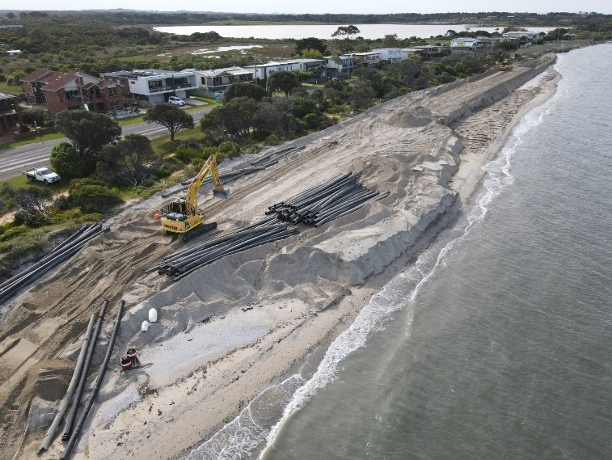

St Leonards North beach renourishment

Expanding the shoreline has provided protection for coastal assets, reduced the likelihood of inundation and erosion along the shoreline and improved the recreational space.

The process involved harvesting sand from an offshore location and pumping it to shore where it was spread out and profiled. Post-works including landscaping and planting of native vegetation along the shoreline are now underway.

Next up in the series of Bellarine beach renourishments are two more renourishments at St Leonards, at Lower Bluff (south of the pier), and north of Bengalat Reserve.

For more information, visit [Bellarine beach renourishments (marineandcoasts.vic.gov.au)](https://www.marineandcoasts.vic.gov.au/coastal-programs/bellarine-renourishments).

## Mallacoota Foreshore seawall replacement

The replacement of a 200-metre-long concrete panel seawall at Mallacoota is complete. The replacement is the first stage of the upgrade of the foreshore adjacent to the Mallacoota Foreshore Holiday Park, as part of the Victorian Government’s investment from the Building Works package.

This stage of the project replaced part of the northern section of the structure which had degraded and was a safety risk to the public.

East Gippsland Shire Council is now working on the landscaping.

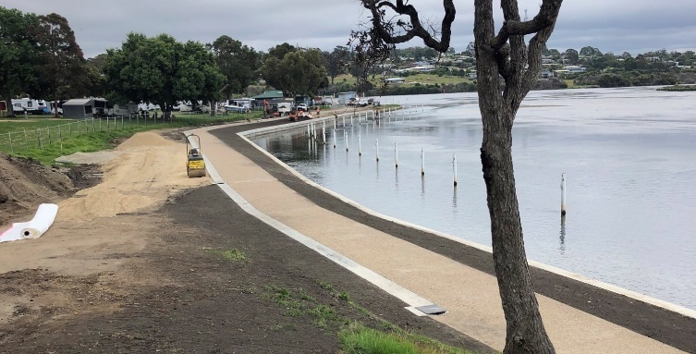

Construction of the Mallacoota Foreshore seawall replacement

## Bullock Island North Arm seawall

Construction on the replacement of the Bullock Island North Arm seawall is nearing completion. The seawall extends from the breakwater at North Arm westward to the Bullock Island fuel jetty, to protect the Bullock Island North Arm foreshore, and prevent further damage to the area.

This project is aligned with the Bullock Island Master Plan, which is managed by the East Gippsland Shire Council.

All concrete panels and capping beams for the northern section have been completed and the rocks placed to protect the interchange of the seawall.

The demobilisation and site clean-up has commenced with the project due to be completed by the end of 2021.

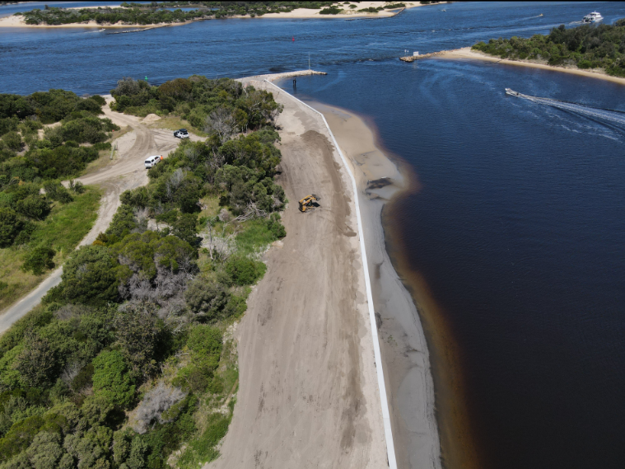

Replacement of a concrete panel seawall for the Bullock Island North Arm seawall

# Marine and coastal knowledge

## Understanding coastal environments and community values in the Cape to Cape region

The Cape to Cape Resilience Project is a long-term coastal hazard adaptation project, to plan for managing future changes to coastal areas between Cape Paterson and Cape Liptrap on the Bass Coast.

It’s been another busy few months for the Cape to Cape project. Various key pieces of work have continued, allowing the project team to understand more about the region’s coastal environment, local communities and their values.

The Coastal Hazard Assessment team has progressed the next stages of technical assessments. This has included additional ground surveys, extensive data analyses and the development, refinement and running of coastal models. The erosion and inundation hazard models are currently being peer-reviewed by technical experts.

From July to September 2021, the project focussed on gathering community perspectives to inform the Community Values Study. Using a range of methods – online workshops, a targeted survey and interactive map story board – we asked people to share what they value most about the Cape to Cape region. A summary of the engagement findings is available at [Cape to Cape Resilience Project (marineandcoasts.vic.gov.au)](https://www.marineandcoasts.vic.gov.au/coastal-programs/cape-to-cape-resilience-project) and the full Community Values Study is set to be released shortly.

In the new year, we will be considering the range of available adaptation options for the region to protect and manage values and assets. Option development, modelling of options and feasibility will initially explore adaptation options for the coastline between Flat Rocks and Screw Creek at Inverloch.

The community continue to have a role in informing the adaptation approach, including providing feedback on the options for managing coastal hazards.

Keep an eye on the [Cape to Cape Resilience Project website](https://www.marineandcoasts.vic.gov.au/coastal-programs/cape-to-cape-resilience-project) to stay up to date with this exciting work.

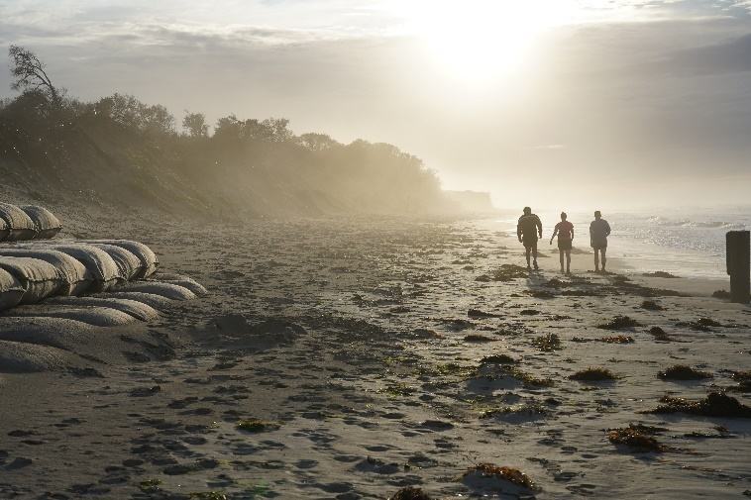

Inverloch Surf Beach and the geotextile sandbag seawall at sunrise, October 2021



# In this issue:

Staffing updates

Coastcare Victoria Community Grants recipients 2021

Summer by the Sea 2022 and Amateur Naturalist Challenge

Victorian Landcare award winners! Coastcare category

Ocean Grove Coastcare celebrates 10 years

Learning about waterway health in Tarwin Lower

Wilderness Coast Project engages youth in Mallacoota

Birds in Backyards survey

Turn in a Fairy Tern in Victoria

# Staffing updates

Welcome to Madison (Madi) Cassie, our new Bellarine and Surf Coast facilitator.

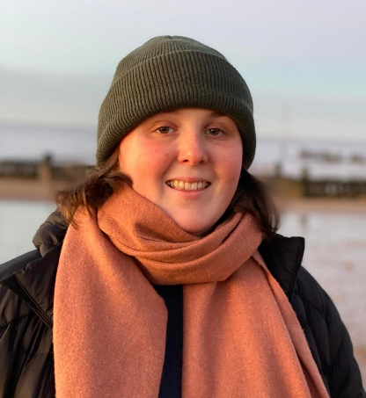

Madison Cassie, Coastcare Victoria’s new Bellarine and Surf Coast facilitator

Madi has a background in environmental sciences, land management, planning approvals and volunteering in a range of locations and habitats.

We welcome back Adam Taylor, who has returned to the Far South West facilitator role after a secondment as the Senior Forest and Roading Officer for the Far South West.

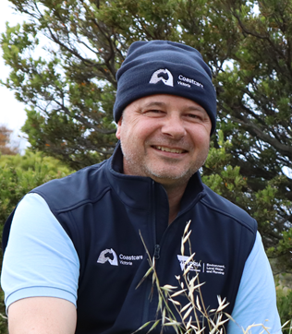

Adam Taylor, Coastcare Victoria’s Far South West facilitator

With Ellie Morrow handing back the reins of the Far South West role, she is currently filling in for the Port Phillip and Westernport facilitator.

Visit [Coastcare Victoria (marineandcoasts.vic.gov.au)](https://www.marineandcoasts.vic.gov.au/coastal-programs/Coastcare-Victoria) to find your local facilitator.

# Coastcare Victoria Community Grants recipients 2021

A total of 32 projects were approved for funding for this year’s Coastcare Victoria Community Grants. The grant recipients and projects being funded are listed at [Coastcare Victoria Community Grants (marineandcoasts.vic.gov.au)](https://www.marineandcoasts.vic.gov.au/coastal-programs/Coastcare-Victoria/coastcare-victoria-community-grants).

Projects span across the Victorian coastline from Gunditjmara Country in the far south west to Tambo Bluff in East Gippsland.

The smallest project will see Camberwell Girls Grammar School spending $1,800 to stop the Northern Pacific seastars through educating their community. One of the largest projects will see Gunditj Mirring Traditional Owners Aboriginal Corporation spending $30,000 on coastal related cultural practices workshops and documenting this cultural knowledge.

Despite the challenges of COVID-19, 78 per cent of projects will hold working bees and events across the state to deliver these projects. Around 60 per cent of projects will focus on on-ground works by tackling weeds and getting over 9,000 plants in the ground along our coastline.

Thank you to all the volunteers working in partnership with Coastcare Victoria on the protection of, and increasing the understanding about, Victoria's marine and coastal environment.

# Summer by the Sea 2022 and Amateur Naturalist Challenge

Planning is in full swing for [Summer by the Sea](https://summerbythesea.vic.gov.au/) 2022, our annual program of free activities along Victoria’s coast during January. Keep an eye on the [Coastcare Victoria website](https://www.marineandcoasts.vic.gov.au/coastal-programs/Coastcare-Victoria/coastcare-victoria-community-grants) as we get some exciting activities and content ready for the community, including an amateur naturalist challenge!

If you a budding photographer or movie maker with a passion for Victoria’s stunning marine and coastal environments and its inhabitants, now is your time to shine!

Make a short movie or visual presentation and submit it to our amateur naturalist challenge. The best submission will be featured as part of our Summer by the Sea program so please share this opportunity with your networks.

Challenge submissions are due by 5pm Monday 10 January 2022 – check out the [flyer](https://www.marineandcoasts.vic.gov.au/__data/assets/pdf_file/0037/549937/CCV-SBTS-amateur-naturalist-video-challenge-flyer-FINAL.pdf) for details and conditions.

# Victorian Landcare award winners! Coastcare category

We’re very excited to share the winners of the Coastcare category in the 2021 Victorian Landcare awards – the Cape Paterson Residents and Ratepayers Association (CPRRA) and Harmers Haven Residents and Ratepayers Group: Friends of Harmers Haven (HHRRG—FoHH).

This award acknowledges a community group or network that has contributed to the significant improvement of a coastal or marine environment.

CPRRA and HHRRG—FoHH have worked together since 2009 to care for coastal foreshore habitat from Coal Point in the west through to the eastern end of Undertow Bay. These two groups are protecting and improving habitat along Victoria’s unique and precious Bass Coast. They will represent Victoria at the 2022 National Landcare Awards.

Medium shot of women smiling (Amaryl Perlesz (left) Rosemary Paterson (right) of Harmers Haven Residents and Ratepayers Group with their award).



Amaryl Perlesz (left) Rosemary Paterson (right) of Harmers Haven Residents and Ratepayers Group with their award.

For more information about this award, visit [Victorian Landcare Magazine](https://www.landcarevic.org.au/landcare-magazine/spring-2021/coastcare-award-cape-paterson-residents-and-ratepayers-association-and-harmers-haven-residents-and-ratepayers-group-friends-of-harmers-haven/).

# Ocean Grove Coastcare celebrates 10 years

Following a year of COVID-19 related delays, Ocean Grove Coastcare was finally able to celebrate its 10th anniversary (due in late 2020) on 17 November 2021, with 40 friends old and new.

Member Jackie Scally spoke warmly on the night about the groups creation: ‘Bolstered by a healthy dose of naivety and enthusiasm (both necessary ingredients) we hosted a movie night at the Piping Hot Chicken Shop in September 2010 to generate community interest in our little idea. Eighty people turned up and Ocean Grove Coastcare was born that evening.’

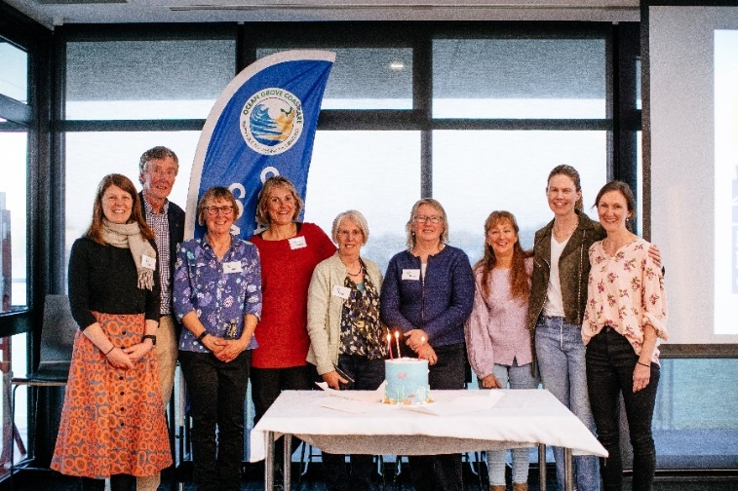

Ocean Grove Coastcare committee with their celebratory sea cake.

In the ten years since, the group has seen hundreds of volunteers contribute a collective 2,700 hours in weeding among the dunes (typically plants that have escaped from local gardens), planting more than 3,000 indigenous plants, giving away 2,000 plants for local gardens, clearing up hundreds of large bags of rubbish, and creating awareness of ocean plastics and other environmental issues.

As we congratulate the group on a successful ten years, we look forward to seeing them keep providing a way for the Ocean Grove community to connect with people and place and give back to the natural environment for many more years to come.

Visit [oceangrovecoastcare.org.au](https://www.oceangrovecoastcare.org.au/) to find out more.

# Learning about waterway health in Tarwin Lower

Tarwin Landcare Group had a great day learning how to assess waterway health along the Tarwin River recently.

Held at the Tarwin Lower jetty, the training day was run by Erin Nowak from BugBlitz and was made possible via funding from the Victorian Government’s Coastcare Victoria Community Grants program.

Erin showed the group how to test for salinity, pH, dissolved oxygen levels and turbidity, which all affect the types of organisms that can live in the water. She also explained how to carry out a quick health check of a waterway by assessing the type and extent of vegetation along its banks. Rivers with high levels of native vegetation and leaf litter are usually the healthiest.

The group also examined water samples for macro-invertebrates (water bugs). Water bugs have different tolerance levels to pollution or water quality, so the presence or absence of particular species is a reliable indicator of the health of a waterway.

The workshop was the first step in a project being carried out by Tarwin Landcare Group to restore and protect mangroves in Andersons Inlet. Over the next 18 months, group members will collect water samples at a nominated site on the Tarwin River to detect trends that may impact the health of the mangroves.

Participants at Tarwin Lower Jetty Water Monitoring Day organised by Tarwin Landcare Group.

If you are interested in joining Tarwin Landcare Group or to help with water monitoring, please contact Jillian Staton at [mjsta9840@bigpond.net.au](mailto:mjsta9840@bigpond.net.au).

# Wilderness Coast Project engages youth in Mallacoota

*By Bethany Hunting, Coastcare Victoria facilitator (East Gippsland)*

The Wilderness Coast Project aims to engage the youth of Mallacoota in conservation and rehabilitation work following the 2019-20 Black Summer bushfires in East Gippsland.

I visited the [Wilderness Coast Project](https://sanctuarymyg.org/portfolio-item/wilderness-coast/) recently with the Mallacoota Sanctuary Youth Group (MSYG), the Friends of Mallacoota, a coastal projects officer from DELWP and a member of East Gippsland Shire Council.

The project has been progressing well, with working bees on weed removal (targeting beach daisy and gladioli species), litter collection and audit using the DELWP [LitterWatch](https://www.litterwatchvictoria.org.au/) methodology of auditing and propagation under the tutelage of members of the Friends of Mallacoota.

The group is now looking to continue the fourth component of the project – revegetation works. This work was postponed in order to see what would naturally regenerate and revegetate in the ecosystem post-fires. Some sites that had been identified as possible sites for revegetation were recovering nicely on their own, and it was agreed with land managers that Betka Beach was an appropriate site for revegetation works.

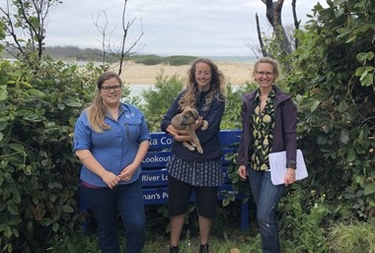

Bethany Hunting (left) with Brodie Gaudion (middle) and Paris Brooke (right) from the Mallacoota Sanctuary Youth Group on site at Betka Beach.

The MSYG is continuing to work with the Friends of Mallacoota to propagate and source native species to be planted after Easter 2022.

The Friends of Mallacoota have also established a new nursery site with funding received over the past 12 months, which enables the Friends group to be even more self-sufficient and grow plants for planting around the township to continue recovery efforts.

It was a pleasure to see both groups – to see the partnership they have developed through mentoring was such a highlight to me as a facilitator.

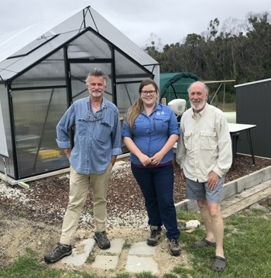

Bethany Hunting (middle) with Max Elliot (left) and Martyn Hiley (right) from the Friends of Mallacoota on site at their nursery.

# Birds in Backyards survey

Time to spruce up your feathers, shake off 2021 and let Birdlife Australia know about your local birds!

The Birds in Backyards Summer Survey is here to give you a fun and relaxing activity to do over your Christmas and New Year break.

New to surveys or need a refresher? Check out the [survey instructions](https://www.birdsinbackyards.net/getinvolved/How-survey) page.

BirdLife Australia want to know about the birds you don’t see just as much as the ones you do. So if your list is only small, full of introduced birds or birds you don’t think are very ‘exciting’, that is still important information so please give it a go!

For more information, visit the [Birds in Backyards website.](https://www.birdsinbackyards.net/content/article/Suns-out-birds-out-Its-summer-survey-time)

# Turn in a Fairy Tern in Victoria

*By Dr Amy Adams, Coastal Birds Program Coordinator, BirdLife Australia*

As the breeding season gears up to begin for Fairy Terns (and Little Terns) here in Victoria, we are once again getting ready to monitor Fairy Tern nesting sites around Victoria. We have two Fairy Tern monitoring projects in Victoria; one in Western Port and Port Phillip Bay and one in East Gippsland.

While we have dedicated volunteers and land managers keeping an eye out for breeding activities over the coming months, we are calling on members of the public, especially those out on the water, to be on the lookout for any breeding birds when we can’t be there ourselves!

There are several tell-tale behaviours that birds are breeding or getting ready to. When colonies are establishing, often birds can be seen performing aerial display flights where they chase after one another, often with fish in their bills, and will be calling loudly. The breeding season is often the only time you will hear Fairy Terns being vocal!

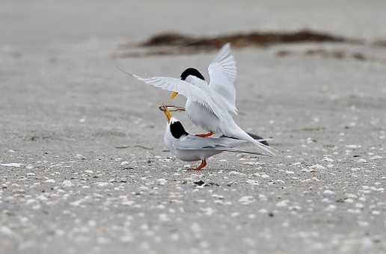

Courtship feeding (Photo: John Hutchison)

Fish wiping is a behaviour where the male stands directly behind a female with a fish in his bill and repeatedly moves his head from side to side while the fish makes contact with the female’s back. This typically results in courtship feeding where the male will feed the fish to a female, often while he is standing on her back ready to copulate.

If you find yourself being swooped and called at loudly (by any tern species) you are too close to a nesting area and you should carefully leave the area as there are likely to be camouflaged eggs or chicks nearby. 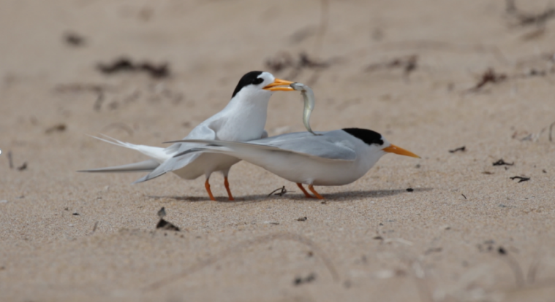

Fish wiping (Photo: Claire Greenwell)

So now it is your turn to help save the terns this summer by reporting any sightings of Fairy Terns as soon as possible to [beachnestingbirds@birdlife.org.au](mailto:beachnestingbirds@birdlife.org.au) – especially if they are performing any of these behaviours!

You can find out more about what is happening across the regions to help raise awareness and protect our precious beach-nesting birds in the latest edition of our beach-nesting birds project newsletter, [Word about the Hood](https://www.birdlife.org.au/projects/beach-nesting-birds/newsletters-bnb).

|  |  |
| --- | --- |
| © The State of Victoria Department of Environment, Land, Water and Planning 2021  LogoThis work is licensed under a Creative Commons Attribution 4.0 International licence. You are free to re-use the work under that licence, on the condition that you credit the State of Victoria as author. The licence does not apply to any images, photographs or branding, including the Victorian Coat of Arms, the Victorian Government logo and the Department of Environment, Land, Water and Planning (DELWP) logo. To view a copy of this licence, visit http://creativecommons.org/licenses/by/4.0/  Disclaimer  This publication may be of assistance to you but the State of Victoria and its employees do not guarantee that the publication is without flaw of any kind or is wholly appropriate for your particular purposes and therefore disclaims all liability for any error, loss or other consequence which may arise from you relying on any information in this publication. | Accessibility  If you would like to receive this publication in an alternative format, please telephone the DELWP Customer Service Centre on 136186, email [customer.service@delwp.vic.gov.au](mailto:customer.service@delwp.vic.gov.au), or via the National Relay Service on 133 677 [www.relayservice.com.au](http://www.relayservice.com.au). This document is also available on the internet at [www.delwp.vic.gov.au](http://www.delwp.vic.gov.au). |