|  |
| --- |
| DELWP marine and coasts newsletter |

Welcome to the Department of Environment, Land, Water and Planning’s (DELWP’s) quarterly marine and coasts newsletter**.**

## In this issue:

* Victoria’s Resilient Coast – Adapting for 2100+
* Successful foreshore protection at Apollo Bay
* Beach renourishment begins at St Leonards
* Lakes Entrance Ocean Rescue seawall replacement
* Mallacoota foreshore seawall replacement – Stage 1b
* Blairgowrie to Tootgarook beach renourishments
* Coastal Asset Management System

|  |
| --- |
| Email [marine.coasts@delwp.vic.gov.au](mailto:marine.coasts@delwp.vic.gov.au) to subscribe or unsubscribe to this newsletter and for more information. |

# Marine and coastal policy reforms

## Victoria’s Resilient Coast – Adapting for 2100+

Victoria’s diverse bio-cultural coastal landscapes have been nurtured by Traditional Owners of Country for countless generations, and are dynamic environments shaped by natural coastal processes.

At times, coastal processes including erosion and inundation may have a negative impact on coastal values and uses. When this occurs, we often refer to these processes as coastal hazards. Coastal hazard exposure is projected to increase with changes in wave action, storm activity and sea level rise associated with climate change.

Victoria’s Resilient Coast – Adapting for 2100+ will provide a statewide approach for coastal hazard risk management and adaptation. This will include a framework, guidelines, and support for local government, land managers and their communities.

In building on the Marine and Coastal Policy (2020) directions, Victoria’s Resilient Coast will provide a staged approach to coastal hazard risk management and adaptation including:

* scoping and preparation
* values, vision and objectives
* coastal hazard exposure
* vulnerability and risk
* adaptation actions and pathways
* plan and implement
* monitoring and review.

The statewide approach is being developed through a collaborative process, including a project partnership with Traditional Owners, and a working group including representatives from coastal councils, committees of management, Catchment Management Authorities, government agencies, water authorities and peak body groups.

Our Victorian framework and guidelines will be informed by:

* leading research on climate adaptation
* national / international approaches
* Victoria’s place-based adaptation needs
* the collaborative development process which is ongoing to early 2022.

From early 2022, initial pilot implementation of the framework and guidelines will commence, with ongoing review.

For more information, visit [Victoria’s Resilient Coast – Adapting for 2100+ (marineandcoasts.vic.gov.au)](https://www.marineandcoasts.vic.gov.au/coastal-management/victorias-resilient-coast-adapting-for-2100) or email [vicresilientcoast@delwp.vic.gov.au](mailto:vicresilientcoast@delwp.vic.gov.au).

# Coastal projects

## Successful foreshore protection at Apollo Bay

Major works as a part of the $7.4 million Apollo Bay Foreshore Protection project are complete!

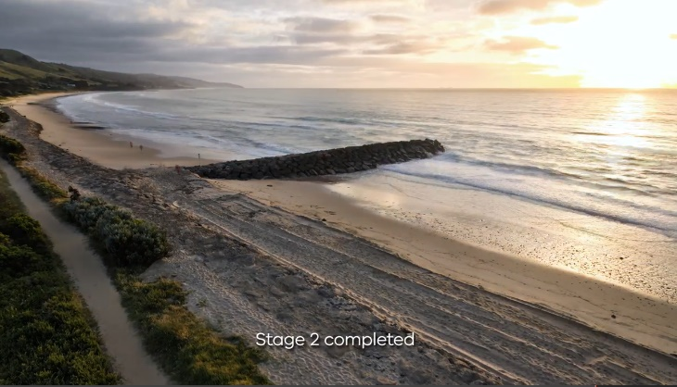

The Apollo Bay Foreshore Protection project.

Stage 1 works were delivered in June 2021 and Stage 2 in December 2021.

The project has mitigated severe coastal erosion, safeguarding the Apollo Bay foreshore and protecting assets along the Great Ocean Road, including heritage cypress trees, walking path, beach access, foreshore dune area, vegetation and services.

Works included:

* three groynes comprising around 63,833 tonnes of rock
* 675 metres of rock seawall
* two heavy vehicle access ramps
* one light vehicle access ramp
* four wooden beach access stairs
* 475 metres of reinstated foreshore path.

Additional revegetation works will be underway in the next few months. DELWP will also work with the Department of Transport to complete additional works at the northern revetment, so that end scour does not impact the foreshore and heritage listed trees along the Great Ocean Road. These works are due to commence on 26 April and will be completed by late May 2022.

The site will be monitored over the coming years to gauge the project’s effectiveness and to inform ongoing management of the area.

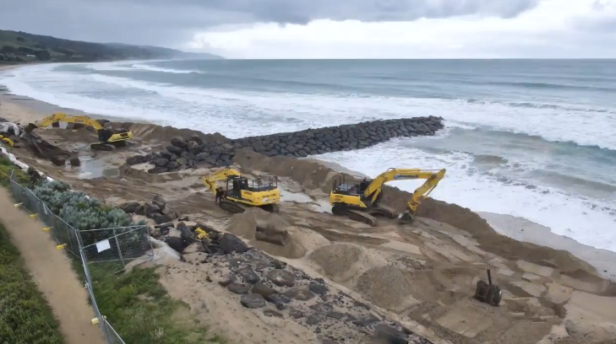

Stage 2 of the Apollo Bay Foreshore Protection project.

The project was funded by the Victorian Government’s $2.7 billion Building Works package and the Victorian State Budget 2020-21, with works delivered in partnership with the Department of Transport’s South-Western Roads Alliance.

## Beach renourishment begins at St Leonards

New works to address coastal erosion at St Leonards on the Bellarine Peninsula have started, with approximately 3,000 cubic metres of sand to be placed along the southern shoreline.

The beach renourishment at Lower Bluff is designed to avoid further erosion at the site, caused by severe storms and rising sea levels attributed to climate change.

By increasing the width of the beach along a 200-metre stretch, the works will provide protection for infrastructure behind the foreshore, including the low-lying coastal trail.

The new sand has been sourced from the seabed of Point Richards Harbour, where excess sand has naturally accumulated over time.

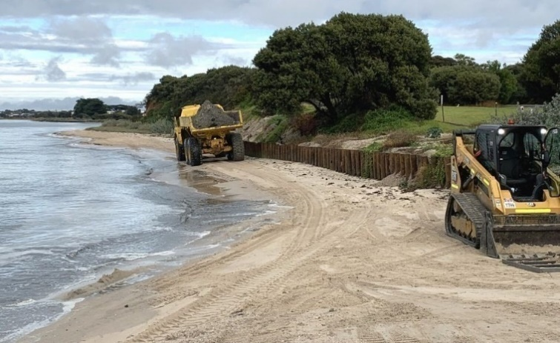

Beach renourishment at St Leonards.

As the sand contains organic material such as seaweed, it will initially appear darker in colour and may have a mild odour. After being deposited on the beach and exposed to several days of air and sun, the sand will bleach to a normal colour and lose any odour.

The works, which are weather dependent, are expected to be completed by the end of March 2022.

Over the coming years, the sand will naturally shift back into the ocean and be distributed along the coast, providing the benefit of additional sand moving through the Bellarine Peninsula beach system.

DELWP and the Bellarine Bayside Committee of Management have worked together to plan, design and coordinate these works, with input from the community.

This is the latest in a series of beach renourishments on the northern Bellarine Peninsula, with almost 30,000 cubic metres of sand having been distributed across four beaches at Indented Head and St Leonards over the last two years.

DELWP is delivering these works as part of the Victorian Government’s $8 million [Port Phillip Bay Beaches Renourishment Program](https://www.marineandcoasts.vic.gov.au/coastal-programs/beach-renourishment).

## Lakes Entrance Ocean Rescue seawall replacement

The 60-metre-long Lakes Entrance Ocean Rescue masonry seawall has deteriorated and is being replaced with a concrete panel seawall.

The seawall is located on the northern shoreline of Cunninghame Arm in Lakes Entrance, running adjacent to the Ocean Rescue (Australian Volunteer Coast Guard) building to the old slipway.

The new seawall, which will be completed in mid-2022, will provide protection for the foreshore reserve, Australian Volunteer Coast Guard buildings and infrastructure and allow for safer public recreation.

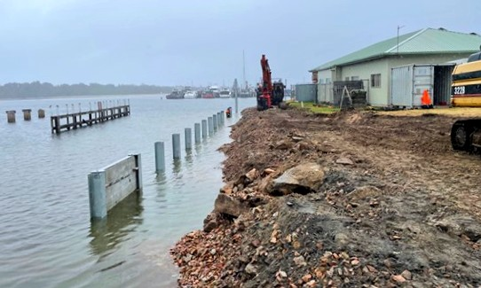

Construction of the seawall at Ocean Rescue, Lakes Entrance

## Mallacoota foreshore seawall replacement –Stage 1b

Construction of a 66-metre-long concrete panel seawall at Mallacoota has begun. This is Stage 1b of a multi-stage project to protect the foreshore adjacent to the Mallacoota Foreshore Holiday Park.

This stage of the project replaces the northern section of the structure which is failing and is a safety risk to the public.

Stage 1b will be completed in mid-2022 and was funded through the Victorian State Budget 2020-21.

Mallacoota Foreshore seawall replacement


Mallacoota Foreshore seawall replacement.

## Blairgowrie to Tootgarook beach renourishments

Work has begun on a series of beach renourishments between Blairgowrie and Tootgarook at the southern end of Port Phillip Bay.

Contractors are dredging sand from identified borrow sites on offshore sand bars, then pumping the sand ashore to be spread at erosion hot spots.

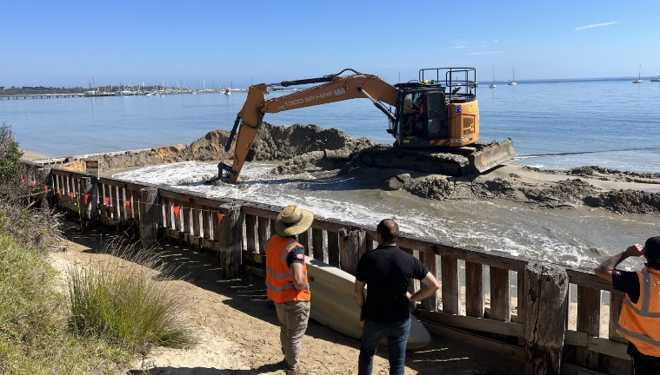

An excavator spreads the incoming sand at Blairgowrie beach.

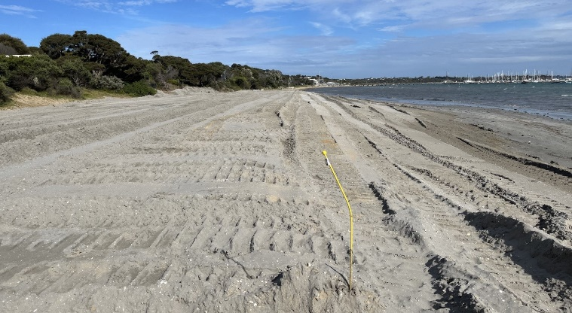

The renourished beach prior to final trimming. The sand will bleach over the coming weeks.

The project aims to protect infrastructure and community assets including Pt Nepean Road, power poles and underground assets, as well as improving beach amenity. The width and height of the beaches will be increased to provide protection to the foreshore from ongoing coastal processes and storm surge. Approximately 19,000 cubic metres (m3) of sand has been spread at Blairgowrie, with 4,000 m3 at WhiteCliffs and 8,000 m3 expected at Tootgarook.

An assessment was also undertaken of nearshore seagrass and rocky/reef marine habitats along the coastal strip from Blairgowrie to Tootgarook. The assessment considered the likely impact from beach renourishments on these habitats. The authors of the assessment concluded that ‘indirect impacts to nearshore seagrass are possible but considered to be a low risk overall’.

Works at Blairgowrie are now complete, with works at Tootgarook to commence shortly.

# Marine and coastal knowledge

## Coastal Asset Management System

DELWP is continuing to maintain its Coastal Asset Management System (CAMS).

Coastal protection structures in Victoria – which include revetments, seawalls, groynes and breakwaters – have a combined length of 220 kilometres, according to CAMS data.

Not all of these structures are new. Shifting beach sands occasionally reveal old, buried structures with the irony that the best performing beach groynes, retaining the most sand, may be completed covered!

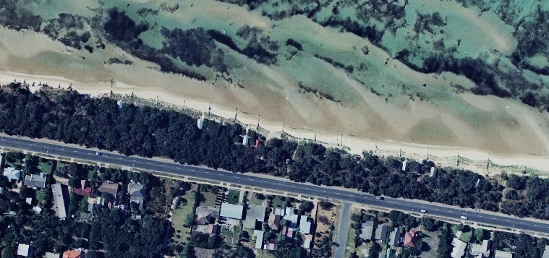

Aerial image of tea tree groynes at Tootgarook beach, 1968 (Image © Land Use Victoria).

Research is often required to determine the purpose of unearthed beach structures, utilising any available archives and DELWP’s inventory of historic aerial imagery.

Remnants of old structures can pose a risk to the community, and DELWP continues to work with land managers to resolve these risks.

While CAMS continues to record details of recently added structures, it also records the evidence of demolition and safe disposal of coastal assets as adaptation forms a more prominent component of our coastal management strategies.



# In this issue:

* Staffing updates – farewell, happy travels and welcome
* Community caring for Corinella foreshore
* Freshwater skin disease in the critically endangered Burrunan dolphin
* Rock lobster fishing gear plastic removal project
* Living on the Edge website redevelopment
* Marine Care Ricketts Point’s first urchin cull of the year
* Volunteer Capacity Building – First Aid training
* Summer by the Sea ‘Coast to Home’ wrap-up
* 2022 Coastcare Victoria Community Grants

## Staffing Updates – farewell, happy travels and welcome

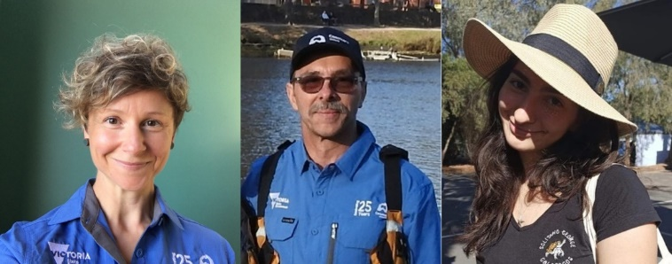

From left: Ellie Morrow, Phillip Wierzbowski, Johanna Tachas.

Farewell to Ellie Morrow who started with Coastcare Victoria in October 2020, first looking after the Far South West region and more recently the Port Phillip and Westernport region. We’d like to thank Ellie for all her hard work and wish her all the best on her return to the Grampians region.

Happy travels to long-term Port Phillip and Westernport facilitator Phillip Wierzbowski, who’s enjoying a well-earned long-service break.

Welcome back Johanna (Joiee) Tachas who will be looking after the Port Phillip and Westernport Region for the next 18 months.

Please visit [Coastcare Victoria (marineandcoasts.vic.gov.au)](https://www.marineandcoasts.vic.gov.au/coastal-programs/Coastcare-Victoria) to find your local facilitator.

## Community caring for Corinella foreshore

Thanks to the support of a Coastcare Victoria Community Grant, the community at Corinella in South Gippsland have been using new technology to plan and conduct works to reduce the impact of pest plants and animals along the foreshore at Settlement Point and the Northern and Southern Precinct areas.

The grant allows for pest animal and weed control in conjunction with community engagement in the form of online information sessions and volunteer field days.

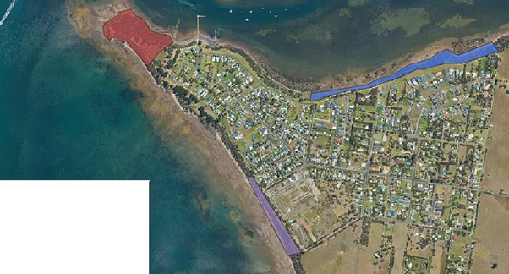

Works area on the Corinella Foreshore. Blue shading represents the Northern Precinct, purple represents the Southern Precinct and red shows Settlement Point. Image: Aaron Stephens, Bass Coast Landcare Network.

In early February 2022, Corinella Foreshore Committee of Management and Bass Coast Landcare led a popular online class on how to use the ‘RabbitScan’ app. The app allows for more effective pest control through accurate mapping and will be an invaluable tool for planning future conservation works.

Rabbit activity mapped within the works areas at Corinella will now be acted upon directly in control efforts such as baiting and fumigation.

In early March, a field day focused on volunteers’ hand-weeding sensitive areas in the Northern precinct, where weed-spraying might cause damage to indigenous plants.

We look forward to seeing the measured results of the rabbit monitoring and reductions in pest and plant animal pressures on sites throughout the beautiful Corinella foreshore.

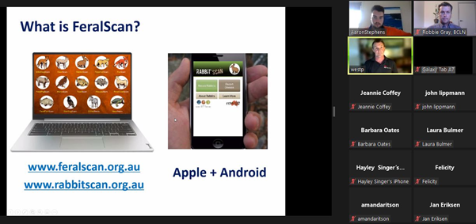

RabbitScan training. Image: Aaron Stephens, Bass Coast Landcare Network.

## Freshwater skin disease in the critically endangered Burrunan dolphin

*Article written by the Marine Mammal Foundation*

The Burrunan dolphin (*Tursiops australis*), formally described as a new species in 2011 (Charlton Robb et al, 2011), is a dolphin species endemic to southern and south-eastern Australia.

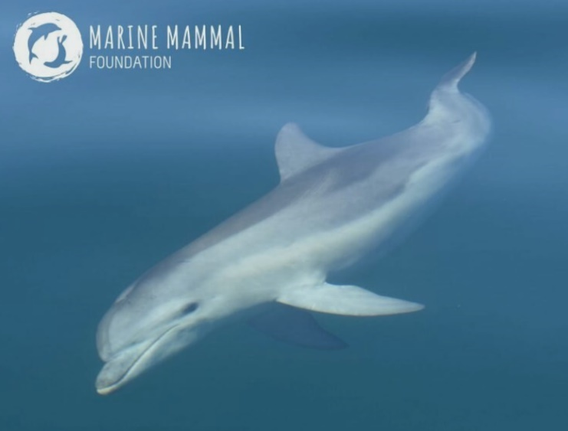

Burrunan dolphin. Image: Marine Mammal Foundation.

In Victoria, there are only two known resident populations of Burrunan dolphins, located in Port Phillip Bay and the Gippsland Lakes.

Unfortunately, Marine Mammal Foundation (MMF) researchers have observed the Gippsland Lakes Burrunan dolphin population to be suffering a mortality event as a result of an emerging freshwater skin disease (Duignan, Stephens & Robb, 2020), causing skin ulcers and lesions akin to burns.

This has occurred due the increase in persistent rainfall and influx of fresh water into the normally brackish-to-salty Lakes system.

Complex environmental changes to the Gippsland Lakes, including increased sedimentation and terrestrial run-off, dramatic fluctuation in salinity, temperature changes and anoxic conditions may also be contributing to the decline in health of the Gippsland Lakes Burrunan dolphin. Given the small population size and low genetic diversity, this poses a severe threat to this unique and highly valued population.

Ongoing field surveys, along with dolphin sightings reported by the community, indicate that a large number of resident dolphins have not been sighted for a significant period of time.

MMF is working alongside DELWP to better understand the current changes to the Gippsland Lakes system and the impact on the Burrunan dolphin. Vital to this survey effort is the contribution of community dolphin sightings across the Gippsland Lakes.

MMF is calling on the public to report any sightings of dolphins across the Gippsland region. Sightings can be reported via TrakMM on the [Marine Mammal Foundation website](https://www.marinemammal.org.au/), or via MMF’s [Dolphin Spotting Victoria TrakkMM Facebook group](https://www.facebook.com/groups/298432527922744/).

Please remember to follow the Wildlife (Marine Mammal) Regulation and remain at least 100 metres away from dolphins if you’re in a powered or unpowered vessel, and at least 300 metres if you’re on a jet ski. Whether it’s alive or dead, please don’t go too close or touch the animal as you could compromise sampling and subsequent testing results.

Any and all sightings will help contribute to a better understanding of this issue and help in the conservation efforts of this incredible species!

To find out more about the Burrunan dolphin, please visit the [Marine Mammal Foundation website](https://www.marinemammal.org.au/) and [Burrunan dolphin (DELWP - environment.vic.gov.au)](https://www.environment.vic.gov.au/conserving-threatened-species/threatened-species/burrunan-dolphin).

## Rock lobster fishing gear plastic removal project

The impact of plastics in our aquatic environments is recognised worldwide as a serious environmental issue.

Despite the broadscale impacts of marine plastic pollution on wildlife, aesthetics, economies, and human health, the rates of input to marine systems continue to rise.

Local and regional efforts to address the problem rely on the identification of sources and clean-up events.

To help reduce the issue, [Beach Patrol 3280](https://www.beachpatrol.com.au/beach-groups/3280/16) in Warrnambool have used a Coastcare Victoria Community Grant to fund a video on plastic pollution from rock lobster fishing gear.

The video features local rock lobster fisherman Gary Ryan, who acted on plastic pollution after he met local rubbish warrior and Warrnambool citizen of the year Colleen Hughson.

Check out [this 9-minute video](https://vimeo.com/678062042) to see how they did it, including a change in pot collar design!

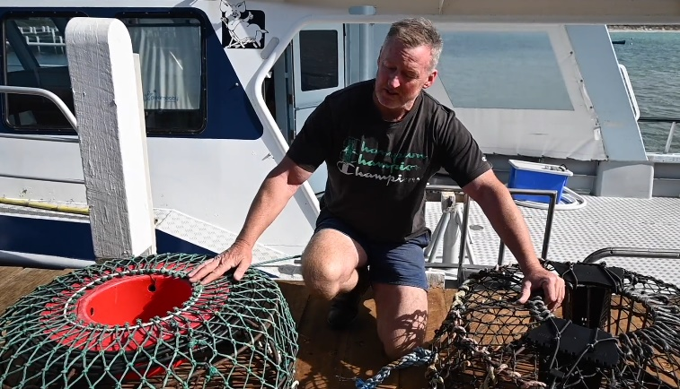

Gary Ryan showing the difference in old and new lobster pots reducing plastic waste. Image: First Ladies Productions.

## Living on the Edge website redevelopment

Friends of the Bluff have been busy hosting two workshops in December 2021 and March 2022 to help reimagine and set new directions for their Living on the Edge website.

With the support of a Coastcare Victoria Community Grant, the Friends of the Bluff are developing a way to allow this award-winning education resource to remain meaningful and relevant to the local community and schools.

The workshops brought together a working group to focus on reviewing website content to determine what should be maintained and carried forward, as well as identifying what new materials and resources users would like to see developed.

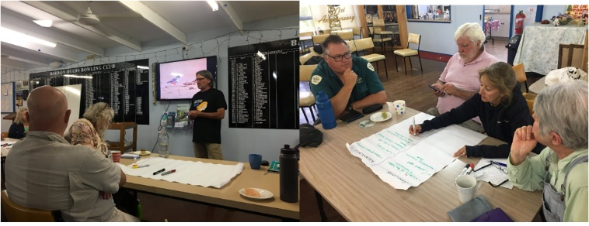

Friends of the Bluff and working group members sharing ideas and concepts for the new website. Images: Mark Rodrigue.

The group is aiming for website completion on 16 November 2022, to coincide with the 20th anniversary of establishing the Barwon Bluff Marine Sanctuary.

For more information, visit [Friends of the Bluff Barwon Heads - Home | Facebook](https://www.facebook.com/Friends-of-the-Bluff-Barwon-Heads-148864151867061/).

## Marine Care Ricketts Point’s first urchin cull of the year

*Text adapted from article by Elizabeth Jensen, President of Marine Care Ricketts Point.*

Marine Care Ricketts Point were delighted to undertake their first urchin cull on 17 February at Tea House Reef as part of their ‘Engaging community to manage overabundant urchins at Ricketts Point Marine Sanctuary’ project, funded by Coastcare Victoria’s Community Grants program.

The project aims to counter overabundant native urchins in the marine sanctuary with the assistance of Victorian National Parks Association (VNPA) scuba leaders and commercial divers.

It was great to get the first cull under way after five cancellations due to adverse La Niña weather.

Parks Victoria provided wonderful guidance and expertise from the water to eight snorkel volunteers facing some choppy conditions at low tide.

Each volunteer had slates and culling sticks, and the group shared two underwater cameras, funded by the Coastcare Victoria grant.

The cullers avoided damage to the reef and macroalgae by culling only on sandy areas.

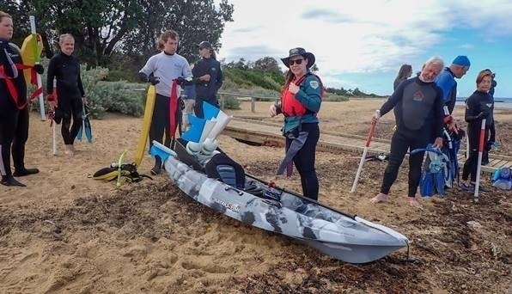

Ellie and Shaun (Parks Victoria) prepared the kayak while volunteers organised the yellow diver floats and learnt how to use their culling poles. Image: David, Marine Care Ricketts Point.

The group culled 1,611 urchins in their hour in the water – local snorkellers are already reporting anecdotal changes in the urchin numbers and surrounding marine life.

Feedback after the snorkel was excellent; the volunteers found the culling poles easy to use and the slates especially good for recording data underwater. It was an excellent chance to record what happens underwater with the cameras.

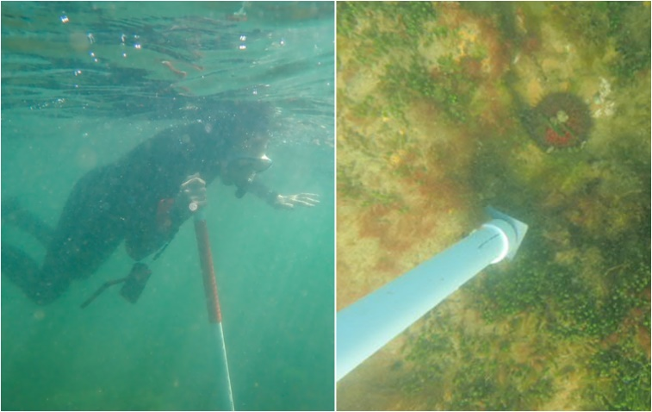

The urchins were culled with one strike, making it quick and humane. Images: Chris and Beth, Marine Care Ricketts Point.

The Marine Care Ricketts Point group look forward to the next cull, when they can see what effect this cull has had on the area.

Visit the [Marine Care Ricketts Point website](https://marinecare.org.au/) for more information.

## Volunteer Capacity Building – First Aid training

First Aid training funded by Coastcare Victoria has been extended due to popular demand! We know how important it is for our volunteers to have a qualified first aider available when delivering Coastcare Victoria funded activities.

Our volunteers can access training online, or face-to-face at the following authorised St John Ambulance providers: Attwood (Tullamarine), Ballarat, Bendigo, Box Hill, Cheltenham, Dandenong, Frankston, Geelong, Keilor East, Laverton, Melbourne CBD, Mont Albert North, Notting Hill, Preston, Ringwood, Shepparton, Sunbury, Traralgon, Warrnambool, and Wodonga.

Bookings must be made by 31 May 2022.

To find out more, please contact your [local Coastcare Victoria Facilitator](https://www.marineandcoasts.vic.gov.au/coastal-programs/Coastcare-Victoria).

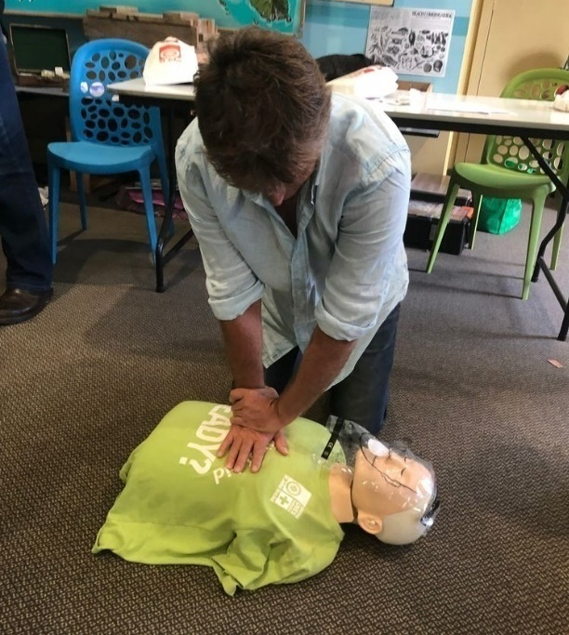

First Aid training at Inverloch, 2019. Image of Gavin O’Connor taken by Coastcare Victoria facilitator Bethany Hunting.

## Summer by the Sea ‘Coast to Home’ wrap-up

What a summer! Our first foray back to some face-to-face activities was dampened (sometimes literally) by La Niña and COVID-19, but we did have some fun coastal walks, great online talks, videos and challenges.

We were fortunate to have Welcome to Country and Smoking Ceremonies by Traditional Owners at several of our walks, including on Eastern Maar Country and Bunurong Country.

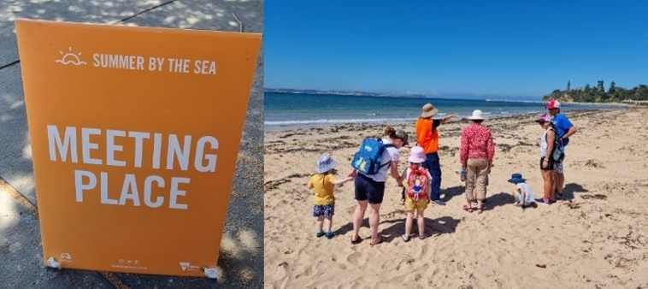

Beach Discovery Walk fun at Queenscliff. Images: Honor Gillies.

We had some fantastic entries to our challenges – thanks to all who participated, we hope you had fun.

Challenge winners:

* Amateur Naturalist Challenge: Stewart Andrews, [Planet Flinders](https://summerbythesea.vic.gov.au/whats-on/event/planet-flinders/)
* Sand Sculpture Challenge: Nina, [Blob City](https://summerbythesea.vic.gov.au/whats-on/event/sand-sculpture-challenge-winner/)
* Photo Challenge: [Connecting with the Coast](https://summerbythesea.vic.gov.au/whats-on/event/photo-challenge-winner-connecting-with-the-coast/) – Katie Emond, oncoming storm at Barwon Bluff
* Photo Challenge: [Creatures of the Coast](https://summerbythesea.vic.gov.au/whats-on/event/photo-challenge-winner-creatures-of-the-coast/) – Myra Kelly, Common Hermit Crab Paguristes frontalis
* Photo Challenge: [Coastal Colours](https://summerbythesea.vic.gov.au/whats-on/event/photo-challenge-winner-coastal-colours/) – Casey Watson, colourful seaweed at Ocean Grove dog beach.

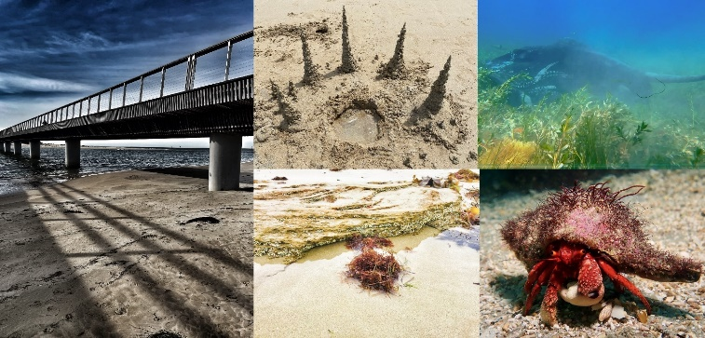

Winning images clockwise from left: Katie Emond, Nina, Stewart Andrews, Myra Kelly, Casey Watson.

We had 81 attendees at our walks, 124 at our talks, and 8,617 views of our videos! Thank you so much for joining us.

Recordings of all talks – which include Blue Whales, Megafauna of the past, Frogs, and Blue Justice and Seaweed – are coming soon to: [marineandcoasts.vic.gov.au/coastal-programs/Coastcare-Victoria/useful-links-for-volunteers](https://www.marineandcoasts.vic.gov.au/coastal-programs/Coastcare-Victoria/useful-links-for-volunteers).

Our videos (Beachcombing for Plastic, Marine Mammals, Volunteering for Threatened Flora and more) will join the talks and are also available on the [DELWP YouTube channel](https://www.youtube.com/c/DELWPVicGovAustralia) and (for now) our [Summer by the Sea website](https://summerbythesea.vic.gov.au/blog/).

All videos have English transcripts and closed captions in Arabic, Traditional Chinese, Simplified Chinese, English, Hindi, Punjabi, and Vietnamese. Please feel free to share them with your networks!

If you participated or watched any of our content, we’d love to hear from you so we know what we did well and what we can work on: [participant feedback form](https://forms.office.com/Pages/ResponsePage.aspx?id=99a96Bj8SE6lVH9UeSciO7Hpa9TzDCJBtNRUCkCiIjxUOTE3NEdUN1NPMVIxSzdUUU5NRldZT0lFMi4u).

## 2022 Coastcare Victoria Community Grants

Our 2022 [Coastcare Victoria Community Grants](https://www.marineandcoasts.vic.gov.au/coastal-programs/Coastcare-Victoria/coastcare-victoria-community-grants) round funded by Victoria’s Great Outdoors has recently closed. We thank all applicants for their time and effort in applying. We’ll be working behind the scenes on assessment and look forward to being able to notify successful applicants in June 2022.

|  |  |
| --- | --- |
| © The State of Victoria Department of Environment, Land, Water and Planning 2022  LogoThis work is licensed under a Creative Commons Attribution 4.0 International licence. You are free to re-use the work under that licence, on the condition that you credit the State of Victoria as author. The licence does not apply to any images, photographs or branding, including the Victorian Coat of Arms, the Victorian Government logo and the Department of Environment, Land, Water and Planning (DELWP) logo. To view a copy of this licence, visit http://creativecommons.org/licenses/by/4.0/  Disclaimer  This publication may be of assistance to you but the State of Victoria and its employees do not guarantee that the publication is without flaw of any kind or is wholly appropriate for your particular purposes and therefore disclaims all liability for any error, loss or other consequence which may arise from you relying on any information in this publication. | Accessibility  If you would like to receive this publication in an alternative format, please telephone the DELWP Customer Service Centre on 136186, email [customer.service@delwp.vic.gov.au](mailto:customer.service@delwp.vic.gov.au), or via the National Relay Service on 133 677 [www.relayservice.com.au](http://www.relayservice.com.au). This document is also available on the internet at [www.delwp.vic.gov.au](http://www.delwp.vic.gov.au). |