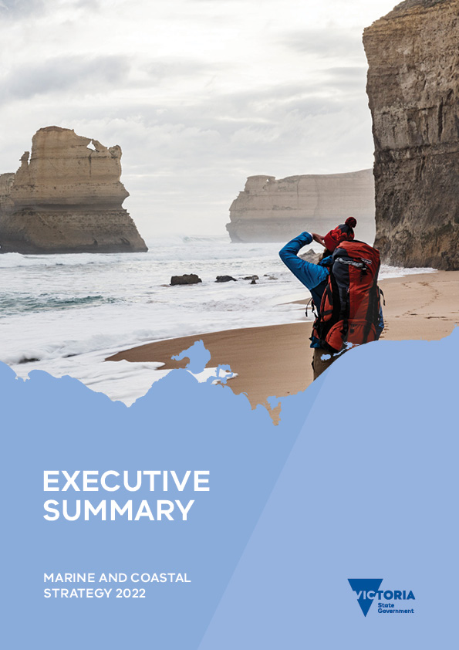

Executive Summary

Marine and Coastal Strategy 2022
Photo credits:
Cover – Gibson Steps, Eastern Maar Country. Credit: Parks Victoria
Page 4 – Mirring – Country. Credit: Tom Day
Page 5 – Seaford Surf Lifesaving Club, Bunurong Country. Credit: John Gollings
Page 7 – Port Phillip. Credit: Parks Victoria
Page 9 – Macrocystis pyrifera. Credit: Parks Victoria
Page 12 – Weedy Seadragon, Phyllopteryx taeniolatus. Credit: Parks Victoria
Page 14 – Gabo Island Lighthouse. Credit: Parks Victoria
© The State of Victoria Department of Environment, Land, Water and Planning 2022
This work is licensed under a Creative Commons Attribution 4.0 International licence. You are free to re-use the work under that licence, on the condition that you credit the State of Victoria as author. The licence does not apply to any images, photographs or branding, including the Victorian Coat of Arms, the Victorian Government logo and the Department of Environment, Land, Water and Planning (DELWP) logo. To view a copy of this licence, visit http://creativecommons.org/licenses/by/4.0/
Printed by Finsbury Green (Melbourne)
ISBN 978-1-76105-975-9 (Print)
ISBN 978-1-76105-976-6 (pdf/online/MS word)
Disclaimer
This publication may be of assistance to you but the State of Victoria and its employees do not guarantee that the publication is without flaw of any kind or is wholly appropriate for your particular purposes and therefore disclaims all liability for any error, loss or other consequence which may arise from you relying on any information in this publication.
Accessibility
If you would like to receive this publication in an alternative format, please telephone the DELWP Customer Service Centre on 136186, email customer.service@delwp.vic.gov.au, or via the National Relay Service on 133 677 www.relayservice.com.au. This document is also available on the internet at www.delwp.vic.gov.au

Contents
Minister’s foreword 3
Acknowledgement of Traditional Owners 4
What the strategy is 4
Why a strategy is needed 5
What the Strategy will do 5
Implementing and evaluating the Strategy 6
Timing for activities in the Strategy 7
How the Strategy was developed 7

Minister’s foreword
Victoria’s marine and coastal environment is fundamental to 60,000 years of Aboriginal culture, and is valued by all Victorians; in its own right, to live near, visit, and experience, and for the huge economic benefits it delivers. These values and the health and resilience of this precious environment are being impacted by climate change and interactions with towns, cities and industries.
This Government is committed to making sure that the marine and coastal environment is cared for now and for future generations. This Strategy continues the era of reform and commitment to best practice management of marine and coastal areas, that was heralded by the Marine and Coastal Act 2018 and the Marine and Coastal Policy 2020. The Marine and Coastal Strategy 2022 is the first five-yearly plan of action to implement the Marine and Coastal Policy 2020. It is a link between the Policy and on ground action.
The Strategy reflects our ambitious environmental agenda, that acts on climate change and supports sustainable social and economic recovery from the pandemic. It also reflects our commitment to work with Traditional Owners in how we all take care of Victoria’s fragile marine and coastal Country.
This Strategy takes action. It enables Traditional Owners to integrate cultural values, uses and practices in the healing and ongoing management of Country. It builds the foundations for long-term climate adaptation and integrates, co-ordinates, and increases our skills to plan and manage for a healthy and resilient marine and coastal environment, now and in the future.
The Hon. Lily D’Ambrosio MP
Minister for Energy, Environment and Climate Change

Acknowledgement of Traditional Owners
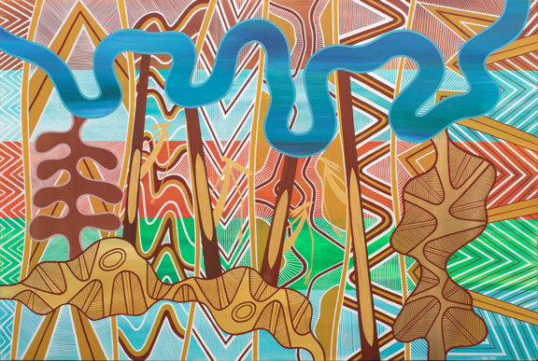
We acknowledge and respect Victorian Traditional Owners and their unique status as the original custodians of Victoria’s land and waters, their timeless ability to care for Country and deep spiritual connection to it. We honour Elders past and present whose knowledge and wisdom has ensured the continuation of culture and traditional practices. The Marine and Coastal Strategy is prefaced with an important message written by representatives of Victorian coastal Traditional Owners.
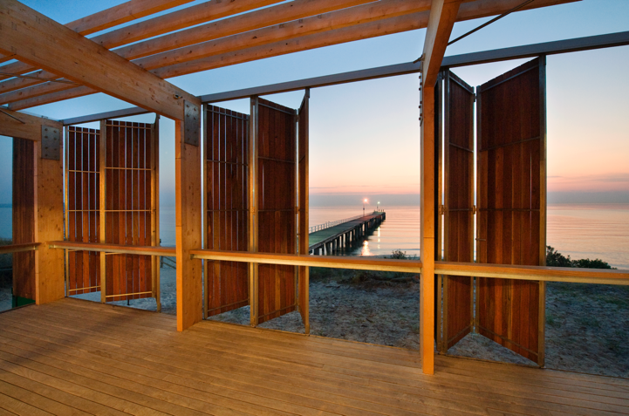

What the strategy is
The Marine and Coastal Strategy (the Strategy) stems from the Marine and Coastal Policy 2020 (the Policy) and the Marine and Coastal Act 2018 (the Act).
The Act sets objectives and guiding principles for the planning and management of Victoria’s marine and coastal environment. It establishes an integrated and coordinated whole-of-government approach to work with Traditional Owners, industry and the community to protect and manage our precious marine and coastal environment.
The Policy assists with planning and managing the marine and coastal environment and provides guidance to decision makers in achieving the Act’s objectives. The Policy sets out a vision for a healthy, dynamic and biodiverse marine and coastal environment that is valued in its own right, and that benefits the Victorian community, now and in the future. It also sets intended outcomes for the next 15 years and includes Victoria’s Planning and Decision Pathway and Marine Spatial Planning Framework.
The Strategy is the first of three, five-year strategies that will cover the lifespan of the Policy. It identifies six priority actions that lay the foundation to achieve the intended outcomes of the Policy. It also includes an important message from Victorian coastal Traditional Owners.
The time is now — to speak, listen and act with courage; to make decisions together and transparently that are in the interests of our oceans, coastlines, connected landscapes and waterways for generations to follow.
We must forge a future together to make things better.
…It is our assertion that this Marine and Coastal Strategy needs to be a living document. The Strategy provides a roadmap for the conversations and transparent decision making Traditional Owners, government and the broader Victorian community need to make together.
…It is all our children and grandchildren who will suffer or thrive as a result of the decisions we make now about our precious marine and coastal environments. We need to work together to change and adapt to the current environmental, social and political climate.
– Traditional Owner Message
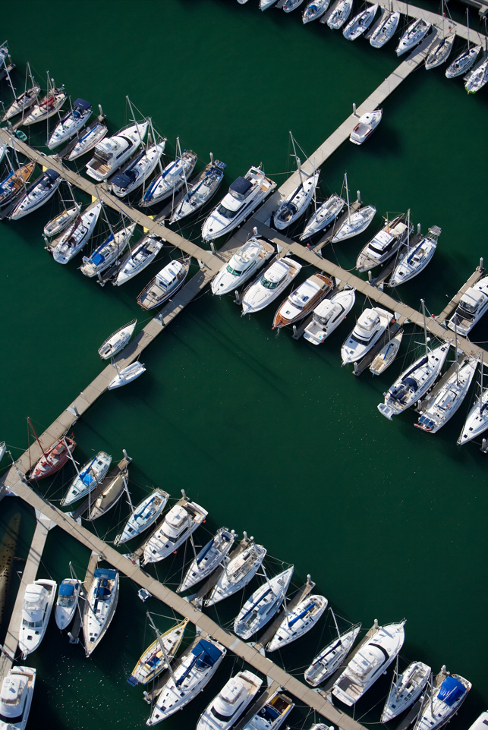

Why a strategy is needed
Aboriginal Victorians have been connected to Victoria’s marine and coastal Country for more than 60,000 years (2,400 generations). Their knowledge, care and practices have kept their lands (Country) in pristine condition for centuries, and remain critical today.
In addition to its intrinsic value and beauty, the marine and coastal environment provides enormous benefits to the Victorian community. Many of us choose to live in, visit and experience our coastal and marine areas. Coastal and marine-dependent industries such as fishing, tourism, ports and shipping support and create jobs for Victorians, and make significant contributions to local and regional economies.
These are only possible when the marine and coastal environment is healthy and resilient. Clean water, diverse species, and sufficient space for shorelines to shift and change are vital to enable us to continue enjoying the coast and ocean. The Strategy aims to address the impacts of climate change, population growth and ageing infrastructure in marine and coastal areas. It embeds the rights and obligations of Traditional Owners into planning and management decisions on Country.
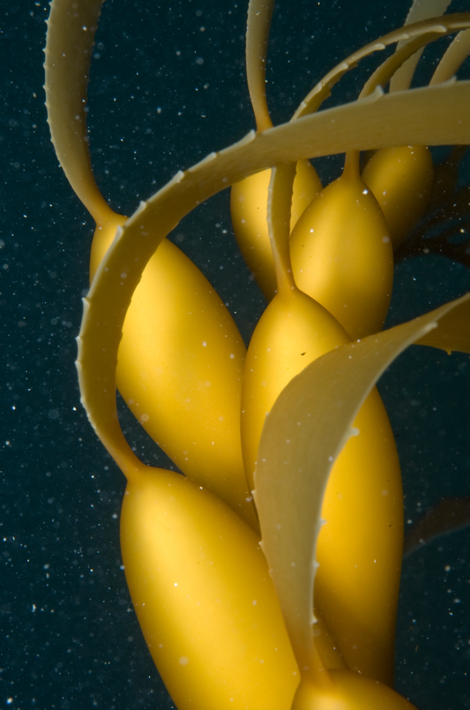

What the Strategy will do
The Strategy lays the foundations to achieve the vision and intended outcomes of the Policy.
The Strategy will:
- enable Traditional Owners to fully integrate cultural values, uses and practices in the healing and ongoing management of Country
- build the foundations for long-term climate adaptation and environmental protection in Victoria’s marine and coastal environment
- improve integration and co-ordination across governments, industries, and communities when planning and managing marine and coastal areas
- build the skills and capability of Traditional Owners, communities, managers, and governments to plan and manage for a healthy and resilient marine and coastal environment.
The Strategy sets out six actions with supporting activities to achieve these objectives.

Action 1: Traditional Owners determine how their rights and obligations are embedded into planning and management of the marine and coastal environment
Traditional Owners are rightsholders in the marine and coastal environment. They have a long-held connection to Country.
Action 1 integrates Traditional Owner values, uses and practices into the management of Country. Action 1 will:
- assess bio-cultural values
- monitor impacts from land use and climate change across Country
- apply objectives and assertions for Country in regional and local planning
- resource and realise Traditional Owners’ ongoing obligations to care for Country
- manage marine and coastal areas and resources
- inform future policy and planning directions at local and state level.

Action 2: Improve the condition and ecological connectivity of habitats and respect and care for our marine and coastal areas
There is intrinsic value in Victoria’s marine and coastal biodiversity. Traditional culture and our personal and economic wellbeing rely on a healthy environment.
Action 2 will improve the condition and connectivity of marine and coastal ecosystems, and empower Victorians to connect with and care for our marine and coastal areas. It also acknowledges the intrinsic value of our marine and coastal environment. Action 2 will:
- map habitat linkages
- strengthen planning tools to manage threats to habitat
- provide incentives to restore habitat
- deliver education, citizen science and volunteering programs.

Action 3: Adapt to impacts of climate change
Victoria is already experiencing the impacts of climate change. We need to prepare for, and adapt to, the increasing frequency and intensity of these impacts on the marine and coastal environment. Action 3 will:
- improve our understanding of climate change impacts and risks
- embed long-term adaptation into planning and management
- build the capacity of land managers to respond to climate change impacts.

Action 4: Support sustainable use and development of the marine and coastal environment
Victoria’s population is growing. This means more people are choosing to enjoy, live by and work in our marine and coastal environment. We need to manage this increased demand to access and use marine and coastal areas to reduce conflict between users, and protect the health of the environment.
Action 4 enables sustainable use and development of the marine and coastal environment. Action 4 will:
- facilitate long-term strategic planning for Crown land management, recreation and industry uses
- build the knowledge, skills and capacity of Victoria’s marine and coastal managers.

Action 5: Implement the Marine Spatial Planning Framework
Victoria’s marine environment is an active place and how we use it continues to grow and change. As use increases and diversifies, so too does the potential for conflict between uses and pressures on marine ecosystems.
Marine spatial planning can be used to integrate planning and management and aid in finding a balance between the needs of different uses, while also supporting cultural, economic, social, and environmental values. It is a participatory approach that involves rightsholders, marine and coastal stakeholders, and communities to identify management actions and solutions.
The Policy includes a Marine Spatial Planning (MSP) Framework that provides guidance and policies for marine planning and management, and outlines Victoria’s approach to marine spatial planning.
Action 5 will continue to implement the MSP Framework. It will:
- identify and determine the mechanism, governance and funding to give effect to marine spatial planning
- develop guidance and tools required to undertake marine spatial planning
- undertake Victoria’s first marine spatial planning process.

Action 6: Identify resource needs for sustainable marine and coastal management
Action 6 will develop options for resourcing sustainable marine and coastal management. It will:
- establish what funding we already have
- identify what funding we will need to manage current and future challenges
- understand the environmental, social and economic value of our marine and coastal environment.
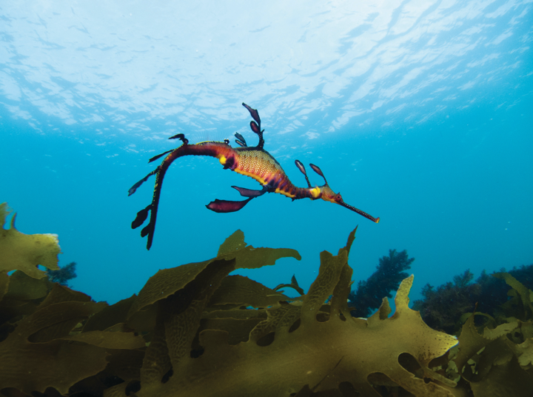

Implementing and evaluating the Strategy
The diversity of organisations, issues and interests in marine and coastal management means that no single entity can deliver the whole-of-landscape response that is needed. Formal and informal collaboration is vital for effective integrated delivery of this Strategy.
There are 54 activities identified to deliver the six actions in the Strategy. Each activity will be delivered by lead and collaborating agencies within a set timeframe. These agencies all have legislated roles to manage the marine and coastal environment.
Lead agencies are responsible for implementing activities. They will consult with all collaborating rightsholders, organisations, and relevant stakeholder groups. Collaborators will provide input and support delivery of the activity.
We must be at the table as equal partners with government and the broader community when knowledge is being shared, and decisions are being debated and agreed.
– Traditional Owner Message
To evaluate if the Strategy is achieving its aims, a Monitoring, Evaluation, Reporting and Improvement Framework will be developed.
The Strategy represents a whole-of-government approach to managing the marine and coastal environment, and has been approved by:
- Minister for Energy, Environment and Climate Change
- Minister for Water
- Minister for Planning
- Minister for Ports and Freight
- Minister for Fishing and Boating
- Minister for Agriculture
- Minister for Resources.

Timing for activities in the Strategy
The Strategy will be delivered between 2022 and 2027. Each activity has its own timeline within this period (Table 1). Evaluation of the Strategy’s implementation will happen alongside delivery of the Strategy.
Table 1: Timeline for implementation and evaluation of the current Strategy and development of the next Strategy.
 | 2022-23 |  | 2023-24 |  | 2024-25 |  | 2025-26 |  | 2026-27 |  | 2027-28
Implementation | Start |  |  |  |  |  |  |  |  | End
Evaluation |  |  |  |  | Start | End |  |  | Start |  |  | End
Develop and release the next Strategy |  |  |  |  |  |  |  |  | Start |  |  | End
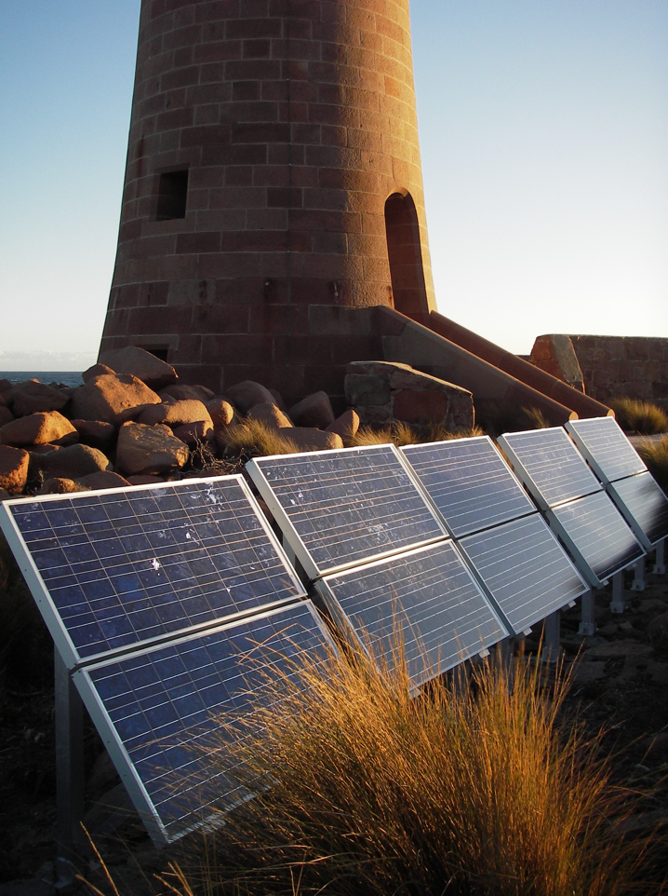

How the Strategy was developed
The Strategy was developed by the Department of Environment, Land Water and Planning (DELWP), working closely with Traditional Owners and the Victorian Marine and Coastal Council, in consultation with state and local government departments, marine and coastal managers, and peak bodies with marine and coastal interests.
A draft Strategy was released for public consultation from July to September 2021. 134 responses were received from individuals, community groups, peak bodies, and local and state agencies and departments. This input informed the finalisation of the Strategy.

Message from Traditional Owners – full message is in the Marine and Coastal Strategy 2022.

