|  |
| --- |
| DELWP marine and coasts newsletter |

Welcome to the Department of Environment, Land, Water and Planning’s (DELWP’s) quarterly marine and coasts newsletter**.**

## In this issue

* Update on Marine Spatial Planning in Victoria
* Grants awarded to support coastal hazard adaptation planning
* VicCoasts program
* Coastal Public Access and Risk Grants 2022-23 now open
* Follow-up of Protecting Victoria’s Coastal Assets audit
* Gippsland seawall replacements complete
* Expansion of the Victorian Coastal Monitoring Program
* Loch Sport Foreshore Coastal Erosion
* Portland cliffs
* Coastcare Victoria’s ‘Coastline’

|  |
| --- |
| Email [marine.coasts@delwp.vic.gov.au](mailto:marine.coasts@delwp.vic.gov.au) to subscribe or unsubscribe to this newsletter and for more information. |

# Marine and coastal policy reforms

## Update on Marine Spatial Planning in Victoria

DELWP’s Land Management Policy (LMP) Division are continuing to implement the Marine Spatial Planning Framework outlined in the [Marine and Coastal Policy](https://www.marineandcoasts.vic.gov.au/coastal-management/marine-and-coastal-policy).

Two draft documents were released for targeted consultation:

* **Victoria’s Marine Planning Areas** – determines marine planning areas in Victoria and identifies areas that could benefit from marine spatial planning (MSP) in the future.
* **Marine Spatial Planning Guidelines** – provide instructions on how to undertake marine spatial planning in a marine planning area.

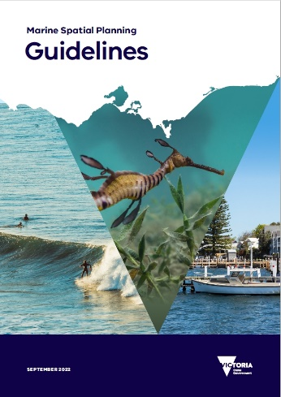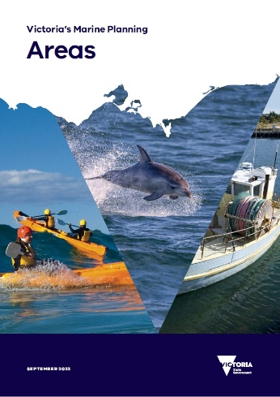

Two stakeholder workshops to support targeted consultation were held in mid-July 2022.

Over 80 participants represented a broad diversity of marine and coastal sectors, including Victoria’s Traditional Owner communities, marine user groups, industry, non-government groups, researchers, and planners and managers from the local, regional, state, and national levels. Many thanks to all participants for their valuable contribution and insights.

LMP are now working to finalise and release the Marine Spatial Planning Guidelines and Victoria’s Marine Planning Areas in the coming weeks. The documents will be tested through implementation of the [Marine and Coastal Strategy](https://www.marineandcoasts.vic.gov.au/coastal-management/marine-and-coastal-strategy), at which point they may be refined as part of the state’s first marine spatial planning process.

For more information, please visit [marineandcoasts.vic.gov.au/marine/marine-spatial-planning](https://www.marineandcoasts.vic.gov.au/marine/marine-spatial-planning) or contact the Marine Spatial Planning Team via [marine.spatial.planning@delwp.vic.gov.au](mailto:marine.spatial.planning@delwp.vic.gov.au).

## Grants awarded to support coastal hazard adaptation planning

DELWP has recently awarded $800,000 across five local councils and land managers to progress planning for the impacts of coastal climate change.

The grants are part of the Victoria’s Resilient Coast – Adapting to 2100+ program, which provides a strategic approach to coastal hazard risk management and adaptation. This includes a framework (pictured), guidelines and funding support.

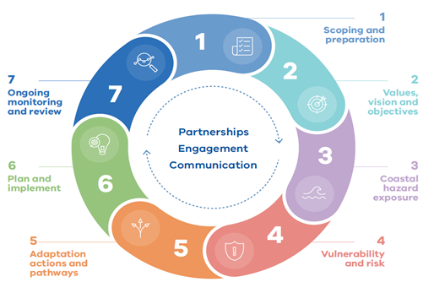

Victoria's Resilient Coast - Adapting for 2100+ framework stages.

The grants will help local councils and land managers to explore, evaluate and adapt to the risk of coastal hazards, such as erosion and inundation.

The round one grant recipients are:

* Port Phillip Coastal Resilience Project – City of Port Phillip
* Mornington Peninsula Coastal Strategy – Mornington Peninsula Shire Council
* Aire Valley Estuary Floodplain Project (Part 2) – Corangamite Catchment Management Authority
* Cape Otway to Point Impossible Scoping Study – Great Ocean Road Coast and Parks Authority
* Anglesea Resilient 2100+ Coast Project – Great Ocean Road Coast and Parks Authority
* Coastal Marine Hazard Assessment – Wilsons Promontory terrestrial and marine parks - Parks Victoria.

Each project will be guided by Victoria’s approach for managing and adapting to coastal hazards. This approach has been developed through a collaborative process with Traditional Owners, coastal councils, committees of management, Catchment Management Authorities, government agencies, water authorities and peak body groups.

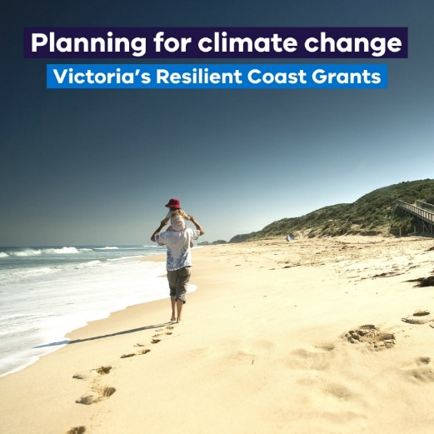

Victoria’s Resilient Coast Grants help progress planning for the impacts of coastal climate change.

Round two grants are expected to open in late 2022.

Visit [marineandcoasts.vic.gov.au/coastal-management/victorias-resilient-coast-adapting-for-2100](https://www.marineandcoasts.vic.gov.au/coastal-management/victorias-resilient-coast-adapting-for-2100) to find out more.

# VicCoasts program

As part of the Victorian State Budget for 2022-23, the ‘VicCoasts’ program received funding of $16.9 million to deliver a range of initiatives from the Marine and Coastal Strategy 2022 including:

* Support to Traditional Owners to self-determine priorities and embed their rights and obligations in marine and coastal management.
* The development of Coastal and Marine Management Plans and implementation of the Victoria’s Resilient Coast framework and guidelines, and Victoria’s marine spatial planning framework.
* Enhance the Victorian Coastal Monitoring Program and the Marine and Coastal Knowledge Framework and continue the implementation of the Port Phillip Bay Environmental Management Plan.
* Deliver the 2022-23 Coastal Public Access and Risk grants program.
* Implement strategic asset management practices to identify priority assets for maintenance and replacement and deliver adaptation-based responses to manage the impacts of coastal hazards at key locations including Inverloch, Eastern View and Loch Sport.
* Some of the locations where coastal protection asset maintenance projects are expected to occur in 2022-23 include: Barwon River North, Black Rock, Lakes Entrance, Portland and Port Welshpool.

The VicCoasts program will build resilience in our marine and coastal areas and establish the foundations for climate adaptation of Victoria’s marine and coastal environment.

Please contact DELWP’s Statewide Coastal Programs team at [marine.coasts@delwp.vic.gov.au](mailto:marine.coasts@delwp.vic.gov.au) for more information regarding coastal protection projects.

# Coastal Public Access and Risk Grants 2022-23 now open

The 2022-23 round of Coastal Public Access and Risk (CPAR) Grants are now open!

With $1 million in funding available, coastal Crown land managers (including volunteer committees of management and local governments) are encouraged to apply for grants to implement projects aiming to improve public access and safety on coastal Crown land.

Grants of up to $150,000 are available to reduce coastal risk through identification, mitigation and monitoring of risks.

Applications close at 4pm on 12 October 2022.

Read the application guidelines and apply via [marineandcoasts.vic.gov.au/grants/coastal-public-access-and-risk-grants](https://www.marineandcoasts.vic.gov.au/grants/coastal-public-access-and-risk-grants).

# Follow-up of Protecting Victoria’s Coastal Assets audit

On 31 August 2022, the Victorian Auditor General’s Office (VAGO) tabled a report in Parliament highlighting the findings from their Protecting Victoria’s Coastal Assets 2018 follow-up audit.

Commencing in April 2022, the objective of this investigation was to determine whether DELWP had effectively actioned the recommendations from the 2018 audit relating to its role in the management of coastal protection assets (such as breakwaters, groynes, revetments and seawalls).

DELWP oversees more than 1,500 coastal protection assets valued at approximately $1.13 billion, and shares management responsibilities with over 54 delegated land managers across the state including Parks Victoria, local councils and committees of management.

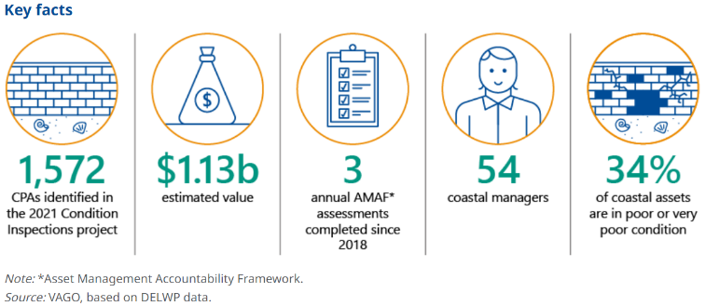

Key facts from the Follow-up of Protecting Victoria’s Coastal Assets audit.

The final assessment from VAGO highlights the significant progress made since 2018.

Major improvements in asset management practices were identified alongside an increased understanding of coastal hazards, particularly following the collection and management of coastal protection asset data –maintained in DELWP’s statewide Coastal Asset Management System (CAMS) – and monitoring implemented at key coastal locations across the state.

The development of the Marine and Coastal Policy 2020 and the Marine and Coastal Strategy 2022 were also noted as considerable steps forward in providing support and clarity for coastal managers.

Learn more on VAGO’s website: [audit.vic.gov.au/report/follow-protecting-victorias-coastal-assets](https://www.audit.vic.gov.au/report/follow-protecting-victorias-coastal-assets).

# Coastal projects

## Gippsland seawall replacements complete

Replacement of the Lakes Entrance Ocean Rescue masonry seawall was completed in late June 2022.

The old seawall, located adjacent to the Ocean Rescue (Australian Volunteer Coast Guard) buildings, protected the building foundations and foreshore reserve from erosion. Its condition had deteriorated significantly over the last three years.

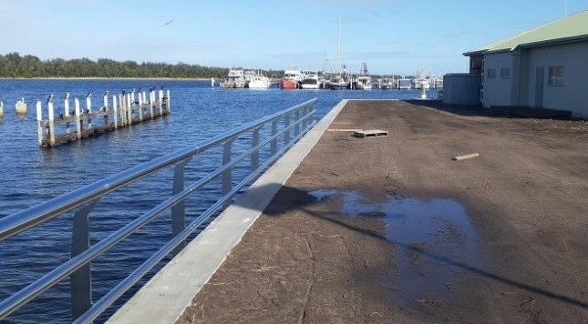

New Lakes Entrance Ocean Rescue seawall.

The new precast concrete panel and steel pile seawall offers increased protection for the reserve and Ocean Rescue buildings and infrastructure for years to come and allows for safer public access and recreation.

Construction to replace a 66-metre-long concrete panel seawall at Mallacoota is also complete. This section is part of a multi-stage project to replace the seawall along the foreshore adjacent to the Mallacoota Foreshore Holiday Park.

The new seawall offers increased protection against erosion and landslips, while providing improved access for the community.

# Marine and coastal knowledge

## Expansion of the Victorian Coastal Monitoring Program

The Victorian Coastal Monitoring Program (VCMP) was established in 2017 to understand and manage our changing coast, to provide the knowledge that coastal managers and communities need to make coastlines resilient in the future.

Part of the Marine Knowledge Group in DELWP’s Biodiversity Division, the VCMP has expanded to become a major field monitoring and knowledge management program, supporting the Marine and Coastal Policy 2020 and implementing the Marine and Coastal Strategy 2022.

The primary monitoring capabilities of the VCMP include:

* A drone-based beach surveying program, with over 30 sites statewide, over 500 surveys to date, and citizen science groups involved at many of the sites.
* A statewide wave buoy network across 13 locations, managed by Deakin University.

The VCMP team has grown rapidly in the last year, with:

* In-house drone surveying capacity, including Blake Allan joining DELWP as Senior Drone Pilot, and Sahar Kirmani as our new Coastal Monitoring Officer.
* Increased analytical and research capacity, with Jin Liu, an ocean modeller from University of Melbourne joining as Coastal Processes Science Officer.

Exciting recent initiatives of the VCMP include:

* Working with and training members of the Wadawurrung Traditional Owner group to monitor culturally sensitive coastal sites along the Great Ocean Road.
* Integration of shoreline trend analysis on CoastKit –<https://mapshare.vic.gov.au/coastkit/> – combining VCMP drone data with satellite and aerial imagery shorelines.
* Commencement of targeted research projects across Port Phillip Bay, partnering with Deakin and Melbourne Universities, made possible by the coastal and oceanographic monitoring data delivered through the VCMP.

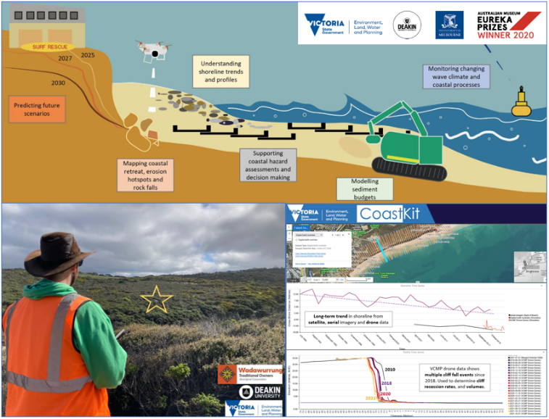

Functions performed by the VCMP (top). Senior Pilot Blake Allan conducting drone training at Point Addis with the Wadawurrung Traditional Owner group (bottom left). VCMP data now on CoastKit (bottom right).

Visit [marineandcoasts.vic.gov.au/coastal-programs/victorian-coastal-monitoring-program](https://www.marineandcoasts.vic.gov.au/coastal-programs/victorian-coastal-monitoring-program) or email [vcmp@delwp.vic.gov.au](mailto:vcmp@delwp.vic.gov.au) to find out more.

## Loch Sport Foreshore Coastal Erosion

It is not too late to have your say on the seven adaptation measures identified to respond to erosion and inundation from sea level rise at Loch Sport.

The measures are identified in a report that considered both short- and long-term adaptation options for the foreshore area around the eastern half of the town lakefront.

You can read the report, watch a recording of the online public information session and complete the survey at the Engage Victoria website – [engage.vic.gov.au/loch-sport-foreshore-coastal-erosion](https://engage.vic.gov.au/loch-sport-foreshore-coastal-erosion).

The feedback period closes on 18 September 2022. Your feedback will help inform the upcoming planning and implementation phase of the program.

## Portland cliffs

The coastal cliffs at Portland are continually changing in response to natural landscape processes. Due to their geological variability, ongoing monitoring and updated actions are required to understand changes in cliff stability and risk to the public.

To better understand the risk areas, drones with photogrammetric and 3D modelling capabilities reconstructed the entire cliff face between Nun’s Beach and Anderson Point. This updated modelling of the cliff pinpoints known risk-areas then compares these with previous surveys evaluating the likelihood of imminent cliff collapse.

This important work will help inform adaptation options, management actions and investment required to address cliff landslips and rockfall risks for the area, leading to improved public safety.

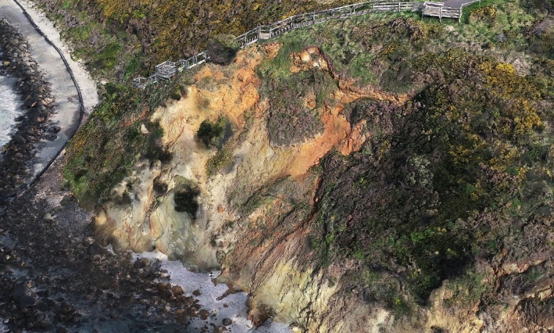

Example of a section of the cliff reconstruction highlighting the erosion near stairs at Portland (3D photogrammetry extract).

Keep reading for Coastcare’s ‘Coastline’!



# In this issue

* Litter Trackers: the citizen science project reducing litter in our waterways and marine and coastal environments
* Bottles overboard
* Environment immersion days
* Volunteer Capacity Building Program 2022-23
* Staff farewells and welcome to our new South Gippsland facilitator
* CoastKit meets Coastcare

## Litter Trackers: the citizen science project reducing litter in our waterways and marine and coastal environments

*Article and photos provided by Monica Tewman - RMIT University (Senior Coordinator, Knowledge and Communications at the Aquatic Environmental Stress Research Group) and Dr Erica Odell.*

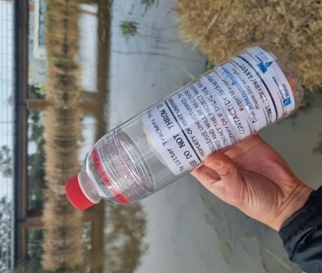

A GPS-enabled Litter Tracker ready for release.

Ninety-five per cent of litter found on our coast originates in our suburbs.

Through Coastcare Victoria, the Victorian Government has invested $29,790 to launch more than 20 GPS-enabled Litter Trackers into Geelong, Bellarine, and Surf Coast waterways. This is part of a collaborative citizen science project aimed to reduce litter in waterways and on our coasts through education.

The Litter Trackers: ‘Burbs to the Bay’ project works with schools and community groups to raise awareness about the environmental cost of litter and drive change by empowering individuals with knowledge to make more sustainable decisions.

By releasing GPS-tracked litter items, the project shows how what we drop on our streets is washed into waterways and eventually ends up in our bays and on our beaches.

The journeys the GPS-enabled litter trackers take can be followed online by everyone at [rmit.edu.au/littertrackers](http://www.rmit.edu.au/littertrackers).

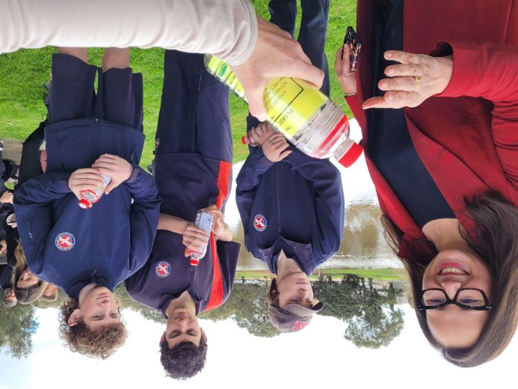

Minister for Water, Hon. Harriet Shing, joined students from Geelong High School and Northern Bay College to launch Litter Trackers into Geelong’s Barwon River.

The project is a collaboration between the Aquatic Environmental Stress Research Group (AQUEST) at RMIT University, the Corangamite Catchment Management Authority (CCMA) and the Bellarine Catchment Network (BCN).

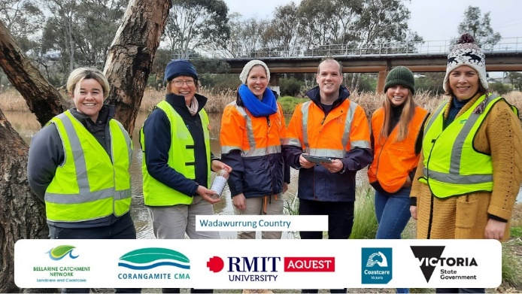The

Litter Trackers project is delivered by RMIT University and supported by Corangamite CMA and Bellarine Catchment Network.

The support Coastcare Victoria provided for this project is essential for creating healthy waterways and building a more sustainable and liveable future for Geelong, Bellarine, and the Surf Coast.

## Bottles overboard

Beach Patrol 3280-3284 are calling for your help!

Foreign bottles and packaging discarded from passing international ships are regularly collected off South West beaches. The group wants to know more about these bottles to better understand where they are coming from.

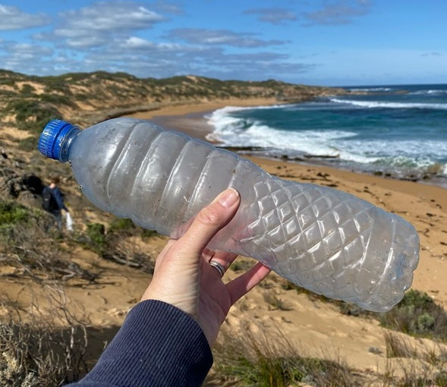

Foreign water bottle washed ashore in Warrnambool. Photo by Colleen Hughson.

The group is auditing and recording all bottles to make a detailed report to encourage improvements in how garbage is handled from international ships.

To join in on this citizen science program, next time you come across a foreign water bottle on your beach walk let Beach Patrol know by uploading a photo with the tag #bottlesoverboard or join their new [Bottles Overboard Facebook page](https://www.facebook.com/groups/704186463979474).

This project is funded by Victorian Government through a Coastcare Victoria Community Grant.

## Environment immersion days

*Article and photos provided by Rebecca St Ledger (Bellarine Catchment Network).*

In June 2022, Bellarine Catchment Network (BCN) hosted an Environmental Immersion Day for Cultura clients, in partnership with the Victorian Fisheries Authority.

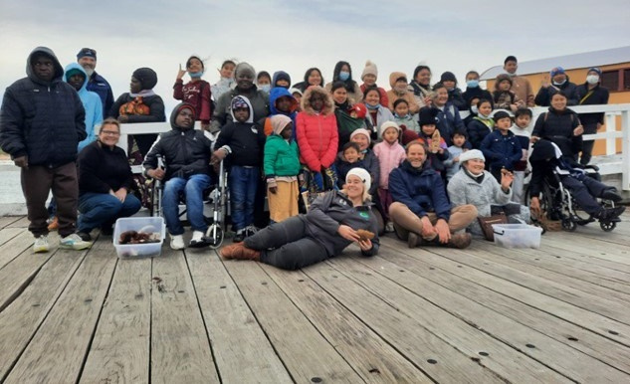

Bellarine Catchment Network, Cultura and Victorian Fisheries Authority smiling after fishing off Queenscliff pier. Photo by Bellarine Catchment Network.

The group had the pleasure of touring the Marine and Freshwater Discovery Centre followed by a fishing clinic at Queenscliff pier, with BCN hosting bird watching tours on the shore of Swan Bay and a beachcomb.

Despite the chilly weather, everyone wore smiles on their faces all day and had a wonderful time learning about Victoria's unique marine ecosystem and exploring beautiful natural landscapes.

These events were funded by the Victorian Government through a Coastcare Victoria Community Grant.

## Volunteer Capacity Building Program 2022-23

Coastcare Victoria is excited to announce plans to deliver the annual Volunteer Capacity Building Program for 2022-23.

The Volunteer Capacity Building Program aims to meet the training and development needs of volunteer groups and networks linked with Coastcare Victoria. It is designed to assist volunteers to undertake their work in a safe manner by offering a program of accessible training with a breadth of delivery options.

Last year we ran a series of volunteer forums across the state with a multitude of learning, development, and networking opportunities on topics from cultural heritage to social media. We also saw a great response to the fully funded first aid training.

The Coastcare Victoria team would love to hear from you about your training and development preferences, key training or capacity gaps in your group/organisation, and any other experiences you'd like to be the focus of this year's program.

If you have any training preferences, ideas, or would like to find out more about our training program please email [coastcare.victoria@delwp.vic.gov.au](mailto:coastcare.victoria@delwp.vic.gov.au) or contact your local facilitator.

Keep an eye out for the fantastic, fun, and free training next year!

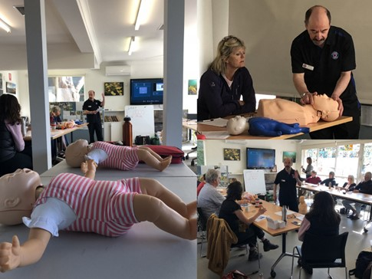

First Aid Training provided in Port Phillip Region 2018 as part of the Volunteer Capacity Building Program. Photo by Phillip Wierzbowski.

## Staff farewells and welcome to our new South Gippsland facilitator

We bid farewell to both Adam Taylor, Coastcare Victoria Facilitator Far South West, and Ally Hughes, our first Coastcare Victoria Grants Officer. Both have taken up roles in other parts of DELWP and we thank them for all their hard work and wish them all the best for the future.

Ally says farewell!

*I was excited to join the Coastcare Victoria team last year just as we were about to assess the grant applications being submitted.*

*I really enjoyed working with the volunteers to get all the necessary paperwork in and the money out to the community.*

*It was a happy experience to call successful grant applicants, usually volunteers who have a special passion about the projects Coastcare Victoria funds and hear the excitement and enthusiasm in their voices.*

*The rest of the Coastcare Victoria team and I have worked hard and the team will continue this legacy to support our grant applicants to apply and deliver their grants smoothly and with the least administrative burden as possible.*

*I look forward to reading about all the projects Coastcare Victoria will be funding in the future. My message to all the carers of the coast would be ‘keep up the great work!’ Ally*

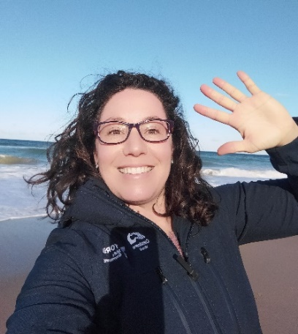

Farewell from Ally, our first Coastcare Victoria Grants Officer

Coastcare Victoria is pleased to announce the new South Gippsland Facilitator, Laura Town-Hopkinson! A message from Laura:

*Hello wonderful Gippsland volunteers,*

*My name is Laura and it is my absolute pleasure and honour to be your new South Gippsland Coastcare facilitator, working alongside the esteemed, hard-working and knowledgeable East Gippsland facilitator Bethany.*

*I am filling the large shoes of Tracey who was South Gippsland’s previous facilitator, who is beloved by so many groups. I am excited to carry on her amazing work!*

*A bit about me: I studied zoology and marine biology at university. I also have a master’s degree looking at bandicoot distribution in south-west Victoria!*

*In my downtime, I enjoy participating in citizen-science, bird-watching, snorkelling and reading a good book (I will take recommendations happily).*

*I look forward to speaking with and meeting as many volunteer groups as possible. I am constantly in awe of the incredible passion and dedication Gippsland’s volunteers contribute to caring for our shared coastal landscape. I truly cannot wait to start working together!*

*Best fishes, Laura*

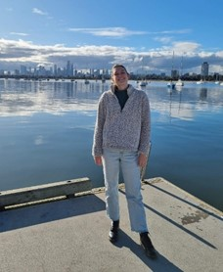

Laura Town-Hopkinson, new South Gippsland Facilitator.

If you have any questions for the South Gippsland facilitator, or would like to introduce yourself or your group, please email [laura.town-hopkinson@delwp.vic.gov.au](mailto:laura.town-hopkinson@delwp.vic.gov.au).

## CoastKit meets Coastcare

*Article and videos created by Kimberley MacDonald, Regan East, Rhiannon Holden, and Kate Watermeyer from DELWP’s Marine Biodiversity Team.*

The brilliant Laura Town-Hopkinson (now a Coastcare Facilitator for South Gippsland) presented CoastKit – a data tool for coastal and marine managers and researchers – at the Port Melbourne and Inverloch Coastcare forums last May and June.

The presentations provided an overview of CoastKit and demonstrated the relevant features, mapped layers and useful functions available to environmental volunteers and land managers operating along the coast of Victoria.

Don’t fret if you missed Laura – you can find out more about CoastKit through the launch of our new training videos. The CoastKit team has prepared six five-minute ‘How-to’ training videos to help users to access the full potential of the mapping portal.

The series of videos delve into the practical toolkit available on CoastKit, including guidance on how to navigate, draw a study area, upload data, create a map, and download data layers.

Be sure to check them out at [marineandcoasts.vic.gov.au/coastal-programs/coastkit](https://www.marineandcoasts.vic.gov.au/coastal-programs/coastkit).

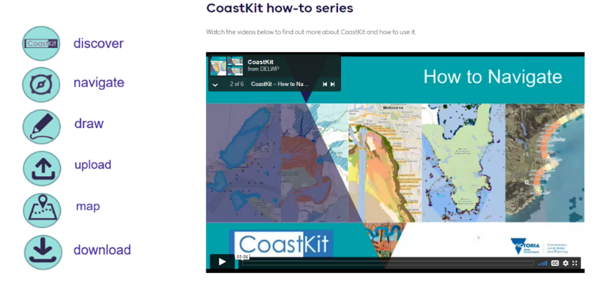

The CoastKit how to video series are available online at [marineandcoasts.vic.gov.au/coastal-programs/coastkit](https://www.marineandcoasts.vic.gov.au/coastal-programs/coastkit).

|  |  |
| --- | --- |
| © The State of Victoria Department of Environment, Land, Water and Planning 2022  LogoThis work is licensed under a Creative Commons Attribution 4.0 International licence. You are free to re-use the work under that licence, on the condition that you credit the State of Victoria as author. The licence does not apply to any images, photographs or branding, including the Victorian Coat of Arms, the Victorian Government logo and the Department of Environment, Land, Water and Planning (DELWP) logo. To view a copy of this licence, visit http://creativecommons.org/licenses/by/4.0/  Disclaimer  This publication may be of assistance to you but the State of Victoria and its employees do not guarantee that the publication is without flaw of any kind or is wholly appropriate for your particular purposes and therefore disclaims all liability for any error, loss or other consequence which may arise from you relying on any information in this publication. | Accessibility  If you would like to receive this publication in an alternative format, please telephone the DELWP Customer Service Centre on 136186, email [customer.service@delwp.vic.gov.au](mailto:customer.service@delwp.vic.gov.au), or via the National Relay Service on 133 677 [www.relayservice.com.au](http://www.relayservice.com.au). This document is also available on the internet at [www.delwp.vic.gov.au](http://www.delwp.vic.gov.au). |