# Strategic approach to adaptation

Factsheet 6

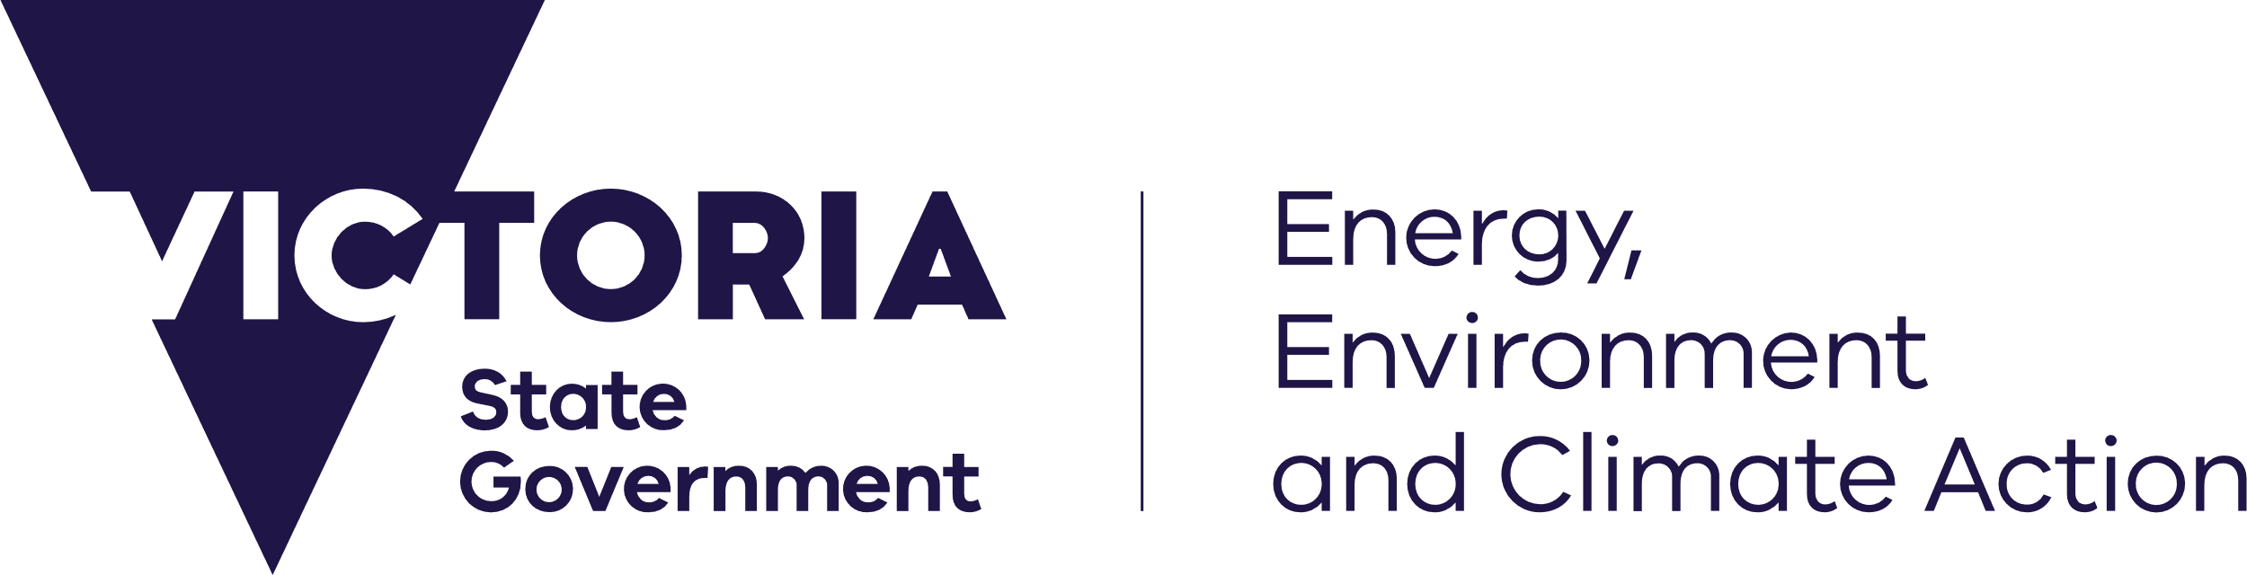

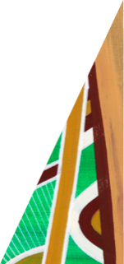

[deeca.vic.gov.au](https://delwpvicgovau.sharepoint.com/Users/fionadurante/Downloads/deeca.vic.gov.au)

This fact sheet provides an overview of how we use coastal adaptation to manage coastal hazard risks. This includes the Victoria’s policy framework, our strategic approach to adaptation and the range of coastal adaptation actions available.

## What is adaptation?

Across Australia and internationally, coastal land managers are taking a strategic approach to managing the risk of coastal hazards.

In coastal hazard management, adaptation can be defined as “the process of adjustment to actual or expected climate and its effects, such as coastal hazards”.

Adaptation seeks to proactively manage or avoid harm or make use of beneficial opportunities. This includes managing risks associated with coastal hazards.

## 

## Shaping our adaptation approach

To develop our adaptation approach, we bring together what we know from the early stages of the project - the technical, strategic and engagement work, and use it to start developing potential adaptation options to manage coastal hazards.

We are informed by:

* consultation with partners, land managers, local communities, and other interested stakeholders
* the values and objectives for different locations
* an understanding of the risk of coastal hazards at different localities
* a regional-scale perspective of the range of values, uses and pressures in the coastal zone
* State guidance, including Victoria’s Marine and Coastal Policy (2020) and Victoria's Resilient Coast, a statewide approach to coastal hazard risk management and adaptation.

This context helps to inform our development of an adaptation approach to manage coastal hazard risk and increase the resilience of the Gippsland region and communities.

Our approach to adaptation:

* will vary from site to site within the region
* is tailored to the needs of local communities
* considers the relative impacts of coastal hazards
* seeks to safeguard the community values (social, cultural, environmental and economic) and character of the landscape.

## Statewide context

Victoria’s Marine and Coastal Policy (2020), frames how coastal hazards are to be managed across the state. The policy approach to adaptation is intended to enable land managers to develop more balanced and positive management options for the long-term benefit of Victoria’s coastline.

Once we identify “at risk” coastal areas, there are six **adaptation options** to consider when developing an adaptation plan to manage (mitigate) the hazard risk. Each option is a different strategic approach and must be considered in the policy defined order when planning a suitable adaptation response.

## Types of adaptation options

Aligned with our six strategic adaptation options, are adaptation actions. These actions are a range of tools, decisions and works that can be implemented to assist with managing coastal hazard risk.

There is a wide range of adaptation actions that can be used to assist with managing coastal hazard risk.

Adaptation actions can be broadly classified under three key types:

* Land management, planning and design
* Nature-based
* Engineering

Adaptation actions are not mutually exclusive, and often a suite of measures is required to effectively manage coastal hazard risk.

|  |  |
| --- | --- |
| **Adaptation options**  (to consider in order) | **Definition**  (as per Marine and Coastal Policy) |
| **Non-intervention** | Allow marine and coastal processes, and the hazards they may pose, to occur. |
| **Avoid** | Locate new uses, development and redevelopment away from areas that are or will be negatively impacted by coastal hazards. |
| **Nature-based methods** | Enhancing or restoring natural features to mitigate coastal hazard risk. |
| **Accommodate** | Structures can be designed to reduce the exposure to, or decrease the impact of, coastal hazard risk, thus ‘accommodating’ the risk. |
| **Retreat** | Existing structures, assets or uses may be decommissioned or relocated away from areas that are, or will be, negatively impacted by coastal hazards. |
| **Protect**  (through major engineering) | Existing physical barriers are enhanced, or new ones constructed, to mitigate the impact of coastal hazards. Protect is an option of last resort; it is often expensive, its benefits tend to be very localised, and it frequently transfers problems to nearby areas. |

By thinking through the adaptation options in this order, it allows management to first focus on avoiding the risk, and then explores opportunities for nature-based methods and working with natural coastal processes.

|  |  |
| --- | --- |
| **Type** | **Sub-category** |
| **Land management, planning and design**  Use policy, planning instruments, guidance materials, communication, capacity building and strategic processes to enact change. | **Land use**  Access control, planning overlays, planning scheme amendments, rolling easements, land acquisition |
| **Resilient design / development**  Design standards, materials and setbacks |
| **Nature-based**  Use the creation or restoration of coastal habitats for hazard risk reduction.  This may be achieved through restoration of habitat alone (“soft” approach), or in combination with hard structures that support habitat establishment (“hybrid” approaches). | **Coastal wetlands / blue carbon ecosystems**  Mangroves, seagrass, saltmarsh |
| **Dune ecosystems**  Dune protection / vegetation, beach nourishment*/scraping |
| **Hybrid actions**  Sand fencing |
| **Engineering**  Use engineering and design to develop coastal structures, engineered changes to landform, and infrastructure modifications.  Includes both “hard” and “soft” engineering and can be used in conjunction with some nature-based methods. | **Beach nourishment**  Beach scraping, cart and place, dredging, sand bypassing |
| **Seawalls** |
| **Groynes** |
| **Breakwaters** |
| **Changes to drainage network**  Pipes, valves (size, functionality, network location, materials) |
| **Changes to road network**  Network, material, drainage |

Adaptation pathways

We use a “pathways approach” to help determine what combinations of adaptation actions might be feasible where and when. This allows us to be planning our adaptation from present day to longer-term (out to 2100), bringing together multiple actions in response to the risks and responding to changes over time.

A pathways approach:

• Is a decision making process

• Is made up of a sequence of steps or decision points over time

• Uses thresholds and triggers for when new decisions need to be made

• Is forward looking

• Recognises the changing nature of climate change impacts

• Aims to ensure the most effective tools are being used at the most effective time.

It enables a range of actions to be identified, along with their relative sequencing and timing, dependencies (actions that rely on each other) and triggers for implementation.



We acknowledge Victorian Traditional Owners and their Elders past and present as the original custodians of Victoria’s land and waters and commit to genuinely partnering with them and Victoria’s Aboriginal community to progress their aspirations.

© The State of Victoria Department of Energy, Environment and Climate Action February 2024.

Creative Commons

This work is licensed under a Creative Commons Attribution 4.0 International licence, visit the [Creative Commons website](http://creativecommons.org/licenses/by/4.0/) (<http://creativecommons.org/licenses/by/4.0/>).

You are free to re-use the work under that licence, on the condition that you credit the State of Victoria as author. The licence does not apply to any images, photographs or branding, including the Victorian Coat of Arms, and the Victorian Government and Department logos.

ISBN 978-1-76136-565-2

Disclaimer

This publication may be of assistance to you but the State of Victoria and its employees do not guarantee that the publication is without flaw of any kind or is wholly appropriate for your particular purposes and therefore disclaims all liability for any error, loss or other consequence which may arise from you relying on any information in this publication.

Accessibility

To receive this document in an alternative format, phone the Customer Service Centre on 136 186, email [customer.service@delwp.vic.gov.au](mailto:customer.service@delwp.vic.gov.au), or contact National Relay Service on 133 677. Available at [DEECA website](http://www.deeca.vic.gov.au/) (www.deeca.vic.gov.au).

**For more information and further fact sheets in this series, please visit www.marineandcoasts.vic.gov.au/coastal-programs/gippsland-projects**