Islands and
Invasive Species

Teacher Guide

Coastcare Victoria School Kit

Volunteering For Threatened Flora
  - Teacher Guide

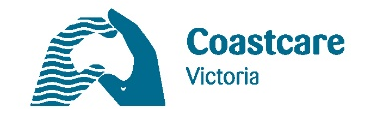
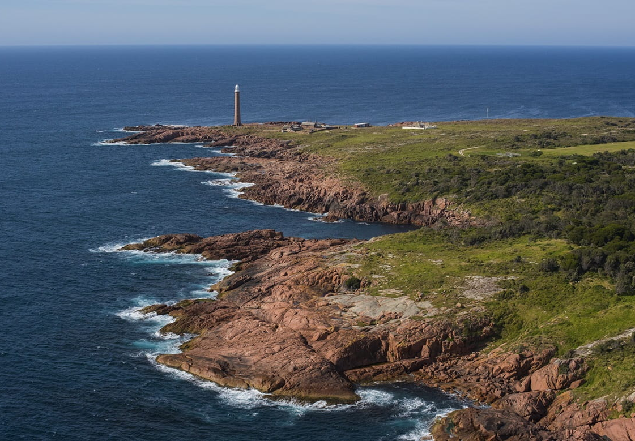
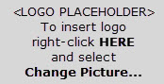 | 

Acknowledgements

Coastcare Victoria would like to acknowledge all our video presenters and individuals who reviewed or assisted with the creation of the Coastcare Victoria School Kit.
Author
Coastcare Victoria and Ecolinc Science and Technology Innovations Centre.
Photo credit
Parks Victoria (David Paul/ Museum Victoria). https://www.parks.vic.gov.au/news/2021/06/07/23/30/protecting-shorebirds-on-important-islands.
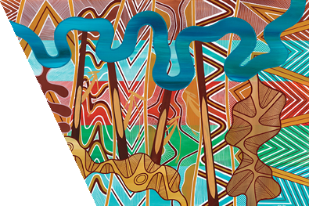
Acknowledgment
We acknowledge and respect Victorian Traditional Owners as the original custodians of Victoria's land and waters, their unique ability to care for Country and deep spiritual connection to it. We honour Elders past and present whose knowledge and wisdom has ensured the continuation of culture and traditional practices.
We are committed to genuinely partner, and meaningfully engage, with Victoria's Traditional Owners and Aboriginal communities to support the protection of Country, the maintenance of spiritual and cultural practices and their broader aspirations in the 21st century and beyond.
© The State of Victoria Department of Energy, Environment, and Climate Action 2026
This work is licensed under a Creative Commons Attribution 4.0 International licence. You are free to re-use the work under that licence, on the condition that you credit the State of Victoria as author. The licence does not apply to any images, photographs or branding, including the Victorian Coat of Arms, the Victorian Government logo and the Department of Energy, Environment, and Climate Action (DEECA) logo. To view a copy of this licence, visit http://creativecommons.org/licenses/by/4.0/
ISBN 978-1-76136-062-6 (pdf/ online/ MS word)
Disclaimer
This publication may be of assistance to you but the State of Victoria and its employees do not guarantee that the publication is without flaw of any kind or is wholly appropriate for your particular purposes and therefore disclaims all liability for any error, loss or other consequence which may arise from you relying on any information in this publication.
Accessibility
If you would like to receive this publication in an alternative format, please telephone the DEECA Customer Service Centre on 136186, email customer.service@delwp.vic.gov.au, or via the National Relay Service on 133 677 www.relayservice.com.au. This document is also available on the internet at http://www.deeca.vic.gov.au/.

Contents
Curriculum links 1
Lessons overview 8
Key themes 9
Learning intentions 9
Success criteria 9
Background 10
Resources 10
Other useful links 10
Lesson plan 11
Activity 1: Quiz 11
Activity 2: My favourite place 12
Activity 3: Mirror Bush identification 13
Activity 4: Mirror Bush weed map 13
Investigation 1: What makes a species invasive? 14
Investigation 2: Island ecosystems 16
Review questions 17
Glossary 18

Curriculum links
Year 5 and 6 curriculum | Curriculum code | Content description | Topic covered – link to Learning Intentions
Science – Science as a Human Endeavour – Nature and development of science | VC2S6H01 | Scientific knowledge changes over time, often resulting from collaboration or by building on the work of others, and leads to advances in science | Interact with iNaturalist, a citizen science resource which provides Artificial Intelligence (AI) assisted species identifications.  Study life history traits, particularly how a species may be more or less invasive in an ecosystem.
Science – Science as a Human Endeavour – Use and influence of science | VC2S6H02 | Scientific knowledge, skills and data can be used by individuals and communities to identify problems, consider responses and make decisions | Interact with iNaturalist, a citizen science resource which provides Artificial Intelligence (AI) assisted species identifications.
Science – Science Understanding – Biological sciences | VC2S6U01 | Habitats can be described by their physical conditions; changing the physical conditions of a habitat, including by human activity, may affect the growth and survival of organisms | Develop skills in species identification.  Study life history traits, particularly how a species may be more or less invasive in an ecosystem.  Explore how interaction between species traits and ecosystem traits determine the distribution of all life on earth.
Science – Science Understanding – Biological sciences | VC2S6U02 | Organisms have evolved over time, as seen in fossils and scientific records; the structural features and behaviours of living organisms enable them to thrive in their environments | Study life history traits, particularly how a species may be more or less invasive in an ecosystem.
Science – Science Inquiry – Processing, modelling and analysing | VC2S6I04 | Data and information can be organised and processed to show patterns, trends and relationships by constructing representation including tables, graphs and visual or physical models | Develop skills in species identification.  Interact with iNaturalist, a citizen science resource which provides Artificial Intelligence (AI) assisted species identifications.  Study life history traits, particularly how a species may be more or less invasive in an ecosystem.
Science – Science Inquiry – Communicating | VC2S6I06 | Scientific ideas, findings, patterns, trends and relationships can be communicated for a specific purpose and audience, using various presentation formats, scientific vocabulary and digital tools as appropriate | Interact with iNaturalist, a citizen science resource which provides Artificial Intelligence (AI) assisted species identifications.
Humanities – Geography – Geographical Knowledge and Understanding – Management of places | VC2HG6K01 | How places and environmental are changed and managed by people | Understand how their personal ethics influence their connection to place and how people care for places.
Humanities – Geography – Geographical Knowledge and Understanding – Management of places | VC2HG6K03 | The specific geographical and other characteristics that shape their place, how their place is changing and how change is managed | Understand how their personal ethics influence their connection to place and how people care for places.  Explore how interaction between species traits and ecosystem traits determine the distribution of all life on earth.
Humanities – Geography – Geographical Skills – Geographical inquiry | VC2HG6S02 | Locate, collect and organise information and data from primary and secondary sources, including from fieldwork | Understand that data can be collected by scientists and citizen scientists, and each have strengths and weaknesses.
Humanities – Geography – Geographical Skills – Geographical inquiry | VC2HG6S03 | Represent information and data collected using maps that conform to cartographic conventions, graphs, tables, sketches and other formats | Research and organise information into the structure of a scientific poster to engage a specific audience.
English – Literacy – Creating texts | VC2E5LY10 | Create different types of texts, written and spoken, with relevant, elaborated and sequenced ideas, using text structure appropriate for topic, purpose and audience, and multimodal elements as appropriates | Understand how their personal ethics influence their connection to place and how people care for places.
English – Literacy – Creating texts | VC2E6LY09 | Create different types of texts, written and spoken, with developed and organised ideas for purpose and audience, and multimodal elements as appropriates | Understand how their personal ethics influence their connection to place and how people care for places.
Digital Technologies – Data, Information and Privacy | VC2TDI6D05 | Select and use appropriate digital tools effectively to share content online, plan tasks and collaborate on projects demonstrating agreed behaviours, supported by trusted adults | Interact with iNaturalist, a citizen science resource which provides Artificial Intelligence (AI) assisted species identifications.
Ethical Capability – Understanding Ethical Concepts and Perspectives | VC2CE6U01 | The meaning of ethical concepts including respect and beneficence, and ethical concepts such as happiness or truth that can vary in importance or meaning in different contexts | Understand how their personal ethics influence their connection to place and how people care for places.
Ethical Capability – Understanding Ethical Concepts and Perspectives | VC2CE6U03 | How conscience, care, personal and non-personal experiences and dispositions including self-restraint influence ethical perspectives, and simple connections between these influences such as between care and experience | Understand how their personal ethics influence their connection to place and how people care for places.
Personal and Social Capability – Social Awareness and Management – Relationships and diversity | VC2CP6O02 | Behaviours and attitudes that demonstrate sensitivity to individual, social and cultural differences, and why sensitivity to difference is important | Understand how their personal ethics influence their connection to place and how people care for places.

Year 7 and 8 curriculum | Curriculum code | Content description | Topic covered – link to Learning Intentions
Science – Science as a Human Endeavour – Nature and development of science | VC2S8H01 | Scientific knowledge, including models and theories, can change because of new evidence | Study life history traits, particularly how a species may be more or less invasive in an ecosystem.
Science – Science as a Human Endeavour – Nature and development of science | VC2S8H02 | Multidisciplinary endeavours to advance scientific knowledge make use of people’s different perspectives | Understand how their personal ethics influence their connection to place and how people care for places.
Science – Science as a Human Endeavour – Use and influence of science | VC2S8H03 | Proposed scientific responses to socio-scientific issues impact on society and may involve ethical, environmental, social and economic considerations | Understand how their personal ethics influence their connection to place and how people care for places.
Science – Science as a Human Endeavour – Use and influence of science | VC2S8H04 | Communication of scientific knowledge has a role in informing individual viewpoints, and community policies and regulations | Understand that island ecosystems have traits which make them globally unique.
Science – Science Understanding – Biological sciences | VC2S8U01 | There are similarities and differences within and between groups of organisms living on Earth; the development and use of classification tools, including dichotomous keys, help order and organise human understanding of the diversity of life | Develop skills in species identification.  Study life history traits, particularly how a species may be more or less invasive in an ecosystem.  Explore how interaction between species traits and ecosystem traits determine the distribution of all life on earth.
Science – Science Understanding – Biological sciences | VC2S8U04 | Matter and energy flow through ecosystems and can be represented using models, including food webs and food pyramids; populations will be affected by changing biotic and abiotic factors in an ecosystem including habitat loss, climate change, seasonal migration and introduction or removal of species | Study life history traits, particularly how a species may be more or less invasive in an ecosystem.  Explore how interaction between species traits and ecosystem traits determine the distribution of all life on earth.  Understand that island ecosystems have traits which make them globally unique.
Science – Science Inquiry – Processing, modelling and analysing | VC2S8I04 | Data and information can be organised and processed by selecting and constructing representations including tables, graphs, keys, models and mathematical relationships | Interact with iNaturalist, a citizen science resource which provides Artificial Intelligence (AI) assisted species identifications.  Study life history traits, particularly how a species may be more or less invasive in an ecosystem.
Science – Science Inquiry – Evaluating | VC2S8I06 | Scientific methods, conclusions and claims can be analysed to identify assumptions, possible sources of error, conflicting evidence and unanswered questions | Interact with iNaturalist, a citizen science resource which provides Artificial Intelligence (AI) assisted species identifications.  Study life history traits, particularly how a species may be more or less invasive in an ecosystem.
Science – Science Inquiry – Communicating | VC2S8I08 | Communicating ideas, findings and arguments for specific purposes and audiences involves the selection and use of appropriate presentation formats, scientific vocabulary, models and other representations, and may include the use of digital tools | Interact with iNaturalist, a citizen science resource which provides Artificial Intelligence (AI) assisted species identifications.
Humanities – Geography – Geographical Knowledge and Understanding – Place and liveability | VC2HG8K08 | The influence of environmental quality on people’s perceptions of the liveability of places | Understand how their personal ethics influence their connection to place and how people care for places.
Humanities – Geography – Geographical Knowledge and Understanding – Place and liveability | VC2HG8K10 | How the concepts of space, environment and interconnection can be applied to evaluate the liveability of a place | Understand how their personal ethics influence their connection to place and how people care for places.  Study life history traits, particularly how a species may be more or less invasive in an ecosystem.
Humanities – Geography – Geographical Knowledge and Understanding – Landforms and landscapes | VC2HG8K12 | Different types of landscapes, their distinctive landform features and their distribution in Australia | Understand that island ecosystems have traits which make them globally unique.  Explore how interaction between species traits and ecosystem traits determine the distribution of all life on earth.
Humanities – Geography – Geographical Knowledge and Understanding – Landforms and landscapes | VC2HG8K13 | The spiritual, aesthetic and cultural value of landscapes and landforms for people, including Aboriginal and Torres Strait Islander Peoples | Understand how their personal ethics influence their connection to place and how people care for places.
Humanities – Geography – Geographical Knowledge and Understanding – Landforms and landscapes | VC2HG8K17 | How interconnection and change can be used to understand environmental phenomena | Understand that island ecosystems have traits which make them globally unique.  Explore how interaction between species traits and ecosystem traits determine the distribution of all life on earth.
English – Literacy – Creating texts | VC2E7LY08 | Create different types of texts, written and spoken, selecting aspects of subject matter and particular language and print, multimodal and/or digital elements to convey information and ideas to a specific audience | Understand how their personal ethics influence their connection to place and how people care for places.
English – Literacy – Creating texts | VC2E8LY08 | Create different types of texts, written and spoken, that raise issues, report events and advance opinions, using deliberate language and textual choices, and print, multimodal and/or digital elements as appropriate | Understand how their personal ethics influence their connection to place and how people care for places.
Ethical Capability – Understanding Ethical Concepts and Perspectives | VC2CE8U02 | How ethical perspectives may be individual or shared and reasons for similarities and differences in ethical perspectives, such as similar or different values or worldviews | Understand how their personal ethics influence their connection to place and how people care for places.
Personal and Social Capability – Social Awareness and Management – Relationships and diversity | VC2CP8O01 | Similarities and differences in people’s values and beliefs; how they can be expressed in diverse ways in relationships | Understand how their personal ethics influence their connection to place and how people care for places.

Key themes
Biogeography, stewardship and connection to place, observable traits and species identification, cartography and mapping, life history traits, invasive species, and species distribution.

Lessons overview
Activity | Time | Difficulty | Topic & Skills
1: Quiz | 5 min video  15 min quiz | Simple | Gabo Island ecology and conservation, weed management and restoration, protection of endangered species, impact of introduced species, communication action and volunteer groups, and connection between people and place.  - Listening comprehension and understanding.
2: My favourite place | 30 min | Simple | Stewardship, personal and community connection to place, motivations for volunteering, emotional and social aspects of caring for the environment, and diversity of values and reasons for environmental action.  - Empathy and reflection, interpretation, critical thinking and personal evaluation, communication skills, and self-awareness of personal values and motivations.
3: Mirror Bush identification | 30 min | Simple | Species identification and observable traits, use of AI and technology in citizen science, introduction to iNaturalist and how it supports scientific data collection, Mirror Bush (introduced species), comparing student observations with official identification skills, and real-world application of plant identification skills.  - Observation and classification, recording and describing biological traits, comparing and analysing data, digital literacy and citizen science apps, fieldwork and environmental awareness, and collaboration and contributing to a scientific database.
4: Mirror Bush weed map | ~30-60 min  &  30 min | Moderate: Multiple step activity using external resources. Outdoors. | Purpose and types of maps, introduction to mapmaking (cartography), elements of map using the DOGTAILS acronym, and application of map elements to real-world data.  - Map reading and interpretation, applying geographical conventions (DOGTAILS), observation and spatial awareness, visual communication and data representation, and critical thinking.
Investigation 1: What makes a species invasive? | 60 min | Complex: Using external resources. Independent learning. | Life history traits of living organisms, characteristics of invasive vs non-invasive species, Mirror Bush as an invasive species, factors influencing weediness, research using real-world data, and designing and describing a new species based on life history traits.  - Understanding and analysing life history traits, comparing species’ adaptations and impacts, researching and interpreting ecological data, critical thinking creativity in species design.
Investigation 2: Island ecosystems | 30-60 min | Complex: Multi-step instructions. Independent problem solving. | What islands are and why they are special, how island conditions affect what lives there, how islands can stay pest-free once invaders are removed, and drawing species distribution maps.  - Understanding how environment affects living things, linking species traits to where they live, researching and comparing different ecosystems, reading and drawing maps, and predicting which species will survive or spread.

Learning intentions
Students will:
- Understand how their personal ethics influence their connection to place and how people care for places.
- Develop skills in species identification.
- Interact with iNaturalist, a citizen science resource which provides Artificial Intelligence (AI) assisted species identifications.
- Learn that maps are more than a picture of the ground; they are made for specific purposes by following a set of guidelines.
- Study life history traits, particularly how a species may be more or less invasive in an ecosystem.
- Understand that island ecosystems have traits which make them globally unique.
- Explore how interaction between species traits and ecosystem traits determine the distribution of all life on earth.

Success criteria
Students are able to:
- Quantify a place which is important to them.
- Successfully identify Mirror Bush from its observable traits.
- Follow mapping guidelines to create an accurate map.
- Recognise life history traits mentioned in research material.
- Describe a new species based on life history traits.
- Research and record geographical terms.
- Draw the distribution of a species in an ecosystem based on life history and ecosystem traits.

Background
Restoring Gabo Island
Twice a year, volunteers from the Friends of Mallacoota make a boat trip out to Gabo Island - located off the coast of Far East Gippsland - to rid the island of weeds. The volunteers work for a week to remove the highly invasive Mirror Bush from the rocky slopes, allowing native flora to return. The long-term goal to completely eradicate introduced plant species from the island.

This module is focused on Geography. Geography is a science which encompasses the whole world, such as natural and man-made places, and populations of all living things, including humans.
The module begins by exploring the concept of ‘place’, and what makes different places special to different people. Also, how people care for places that they are connected to through stewardship.
Species identification is a necessary skill for observing organisms and studying their distribution in the world. All living things have a set of observable traits, such as size, colour and shape. When these traits are considered in combination, they build up into a set of characteristics which describe a species and set it apart from all other species. iNaturalist is a citizen science program which facilitates species identification through ‘community experts’ and Artificial Intelligence (AI) image recognition. iNaturalist also creates global maps of species records. This allows for the collection and display of large amounts of high-quality data so that communities and scientists can study that data.
The purpose of a map is to simplify and represent complex spatial information. Maps provide a means to understand the physical and cultural features of a region. Maps collate geographical data, such as landforms and cities, also boundaries like national parks and countries. Due to the large amount of information compression, maps have specific design elements which they use to translate the real world into a visual representation.
In the same way that individual organisms are categorised by their traits, groupings such as invasive and non-invasive species, and even ecosystems, are also categorised using traits. Understanding these categories allows scientists to predict how organisms will interact with their environment. For example, a weed or invasive species being dominant in their habitat due to having more competitive traits. The interaction between species traits and ecosystem traits are part of what determines a species’ geographical distribution (where a species can and cannot live).

Resources
- Islands & Invasive Species video
- Video transcript
- Presentation slides
- Answers
- Quiz
- My favourite place worksheet
- Mirror Bush identification worksheet
- Mirror Bush weed map worksheet
- Investigation: What makes a species invasive? worksheet
- Investigation: Island ecosystems worksheet
- Review questions
- Glossary

Other useful links
- iNaturalist home page
- Coastcare School Kit Mirror Bush Map project page
- National Geographic lesson for Year 7/8 on essential elements of a map
- Short video on recursive islands/lakes by Geomargin on Youtube

Lesson plan

Activity 1: Quiz
Use this 10-question quiz to assess comprehension and understanding of the video. This could be run as a Kahoot quiz, online form or worksheet.

1.What is the goal of the volunteers?
- To remove every trace of humans from Gabo Island
- The chance to see wildlife
- To make Gabo Island weed free
- To pick up all the litter from Gabo Island
2. What type of rock is Gabo Island
- Oceanic
- Granite
- Sandstone
- Basalt
3. Where did the Mirror Bush weed come from?
- Seeds dropped by birds
- Escaped from gardens
- Sealers introduced it
4. What is the scientific name of Mirror Bush?
- Diosma
- Woody weed
- Coprosma
- None of the above
5. Mirror Bush competes with native ________ for space on Gabo Island?
- Plants
- Mammals
- Birds
- Rocks
6. How often does weeding on Gabo Island need to be done?
- Once every ten years
- Just once
- Three times a year
- All the time

7. What is another reason that the volunteers were weeding on Gabo Island?
- To make it beautiful
- To watch whales
- To protect native plants
- All of the above
8. Can Gabo Island ever be free of Mirror Bush?
- Yes
- No
- Maybe
- I don’t know
9. Which of these is a native plant which belongs on Gabo Island?
- Feather fern
- Cutting grass
- Downy zieria
- Mirror bush
10. Which of these weeding techniques did you NOT see the volunteers using?
- Weeding by hand
- Covering weeds with matting
- Cutting branches with secateurs (snips)
- Cutting branches with power tools

Activity 2: My favourite place
This activity helps students understand stewardship and the different motivations people have for caring for a place. Visiting and volunteering, as seen on Gabo Island, build a deeper connection to a place and foster a sense of personal ownership and responsibility. By reading, re-writing, and ranking quotes from Gabo Island volunteers, students reflect on their own values and reasons for connection to a place. Comparing responses with peers develops discussion and empathy, while linking the ideas to a personal place encourages students to recognise their own sense of responsibility and ownership in protecting and improving spaces they care about.

In this activity students will read quotes from the Friends of Gabo Island video, about why they love volunteering on the island. Students will gain an understanding of the different motivations by re-writing them in their own words. Students will then explore their own motivations by ranking the quotes from most to least important, according to them. Have students compare responses with a peer or explore the similarities and differences in your class motivations. Remembering that different motivations for the same outcome are equal.

Student worksheet provocation:
“Think of a place which makes you feel the same way that the Coastcare volunteers feel about Gabo Island. It might be your backyard, favourite park, beach or national park. It does not have to be a natural place. People also feel connected to their home, school, neighbourhood, or places like the museum. Connection to a place makes people feel good about being there and responsible for protecting and improving their favourite place.”

Next, students can answer the Activity 2 questions about their favourite place.

Activity 3: Mirror Bush identification
In this activity, students will practice identifying plant species by observing a set of traits, or phenotype, which collectively define a species. They will focus on Mirror Bush (Coprosma repens), examining either the presentation slide images or real foliage to record the distinguishing characteristics of the plant. Students will then compare their observations with official weed identification information and test their new skills by contributing real-world data to the Coastcare Schools Kit Mirror Bush Map on iNaturalist. This activity allows students to apply scientific observation, understand how species are identifies, and participate in a citizen science project that contributes to mapping invasive species in their local area.

Every living thing has a list of traits which define them and set them apart from their closest relatives. One trait may not be enough for an accurate species identification. For example, most plants have green leaves. A set of observable traits which define a species are known as a phenotype, essentially, what a species looks like. Learning a list can seem daunting, but the brain very quickly learns to recognise the whole (phenotype), instead of each part. Your students already know how to recognise many plants from their unique combination of traits, such as a Christmas tree, palm tree and gumtree.
iNaturalist has become a popular tool because it has two types of support for identifying species. Users can upload photographs and AI image recognition will offer initial species identification (ID) based on similar images and location. This is followed up by certified users who use their expertise to confirm the AI species ID.
*You can prime your students on the concept of observable traits using the cats and dogs table in the slide deck [slide 5].
CAT Traits | DOG Traits
4 legs | 4 legs
Covered in fur | Covered in fur
Head at the front | Head at the front
Tail at the back | Tail at the back
Average size? Small | Average size? Large
Ear shape? Pointed/ Upright | Ear shape? Rounded/ floppy
What noise do they make? “Meow” | What noise do they make? “Woof”

In this activity students will view the Mirror Bush Identification slide in the slide deck [slide 6] (or you can provide real foliage for them to study) and use their observations about the plant to answer the Mirror Bush identification questions on their worksheet. Once they have written their own description of the traits which identify Mirror Bush, compare their answers to the official weed ID slides [slides 7,8,9].
Now that your students know how to identify Mirror Bush, consider testing their skills by contributing to the Coastcare School Kit Mirror Bush Map on iNaturalist.
[https://www.inaturalist.org/projects/coast-care-school-kit-mirror-bush-map].
  - Download the iNaturalist app, (it’s free) and make an account.
  - Go to the ‘Coastcare School Kit Mirror Bush Map’ project page, click on ‘Join this Project’ in the top right-hand corner, and follow the steps as prompted.
  - Once you are a project member, anytime you ‘Add an Observation’ that is Mirror Bush (Coprosma repens) within Australia, that observation will automatically be added to the project.
  - Take a class walk around the block or along the foreshore and add your observations of Mirror Bush to iNaturalist using your device (iPad/smart phone and camera). [slides 10, 11] The app has AI image recognition which will help you confirm your plant ID.
  - Once your observations are uploaded, your class can see their data on the Mirror Bush map (desktop version is best).

Activity 4: Mirror Bush weed map
In this activity, students will learn how to turn a picture of the Earth into an accurate map my applying key cartographic elements. They will explore the DOGSTAILS acronym, which outlines all the essential components a map must include, such as date, orientation, grid, scale, title, author, index, legend,, and sources. Using a screenshot of the Mirror Bush map from the Coastcare Schools Kit iNaturalist project, students will add these map elements to create a technically accurate and useful map, reinforcing their understanding of how maps convey information about the world.

A map is more than just a picture of the ground. A map is a symbolic representation of the Earth, designed to present information in a simplified way. Mapmakers, called cartographers, create different maps for different needs. When you’re on holiday you need a small local map which shows footpaths to the beach. City planners, for example, decide where to put hospitals and parks using maps of housing density and population.
We can turn a picture into a map using DOGSTAILS: this is an acronym to remind us of all the essential information that a map must include to be truly accurate and useful.
Date – The map was made tells us if it is current or maybe out of date.
Orientation – North point diagram tells you which way is North.
Grid – A global (longitude/latitude) or local (A/1) grid system to assist finding places on the map.
Scale – A scale bar converting distance on the map into distance on the ground. *The grid is often scaled to be used for measurement where one grid square on the map = 1km on the ground.
Title – Indicating what the map is and is not designed for.
Author – Who made the map can influence its accuracy.
Index – A list of locations shown on the map, and the grid reference used to find them.
Legend – A list of icons used on the map and what they mean in real life (bridge, gate, school).
Sources – The data that the map is based on influences its accuracy.

In this activity, your students will take a picture of the Earth and transform it into a technically accurate map.
- Teach your class about each of the essential map elements using the DOGSTAILS acronym; either by:
  - Using the ‘Spot the Difference’ slide [slide 12], and Activity 4 on the worksheet. See next page for the answers.
  - EXTENSION: Have your students read a short description of each map element in this National Geographic lesson https://education.nationalgeographic.org/resource/map/
- Print out a screen shot of your region of the Mirror Bush Map from the iNaturalist project page. Give one to each student to draw the missing map elements onto.

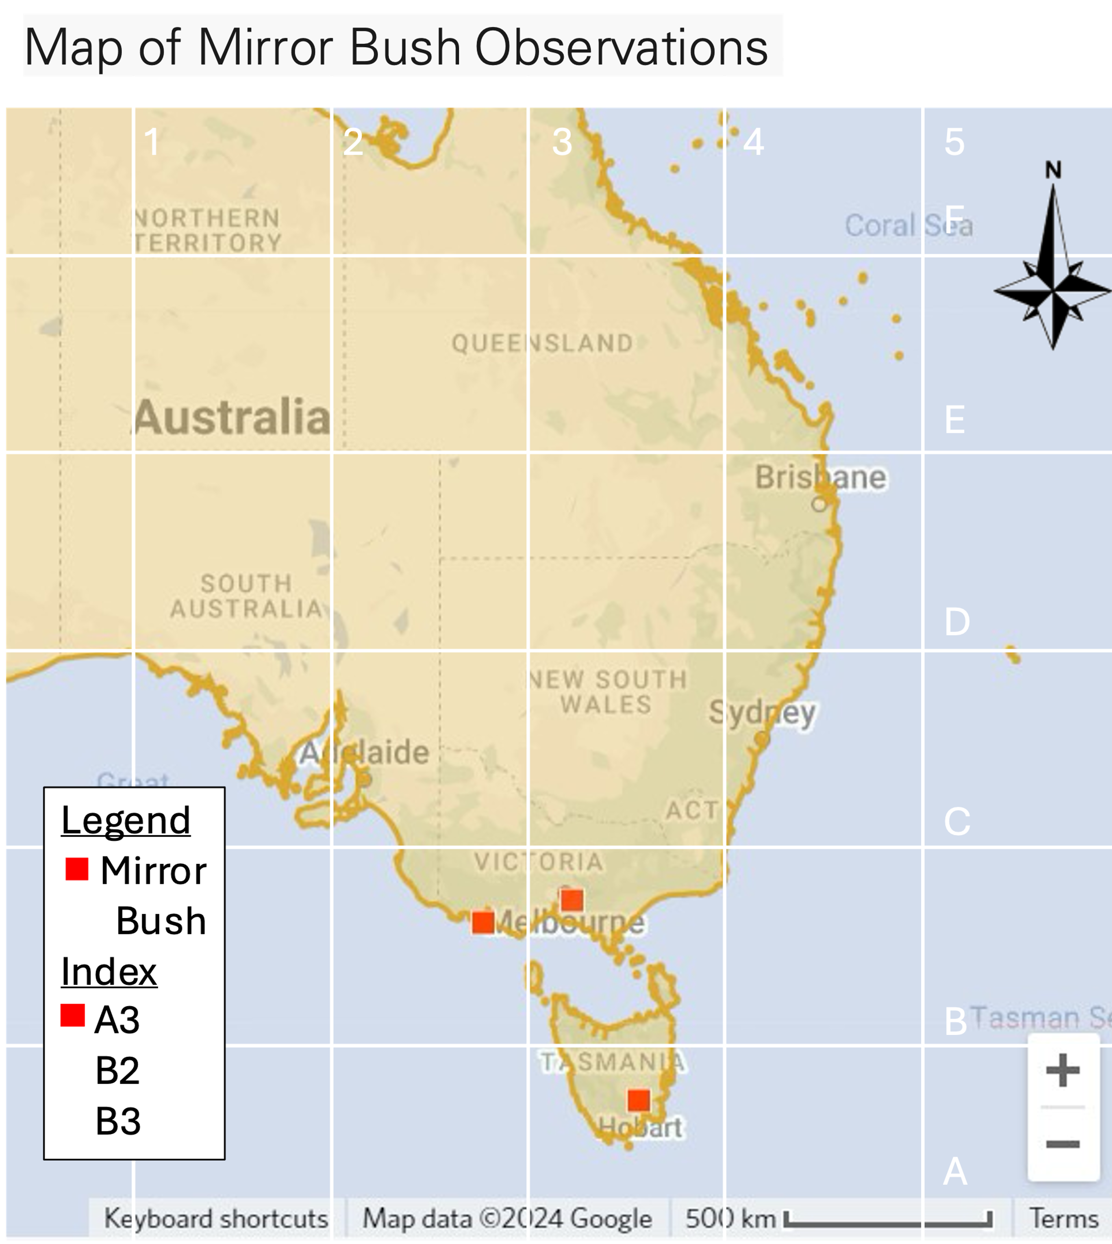
DATE: 2024
SOURCE: INATURALIST
AUTHOR: GOOGLE
SCALE
LEGEND
INDEX
ORIENTATION
GRID
&
A1 SYSTEM
DETAILED TITLE

Investigation 1: What makes a species invasive?
In this activity, student will investigate what makes a species invasive by exploring the life history traits that allow some plants and animals to grow, reproduce, and spread quickly. They will research the traits of Mirror Bush using the Coastcare iNaturalist project, identifying factors such as growth rate, reproduction, damage tolerance, and food and habitat flexibility. Students will then apply their understanding by creating a new “weed species”, assigning life history traits, and predicting how invasive it could become in different environments. This hands-on investigation helps students connect biological concepts to real-world environmental impacts and understand why come species thrive while others remain limited.

Life history traits is what makes a species invasive. A species' life history is the pattern of life cycle processes, including growth, development, reproduction, and death. Some life history traits include the age or size of a plant when it can reproduce, how many flowers, fruits and seeds it produces, how long the plant can live for, and the kind of stressors that the plant can tolerate without dying.
Mirror Bush is native to New Zealand where it has adapted to grow along harsh, rocky coast. It is well suited to Australia’s coasts, and it grows here like a weed. Mirror Bush is an invasive species in Australia.

Introduce your class to invasive and non-invasive life history traits in the slide deck [slide 13, 14], and the background information below.
Reproduction & Growth Rate
Plants and animals which grow quickly and have a fast (high) reproduction rate will fill the landscape and outcompete ones which grow and reproduce slowly.
Examples:
- Fast: Rabbits produce many kits in a litter, and can have 7-8 litters a year, starting when they are four months old.
- Slow: Humans can produce about one baby a year.
Damage
Some organisms are weak, delicate and easy to damage. If they get damaged, they do not grow and reproduce. Whereas other organisms are the opposite and can even benefit from damage.
Examples:
- Strong: Some lizards can regrow their tail and spiders can regrow legs if they are pulled off by a predator. Starfish and cacti can regrow a whole new body/plant from pieces that are cut off! They spread and reproduce when they are cut up (an elephant definitely cannot do that).
- Weak: Many trees can grow new leaves if a herbivore eats some, but cannot regrow if their trunk is cut down.
Food & Habitat
The more abundant your food and habitat is, the more abundant an organism can become. Either you eat one thing that is very abundant, like grass, or eat many different things so you always have options available.
Examples:
- Many: Pigeons can eat plants, grains and meat from the wild or from human food scraps in cities. Oscar the Grouch eats garbage and lives in garbage, meaning he can live everywhere! In addition, organisms which can tolerate a wide range of temperature or soil conditions, have more places that they can grow.
- Few: Swift Parrots only drink nectar from specific flowering gum trees and are limited by the number of food trees. While the Cookie Monster only eats cookies, he could only live near bakeries or supermarkets.

Research life history traits
Your students will find information on the life history traits of Mirror Bush on the iNaturalist Coastcare Mirror Bush Map project page [slide 15].
- Direct them to read the observations notes made by user ‘MirrorBushMaster’ to help them complete Table 1 on their worksheet.
  - You can break the class into research groups or break the observations into sub-groups (Tasmania and Warrnambool) to reduce the task size.
- Confirm student answers using the slide deck^ [slides 16-20].

Create a new weed species
Students flip a coin to determine High or Low weediness for each of the five life history traits in Table 2 on their worksheet.
^As you share each of the five answer slides showing Mirror Bush life history traits [slides 16-20], students can flip a coin to select their weediness (High/Low) in Table 2 on their worksheet.
Students then create a description (a character profile) of their new species. Drawings, maps or narrative writing may help.
*Students can test their species’ invasiveness by looking at the island worksheet from Investigation 2 and drawing how wide their weed will spread into the different habitats on the Island. This can also be done at the end of Investigation 2.

Investigation 2: Island ecosystems
In this activity, students will explore how the unique characteristics of islands influence which plants and animals can survive there. They will learn about the challenges of island ecosystems, including limited space, exposure to salt, pool soil, and harsh environmental conditions, and how these factors favor hardy species. Students will then apply their understanding of life history traits to map the distribution of different species across an island, predicting where they could live based on habitat preferences and environmental pressures. As an extension, students can test whether their invasive species from Investigation 1 would succeed on the island, helping them understand the interactions between species traits and ecosystem constraints.

Islands are small pieces of land (smaller than continents) which are surrounded by water. The largest island, Greenland, is three times smaller than the smallest continent, Australia. Being small and isolated are two traits of islands which also influence the plants and animals which live there. The smaller an island is, the more difficult it is for plants and animals to live there, so only the strongest will survive.
Referring to the picture of Gabo Island in the slide deck [slide 21] (or live on Google Maps), explain the following geographical traits of islands to your class.
Small islands:
- Are exposed to a lot of salt from the ocean. Too much salt can poison plants and animals.
- Have very sandy or rocky soil which has less nutrients and holds less water for plants to grow.
Without good water and soil less trees can grow, offering less shade, therefore only very sun and wind tolerant plants will grow. This means that any plant or animal which can live on an island is very hardy, can tolerate very difficult conditions, and are also very difficult to kill/remove. For example, invasive animals like rats and rabbits, and plants like Mirror Bush.
However, an Island is protected from re-invasion. Like a castle, an island has a moat made of sea water. The water prevents most plants and animals from ever reaching the island. So, if volunteers and researchers can work hard and remove an invasive species completely, it is highly likely the island will remain free from the invader forever.

Island Similes
There are other ecosystems on Earth, which are isolated like islands, although isolated in different ways. Students use a search engine to help them complete the Island Similes table on their worksheet.
Answers:
A lake is like an island of water | in an ocean of land
A cave is like an island of deep, dark, cool | in an ocean of bright and light
A mountain is like an island of high elevation | in an ocean of low land
An oasis is like an island of green | in an ocean of desert
A nunatak is like an island of rock | in an ocean of ice

Just for fun: Use Google Maps to visit Yathkyed Lake, on the Inuit lands of Nunavut, Canada. Where you can zoom in on an island, which has a lake, which has an island, which has a lake. These are called recursive islands and lakes. Watch this short, informative video on recursive islands by Geomargin on YouTube.

Species Distribution Mapping
The combination of a species’ life history traits and ecosystem traits determine where a species can live, and its distribution (also called its range).
Test your students’ understanding of life history traits and island ecosystems using the species distribution map slides [slides 22-30].
- On the student worksheet, there is a blank map for each student to draw the species distributions onto. The answer booklet includes a map with all of the distributions illustrated.
- Make sure your students understand the different habitats on the island and how they will impact habitation. For example, beaches are exposed to sun and salt, and they will be hotter and drier than the forest, which is shaded by trees.
- Introduce the imaginary species to the island using the slide deck [slides 23-28, and 30]. Read out the species life history traits. These should inform the students where to draw the outline of the species range on the island map. Confirm their answers using the slide deck.
- Extension: Blue range - this is a forest and mountain habitat [slide 29]. Students can create a species which would occupy the blue range illustrated. It will prefer shaded forests and cool mountain temperatures and will avoid the exposure to the ocean and high temperatures of the coast.
- Extension: Students can experiment with introducing their weed species from Investigation 1 to the Island. Is your weed species successful? Is it invasive?

Review questions
- Write a one sentence definition of stewardship. (3 marks)
Stewardship is a sense or feeling that a person develops as they grow close to a place. It makes them want to do work to protect and improve that place.
- Describe a life history trait which makes a species more likely to be invasive? (4 marks)
Abundant reproduction, fast growth, eats a variety of food, high tolerance to destruction, and able to live in many environments.
- List two of the features which make an accurate map [DOGSTAILS]. (2 marks)
Date, Orientation, Grid, Scale, Title, Author, Index, Legend, Sources.

- Describe a trait of islands and how it impacts plants or animals in the island ecosystem? (4 mark)
Islands are small; therefore, a lot of the area is exposed to salt from the sea, therefore species need to be salt tolerant. Because they are salt tolerant, they can live in most places on the island and may become dominant.
- Why is an island the best place to do a weed eradication program? (2 marks)
Because islands are isolated from the mainland, they are protected from a reintroduction of weeds. Once a weed has been removed it can be kept off the island forever.

Glossary
AI image recognition: Technology that identifies and classifies objects or organisms in images using artificial intelligence algorithms.
Habitat: The natural environment where a particular species lives and thrives, characterized by specific geographical and biological features.
Herbivore: An animal which only feeds on plants.
Invasive: An organism in a context where it is highly competitive in an ecosystem and is able to establish and outcompete native organisms.
Litter: In this context, a group of baby rabbits all born together, ‘a litter of rabbit kits’.
Longitude/latitude: Geographic coordinates used to specify locations on the Earth's surface. Latitude measures distance north or south of the equator, while longitude measures distance east or west of the Prime Meridian.
Nectar: A sweet liquid food for animals, created by flowers on plants.
Non-invasive: An organism which is not highly competitive in an ecosystem and is less likely to establish or compete with native organisms.
Outcompeting: All organisms in an ecosystem compete for limited resources. A highly competitive organism is one which can monopolise more resources and outcompete other organisms.
Phenotype: The typical physical appearance of a species which is the combination of their observable physical traits.
Recursive Island/ Lake: When an island has a lake on it with an island within, or the reverse.
Region: In geography, a region refers to an area on the Earth's surface that is defined by certain characteristics, such as physical features, climate, vegetation, human activities, cultural traits, or administrative boundaries. Regions can vary in size and scale and are often studied to understand spatial patterns and relationships within and between areas.
Reproduction: In biology, reproduction is the process by which organisms produce offspring and create the next generation.
Species: The basic unit of classification which sorts plants and animals into groupings based on similarities. Each species is a group of individuals able to breed among themselves but not breed with the organisms of another species.
Species distribution: The geographical area or range where a particular species can be found in nature.
Stewardship: Is the responsible management and care of resources, often with a focus on sustainability and long-term preservation.
Trait: Observable features of an organism which can be used to tell one species apart from the next.
Weed: A plant with life history traits which allow it to grow out of control or outcompete other local plants.

